Multiple measures of depression to enhance validity of Major Depressive Disorder in the UK Biobank

Supplement
Table of Contents
1 Derivation of depression phenotypes 3
1.1 Help-seeking 3
1.2 Self-reported Depression 3
1.3 Antidepressant Usage 3
1.4 Depression (Smith) 4
1.5 Hospital (ICD-10) 5
1.6 Lifetime Depression (MHQ) 5
2 Derivation of psychosis phenotypes 7
2.1 Self-reported Psychosis 7
2.2 Antipsychotic Usage 7
2.3 Bipolar (Smith) 7
2.4 Hospital (ICD-10) Psychosis 8
2.5 Psychosis (MHQ Screen) 8
3 Derivation of Controls 9
3.1 Controls 9
3.2 MHQ controls 9
4 Demographic data 11
5 Count of individuals per phenotypic sub-category 12
5.1 Depression 12
Supplementary Table 1: Lifetime Depression (MHQ) 12
Supplementary Table 2: Help-seeking 12
Supplementary Table 3: Depression (Smith) 12
Supplementary Table 4: Hospital (ICD-10) 12
Supplementary Table 5: Self-reported Depression 13
Supplementary Table 6: Antidepressant usage 13
5.2 Psychosis 15
Supplementary Table 7: Psychosis (MHQ screen) 15
Supplementary Table 8: Bipolar (Smith) 15
Supplementary Table 9: Hospital (ICD-10) Psychosis 15
Supplementary Table 10: Self-reported Psychosis 17
Supplementary Table 11: Antipsychotic Usage 17
6 Number of depression measures observed in MHQ participants 19
Supplementary Figure 1: Number of depression measures observed in MHQ participants. 19
7 Polygenic risk score analyses results 20
Supplementary Table 12: Results for tests of association between PRS and depression phenotypes. 20
Supplementary Figure 2: Association between PRS and depression phenotypes across eight P_{T}. 23
8 Area Under the Curve Analyses 24
Supplementary Figure 3: ROC plots. 24
9 GWAS results 25
Supplementary Figure 4: Manhattan and QQ plots from GWAS of One Measure of Depression 25
Supplementary Figure 5: Manhattan and QQ plots from GWAS of Two Measures of Depression 26
Supplementary Figure 6: Manhattan and QQ plots from GWAS of Three Measures of Depression 27
Supplementary Figure 7: Manhattan and QQ plots from GWAS of Four & Five Measure of Depression 28
Supplementary Figure 8: Manhattan and QQ plots from GWAS of Lifetime Depression (MHQ) 29
Supplementary Table 13: FUMA titles and IDs for GWAS performed in this study 30
Supplementary Table 14: GWAS and h²_{SNP} results: depression cases compared to controls. 31
Supplementary Table 15: GWAS and h²_{SNP} results: depression cases compared to MHQ controls. 32
10 Genetic Correlations 33
Supplementary Table 16: Genetic correlations between UKB and PGC depression phenotypes. 33
Supplementary Figure 9: Genetic correlation matrix. 34
11 References 35

Derivation of depression phenotypes
This section describes the criteria for defining cases for each of the six depression phenotypes derived from different sources of phenotypic information in the UK Biobank. [ID] refers to the corresponding UK Biobank (UKB) Field ID.

Help-seeking
The criteria for defining ‘Help-seeking’ cases was endorsement of either of the following questions at baseline or the subsequent two repeat assessments:
- "Have you ever seen a general practitioner (GP) for nerves, anxiety, tension or depression?" [ID 2090]; OR
- "Have you ever seen a psychiatrist for nerves, anxiety, tension or depression?" [ID 2100]

Self-reported Depression
Criteria for defining ‘Self-reported Depression’ cases:
- Endorsed “depression” at baseline or the subsequent two repeat assessments [ID 20002] [UKB Data-Coding 6 = 1286]

Antidepressant Usage
The criteria for defining ‘Antidepressant Usage’ cases:
- Self-reported taking antidepressant medication at baseline or the subsequent two repeat assessments [ID 20003]. Antidepressant codes [UKB Data-Coding 4]: 1140879616, 1140921600, 1140879540, 1140867878, 1140916282, 1140909806, 1140867888, 1141152732, 1141180212, 1140879634, 1140867876, 1140882236, 1141190158, 1141200564, 1140867726, 1140879620, 1140867818, 1140879630, 1140879628, 1141151946, 1140867948, 1140867624, 1140867756, 1140867884, 1141151978, 1141152736, 1141201834, 1140867690, 1140867640, 1140867920, 1140867850, 1140879544, 1141200570, 1140867934, 1140867758, 1140867914, 1140867820, 1141151982, 1140882244, 1140879556, 1140867852, 1140867860, 1140917460, 1140867938, 1140867856, 1140867922, 1140910820, 1140882312, 1140867944, 1140867784, 1140867812, 1140867668

Depression (Smith)
The criteria for defining ‘Depression (Smith)’ cases is shown below, comprising the criteria for three depression phenotypes previously defined by Smith, et al. (2013)¹.
- Single episode of probable Major Depression [ID 20126, Case Coding = 5]
  - EITHER
    - Ever depressed/down for a whole week [ID 4598]; AND
    - At least two weeks duration [ID 4609]; AND
    - Only one episode [ID 4620]; AND
    - Ever seen a GP [ID 2090] OR a psychiatrist [ID 2100] for nerves, anxiety, depression
  - OR
    - Ever anhedonic (unenthusiasm/uninterest) for a whole week [ID 4631]; AND
    - At least two weeks duration [ID 5375]; AND
    - Only one episode [ID 5386]; AND
    - Ever seen a GP [ID 2090] OR a psychiatrist [ID 2100] for nerves, anxiety, depression
- Probable recurrent Major Depression (moderate) [ID 20126, Case Coding = 4]
  - EITHER
    - Ever depressed/down for a whole week [ID 4598]; AND
    - At least two weeks duration [ID 4609]; AND
    - At least two episodes [ID 4620]; AND
    - Ever seen a GP [ID 2090] (but not a psychiatrist) for nerves, anxiety, depression
  - OR
    - Ever anhedonic (unenthusiasm/uninterest) for a whole week [ID 4631]; AND
    - At least two weeks duration [ID 5375]; AND
    - At least two episodes [ID 5386]; AND
    - Ever seen a GP [ID 2090] (but not a psychiatrist) for nerves, anxiety, depression
- Probable recurrent Major Depression (severe) [ID 20126, Case Coding = 3]
  - EITHER
    - Ever depressed/down for a whole week [ID 4598]; AND
    - At least two weeks duration [ID 4609]; AND
    - At least two episodes [ID 4620]; AND
    - Ever seen a psychiatrist [ID 2100] for nerves, anxiety, depression
  - OR
    - Ever anhedonic (unenthusiasm/uninterest) for a whole week [ID 4631]; AND
    - At least two weeks duration [ID 5375]; AND
    - At least two episodes [ID 5386]; AND
    - Ever seen a psychiatrist [ID 2100] for nerves, anxiety, depression

Hospital (ICD-10)
Participants were classified as ‘Hospital (ICD-10)’ cases if they were assigned any of the following primary [ID 41202] or secondary [ID 41204] ICD-10 codes between April 1997 and October 2016:
- Depressive episode: F32, F320, F321, F322, F323, F328, F329.
- Recurrent depressive disorder: F33, F330, F331, F332, F333, F334, F338, F339.

Lifetime Depression (MHQ)
The criteria for defining ‘Lifetime Depression (MHQ)’ cases is shown below. These criteria mirror those defined by Davis, et al. (2020)² for identifying individuals with a lifetime history of depression (referred to as ‘Depression ever’ in Davis, et al.).
- Endorsed at least one of the two core symptoms:
  - “Have you ever had a time in your life when you felt sad, blue, or depressed for two weeks or more in a row?” [ID 20446]; OR
  - “Have you ever had a time in your life lasting two weeks or more when you lost interest in most things like hobbies, work, or activities that usually give you pleasure?” [ID 20441]; AND
- Endorsed a score above threshold on the following questions:
  - “Please think of the two-week period in your life when your feelings of depression or loss of interest were worst.”
    - “How much of the day did these feelings usually last?” 4 = All day long, 3 = Most of the day, 2 = About half of the day, 1 = Less than half of the day [ID 20436]. Threshold > 2; AND
    - “Did you feel this way” 3 = every day, 2 = almost every day, 1 = less often [ID 20439]. Threshold > 1; AND
    - “Think about your roles at the time of this episode, including study / employment, childcare and housework, leisure pursuits. How much did these problems interfere with your life or activities?” 3 = a lot, 2 = somewhat, 1 = a little [ID 20440]. Threshold > 1; AND
- Endorsed experiencing >=5 symptoms (including core) during worst episode of depression:
  - “Please think of the two-week period in your life when your feelings of depression or loss of interest were worst.”
    - “Did you feel more tired out or low on energy than is usual for you?” [ID 20449]
    - “Did you gain or lose weight without trying, or did you stay about the same weight?” [ID 20536]
    - “Did your sleep change?” [ID 20532]
    - “Did you have a lot more trouble concentrating than usual?” [ID 20435]
    - “People sometimes feel down on themselves, no good, worthless. Did you feel this way?” [ID 20450]
    - “Did you think a lot about death – either your own, someone else’s or death in general?” [ID 20437]

Derivation of psychosis phenotypes
This section describes the criteria for defining cases for each of the five psychosis phenotypes derived from different sources of phenotypic information in the UK Biobank. Participants who met the criteria for any of the five psychosis phenotypes were excluded from analysis. [ID] refers to the corresponding UK Biobank (UKB) Field ID.

Self-reported Psychosis
Criteria for defining ‘Self-reported Psychosis’ cases:
- Endorsed “schizophrenia” [UKB Data-Coding 6 = 1289]; OR “mania/bipolar disorder/manic depression” [UKB Data-Coding 6 = 1291] at baseline or the subsequent two repeat assessments [ID 20002]

Antipsychotic Usage
The criteria for defining ‘Antipsychotic Usage’ cases:
- Self-reported taking antipsychotic medication at baseline or the subsequent two repeat assessments [ID 20003]. Antipsychotic codes [UKB Data-Coding 4]: 1140868170, 1140928916, 1141152848, 1140867444, 1140879658, 1140868120, 1141153490, 1140867304, 1141152860, 1140867168, 1141195974, 1140867244, 1140867152, 1140909800, 1140867420, 1140879746, 1141177762, 1140867456, 1140867952, 1140867150, 1141167976, 1140882100, 1140867342, 1140863416, 1141202024, 1140882098, 1140867184, 1140867092, 1140882320, 1140910358, 1140867208, 1140909802, 1140867134, 1140867306, 1140867210, 1140867398, 1140867078, 1140867218, 1141201792, 1141200458, 1140867136, 1140879750, 1140867180, 1140867546, 1140928260, 1140927956.

Bipolar (Smith)
The criteria for defining ‘Bipolar (Smith)’ cases is shown below, comprising the criteria for two bipolar phenotypes previously defined by Smith, et al. (2013)¹.
- Bipolar Type I (Mania) [ID 20126, Case Coding = 1]
  - Ever manic/hyper 2 days [4642] OR Ever irritable/argumentative for 2 days [4653]; AND
  - At least 3 from 6156.01 (more active), 6156.02 (more talkative), 6156.03 (needed less sleep), and 6156.04 (more creative/more ideas); AND
  - Duration of a week or more [5663]; AND
  - Needed treatment or caused problems at work [5674]
- Bipolar Type II (Hypomania) [ID 20126, Case Coding = 2]
  - Ever manic/hyper 2 days [4642] OR Ever irritable/argumentative for 2 days [4653]; AND
  - At least 3 from 6156.01 (more active), 6156.02 (more talkative), 6156.03 (needed less sleep), and 6156.04 (more creative/more ideas); AND
  - Duration of a week or more [5663]

Hospital (ICD-10) Psychosis
Participants were classified as ‘Hospital (ICD-10) Psychosis’ cases if they were assigned any of the following primary [ID 41202] or secondary [ID 41204] ICD-10 codes between April 1997 and October 2016:
- Schizophrenia, schizotypal and delusional disorders: F20, F200, F201, F202, F203, F204, F205, F206, F208, F209, F21, F22, F220, F228, F229, F23, F230, F231, F232, F233, F238, F239, F24, F25, F250, F251, F252, F258, F259, F28, F29.
- Mood [affective] disorders (excluding Depression codes F32-F33): F30, F300, F301, F302, F308, F309, F31, F310, F311, F312, F313, F314, F315, F316, F317, F318, F319, F34, F340, F341, F348, F349, F38, F380, F381, F388, F39.

Psychosis (MHQ Screen)
Criteria for defining ‘Psychosis (MHQ Screen)’ cases:
- Endorsed the question (from the MHQ, Section A, screening questions): “Have you been diagnosed with one or more of the following mental health problems by a professional, even if you don’t have it currently?” [ID 20544] for:
  - “Schizophrenia” [UKB Data-Coding 1401 = 2]; OR
  - “Any other type of psychosis or psychotic illness” [UKB Data-Coding 1401 = 3]; OR
  - “Mania, hypomania, bipolar or manic-depression” [UKB Data-Coding 1401 = 10].

Derivation of Controls

Controls
Controls comprised all UK Biobank participants who did not meet the criteria for depression or psychosis indications as follows:
- Did not meet the criteria for any indication of depression, i.e.: ‘Lifetime Depression (MHQ)’, ‘Help-seeking’, ‘Depression (Smith)’, ‘Hospital (ICD-10)’, ‘Self-reported Depression’, or ‘Antidepressant Usage’; AND
- Did not meet the criteria for any indication of psychosis, i.e.: ‘Psychosis (MHQ Screen)’, ‘Bipolar (Smith)’, ‘Hospital (ICD-10) Psychosis’, ‘Self-reported Psychosis’, or ‘Antipsychotic Usage’; AND
- Did not endorse the question “Have you been diagnosed with one or more of the following mental health problems by a professional, even if you don’t have it currently?” [ID 20544] for depression [UKB Data-Coding 1401 = 11] in the MHQ, Section A, screening questions.

MHQ controls
MHQ controls comprised UK Biobank participants who completed the MHQ, met the same criteria as controls, and also met the following criteria:
- Did not endorse the question “Have you been diagnosed with one or more of the following mental health problems by a professional, even if you don’t have it currently?” [ID 20544] for any of the disorders coded 1 to 18 [UKB Data-Coding 1401] in the MHQ, Section A, screening questions. UKB Data-Coding 1401:
  - 1: Social anxiety or social phobia
  - 2: Schizophrenia
  - 3: Any other type of psychosis or psychotic illness
  - 4: A personality disorder
  - 5: Any other phobia
  - 6: Panic attacks
  - 7: Obsessive compulsive disorder
  - 10: Mania hypomania bipolar or manic-depression
  - 11: Depression
  - 12: Bulimia nervosa
  - 13: Psychological over-eating or binge-eating
  - 14: Autism, Aspergers or autistic spectrum disorder
  - 15: Anxiety nerves or generalized anxiety disorder
  - 16: Anorexia nervosa
  - 17: Agoraphobia
  - 18: Attention deficit or attention deficit and hyperactivity disorder; AND
- Scored < 5 on the Patient Health Questionnaire 9-question version (PHQ-9)³, from Section B1 of the MHQ:
  - “Over the last 2 weeks, how often have you been bothered by any of the following problems?”
    - “a. Little interest or pleasure in doing things” [ID 20514]
    - “b. Feeling down, depressed, or hopeless” [ID 20510]
    - “c. Trouble falling or staying asleep, or sleeping too much” [ID 20534]
    - “d. Feeling tired or having little energy” [ID 20519]
    - “e. Poor appetite or overeating” [ID 20511]
    - “f. Feeling bad about yourself or that you are a failure or have let yourself or your family down” [ID 20507]
    - “g. Trouble concentrating on things, such as reading the newspaper or watching television” [ID 20508]
    - “h. Moving or speaking so slowly that other people could have noticed? Or the opposite —being so fidgety or restless that you have been moving around a lot more than usual” [ID 20518]
    - “i. Thoughts that you would be better off dead or of hurting yourself in some way” [ID 20513]
      - Scoring for items a. to i. on PHQ9: 4 = nearly every day, 3 = more than half the days, 2 = several days, 1 = not at all.
      - We subtracted 1 from each score and summed across a. to i. Thus, the minimum possible score on the PHQ9 was 0 (e.g. participant responded “not at all” for items a. to i.) and the maximum possible score on the PHQ9 was 27 (e.g. participant responded “nearly every day” for items a. to i.); AND
- Provided sufficient information in Section B (Lifetime Depression) of the MHQ. Participants who responded “prefer not to respond” were excluded from MHQ controls.

Demographic data
We used the baseline assessment for the following six variables to summarise demographic data in cases and controls.
- Age at recruitment [ID 21002]
- Sex [ID 31]
- Townsend deprivation index [ID 189] – referred to as SES in our study
- Body mass index [ID 21001]
- Smoking status [ID 20116]
  - UKB Data-Coding 90: -3 = Prefer not to answer, 0 = Never, 1 = Previous, 2 = Current
- Overall health rating [ID 2178]. Participants were asked "In general how would you rate your overall health?".
  - UKB Data-Coding 100508: 1 = Excellent, 2 = Good, 3 = Fair, 4 = Poor, -1 = Do not know, -3 = Prefer not to answer
  - We coded negative integers as NA to calculate the average health rating using valid responses

Count of individuals per phenotypic sub-category

Depression
Supplementary Tables 1 to 6 show the number of individuals who passed QC and met the criteria for each of the sub-categories of depression phenotypes (before screening for psychosis).
Supplementary Table 1: Lifetime Depression (MHQ)
MHQ | Number
Lifetime Depression (MHQ) | 29,344

Supplementary Table 2: Help-seeking
Help-seeking | Number
Have you ever seen a GP for nerves, anxiety, tension or depression? | 133,235
Have you ever seen a psychiatrist for nerves, anxiety, tension or depression? | 45,302

Supplementary Table 3: Depression (Smith)
Depression (Smith) | Number
Single episode of probable major depression | 6,154
Probable recurrent major depression (moderate) | 11,654
Probable recurrent major depression (severe) | 6,828

Supplementary Table 4: Hospital (ICD-10)
ICD-10 sub-codes | Primary | Secondary
F32 Depressive episode
F32 Depressive episode | 3 | 0
F32.0 Mild depressive episode | 60 | 70
F32.1 Moderate depressive episode | 198 | 60
F32.2 Severe depressive episode without psychotic symptoms | 213 | 94
F32.3 Severe depressive episode with psychotic symptoms | 213 | 74
F32.8 Other depressive episodes | 12 | 25
F32.9 Depressive episode, unspecified | 544 | 13,660
F33 Recurrent depressive disorder
F33.0 Recurrent depressive disorder, current episode mild | 38 | 12
F33.1 Recurrent depressive disorder, current episode moderate | 133 | 18
F33.2 Recurrent depressive disorder, current episode severe without psychotic symptoms | 106 | 30
F33.3 Recurrent depressive disorder, current episode severe with psychotic symptoms | 94 | 13
F33.4 Recurrent depressive disorder, currently in remission | 8 | 7
F33.8 Other recurrent depressive disorders | 2 | 5
F33.9 Recurrent depressive disorder, unspecified | 125 | 338

Supplementary Table 5: Self-reported Depression
Self-reported disorder | Number
Depression | 23,628

Supplementary Table 6: Antidepressant usage
Medication | Number
amitriptyline | 7,458
citalopram | 6,957
fluoxetine | 4,578
sertraline | 1,833
venlafaxine | 1,624
dosulepin | 1,354
paroxetine | 1,301
mirtazapine | 1,121
escitalopram | 711
trazodone | 563
prozac 20mg capsule | 544
seroxat 20mg tablet | 540
cipralex 5mg tablet | 349
duloxetine | 354
lofepramine | 296
clomipramine | 257
nortriptyline | 252
imipramine | 197
dothiepin | 148
cipramil 10mg tablet | 132
amitriptyline hydrochloride+perphenazine 10mg/2mg tablet | 90
prothiaden 25mg capsule | 75
trimipramine | 69
lustral 50mg tablet | 60
reboxetine | 39
zispin 30mg tablet | 50
cymbalta 30mg gastro-resistant capsule | 38
anafranil 10mg capsule | 36
doxepin | 29
moclobemide | 24
phenelzine | 26
fluvoxamine | 27
yentreve 20mg gastro-resistant capsule | 17
triptafen tablet | 23
surmontil 10mg tablet | 17
tranylcypromine | 13
allegron 10mg tablet | 5
edronax 4mg tablet | 6
molipaxin 50mg capsule | 4
mianserin | 3
nardil 15mg tablet | 4
faverin 50mg tablet | 1
nefazodone | 3
amitriptyline+chlordiazepoxide 12.5mg/5mg capsule | 0
isocarboxazid | 0
manerix 150mg tablet | 1
maoi - tranylcypromine | 1
sinequan 10mg capsule | 2
tranylcypromine+trifluoperazine 10mg/1mg tablet | 1
ludiomil 10mg tablet | 1
norval 10mg tablet | 1
tryptizol 10mg tablet | 1

Psychosis
Supplementary Tables 7 to 11 show the number of individuals who passed QC and met the criteria for sub-categories of psychosis phenotypes. These individuals were excluded from analyses.
Supplementary Table 7: Psychosis (MHQ screen)
MHQ screening | Number
Schizophrenia | 112
Any other type of psychosis or psychotic illness | 483
Mania hypomania bipolar or manic-depression | 649

Supplementary Table 8: Bipolar (Smith)
Bipolar (Smith) | Number
Probable bipolar disorder (type I) | 614
Probable bipolar disorder (type II) | 565

Supplementary Table 9: Hospital (ICD-10) Psychosis
ICD-10 sub-codes | Primary | Secondary
F20-F29 Schizophrenia, schizotypal and delusional disorders
F20 Schizophrenia | 2 | 1
F20.0 Paranoid schizophrenia | 182 | 114
F20.1 Hebephrenic schizophrenia | 5 | 1
F20.2 Catatonic schizophrenia | 6 | 3
F20.3 Undifferentiated schizophrenia | 4 | 0
F20.4 Postschizophrenic depression | 3 | 0
F20.5 Residual schizophrenia | 9 | 13
F20.6 Simple schizophrenia | 2 | 4
F20.8 Other schizophrenia | 6 | 5
F20.9 Schizophrenia, unspecified | 109 | 422
F21 Schizotypal disorder | 5 | 7
F22.0 Delusional disorder | 83 | 135
F22.8 Other persistent delusional disorders | 2 | 1
F22.9 Persistent delusional disorder, unspecified | 15 | 10
F23 Acute and transient psychotic disorders | 0 | 1
F23.0 Acute polymorphic psychotic disorder without symptoms of schizophrenia | 15 | 1
F23.1 Acute polymorphic psychotic disorder with symptoms of schizophrenia | 8 | 3
F23.2 Acute schizophrenia-like psychotic disorder | 7 | 0
F23.3 Other acute predominantly delusional psychotic disorders | 10 | 4
F23.8 Other acute and transient psychotic disorders | 7 | 1
F23.9 Acute and transient psychotic disorder, unspecified | 76 | 30
F24 Induced delusional disorder | 2 | 0
F25.0 Schizoaffective disorder, manic type | 34 | 7
F25.1 Schizoaffective disorder, depressive type | 26 | 5
F25.2 Schizoaffective disorder, mixed type | 10 | 7
F25.8 Other schizoaffective disorders | 1 | 1
F25.9 Schizoaffective disorder, unspecified | 52 | 68
F28 Other nonorganic psychotic disorders | 2 | 2
F29 Unspecified nonorganic psychosis | 77 | 120
F30-F39 Mood [affective] disorders
F30.0 Hypomania | 52 | 15
F30.1 Mania without psychotic symptoms | 7 | 0
F30.2 Mania with psychotic symptoms | 30 | 5
F30.8 Other manic episodes | 2 | 1
F30.9 Manic episode, unspecified | 43 | 27
F31.0 Bipolar affective disorder, current episode hypomanic | 150 | 16
F31.1 Bipolar affective disorder, current episode manic without psychotic symptoms | 116 | 13
F31.2 Bipolar affective disorder, current episode manic with psychotic symptoms | 105 | 13
F31.3 Bipolar affective disorder, current episode mild or moderate depression | 84 | 22
F31.4 Bipolar affective disorder, current episode severe depression without psychotic symptoms | 44 | 7
F31.5 Bipolar affective disorder, current episode severe depression with psychotic symptoms | 32 | 3
F31.6 Bipolar affective disorder, current episode mixed | 40 | 9
F31.7 Bipolar affective disorder, currently in remission | 25 | 10
F31.8 Other bipolar affective disorders | 12 | 12
F31.9 Bipolar affective disorder, unspecified | 204 | 828
F34.0 Cyclothymia | 5 | 6
F34.1 Dysthymia | 20 | 40
F34.8 Other persistent mood [affective] disorders | 1 | 1
F34.9 Persistent mood [affective] disorder, unspecified | 0 | 8
F38.0 Other single mood [affective] disorders | 5 | 4
F38.1 Other recurrent mood [affective] disorders | 0 | 1
F38.8 Other specified mood [affective] disorders | 2 | 6
F39 Unspecified mood [affective] disorder | 16 | 37

Supplementary Table 10: Self-reported Psychosis
Self-reported disorder | Number
Schizophrenia | 432
Mania/bipolar disorder/manic depression | 1,110

Supplementary Table 11: Antipsychotic Usage
Medication | Number
prochlorperazine | 551
olanzapine | 431
quetiapine | 236
risperidone | 200
chlorpromazine | 128
trifluoperazine | 78
amisulpride | 77
sulpiride | 55
seroquel 25mg tablet | 60
haloperidol | 47
aripiprazole | 44
stelazine 1mg tablet | 50
depixol 3mg tablet | 44
flupentixol | 51
clozapine | 29
promazine | 29
risperdal 0.5mg tablet | 26
modecate 12.5mg/0.5ml oily injection | 25
fluanxol 500micrograms tablet | 23
flupenthixol | 15
zyprexa 2.5mg tablet | 16
zuclopenthixol | 16
clopixol 2mg tablet | 14
largactil 10mg tablet | 10
abilify 5mg tablet | 8
fluphenazine | 8
haldol 5mg tablet | 5
serenace 500micrograms capsule | 11
clozaril 25mg tablet | 8
cpz - chlorpromazine | 6
perphenazine | 5
levomepromazine | 6
pericyazine | 5
dolmatil 200mg tablet | 3
fentazin 2mg tablet | 3
fluphenazine decanoate | 3
benperidol | 3
pimozide | 3
zaponex 25mg tablet | 1
denzapine 25mg tablet | 1
neulactil 2.5mg tablet | 1
thioridazine | 1
dozic 1mg/ml oral liquid | 1
fluspirilene | 1
panadeine co tablet | 1
sertindole | 0

Number of depression measures observed in MHQ participants
A | Lifetime Depression (MHQ) cases
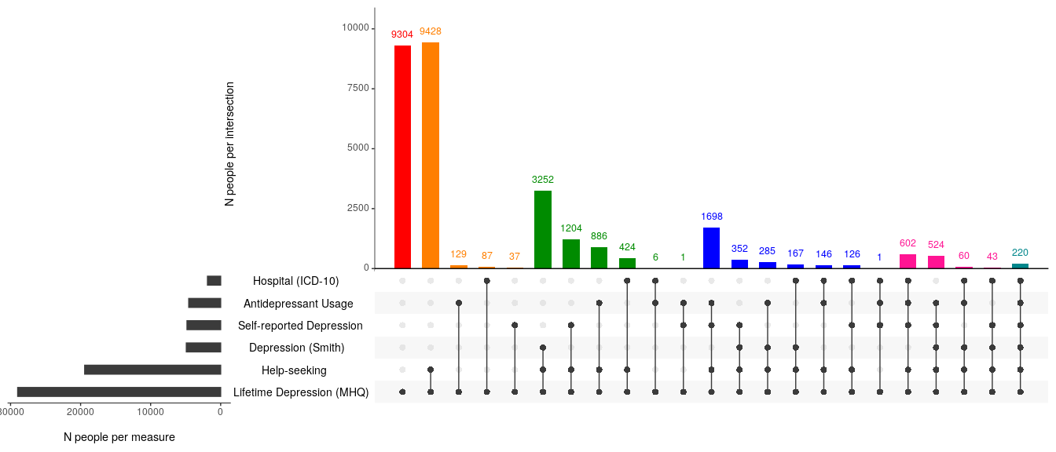
B | Did not meet CIDI-SF criteria for Lifetime Depression
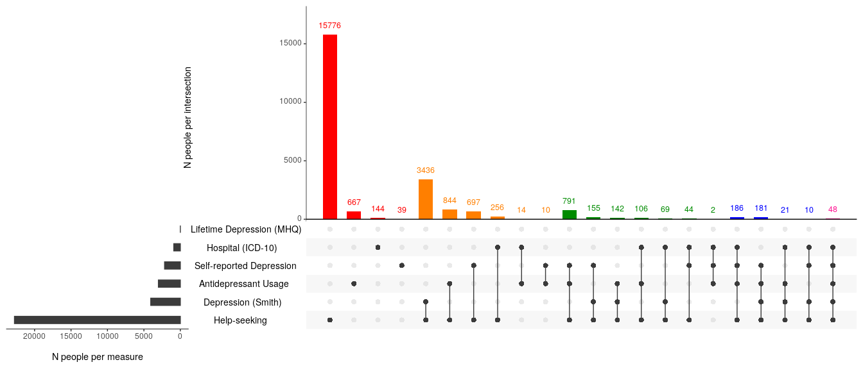

Supplementary Figure 1: Number of depression measures observed in MHQ participants. Horizontal grey bars indicate the number of individuals who met the criteria for any of the corresponding depression phenotypes. Vertical bars indicate the number of individuals endorsing combinations of the six depression phenotypes. Vertical bars are coloured by the number of depression measures endorsed: red = 1, orange = 2, green = 3, blue = 4, pink = 5, turquoise = 6. Panel A = MHQ participants who met the criteria for Lifetime Depression (N = 28,982); Panel B = MHQ participants who did not meet the CIDI-SF criteria for Lifetime Depression (Total N = 95,486. N = 37,681 had other indications of depression and were excluded from MHQ controls. N = 57,805 had no other indications of depression and were retained as MHQ controls). N = 1,793 MHQ participants excluded for indications of psychosis or missing data in the MHQ.

Polygenic risk score analyses results
Supplementary Table 12: Results for tests of association between PRS and depression phenotypes.
Base GWAS | Controls | Cases | Optimal p-value threshold (P_{T}) | No. SNPs used to construct PRS at (P_{T}) | Population Prevalence | Adjusted Variance explained (Liability R²) | Coefficient | Observed p-value | Empirical p-value
PGC MDD  Excl. 23andMe | Controls | One Measure | 0.3 | 45,292 | 0.15 | 0.52% | 0.14 | 9e-179 | 1e-04
 |  | Two Measures | 0.3 | 45,292 | 0.15 | 0.77% | 0.17 | 1e-116 | 1e-04
 |  | Three Measures | 0.3 | 45,292 | 0.15 | 1.21% | 0.21 | 3e-85 | 1e-04
 |  | Four Measures | 0.4 | 55,560 | 0.15 | 1.76% | 0.25 | 4e-58 | 1e-04
 |  | Five Measures | 0.2 | 33,491 | 0.15 | 1.45% | 0.28 | 5e-12 | 1e-04
 |  | Lifetime Depression (MHQ) | 0.5 | 64,483 | 0.15 | 0.54% | 0.14 | 3e-104 | 1e-04
PGC MDD  Excl. 23andMe | MHQ controls | One Measure | 0.3 | 45,292 | 0.15 | 0.91% | 0.19 | 5e-195 | 1e-04
 |  | Two Measures | 0.3 | 45,292 | 0.15 | 1.25% | 0.22 | 3e-146 | 1e-04
 |  | Three Measures | 0.3 | 45,292 | 0.15 | 1.77% | 0.25 | 1e-110 | 1e-04
 |  | Four Measures | 0.4 | 55,560 | 0.15 | 2.39% | 0.30 | 3e-74 | 1e-04
 |  | Five Measures | 0.2 | 33,491 | 0.15 | 1.98% | 0.33 | 2e-15 | 1e-04
 |  | Lifetime Depression (MHQ) | 0.3 | 45,292 | 0.15 | 0.96% | 0.18 | 6e-136 | 1e-04
PGC MDD  Incl. 23andMe | Controls | One Measure | 0.5 | 67,956 | 0.15 | 0.88% | 0.18 | 9e-299 | 1e-04
 |  | Two Measures | 0.4 | 59,001 | 0.15 | 1.41% | 0.23 | 2e-211 | 1e-04
 |  | Three Measures | 0.2 | 36,975 | 0.15 | 1.96% | 0.26 | 4e-137 | 1e-04
 |  | Four Measures | 0.4 | 59,001 | 0.15 | 2.83% | 0.32 | 2e-92 | 1e-04
 |  | Five Measures | 0.1 | 22,831 | 0.15 | 2.16% | 0.34 | 4e-17 | 1e-04
 |  | Lifetime Depression (MHQ) | 1.0 | 99,216 | 0.15 | 1.20% | 0.20 | 7e-228 | 1e-04
PGC MDD  Incl. 23andMe | MHQ controls | One Measure | 0.5 | 67,956 | 0.15 | 1.26% | 0.22 | 5e-269 | 1e-04
 |  | Two Measures | 0.4 | 59,001 | 0.15 | 1.96% | 0.27 | 1e-226 | 1e-04
 |  | Three Measures | 0.2 | 36,975 | 0.15 | 2.56% | 0.31 | 9e-159 | 1e-04
 |  | Four Measures | 0.4 | 59,001 | 0.15 | 3.54% | 0.36 | 2e-108 | 1e-04
 |  | Five Measures | 0.1 | 22,831 | 0.15 | 2.62% | 0.37 | 6e-20 | 1e-04
 |  | Lifetime Depression (MHQ) | 1.0 | 99,216 | 0.15 | 1.70% | 0.24 | 2e-237 | 1e-04

A | 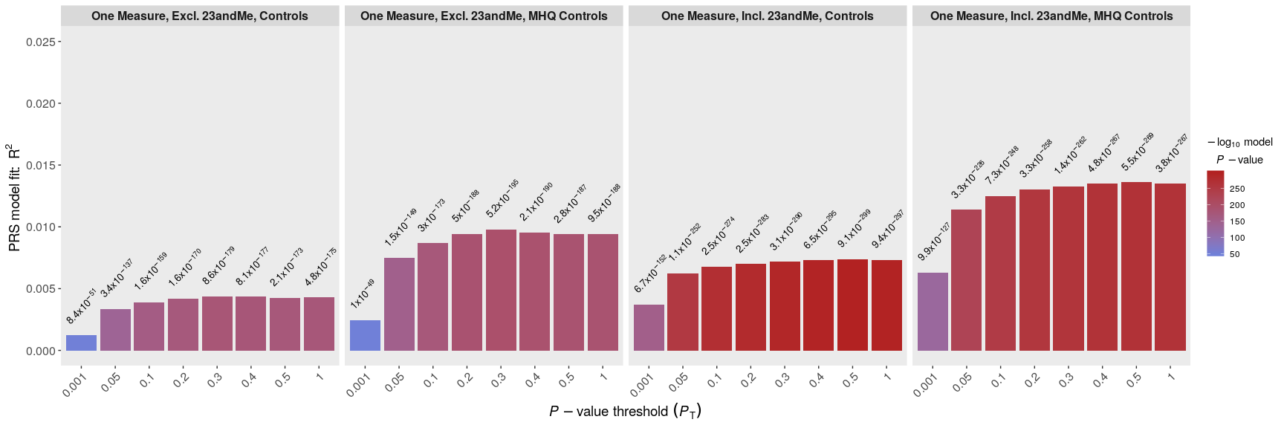
B | 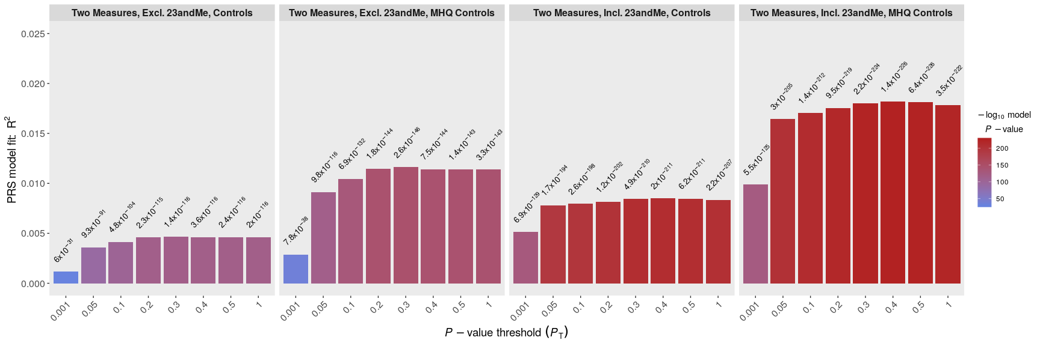
C | 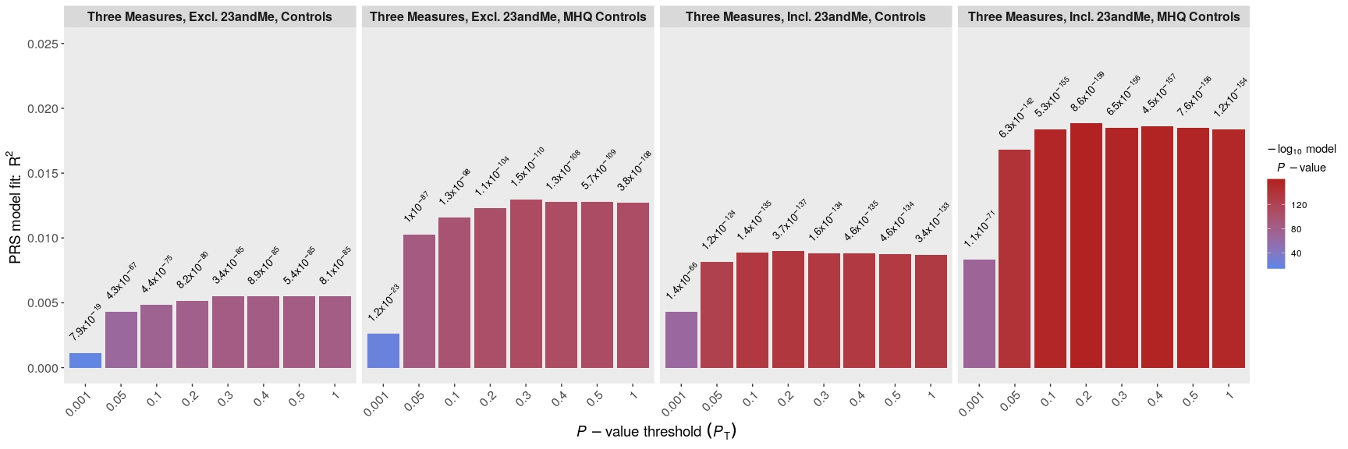
D | 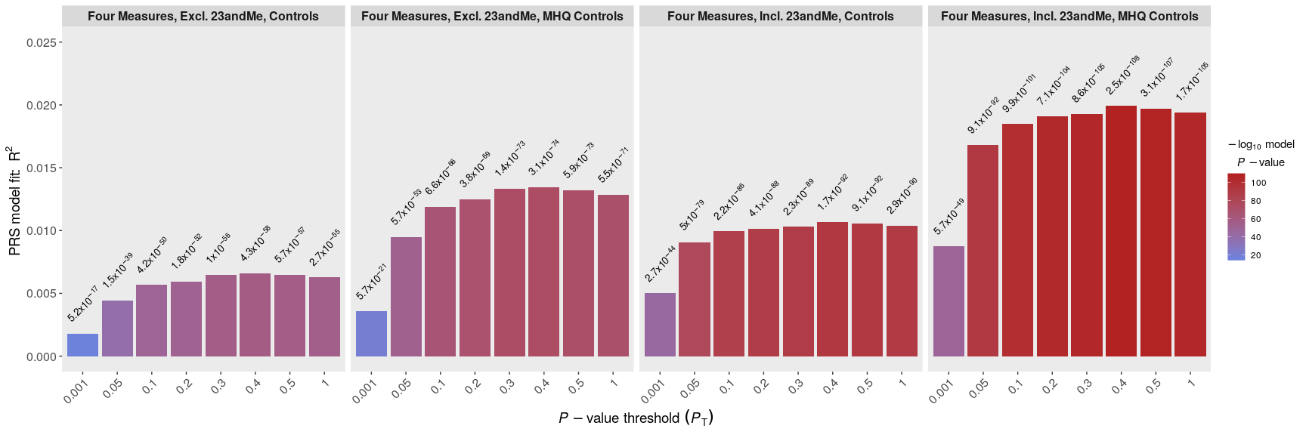
E | 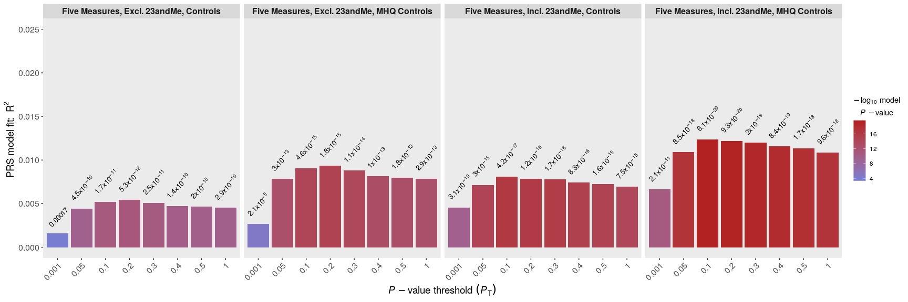
F | 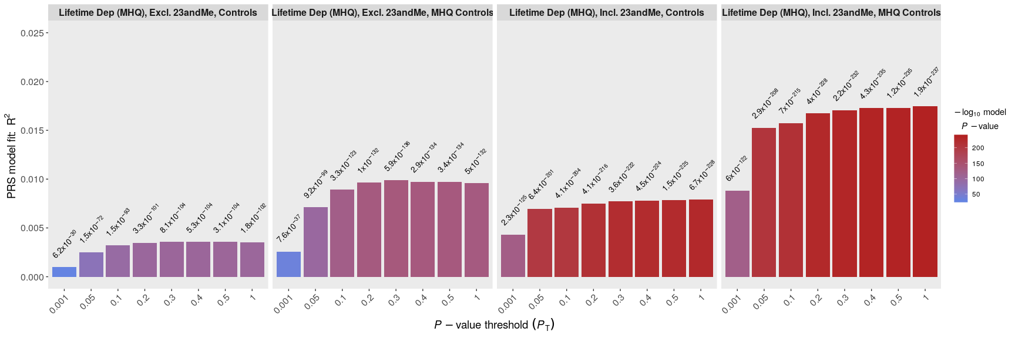
Supplementary Figure 2: Association between PRS and depression phenotypes across eight P_{T}. Row A = One Measure, Row B = Two Measures, Row C = Three Measures, Row D = Four Measures, Row E = Five Measures, Row F = Lifetime Depression (MHQ). Excl. 23andMe = PRS calculated using summary statistics from the sub-set of the PGC MDD sample (excluding UKB and 23andMe). Incl. 23andMe = PRS calculated using summary statistics from the full PGC MDD sample (excluding UKB). Observed p-values are shown atop each bar. Y-axis shows unadjusted R² (observed-scale).

Area Under the Curve Analyses
Controls
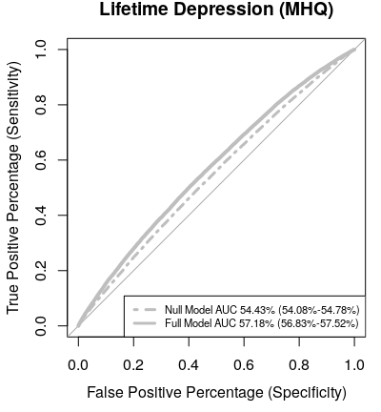 | 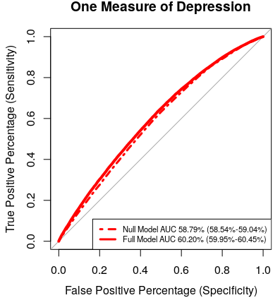 | 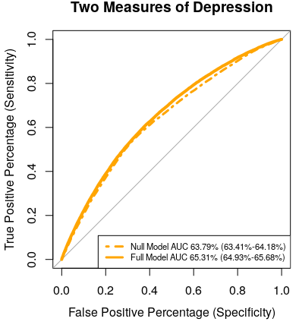 | 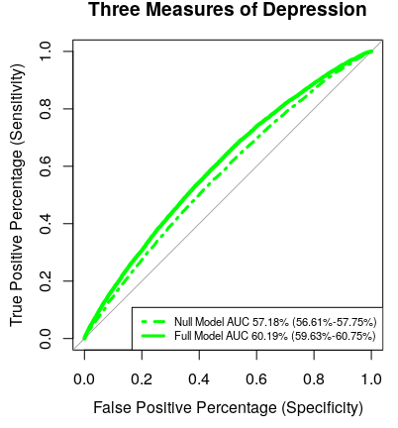 | 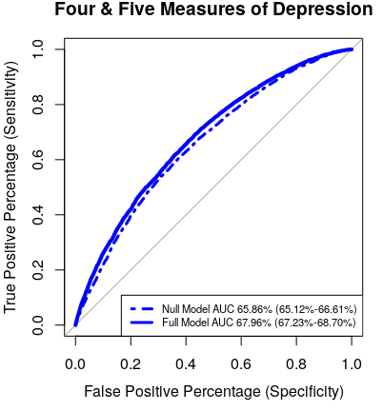
MHQ controls
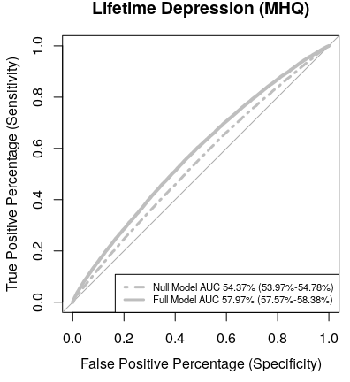 | 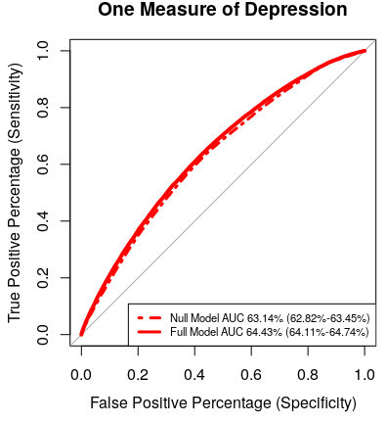 | 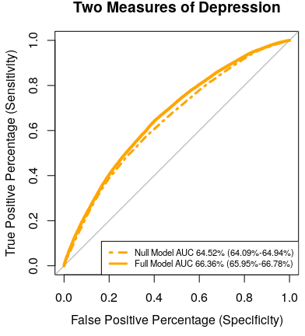 | 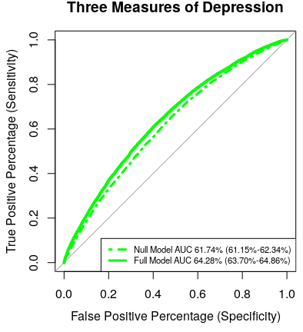 | 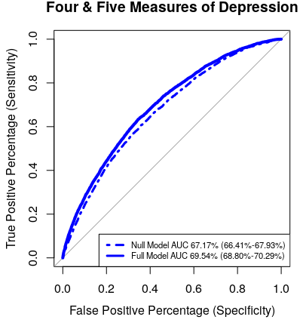

Supplementary Figure 3: ROC plots. AUC estimates from Null Models (Phenotype ~ 6PCs + Genotyping Batch + Centre of Assessment) and Full Models (Phenotype ~ PRS + 6PCs + Genotyping Batch + Centre of Assessment). PRS calculated using PGC MDD summary statistics including 23andMe at the P_{T} identified for each phenotype in PRSice analysis. Logistic regressions performed on depression phenotypes shown in plot titles, using controls (upper panel) and MHQ controls (lower panel).

GWAS results

A | 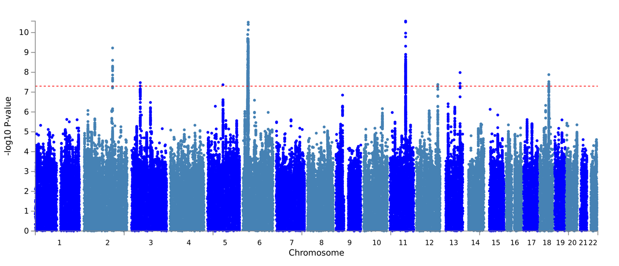 | 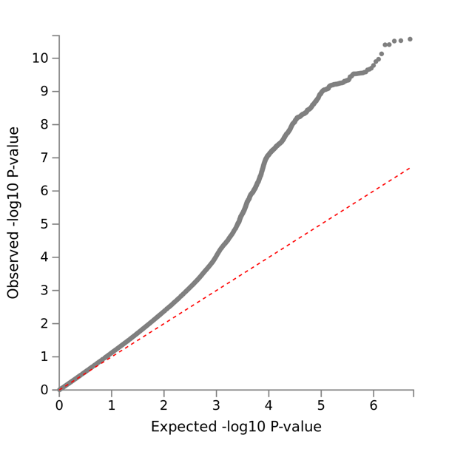
B | 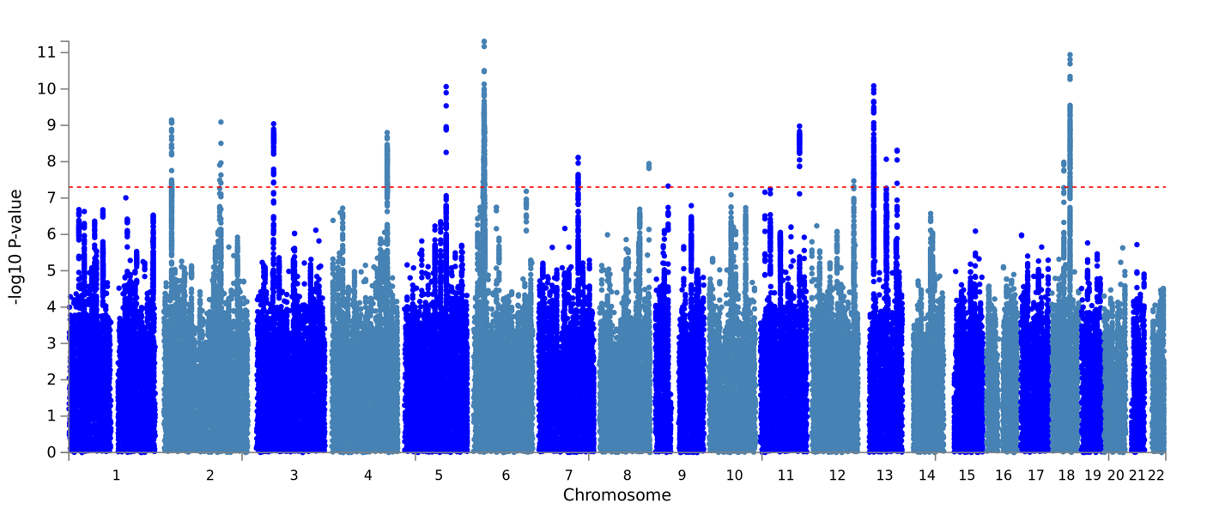 | 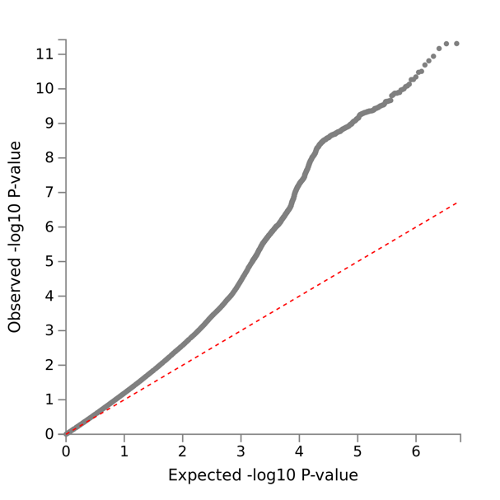

Supplementary Figure 4: Manhattan and QQ plots from GWAS of One Measure of Depression. A: controls, B: MHQ controls.

A | 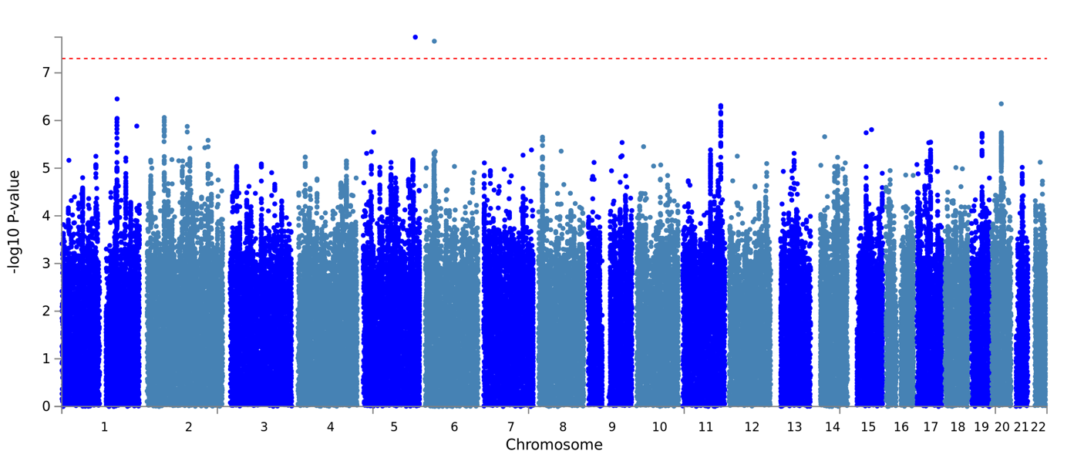 | 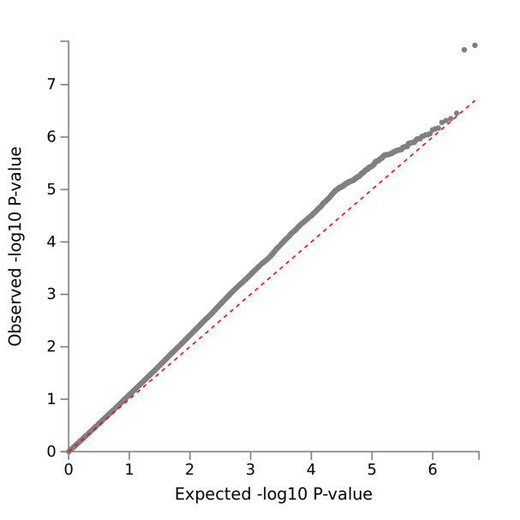
B | 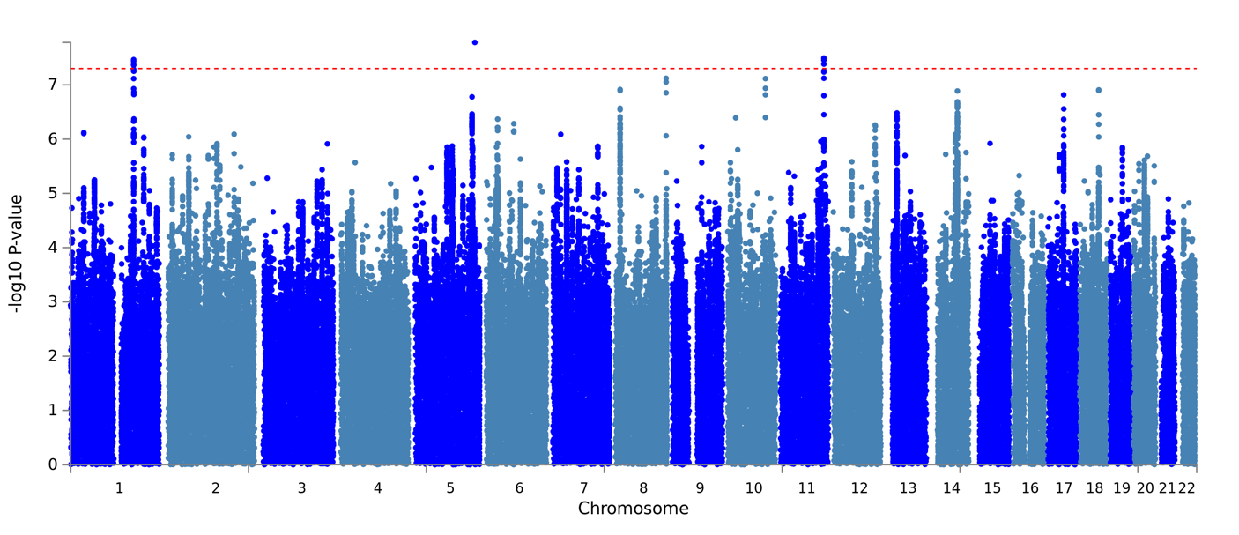 | 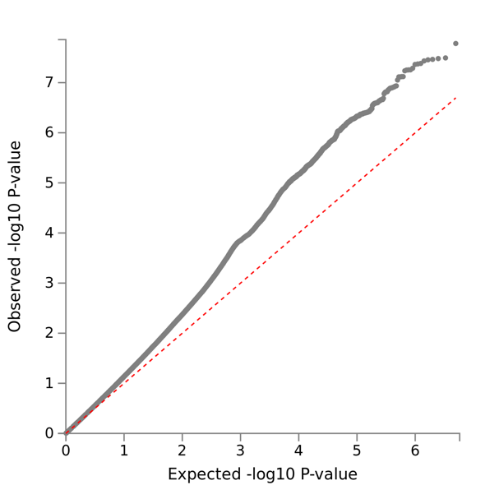

Supplementary Figure 5: Manhattan and QQ plots from GWAS of Two Measures of Depression. A: controls, B: MHQ controls.

A | 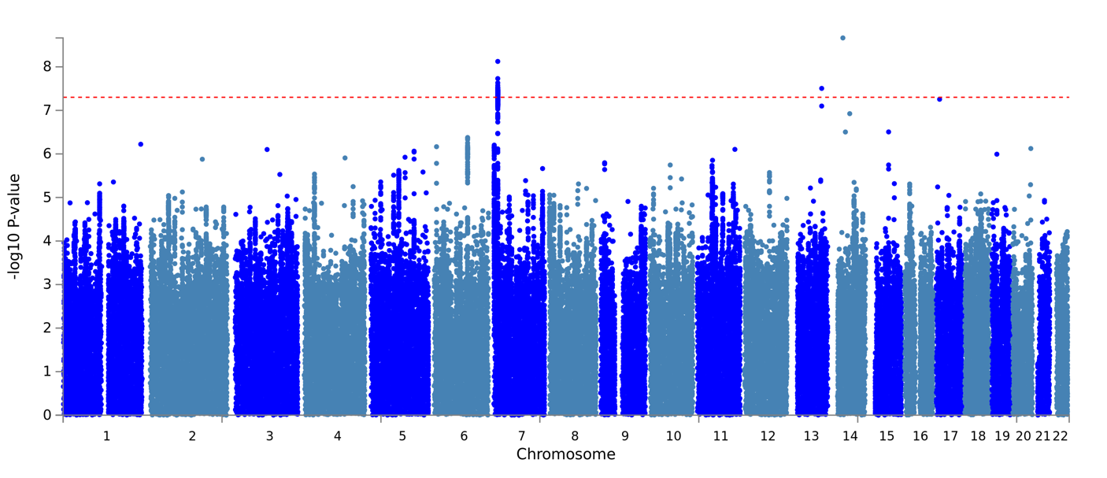 | 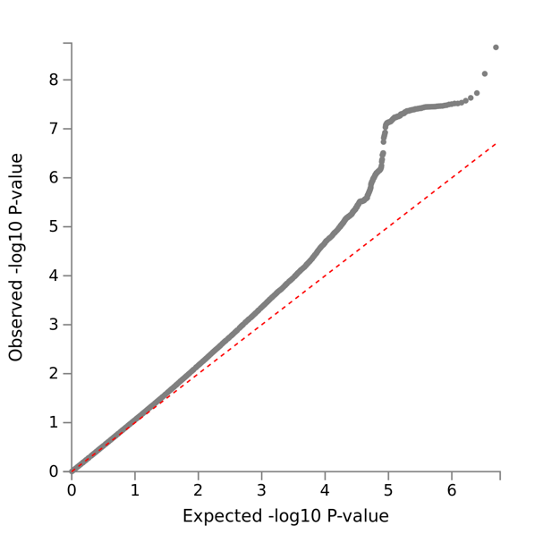
B | 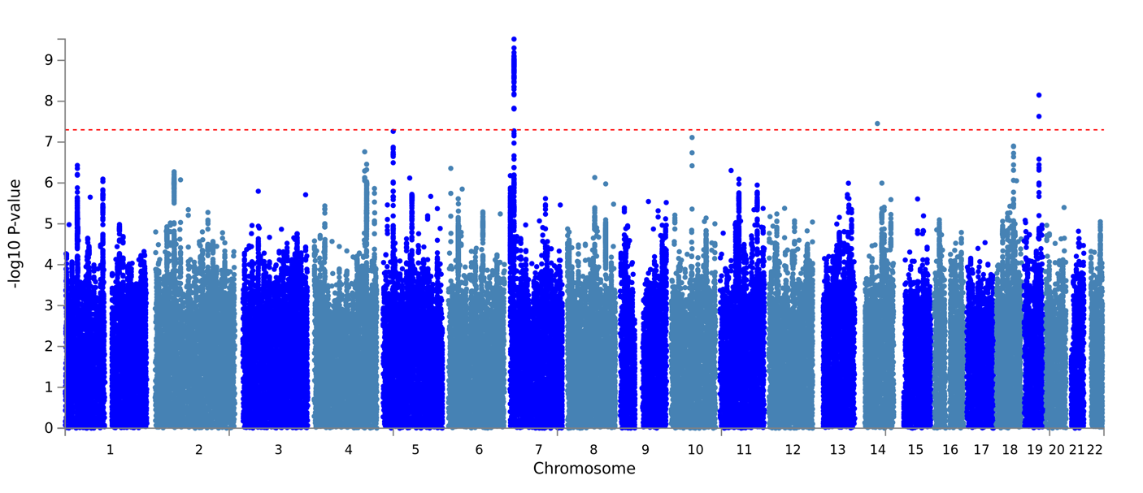 | 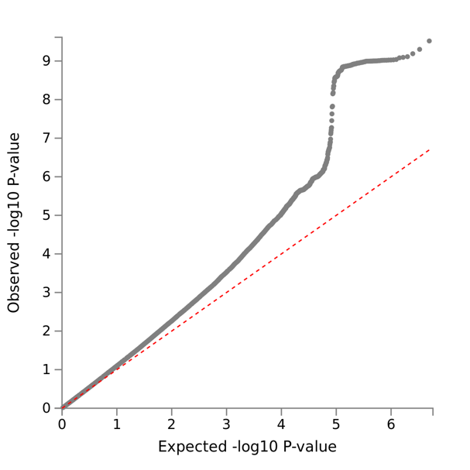

Supplementary Figure 6: Manhattan and QQ plots from GWAS of Three Measures of Depression. A: controls, B: MHQ controls.

A | 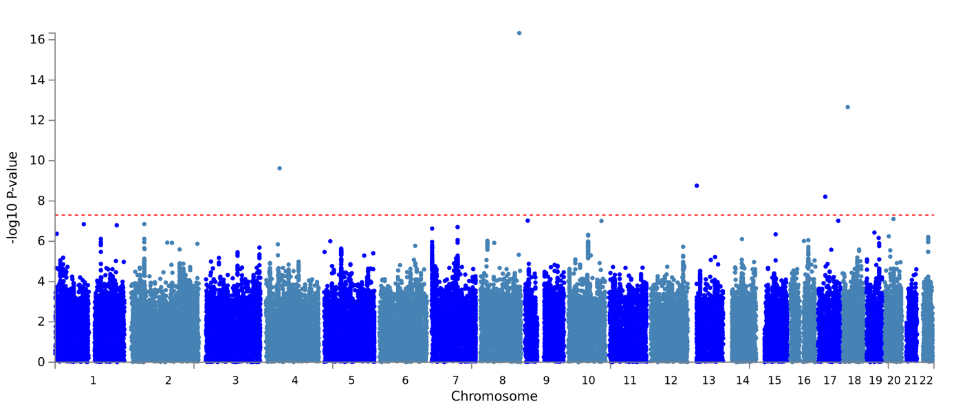 | 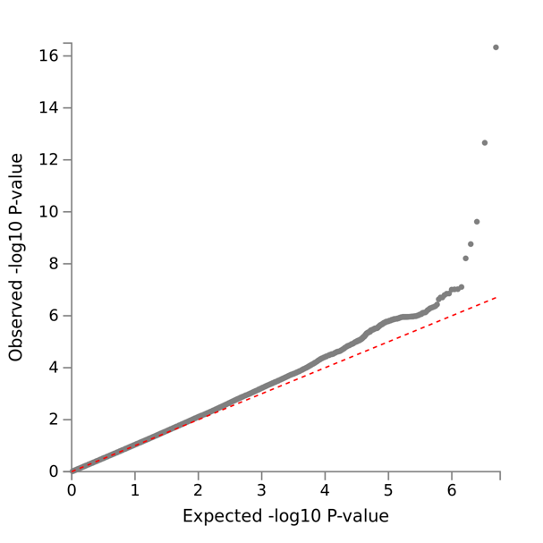
B | 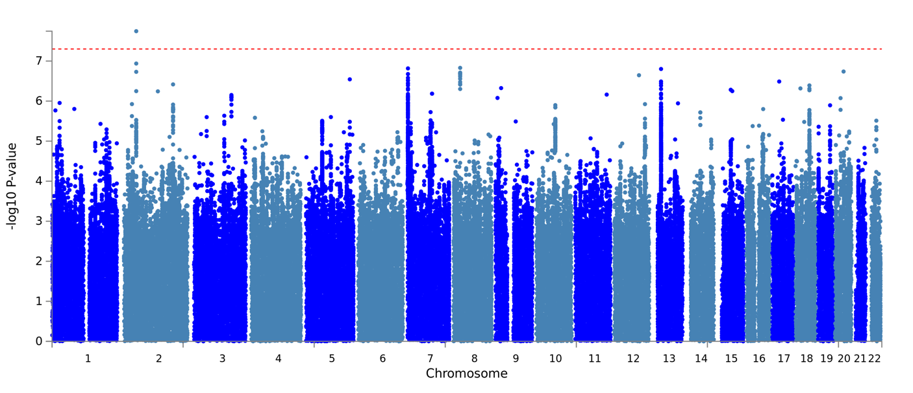 | 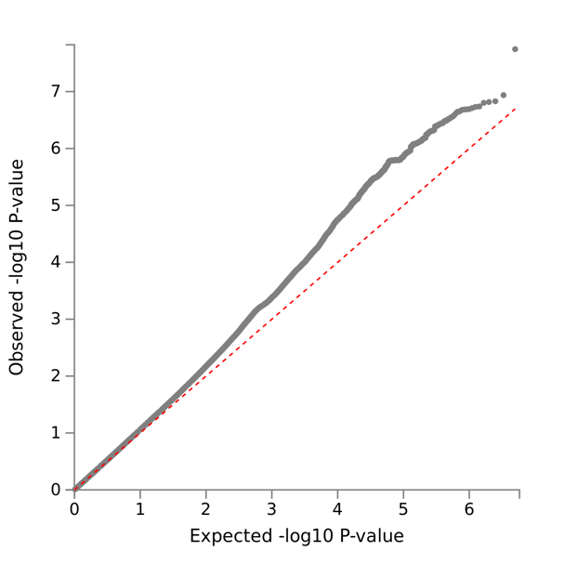

Supplementary Figure 7: Manhattan and QQ plots from GWAS of Four & Five Measure of Depression. A: controls, B: MHQ controls.

A | 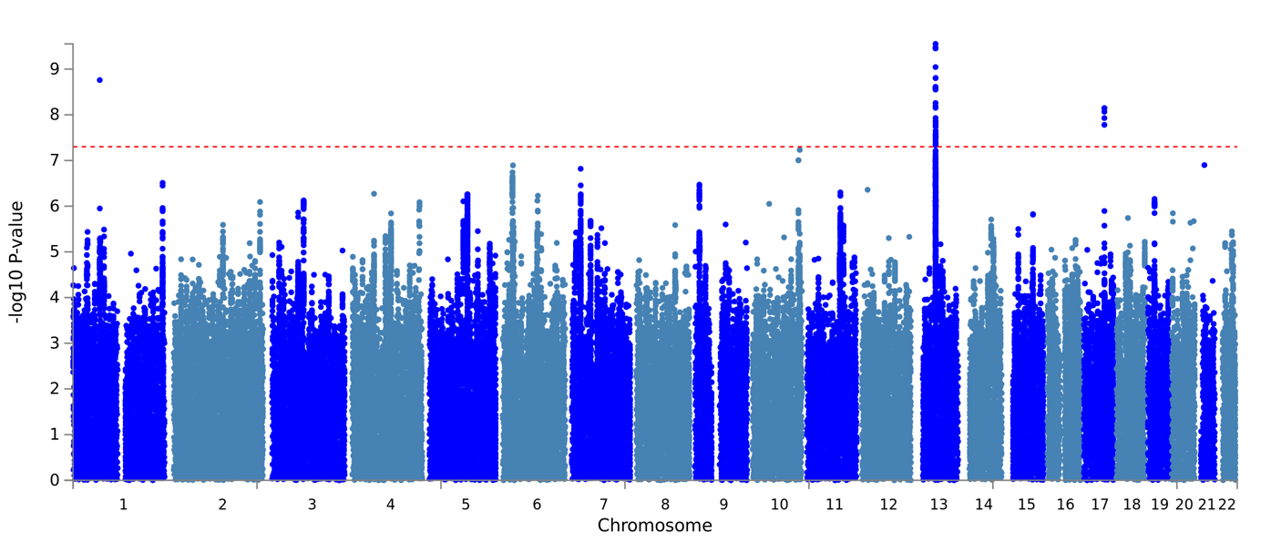 | 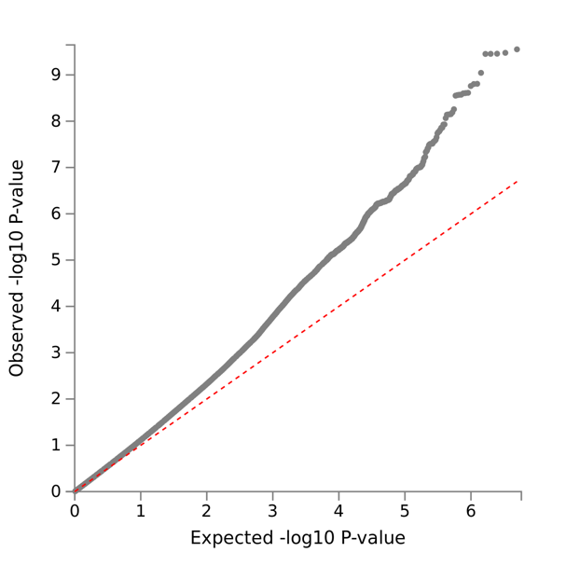
B | 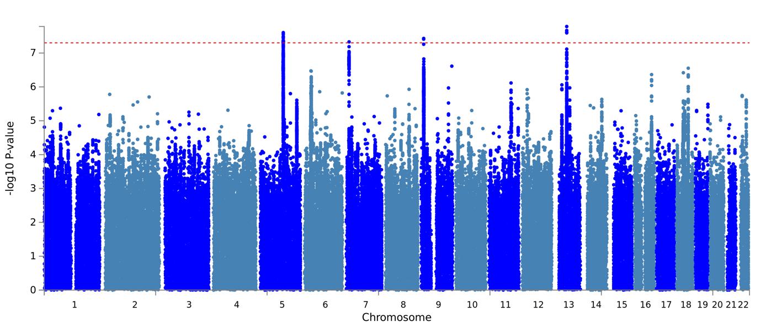 | 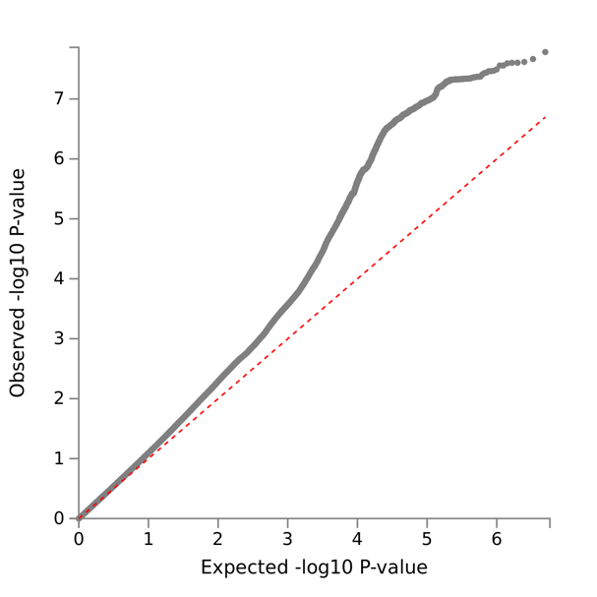

Supplementary Figure 8: Manhattan and QQ plots from GWAS of Lifetime Depression (MHQ). A: controls, B: MHQ controls.

GWAS results have been published on FUMA⁴ (https://fuma.ctglab.nl/) to show details of significant SNPs including evidence for association with other traits in the GWAS catalogue.
Supplementary Table 13: FUMA titles and IDs for GWAS performed in this study.

GWAS Trait | Controls | FUMA ID | FUMA Title
One Measure | Controls | 151 | One_232k_controls
Two Measures |  | 153 | Two_232k_controls
Three Measures |  | 152 | Three_232k_controls
Four Measures |  | 154 | Four_five_232k_controls
Lifetime Depression (MHQ) |  | 150 | MHQ_232k_controls
One Measure | MHQ controls | 146 | One_58k_controls
Two Measures |  | 147 | Two_58k_controls
Three Measures |  | 148 | Three_58k_controls
Four & Five Measures |  | 149 | Four_five_58k_controls
Lifetime Depression (MHQ) |  | 145 | MHQ_58k_controls

Supplementary Table 14: GWAS and h²_{SNP} results: depression cases compared to controls.

 | Depression phenotype in the UKB
Parameter | Lifetime Depression (MHQ) | One Measure | Two Measures | Three Measures | Four & Five Measures
GWAS results (BGENIE)
No. SNPs in GWAS | 9,940,917 | 9,940,917 | 9,940,917 | 9,940,917 | 9,940,917
Mean chi² | 1.162 | 1.182 | 1.115 | 1.083 | 1.053
Lambda GC | 1.138 | 1.151 | 1.103 | 1.076 | 1.045
Max chi² | 39.807 | 44.425 | 31.343 | 33.399 | 70.477
No. Significant SNPs | 40 | 692 | 1 | 67 | 5
Heritability results (LDSC)
Population Prevalence | 0.15 | 0.15 | 0.15 | 0.15 | 0.15
Sample Prevalence | 0.110 | 0.197 | 0.084 | 0.040 | 0.020
No. SNPs post-munge | 7,353,982 | 7,353,982 | 7,353,982 | 7,353,982 | 7,353,982
No. SNPs post LD merge | 1,184,555 | 1,184,555 | 1,184,555 | 1,184,555 | 1,184,555
Liability scale h² (SE) | 0.1134 (0.008) | 0.0723 (0.0047) | 0.1121 (0.0093) | 0.1874 (0.0183) | 0.2086 (0.0289)
Liability scale h² 95% CIs | 0.098 - 0.129 | 0.063 - 0.082 | 0.094 - 0.130 | 0.152 - 0.223 | 0.152 - 0.265
Lambda | 1.1619 | 1.194 | 1.127 | 1.0988 | 1.0557
Mean Chi² | 1.1949 | 1.2186 | 1.1379 | 1.1058 | 1.0599
Intercept (SE) | 1.0047 (0.0076) | - (0.0076) | 0.9954 (0.0068) | 0.9923 (0.0069) | 0.9971 (0.0068)

Supplementary Table 15: GWAS and h²_{SNP} results: depression cases compared to MHQ controls.

 | Depression phenotype in the UKB
Parameter | Lifetime Depression (MHQ) | One Measure | Two Measures | Three Measures | Four & Five Measures
GWAS results (BGENIE)
No. SNPs in GWAS | 9,940,917 | 9,940,917 | 9,940,917 | 9,940,917 | 9,940,917
Mean chi² | 1.137 | 1.282 | 1.193 | 1.137 | 1.086
Lambda GC | 1.12 | 1.226 | 1.171 | 1.125 | 1.077
Max chi² | 31.349 | 47.732 | 30.521 | 39.661 | 31.705
No. Significant SNPs | 52 | 786 | 8 | 85 | 1
Heritability results (LDSC)
Population Prevalence | 0.15 | 0.15 | 0.15 | 0.15 | 0.15
Sample Prevalence | 0.333 | 0.497 | 0.270 | 0.144 | 0.077
No. SNPs post-munge | 7,353,982 | 7,353,982 | 7,353,982 | 7,353,982 | 7,353,982
No. SNPs post LD merge | 1,184,555 | 1,184,555 | 1,184,555 | 1,184,555 | 1,184,555
Liability scale h² (SE) | 0.1268 (0.0091) | 0.1729 (0.0091) | 0.2259 (0.0132) | 0.3315 (0.0212) | 0.336 (0.0337)
Liability scale h² 95% CIs | 0.109 - 0.145 | 0.155 - 0.191 | 0.200 - 0.252 | 0.290 - 0.373 | 0.270 - 0.402
Lambda | 1.1428 | 1.2831 | 1.207 | 1.1587 | 1.0895
Mean Chi² | 1.1599 | 1.3391 | 1.2293 | 1.1697 | 1.0966
Intercept (SE) | 0.9984 (0.0071) | 1.0136 (0.0085) | 1.0014 (0.0074) | 0.9911 (0.0072) | 0.9998 (0.007)

Genetic Correlations
Supplementary Table 16: Genetic correlations between UKB and PGC depression phenotypes. PGC Incl. 23andMe = summary statistics from the full PGC MDD sample (excluding UKB). PGC excl. 23andMe = summary statistics from the sub-set of the PGC MDD sample with self-reported cases removed (excluding UKB and 23andMe). Pairwise r_{G} estimates were calculated using summary statistics generated from GWASs of UKB depression phenotypes using controls and MHQ controls.
Phenotype 1 | Phenotype 2 | r_{G} | 95% CIs | P-value | r_{G} | 95% CIs | P-value
 |  | Controls |  |  | MHQ controls
Lifetime Depression (MHQ) | One Measure | 0.53 | 0.46 - 0.60 | 3e-48 | 0.71 | 0.66 - 0.76 | 3e-152
Lifetime Depression (MHQ) | Two Measures | 0.62 | 0.53 - 0.71 | 1e-43 | 0.79 | 0.73 - 0.85 | 7e-138
Lifetime Depression (MHQ) | Three Measures | 0.52 | 0.42 - 0.62 | 4e-26 | 0.76 | 0.68 - 0.84 | 2e-85
Lifetime Depression (MHQ) | Four and Five Measures | 0.50 | 0.36 - 0.64 | 1e-12 | 0.73 | 0.62 - 0.84 | 1e-37
Lifetime Depression (MHQ) | PGC Incl. 23andMe | 0.80 | 0.74 - 0.86 | 2e-140 | 0.88 | 0.80 - 0.96 | 1e-112
Lifetime Depression (MHQ) | PGC excl. 23andMe | 0.72 | 0.63 - 0.81 | 9e-57 | 0.90 | 0.80 - 1.00 | 2e-65
One Measure | Two Measures | 1.00 | 0.92 - 1.08 | 6e-118 | 0.99 | 0.95 - 1.03 | 0e+00
One Measure | Three Measures | 0.90 | 0.81 - 0.99 | 2e-76 | 0.95 | 0.90 - 1.00 | 1e-260
One Measure | Four and Five Measures | 0.94 | *0.79 - 1.09 | 9e-33 | 0.96 | *0.87 - 1.05 | 2e-93
One Measure | PGC Incl. 23andMe | 0.84 | 0.78 - 0.90 | 5e-167 | 0.65 | 0.60 - 0.70 | 5e-126
One Measure | PGC excl. 23andMe | 0.86 | 0.77 - 0.95 | 3e-79 | 0.74 | 0.66 - 0.82 | 2e-78
Two Measures | Three Measures | 0.86 | 0.74 - 0.98 | 1e-43 | 0.92 | 0.85 - 0.99 | 5e-158
Two Measures | Four and Five Measures | 0.88 | 0.70 - 1.06 | 1e-21 | 0.94 | 0.83 - 1.05 | 3e-64
Two Measures | PGC Incl. 23andMe | 0.82 | 0.75 - 0.89 | 1e-106 | 0.67 | 0.61 - 0.73 | 1e-110
Two Measures | PGC excl. 23andMe | 0.86 | 0.76 - 0.96 | 6e-68 | 0.75 | 0.67 - 0.83 | 1e-81
Three Measures | Four and Five Measures | *1.01 | 0.81 - 1.21 | 2e-22 | *1.01 | 0.89 - 1.13 | 6e-61
Three Measures | PGC Incl. 23andMe | 0.72 | 0.64 - 0.80 | 7e-76 | 0.62 | 0.57 - 0.67 | 1e-107
Three Measures | PGC excl. 23andMe | 0.76 | 0.64 - 0.88 | 4e-37 | 0.69 | 0.60 - 0.78 | 4e-50
Four and Five Measures | PGC Incl. 23andMe | 0.78 | 0.65 - 0.91 | 6e-34 | 0.69 | 0.60 - 0.78 | 1e-50
Four and Five Measures | PGC excl. 23andMe | 0.86 | *0.70 - 1.02 | 6e-25 | 0.81 | 0.69 - 0.93 | 2e-39
PGC Incl. 23andMe | PGC excl. 23andMe | 0.97 | 0.94 - 1.00 | 0e+00 | 0.97 | 0.94 - 1.00 | 0e+00

*LDSC is not a bounded estimator and can produce estimates outside the range or -1, 1 when standard errors are large due to small samples. This issue is discussed in the LDSC GitHub issue log: https://github.com/bulik/ldsc/issues/89

A) Controls  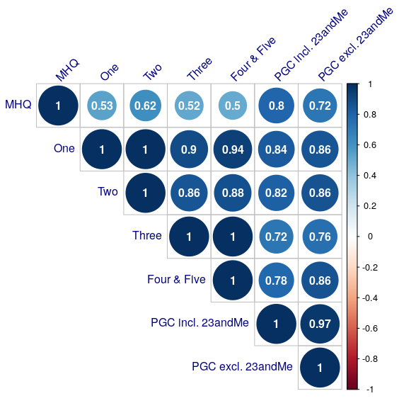 | B) MHQ controls  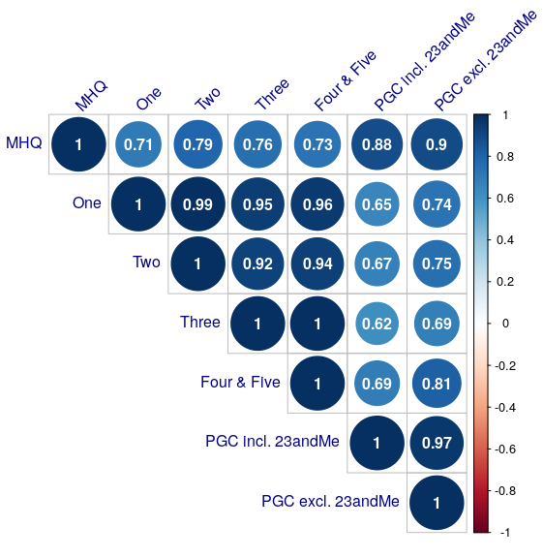

Supplementary Figure 9: Genetic correlation matrix. Circle sizes correspond to the magnitude of correlation, increasing as r_{G} approaches 1. MHQ = Lifetime Depression (MHQ). One, Two, Three, Four & Five = cases determined by number of observed depression measures. PGC Incl. 23andMe = summary statistics from the full PGC MDD sample (excluding UKB). PGC excl. 23andMe = summary statistics from the sub-set of the PGC MDD sample with self-reported cases removed (excluding UKB and 23andMe). Summary statistics used to estimate r_{G} were generated from GWASs of UKB depression phenotypes using controls (left matrix) and MHQ controls (right matrix).

References

1. Smith DJ, Nicholl BI, Cullen B, Martin D, Ul-Haq Z, Evans J, et al. Prevalence and Characteristics of Probable Major Depression and Bipolar Disorder within UK Biobank: Cross-Sectional Study of 172,751 Participants. Potash JB, editor. PLOS ONE. 2013 Nov 25;8(11):e75362.
2. Davis KAS, Coleman JRI, Adams M, Allen N, Breen G, Cullen B, et al. Mental health in UK Biobank – development, implementation and results from an online questionnaire completed by 157 366 participants: a reanalysis. BJPsych Open. Cambridge University Press; 2020 Mar 1;6(2):e18.
3. Kroenke K, Spitzer RL, Williams JBW, Löwe B. The Patient Health Questionnaire Somatic, Anxiety, and Depressive Symptom Scales: a systematic review. General Hospital Psychiatry. 2010 Jul;32(4):345–59.
4. Watanabe K, Taskesen E, van Bochoven A, Posthuma D. Functional mapping and annotation of genetic associations with FUMA. Nature Communications. Nature Publishing Group; 2017 Nov 28;8(1):D1001.

