Supplemental information
-
Associations between psychiatric disorders, COVID-19 testing probability and COVID-19 testing results
Findings from a population-based study

Authors: Dennis van der Meer, PhD^{1,2,*}; Justo Pinzón-Espinosa, MD, MSc^{3-6,*}; Bochao D. Lin, PhD^{7,8}; Joeri K. Tijdink, MD, PhD^{9,10}; Christiaan H. Vinkers^{11,12}; Sinan Guloksuz, MD, PhD^{13,14}; Jurjen J. Luykx, MD, PhD¹⁵⁻¹⁷

* These authors contributed equally.

1 NORMENT, Division of Mental Health and Addiction, Oslo University Hospital & Institute of Clinical Medicine, University of Oslo, Oslo, Norway
2 School of Mental Health and Neuroscience, Faculty of Health, Medicine and Life Sciences, Maastricht University, The Netherlands
3 Psychiatry Trainee, Barcelona Clínic Schizophrenia Unit, Department of Psychiatry and Psychology, Institute of Neuroscience, Hospital Clínic of Barcelona, Catalonia, Spain.
4 Predoctoral researcher, Department of Medicine, School of Medicine, University of Barcelona, Catalonia, Spain.
5 Predoctoral researcher, August Pi i Sunyer Biomedical Research Institute (IDIBAPS), Barcelona, Catalonia, Spain.
6 Ad-honorem Clinical Professor, Department of Clinical Psychiatry, School of Medicine, University of Panama, Panama City, Panama.
7 Post-doctoral researcher, Department of Psychiatry, Brain Center Rudolf Magnus, University Medical Center Utrecht, Utrecht University, Utrecht, the Netherlands
8 Post-doctoral researcher, Department of Translational Neuroscience, Brain Center Rudolf Magnus, University Medical Center Utrecht, Utrecht University, Utrecht, the Netherlands
9 Assistant professor, Department of Medical Humanities, Amsterdam University Medical Center, Amsterdam, the Netherlands
10 Assistant professor, Department of Philosophy, Vrije Universiteit, Amsterdam, the Netherlands
11 Associate professor, Department of Psychiatry, Amsterdam University Medical Center, Amsterdam, the Netherlands
12 Associate professor, Department of Anatomy and Neurosciences, Amsterdam University Medical Center, Amsterdam, the Netherlands
13 Assistant professor, Department of Psychiatry and Neuropsychology, School for Mental Health and Neuroscience, Maastricht University Medical Center, Maastricht, the Netherlands
14 Asssistant professor, Department of Psychiatry, Yale University School of Medicine, New Haven, Connecticut, USA
15 Assistant professor, Outpatient Second Opinion Clinic, GGNet Mental Health, Warnsveld, The Netherlands
16 Assistant professor, Department of Psychiatry, Brain Center Rudolf Magnus, University Medical Center Utrecht, Utrecht University, Utrecht, the Netherlands
17 Assistant professor, Department of Translational Neuroscience, Brain Center Rudolf Magnus, University Medical Center Utrecht, Utrecht University, Utrecht, the Netherlands

Table S1. Conditions included in the analysis by ICD-10 diseases category. ICD-10 codes begin each disease category.

Psychiatric (F00 – F99)
F00-09 Dementias and other types of brain disorders causing behavioral symptoms
F10-19 Substance use disorders
F20-29 Psychotic disorders
F32-39 Mood disorders – unipolar
F30-31 Mood disorders – bipolar
F40-41 Anxiety disorders
F42-48 Obsessive-compulsive disorder and stress-related disorders
F60-62, F68-69 Personality disorders
F70-79 Intellectual disability
F80-98 Developmental and other childhood-onset disorders
F50-F54; F63-F66; F99 Other psychiatric disorders

Neurological (G0x-G4x), i.e. specifically central nervous system disorders
G00-G09 Inflammatory diseases of the central nervous system
G10-G14 Systemic atrophies primarily affecting the central nervous system
G20-G26 Extrapyramidal and movement disorders
G30-G32 Other degenerative diseases of the nervous system
G35-G37 Demyelinating diseases of the central nervous system
G40-G47 Episodic and paroxysmal disorders

Circulatory (Ixx)
I00-I02 Acute rheumatic fever
I05-I09 Chronic rheumatic heart diseases
I10-I16 Hypertensive diseases
I20-I25 Ischemic heart diseases
I26-I28 Pulmonary heart disease and diseases of pulmonary circulation
I30-I52 Other forms of heart disease
I60-I69 Cerebrovascular diseases
I70-I79 Diseases of arteries, arterioles, and capillaries

Respiratory (Jxx)
J00-J06 Acute upper respiratory infections
J09-J18 Influenza and pneumonia
J20-J22 Other acute lower respiratory infections
J30-J39 Other diseases of upper respiratory tract
J40-J47 Chronic lower respiratory diseases
J60-J70 Lung diseases due to external agents
J80-J84 Other respiratory diseases principally affecting the interstitium
J85-J86 Suppurative and necrotic conditions of lower respiratory tract
J90-J94 Other diseases of pleura
J95-J99 Other diseases of the respiratory system

Metabolic (Exx)
E00-E07 Disorders of thyroid gland
E08-E13 Diabetes mellitus
E15-E16 Other disorders of glucose regulation and pancreatic internal secretion
E40-E46 Malnutrition
E50-E64 Other nutritional deficiencies
E65-E68 Overweight, obesity and other hyperalimentation
E70-E88 Metabolic disorders
Overview of comorbidity
In Table S2 we present an overview of the comorbidity rates between the ICD-10 diagnoses among individuals tested for COVID-19. Each cell indicates the proportion of individuals with the diagnosis specified in the first column who also have the diagnosis specified at the top of the subsequent columns.

Table S2. Comorbidity between the ICD-10 diagnoses included in the analyses. Association between COVID-19 test outcome and ICD-10 diagnosis, covarying for respiratory, cardiovascular, and metabolic disease.

 | Psychiatric | Substance | Anxiety | Depression | Neurological | Respiratory | Cardiovascular | Metabolic
Psychiatric disorder | 1 | 0.50 | 0.23 | 0.45 | 0.28 | 0.53 | 0.76 | 0.62
- Substance use | 1 | 1 | 0.17 | 0.26 | 0.23 | 0.56 | 0.76 | 0.61
- Anxiety | 1 | 0.38 | 1 | 0 .56 | 0.29 | 0.55 | 0.79 | 0.71
- Depression | 1 | 0.29 | 0.29 | 1 | 0.35 | 0.55 | 0.74 | 0.63
Neurological | 0.52 | 0.21 | 0.12 | 0.29 | 1 | 0.52 | 0.78 | 0.68
Respiratory | 0.40 | 0.21 | 0.09 | 0.18 | 0.21 | 1 | 0.78 | 0.58
Cardiovascular | 0.33 | 0.16 | 0.08 | 0.14 | 0.18 | 0.45 | 1 | 0.59
Metabolic | 0.37 | 0.18 | 0.10 | 0.17 | 0.22 | 0.47 | 0.82 | 1

As a sensitivity analysis, we reran the primary analyses, predicting COVID-19 test outcome from ICD-10 diagnoses, with four additional covariates, namely diagnoses of respiratory, cardiovascular, and metabolic disease, and the Townsend deprivation index (as a measure of socio-economic status). The pattern of results was highly similar to the main results, as shown in Figure S1. Note, for the association of respiratory, cardiovascular, and metabolic disease diagnoses with test outcome we left out the covariate for that disease, i.e. we did not include the outcome as covariate.

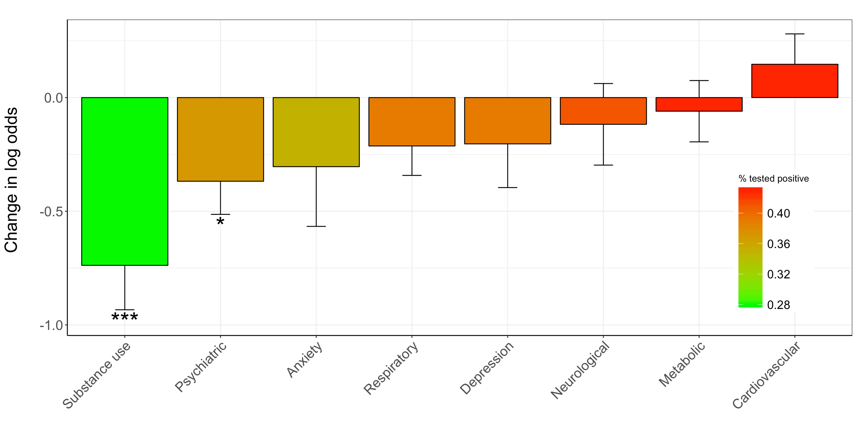
Figure S1. Bar plot of odds ratios for testing positive, by ICD-10 diagnosis while additionally covarying for diagnoses of respiratory, cardiovascular, and metabolic disease diagnoses, and socio-economic status. Odds ratios are shown on the y-axis, on the x-axis are the diagnoses, colors indicate percent that tested positive. Note that ‘psychiatric’ category includes participants with substance, anxiety, and depressive disorders as those three are subcategories of the ‘psychiatric disorders’. Stars indicate significance: * p< .05, ** p< .005, ***p<.0005.

Associations between mental health items derived from the UKB mental health questionnaire and COVID-19 testing
We additionally tested whether mental health in the general population, regardless of ICD-10 diagnoses, was associated with COVID-19 testing prevalence and outcome. For this, we categorized people based on whether they responded affirmative to the mental health questions listed in Table S3. We then analysed the data identical to the primary analyses of ICD-10 diagnostic categories using affirmative answers as representing being a case. Please see the main text for the main results.

Table S3. Mental health questions used to categorize individuals. Within each category, we binarized individuals on whether they responded affirmative or not on any of the questions. For happiness we binarized based on a mean split. The numbers before the categories and questions indicate the UKB data repository field codes.
138: Depression
20446 Ever had prolonged feelings of sadness or depression
20441 Ever had prolonged loss of interest in normal activities

139: Mania
20502 Ever had period extreme irritability
20501 Ever had period of mania / excitability

140: Anxiety
20421 Ever felt worried, tense, or anxious for most of a month or longer
20425 Ever worried more than most people would in similar situation

141: Addiction
20401 Ever addicted to any substance or behaviour

144: Psychotic experiences
20468 Ever believed in an un-real conspiracy against self
20474 Ever believed in un-real communications or signs
20463 Ever heard an un-real voice
20471 Ever seen an un-real vision

146: Self-harm
20479 Ever thought that life not worth living
20485 Ever contemplated self-harm
20480 Ever self-harmed

147: Happiness
20458 General happiness*

* Coded as follows:
1 Extremely happy
2 Very happy
3 Moderately happy
4 Moderately unhappy
5 Very unhappy
6 Extremely unhappy

We found no significant associations between test outcome and the mental health questions. Figure S2 and S3 summarize this; in Figure S2 we show the results with and without including individuals with a psychiatric disorder, and in Figure S3 we show the results after additionally covarying for respiratory, cardiovascular, and metabolic diagnoses, and socio-economic status.

A
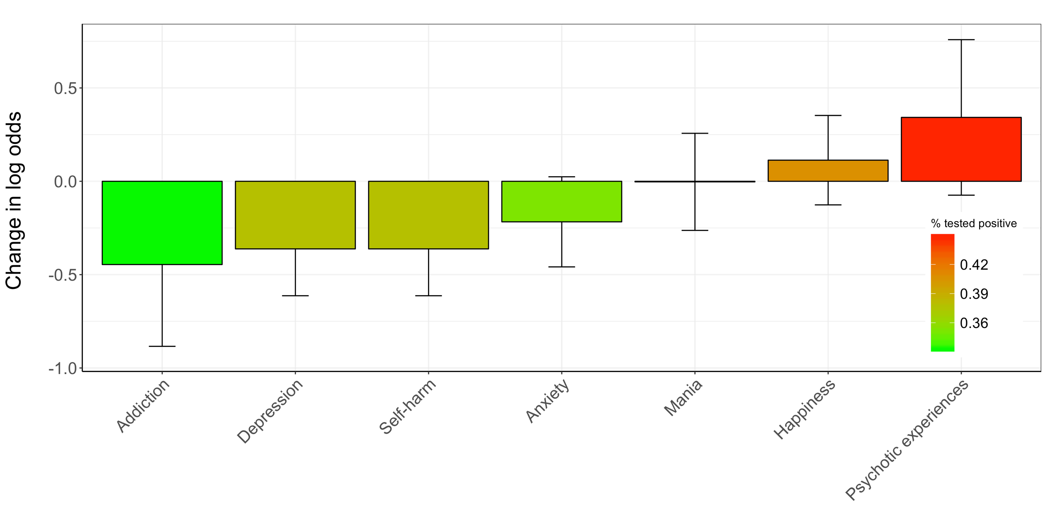
B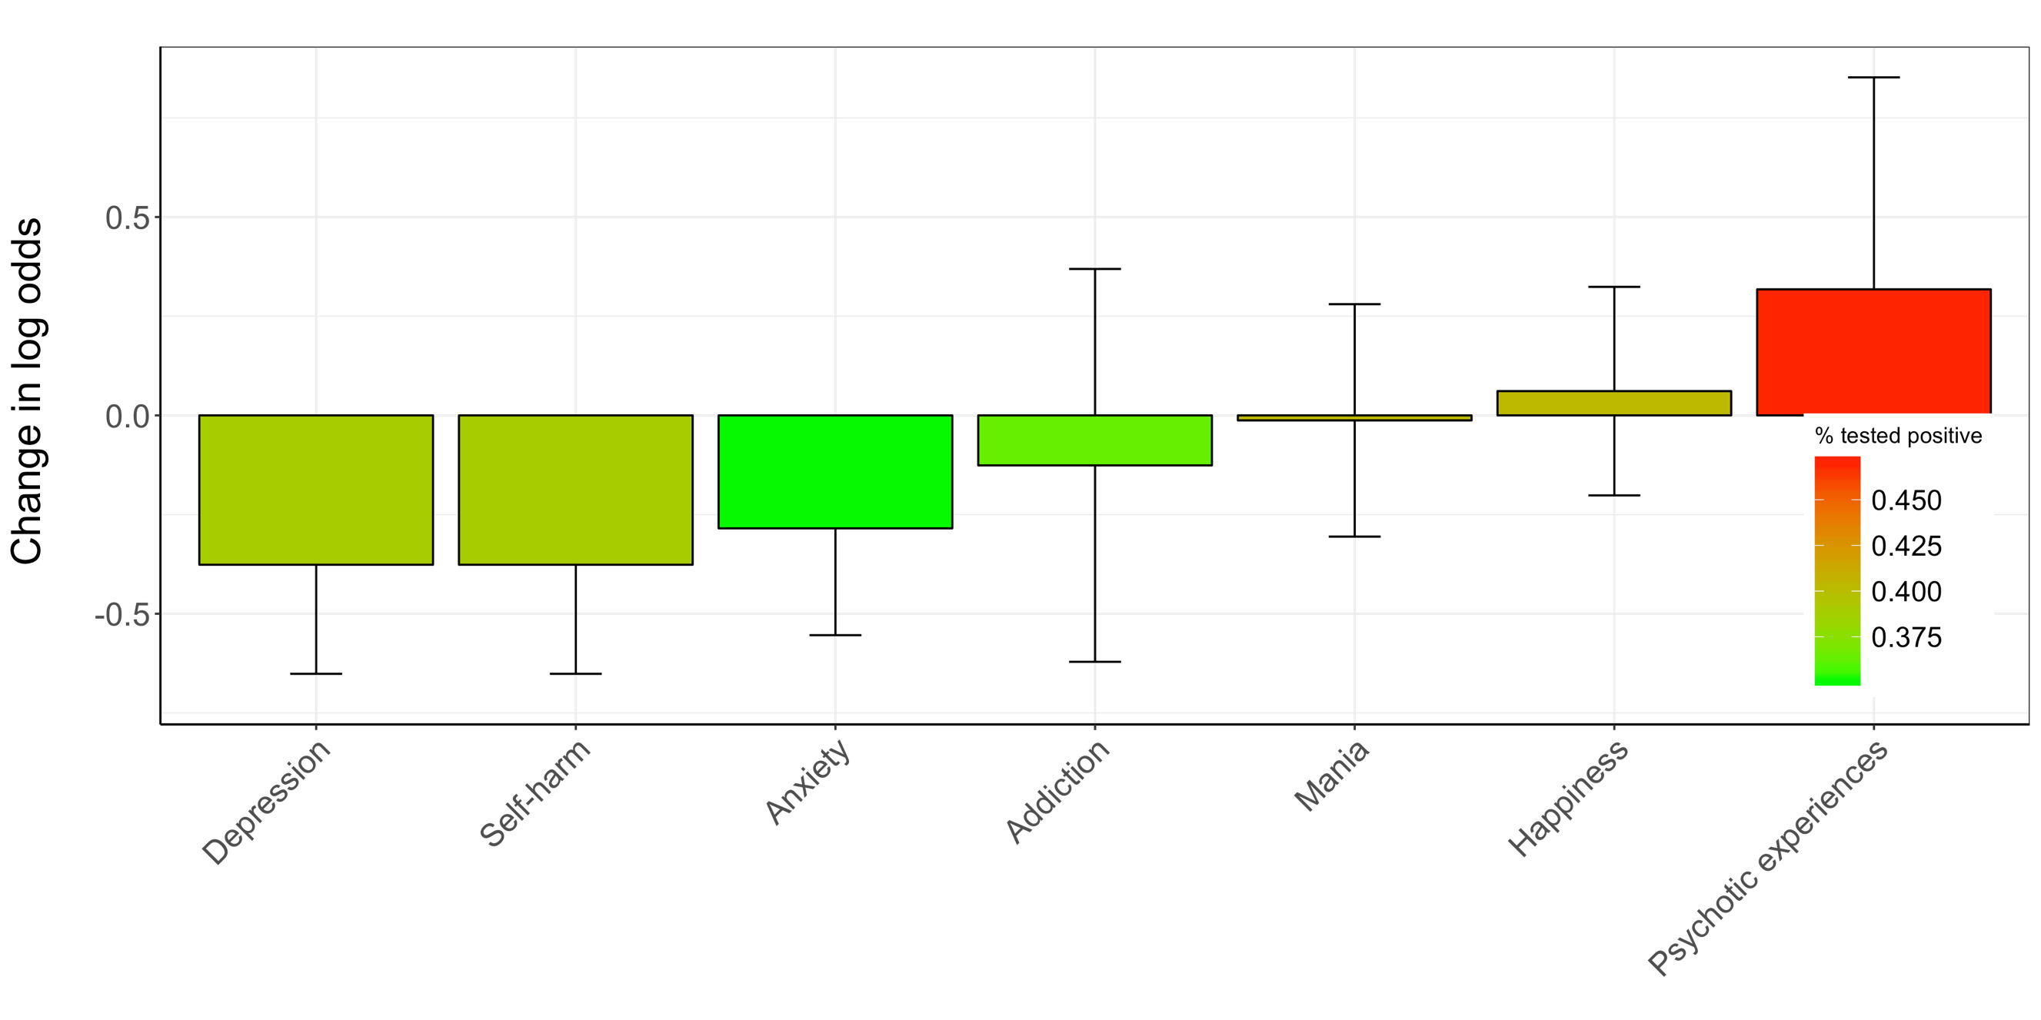
Figure S2. Bar plots of odds ratios for testing positive, per mental health category based on affirmative responses to mental health questions in the mental health questionnaire of the UKB. Odds ratios are shown on the y-axis, on the x-axis are the categories, colors indicate percent that tested positive. A) is across the entire cohort with complete data, B) is after excluding those with a psychiatric disorder diagnosis.

A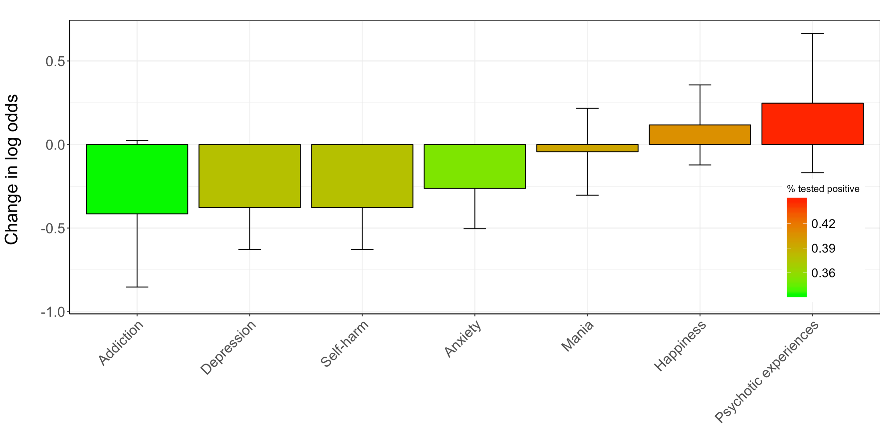
B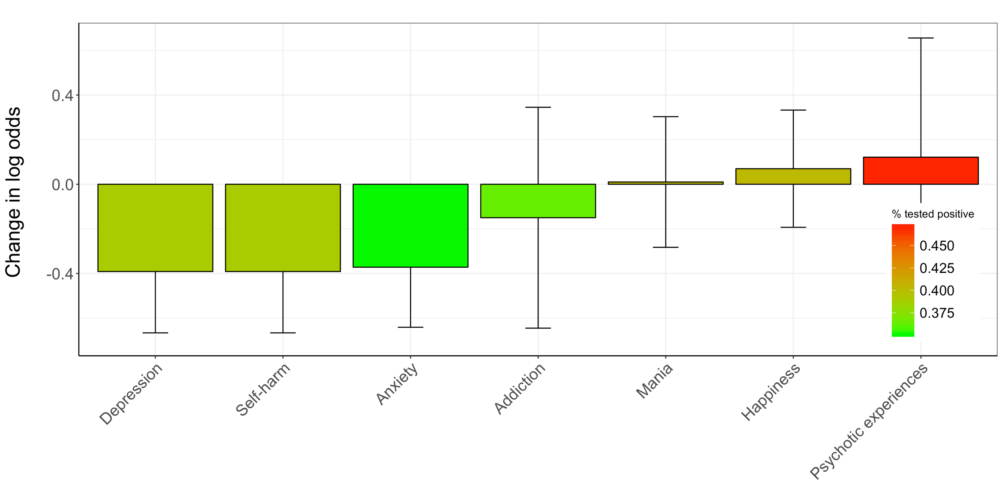
Figure S3. Bar plots of odds ratios for testing positive, per mental health category based on affirmative responses to mental health questions in the mental health questionnaire of the UKB., additionally covarying for respiratory, cardiovascular, and metabolic diagnoses, and socio-economic status. Odds ratios are shown on the y-axis, on the x-axis are the categories, colors indicate percent that tested positive. A) is across the entire cohort with complete data, B) is after excluding those with a psychiatric disorder diagnosis

