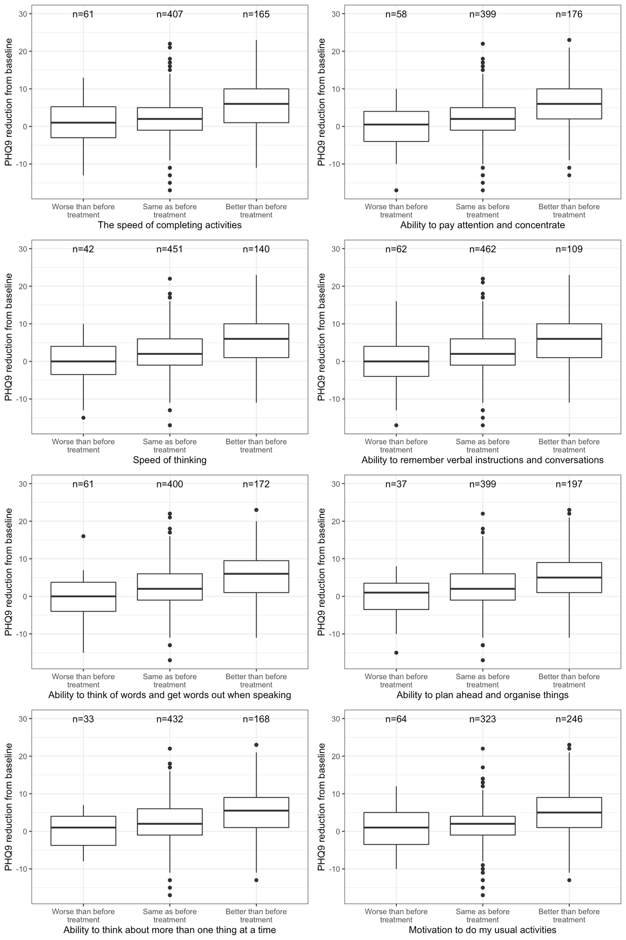

Supplementary Figure A1. Boxplot of changes in PHQ9 from baseline by NSSR outcome groups.

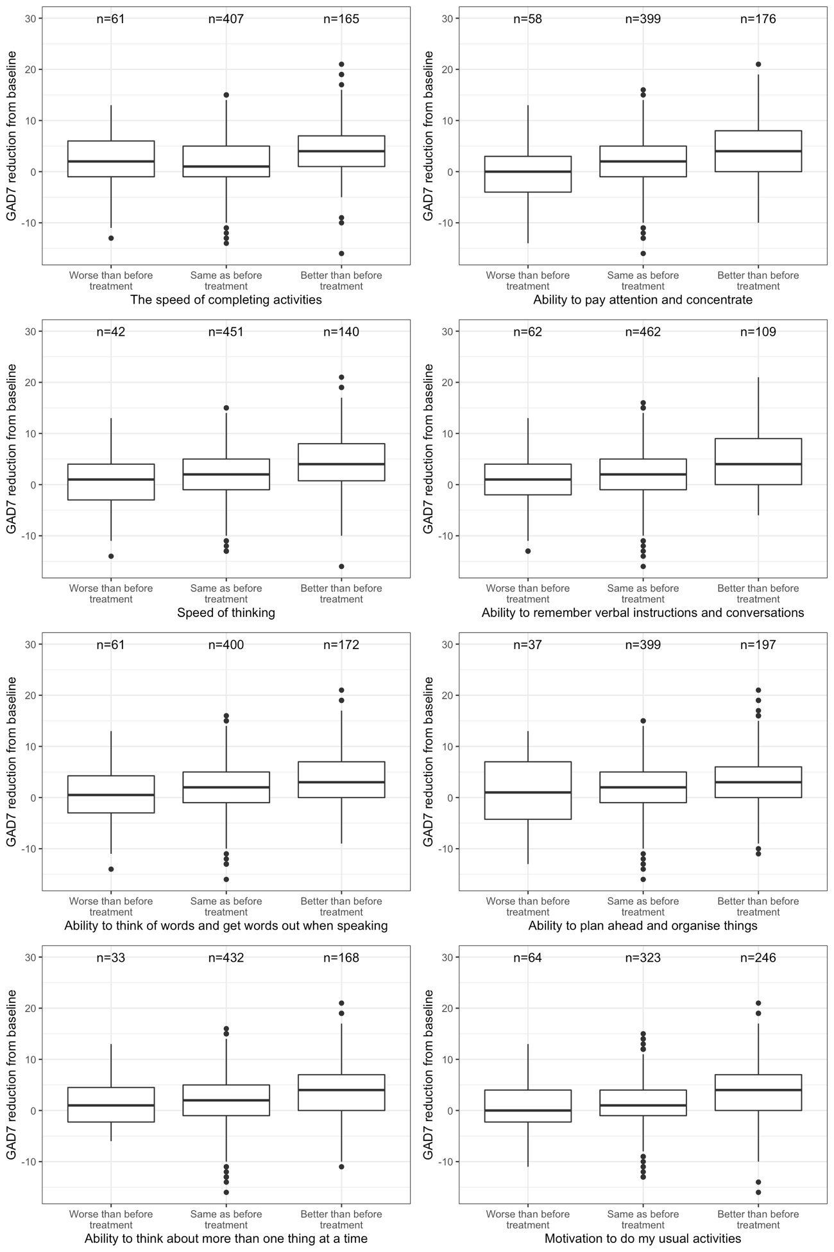
Supplementary Figure A2. Boxplot of changes in GAD7 from baseline by NSSR outcome groups.

Supplementary Table A1. Multinomial logistic regression results for the speed of completing activities
 | Model with PHQ9 |  |  |  |  |  | Model with GAD7
 | Worse than before treatment |  |  | Better than before treatment |  |  | Worse than before treatment |  |  | Better than before treatment
Predictor | RRR | 95% CI | p-value | RRR | 95% CI | p-value | RRR | 95% CI | p-value | RRR | 95% CI | p-value
Score at baseline | 1.15 | 1.09 - 1.22 | <0.001 | 0.96 | 0.92 - 0.99 | 0.022 | 1.11 | 1.05 - 1.18 | 0.001 | 0.98 | 0.94 - 1.02 | 0.325
Score reduction from baseline | 0.91 | 0.86 - 0.97 | 0.002 | 1.15 | 1.10 - 1.20 | <0.001 | 0.96 | 0.90 - 1.02 | 0.182 | 1.12 | 1.07 - 1.17 | <0.001
Age group
12-14 | Ref |  |  | Ref |  |  | Ref |  |  | Ref
15-17 | 4.55 | 1.48 - 13.97 | 0.008 | 0.69 | 0.38 - 1.26 | 0.233 | 4.31 | 1.41 - 13.22 | 0.011 | 0.75 | 0.42 - 1.36 | 0.349
18-21 | 1.06 | 0.30 - 3.69 | 0.928 | 0.66 | 0.36 - 1.19 | 0.169 | 1.15 | 0.34 - 3.95 | 0.82 | 0.70 | 0.39 - 1.26 | 0.239
21+ | 1.89 | 0.56 - 6.40 | 0.308 | 0.93 | 0.51 - 1.69 | 0.822 | 1.85 | 0.55 - 6.19 | 0.32 | 1.05 | 0.58 - 1.89 | 0.866
Sex
Female | Ref |  |  | Ref |  |  | Ref |  |  | Ref
Male | 0.84 | 0.42 - 1.66 | 0.609 | 1.3 | 0.87 - 1.94 | 0.206 | 0.73 | 0.37 - 1.43 | 0.354 | 1.17 | 0.78 - 1.76 | 0.448
Primary diagnosis
Depression | Ref |  |  | Ref |  |  | Ref |  |  | Ref
Anxiety | 0.61 | 0.22 - 1.67 | 0.340 | 0.96 | 0.48 - 1.89 | 0.899 | 0.39 | 0.15 - 0.99 | 0.047 | 0.99 | 0.55 - 1.81 | 0.984
Depression and Anxiety | 1.24 | 0.52 - 2.94 | 0.626 | 1.3 | 0.68 - 2.48 | 0.423 | 0.95 | 0.42 - 2.15 | 0.905 | 1.21 | 0.67 - 2.19 | 0.520
Other | 1.75 | 0.69 - 4.45 | 0.241 | 1.35 | 0.69 - 2.64 | 0.380 | 1.07 | 0.46 - 2.48 | 0.883 | 1.27 | 0.68 - 2.37 | 0.446
Alcohol use risk
Low risk | Ref |  |  | Ref |  |  | Ref |  |  | Ref
Moderate or high risk | 1.87 | 0.89 - 3.90 | 0.097 | 0.86 | 0.47 - 1.57 | 0.623 | 1.96 | 0.96 - 4.00 | 0.065 | 0.89 | 0.49 - 1.60 | 0.693
Cannabis use risk
Low risk | Ref |  |  | Ref |  |  | Ref |  |  | Ref
Moderate or high risk | 0.43 | 0.17 - 1.09 | 0.076 | 0.89 | 0.52 - 1.53 | 0.678 | 0.53 | 0.22 - 1.30 | 0.167 | 0.85 | 0.50 - 1.46 | 0.563

Supplementary Table A2. Multinomial logistic regression results for the ability to pay attention and concentrate
 | Model with PHQ9 |  |  |  |  |  | Model with GAD7
 | Worse than before treatment |  |  | Better than before treatment |  |  | Worse than before treatment |  |  | Better than before treatment
Predictor | RRR | 95% CI | p-value | RRR | 95% CI | p-value | RRR | 95% CI | p-value | RRR | 95% CI | p-value
Score at baseline | 1.15 | 1.08 - 1.22 | <0.001 | 0.93 | 0.89 - 0.96 | <0.001 | 1.18 | 1.10 - 1.26 | <0.001 | 0.97 | 0.93 - 1.01 | 0.097
Score reduction from baseline | 0.87 | 0.81 - 0.93 | <0.001 | 1.18 | 1.13 - 1.23 | <0.001 | 0.85 | 0.79 - 0.92 | <0.001 | 1.13 | 1.08 - 1.18 | <0.001
Age group
12-14 | Ref |  |  | Ref |  |  | Ref |  |  | Ref
15-17 | 1.21 | 0.51 - 2.86 | 0.671 | 0.81 | 0.44 - 1.48 | 0.49 | 1.41 | 0.59 - 3.39 | 0.444 | 0.89 | 0.49 - 1.61 | 0.710
18-21 | 0.33 | 0.12 - 0.90 | 0.03 | 0.75 | 0.40 - 1.37 | 0.348 | 0.4 | 0.15 - 1.11 | 0.078 | 0.84 | 0.46 - 1.55 | 0.581
21+ | 0.48 | 0.17 - 1.33 | 0.157 | 0.98 | 0.54 - 1.80 | 0.957 | 0.51 | 0.18 - 1.40 | 0.191 | 1.15 | 0.63 - 2.07 | 0.654
Sex
Female | Ref |  |  | Ref |  |  | Ref |  |  | Ref
Male | 0.61 | 0.30 - 1.27 | 0.189 | 1.14 | 0.76 - 1.70 | 0.525 | 0.69 | 0.33 - 1.45 | 0.326 | 1.09 | 0.73 - 1.62 | 0.685
Primary diagnosis
Depression | Ref |  |  | Ref |  |  | Ref |  |  | Ref
Anxiety | 0.39 | 0.15 - 1.01 | 0.053 | 1.16 | 0.63 - 2.13 | 0.633 | 0.25 | 0.10 - 0.63 | 0.003 | 1.20 | 0.67 - 2.16 | 0.538
Depression and Anxiety | 0.72 | 0.34 - 1.55 | 0.404 | 1.18 | 0.63 - 2.21 | 0.616 | 0.60 | 0.28 - 1.30 | 0.194 | 1.07 | 0.60 - 1.93 | 0.817
Other | 0.5 | 0.17 - 1.45 | 0.209 | 1.16 | 0.61 - 2.24 | 0.65 | 0.36 | 0.14 - 0.88 | 0.026 | 1.17 | 0.62 - 2.18 | 0.631
Alcohol use risk
Low risk | Ref |  |  | Ref |  |  | Ref |  |  | Ref
Moderate or high risk | 1.49 | 0.70 - 3.18 | 0.302 | 0.88 | 0.49 - 1.57 | 0.666 | 1.73 | 0.78 - 3.84 | 0.178 | 0.83 | 0.47 - 1.47 | 0.522
Cannabis use risk
Low risk | Ref |  |  | Ref |  |  | Ref |  |  | Ref
Moderate or high risk | 1.25 | 0.56 - 2.79 | 0.579 | 0.82 | 0.47 - 1.43 | 0.485 | 1.38 | 0.64 - 2.97 | 0.414 | 0.83 | 0.48 - 1.43 | 0.496

Supplementary Table A3. Multinomial logistic regression results for speed of thinking
 | Model with PHQ9 |  |  |  |  |  | Model with GAD7
 | Worse than before treatment |  |  | Better than before treatment |  |  | Worse than before treatment |  |  | Better than before treatment
Predictor | RRR | 95% CI | p-value | RRR | 95% CI | p-value | RRR | 95% CI | p-value | RRR | 95% CI | p-value
Score at baseline | 1.18 | 1.10 - 1.27 | <0.001 | 0.94 | 0.90 - 0.98 | 0.005 | 1.16 | 1.08 - 1.25 | <0.001 | 0.97 | 0.93 - 1.02 | 0.241
Score reduction from baseline | 0.87 | 0.80 - 0.94 | 0.001 | 1.16 | 1.10 - 1.21 | <0.001 | 0.88 | 0.82 - 0.95 | 0.001 | 1.12 | 1.07 - 1.17 | <0.001
Age group
12-14 | Ref |  |  | Ref |  |  | Ref |  |  | Ref
15-17 | 1.68 | 0.56 - 5.00 | 0.354 | 0.61 | 0.33 - 1.12 | 0.112 | 1.64 | 0.56 - 4.79 | 0.364 | 0.64 | 0.35 - 1.17 | 0.144
18-21 | 1.02 | 0.32 - 3.29 | 0.976 | 0.56 | 0.29 - 1.06 | 0.077 | 1.19 | 0.38 - 3.69 | 0.765 | 0.65 | 0.35 - 1.19 | 0.164
21+ | 0.66 | 0.19 - 2.37 | 0.527 | 0.64 | 0.34 - 1.21 | 0.172 | 0.70 | 0.20 - 2.44 | 0.572 | 0.76 | 0.41 - 1.41 | 0.387
Sex
Female | Ref |  |  | Ref |  |  | Ref |  |  | Ref
Male | 2.01 | 0.96 - 4.23 | 0.066 | 1.92 | 1.26 - 2.92 | 0.002 | 1.88 | 0.92 - 3.84 | 0.083 | 1.79 | 1.18 - 2.71 | 0.006
Primary diagnosis
Depression | Ref |  |  | Ref |  |  | Ref |  |  | Ref
Anxiety | 0.86 | 0.30 - 2.47 | 0.777 | 1.1 | 0.57 - 2.11 | 0.774 | 0.56 | 0.20 - 1.55 | 0.264 | 1.02 | 0.54 - 1.96 | 0.944
Depression and Anxiety | 1.26 | 0.48 - 3.30 | 0.638 | 1.4 | 0.73 - 2.66 | 0.309 | 0.95 | 0.38 - 2.37 | 0.917 | 1.23 | 0.65 - 2.33 | 0.527
Other | 1.19 | 0.41 - 3.40 | 0.752 | 1.44 | 0.75 - 2.77 | 0.276 | 0.88 | 0.32 - 2.36 | 0.793 | 1.35 | 0.70 - 2.59 | 0.365
Alcohol use risk
Low risk | Ref |  |  | Ref |  |  | Ref |  |  | Ref
Moderate or high risk | 0.88 | 0.36 - 2.20 | 0.792 | 0.86 | 0.46 - 1.58 | 0.621 | 1.06 | 0.44 - 2.54 | 0.905 | 0.87 | 0.48 - 1.57 | 0.636
Cannabis use risk
Low risk | Ref |  |  | Ref |  |  | Ref |  |  | Ref
Moderate or high risk | 1.34 | 0.57 - 3.15 | 0.502 | 1.15 | 0.65 - 2.05 | 0.635 | 1.41 | 0.62 - 3.19 | 0.411 | 1.12 | 0.64 - 1.94 | 0.692

Supplementary Table A4. Multinomial logistic regression results for ability to remember verbal instructions and conversations
 | Model with PHQ9 |  |  |  |  |  | Model with GAD7
 | Worse than before treatment |  |  | Better than before treatment |  |  | Worse than before treatment |  |  | Better than before treatment
Predictor | RRR | 95% CI | p-value | RRR | 95% CI | p-value | RRR | 95% CI | p-value | RRR | 95% CI | p-value
Score at baseline | 1.15 | 1.08 - 1.22 | <0.001 | 0.93 | 0.89 - 0.98 | 0.008 | 1.14 | 1.07 - 1.21 | <0.001 | 0.97 | 0.92 - 1.02 | 0.255
Score reduction from baseline | 0.85 | 0.81 - 0.90 | <0.001 | 1.16 | 1.10 - 1.22 | <0.001 | 0.90 | 0.84 - 0.95 | <0.001 | 1.13 | 1.07 - 1.19 | <0.001
Age group
12-14 | Ref |  |  | Ref |  |  | Ref |  |  | Ref
15-17 | 0.83 | 0.35 - 1.97 | 0.667 | 0.86 | 0.44 - 1.69 | 0.657 | 0.89 | 0.38 - 2.08 | 0.794 | 0.89 | 0.45 - 1.76 | 0.735
18-21 | 0.66 | 0.27 - 1.62 | 0.365 | 0.74 | 0.37 - 1.48 | 0.389 | 0.78 | 0.32 - 1.87 | 0.575 | 0.74 | 0.37 - 1.48 | 0.39
21+ | 0.62 | 0.24 - 1.59 | 0.315 | 0.77 | 0.39 - 1.55 | 0.471 | 0.64 | 0.25 - 1.61 | 0.345 | 0.84 | 0.42 - 1.67 | 0.614
Sex
Female | Ref |  |  | Ref |  |  | Ref |  |  | Ref
Male | 1.42 | 0.76 - 2.66 | 0.271 | 1.74 | 1.10 - 2.75 | 0.018 | 1.44 | 0.79 - 2.62 | 0.240 | 1.64 | 1.04 - 2.58 | 0.034
Primary diagnosis
Depression | Ref |  |  | Ref |  |  | Ref |  |  | Ref
Anxiety | 0.93 | 0.38 - 2.26 | 0.869 | 1.07 | 0.50 - 2.26 | 0.866 | 0.59 | 0.26 - 1.34 | 0.211 | 1.00 | 0.49 - 2.04 | 0.997
Depression and Anxiety | 0.94 | 0.42 - 2.09 | 0.876 | 1.5 | 0.73 - 3.08 | 0.267 | 0.73 | 0.34 - 1.58 | 0.427 | 1.25 | 0.62 - 2.52 | 0.535
Other | 0.84 | 0.34 - 2.08 | 0.709 | 1.75 | 0.83 - 3.69 | 0.145 | 0.70 | 0.31 - 1.60 | 0.401 | 1.68 | 0.82 - 3.45 | 0.159
Alcohol use risk
Low risk | Ref |  |  | Ref |  |  | Ref |  |  | Ref
Moderate or high risk | 1.55 | 0.74 - 3.24 | 0.249 | 0.87 | 0.43 - 1.76 | 0.703 | 1.64 | 0.81 - 3.30 | 0.169 | 0.90 | 0.45 - 1.79 | 0.765
Cannabis use risk
Low risk | Ref |  |  | Ref |  |  | Ref |  |  | Ref
Moderate or high risk | 1.19 | 0.56 - 2.52 | 0.648 | 1 | 0.54 - 1.87 | 0.999 | 1.28 | 0.64 - 2.57 | 0.482 | 0.99 | 0.52 - 1.88 | 0.965

Supplementary Table A5. Multinomial logistic regression results for ability to think of words and get words out when speaking
 | Model with PHQ9 |  |  |  |  |  | Model with GAD7
 | Worse than before treatment |  |  | Better than before treatment |  |  | Worse than before treatment |  |  | Better than before treatment
Predictor | RRR | 95% CI | p-value | RRR | 95% CI | p-value | RRR | 95% CI | p-value | RRR | 95% CI | p-value
Score at baseline | 1.13 | 1.07 - 1.19 | <0.001 | 0.97 | 0.93 - 1.01 | 0.152 | 1.14 | 1.07 - 1.21 | <0.001 | 1.01 | 0.97 - 1.05 | 0.752
Score reduction from baseline | 0.86 | 0.81 - 0.91 | <0.001 | 1.11 | 1.07 - 1.15 | <0.001 | 0.90 | 0.84 - 0.95 | 0.001 | 1.07 | 1.03 - 1.12 | 0.002
Age group
12-14 | Ref |  |  | Ref |  |  | Ref |  |  | Ref
15-17 | 0.55 | 0.23 - 1.31 | 0.178 | 0.6 | 0.32 - 1.10 | 0.101 | 0.59 | 0.26 - 1.38 | 0.226 | 0.61 | 0.34 - 1.11 | 0.109
18-21 | 0.57 | 0.24 - 1.39 | 0.220 | 0.97 | 0.54 - 1.74 | 0.91 | 0.67 | 0.29 - 1.58 | 0.364 | 1.04 | 0.58 - 1.87 | 0.891
21+ | 0.57 | 0.23 - 1.42 | 0.230 | 0.84 | 0.46 - 1.55 | 0.578 | 0.55 | 0.22 - 1.34 | 0.188 | 0.94 | 0.52 - 1.69 | 0.832
Sex
Female | Ref |  |  | Ref |  |  | Ref |  |  | Ref
Male | 1.06 | 0.56 - 2.04 | 0.853 | 1.44 | 0.95 - 2.19 | 0.089 | 1.07 | 0.56 - 2.05 | 0.834 | 1.43 | 0.96 - 2.12 | 0.075
Primary diagnosis
Depression | Ref |  |  | Ref |  |  | Ref |  |  | Ref
Anxiety | 0.67 | 0.25 - 1.79 | 0.430 | 0.89 | 0.50 - 1.60 | 0.702 | 0.47 | 0.19 - 1.17 | 0.106 | 0.90 | 0.51 - 1.62 | 0.736
Depression and Anxiety | 1.46 | 0.66 - 3.25 | 0.351 | 1.23 | 0.70 - 2.18 | 0.469 | 1.20 | 0.55 - 2.61 | 0.644 | 1.20 | 0.68 - 2.12 | 0.521
Other | 1.02 | 0.40 - 2.62 | 0.96 | 1.06 | 0.56 - 2.00 | 0.857 | 0.77 | 0.32 - 1.85 | 0.563 | 1.07 | 0.58 - 1.97 | 0.827
Alcohol use risk
Low risk | Ref |  |  | Ref |  |  | Ref |  |  | Ref
Moderate or high risk | 1.08 | 0.50 - 2.36 | 0.843 | 0.84 | 0.47 - 1.48 | 0.546 | 1.17 | 0.55 - 2.49 | 0.684 | 0.80 | 0.47 - 1.38 | 0.430
Cannabis use risk
Low risk | Ref |  |  | Ref |  |  | Ref |  |  | Ref
Moderate or high risk | 1.05 | 0.48 - 2.29 | 0.908 | 0.97 | 0.57 - 1.63 | 0.904 | 1.10 | 0.52 - 2.30 | 0.808 | 0.96 | 0.57 - 1.62 | 0.884

Supplementary Table A6. Multinomial logistic regression results for ability to plan ahead and organise things
 | Model with PHQ9 |  |  |  |  |  | Model with GAD7
 | Worse than before treatment |  |  | Better than before treatment |  |  | Worse than before treatment |  |  | Better than before treatment
Predictor | RRR | 95% CI | p-value | RRR | 95% CI | p-value | RRR | 95% CI | p-value | RRR | 95% CI | p-value
Score at baseline | 1.12 | 1.05 - 1.20 | 0.001 | 0.92 | 0.89 - 0.96 | <0.001 | 1.13 | 1.05 - 1.22 | 0.002 | 0.96 | 0.92 - 1.00 | 0.054
Score reduction from baseline | 0.89 | 0.83 - 0.96 | 0.002 | 1.15 | 1.11 - 1.20 | <0.001 | 0.93 | 0.86 - 1.01 | 0.084 | 1.11 | 1.06 - 1.16 | <0.001
Age group
12-14 | Ref |  |  | Ref |  |  | Ref |  |  | Ref
15-17 | 0.61 | 0.23 - 1.62 | 0.32 | 0.48 | 0.26 - 0.87 | 0.015 | 0.61 | 0.23 - 1.61 | 0.322 | 0.50 | 0.28 - 0.90 | 0.020
18-21 | 0.49 | 0.17 - 1.43 | 0.192 | 0.79 | 0.44 - 1.40 | 0.413 | 0.5 | 0.17 - 1.42 | 0.193 | 0.83 | 0.47 - 1.46 | 0.519
21+ | 0.49 | 0.16 - 1.53 | 0.221 | 1.01 | 0.57 - 1.79 | 0.979 | 0.44 | 0.14 - 1.35 | 0.152 | 1.10 | 0.63 - 1.93 | 0.738
Sex
Female | Ref |  |  | Ref |  |  | Ref |  |  | Ref
Male | 0.94 | 0.43 - 2.08 | 0.88 | 0.84 | 0.56 - 1.26 | 0.406 | 0.91 | 0.41 - 2.02 | 0.821 | 0.84 | 0.57 - 1.25 | 0.387
Primary diagnosis
Depression | Ref |  |  | Ref |  |  | Ref |  |  | Ref
Anxiety | 1.49 | 0.48 - 4.59 | 0.492 | 1.33 | 0.74 - 2.37 | 0.34 | 1.04 | 0.35 - 3.12 | 0.938 | 1.35 | 0.77 - 2.36 | 0.302
Depression and Anxiety | 0.97 | 0.32 - 2.91 | 0.956 | 1.28 | 0.70 - 2.33 | 0.416 | 0.8 | 0.27 - 2.44 | 0.700 | 1.19 | 0.68 - 2.08 | 0.544
Other | 2.51 | 0.85 - 7.38 | 0.096 | 1.39 | 0.75 - 2.59 | 0.294 | 2.02 | 0.71 - 5.72 | 0.185 | 1.43 | 0.80 - 2.55 | 0.230
Alcohol use risk
Low risk | Ref |  |  | Ref |  |  | Ref |  |  | Ref
Moderate or high risk | 1.24 | 0.48 - 3.19 | 0.652 | 0.99 | 0.56 - 1.74 | 0.959 | 1.47 | 0.59 - 3.64 | 0.406 | 0.91 | 0.54 - 1.52 | 0.719
Cannabis use risk
Low risk | Ref |  |  | Ref |  |  | Ref |  |  | Ref
Moderate or high risk | 0.9 | 0.33 - 2.51 | 0.845 | 1.35 | 0.81 - 2.26 | 0.247 | 1.00 | 0.37 - 2.71 | 0.994 | 1.33 | 0.80 - 2.22 | 0.278

Supplementary Table A7. Multinomial logistic regression results for ability to think about more than one thing at a time
 | Model with PHQ9 |  |  |  |  |  | Model with GAD7
 | Worse than before treatment |  |  | Better than before treatment |  |  | Worse than before treatment |  |  | Better than before treatment
Predictor | RRR | 95% CI | p-value | RRR | 95% CI | p-value | RRR | 95% CI | p-value | RRR | 95% CI | p-value
Score at baseline | 1.20 | 1.11 - 1.31 | <0.001 | 0.94 | 0.90 - 0.98 | 0.002 | 1.21 | 1.11 - 1.32 | <0.001 | 0.97 | 0.93 - 1.01 | 0.116
Score reduction from baseline | 0.88 | 0.82 - 0.96 | 0.002 | 1.15 | 1.10 - 1.19 | <0.001 | 0.89 | 0.82 - 0.97 | 0.006 | 1.11 | 1.06 - 1.16 | <0.001
Age group
12-14 | Ref |  |  | Ref |  |  | Ref |  |  | Ref
15-17 | 0.96 | 0.32 - 2.85 | 0.944 | 0.59 | 0.33 - 1.05 | 0.075 | 0.91 | 0.31 - 2.62 | 0.855 | 0.62 | 0.35 - 1.10 | 0.104
18-21 | 0.46 | 0.14 - 1.52 | 0.204 | 0.51 | 0.28 - 0.95 | 0.034 | 0.49 | 0.15 - 1.57 | 0.230 | 0.58 | 0.33 - 1.04 | 0.066
21+ | 0.28 | 0.07 - 1.09 | 0.067 | 0.66 | 0.36 - 1.20 | 0.176 | 0.31 | 0.08 - 1.20 | 0.092 | 0.73 | 0.41 - 1.30 | 0.283
Sex
Female | Ref |  |  | Ref |  |  | Ref |  |  | Ref
Male | 2.52 | 1.07 - 5.92 | 0.035 | 1.50 | 1.00 - 2.25 | 0.048 | 2.44 | 1.09 - 5.46 | 0.031 | 1.39 | 0.93 - 2.08 | 0.107
Primary diagnosis
Depression | Ref |  |  | Ref |  |  | Ref |  |  | Ref
Anxiety | 0.76 | 0.23 - 2.50 | 0.651 | 1.47 | 0.79 - 2.72 | 0.226 | 0.47 | 0.15 - 1.52 | 0.208 | 1.40 | 0.79 - 2.48 | 0.255
Depression and Anxiety | 0.99 | 0.35 - 2.83 | 0.984 | 1.29 | 0.71 - 2.35 | 0.408 | 0.64 | 0.23 - 1.77 | 0.392 | 1.16 | 0.64 - 2.12 | 0.625
Other | 0.89 | 0.25 - 3.15 | 0.862 | 1.07 | 0.57 - 2.03 | 0.833 | 0.59 | 0.19 - 1.82 | 0.362 | 1.02 | 0.55 - 1.88 | 0.946
Alcohol use risk
Low risk | Ref |  |  | Ref |  |  | Ref |  |  | Ref
Moderate or high risk | 1.19 | 0.40 - 3.51 | 0.751 | 1.07 | 0.61 - 1.88 | 0.814 | 1.32 | 0.51 - 3.43 | 0.567 | 1.06 | 0.60 - 1.85 | 0.848
Cannabis use risk
Low risk | Ref |  |  | Ref |  |  | Ref |  |  | Ref
Moderate or high risk | 1.73 | 0.66 - 4.53 | 0.263 | 1.09 | 0.64 - 1.85 | 0.758 | 2.02 | 0.81 - 5.01 | 0.131 | 1.13 | 0.67 - 1.91 | 0.645

Supplementary Table A8. Multinomial logistic regression results for motivation to do my usual activities
 | Model with PHQ9 |  |  |  |  |  | Model with GAD7
 | Worse than before treatment |  |  | Better than before treatment |  |  | Worse than before treatment |  |  | Better than before treatment
Predictor | RRR | 95% CI | p-value | RRR | 95% CI | p-value | RRR | 95% CI | p-value | RRR | 95% CI | p-value
Score at baseline | 1.13 | 1.07 - 1.20 | <0.001 | 0.92 | 0.89 - 0.96 | <0.001 | 1.14 | 1.07 - 1.21 | <0.001 | 0.96 | 0.92 - 0.99 | 0.021
Score reduction from baseline | 0.93 | 0.88 - 0.98 | 0.012 | 1.18 | 1.14 - 1.23 | <0.001 | 0.92 | 0.86 - 0.98 | 0.007 | 1.12 | 1.08 - 1.17 | <0.001
Age group
12-14 | Ref |  |  | Ref |  |  | Ref |  |  | Ref
15-17 | 1.71 | 0.75 - 3.93 | 0.202 | 1.18 | 0.66 - 2.14 | 0.575 | 1.79 | 0.78 - 4.09 | 0.169 | 1.23 | 0.70 - 2.18 | 0.472
18-21 | 0.60 | 0.23 - 1.53 | 0.281 | 1.39 | 0.77 - 2.49 | 0.273 | 0.7 | 0.27 - 1.79 | 0.453 | 1.5 | 0.85 - 2.65 | 0.166
21+ | 0.56 | 0.21 - 1.54 | 0.263 | 1.69 | 0.94 - 3.06 | 0.081 | 0.61 | 0.22 - 1.64 | 0.324 | 1.9 | 1.06 - 3.40 | 0.031
Sex
Female | Ref |  |  | Ref |  |  | Ref |  |  | Ref
Male | 0.65 | 0.33 - 1.30 | 0.221 | 1.12 | 0.76 - 1.63 | 0.574 | 0.61 | 0.30 - 1.25 | 0.178 | 1.08 | 0.74 - 1.57 | 0.688
Primary diagnosis
Depression | Ref |  |  | Ref |  |  | Ref |  |  | Ref
Anxiety | 0.40 | 0.16 - 1.02 | 0.055 | 1.53 | 0.85 - 2.78 | 0.161 | 0.23 | 0.09 - 0.61 | 0.004 | 1.5 | 0.87 - 2.59 | 0.149
Depression and Anxiety | 0.67 | 0.32 - 1.40 | 0.284 | 1.48 | 0.83 - 2.67 | 0.187 | 0.52 | 0.24 - 1.12 | 0.095 | 1.27 | 0.73 - 2.21 | 0.405
Other | 0.66 | 0.28 - 1.55 | 0.339 | 1.28 | 0.69 - 2.37 | 0.427 | 0.49 | 0.22 - 1.09 | 0.08 | 1.24 | 0.70 - 2.19 | 0.46
Alcohol use risk
Low risk | Ref |  |  | Ref |  |  | Ref |  |  | Ref
Moderate or high risk | 0.87 | 0.38 - 1.99 | 0.749 | 1.31 | 0.78 - 2.21 | 0.309 | 0.97 | 0.43 - 2.15 | 0.934 | 1.1 | 0.66 - 1.83 | 0.707
Cannabis use risk
Low risk | Ref |  |  | Ref |  |  | Ref |  |  | Ref
Moderate or high risk | 1.25 | 0.57 - 2.76 | 0.579 | 1.20 | 0.73 - 1.98 | 0.467 | 1.31 | 0.61 - 2.83 | 0.487 | 1.16 | 0.71 - 1.90 | 0.546

(A)
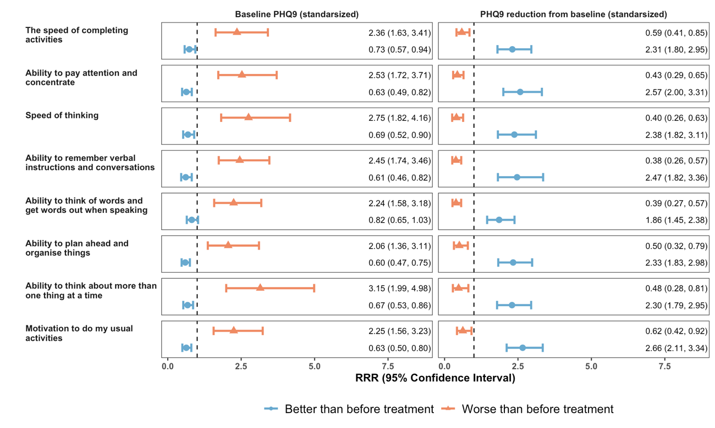

(B)

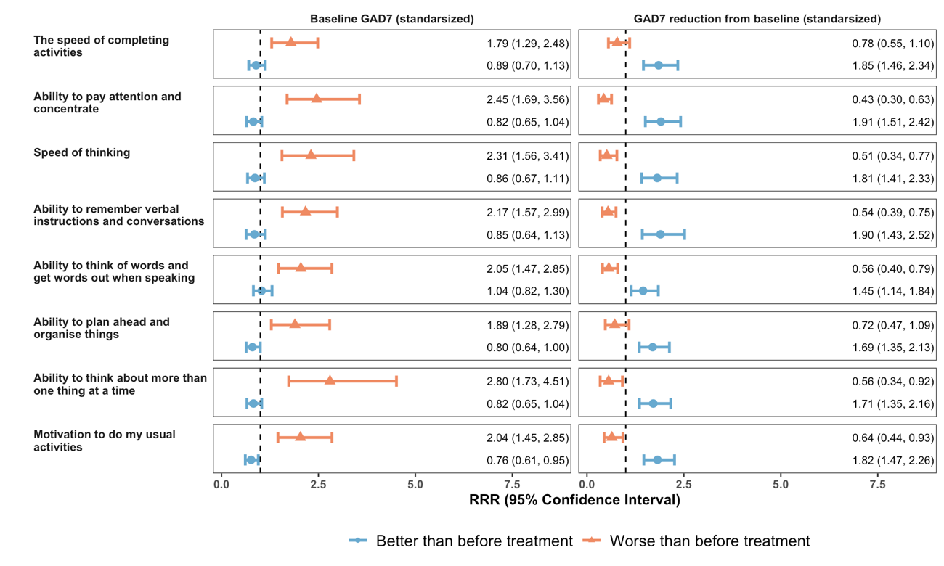
Supplementary Figure A3. Estimated RRR for better than before treatment and worse than before treatment compared with same as before treatment associated with standardized scores of baseline and reduction from baseline in PHQ9 (A) and GAD7 (B) from multiple imputed multinomial logistic regression model controlling for key confounding variables including age, sex, diagnosis, alcohol and cannabis use risk.

