Fig. S1 Distribution of EQ-5D-5L and SF-6D utility at baseline and follow-up for cases with depression only
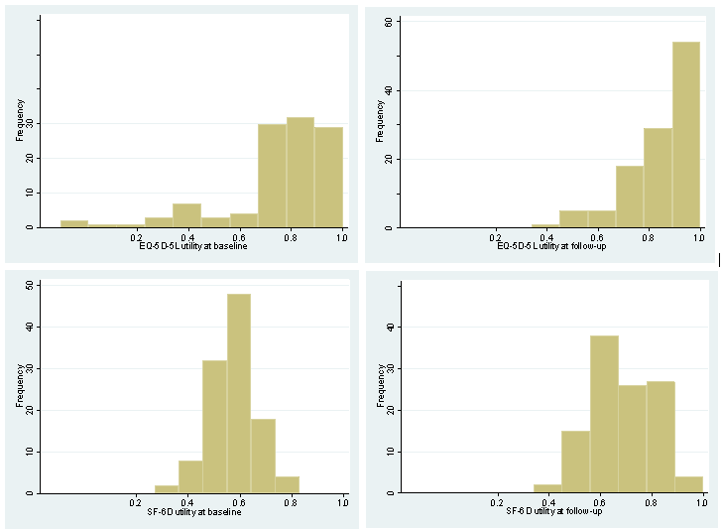

Fig. S2 Scatterplot of EQ-5D-5L and SF-6D utility plotted between baseline and follow-up for cases with depression only
