Appendix 1: Example MEDLINE search strategy:

(crisis adj2 (plan* OR card*)) OR ((advance* OR joint OR adverse) adj2 (statement* OR plan* OR directive* OR decision*)) OR advance directives [Mesh term]

AND

Bipolar disorder [MeSH terms] OR Schizophrenia [MeSH terms] OR bipolar disorder OR schizophrenia OR mental disorder* OR mental illness* OR mental health OR psychiatr*

AND

(trial* OR controlled OR 'control group' OR RCT OR random* OR OR single blind* OR double blind* OR triple blind* OR experimental OR intervention) OR Clinical study [publication type] OR Clinical trial [publication type] OR Controlled clinical trial [publication type] OR Pragmatic trial [publication type] OR Randomized controlled trial [publication type]

Appendix 2: Characteristics of studies
Authors | Participants | Setting | Method | Intervention/control | Outcomes
Henderson et al. (2004) | No. of participants entered study = 160  Age: mean age 39 years  Gender: 94 M, 66 F  Diagnosis: psychotic illness or non-psychotic bipolar disorder according to the operational criteria checklist  Inclusion criteria: age 18-65 years, at least one admission to inpatient mental health service during the previous 2 years  Exclusion criteria: unable to give informed consent, insufficient language skills and current inpatients | Eight community mental health teams in London, England | Allocation: randomised  Blinding: single blind  Duration: 15 months | Intervention: joint crisis plans consisting of indicators for relapse and treatment preferences. Facilitated by a project worker and developed in meeting with patient, their care coordinator and any family members of friends specified by the patient. Crisis plan held by patient and the service they belong to, and disseminated to anyone else the patient specifies (n=80)  Control: treatment as usual under the Care Programme Approach, plus participants received information leaflets about local services, mental illness and treatment and the Mental Health Act (n=80) | Primary outcome(s): admission to hospital, duration of inpatient psychiatric treatment  Secondary outcome(s): compulsory hospital admission (use of the Mental Health Act)
Lay et al. (2017) | No. of participants entered study = 238  Age: mean age 42 years  Gender: 105 M, 133 F  Diagnosis: mixed diagnoses from secondary care services  Inclusion criteria: age 18-65 years, at least one compulsory admission to inpatient services during the previous 2 years and resident in Canton of Zurich  Exclusion criteria: uncontactable by telephone, insufficient language skills, diagnosis of an organic mental disorder, mental retardation or a behavioural syndrome associated with physical factors | Four psychiatric hospitals in Canton of Zurich, Switzerland | Allocation: randomised  Blinding: non-blind  Duration: 24 months | Intervention: individualised psycho-education sessions focusing on behaviours occurring prior to crisis, crisis cards developed with patient and facilitator that consist of treatment preferences and early relapse signs, and 4-weekly ongoing telephone monitoring to review crisis plan (n=119)  Control: treatment as usual, consisting of standard community psychiatric care once discharged from hospital (n=119) | Primary outcome(s): compulsory hospital readmission  Secondary outcome(s): voluntary hospital readmission, duration of voluntary and compulsory inpatient treatment
Papageorgiou et al. (2002) | No. of participants entered study = 161  Age: mean age 36 years  Gender: 96 M 60 F  Diagnosis: mixed population from secondary care services, majority have diagnosis of psychosis  Inclusion criteria:  Exclusion criteria: under specialised sections, about to be transferred to other orders or hospitals and those with organic brain disease | Two acute psychiatric services, Southern England | Allocation: randomised  Blinding: non-blind  Duration: 12 months | Intervention: advanced directives; patients completed a booklet consisting of seven statements on future preferences for treatment. These were shared with key worker, general practitioner and the hospital (n=80)  Control: treatment as usual, consisting of standard community psychiatric care once discharged from hospital (n=81) | Primary outcome(s): compulsory readmission to hospital  Secondary outcome(s): duration of inpatient psychiatric treatment, self-reported symptoms of mental illness (BASIS-32), service satisfaction (The Hospital Service Satisfaction Scale) and functioning (The Health of the Nation Outcome Scales)
Ruchlewska et al. (2014) | No. of participants entered study = 212  Age: mean age 40 years  Gender: 145 M, 67 F  Diagnosis: psychotic illness or non-psychotic bipolar disorder  Inclusion criteria: age 18-65 years, at least one emergency outpatient contact with mental health services or one voluntary or involuntary admission during the previous 2 years  Exclusion criteria: having a somatic illness that caused a psychotic disorder, unable to give informed consent, insufficient language skills and already having an existing crisis plan | Twelve Assertive Community teams and Illness Management and Recovery teams in Rotterdam, the Netherlands | Allocation: randomised  Blinding: single blind  Duration: 18 months | Intervention:  1. Patient Advocate Crisis Plan (PACP): crisis plan developed with the existing patient and a former psychiatric patient, consisting of early warning signs of crisis and future treatment preferences. Held by patient and in patients’ records.  2. Clinician facilitated Crisis Plan (CCP): crisis plan developed with patient and clinician (mostly psychiatric nurses), consisting of early warning signs of crisis and future treatment preferences. Held by patient and in patients’ records.  Control: treatment as usual, consisting of standard community psychiatric care | Primary outcome(s): compulsory hospital admissions; emergency admissions and court-ordered admissions  Secondary outcome(s): outpatient emergency visits, voluntary hospital admission, duration of inpatient psychiatric treatment, clinician-rated service engagement (Services Engagement Scale), therapeutic alliance (Working Alliance Inventory), social support (Adult Social Report scale) and insight into their mental illness (Insight into Psychosis Scale)
Thornicroft et al. (2013) | No. of participants entered study = 569  Age: mean age 40 years  Gender: 285 M, 284 F  Diagnosis: relapsing psychotic illness  Inclusion criteria: aged over 16, at least one psychiatric admission during the previous 2 years and on the Enhanced Care Programme Approach register  Exclusion criteria: already detained under the Mental Health Act and current inpatients | 64 community mental health teams from four mental health trusts across England | Allocation: randomised  Blinding: single blind  Duration: 18 months | Intervention: joint crisis plan facilitated by a psychiatric nurse and developed with patient, their care coordinator, and psychiatrist, consisting of indicators for relapse and treatment preferences. Crisis plan held by patient and the service they belong to, and disseminated to anyone else the patient specifies (n=285)  Control: treatment as usual, under the Enhanced Care Programme Approach (n=284) | Primary outcome(s): compulsory hospital admission (use of the Mental Health Act)  Secondary outcome(s): voluntary hospital admissions, duration of inpatient psychiatric treatment, perceived coercion (MacArthur Perceived Coercion Scale), clinician-rated service engagement (Service Engagement Scale), therapeutic relationship (Working Alliance Inventory) and recovery style (Recovery Style Questionnaire)

Appendix 3: Sensitivity analyses for the primary outcome
Figure 3.1: Forest plot showing the risk of compulsory hospital admissions among those receiving a crisis planning intervention compared with controls among all participants randomised (assuming no admissions when participants have missing outcome data)
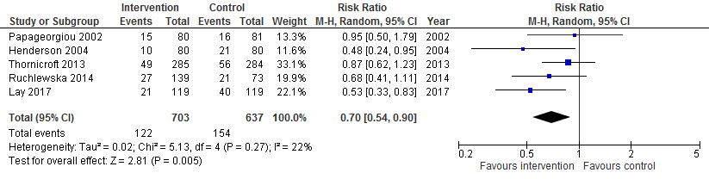
Figure 3.2: Forest plot showing the risk of compulsory hospital admissions among those receiving a crisis planning intervention compared with controls among all participants randomised (assuming that participants with missing outcome data had the same prevalence of admissions as other participants in the same arm of the same trial)
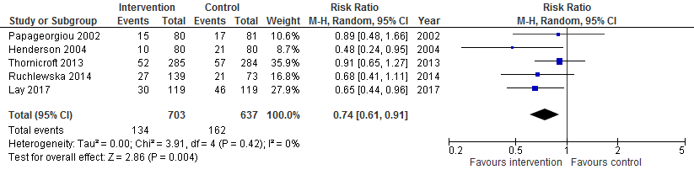
Figure 3.3: Forest plot showing the risk of compulsory hospital admissions among those receiving a crisis planning intervention compared with controls among all participants randomised (assuming that the prevalence of admissions was 10 percentage points lower among participants with missing outcome data compared with participants in the same arm of the same trial)
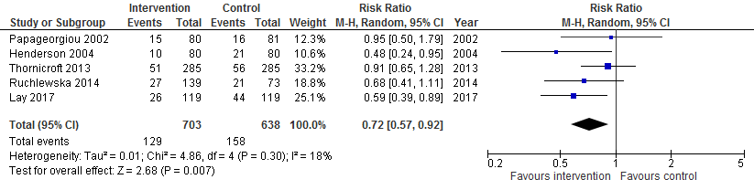
Figure 3.4: Forest plot showing the risk of compulsory hospital admissions among those receiving a crisis planning intervention compared with controls among all participants randomised (assuming that the prevalence of admissions was 10 percentage points higher among participants with missing outcome data compared with participants in the same arm of the same trial)
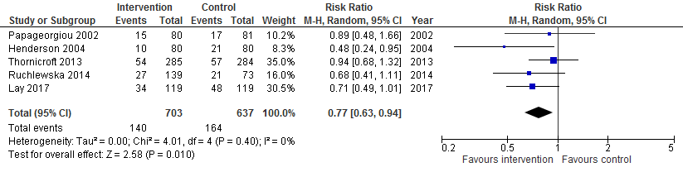
Figure 3.5: Forest plot showing the risk of compulsory hospital admissions among those receiving a crisis planning intervention compared with controls among all participants randomised, excluding Lay et al. 2017 (as this study had high risk of bias relating to incomplete outcome data)
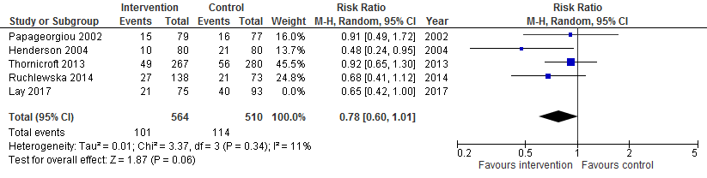

Table 3:1 Results of the influence analysis for the pooled estimate of risk of compulsory hospital admissions among those receiving a crisis planning intervention compared with controls
Pooled estimate excluding: | RR (95%CI)
Papageorgiou et al. 2002 | 0.72 (0.57-0.93)
Henderson et al. 2002 | 0.79 (0.63-0.98)
Thornicroft et al. 2013 | 0.67 (0.51-0.87)
Ruchlewska et al. 2014 | 0.76 (0.58-0.99)
Lay et al. 2017 | 0.78 (0.60-1.01)

McGuffin P, Farmer A, Harvey I. A polydiagnostic application of operational criteria in studies of psychotic illness: development and reliability of the OPCRIT system. Archives of general psychiatry. 1991 Aug 1;48(8):764-70.
Department of Health. The Care Programme Approach. London: Department of Health, 1991.

