Additional file 4: Summary of Quality of reporting of the reviewed studies based on CONSORT checklist

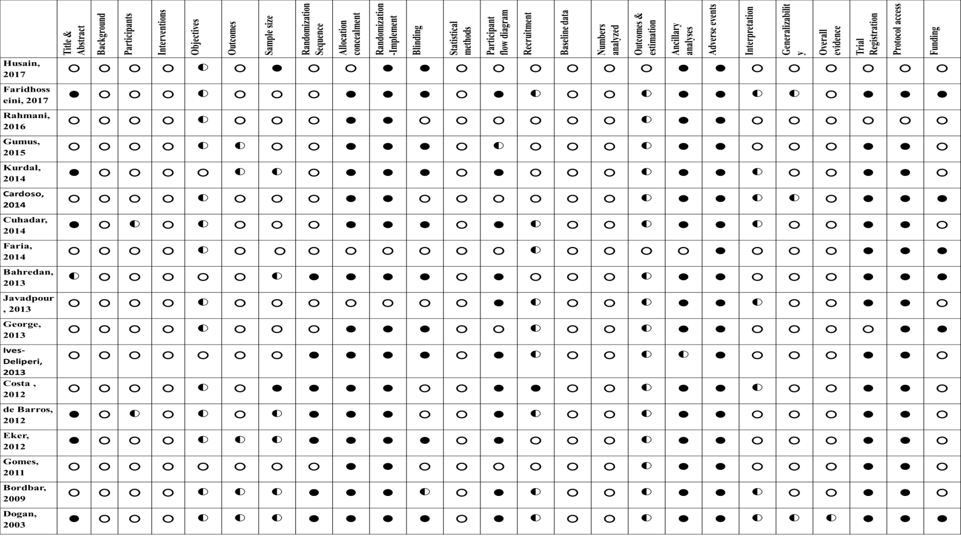
● =not reported; ◐= if partial reported and; ○=fully reported

