Additional file 3: figure 3. Risk of Bias assessment summary

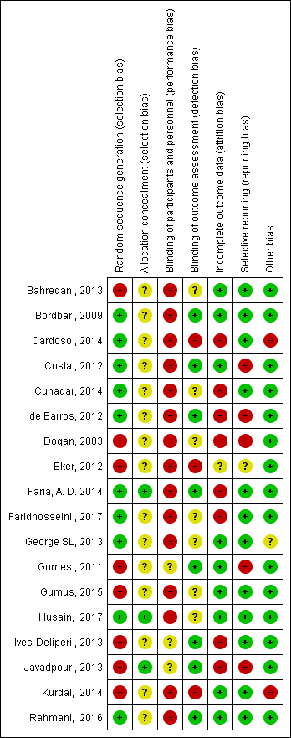
Risk of bias was rated as low (+), high (-), or unclear (?)

