Antipsychotic Monitoring in Dementia - Examining the quality of completion of antipsychotic in dementia monitoring forms in SLaM

Supplementary Information

Initiation of antipsychotic monitoring form
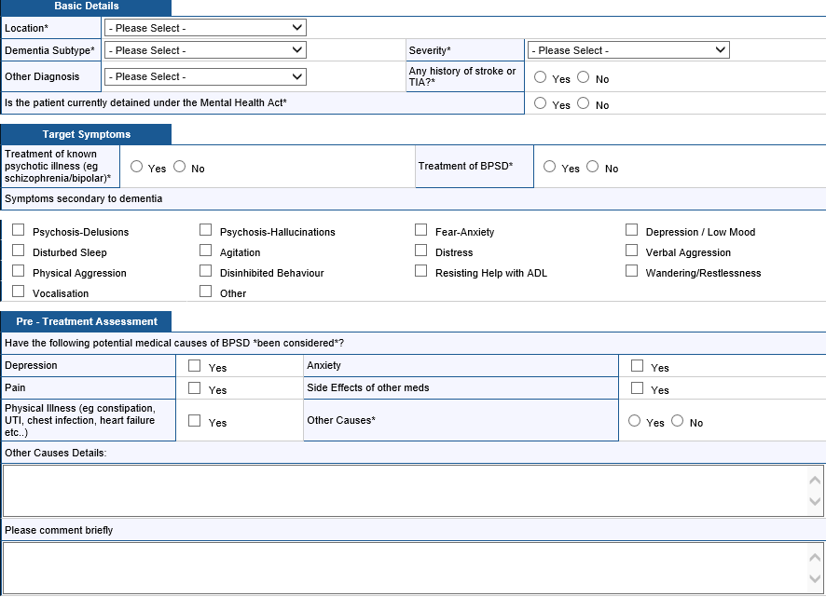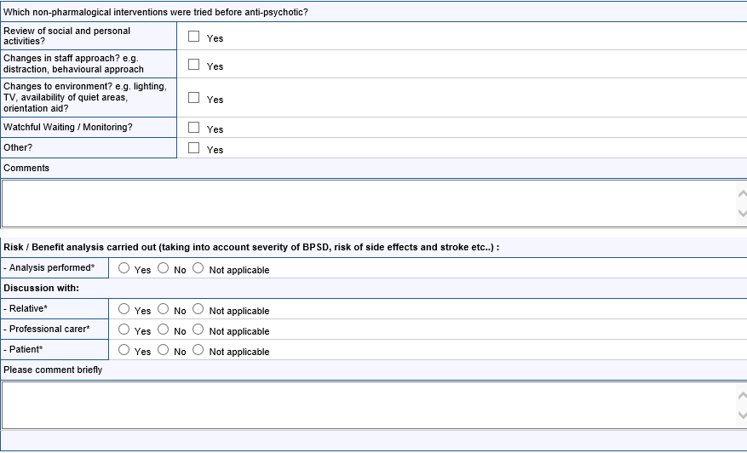
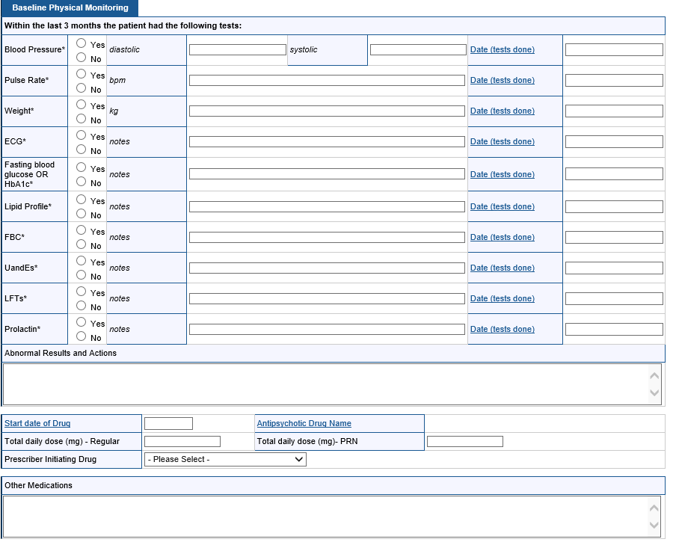

Review of antipsychotic monitoring form
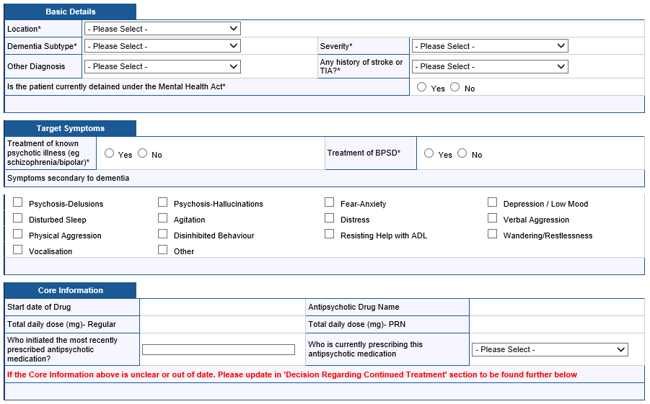

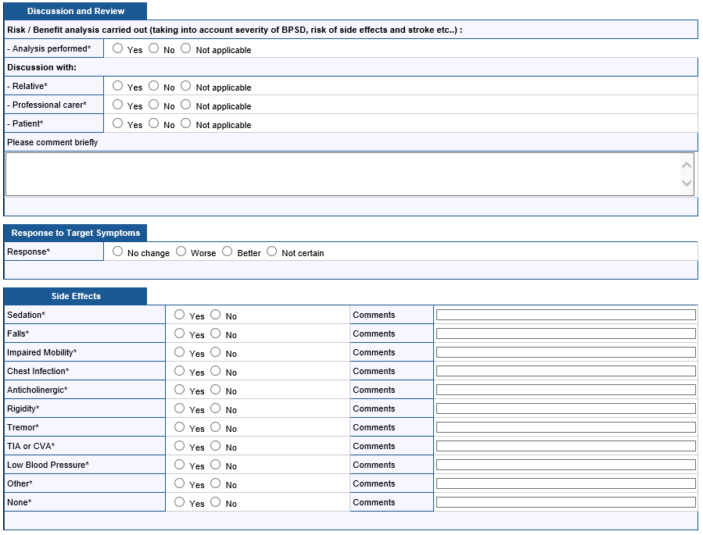
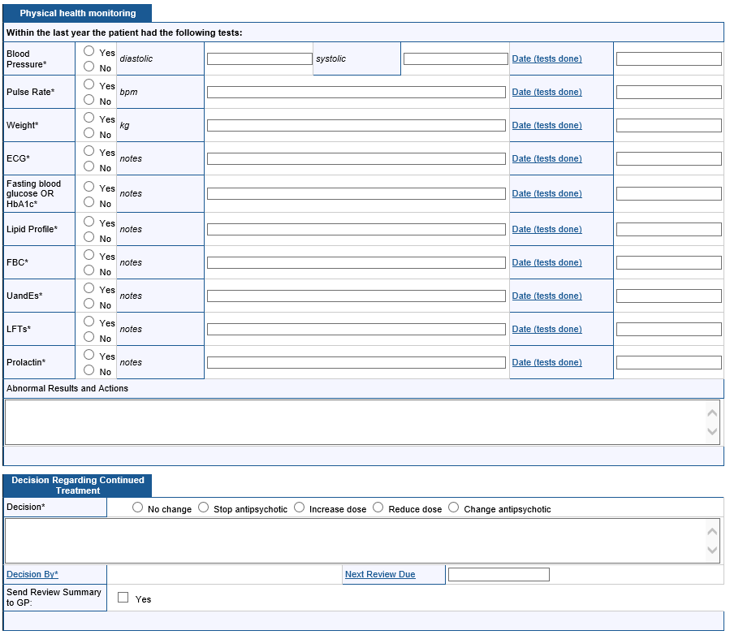

Supplementary Table 1. Clinical characteristics of the patient group (n = 203)

Key clinical characteristics |  |  | n (%)
Dementia subtype
 | Alzheimer’s dementia |  | 108 (53.2)
 | ‘Other’ dementia |  | 44 (21.7)
 | Vascular dementia |  | 25 (12.3)
 | Mixed dementia |  | 11 (5.4)
 | Dementia with Lewy bodies |  | 9 (4.4)
 | Subtype not yet determined |  | 5 (2.5)
 | Parkinson’s disease dementia |  | 1 (0.5)
Dementia severity
 | Mild |  | 7 (3.4)
 | Moderate |  | 97 (47.8)
 | Severe |  | 99 (48.8)
Previous CVA/TIA
 | Yes |  | 33 (16.3)
 | No |  | 170 (83.7)
Detained under the MHA
 | Yes |  | 37 (18.2)
 | No |  | 166 (81.8)

