**Supplementary Appendix**

**The three photographs show empty/unoccupied rooms (photographs taken before the unit began admitting patients).**

1. **INDIVIDUAL PATIENT BEDROOM – EVENING TIME**

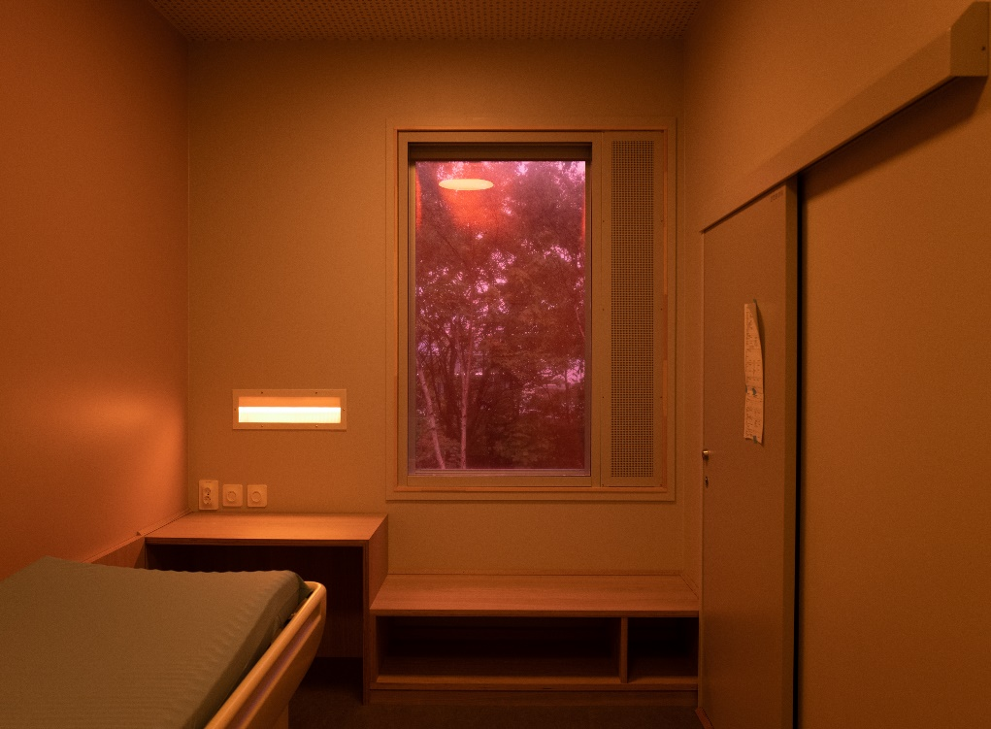

1. **PATIENT COMMON ROOM – EVENING TIME**

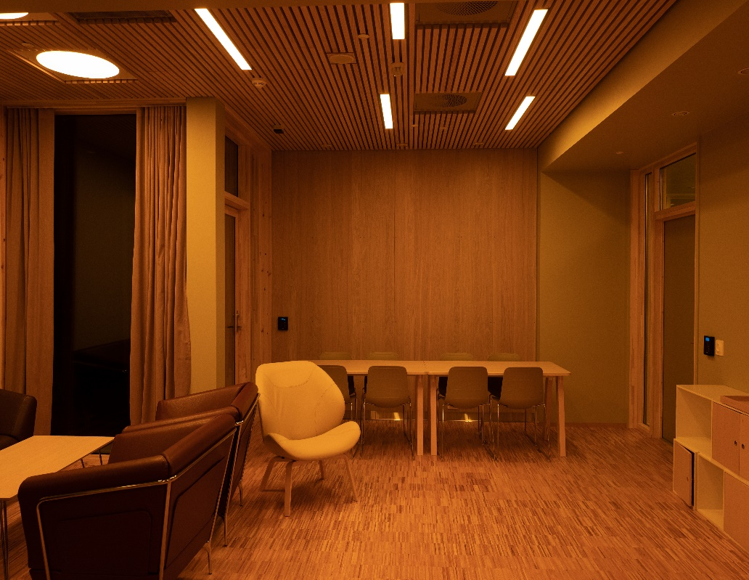

1. **BRIGHT LIGHT WALL – MORNING TIME (INDIVIDUALS IN PHOTOGRAPH ARE VOLUNTEERS NOT PATIENTS)**

