Supplementary material

Table 1S The specific primers to Tsserpin genes
Name of Primers | sequences(5'to3') | Enzyme cleavage site
Ts12383-F | 5'CGCGGATCCATGTTTGCCAAGGATAGCTTC3' | BamH I
Ts12384-R | 5'CCCAAGCTTGGTACTTGCTTTCCGGTTCG3' | Hind III
TsEP45-F | 5'CGAGCTCATGATTTCTCTACGTATGAGAGAC3' | Sac I
TsEP45-R | 5'CCCAAGCTTGCTAGTGGCAGAGTGTGGAG3' | Hind III
Ts4848-F | 5'CGCGGATCCATGTCCCCACTGAGCATA3' | BamH I
Ts4848-R | 5'CCCAAGCTTGGTACTTGCTTTCCGGTTC3' | Hind III
Ts570-F | 5'CGCGGATCCATGAGAGAGAAAACTCTGAAC3' | BamH I
Ts570-R | 5'CCCAAGCTTG ATAGCGAGGATCGGTAATGC3' | Hind III
TsB6-F | 5'CGCGGATCCATGCTAGATGAATATTACTTTAATCACC3' | BamH I
TsB6-R | 5'CCCAAGCTTGGCAGGCCAGGGGATTGAC3' | Hind III

Table 2S Sequences alignment of RCLs of Tsserpins with other species serpins. Residues marked blue refer to the consensus sequence of RCL. The boxed residues representing the scissile-bond and bold-face residues were predicted P1. TsB6, Ts570, TsEP45, Ts4848, Ts12383 (Taenia solium), Em (Echinococcus multilocularis), SjB10 (Schistosoma japonicum), SjB6 (Schistosoma japonicum), Sm1 and Sm2 (Schistosoma mansoni), Csi (Clonorchis sinensis), Pwe (Paragonimus westermani), Bm-1 and Bm-2 (Brugia malayi), Hco (Haemonchus contorus), Tvi (Trichostrongylus vitrinus), A1AT (Human α1-antitrypsin)

ID | P₁₇ | P₁₆ | P₁₅ | P₁₄ | P₁₃ | P₁₂ | P₁₁ | P₁₀ | P₉ | P₈ | P₇ | P₆ | P₅ | P₄ | P₃ | P₂ | P₁ | P_{1'} | P_{2'} | P_{3'} | P_{4'}
TsB6 | E | E | G | A | E | A | A | A | A | T | G | M | A | I | A | P | M | C | L | C | P
Ts12383 | E | E | G | A | E | A | A | A | A | T | G | M | V | M | M | C | R | C | M | P | M
Ts4848 | E | E | G | A | E | A | A | A | A | T | G | M | V | M | M | C | R | C | M | P | M
Ts570 | E | A | G | V | K | A | A | A | V | S | S | I | A | I | V | P | M | S | L | P | P
TsEP45 | R | S | G | I | R | L | L | S | V | G | T | L | N | L | E | T | N | Q | H | Q | F
Emu | E | E | G | A | E | A | A | A | A | T | A | M | P | M | M | V | R | C | M | P | A
SjB10 | E | S | G | I | E | A | A | S | V | T | S | P | I | I | V | P | I | S | A | L | I
SjB6 | E | E | G | A | V | A | A | A | A | S | A | T | V | M | L | K | C | S | A | I | R
Sm1 | E | K | G | A | V | A | A | A | A | T | A | T | Q | M | V | R | C | T | A | F | I
Sm2 | E | K | G | A | V | A | A | A | A | T | A | T | R | M | I | R | C | T | A | F | I
Csi | E | E | G | A | T | A | A | A | S | T | A | G | M | M | V | S | M | M | M | G | P
Pwe | E | E | G | A | T | A | A | A | A | T | A | V | M | M | N | M | R | C | A | M | M
Bma1 | E | K | G | T | E | S | T | A | A | T | V | V | D | L | I | D | R | M | G | T | Q
Bma2 | E | K | G | T | E | S | A | A | A | T | I | I | E | L | E | D | R | M | G | S | S
Hco | E | D | G | T | T | A | A | G | A | T | V | F | C | K | F | E | S | M | S | A | I
Tsp | E | E | G | T | E | A | A | V | S | T | A | V | R | I | V | P | M | S | G | V | M
Tvi | E | E | G | T | T | A | A | A | A | R | C | G | K | W | Y | H | C | R | L | C | W
A1AT | E | K | G | T | E | A | A | G | A | M | F | L | E | A | I | P | M | S | I | P | P

Table 3S Predicted post-translational modification (PTM) sites of the putative Tsserpin proteins

 | position
PTM site | TsB6 | Ts4848 | TsEP45 | Ts570 | Ts12383
cAMP- and cGMP-dependent protein kinase | 140-143 | 175-178 | 299-302 | 84-87、149-152 | 203-206
Casein kinase II | 43-46、70-73、76-79、94-97、121-124、185-188、205-208、258-261、263-266、306-309 | 17-22、 21-24、33-36、52-55、59-62、 97-100、 105-108、152-155、164-167、267-270 | 15-18、82-85、105-108、109-112、171-174、234-237、319-322、347-350、356-359、 | 19-22、65-68、104-107、156-159、163-166、175-178、386-389 | 21-24、45-48、49-52、61-64、80-83、87-89、125-128、133-136、180-183、192-195、295-298
N-myristoylation | 162-172、275-280 | 30-35、101-106、158-163、264-269、302-307 | 75-80、100-105、164-169、222-227、292-297 | 36-41、100-105、350-355 | 58-63、129-134、186-191、292-297、330-335
Protein kinase C | 17-19、40-42、80-82、138-140、168-170、306-308 | 33-35、40-42、144-146、154-156 | 3-5、27-29、56-58、65-67、150-152、160-162、170-172、223-225、244-246、253-255、300-302、338-340、356-358 | 31-33、57-59、65-67、104-106 | 61-63、68-70、172-174、182-184
Tyrosine kinase | 252-260 |  | 288-295

Table 4S Potential B cell epitope positions and sequences of Tsserpins
TsB6 |  | Ts4848 |  | TsEP45 |  | Ts570 |  | Ts12383
sequences | position | sequences | position | sequences | position | sequences | position | sequences | position
LVLFPRGSKK | 10-19 | ALAGSEGDTR | 13-22 | ISLRMRDKG | 2-10 | ALLTSKGPE | 54-62 | AQLQSSEGE | 16-24
SLALSGSSGR | 33-42 | QAVTSSDAK | 49-57 | AAASEPERPKSTFS | 12-25 | EAIVGEREKKTC | 71-82 | ALAGSEGDTR | 41-50
DAVSDGDTG | 73-81 | LDFSSDPEGSR | 93-103 | INDITKKSGHS | 52-62 | IGVANSRREDN | 99-109 | QAVTSSDAK | 77-85
SNAEKAR | 121-127 | EWISENTK | 108-115 | KAARGTS | 77-83 | NDWARSST | 158-165 | LDFSSDPEGSR | 121-131
LMTRESI | 145-151 | WKWKFEKSETDR | 145-156 | QALSTTNSRD | 89-98 | EQFLKSN | 170-176 | EWISENTK | 136-143
ADFSRITKKE | 300-309 | HTLSKGD | 161-167 | VVWTQTSRK | 165-173 |  |  | WKWKFEKSETDR | 173-184
 |  | IVLPEKR | 203-209 | KWLSKVS | 180-186 |  |  | HTLSKGD | 189-195
 |  | PRFSLGGRNMKLKESL | 245-260 | LELYGSSKGS | 218-227 |  |  | IVLPEKR | 231-237
 |  | HVVEPES | 347-353 | IYYKDTK | 248-254 |  |  | PRFSLGGRNMKLKESL | 273-283
 |  |  |  | NPFDSDR | 334-340 |  |  | HVVEPES | 375-381
 |  |  |  | LHINSGKE | 352-359
 |  |  |  | AFLQVSRSG | 361-369
 |  |  |  | ILIDRES | 421-427

Fig 1S. Amplification of the serpins from T.solium by PCR. 4A: TsB6 (1131bp); 4B: TsEP45 (1350bp); 4C: Ts570 (1206bp); 4D: Ts4848 (1065bp); 4E: Ts12383 (1149bp)

Fig 2S. Identification of recombinant plasmid pET-30a (+)-Tsserpins by enzyme digestion. M: DNA Marker; 5A: 1, Recombinant plasmid of pET-30a (+)-TsB6; 2, Enzyme digestion of pET-30a (+)-TsB6. 5B: 1, Recombinant plasmid of pET-30a (+)-TsEP45; 2, Enzyme digestion of pET-30a (+)-TsEP45. 5C: 1, Recombinant plasmid of pET-30a (+)-Ts570; 2, Enzyme digestion of pET-30a (+)-Ts570. 5D: 1, Recombinant plasmid of pET-30a (+)-Ts4848; 2, Enzyme digestion of pET-30a (+)-Ts4848. 5E: 1, Recombinant plasmid of pET-30a (+)-Ts12383; 2, Enzyme digestion of pET-30a (+)-Ts12383.
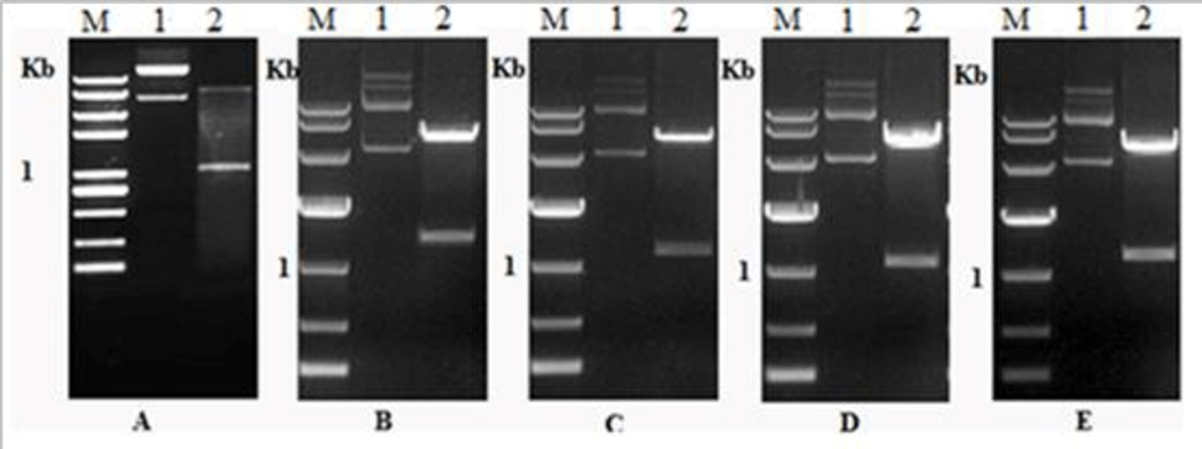

Fig 3S. Expression of recombinant Tsserpins proteins. M: Protein molecular weight Markers; 6A: Recombinant proteins of the Tsserpins induced expression: 1, 3, 5, 7, 9: Expression products without inducement of TsEP45, Ts4848, Ts12383, Ts570, TsB6, respectively; 2, 4, 6, 8, 10: Expression products with inducement of TsEP45, Ts4848, Ts12383, Ts570, TsB6, respectively.

