Supplementary Materials
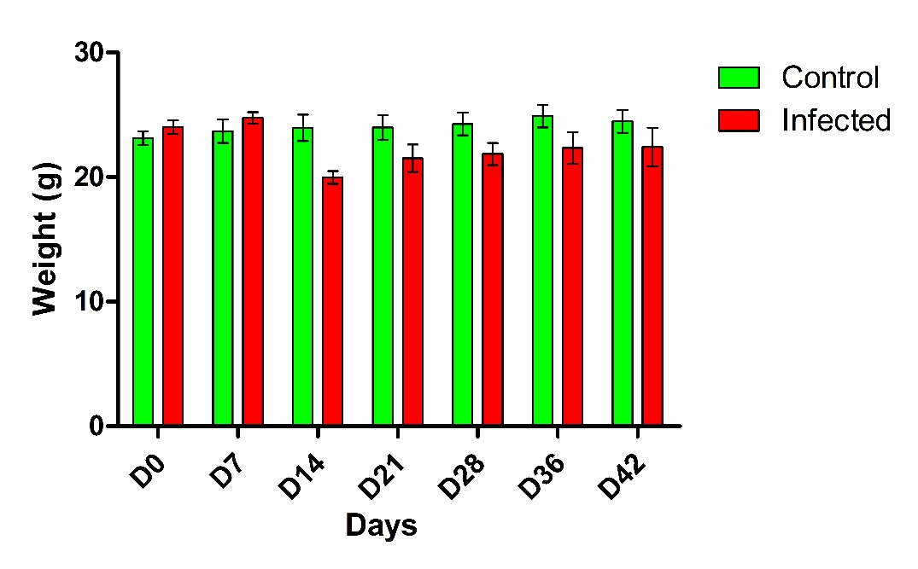
Figure S1. Mean weight of mice across treatments (n = 8 for control, n = 8 for infected)

Table S1. Cytokines profile of different treatment groups
Groups | N | IFNg | IL-1b | IL-2 | IL-4 | IL-5 | IL-6 | IL-10 | IL-12p40 | IL-17 | TNFα
PIC | 5 | 2.17±0.94 | 6.82±2.81 | 0.40±0.40 | 2.04±0.16 | 28.87±5.61 | 11.90±2.22 | 7.42±0.75 | 5.30±0.45 | 9.82±2.60 | 3.77±1.41
D7C | 5 | 0.30±0.19 | 8.52±1.48 | ND | 2.25±0.92 | 16.47±4.70 | 3.33±1.29 | 5.73±2.39 | 5.10±0.65 | 3.26±0.97 | 4.99±1.16
D14C | 5 | 0.62±0.38 | 10.16±1.98 | ND | 62±44.50 | 103.2±56.3 | 101.7±65.7 | 259±156 | 4.46±0.72 | 95.5±59 | 5.05±3.37
D21C | 5 | 0.62±0.62 | 2.63±1.65 | ND | 52.9±51.7 | 91.4±66.9 | 46.5±42.2 | 200±197 | 3.78±0.70 | 61.2±58.5 | 2.39±1.45
D28C | 5 | 1.77±1.44 | 7.49±4.39 | ND | 206±202 | 182±157 | 387±379 | 1681±1672 | 5.87±1.95 | 287±279 | 6.46±1.28
D36C | 5 | 0.11±0.11 | ND | ND | 101±97.7 | 92.1±72.1 | 184±174 | 741±741 | 0.21±0.21 | 217±207 | 4.45±0.63
D42C | 5 | 0.70±0.34 | 2.12±1.86 | ND | 104±101 | 92.3±77.6 | 279±272 | 907±907 | ND | 220±212 | 5.47±1.05
PII | 5 | 0.78±0.60 | 11.81±6.38 | ND | 308±307 | 74.2±59.2 | 1761±1746 | 2109±2105 | 2.39±0.46 | 399±389 | 4.86±4.30
D7I | 5 | 2577±319 | 13.41±6.46 | 0.40±0.40 | 95.20±94 | 37.1±26.8 | 336±280 | 345±290 | 10.73±1.58 | 112±111 | 15.69±3.03
D14I | 5 | 1133±408 | 24.5±23.1 | ND | 160±160 | 84.9±81.5 | 546±530 | 674±658 | 2.17±1.36 | 99.5±99.1 | 34.69±8.07
D21I | 5 | 78.7±7.39 | 18±16.10 | ND | 304±302 | 122.5±88.8 | 1068±1032 | 895±889 | 5.04±1.60 | 151±146 | 17.46±6.87
D28I | 5 | 38.15±7.79 | 7.10±7.10 | ND | 586±576 | 121.4±91.2 | 3452±3183 | 72.4±72.4 | ND | 752±727 | 7.14±1.15
D36I | 5 | 13.26±1.62 | 6.68±5.60 | ND | 232±223 | 53.8±29.4 | 1190±1116 | 670±591 | ND | 250±225 | 6.22±0.87
D42I | 5 | 12.77±4.35 | 4.73±4.73 | ND | 242±222 | 47.1±24.2 | 1364±1256 | 910±652 | ND | 309±271 | 5.52±1.04

Table S2. Host faecal bacterial diversity indices inferred from TRFLP profiling. Note: H’ = Shannon Diversity Index, J’ = Pielou’s Evenness Index
Group | N* | H' | J'
PIC | 6 | 3.22±0.52 | 0.82±0.04
D7C | 6 | 3.29±0.10 | 0.81±0.02
D14C | 6 | 2.98±0.61 | 0.75±0.02
D21C | 6 | 3.81±0.16 | 0.76±0.02
D28C | 6 | 2.97±0.16 | 0.81±0.02
D36C | 6 | 3.24±0.09 | 0.80±0.01
D42C | 6 | 3.06±0.090 | 0.81±0.01
PII | 5 | 3.42±0.20 | 0.77±0.02
D7I | 6 | 2.99±0.15 | 0.78±0.03
D14I | 6 | 2.98±0.61 | 0.75±0.02
D21I | 6 | 3.51±0.15 | 0.75±0.03
D28I | 5 | 2.60±0.31 | 0.79±0.04
D36I | 5 | 2.59±0.12 | 0.76±0.02
D42I | 5 | 2.66±0.12 | 0.77±0.02

