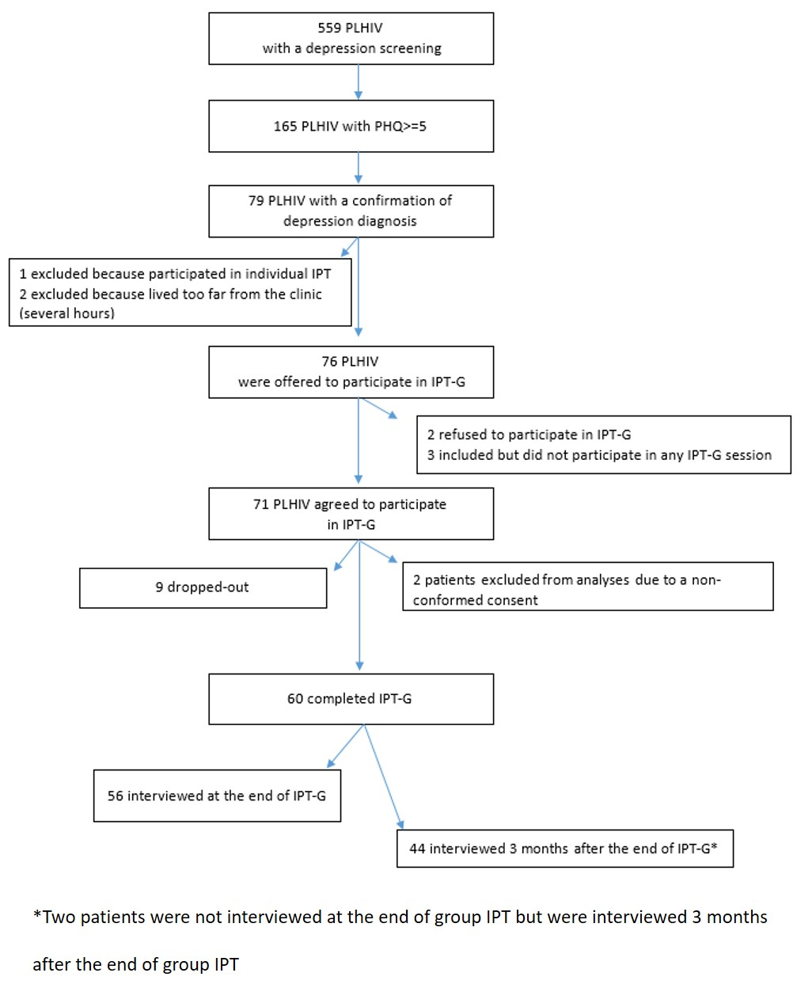

Figure S1: Flow Chart of study participants

Table S1: Characteristics of the patients who dropped out and the patients who completed group IPT
Variables | Patients who complete group IPT | Patients who dropped out | p-value
N | 60 | 9
Age (years) (median IQR) | 41 (49-55) | 42 (47-54) | 0.85
Female | 29 (48%) | 6 (67%) | 0.48
Living alone | 26 (43%) | 4 (44%) | 1.00
Unemployed | 24 (40%) | 5 (56%) | 0.48
No Sharing status (mis. 2) | 11 (18%) | 3 (33%) | 0.66
Financial difficulties | 49 (82%) | 8 (89%) | 1.00
PHQ-9 total score | 13 (10-15) | 13 (12-14) | 0.98

Figure S2: Assessment of the feasibility by the facilitators (N=3)
