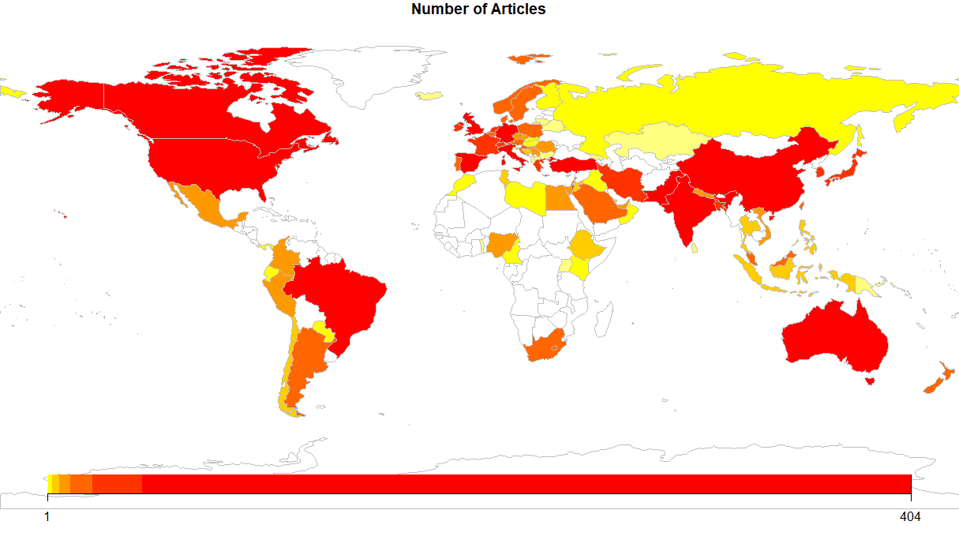Supplementary Material 1. Mean number of articles per country based on the corresponding author

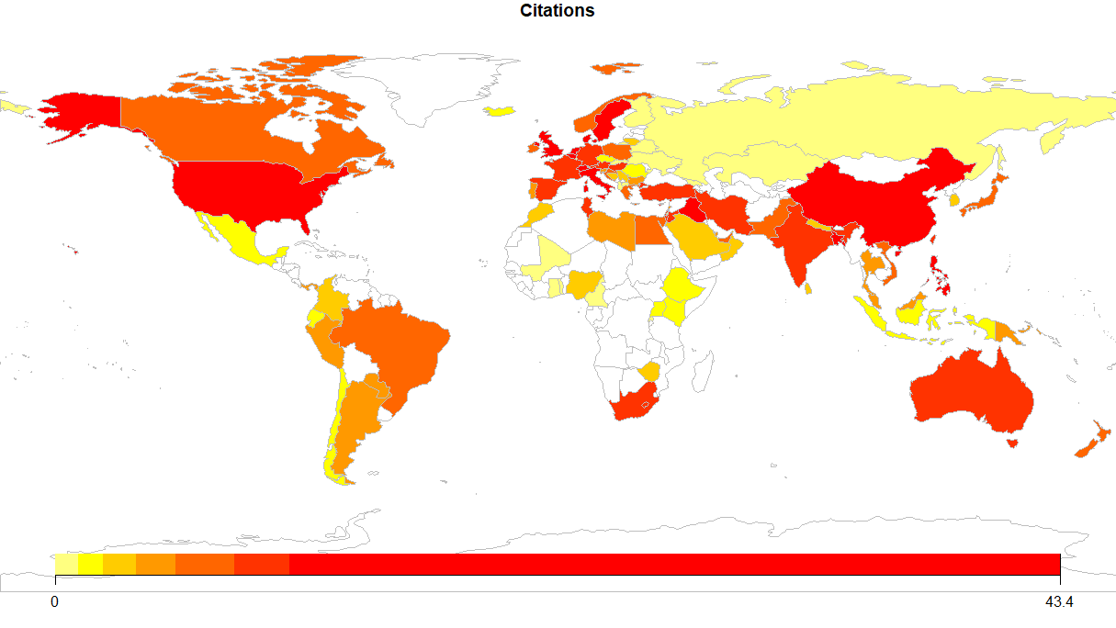

Supplementary Material 2. Mean number of citations per country based on the corresponding author

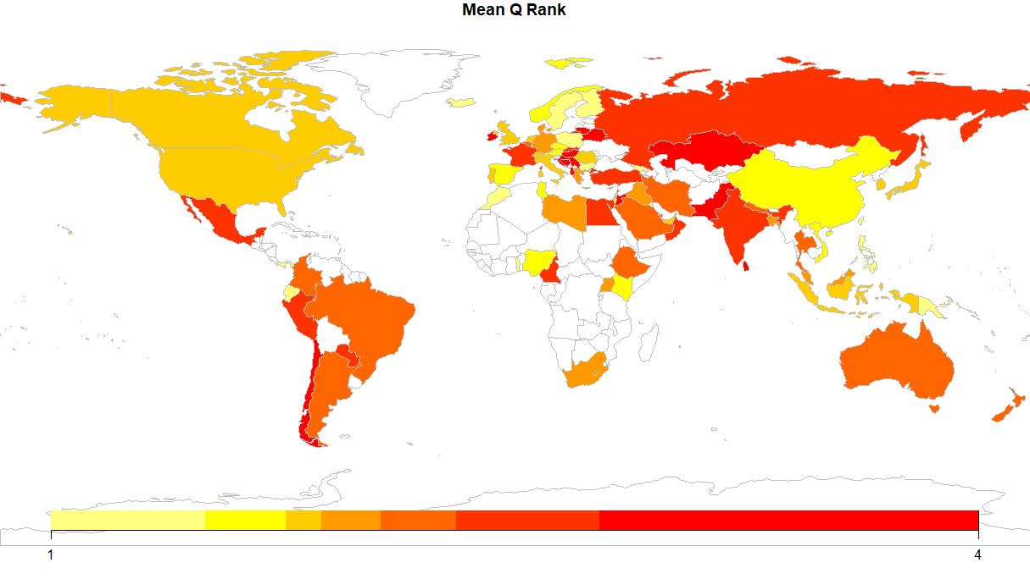

Supplementary Material 3. Mean number of Q Rank per country based on the corresponding author

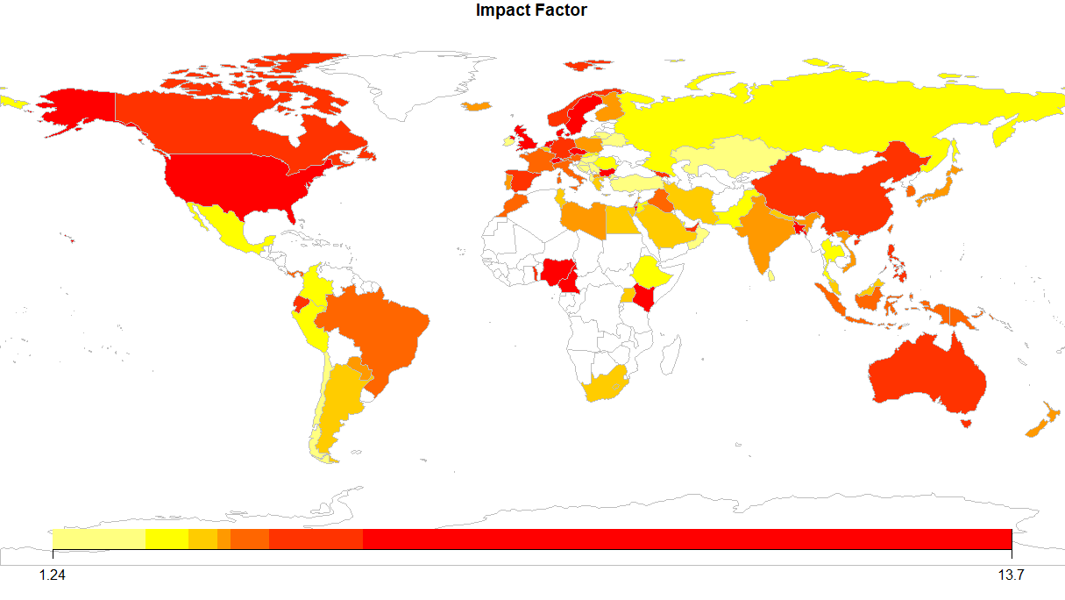

Supplementary Material 4. Mean number of Journal Impact Factor per country based on the corresponding author

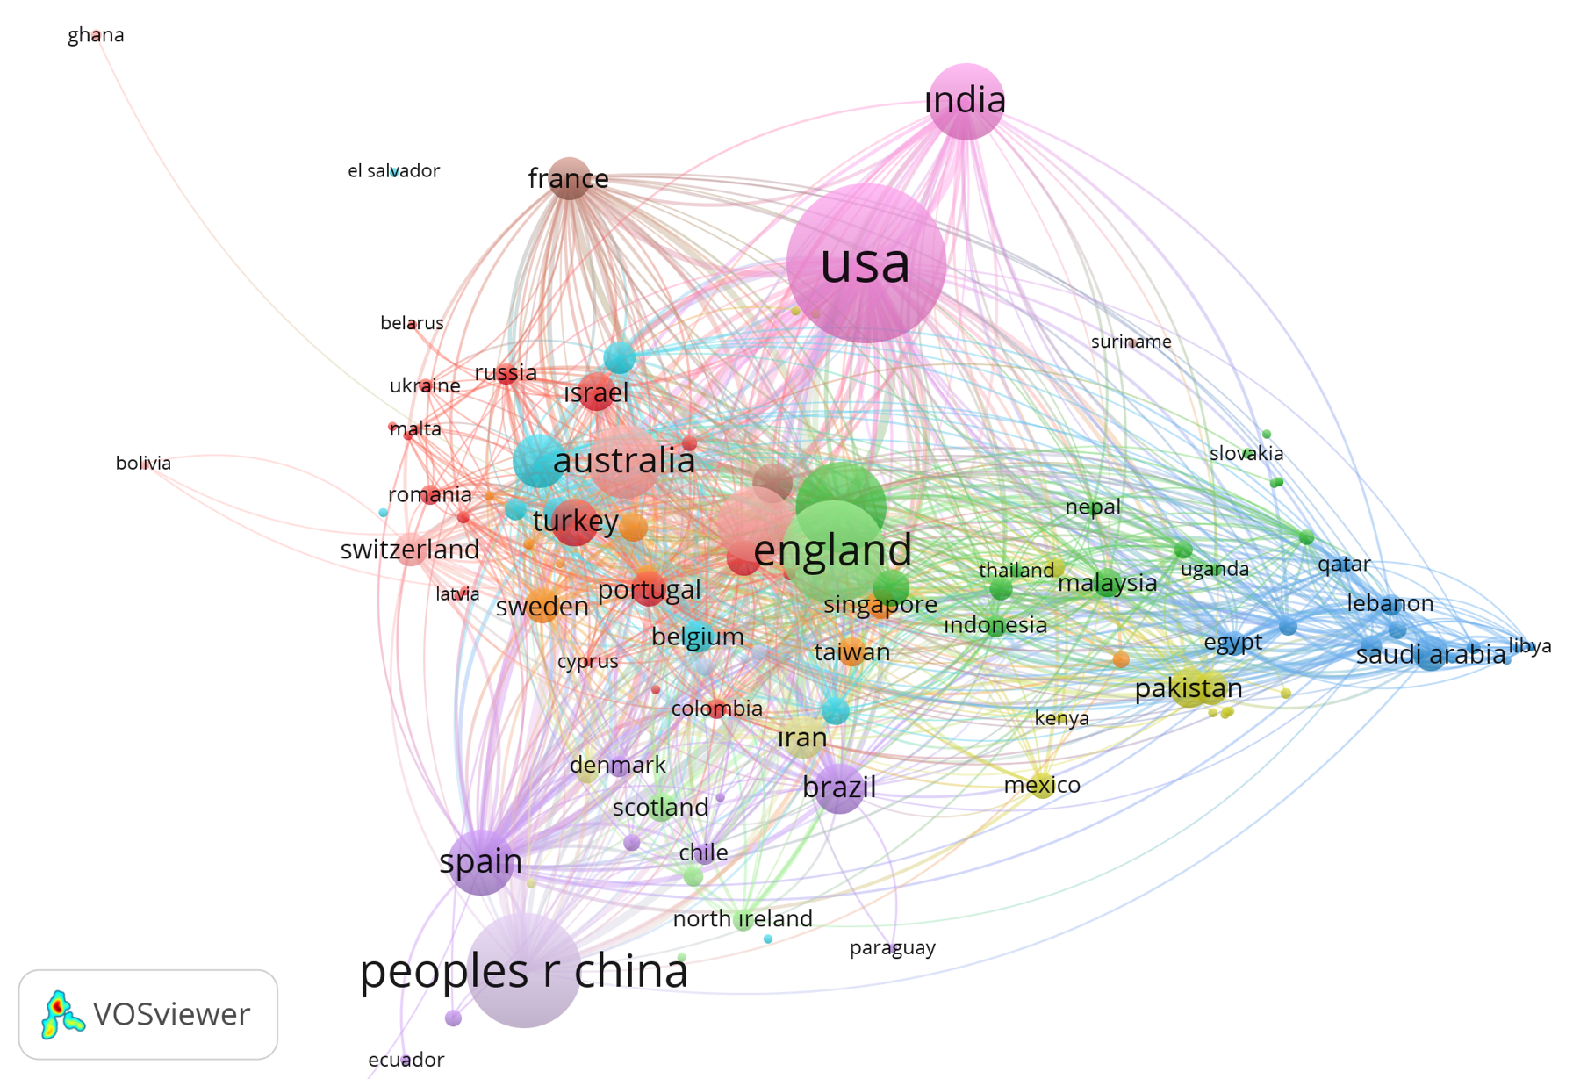
Supplementary Material 5. Inter-country collaborations in the VOSviewer software tool

