Supplementary Material

Table 1S. Pre-post changes in study outcomes for Brief and Standard CETA compared to Waitlist controls (unimputed)
Outcomes |  | Brief CETA | Standard CETA | Waitlist Control
Depression
 | Baseline, mean (se) | 1.47 (0.07) | 1.58 (0.10) | 1.51 (0.11)
 | Follow-up, mean (se) | 0.66 (0.07) | 0.44 (0.08) | 1.00 (0.06)
 | Pre-post change | -0.81 (0.03) | -1.14 (0.04) | -0.51 (0.10)
 | Net effect ($β,$95% CI)* | -0.30 (-0.44, -0.16) | -0.63 (-0.75, -0.51) | -
 | Effect estimate (d) | 0.54 | 1.09 | -
Posttraumatic Stress
 | Baseline, mean (se) | 1.37 (0.10) | 1.49 (0.06) | 1.30 (0.06)
 | Follow-up, mean (se) | 0.60 (0.10) | 0.43 (0.08) | 0.88 (0.09)
 | Pre-post change | -0.77 (0.06) | -1.05 (0.05) | -0.42 (0.08)
 | Net effect ($β,$95% CI)* | -0.35 (-0.49, -0.22) | -0.63 (-0.83, -0.44) | -
 | Effect estimate (d) | 0.59 | 1.06 | -
Anxiety
 | Baseline, mean (se) | 1.35 (0.05) | 1.37 (0.07) | 1.31 (0.12)
 | Follow-up, mean (se) | 0.67 (0.06) | 0.49 (0.10) | 1.00 (0.09)
 | Pre-post change | -0.68 (0.04) | -0.89 (0.05) | -0.31 (0.13)
 | Net effect ($β,$95% CI)* | -0.37 (-0.55, -0.19) | -0.58 (-0.92, -0.24) | -
 | Effect estimate (d) | 0.62 | 0.95 | -
Dysfunction
 | Baseline, mean (se) | 1.20 (0.01) | 1.25 (0.10) | 1.14 (0.09)
 | Follow-up, mean (se) | 0.83 (0.09) | 0.78 (0.13) | 1.07 (0.20)
 | Pre-post change | -0.36 (0.08) | -0.48 (0.03) | -0.07 (0.13)
 | Net effect ($β,$95% CI)* | -0.29 (-0.42, -0.17) | -0.41 (-0.61, -0.20) | -
 | Effect estimate (d) | 0.49 | 0.61 | -
NB: Means are from predicted models and take into account clustering.
* This is the interaction term beta and 95% CI
Table 2s. Pre-post changes in study outcomes for Standard CETA compared to Brief CETA (unimputed)
Outcomes |  | Standard CETA
Depression
 | Net effect ($β,$95% CI) | -0.33 (-0.37, -0.30)
 | Effect estimate (d) | 0.59
Posttraumatic Stress
 | Net effect ($β,$95% CI) | -0.28 (-0.50, -0.07)
 | Effect estimate (d) | 0.49
Anxiety
 | Net effect ($β,$95% CI) | -0.21 (-0.37, -0.04)
 | Effect estimate (d) | -0.35
Dysfunction
 | Net effect ($β,$95% CI) | -0.11 (-0.21, -0.02)
 | Effect estimate (d) | -0.18
NB: Means are from predicted models and take into account clustering.

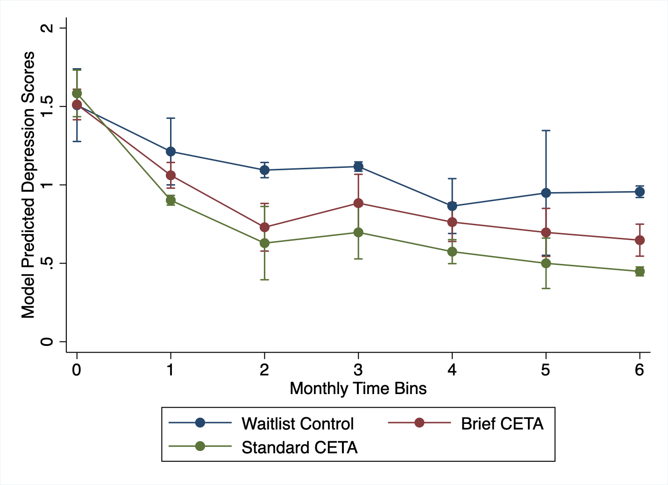
Figure 1S. Model predicted depression scores by treatment group over the six month period after baseline
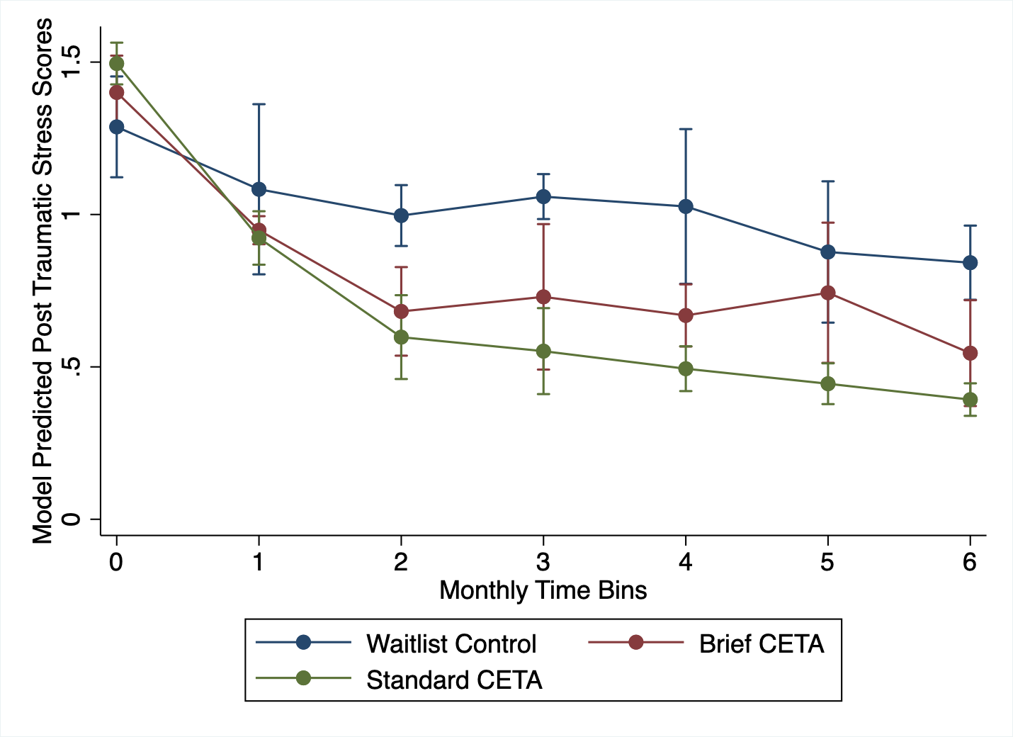
Figure 2S. Model predicted posttraumatic stress scores by treatment group over the six month period after baseline
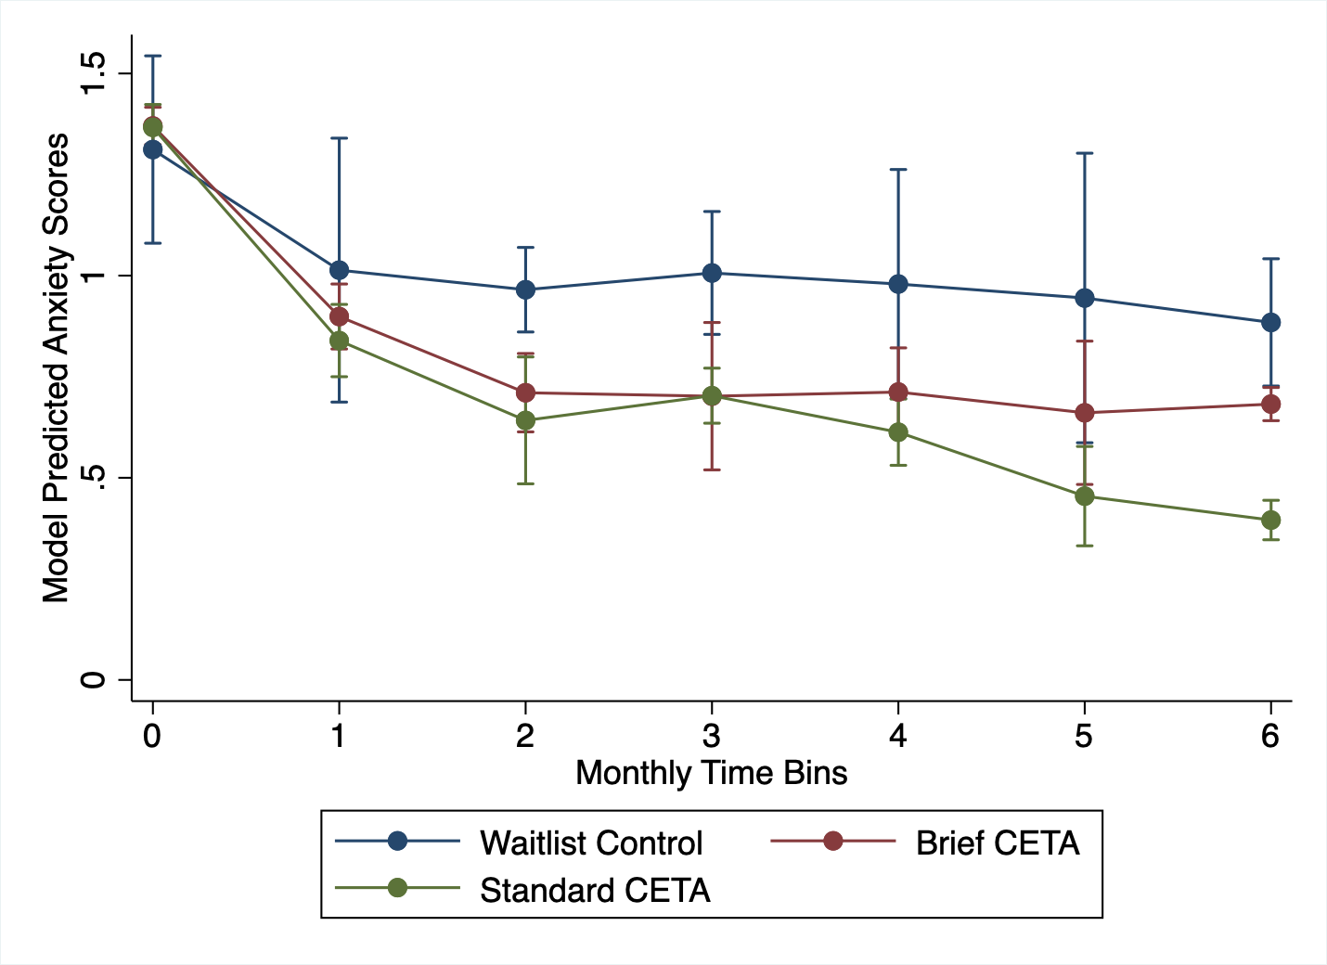
Figure 3S. Model predicted anxiety scores by treatment group over the six month period after baseline
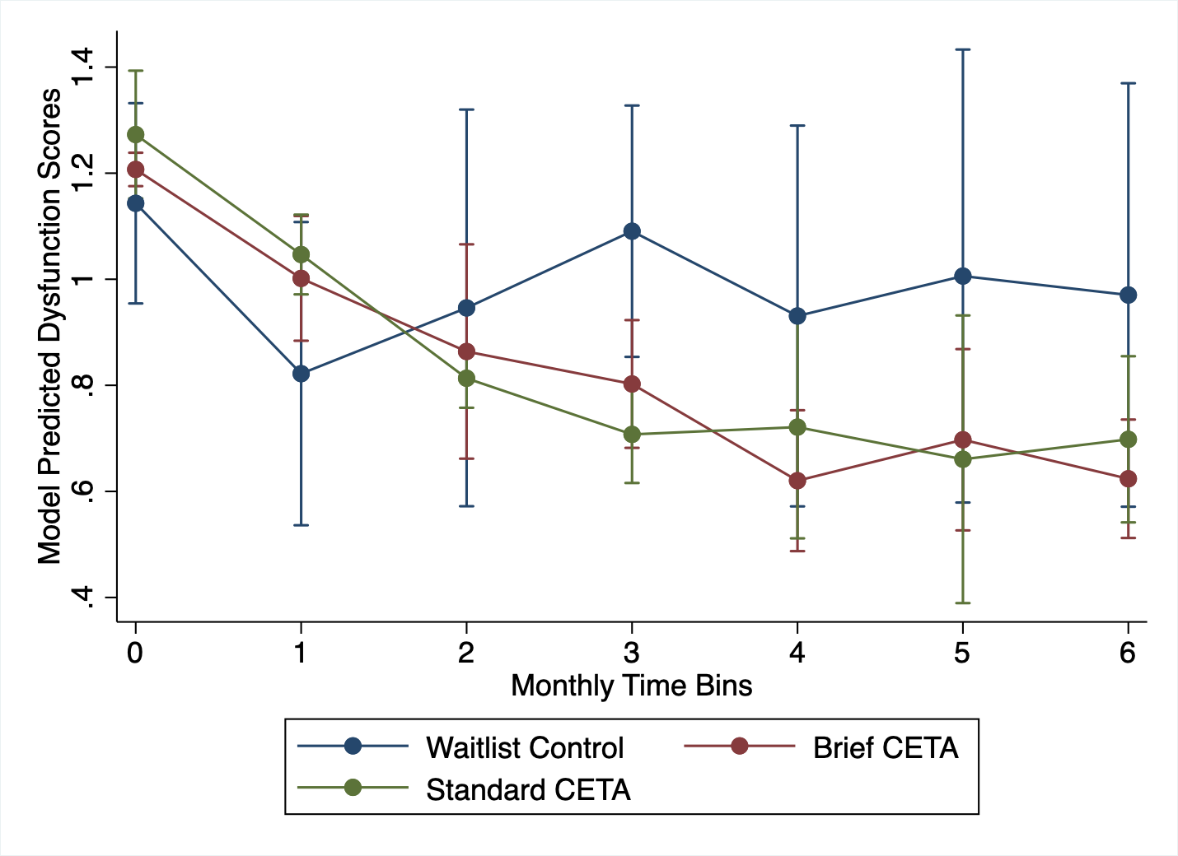
Figure 4S. Model predicted dysfunction scores by treatment group over the six month period after baseline

