Data Input: Estimation of expected cases
Figure 1: Flow of data inputs, adjustments and outputs

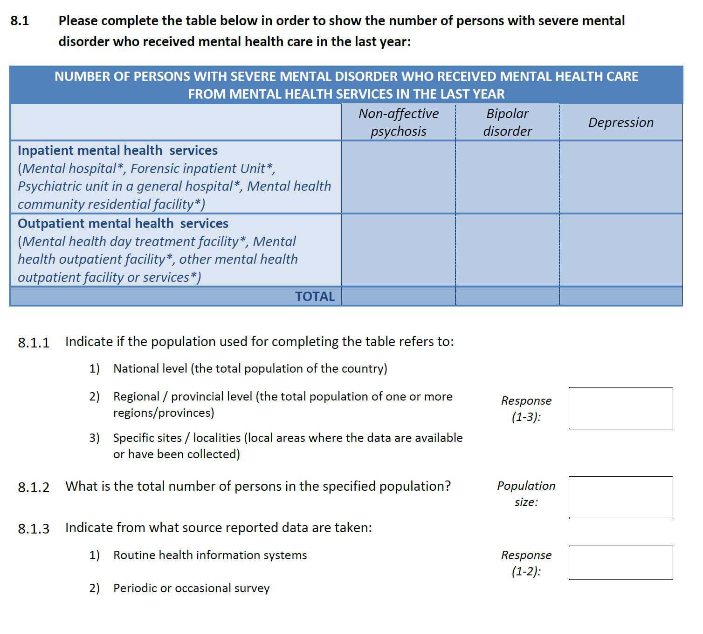
Figure S1: Section 8 of the Mental Health Atlas Questionnaire 2017
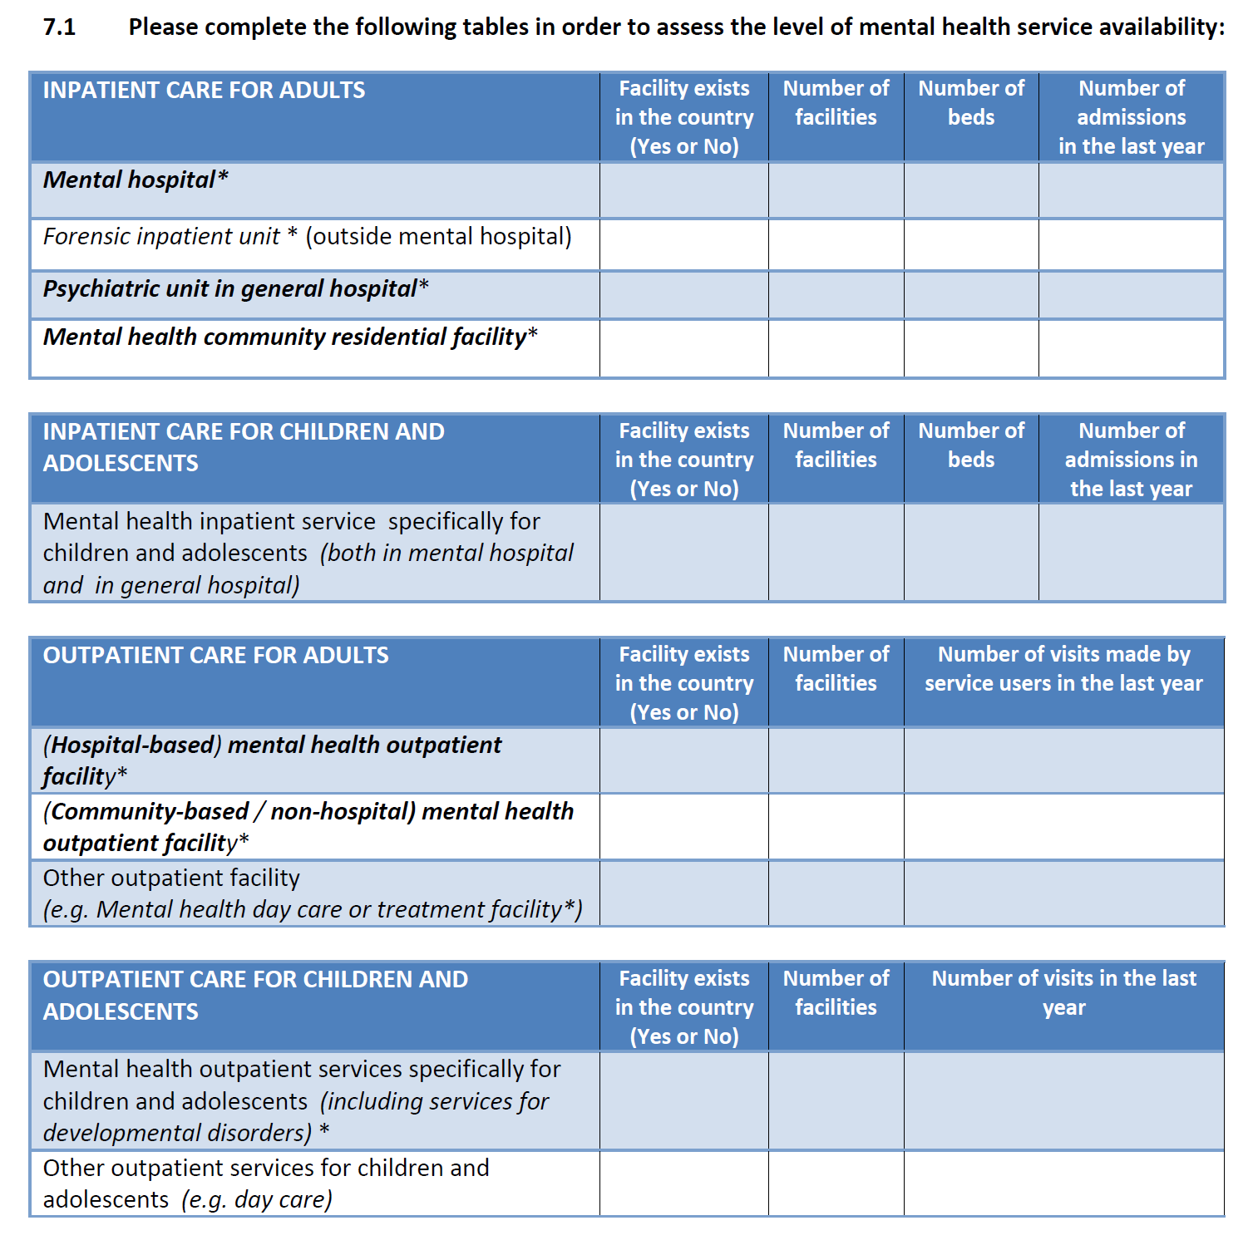
Figure S2: Section 7 of the Mental Health Atlas Questionnaire 2017

Table 1: Applied lower and upper service coverage estimate thresholds
Income level | Country | Coverage | Lower CI | Upper CI
Psychosis* | ***
Low income | Nigeria | 21.3% | 1.3% | -
Low-middle income | China | 11.0% | 0.4% | -
Upper-middle income | Lebanon | 20.1% | 9.9% | -
High-income | Japan | 24.2% | 14.4% | -
Depression* | ****
Low income | Nigeria | 21.3% | - | 41.3%
Low-middle income | Colombia | 27.8% | - | 37.2%
Upper-middle income | Mexico | 25.8% | - | 34.2%
High-income | Belgium | 60.9% | - | 78.7%
Bipolar disorder** | *****
Low and low-middle income | All | 13.0% | - | 21.6%
Upper-middle income | All | 15.9% | - | 21.8%
High-income income | All | 28.4% | - | 32.3%
*taken from ‘severe’ category of Table 3: 12-month service use by severity of mental disorders in the WMH surveys (29)
**taken from 12-month treatment from ‘any mental health service’ of Table 6: Lifetime and 12-month treatment of DSM-IV/CIDI Bipolar Spectrum Disorders (30).
*** The country listed has the lowest coverage in the WMH surveys for that income group. This is used as the lower threshold for psychosis coverage estimates.
****The country listed has the highest coverage in the WMH surveys for that income group. This is used as the highest threshold for depression coverage estimates.
*****For bipolar disorder, there are only global values from the WMH surveys, which are used as the highest threshold for bipolar coverage estimates. Note: missing values mean no thresholds were set.

Table 2: Estimates of service coverage for psychosis using Atlas 2017
Grouping | n | Mean | Lower 95% CI | Upper 95% CI
Income
Low income | 7 | 10.9% | 3.3% | 30.4%
Lower middle-income | 14 | 21.5% | 11.9% | 35.7%
Upper middle-income | 14 | 29.2% | 19.9% | 40.7%
High income | 15 | 59.5% | 42.9% | 74.1%
WHO region
African Region | 8 | 12.8% | 5.7% | 26.2%
Region of The Americas | 11 | 25.6% | 14.5% | 41.2%
Eastern Mediterranean Region | 6 | 16.1% | 3.4% | 51.4%
European Region | 16 | 56.8% | 44.3% | 68.4%
South-East Asia Region | 2 | 18.4% | 1.8% | 73.5%
Western Pacific Region | 7 | 34.7% | 20.2% | 52.8%
GBD region
High income | 11 | 51.5% | 35.0% | 67.6%
Latin America & Caribbean | 10 | 26.7% | 14.1% | 44.7%
Central Europe, Eastern Europe, and Central Asia | 9 | 56.5% | 37.4% | 73.9%
North Africa and Middle East | 5 | 24.3% | 5.9% | 62.2%
South Asia | 2 | 18.4% | 1.8% | 73.5%
Sub‐Saharan Africa | 9 | 10.0% | 4.1% | 22.3%
Southeast Asia, East Asia, and Oceania | 4 | 25.9% | 20.3% | 32.3%
Overall | 50 | 31.3% | 22.9% | 41.0%

Table 3: Estimates of service coverage for bipolar disorder using Atlas 2017
Grouping | n | Mean | Lower 95% CI | Upper 95% CI
Income
Low income | 7 | 3.1% | 0.8% | 11.5%
Lower middle-income | 15 | 3.5% | 1.8% | 6.8%
Upper middle-income | 20 | 3.1% | 1.8% | 5.5%
High income | 14 | 10.4% | 6.7% | 15.9%
WHO region
African Region | 9 | 2.6% | 0.9% | 7.2%
Region of The Americas | 14 | 4.2% | 2.6% | 6.7%
Eastern Mediterranean Region | 8 | 1.4% | 0.4% | 5.1%
European Region | 16 | 7.2% | 4.2% | 12.2%
South-East Asia Region | 1 | 21.7% | - | -
Western Pacific Region | 8 | 7.5% | 4.1% | 13.1%
GBD region
High income | 8 | 14.5% | 10.3% | 20.1%
Latin America & Caribbean | 13 | 4.1% | 2.4% | 6.7%
Central Europe, Eastern Europe, and Central Asia | 11 | 4.3% | 2.3% | 8.0%
North Africa and Middle East | 7 | 2.0% | 0.6% | 6.9%
South Asia | 7 | 2.0% | 0.6% | 6.9%
Sub‐Saharan Africa | 10 | 1.9% | 0.6% | 5.6%
Southeast Asia, East Asia, and Oceania | 7 | 8.5% | 4.3% | 16.0%
Overall | 56 | 4.4% | 3.1% | 6.3%

Table 4: Estimates of service coverage for moderate to severe depression using Atlas 2017
Grouping | n | Mean | Lower 95% CI | Upper 95% CI
Income
Low income | 8 | 2.9% | 1.3% | 6.3%
Lower middle-income | 16 | 4.3% | 2.3% | 7.9%
Upper middle-income | 22 | 13.0% | 8.0% | 20.3%
High income | 17 | 31.1% | 18.3% | 47.6%
WHO region
African Region | 10 | 3.4% | 2.2% | 5.3%
Region of The Americas | 14 | 14.6% | 8.2% | 24.6%
Eastern Mediterranean Region | 9 | 3.6% | 1.5% | 8.3%
European Region | 18 | 30.9% | 18.9% | 46.1%
South-East Asia Region | 3 | 11.0% | 1.0% | 61.1%
Western Pacific Region | 9 | 6.1% | 2.2% | 15.7%
GBD region
High income | 11 | 35.5% | 20.1% | 54.6%
Latin America & Caribbean | 13 | 15.0% | 8.1% | 26.2%
Central Europe, Eastern Europe, and Central Asia | 10 | 20.3% | 8.7% | 40.3%
North Africa and Middle East | 8 | 5.0% | 2.8% | 9.0%
South Asia | 2 | 3.7% | 0.6% | 19.4%
Sub‐Saharan Africa | 11 | 2.7% | 1.4% | 5.0%
Southeast Asia, East Asia, and Oceania | 8 | 6.9% | 2.2% | 19.8%
Overall | 63 | 10.7% | 7.4% | 15.2%

Table S1: Checklist of information that should be included in new reports of global health estimates
Item # | Checklist item | Reported on page #
Objectives and funding
1 | Define the indicator(s), populations (including age, sex, and geographic entities), and time period(s) for which estimates were made.
2 | List the funding sources for the work.
Data Inputs
For all data inputs from multiple sources that are synthesized as part of the study:
3 | Describe how the data were identified and how the data were accessed.
4 | Specify the inclusion and exclusion criteria. Identify all ad-hoc exclusions.
5 | Provide information on all included data sources and their main characteristics. For each data source used, report reference information or contact name/institution, population represented, data collection method, year(s) of data collection, sex and age range, diagnostic criteria or measurement method, and sample size, as relevant.
6 | Identify and describe any categories of input data that have potentially important biases (e.g., based on characteristics listed in item 5).
For data inputs that contribute to the analysis but were not synthesized as part of the study:
7 | Describe and give sources for any other data inputs.
For all data inputs:
8 | Provide all data inputs in a file format from which data can be efficiently extracted (e.g., a spreadsheet rather than a PDF), including all relevant meta-data listed in item 5. For any data inputs that cannot be shared because of ethical or legal reasons, such as third-party ownership, provide a contact name or the name of the institution that retains the right to the data.
Data analysis
9 | Provide a conceptual overview of the data analysis method. A diagram may be helpful.
10 | Provide a detailed description of all steps of the analysis, including mathematical formulae. This description should cover, as relevant, data cleaning, data pre-processing, data adjustments and weighting of data sources, and mathematical or statistical model(s).
11 | Describe how candidate models were evaluated and how the final model(s) were selected.
12 | Provide the results of an evaluation of model performance, if done, as well as the results of any relevant sensitivity analysis.
13 | Describe methods for calculating uncertainty of the estimates. State which sources of uncertainty were, and were not, accounted for in the uncertainty analysis.
14 | State how analytic or statistical source code used to generate estimates can be accessed.
Results and Discussion
15 | Provide published estimates in a file format from which data can be efficiently extracted.
16 | Report a quantitative measure of the uncertainty of the estimates (e.g. uncertainty intervals).
17 | Interpret results in light of existing evidence. If updating a previous set of estimates, describe the reasons for changes in estimates.
18 | Discuss limitations of the estimates. Include a discussion of any modelling assumptions or data limitations that affect interpretation of the estimates.

