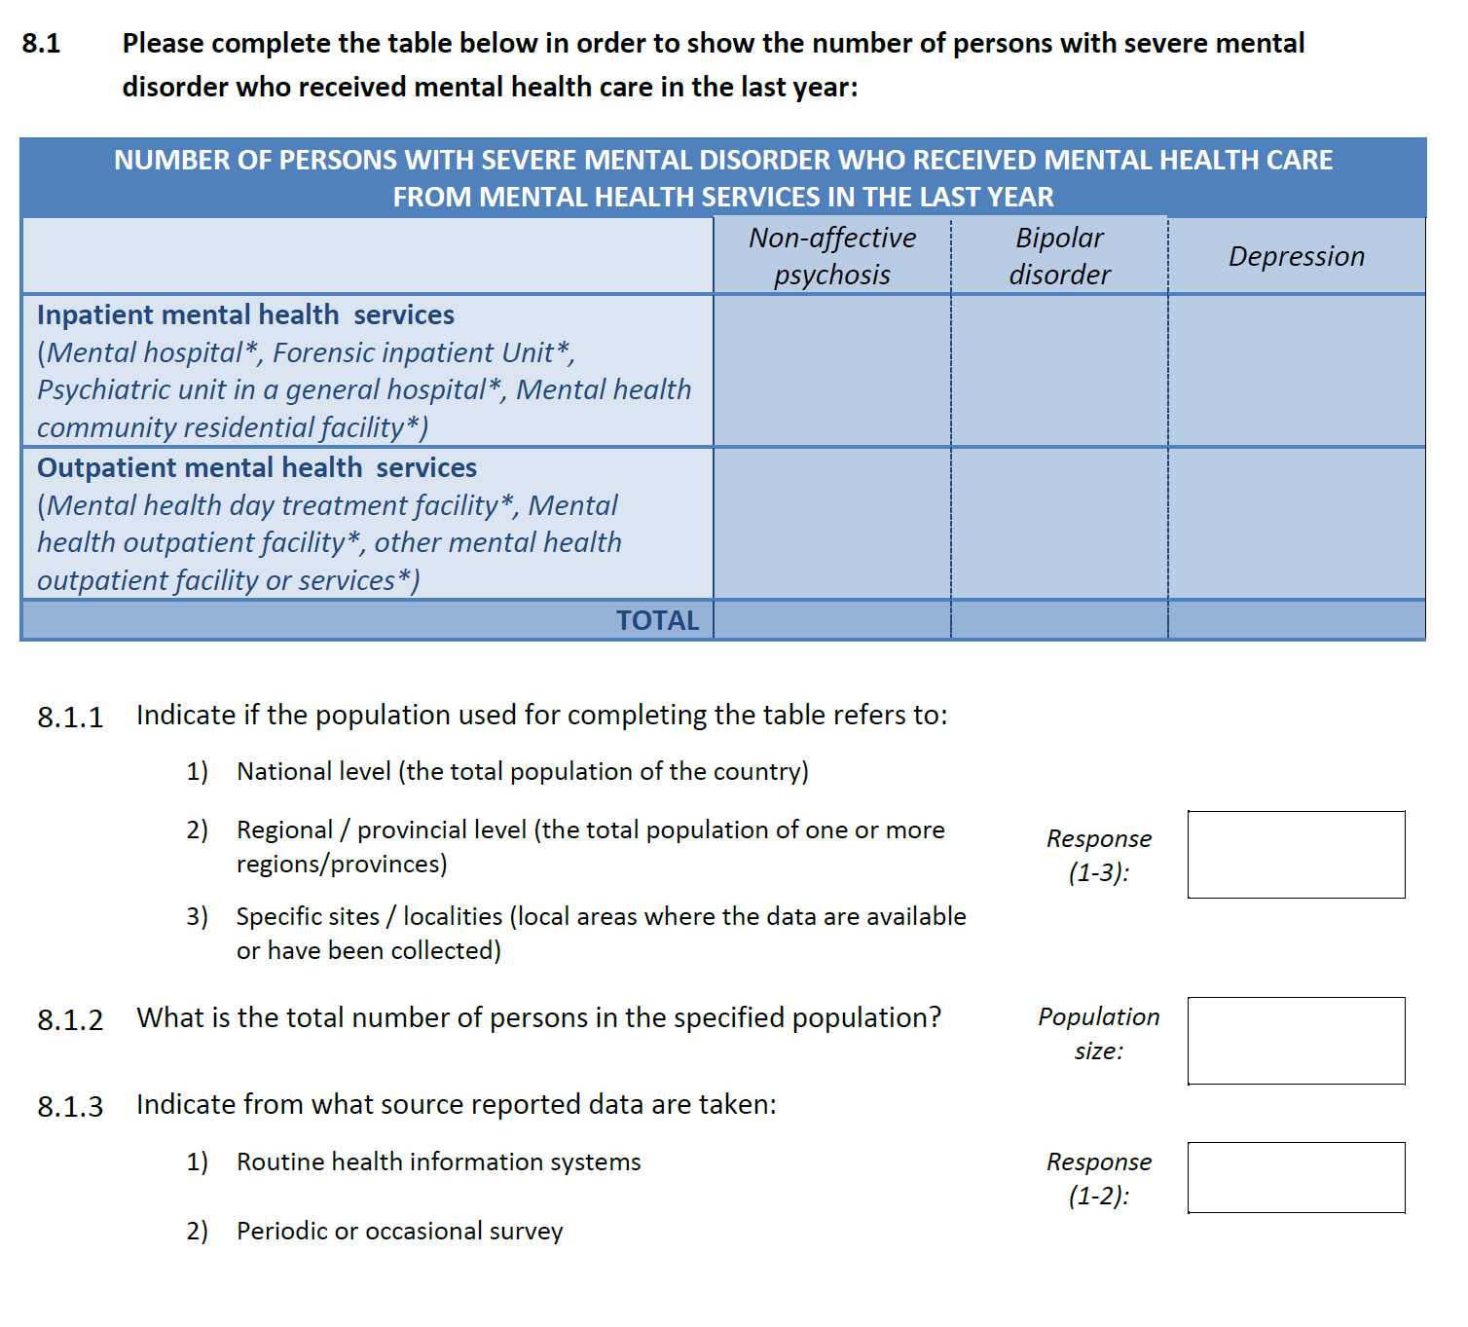
Figure S1: Section 8 of the Mental Health Atlas Questionnaire 2017

