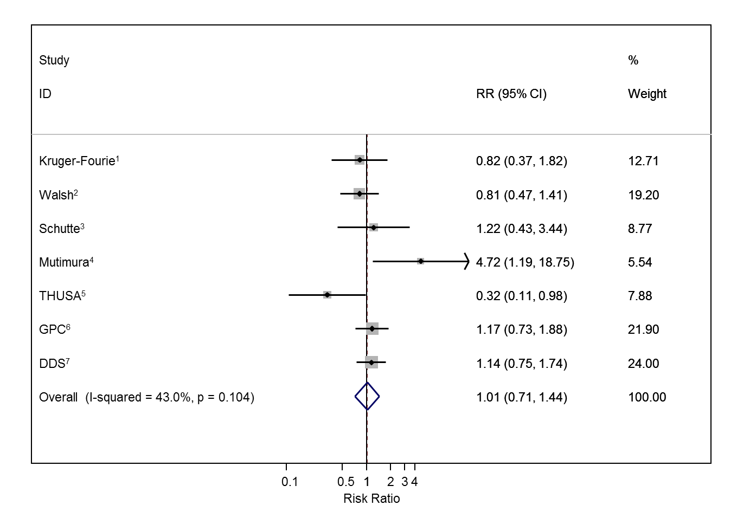
Fig S4. Association between untreated HIV infection and raised triglycerides with HIV negative individuals as the reference group

All studies adjusted for age, sex, body mass index, low-density lipoprotein, high-density lipoprotein and blood pressure; ¹Also adjusted for alcohol, lipid medication, education, glucose and glycated haemoglobin; ²Also adjusted for smoking, alcohol, education glucose and haemoglobin; ³Also adjusted for smoking, alcohol, lipid medication, education and glucose; ^{4,5}Also adjusted for smoking, alcohol, education and glucose; ⁶Also adjusted for smoking, alcohol, diet, physical activity, cholesterol treatment, socio-economic position and glycated haemoglobin; ⁷Also adjusted for smoking, alcohol, physical activity, occupation, education, socio-economic position, glucose and glycated haemoglobin; RR=Risk Ratio comparing untreated HIV positive individuals with untreated HIV negative individuals.

