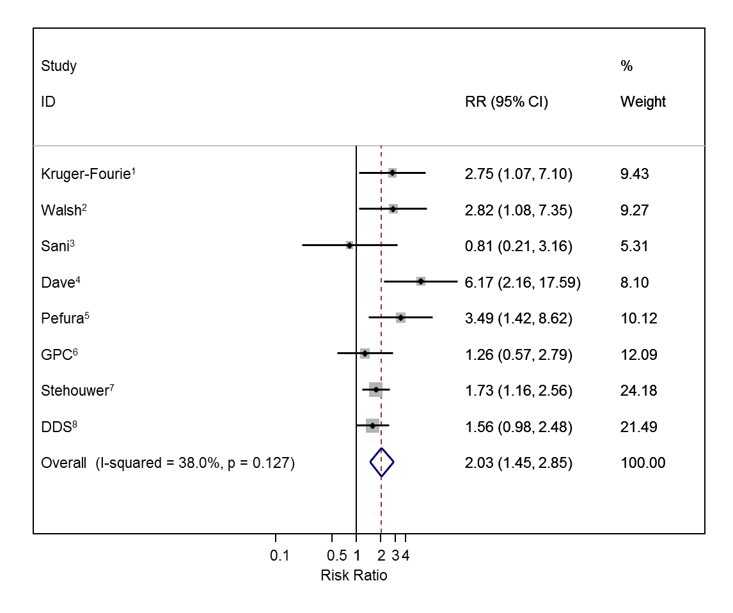
Fig S3. Association between antiretroviral therapy and raised triglycerides with untreated HIV positive individuals as the reference group

All studies adjusted for age, sex and body mass index; ¹Also adjusted for low-density lipoprotein, high-density lipoprotein, blood pressure, alcohol, lipid medication, education, glucose and glycated haemoglobin; ²Also adjusted for low-density lipoprotein, high-density lipoprotein, blood pressure, smoking, alcohol, education glucose and glycated haemoglobin; ³Also adjusted for low-density lipoprotein, high-density lipoprotein, blood pressure, smoking, alcohol, lipid medication, education and glucose; ^{4,5}Also adjusted for low-density lipoprotein, high-density lipoprotein, blood pressure, smoking, alcohol, education and glucose; ⁶Also adjusted for low-density lipoprotein, high-density lipoprotein, blood pressure, smoking, alcohol, diet, physical activity, cholesterol treatment, socio-economic position and glycated haemoglobin; ⁷Made no further adjustments; ⁸Also adjusted for low-density lipoprotein, high-density lipoprotein, blood pressure, physical activity, occupation, education, socio-economic position, glucose and glycated haemoglobin; RR=Risk Ratio comparing antiretroviral therapy users with untreated HIV positive individuals.

