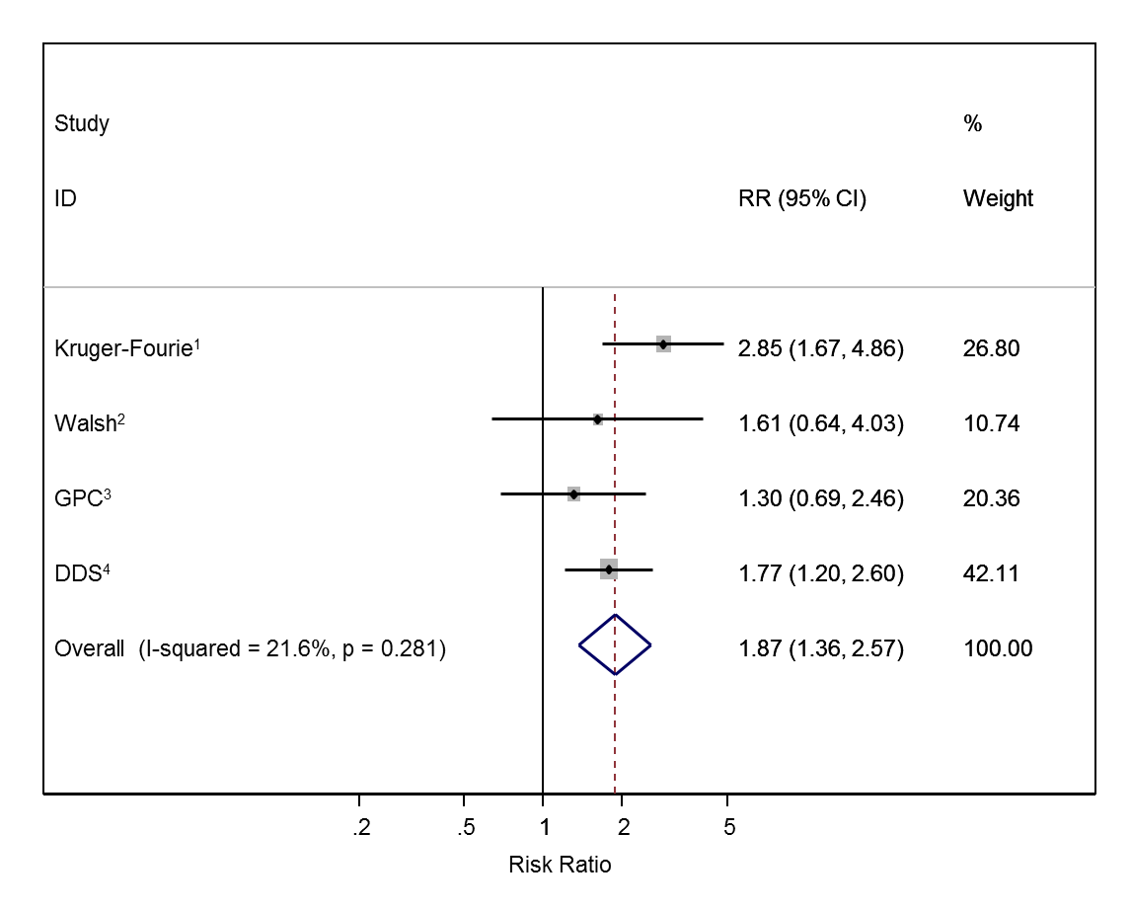
Fig S2. Association between antiretroviral therapy and raised triglycerides with HIV negative individuals as the reference group

All studies adjusted for age, sex, body mass index, low-density lipoprotein, high-density lipoprotein, blood pressure and glycated haemoglobin. ¹Also adjusted for alcohol, lipid medication, education and glucose; ²Also adjusted for smoking, alcohol, education and glucose; ³Also adjusted for smoking, alcohol, diet, physical activity, cholesterol treatment and socio-economic position; ⁴Also adjusted for smoking, alcohol, physical activity, occupation, education, socio-economic position and glucose; RR=Risk Ratio comparing antiretroviral therapy users with HIV negative individuals

