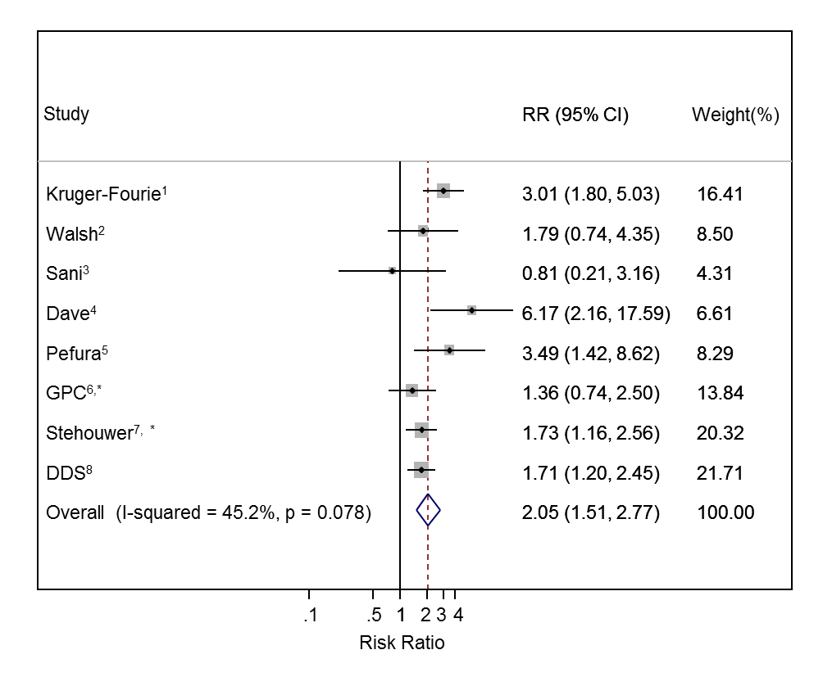
All studies adjusted for age, sex, body mass index, low-density lipoprotein, high-density lipoprotein and blood pressure. ¹Also adjusted for alcohol, lipid medication, education, glucose and glycated haemoglobin; ²Also adjusted for smoking, alcohol, education, glucose and glycated haemoglobin; ³Also adjusted smoking, alcohol, lipid medication, education and glucose; ^{4,5}Also adjusted for smoking, alcohol, education and glucose; ⁶Also adjusted for smoking, alcohol, diet, physical activity, cholesterol treatment, socio-economic position and glycated haemoglobin; ⁷Made no further adjustments; ⁸Also adjusted for smoking, alcohol, physical activity, occupation, education, socio-economic position and glucose; *Nonfasting samples; RR=Risk ratio comparing antiretroviral therapy users to antiretroviral therapy non-users.

Fig S1. Association between antiretroviral therapy and raised triglycerides with individuals not on antiretroviral therapy (untreated HIV positive or untreated HIV positive and HIV negative combined) as the reference group

