Figure 2: Section specific median competence score (%) of the 1st ANMs in detection & management of common syndromic conditions - diarrhoea, ARI, fever & malaria: Cross-sectional study of competency among peripheral health workers, North 24 Parganas district, West Bengal, India, 2016
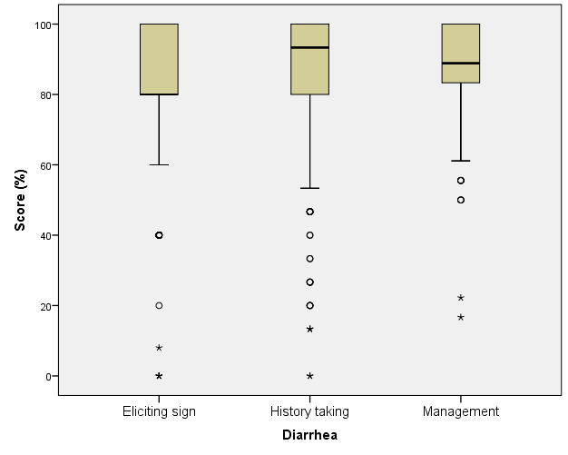 | 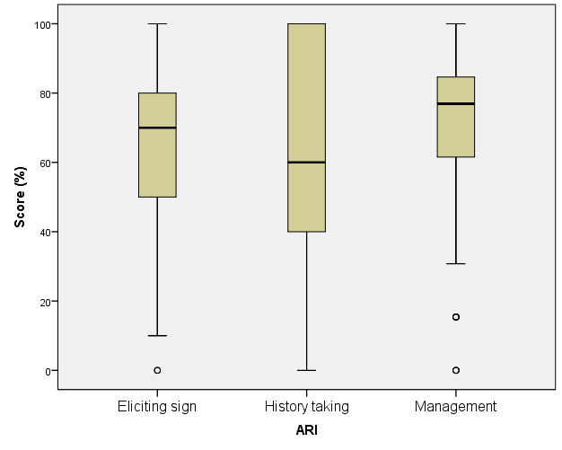
Diarrhoea | ARI
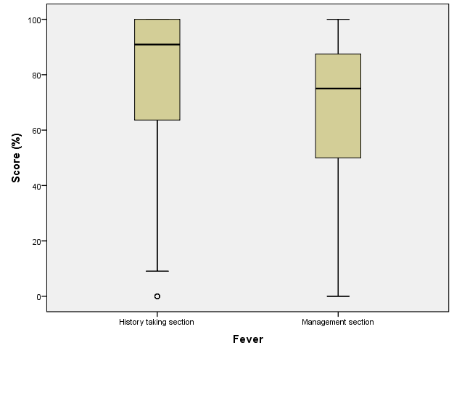 | 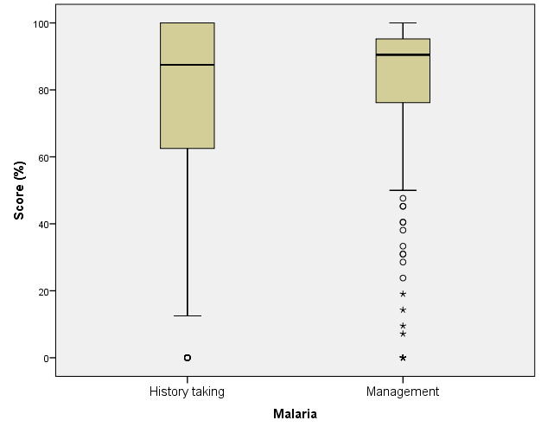
Fever | Malaria

