Appendix C: Supplementary Material

Gendered Fertility Intentions and Child Schooling: Insights on the Quantity-Quality Trade-off from Ethiopia

Eva Boonaert*, Kaat Van Hoyweghen, Ashenafi Duguma Feyisa, Peter Goos, Miet Maertens
⁎ Corresponding author. E-mail address: eva.boonaert@kuleuven.be. Telephone number: +3216194986. Correspondence to: Celestijnenlaan 200E bus 2411, 3001 Leuven, Belgium.

Table C1: Experimental design of the DCE
 |  |  |  |  |  | Option A |  |  |  |  |  |  |  |  |  |  |  |  | Option B
Block | Set | a | x₁ |  | x₁₁ |  | x₁₂ | x₁₃ | x₁₄ | x₂ | x₂₁ | x₂₂ | x₂₃ | x₂₄ | a | x₁ |  | x₁₁ |  | x₁₂ | x₁₃ | x₁₄ | x₂ | x₂₁ | x₂₂ | x₂₃ | x₂₄
1 | 1 | 1 | 0 |  | 0 |  | 0 | 0 | 0 | 1 | 0 | 0 | 1 | 0 | 3 | 3 |  | 1 |  | 2 | 0 | 0 | 0 | 0 | 0 | 0 | 0
 | 2 | 1 | 1 |  | 0 |  | 0 | 1 | 0 | 0 | 0 | 0 | 0 | 0 | 4 | 1 |  | 0 |  | 0 | 1 | 0 | 3 | 0 | 0 | 1 | 2
 | 3 | 3 | 0 |  | 0 |  | 0 | 0 | 0 | 3 | 1 | 0 | 2 | 0 | 3 | 0 |  | 0 |  | 0 | 0 | 0 | 3 | 0 | 2 | 1 | 0
 | 4 | 3 | 0 |  | 0 |  | 0 | 0 | 0 | 3 | 1 | 0 | 0 | 2 | 10 | 6 |  | 0 |  | 0 | 0 | 6 | 4 | 4 | 0 | 0 | 0
 | 5 | 3 | 3 |  | 1 |  | 1 | 1 | 0 | 0 | 0 | 0 | 0 | 0 | 4 | 2 |  | 1 |  | 0 | 1 | 0 | 2 | 0 | 0 | 0 | 2
 | 6 | 2 | 0 |  | 0 |  | 0 | 0 | 0 | 2 | 0 | 0 | 1 | 1 | 8 | 6 |  | 0 |  | 0 | 0 | 6 | 2 | 2 | 0 | 0 | 0
 | 7 | 3 | 3 |  | 0 |  | 3 | 0 | 0 | 0 | 0 | 0 | 0 | 0 | 10 | 4 |  | 2 |  | 2 | 0 | 0 | 6 | 2 | 0 | 0 | 4
 | 8 | 5 | 3 |  | 1 |  | 0 | 2 | 0 | 2 | 1 | 0 | 1 | 0 | 12 | 8 |  | 4 |  | 0 | 4 | 0 | 4 | 0 | 0 | 0 | 4
 | 9 | 5 | 4 |  | 0 |  | 2 | 0 | 2 | 1 | 1 | 0 | 0 | 0 | 12 | 8 |  | 4 |  | 0 | 4 | 0 | 4 | 0 | 0 | 4 | 0
 | 10 | 5 | 4 |  | 0 |  | 0 | 2 | 2 | 1 | 0 | 0 | 1 | 0 | 5 | 4 |  | 2 |  | 2 | 0 | 0 | 1 | 0 | 1 | 0 | 0
 | 11 | 2 | 2 |  | 0 |  | 1 | 1 | 0 | 0 | 0 | 0 | 0 | 0 | 10 | 4 |  | 0 |  | 4 | 0 | 0 | 6 | 0 | 0 | 6 | 0
 | 12 | 9 | 6 |  | 3 |  | 3 | 0 | 0 | 3 | 0 | 0 | 0 | 3 | 12 | 6 |  | 2 |  | 0 | 0 | 4 | 6 | 2 | 0 | 0 | 4
2 | 1 | 5 | 1 |  | 1 |  | 0 | 0 | 0 | 4 | 1 | 3 | 0 | 0 | 5 | 4 |  | 1 |  | 0 | 0 | 3 | 1 | 1 | 0 | 0 | 0
 | 2 | 5 | 4 |  | 1 |  | 3 | 0 | 0 | 1 | 1 | 0 | 0 | 0 | 12 | 4 |  | 0 |  | 4 | 0 | 0 | 8 | 2 | 0 | 0 | 6
 | 3 | 1 | 0 |  | 0 |  | 0 | 0 | 0 | 1 | 0 | 0 | 0 | 1 | 4 | 3 |  | 0 |  | 3 | 0 | 0 | 1 | 0 | 0 | 0 | 1
 | 4 | 1 | 1 |  | 0 |  | 1 | 0 | 0 | 0 | 0 | 0 | 0 | 0 | 5 | 4 |  | 2 |  | 0 | 2 | 0 | 1 | 0 | 0 | 1 | 0
 | 5 | 10 | 6 |  | 2 |  | 0 | 4 | 0 | 4 | 0 | 0 | 0 | 4 | 3 | 0 |  | 0 |  | 0 | 0 | 0 | 3 | 1 | 1 | 1 | 0
 | 6 | 10 | 4 |  | 4 |  | 0 | 0 | 0 | 6 | 0 | 0 | 6 | 0 | 3 | 0 |  | 0 |  | 0 | 0 | 0 | 3 | 0 | 0 | 3 | 0
 | 7 | 8 | 2 |  | 0 |  | 0 | 0 | 2 | 6 | 0 | 2 | 4 | 0 | 12 | 8 |  | 0 |  | 0 | 8 | 0 | 4 | 0 | 0 | 4 | 0
 | 8 | 12 | 4 |  | 0 |  | 4 | 0 | 0 | 8 | 4 | 0 | 4 | 0 | 3 | 3 |  | 1 |  | 0 | 1 | 1 | 0 | 0 | 0 | 0 | 0
 | 9 | 3 | 2 |  | 1 |  | 0 | 0 | 1 | 1 | 0 | 0 | 0 | 1 | 12 | 4 |  | 4 |  | 0 | 0 | 0 | 8 | 0 | 4 | 0 | 4
 | 10 | 3 | 0 |  | 0 |  | 0 | 0 | 0 | 3 | 0 | 3 | 0 | 0 | 9 | 6 |  | 0 |  | 3 | 3 | 0 | 3 | 0 | 0 | 3 | 0
 | 11 | 3 | 1 |  | 0 |  | 0 | 1 | 0 | 2 | 1 | 0 | 1 | 0 | 5 | 1 |  | 1 |  | 0 | 0 | 0 | 4 | 1 | 0 | 3 | 0
 | 12 | 2 | 0 |  | 0 |  | 0 | 0 | 0 | 2 | 0 | 1 | 1 | 0 | 12 | 6 |  | 0 |  | 0 | 0 | 6 | 6 | 0 | 0 | 6 | 0
3 | 1 | 2 | 1 |  | 0 |  | 0 | 0 | 1 | 1 | 0 | 0 | 0 | 1 | 5 | 1 |  | 0 |  | 1 | 0 | 0 | 4 | 2 | 0 | 0 | 2
 | 2 | 3 | 3 |  | 1 |  | 0 | 2 | 0 | 0 | 0 | 0 | 0 | 0 | 2 | 2 |  | 0 |  | 0 | 1 | 1 | 0 | 0 | 0 | 0 | 0
 | 3 | 2 | 1 |  | 0 |  | 1 | 0 | 0 | 1 | 0 | 1 | 0 | 0 | 3 | 0 |  | 0 |  | 0 | 0 | 0 | 3 | 0 | 1 | 0 | 2
 | 4 | 3 | 0 |  | 0 |  | 0 | 0 | 0 | 3 | 1 | 0 | 1 | 1 | 5 | 2 |  | 0 |  | 2 | 0 | 0 | 3 | 2 | 0 | 1 | 0
 | 5 | 10 | 6 |  | 0 |  | 4 | 0 | 2 | 4 | 4 | 0 | 0 | 0 | 4 | 3 |  | 0 |  | 0 | 3 | 0 | 1 | 1 | 0 | 0 | 0
 | 6 | 5 | 1 |  | 1 |  | 0 | 0 | 0 | 4 | 1 | 0 | 0 | 3 | 12 | 4 |  | 0 |  | 4 | 0 | 0 | 8 | 4 | 0 | 0 | 4
 | 7 | 3 | 1 |  | 0 |  | 0 | 0 | 1 | 2 | 1 | 1 | 0 | 0 | 5 | 4 |  | 1 |  | 0 | 0 | 3 | 1 | 1 | 0 | 0 | 0
 | 8 | 3 | 0 |  | 0 |  | 0 | 0 | 0 | 3 | 1 | 2 | 0 | 0 | 5 | 3 |  | 0 |  | 1 | 2 | 0 | 2 | 2 | 0 | 0 | 0
 | 9 | 12 | 4 |  | 0 |  | 0 | 4 | 0 | 8 | 4 | 0 | 4 | 0 | 2 | 1 |  | 0 |  | 0 | 1 | 0 | 1 | 0 | 1 | 0 | 0
 | 10 | 5 | 1 |  | 0 |  | 0 | 1 | 0 | 4 | 2 | 2 | 0 | 0 | 12 | 4 |  | 4 |  | 0 | 0 | 0 | 8 | 0 | 0 | 4 | 4
 | 11 | 5 | 2 |  | 1 |  | 0 | 0 | 1 | 3 | 1 | 2 | 0 | 0 | 12 | 8 |  | 0 |  | 0 | 8 | 0 | 4 | 0 | 0 | 0 | 4
 | 12 | 2 | 1 |  | 0 |  | 1 | 0 | 0 | 1 | 0 | 0 | 0 | 1 | 9 | 6 |  | 0 |  | 0 | 0 | 6 | 3 | 0 | 0 | 0 | 3
4 | 1 | 10 | 4 |  | 0 |  | 4 | 0 | 0 | 6 | 2 | 0 | 4 | 0 | 5 | 2 |  | 2 |  | 0 | 0 | 0 | 3 | 0 | 0 | 0 | 3
 | 2 | 2 | 1 |  | 0 |  | 0 | 1 | 0 | 1 | 0 | 0 | 0 | 1 | 12 | 4 |  | 0 |  | 0 | 0 | 4 | 8 | 4 | 0 | 0 | 4
 | 3 | 1 | 1 |  | 0 |  | 0 | 0 | 1 | 0 | 0 | 0 | 0 | 0 | 12 | 4 |  | 0 |  | 0 | 0 | 4 | 8 | 0 | 8 | 0 | 0
 | 4 | 3 | 0 |  | 0 |  | 0 | 0 | 0 | 3 | 1 | 1 | 0 | 1 | 8 | 6 |  | 0 |  | 6 | 0 | 0 | 2 | 2 | 0 | 0 | 0
 | 5 | 10 | 6 |  | 4 |  | 0 | 0 | 2 | 4 | 0 | 4 | 0 | 0 | 3 | 1 |  | 0 |  | 0 | 1 | 0 | 2 | 1 | 0 | 0 | 1
 | 6 | 5 | 1 |  | 1 |  | 0 | 0 | 0 | 4 | 0 | 0 | 4 | 0 | 5 | 4 |  | 2 |  | 0 | 0 | 2 | 1 | 0 | 0 | 1 | 0
 | 7 | 10 | 6 |  | 4 |  | 0 | 0 | 2 | 4 | 0 | 0 | 0 | 4 | 12 | 8 |  | 2 |  | 0 | 0 | 6 | 4 | 0 | 4 | 0 | 0
 | 8 | 9 | 6 |  | 3 |  | 0 | 3 | 0 | 3 | 0 | 3 | 0 | 0 | 4 | 2 |  | 0 |  | 2 | 0 | 0 | 2 | 0 | 0 | 2 | 0
 | 9 | 8 | 2 |  | 0 |  | 2 | 0 | 0 | 6 | 0 | 4 | 0 | 2 | 12 | 4 |  | 0 |  | 0 | 0 | 4 | 8 | 4 | 0 | 4 | 0
 | 10 | 8 | 4 |  | 2 |  | 2 | 0 | 0 | 4 | 0 | 4 | 0 | 0 | 5 | 4 |  | 2 |  | 2 | 0 | 0 | 1 | 0 | 0 | 1 | 0
 | 11 | 3 | 1 |  | 0 |  | 1 | 0 | 0 | 2 | 1 | 1 | 0 | 0 | 12 | 4 |  | 0 |  | 0 | 4 | 0 | 8 | 4 | 4 | 0 | 0
 | 12 | 12 | 4 |  | 4 |  | 0 | 0 | 0 | 8 | 0 | 4 | 4 | 0 | 9 | 6 |  | 0 |  | 0 | 3 | 3 | 3 | 3 | 0 | 0 | 0
5 | 1 | 5 | 2 |  | 2 |  | 0 | 0 | 0 | 3 | 0 | 3 | 0 | 0 | 12 | 8 |  | 0 |  | 4 | 4 | 0 | 4 | 4 | 0 | 0 | 0
 | 2 | 12 | 8 |  | 0 |  | 0 | 4 | 4 | 4 | 4 | 0 | 0 | 0 | 5 | 1 |  | 0 |  | 0 | 0 | 1 | 4 | 2 | 0 | 2 | 0
 | 3 | 1 | 0 |  | 0 |  | 0 | 0 | 0 | 1 | 0 | 1 | 0 | 0 | 12 | 8 |  | 0 |  | 8 | 0 | 0 | 4 | 0 | 4 | 0 | 0
 | 4 | 5 | 3 |  | 0 |  | 3 | 0 | 0 | 2 | 2 | 0 | 0 | 0 | 2 | 2 |  | 0 |  | 1 | 0 | 1 | 0 | 0 | 0 | 0 | 0
 | 5 | 4 | 2 |  | 1 |  | 0 | 0 | 1 | 2 | 0 | 0 | 2 | 0 | 10 | 6 |  | 0 |  | 0 | 0 | 6 | 4 | 0 | 4 | 0 | 0
 | 6 | 10 | 6 |  | 2 |  | 4 | 0 | 0 | 4 | 0 | 0 | 4 | 0 | 3 | 3 |  | 1 |  | 1 | 0 | 1 | 0 | 0 | 0 | 0 | 0
 | 7 | 3 | 2 |  | 0 |  | 0 | 0 | 2 | 1 | 0 | 1 | 0 | 0 | 10 | 4 |  | 0 |  | 0 | 4 | 0 | 6 | 4 | 0 | 0 | 2
 | 8 | 3 | 3 |  | 1 |  | 0 | 0 | 2 | 0 | 0 | 0 | 0 | 0 | 5 | 4 |  | 2 |  | 0 | 2 | 0 | 1 | 0 | 0 | 0 | 1
 | 9 | 12 | 4 |  | 0 |  | 0 | 4 | 0 | 8 | 0 | 8 | 0 | 0 | 3 | 1 |  | 0 |  | 0 | 0 | 1 | 2 | 1 | 0 | 0 | 1
 | 10 | 8 | 4 |  | 0 |  | 0 | 4 | 0 | 4 | 0 | 0 | 4 | 0 | 12 | 8 |  | 4 |  | 0 | 4 | 0 | 4 | 0 | 4 | 0 | 0
 | 11 | 8 | 2 |  | 0 |  | 2 | 0 | 0 | 6 | 0 | 0 | 0 | 6 | 2 | 0 |  | 0 |  | 0 | 0 | 0 | 2 | 0 | 1 | 0 | 1
 | 12 | 5 | 1 |  | 1 |  | 0 | 0 | 0 | 4 | 1 | 0 | 3 | 0 | 5 | 4 |  | 1 |  | 0 | 3 | 0 | 1 | 1 | 0 | 0 | 0
Note: with a the amount, x₁₁-x₁₄ the number of girls attending no schooling, primary, secondary or tertiary schooling respectively and x₂₁-x₂₄ the number of boys attending no schooling, primary, secondary or tertiary schooling respectively
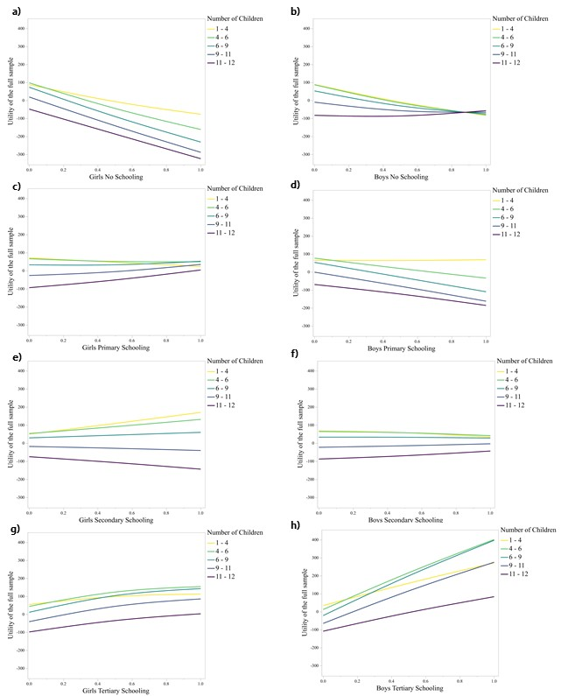
Figure C1: Visualization of the educational system in Ethiopia
Figure C2: Visualization of the MXLM parameter estimates of respondents’ utility in function of the different schooling components for different ranges of the number of children. Note: all results need to be interpreted with respect to the variable Girls No Schooling.
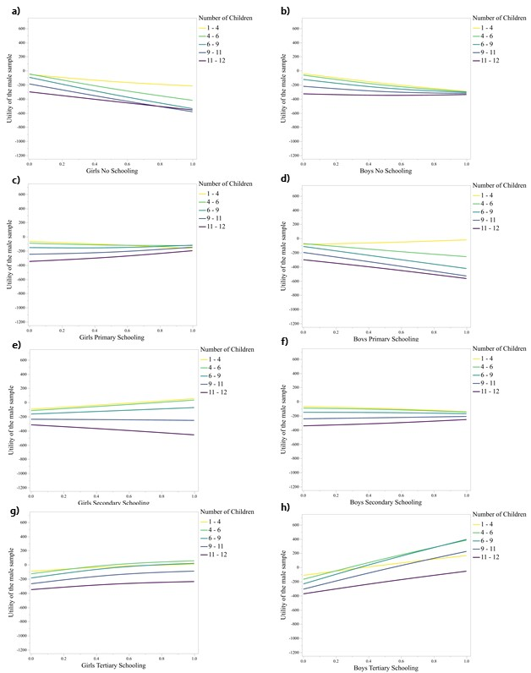
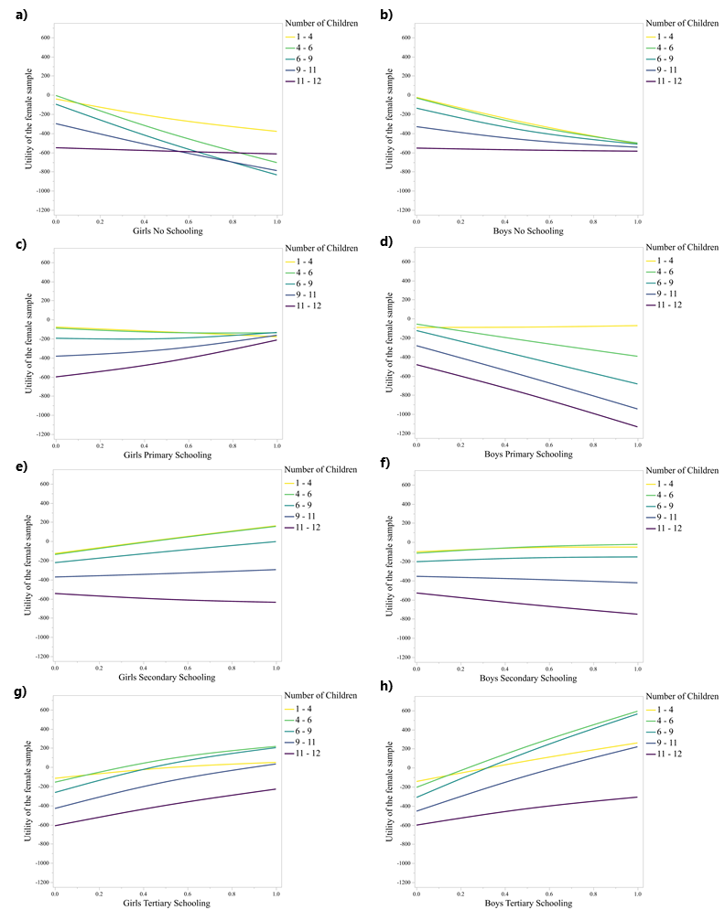
Figure C3: Visualization of the MXLM parameter estimates of male respondents’ utility in function of the different schooling components for different ranges of the number of children. Note: all results need to be interpreted with respect to the variable Girls No Schooling.
Figure C4: Visualization of the MXLM parameter estimates of female respondents’ utility in function of the different schooling components for different ranges of the number of children. Note: all results need to be interpreted with respect to the variable Girls No Schooling.

