Educational Assortative Mating and Income Inequality in Thailand

Sasiwimon Warunsiri Paweenawat, Lusi Liao
Online Appendix: Tables and Figures

Table 1A Gini coefficient in Thailand
 | 1985 | 1990 | 1995 | 2000 | 2005 | 2010 | 2015
Household income (general) | 0.448 | 0.458 | 0.463 | 0.462 | 0.488 | 0.476 | 0.415
Household income (general) per capita | 0.446 | 0.461 | 0.470 | 0.479 | 0.501 | 0.493 | 0.444
Household income (with one couple) | 0.425 | 0.422 | 0.412 | 0.426 | 0.458 | 0.448 | 0.389
Household income per capita (with one couple) | 0.468 | 0.446 | 0.446 | 0.462 | 0.496 | 0.492 | 0.435
Note: Household income (general) includes the income of all family members in the household (multiple couples may be included in one household), while household income (with one couple) includes only households under the family structure of a head of household, husband/wife, and children.
Source: Authors’ calculation

Table 2A OLS estimates of log hourly wage for married individuals
 | (1) | (2) | (3)
 | 1985-1994 | 1995-2004 | 2005-2016
Years of schooling | 0.171*** | 0.167*** | 0.151***
 | (0.001) | (0.000) | (0.000)
Potential experience | 0.082*** | 0.077*** | 0.071***
 | (0.001) | (0.001) | (0.001)
Potential experience squared | -0.001*** | -0.001*** | -0.001***
 | (0.000) | (0.000) | (0.000)
University earning premium (%) | 42.6% | 40.2% | 35.6%
Constant | 0.583*** | 0.717*** | 0.914***
 | (0.022) | (0.013) | (0.011)
Observations | 73,348 | 187,439 | 232,594
R-squared | 0.582 | 0.621 | 0.567
Standard errors in parentheses
*** p<0.01, ** p<0.05, * p<0.1

Table 3A Summary statistics for married couples aged 25-60

 | 1985-1994 |  | 1995-2004 |  | 2005-2016
 | Women | Men | Women | Men | Women | Men
Sample means:
Age | 40.2 | 44.1 | 41.5 | 45.2 | 44.7 | 48.0
University degree | 0.043 | 0.119 | 0.075 | 0.148 | 0.115 | 0.175
Secondary degree | 0.118 | 0.160 | 0.173 | 0.214 | 0.238 | 0.258
Primary degree | 0.839 | 0.722 | 0.752 | 0.638 | 0.647 | 0.567
Annual income (Baht) | 107,494 | 132,345 | 131,922 | 155,225 | 150,033 | 167,207
Labor force Participation rate | 0.772 | 0.971 | 0.769 | 0.965 | 0.789 | 0.959
Observations | 31,865 | 43,962 | 95,515 | 105,144 | 149,242 | 156,447
Source: Authors’ calculation

Table 4A Marginal effects of assortative mating using SES panel
2005 |  |  |  | 2012
 | Wife |  |  |  | Wife
Husband | University | Secondary | Primary | Husband | University | Secondary | Primary
University | 0.087*** | 0.011 | -0.097*** | University | 0.142*** | -0.007 | -0.132***
 | (0.012) | (0.014) | (0.016) |  | (0.014) | (0.016) | (0.017)
Secondary | 0.004 | 0.121*** | -0.402*** | Secondary | -0.061*** | 0.181*** | -0.153***
 | (0.014) | (0.014) | (0.057) |  | (0.019) | (0.016) | (0.022)
Primary | -0.124*** | -0.148*** | 0.252*** | Primary | -0.139*** | -0.163*** | 0.268***
 | (0.015) | (0.016) | (0.018) |  | (0.017) | (0.018) | (0.018)
Standard errors in parentheses
*** p<0.01, ** p<0.05, * p<0.1

Figure 1A Household Gini coefficient based on LFS (1985-2016)
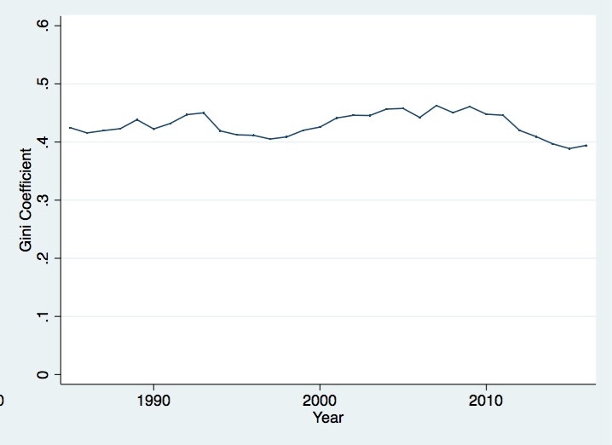
Source: Authors’ calculation

Figure 2A Proportion of couples that have the same education (overall trend)
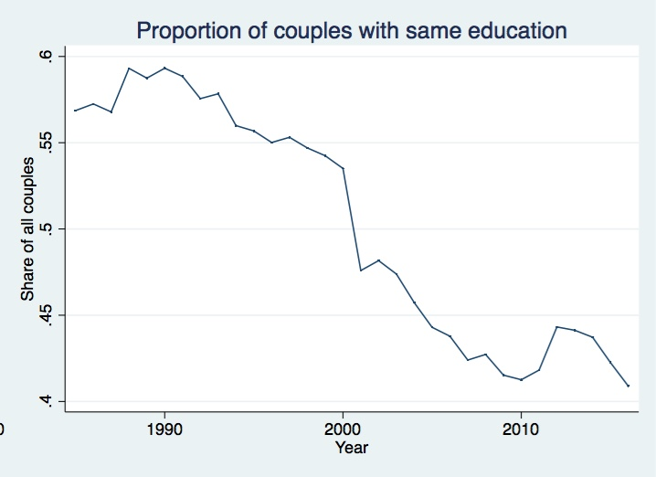
Source: Authors’ calculation

Figure 3A Proportion of couples with the same education
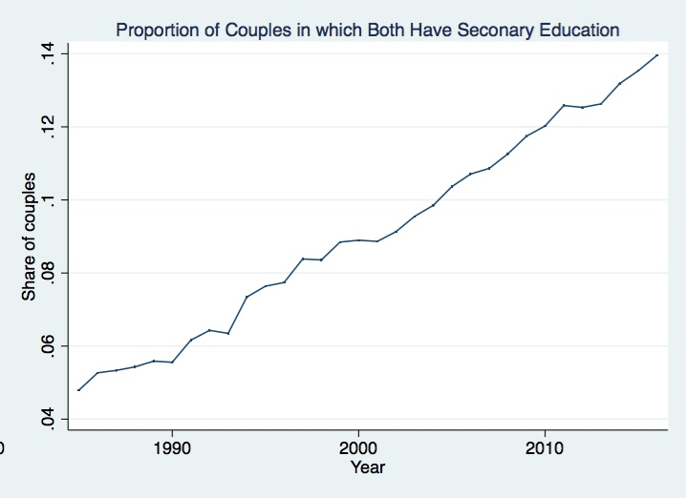
(Homogamy classified by education level)
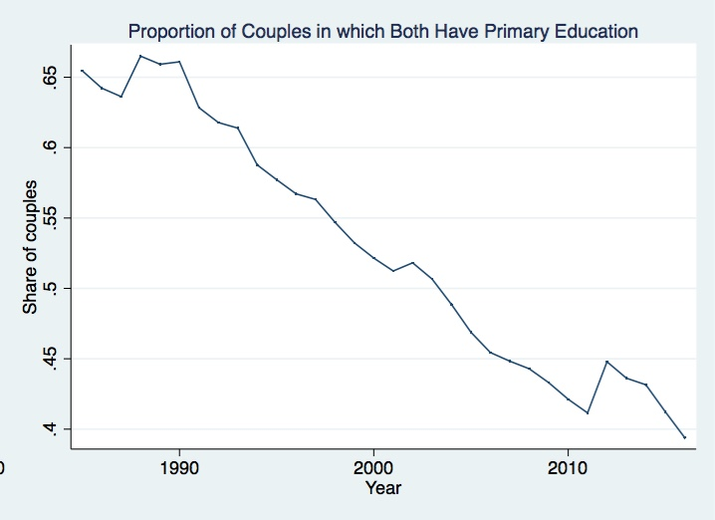
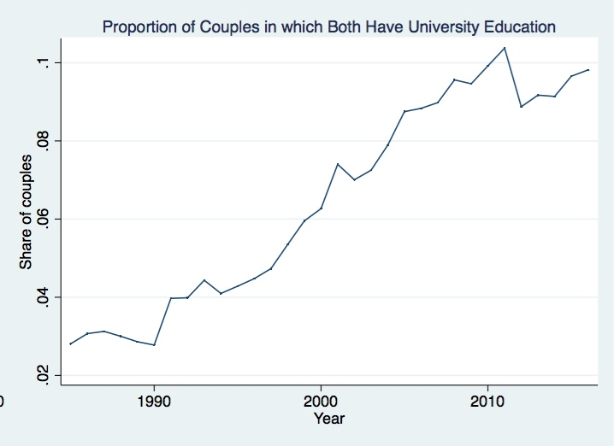

Source: Authors’ calculation

Figure 4A Trend in husbands’ and wives’ educational attainments
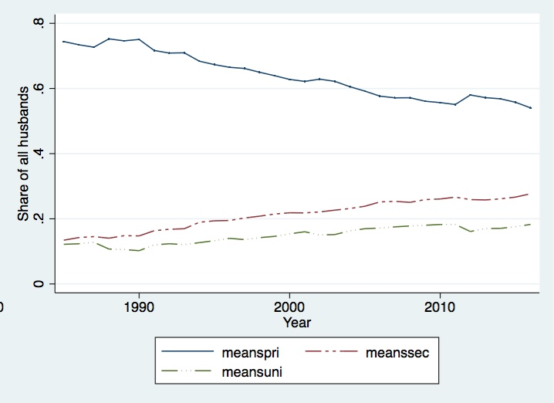
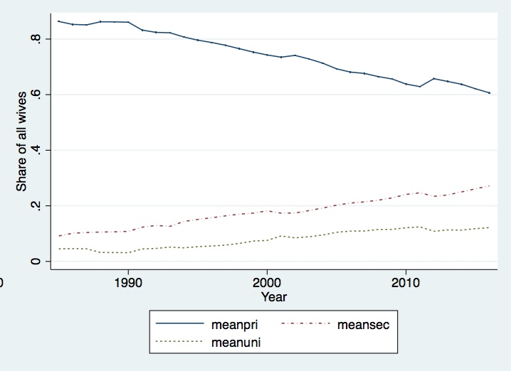
Source: Authors’ calculation

Figure 5A Average labor participation rate for married women (1985-2016)
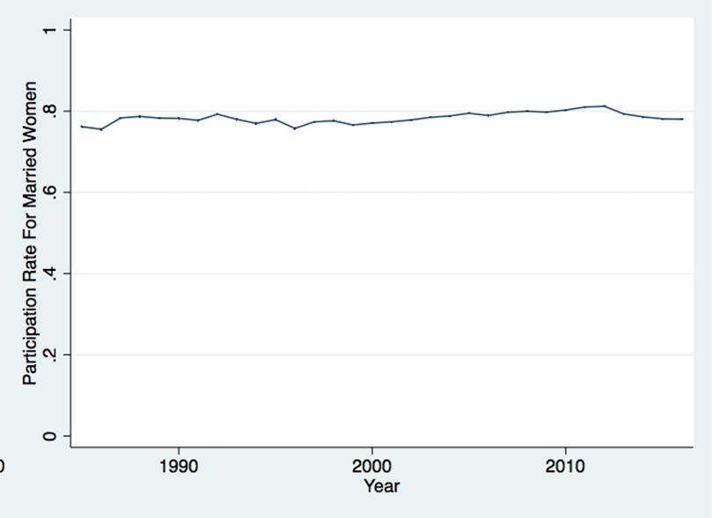
Source: Authors’ calculation

Figure 6A Income of wives as a share of household income (1985-2016)
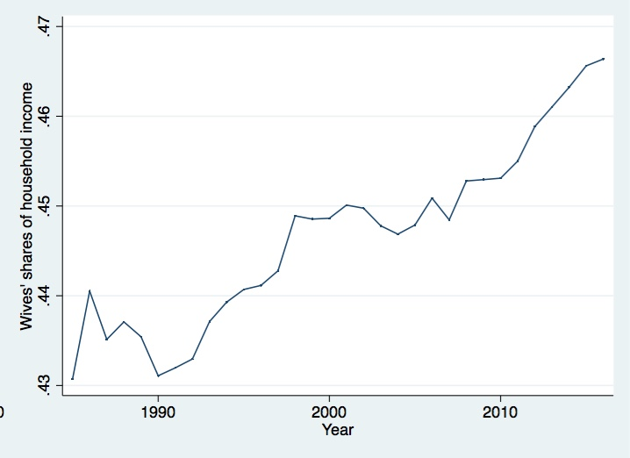
Source: Authors’ calculation

