Annex A

Table A 1: Immigration in Italy in 2006
 | Immigrants  (rate wrt native population) |  |  | Of which…
 |  | High skilled | Low skilled |  | Male |  | Female |  | Romania
Italy | 0.046 | 0.104 | 0.795 |  | 0.432 |  | 0.568 |  | 0.098
By Macroarea
North West | 0.057 | 0.117 | 0.762 |  | 0.460 |  | 0.540 |  | 0.134
Nort East | 0.069 | 0.088 | 0.824 |  | 0.424 |  | 0.576 |  | 0.073
Centre | 0.055 | 0.113 | 0.779 |  | 0.419 |  | 0.581 |  | 0.145
South | 0.030 | 0.102 | 0.810 |  | 0.412 |  | 0.588 |  | 0.054
Islands | 0.018 | 0.088 | 0.831 |  | 0.432 |  | 0.568 |  | 0.028
By Sector
Agriculture | 0.060 | 0.033 | 0.967 |  | 0.514 |  | 0.486 |  | 0.137
Natural Resources | 0.033 | . | 1.000 |  | 1.000 |  | . |  | .
Manufacturing | 0.083 | 0.082 | 0.918 |  | 0.766 |  | 0.234 |  | 0.075
Constructions | 0.106 | 0.005 | 0.995 |  | 0.977 |  | 0.023 |  | 0.281
Retail Trade | 0.057 | 0.072 | 0.928 |  | 0.640 |  | 0.360 |  | 0.091
Hotels and Restaurants | 0.122 | 0.078 | 0.922 |  | 0.448 |  | 0.552 |  | 0.135
Transports | 0.070 | 0.125 | 0.875 |  | 0.864 |  | 0.136 |  | 0.090
Finance | 0.018 | 0.248 | 0.752 |  | 0.434 |  | 0.566 |  | 0.035
Services | 0.055 | 0.200 | 0.800 |  | 0.392 |  | 0.608 |  | 0.105
Public Sector | 0.030 | 0.219 | 0.781 |  | 0.490 |  | 0.510 |  | 0.027
Health | 0.041 | 0.491 | 0.509 |  | 0.181 |  | 0.819 |  | 0.087
Personal Services | 0.191 | 0.094 | 0.906 |  | 0.179 |  | 0.821 |  | 0.139
Notes: authors’ elaboration on Istat data.

Table A 2: Immigration in Italy in 2007
 | Immigrants  (rate wrt native population) |  |  | Of which…
 |  | High-skilled | Low-skilled |  | Male |  | Female |  | Romania
Italy | 0.060 | 0.092 | 0.811 |  | 0.440 |  | 0.560 |  | 0.113
By Macroarea
North West | 0.078 | 0.089 | 0.818 |  | 0.419 |  | 0.581 |  | 0.127
Nort East | 0.091 | 0.081 | 0.801 |  | 0.458 |  | 0.542 |  | 0.094
Centre | 0.068 | 0.117 | 0.800 |  | 0.443 |  | 0.557 |  | 0.194
South | 0.035 | 0.106 | 0.809 |  | 0.427 |  | 0.573 |  | 0.054
Islands | 0.024 | 0.040 | 0.864 |  | 0.501 |  | 0.499 |  | 0.041
By Sector
Agriculture | 0.070 | 0.018 | 0.982 |  | 0.770 |  | 0.230 |  | 0.124
Natural Resources | 0.024 | 0.147 | 0.853 |  | 0.853 |  | 0.147 |  | 0.147
Manufacturing | 0.108 | 0.057 | 0.943 |  | 0.760 |  | 0.240 |  | 0.097
Constructions | 0.152 | 0.042 | 0.958 |  | 0.988 |  | 0.012 |  | 0.239
Retail Trade | 0.068 | 0.091 | 0.909 |  | 0.588 |  | 0.412 |  | 0.056
Hotels and Restaurants | 0.147 | 0.146 | 0.854 |  | 0.379 |  | 0.621 |  | 0.142
Transports | 0.080 | 0.158 | 0.842 |  | 0.826 |  | 0.174 |  | 0.117
Finance | 0.045 | 0.207 | 0.793 |  | 0.355 |  | 0.645 |  | 0.021
Services | 0.075 | 0.180 | 0.820 |  | 0.411 |  | 0.589 |  | 0.136
Public Sector | 0.015 | 0.219 | 0.781 |  | 0.499 |  | 0.501 |  | .
Health | 0.038 | 0.414 | 0.586 |  | 0.163 |  | 0.837 |  | 0.117
Personal Services | 0.246 | 0.158 | 0.842 |  | 0.205 |  | 0.795 |  | 0.124
Notes: authors’ elaboration on Istat data.

Table A 3: Sample Means
 | Overall | Above  50th | Below  50th | Above  75th | Below  75th | Pre  Policy | Post  Policy
Shares (2006) | 0.002 | 0.003 | 0.000 | 0.006 | 0.000 | 0.002 | 0.002
Stock (Romania) | 462 | 857 | 67 | 1480 | 125 | 251 | 674
Flow (Romania) | 106 | 189 | 23 | 314 | 37 | 49 | 163
Births | 819 | 1 316 | 323 | 1 919 | 454 | 824 | 815
Native Women (15-49) | 20 818 | 33 134 | 8 502 | 47 658 | 11 911 | 21 091 | 20 546
Observations | 3660 | 1830 | 1830 | 912 | 2748 | 1830 | 1830
Notes: authors’ elaboration on Istat data.

Figure A 1: Shares of Immigrant Workers in Personal Service Activities by Nationality
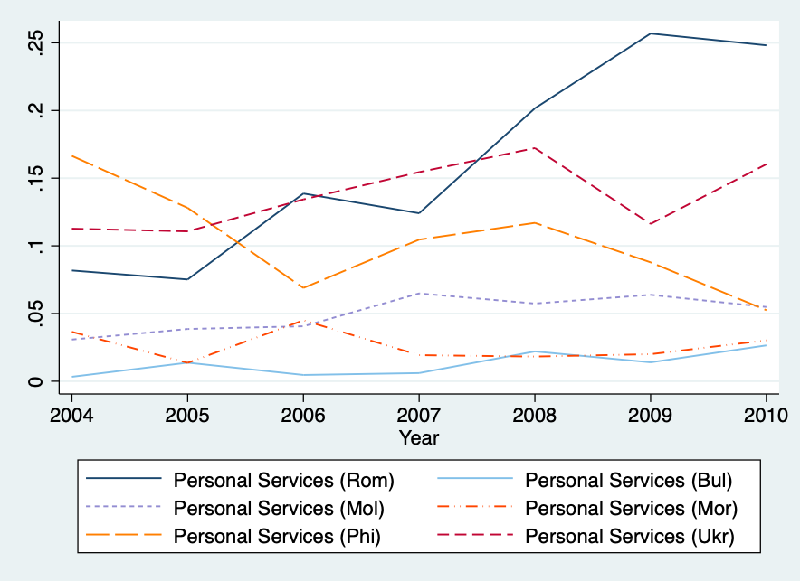
Notes: authors’ elaboration on LFS data. The graph shows the shares of immigrant workers by nationality employed in the sector of “Personal Services”. The top 5 most present nationalities in the sector are reported. Also immigrants from Bulgaria are added, since the 2007 Eu-enlargement included Romania and Bulgaria.

Table A 4: Summary Statistics (2005 - 2010)
 | Mean | St. Dev. | Min | Max
New-Born Babies | 819 | 2 318 | 13 | 32 532
Native Women (15-49) | 20 818 | 55 285 | 583 | 760 782
Fertility Rate | 0.038 | 0.005 | 0.020 | 0.068
Share of Immigrants from Romania (2006) | 0.002 | 0.008 | 0 | 0.159
Female Immigrants from Romania (Stock 2004-2006) | 126 | 895 | 0 | 27,168
Female Immigrants from Romania (Stock 2007-2009) | 386 | 2086 | 0 | 62,284
Female Immigrants from Romania (Flow 2004-2006) | 24 | 176 | -9 | 6 320
Female Immigrants from Romania (Flow 2007-2010) | 82 | 457 | -161 | 13 557
Per Capita Child-Care Services (2006) | 162.93 | 132.07 | 0 | 959.64
Per Capita Income (2006) | 8 954 | 3 117 | 3 122 | 27 136
Employment Rate (2006) | 43.49 | 7.92 | 23.1 | 63.7
Share of Native Women 15-24 | 0.224 | 0.032 | 0.154 | 0.340
Share of Native Women 25-34 | 0.277 | 0.017 | 0.206 | 0.353
Share of Native Women 35-44 | 0.339 | 0.027 | 0.264 | 0.423
Share of Native Women 44-49 | 0.160 | 0.0162 | 0.109 | 0.231
Share of Population Over 65 | 0.208 | 0.036 | 0.110 | 0.331
Observations | 3660
Notes: authors’ elaboration on Istat data. Yearly public expenditure in child-care services and per capita income are measured in Euros.

Annex B

Table B 1: Interaction Between 2006-Shares and Yearly Dummies
 | (1)
 | Births
Share (2006) * 2005 | -3,624
 | (2,418)
Share (2006) * 2006 | 2,405
 | (2,328)
Share (2006) * 2007 | 1,841
 | (3,990)
Share (2006) * 2008 | 16,333***
 | (4,557)
Share (2006) * 2009 | 9,226*
 | (5,429)
Share (2006) * 2010 | 9,094
 | (6,752)
Native Women (15-49) | 0.0562**
 | (0.0222)
Observations | 4,263
R-squared | 0.999
Controls | YES
Year FE | YES
LMA FE | YES
Notes: authors’ elaboration on Istat data. Robust standard errors are clustered at the LMA level.
* p<0.10, ** p<0.05, *** p<0.01

Table B 2: Epps-Singleton Two-Sample Empirical Characteristic Function Test
Group variable | Treatment period
Test statistic W2 | 118.376
Null hypothesis | distributions are identical
P-value | 0.000
Critical value at .10 | 7.779
Critical value at .05 | 9.488
Critical value at .01 | 13.277
Notes: Authors’ elaboration on Istat data.

Table B 3: Dickey-Fuller Test for Unit Root
 | (1) | (2) | (3) | (4)
 | Stocks | $Δ$Stocks | Births | $Δ$Births
DF Test | 121.63 | 1465.59 | 662.74 | 2082.99
P-Value | 1.00 | 0.00 | 1.00 | 0.00
Notes: authors' elaboration on Istat data. DF Test is the augmented Dickey-Fuller test (1 lags).
Annex C

Table C 1: First-Stage Regressions
 | (1) | (2)
 | Network Instrument | Distance Instrument
 | Immigrants | Immigrants
Instrument * Post | 1.63*** | -0.00***
 | (11.35) | (-4.00)
Native Women (15-49) | -0.66* | -1.00**
 | (-2.38) | (-2.68)
Child-Care Services (2006) | 0.00** | 0.01**
 | (2.65) | (3.02)
Per Capita Income (2006) | -0.33*** | -0.39***
 | (-3.54) | (-3.66)
Employment Rate (2006) | -702.65* | -1037.33**
 | (-2.56) | (-2.87)
Share of Women 15-24 | -3006.49 | -2900.93
 | (-0.91) | (-0.65)
Share of Women 25-34 | -8824.06** | -7881.48
 | (-2.65) | (-1.77)
Share of Women 35-44 | -2472.74 | -1810.85
 | (-0.61) | (-0.36)
Share of Population over 65 | -1.8e+04** | -2.3e+04**
 | (-2.80) | (-2.82)
Observations | 3654 | 3654
Notes: authors’ elaboration on Istat data. Column (1) refers to the First-stage regression of the shift-share instrument model. Column (2) refers to the First-stage regression of the distance instrument model. * p<0.10, ** p<0.05, *** p<0.01

Annex D

As a falsification test we estimate the baseline model (equation 2) with the number of female immigrants from Bulgaria as explanatory variable. As shown in Table 9, Bulgarian women did not significantly increase the number of native children after the EU-Enlargement in 2007. This is not surprisingly, since, as we have shown, after the open of the borders the newly-arrived immigrants were mostly from Romania.

Table D 1: Estimation Results of the DiD with a Continous Treatment (Immigrants from Bulgaria)
 | (1) | (2)
 | Births | Births
Female Immigrants (Bulgaria) * Post | 0.173 | 0.750*
 | (0.173) | (0.390)
Native Women (15-49) | 0.0386*** | 0.0636***
 | (0.0128) | (0.0234)
Observations | 3,517 | 3,374
R-squared | 0.191 | 0.087
Controls | YES | YES
Year FE | YES | YES
LMA FE | YES | YES
F Stat |  | 31.823
Notes: authors' elaboration on ISTAT dataset. Controls include yearly age-specific population shares, per-capita income, child-care services and the employment rate in 2006. Data on per-capita income comes from the Ministry of Finance which uses an older classification for the LMAs, so data on the per-capita income of “Corigliano-Rossano” (1845) LMA are missing. Model in column (1) refers to a DiD with a continuous treatment estimated with an OLS method. Model in column (2) refers to a DiD with a continuous treatment estimated with a 2SLS method. In particular, the instrumental variable is the shift-share instrument explained in equation (3). The reported F Statistics is the Kleinbergen-Paap rk Wald F Statistics. Robust standard errors are clustered at the LMA level. * p<0.10, ** p<0.05, *** p<0.01

Annex E

Table E 1: DiD Estimation with a Continuous Treatment by Macroarea
 | (1) | (2) | (3) | (4) | (5) | (6)
 | Baseline | North West | North East | Centre | South | Island
Flow (Rom) * Post | 0.0579*** | 0.0203** | -0.00488 | 0.107*** | 0.0187 | 0.0457
 | (0.0174) | (0.00853) | (0.00613) | (0.0167) | (0.0366) | (0.0556)
Observations | 3,654 | 636 | 714 | 630 | 1,014 | 660
R-squared | 0.061 | 0.621 | 0.920 | 0.634 | 0.752 | 0.180
Controls | YES | YES | YES | YES | YES | YES
Year FE | YES | YES | YES | YES | YES | YES
LLM FE | YES | YES | YES | YES | YES | YES
F Stat | 128.925 | 753.972 | 161.831 | 49.163 | 180.554 | 95.053
Notes: authors' elaboration on Istat dataset. Controls include the number of native women (15-49), age-specific population shares, per capita income, child-care services and the employment rate in 2006. Robust standard errors are clustered at the LMA level. * p<0.10, ** p<0.05, *** p<0.01

Table E 2: DiD Estimation with a Continuous Treatment by Year
 | (1) | (2) | (3) | (4)
 | Baseline | 2008 | 2009 | 2010
Flow (Rom) * Post | 0.0561*** | 0.0602*** | 0.0286*** | 0.0236*
 | (0.0151) | (0.0165) | (0.0104) | (0.0135)
Observations | 4,263 | 2,436 | 2,436 | 2,436
R-squared | 0.202 | 0.340 | 0.349 | 0.387
Controls | YES | YES | YES | YES
Year FE | YES | YES | YES | YES
LLM FE | YES | YES | YES | YES
F Stat | 154.516 | 631.798 | 6554.936 | 924.956
Notes: authors' elaboration on Istat dataset. Controls include the number of native women (15-49), age-specific population shares, per capita income, child-care services and the employment rate in 2006. Robust standard errors are clustered at the LMA level. * p<0.10, ** p<0.05, *** p<0.01

Table E 3: D-i-D Estimation with Continuous Treatment by Population Size
 | (1) | (2) | (3) | (4)
 | Baseline | Less 100 | Less 250 | More 250
Flow (Rom) * Post | 0.0579*** | 0.0378*** | 0.0259* | 0.0580***
 | (0.0174) | (0.0132) | (0.0144) | (0.0195)
Observations | 3,654 | 2,886 | 522 | 246
R-squared | 0.061 | 0.096 | 0.504 | 0.919
Controls | YES | YES | YES | YES
Year FE | YES | YES | YES | YES
LLM FE | YES | YES | YES | YES
F Stat | 128.925 | 453.264 | 348.988 | 95.444
Notes: authors' elaboration on Istat dataset. Controls include the number of native women (15-49), age-specific population shares, per capita income, child-care services and the employment rate in 2006. Robust standard errors are clustered at the LMA level. * p<0.10, ** p<0.05, *** p<0.01

