Supplementary Data:

Designing With Biobased Composites: Understanding Material Perception Through Semiotic Attributes

Table S 1
Uncertainty In Perception for Materials and Attribute Pairs-Percentage of Respondents Who Rated Can’t Say.
Material Sample | Perceptual Uncertainty  (Can’t Say %) | Attribute Pair | Perceptual Uncertainty  (Can’t Say %)
Cellulose + Wood | 26.37% | Hot - Cold | 42.48%
NW Sisal | 24.96% | Valuable - Worthless | 32.26%
Poplar | 24.78% | Aged - New | 31.30%
Cordenka | 24.42% | Strong - Weak | 25.74%
Leather | 24.34% | Beautiful - Ugly | 21.08%
TW Cotton | 22.39% | Interesting - Boring | 16.89%
Walnut | 21.50% | Complex - Simple | 16.65%
NW Coir | 21.15% | Unusual - Ordinary | 15.85%
TW Flax 1 | 20.62% | Natural - Artificial | 13.11%
TW Flax 2 | 19.91% | Rough - Smooth | 11.50%
UD Flax | 19.12%

Table S 2
Fraction of Positive Responses(Looks Like & Definitely) Against Each attribute
 | Aged | Complex | Interesting | Natural | Unusual | Beautiful | Valuable | Strong | Rough | Hot | New | Simple | Boring | Artificial | Ordinary | Ugly | Worthless | Weak | Smooth | Cold
Cellulose + Wood | 47% | 79% | 81% | 61% | 80% | 58% | 40% | 47% | 41% | 38% | 11% | 7% | 8% | 15% | 7% | 20% | 18% | 21% | 36% | 22%
Cordenka | 47% | 65% | 75% | 56% | 68% | 43% | 39% | 28% | 38% | 21% | 20% | 18% | 14% | 23% | 18% | 30% | 25% | 40% | 47% | 42%
Leather | 51% | 60% | 74% | 62% | 58% | 66% | 55% | 54% | 47% | 42% | 14% | 24% | 8% | 14% | 25% | 19% | 14% | 19% | 38% | 13%
NW Coir | 48% | 69% | 69% | 91% | 66% | 35% | 24% | 31% | 90% | 32% | 18% | 17% | 16% | 5% | 19% | 43% | 43% | 47% | 5% | 21%
NW Sisal | 41% | 66% | 66% | 78% | 68% | 24% | 25% | 29% | 79% | 38% | 21% | 18% | 15% | 10% | 17% | 51% | 42% | 35% | 12% | 18%
Poplar | 8% | 24% | 49% | 58% | 17% | 65% | 40% | 53% | 18% | 27% | 66% | 61% | 26% | 26% | 62% | 13% | 27% | 19% | 65% | 31%
TW Cotton | 64% | 34% | 38% | 65% | 26% | 18% | 31% | 50% | 71% | 18% | 10% | 48% | 39% | 25% | 59% | 56% | 46% | 25% | 20% | 35%
TW Flax 1 | 58% | 50% | 53% | 61% | 28% | 32% | 34% | 66% | 71% | 22% | 14% | 33% | 30% | 27% | 58% | 50% | 36% | 17% | 24% | 33%
TW Flax 2 | 35% | 44% | 54% | 69% | 17% | 47% | 43% | 63% | 74% | 27% | 35% | 42% | 27% | 26% | 67% | 33% | 29% | 20% | 17% | 34%
UD Flax | 70% | 58% | 75% | 90% | 60% | 41% | 31% | 48% | 86% | 37% | 10% | 26% | 11% | 5% | 24% | 42% | 35% | 31% | 9% | 21%
Walnut | 28% | 35% | 66% | 73% | 29% | 74% | 58% | 61% | 34% | 43% | 40% | 43% | 21% | 18% | 53% | 12% | 12% | 15% | 54% | 20%

Table S 3
Spearman's Rank Correlation Coefficients for Various Attribute Pairs (Unweighted)
 | Aged | Complex | Interesting | Natural | Unusual | Beautiful | Valuable | Strong | Rough | Hot | New | Simple | Boring | Artificial | Ordinary | Ugly | Worthless | Weak | Smooth | Cold
Aged | 1.00
Complex | 0.19 | 1.00
Interesting | 0.16 | .747** | 1.00
Natural | 0.20 | 0.18 | 0.05 | 1.00
Unusual | 0.16 | .904** | .799** | 0.10 | 1.00
Beautiful | -0.54 | -0.14 | 0.33 | -0.26 | -0.10 | 1.00
Valuable | -0.47 | -0.35 | 0.08 | -0.41 | -0.32 | .872** | 1.00
Strong | -0.06 | -.627* | -0.48 | -0.09 | -.767** | 0.31 | 0.57 | 1.00
Rough | 0.53 | 0.39 | 0.05 | .765** | 0.17 | -.647* | -.707* | -0.19 | 1.00
Hot | -0.26 | 0.32 | 0.46 | 0.40 | 0.35 | 0.58 | 0.38 | 0.04 | -0.05 | 1.00
New | -.924** | -0.29 | -0.29 | -0.12 | -0.30 | 0.45 | 0.39 | 0.15 | -0.42 | 0.17 | 1.00
Simple | -0.19 | -.998** | -.769** | -0.15 | -.906** | 0.12 | 0.33 | .633* | -0.36 | -0.29 | 0.30 | 1.00
Boring | -0.09 | -.702* | -.904** | -0.02 | -.755** | -0.39 | -0.12 | 0.49 | 0.01 | -.606* | 0.22 | .708* | 1.00
Artificial | -0.27 | -.635* | -.629* | -.668* | -.670* | 0.04 | 0.39 | 0.60 | -0.51 | -0.57 | 0.30 | .618* | .691* | 1.00
Ordinary | -0.15 | -.891** | -.765** | -0.11 | -.995** | 0.11 | 0.34 | .773** | -0.17 | -0.37 | 0.28 | .888** | .752** | .685* | 1.00
Ugly | 0.58 | 0.15 | -0.33 | 0.34 | 0.07 | -.982** | -.822** | -0.22 | .729* | -0.50 | -0.49 | -0.13 | 0.38 | -0.07 | -0.07 | 1.00
Worthless | 0.44 | 0.00 | -0.48 | 0.40 | -0.11 | -.927** | -.877** | -0.21 | .706* | -0.56 | -0.33 | 0.02 | 0.51 | -0.05 | 0.09 | .918** | 1.00
Weak | 0.27 | 0.58 | 0.34 | 0.31 | 0.57 | -0.55 | -.753** | -.870** | 0.56 | -0.27 | -0.27 | -0.59 | -0.27 | -0.57 | -0.56 | 0.51 | 0.52 | 1.00
Smooth | -0.51 | -0.41 | -0.07 | -.761** | -0.21 | .673* | .735** | 0.25 | -.989** | 0.07 | 0.44 | 0.38 | -0.01 | 0.51 | 0.21 | -.745** | -.727* | -.606* | 1.00
Cold | 0.06 | -0.30 | -0.29 | -0.53 | -0.29 | -0.31 | -0.08 | 0.01 | -0.18 | -.902** | -0.07 | 0.26 | 0.52 | .664* | 0.34 | 0.24 | 0.26 | 0.14 | 0.12 | 1.00
** Correlation is significant at the 0.01 level (2-tailed).
* Correlation is significant at the 0.05 level (2-tailed).
Note: ∎ Significant (Inverse) correlations, ∎ Significant (Negative) correlations and ∎ Significant (Positive) correlations.

Table S 4
Spearman's Rank Correlation Coefficients for Various Attribute Pairs (Weighted)
 | Aged | Complex | Interesting | Natural | Unusual | Beautiful | Valuable | Strong | Rough | Hot | New | Simple | Boring | Artificial | Ordinary | Ugly | Worthless | Weak | Smooth | Cold
Aged | 1.00
Complex | 0.21 | 1.00
Interesting | 0.24 | .717* | 1.00
Natural | -0.03 | 0.24 | 0.00 | 1.00
Unusual | 0.20 | .943** | .797** | 0.21 | 1.00
Beautiful | -0.51 | -0.12 | 0.43 | -0.29 | 0.02 | 1.00
Valuable | -0.36 | -0.32 | 0.20 | -0.51 | -0.26 | .854** | 1.00
Strong | 0.00 | -.648* | -0.33 | -0.38 | -.656* | 0.28 | .638* | 1.00
Rough | 0.53 | 0.43 | 0.02 | 0.59 | 0.23 | -.682* | -.616* | -0.25 | 1.00
Hot | -0.19 | 0.35 | .653* | 0.17 | 0.41 | 0.60 | 0.41 | -0.03 | -0.08 | 1.00
New | -.936** | -0.32 | -0.32 | -0.09 | -0.34 | 0.50 | 0.41 | 0.14 | -0.48 | 0.17 | 1.00
Simple | -0.20 | -.986** | -.781** | -0.20 | -.980** | 0.03 | 0.27 | .630* | -0.32 | -0.39 | 0.32 | 1.00
Boring | -0.09 | -.692* | -.913** | -0.07 | -.729* | -0.39 | -0.13 | 0.49 | -0.05 | -.753** | 0.17 | .726* | 1.00
Artificial | -0.36 | -.711* | -.674* | -.638* | -.736** | 0.10 | 0.37 | 0.57 | -0.56 | -0.55 | 0.44 | .711* | .715* | 1.00
Ordinary | -0.20 | -.881** | -.772** | -0.15 | -.952** | 0.03 | 0.34 | .731* | -0.14 | -0.33 | 0.35 | .932** | .740** | .683* | 1.00
Ugly | 0.60 | 0.19 | -0.32 | 0.20 | 0.08 | -.975** | -.840** | -0.32 | .679* | -0.55 | -0.55 | -0.12 | 0.30 | -0.17 | -0.12 | 1.00
Worthless | 0.42 | 0.00 | -0.51 | 0.36 | -0.12 | -.918** | -.872** | -0.30 | .627* | -0.59 | -0.39 | 0.09 | 0.45 | -0.06 | 0.10 | .870** | 1.00
Weak | 0.17 | 0.50 | 0.08 | 0.48 | 0.45 | -0.50 | -.765** | -.874** | 0.50 | -0.29 | -0.24 | -0.44 | -0.17 | -0.48 | -0.47 | 0.52 | 0.56 | 1.00
Smooth | -0.52 | -0.44 | 0.00 | -.665* | -0.25 | .718* | .671* | 0.33 | -.982** | 0.11 | 0.53 | 0.33 | 0.04 | 0.59 | 0.17 | -.697* | -.664* | -0.56 | 1.00
Cold | 0.04 | -0.41 | -0.51 | -0.17 | -0.41 | -0.30 | -0.17 | 0.02 | -0.13 | -.911** | -0.06 | 0.42 | .624* | 0.55 | 0.33 | 0.24 | 0.31 | 0.28 | 0.07 | 1.00
** Correlation is significant at the 0.01 level (2-tailed).
* Correlation is significant at the 0.05 level (2-tailed).
Note: ∎ Significant (Inverse) correlations, ∎ Significant (Negative) correlations and ∎ Significant (Positive) correlations.

Table S 5
Attributes And Respective Number of Statistically Significant Correlations Along with Percentage of Can’t Say Ratings.
Attributes  (with number of significant correlations) |  | Can’t Say  [average %, for each pair]
Rough (5) | Smooth (6) | 11.50%
Natural (2) | Artificial (7) | 13.11%
Unusual (6) | Ordinary (6) | 15.85%
Complex (6) | Simple (6) | 16.65%
Interesting (5) | Boring (6) | 16.89%
Beautiful (4) | Ugly (4) | 21.08%
Strong (4) | Weak (2) | 25.74%
Aged (0) | New (0) | 31.30%
Valuable (5) | Worthless (4) | 32.26%
Hot (1) | Cold (1) | 42.48%

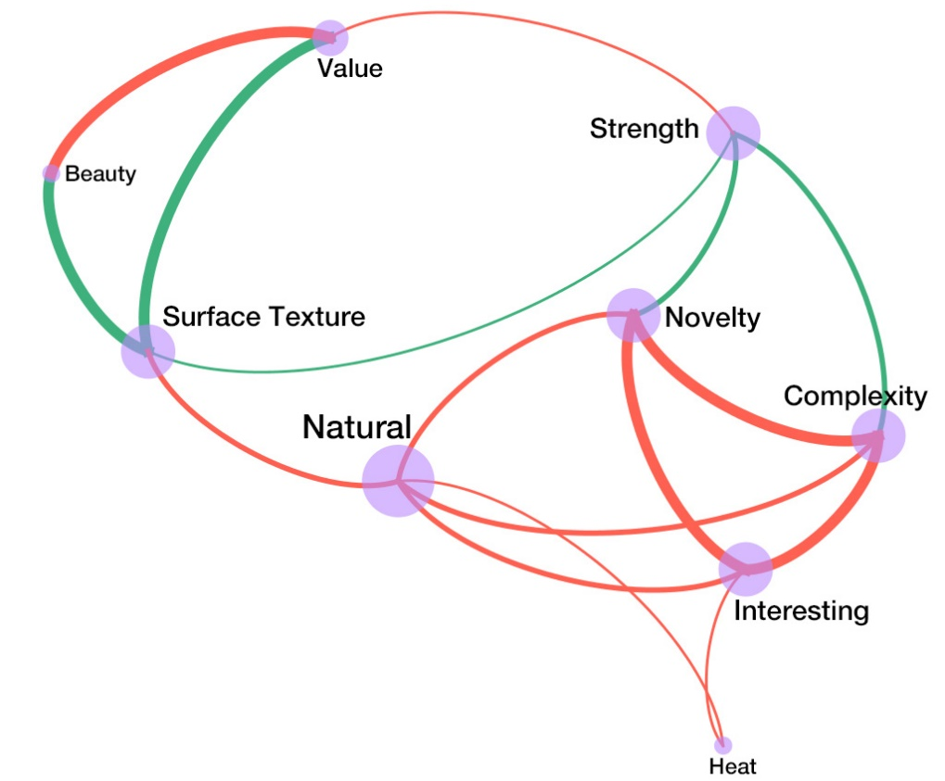
Figure S 1 Simplified Attribute Relations Developed by Combining Bipolar Adjectives

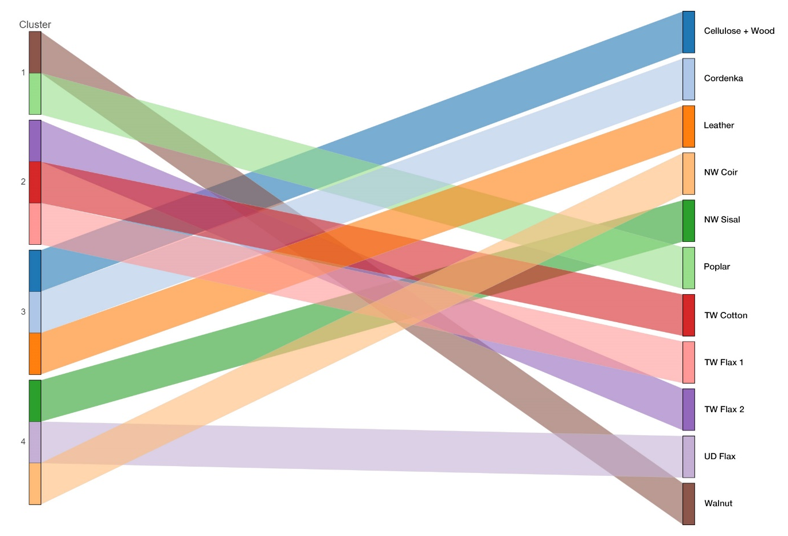
Figure S 2 Clustering of materials using k-means algorithm

Table S 6
Correlation Between Attribute Ratings Amongst Female and Male Groups
Attribute | Female- Male Correlation |  | Attribute | Female- Male Correlation
 | Correlation Coefficient | Sig. (2-tailed) |  | Correlation Coefficient | Sig. (2-tailed)
Aged | .840** | 0.001 | New | .772** | 0.005
Complex | .845** | 0.001 | Simple | .888** | 0.000
Interesting | .775** | 0.005 | Boring | .758** | 0.007
Natural | .869** | 0.001 | Artificial | .931** | 0.000
Unusual | .908** | 0.000 | Ordinary | .818** | 0.002
Beautiful | .964** | 0.000 | Ugly | .973** | 0.000
Valuable | .858** | 0.001 | Worthless | .845** | 0.001
Strong | .889** | 0.000 | Weak | .800** | 0.003
Rough | .888** | 0.000 | Smooth | .890** | 0.000
Hot | .867** | 0.001 | Cold | .748** | 0.008
**. Correlations are significant at the 0.01 level (2-tailed).

Table S 7
Correlation Between Attribute Ratings Amongst Young (<=27) And Old (>27) Age Groups
Attribute | Young - Old Correlation |  | Attribute | Young - Old Correlation
 | Correlation Coefficient | Sig. (2-tailed) |  | Correlation Coefficient | Sig. (2-tailed)
Aged | .897** | 0.000 | New | .858** | 0.001
Complex | .722* | 0.012 | Simple | .895** | 0.000
Interesting | .633* | 0.037 | Boring | .770** | 0.006
Natural | .644* | 0.033 | Artificial | 0.602 | 0.050
Unusual | .827** | 0.002 | Ordinary | .795** | 0.003
Beautiful | .906** | 0.000 | Ugly | .805** | 0.003
Valuable | .753** | 0.007 | Worthless | .697* | 0.017
Strong | .802** | 0.003 | Weak | .737** | 0.010
Rough | .920** | 0.000 | Smooth | .973** | 0.000
Hot | .762** | 0.006 | Cold | 0.599 | 0.052
**. Correlation is significant at the 0.01 level (2-tailed).
*. Correlation is significant at the 0.05 level (2-tailed).

Table S 8
Correlation Between Attribute Ratings Amongst ESBBC And General Participant Groups
Attribute | ESBBC-General Correlation |  | Attribute | ESBBC-General Correlation
 | Correlation Coefficient | Sig. (2-tailed) |  | Correlation Coefficient | Sig. (2-tailed)
Aged | .918** | 0.000 | New | .920** | 0.000
Complex | .947** | 0.000 | Simple | .890** | 0.000
Interesting | .713* | 0.014 | Boring | .917** | 0.000
Natural | .726* | 0.011 | Artificial | .628* | 0.038
Unusual | .895** | 0.000 | Ordinary | .934** | 0.000
Beautiful | .740** | 0.009 | Ugly | .784** | 0.004
Valuable | 0.469 | 0.146 | Worthless | 0.543 | 0.085
Strong | .640* | 0.034 | Weak | .606* | 0.048
Rough | .936** | 0.000 | Smooth | .964** | 0.000
Hot | .609* | 0.047 | Cold | .716* | 0.013
**. Correlation is significant at the 0.01 level (2-tailed).
*. Correlation is significant at the 0.05 level (2-tailed).

