Measuring Virtuous Responses to Peer Disagreement: The Intellectual Humility and Actively Open-Minded Thinking of Conciliationists
James R. Beebe (University at Buffalo, jbeebe2@buffalo.edu)
Jonathan Matheson (University of North Florida, j.matheson@unf.edu)

Supplementary Materials

Scales Used in Study 1

Comprehensive Intellectual Humility Scale (CIHS) (Krumrei-Mancuso & Rouse, 2016)
Instructions: Please indicate the extent to which you agree or disagree with the following statements.
Answer choices:
Strongly Disagree
Disagree
Slightly Disagree
Neither Agree nor Disagree
Slightly Agree
Agree
Strongly Agree
Factor 1: Independence of intellect and ego
- I feel small when others disagree with me on topics that are close to my heart.^{R}
- When someone contradicts my most important beliefs, it feels like a personal attack.^{R}
- When someone disagrees with ideas that are important to me, it feels as though I’m being attacked.^{R}
- I tend to feel threatened when others disagree with me on topics that are close to my heart.^{R}
- When someone disagrees with ideas that are important to me, it makes me feel insignificant.^{R}
Factor 2: Openness to revising one’s viewpoint
- I am open to revising my important beliefs in the face of new information.
- I am willing to change my position on an important issue in the face of good reasons.
- I am willing to change my opinions on the basis of compelling reason.
- I have at times changed opinions that were important to me, when someone showed me I was wrong.
- I’m willing to change my mind once it’s made up about an important topic.
Factor 3: Respect for others’ viewpoints
- I can respect others, even if I disagree with them in important ways.
- I can have great respect for someone, even when we don’t see eye-to-eye on important topics.
- Even when I disagree with others, I can recognize that they have sound points.
- I am willing to hear others out, even if I disagree with them.
- I welcome different ways of thinking about important topics.
- I respect that there are ways of making important decisions that are different from the way I make decisions.
Factor 4: Lack of intellectual overconfidence
- My ideas are usually better than other people’s ideas.^{R}
- For the most part, others have more to learn from me than I have to learn from them.^{R}
- When I am really confident in a belief, there is very little chance that belief is wrong.^{R}
- On important topics, I am not likely to be swayed by the viewpoints of others.^{R}
- I’d rather rely on my own knowledge about most topics than turn to others for expertise.^{R}
- Listening to perspectives of others seldom changes my important opinions.^{R}
^{R} Reverse-scored item

The General Intellectual Humility Scale (GIHS) (Leary et al., 2017)
Instructions: Please indicate the extent to which the following qualities describe you.
Answer choices:
Not at all true or characteristic of me
Slightly true or characteristic of me
Moderately true or characteristic of me
Very true or characteristic of me
Extremely true or characteristic of me
- I question my own opinions, positions, and viewpoints because they could be wrong.
- I reconsider my opinions when presented with new evidence.
- I recognize the value in opinions that are different from my own.
- I accept that my beliefs and attitudes may be wrong.
- In the face of conflicting evidence, I am open to changing my opinions.
- I like finding out new information that differs from what I already think is true.

The Limitations-Owning Intellectual Humility Scale (L-OIHS) (Haggard et al., 2018)
Instructions: Please indicate the extent to which you agree or disagree with the following statements.
Answer choices:
Strongly Disagree
Disagree
Slightly Disagree
Neither Agree nor Disagree
Slightly Agree
Agree
Strongly Agree
Factor 1: Love of learning
- If I don’t understand something, I try to get clear about what exactly is confusing to me.
- When I don’t understand something, I try hard to figure it out.
- I love learning.
- I care about truth.
Factor 2: Appropriate discomfort with limitations
- I focus on my intellectual weaknesses too much.^{R}
- When I know that I have an intellectual weakness in one area, I tend to doubt my intellectual abilities in other areas as well.^{R}
- When I think about the limitations of what I know, I feel uncomfortable.^{R}
- I tend to get defensive about my intellectual limitations and weaknesses.^{R}
Factor 3: Owning intellectual limitations
- I have a hard time admitting when one of my beliefs is mistaken.^{R}
- When someone points out a mistake in my thinking, I am quick to admit that I was wrong.
- I am quick to acknowledge my intellectual limitations.
- I feel comfortable admitting my intellectual limitations.
^{R} Reverse-scored item

Woodard Pury Courage Scale-23 (Woodard & Pury, 2007)
Instructions: Listed below are some situations for you to consider. Once you have read an item, please check the box that indicates your level of agreement with that item.
Answer choices:
Strongly Disagree
Disagree
Neutral
Agree
Strongly Agree
- I would accept an important project at my place of employment even though it would bring intense public criticism and publicity.
- If it looked like someone would get badly hurt, I would intervene directly in a dangerous domestic dispute.
- I could approach someone whose family members had just been killed, knowing they were feeling overwhelming grief.
- I would risk rejection by important others for a chance at achieving my life goals.
- If called upon during times of national emergency, I would give my life for my country.
- I am able to participate in intense conflict in a work environment for the right cause.
- I would talk to my supervisor about a raise if I really needed one.
- I would go to the dentist and have painful surgery if it meant saving a tooth.
- I would risk my life if it meant lasting world peace.
- Intense social pressure would not stop me from doing the right thing.
- I would refuse the order of a commanding officer if it meant hurting someone needlessly.
- I could do without the absolute necessities of life if there were others in greater need.
- I would confront a parent abusing his or her child in public.
- I would walk across a dangerously high bridge to continue on an important journey.
- I would endure physical pain for my religious or moral beliefs.
- I would go where I wanted to go and do what I wanted to do, even though I might be bullied as an ethnic minority.
- I would open myself to professional criticism by publishing my work.
- I could move to a foreign country to have the perfect job.
- I could keep my wits about me if I were lost in the woods at night.
- I would undergo physical pain and torture rather than tell political secrets.
- I could work under the stress of an emergency room if needed.
- I would return into a burning building to save a family pet I loved dearly.
- I would have hidden Jewish friends during the time of the Holocaust.

Grit Scale (Duckworth, et al., 2007)
Instructions: Here are a number of statements that may or may not apply to you. For the most accurate score, when responding, think of how you compare to most people—not just the people you know well, but most people in the world. There are no right or wrong answers, so just answer honestly!
Answer choices:
Very much like me
Mostly like me
Somewhat like me
Not much like me
Not like me at all
- I have overcome setbacks to conquer an important challenge.
- New ideas and projects sometimes distract me from previous ones.^{R}
- My interests change from year to year.^{R}
- Setbacks don’t discourage me.
- I have been obsessed with a certain idea or project for a short time but later lost interest.^{R}
- I am a hard worker.
- I often set a goal but later choose to pursue a different one.^{R}
- I have difficulty maintaining my focus on projects that take more than a few months to complete.^{R}
- I finish whatever I begin.
- I have achieved a goal that took years of work.
- I become interested in new pursuits every few months.^{R}
- I am diligent.
^{R} Reverse-scored item

Supplemental Charts & Analyses from Study 1

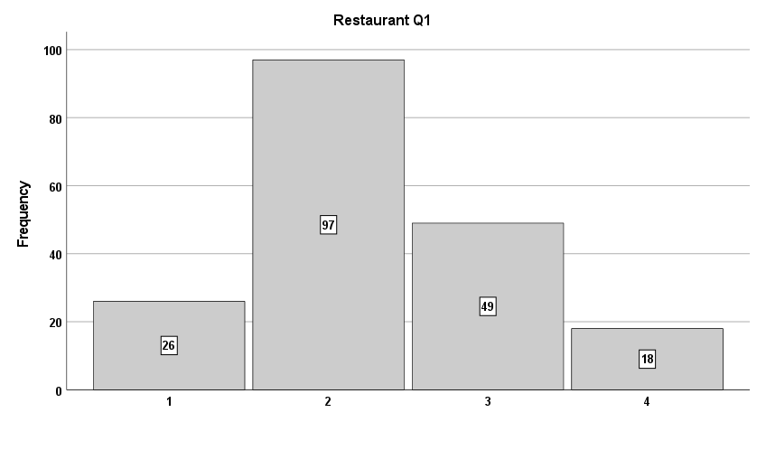
Figure S1. Histogram of participant responses to Q1 for the Restaurant vignette.

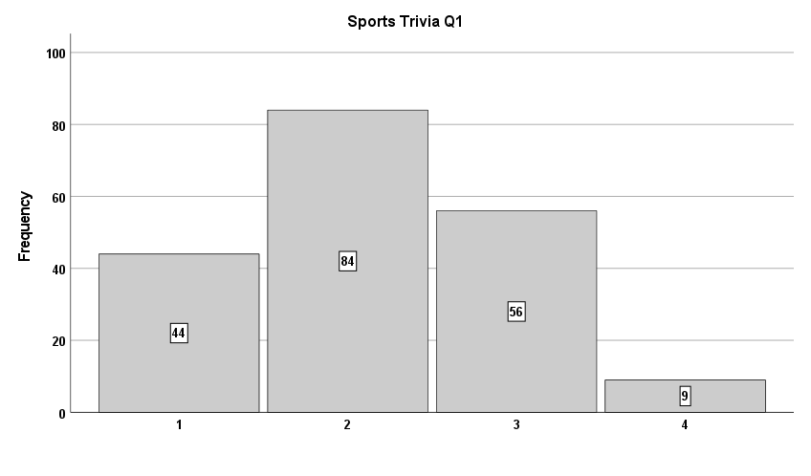
Figure S2. Histogram of participant responses to Q1 for the Sports trivia vignette.

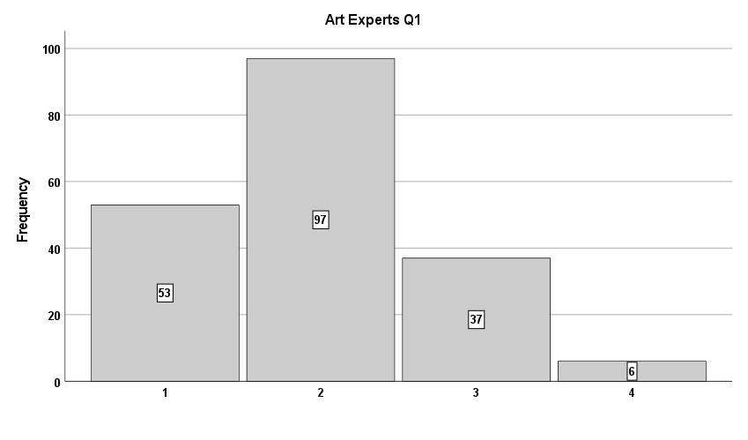
Figure S3. Histogram of participant responses to Q1 for the Art experts vignette.

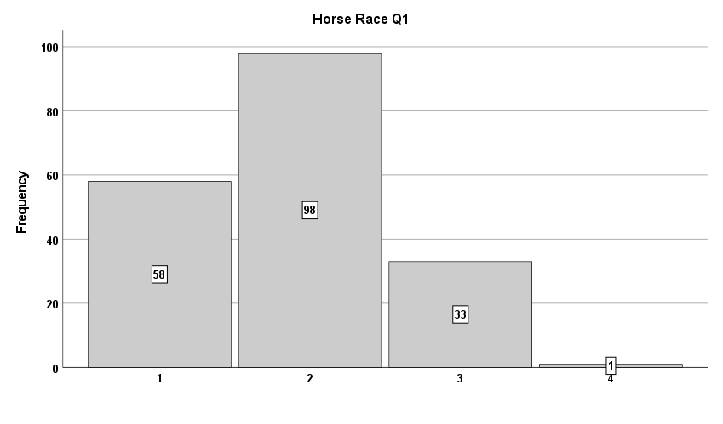
Figure S4. Histogram of participant responses to Q1 for the Horse race vignette.

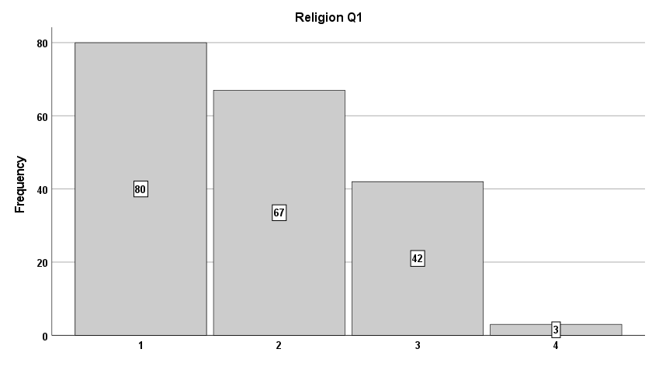
Figure S5. Histogram of participant responses to Q1 for the Religion vignette.

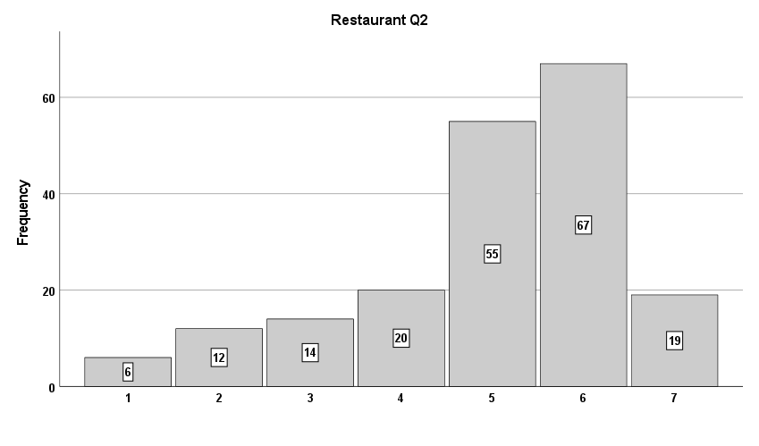
Figure S6. Histogram of participant responses to Q2 for the Restaurant vignette.

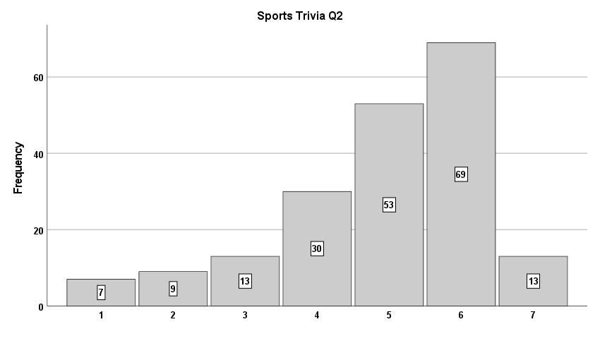
Figure S7. Histogram of participant responses to Q2 for the Sports trivia vignette.

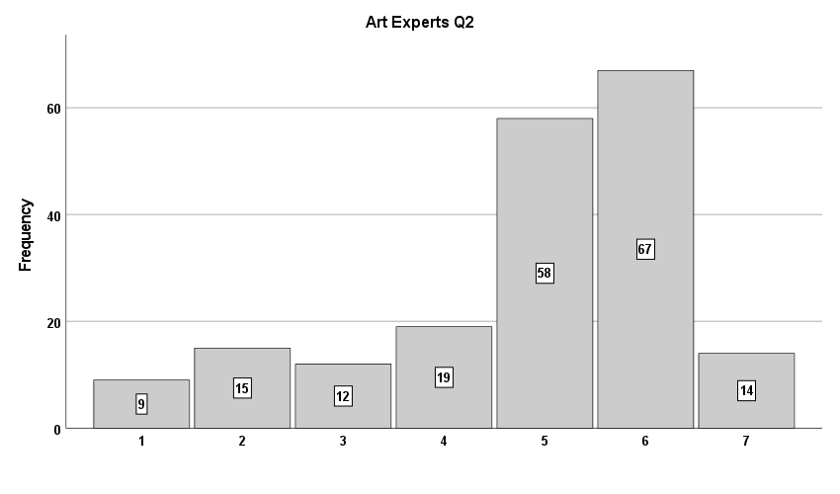
Figure S8. Histogram of participant responses to Q2 for the Arts experts vignette.

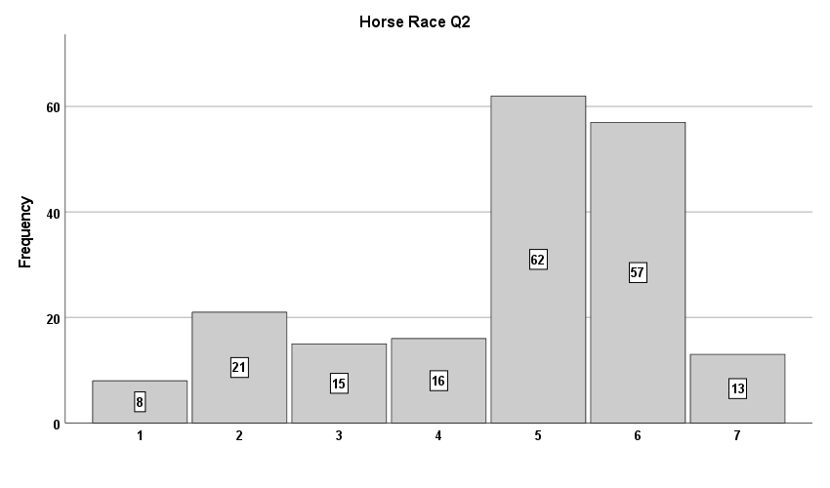
Figure S9. Histogram of participant responses to Q2 for the Horse race vignette.

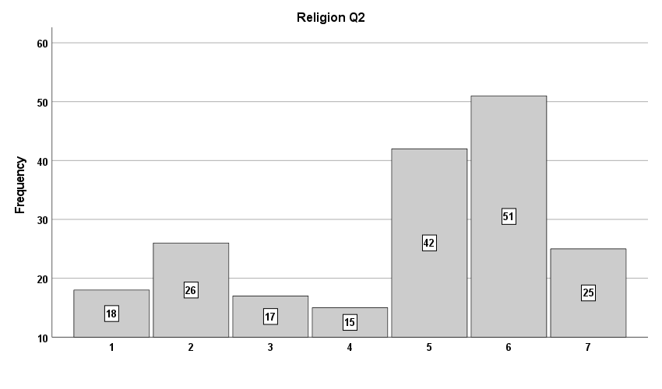
Figure S10. Histogram of participant responses to Q2 for the Religion vignette.

Mean Q1 and Q2 Responses
 |  | Mean | SD | Min. | Max | Boundary
Q1 | Restaurant | 2.3 | .8 | 1 | 4 | 1.5
 | Sports Trivia | 2.2 | .8
 | Art Experts | 2.0 | .8
 | Horse Race | 1.9 | .7
 | Religion | 1.8 | .8
 |  | Mean | SD | Min. | Max | Midpoint
Q2 | Restaurant | 5.0 | 1.5 | 1 | 7 | 4
 | Sports Trivia | 4.9 | 1.4
 | Art Experts | 4.9 | 1.6
 | Horse Race | 4.7 | 1.6
 | Religion | 4.5 | 1.9
Table S1. Mean Q1 and Q2 responses, with standard deviations (SD), minimums, maximums, and boundaries or midpoints.

Correlation Matrix for PD Scores
 | Restaurant | Sports Trivia | Art Experts | Horse Race | Religion
Restaurant | 1
Sports Trivia | .45*** | 1
Art Experts | .43*** | .58*** | 1
Horse Race | .45*** | .49*** | .47*** | 1
Religion | .26*** | .49*** | .41*** | .38*** | 1
Table S2. Correlation matrix for PD scores from the five vignettes.

PD scores on the five vignettes correlated substantially with all items on the ‘Openness to revising one’s viewpoint’ subscale of the CIHS, half of the items on the ‘Lack of intellectual overconfidence’ subscale, and almost none of the items on the ‘Independence of intellect and ego’ and the ‘Respect for others’ viewpoints’ subscales.

Significant Correlations Between PD Scores and CIHS Items
 |  | Restaurant | Sports Trivia | Art Experts | Horse Race | Religion
Independence of intellect and ego | CIHS2 |  |  |  | .16*
 | CIHS3 |  |  |  | .16*
Openness to revising one’s viewpoint | CIHS6 |  | .25*** |  | .26*** | .28***
 | CIHS7 |  | .20** | .17* | .17*
 | CIHS8 |  | .15* | .15* | .16*
 | CIHS9 | .18* | .17* | .19** | .18* | .16*
 | CIHS10 | .17* | .16* | .16* | .24**
Respect for others’ viewpoints | CIHS13 |  | .17*
Lack of intellectual overconfidence | CIHS19 |  |  |  |  | .20**
 | CIHS20 |  |  | .16* | .22** | .25***
 | CIHS21 |  | .15* |  | .24** | .19*
Table S3. Significant correlations between PD scores and CIHS items.

Significant Correlations Between Conciliationism Scores, PD Scores, and GIHS Items
 | Conciliationism | Restaurant | Sports Trivia | Art Experts | Horse Race | Religion
GIHS1 | .41*** | .29*** | .20** | .32*** | .37*** | .32***
GIHS2 | .26*** | .15* |  | .15* | .24*** | .26***
GIHS4 | .25** |  |  | .19** | .28*** | .21**
GIHS5 | .20** |  |  |  | .19** | .20**
GIHS6 |  |  |  |  |  | .16*
Table S4. Significant correlations between conciliationism scores, PD scores, and GIHS items.

Significant Correlations Between Conciliationism Scores,
PD scores, LOIHS Items, and LOIHS Subscales
 | Conciliationism | Restaurant | Sports Trivia | Art Experts | Horse Race | Religion
LOIHS6 | -.26*** | -.17* | -.21** | -.21** | -.27*** | -.15*
LOIHS10 | .21** | .23** | .18* |  | .18* | .17*
Appropriate Discomfort with Limitations |  |  | -.14*
Owning Intellectual Limitations | .16* | .16* |  |  | .17*
Table S5. Significant correlations between conciliationism scores, PD scores, LOIHS items, and LOIHS subscales.

Correlations were calculated between conciliationism scores, on the one hand, and both overall intellectual humility scale scores (GIHS, CIHS, LOIHS) and intellectual humility subscales. Conciliationism scores correlated significantly with three of the seven subscales. Intellectual humility scales and their factors correlated more strongly with each other than with conciliationism. The seven IH scale factors correlated significantly with each other in 16 out of 21 pairwise correlational analyses. However, only 9 of these correlations were medium to large. The four CIHS factors all correlated significantly with each other, but in only 5 out of 10 pairwise correlational analyses were these correlations large. Three were medium, and two were small. The three LOIHS factors did not correlate significantly with each other in 2 out of pairwise correlational analyses, and the only significant one was small.
Correlation Matrix for Conciliationism, IH Scales, and IH Subscales
 |  | Conciliationism | CIHS | GIHS | LOIHS | Independence of intellect & ego | Openness to revising viewpoint | Respect for other viewpoints | Lack of intellectual overconfidence | Love of Learning | Appropriate Discomfort with Limitations | Owning Intellectual Limitations
 | Conciliationism | 1
 | CIHS | .23** | 1
 | GIHS | .28*** | .56*** | 1
 | LOIHS | .03 | .59*** | .34*** | 1
CIHS Subscales | Independence of intellect & ego | .10 | .69*** | .16* | .59*** | 1
 | Openness to revising viewpoint | .31*** | .66*** | .59*** | .31*** | .15* | 1
 | Respect for other viewpoints | .08 | .71*** | .57*** | .50*** | .29*** | .53*** | 1
 | Lack of intellectual overconfidence | .18* | .70*** | .39*** | .24** | .19* | .40*** | .38*** | 1
LOIHS Subscales | Love of Learning | .04 | .46*** | .42*** | .59*** | .24** | .41*** | .54*** | .21** | 1
 | Appropriate Discomfort with Limitations | -.11 | .29*** | -.08 | .73*** | .55*** | -.04 | .11 | .02 | .13 | 1
 | Owning Intellectual Limitations | .16* | .49*** | .48*** | .66*** | .25*** | .38*** | .48*** | .31*** | .27*** | .12 | 1

Table S6. Correlation Matrix for conciliationism scores, intellectual humility scales, and intellectual humility subscales.

Significant Correlations between Conciliationism and Intellectual Humility Scale Items
Conciliationism | GIHS
 | GIHS1 |  |  | GIHS2 |  |  |  | GIHS4 |  |  |  | GIHS5
 | .41*** |  |  | .26*** |  |  |  | .25** |  |  |  | .20**
 | CIHS
 | CIHS 11 | CIHS7 | CIHS 12 |  | CIHS 18 | CIHS 3 |  |  | CIHS8 | CIHS 4 | CIHS 15 |  | CIHS 21 | CIHS 16
 | .14* | .29*** | .22** |  | .16* | .24** |  |  | .22** | .14* | .16* |  | .23** | .19**
 | LOIHS
 | LOIHS6 |  |  |  |  |  | LOIHS10
 | -.26*** |  |  |  |  |  | .21**
Table S7. Significant correlations between conciliationism scores and responses to individual intellectual humility scale items.

Correlations ≥ .3 Between PD Scores and Intellectual Humility Scale Items
 | Restaurant | Horse Race | Art Experts | Sports Trivia | Religion
CIHS7 |  |  |  |  | .30***
GIHS1 |  | .37*** | .32*** |  | .33***
Table S8. Significant correlations greater than .3 between PD scores and individual intellectual humility scale items.

Correlations Between PD Scores and CIHS Items
 | Restaurant | Sports Trivia | Art Experts | Horse Race | Religion
CIHS1 | -.05 | -.05 | .03 | .00 | .00
CIHS2 | -.05 | .04 | .08 | .16* | .11
CIHS3 | .05 | .10 | .02 | .16* | .14
CIHS4 | .05 | .03 | .04 | .10 | .06
CIHS5 | -.06 | .11 | .02 | .09 | -.01
CIHS6 | .13 | .25*** | .13 | .26*** | .28***
CIHS7 | .10 | .20** | .17* | .17* | .13
CIHS8 | .04 | .15* | .15* | .16* | .11
CIHS9 | .18* | .17* | .19** | .18* | .16*
CIHS10 | .17* | .16* | .16* | .24** | .09
CIHS11 | -.06 | .05 | .04 | -.01 | -.02
CIHS12 | .02 | -.01 | -.05 | .00 | -.07
CIHS13 | .09 | .17* | .09 | .12 | .07
CIHS14 | .05 | .09 | .02 | -.02 | .07
CIHS15 | .03 | .06 | .07 | .07 | .12
CIHS16 | .00 | .03 | .01 | .09 | .06
CIHS17 | -.02 | .02 | -.07 | .03 | -.02
CIHS18 | -.06 | .13 | .05 | .01 | -.03
CIHS19 | .14 | .13 | .05 | .13 | .20**
CIHS20 | .09 | .14 | .16* | .22** | .25***
CIHS21 | .06 | .15* | .08 | .24** | .19*
CIHS22 | .05 | .03 | .08 | .08 | .10
Table S9. Correlations between PD scores and CIHS items.

Correlations Between Conciliationism Scores, PD scores,
and LOIHS (Overall, Items, Subscales)
 | Conciliationism | Restaurant | Sports Trivia | Art Experts | Horse Race | Religion
LOIHS Overall | .03 | .06 | -.01 | -.04 | .02 | .03
LOIHS1 | .03 | -.05 | .11 | -.08 | -.01 | .10
LOIHS2 | -.04 | -.11 | .03 | -.05 | -.11 | .08
LOIHS3 | .05 | .06 | .09 | -.06 | -.01 | .08
LOIHS4 | .05 | -.05 | .10 | -.03 | .06 | .06
LOIHS5 | -.05 | .08 | -.09 | .03 | -.08 | -.10
LOIHS6 | -.26*** | -.17* | -.21** | -.21** | -.27*** | -.15*
LOIHS7 | .01 | .08 | -.06 | -.03 | .04 | -.03
LOIHS8 | .04 | -.01 | -.03 | -.02 | .07 | .07
LOIHS9 | .00 | .05 | -.08 | -.05 | .06 | -.02
LOIHS10 | .21** | .23** | .18* | .07 | .18* | .17*
LOIHS11 | .12 | .08 | .06 | .11 | .13 | .05
LOIHS12 | .10 | .07 | .06 | .10 | .06 | .04
Love of Learning | .05 | -.03 | .11 | -.06 | -.02 | .11
Appropriate Discomfort with Limitations | -.11 | -.01 | -.14* | -.09 | -.10 | -.08
Owning Intellectual Limitations | .16* | .16* | .08 | .08 | .17* | .09
Table S10. Correlations between conciliationism scores, PD scores, and LOIHS scores (Overall, Items, Subscales).

Kaiser-Meyer-Olkin measures of sampling adequacy, which analyze data sets for how suitable they are for factor analysis, were performed on each of the data sets we wished to factor analyze. KMO scores and qualitative interpretations of these scores from Hutcheson and Sofroniou (The Multivariate Social Scientist, Sage, 1999) appear below.

KMO Measures of Sampling Adequacy
 | KMO measures | Hutcheson & Sofroniou’s interpretation
PD scores & CIHS item scores | .80 | Meritorious
PD scores & GIHS item scores | .83 | Meritorious
PD scores & LOIHS item scores | .72 | Middling
PD scores & CIHS & GIHS & LOIHS item scores | .82 | Meritorious
Table S11. Kaiser-Meyer-Olkin measures of sampling adequacy for four subsets of our data, together with qualitative interpretations of these measures from Hutcheson and Sofroniou (1999).

The pattern matrix for the factor analysis of PD scores and CIHS items show that PD scores load onto a factor that is distinct from what the intellectual humility scale items measure, with intellectual humility items being further organized according to separate factors with which they are most strongly associated. The latter factors match those reported by the original scale developers.

Pattern Matrix
 |  | Factor
 |  | 1 | 2 | 3 | 4 | 5
PD Scores | Restaurant |  |  | .611
 | Sports Trivia |  |  | .824
 | Art Experts |  |  | .724
 | Horse Race |  |  | .641
 | Religion |  |  | .533
CIHS Items | CIHS1 |  | -.622
 | CIHS2 |  | -.757
 | CIHS3 |  | -.819
 | CIHS4 |  | -.788
 | CIHS5 |  | -.709
 | CIHS6 |  |  |  |  | -.502
 | CIHS7 |  |  |  |  | -.685
 | CIHS8 |  |  |  |  | -.668
 | CIHS9 |  |  |  |  | -.615
 | CIHS10 |  |  |  |  | -.409
 | CIHS11 | .778
 | CIHS12 | .763
 | CIHS13 | .499
 | CIHS14 | .687
 | CIHS15 | .532
 | CIHS16 | .485
 | CIHS17 |  |  |  | .558
 | CIHS18 |  |  |  | .616
 | CIHS19 |  |  |  | .612
 | CIHS20 |  |  |  | .383
 | CIHS21 |  |  |  | .489
 | CIHS22 |  |  |  | .307
Table S12. Pattern matrix for an exploratory factor analysis of PD scores and CIHS item scores. In accord with common practice, factor loadings below .3 are suppressed for the sake of clarity and simplicity.

Pattern Matrix
 | Factor
 | 1 | 2 | 3 | 4
Restaurant | .584
Sports Trivia | .816
Art Experts | .714
Horse Race | .613
Religion | .522
LOIHS1 |  | .726
LOIHS2 |  | .734
LOIHS3 |  | .689
LOIHS4 |  | .553
LOIHS5 |  |  | .630
LOIHS6 |  |  | .770
LOIHS7 |  |  | .450
LOIHS8 |  |  | .430 | .397
LOIHS9 |  |  |  | .558
LOIHS10 |  |  |  | .423
LOIHS11 |  |  |  | .449
LOIHS12 |  |  |  | .460
Table S13. Pattern matrix for principal axis factoring analysis with oblique (direct oblimin) rotation for PD scores and LOIHS item scores. Factor loadings below .3 are suppressed for the sake of clarity and simplicity.

Pattern Matrix
 | Factor
 | 1 | 2 | 3 | 4 | 5 | 6
Restaurant |  |  | .607
Sports Trivia |  |  | .783
Art Experts |  |  | .719
Horse Race |  |  | .615
Religion |  |  | .467
CIHS1 |  | .630
CIHS2 |  | .684 |  |  |  | -.306
CIHS3 |  | .753
CIHS4 |  | .782
CIHS5 |  | .706
CIHS6 |  |  |  |  |  | -.309
CIHS7 |  |  |  |  | .417
CIHS8 |  |  |  |  | .402
CIHS9
CIHS10 |  |  |  | -.302
CIHS11 | .732
CIHS12 | .633
CIHS13 | .505
CIHS14 | .503 |  |  |  | .332
CIHS15 | .370 |  |  |  | .319
CIHS16 | .411
CIHS17 |  |  |  | -.547
CIHS18 |  |  |  | -.533
CIHS19 |  |  |  | -.665
CIHS20 |  |  |  | -.434
CIHS21 |  |  |  | -.496
CIHS22 |  |  |  | -.316
GIHS1 |  |  |  |  |  | -.575
GIHS2 |  |  |  |  |  | -.659
GIHS3 | .437 |  |  |  |  | -.307
GIHS4 |  |  |  |  |  | -.522
GIHS5 |  |  |  |  |  | -.573
GIHS6 |  |  |  |  |  | -.483
LOIHS1 |  |  |  |  | .701
LOIHS2 |  |  |  |  | .686
LOIHS3 |  |  |  |  | .665
LOIHS4 |  |  |  |  | .487
LOIHS5 |  | .467
LOIHS6 |  | .518
LOIHS7 |  | .386
LOIHS8 |  | .592
LOIHS9 |  | .400
LOIHS10 | .317
LOIHS11 | .353
LOIHS 12 | .427
Table S14. Pattern matrix for principal axis factoring analysis with oblique (direct oblimin) rotation for PD scores and all individual IH scale items. Factor loadings below .3 are suppressed for the sake of clarity and simplicity.

New Materials for Study 2

New questions for peer disagreement cases:
Answer choices:
Strongly disagree
Disagree
Neither agree nor disagree
Agree
Strongly agree

(Restaurant Q3) When you discover that you and your friend disagree about whether the shares are $43 or $45, it’s OK for you to continue believing that the shares are $43 just as strongly as you did before.

(Restaurant Q4) When you discover that you and your friend disagree about whether the shares are $43 or $45, you should become less confident in believing that the shares are $43.

(Restaurant Q2') Discovering that you and your friend disagree about whether the shares are $43 or $45 gives you reason to doubt the reliability of your original judgment.

(Sports trivia Q3) When Jim discovers that John disagrees with him about whether Jackson was selected as an all-star player from their team in 1968 or 1969, it's OK for Jim to continue believing that Jackson was selected in 1968 just as strongly as he did before.

(Sports trivia Q4) When Jim discovers that John disagrees with him about whether Jackson was selected as an all-star player from their team in 1968 or 1969, he should become less confident in believing that Jackson was selected in 1968.

(Sports trivia Q2') Discovering that John disagrees with him about whether Jackson was selected as an all-star player from their team in 1968 or 1969 gives Jim reason to doubt the reliability of his original judgment.

(Art experts Q3) When the first art expert discovers that the second art expert disagrees with them about whether the painting is authentic or fraudulent, it's OK for the first art expert to continue believing that the painting is authentic just as strongly as they did before.

(Art experts Q4) When the first art expert discovers that the second art expert disagrees with them about whether the painting is authentic or fraudulent, they should become less confident in believing that the painting is authentic.

(Art experts Q2') Discovering that the second art expert disagrees with them about whether the painting is authentic or fraudulent gives the first art expert reason to doubt the reliability of their original judgment.

(Horse race Q3) When you discover that you and your friend disagree about whether Horse A won the race or Horse B won the race, it's OK for you to continue believing that Horse A won the race just as strongly as you did before.

(Horse race Q4) When you discover that you and your friend disagree about whether Horse A won the race or Horse B won the race, you should become less confident in believing that Horse A won the race.

(Horse race Q2') Discovering that you and your friend disagree about whether Horse A won the race or Horse B won the race gives you reason to doubt the reliability of your original judgment.

(Religion Q3) When Gillian discovers that many other people disagree about whether her family’s religion is true, it's OK for her to continue believing that her family’s religion is true just as strongly as she did before.

(Religion Q4) When Gillian discovers that many other people disagree about whether her family’s religion is true, she should become less confident in believing that her family’s religion is true.

(Religion Q2') Discovering that many other people disagree about whether her family’s religion is true gives Gillian reason to doubt the reliability of her original beliefs.

Actively Open-Minded Thinking Scale-7 (Haran et al., 2013)
Instructions: Please indicate the extent to which you agree or disagree with the following statements.
Answer choices:
Strongly disagree
Disagree
Neither agree nor disagree
Agree
Strongly agree
- Allowing oneself to be convinced by an opposing argument is a sign of good character.
- People should take into consideration evidence that goes against their beliefs.
- People should revise their beliefs in response to new information or evidence.
- Changing your mind is a sign of weakness.^{R}
- Intuition is the best guide in making decisions.^{R}
- It is important to persevere in your beliefs even when evidence is brought to bear against them.^{R}
- One should disregard evidence that conflicts with one’s established beliefs.^{R}

^{R} Reverse-scored item

