Online Appendix

Moderator Placement in Survey Experiments:
Racial Resentment and the “Welfare” vs. “Assistance to the Poor” Question Wording Experiment

Survey instrument

Racial Resentment Battery
Agree strongly, Agree somewhat, Neither agree nor disagree, Disagree somewhat, Disagree strongly
- Irish, Italians, Jewish and many other minorities overcame prejudice and worked their way up. Blacks should do the same without any special favors.
- Generations of slavery and discrimination have created conditions that make it difficult for blacks to work their way out of the lower class. (Reversed)
- Over the past few years, blacks have gotten less than they deserve (Reversed)
- It’s really a matter of some people not trying hard enough; if blacks would only try harder they could be just as well off as whites.

Welfare/Aid to the Poor Spending Experiment
- We are faced with many problems in this country, none of which can be solved easily or inexpensively. Please tell us whether you think we are spending too much, too little, or about the right amount on welfare.
- We are faced with many problems in this country, none of which can be solved easily or inexpensively. Please tell us whether you think we are spending too much, too little, or about the right amount on assistance to the poor.

Other questions
- How often do you pay attention to what's going on in government and politics?
- Do you happen to know which political party has a majority in the U.S. House of Representatives? (80% responded Democrats)
- Which of the following is the name of the series of government programs passed while Franklin D. Roosevelt was President? (74% answered The New Deal)
- Who is the current Speaker of the U.S. House of Representatives? (91% answered Nancy Pelosi)

Demographics
- Generally speaking, do you think of yourself as a Democrat, a Republican or Independent or what?
  - Would you call yourself a strong Democrat?
  - Would you call yourself a strong Republican?
  - Do you think of yourself as closer to the Republican Party, the Democratic Party, or neither?
- How old are you?
- How would you describe your gender?
- What is the highest level of education you have completed?
- Thinking back over the last year, what was your family's annual income?
- What racial or ethnic group best describes you?
- What is your ideology?

The survey was fielded August 12 - August 13, 2021.
Table A1: Sample Characteristics

Female | 55%
Democrat (with leaners) | 55%
Republicans (with leaners) | 31%
College degree or higher | 55%
White | 71%
Black or African American | 10%
Asian or Asian American | 7%
Liberal or Slightly Liberal | 47%
Conservative or Slightly Conservative | 28%
N = 1,590. Racial percentages include only those identifying as that race alone.
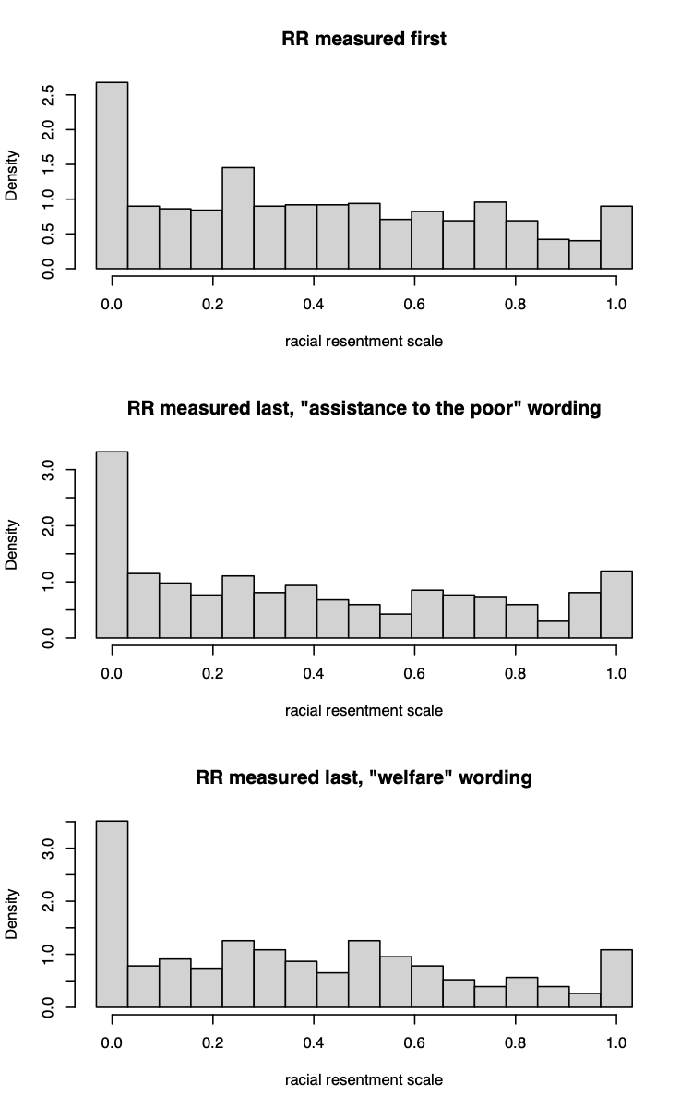
Figure A1: Distribution of Racial Resentment Scale by Question order and Treatment Condition
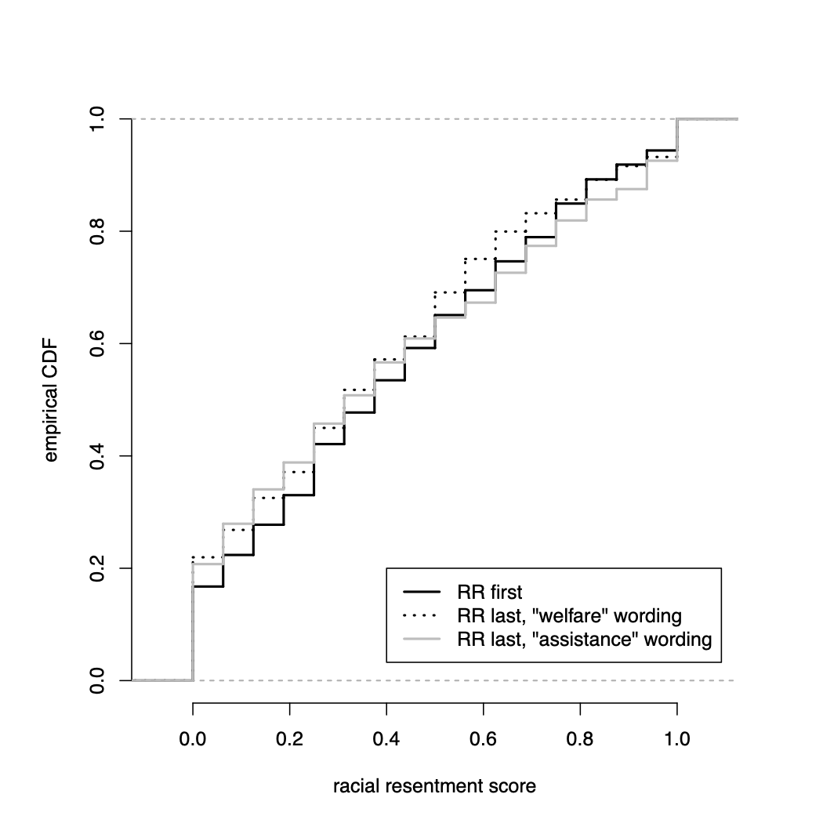
Figure A2: Empirical CDF of Racial Resentment Scale by Question order and Treatment Condition. Lines represent the proportion of observations in a given group that are at or below the specified value on the racial resentment scale.

Table A2. Effect of question wording on spending views, Splitting Sample by Whether Racial Resentment is Asked Pre- or Post-Treatment
 | Dependent variable: spending views
 | Model 1 |  | Model 2 |  | Model 3
 | RR pre | RR post | RR pre | RR post | RR pre | RR post
(Intercept) | -.40***  (.04) | -.43***  (.04) | -1.05***  (.04) | -.96***  (.04) | -.99***  (.05) | -.88***  (.05)
 | p=.62 |  | p=.15 |  | p=.16
“Welfare” wording | .29***  (.05) | .24***  (.06) | .32***  (.04) | .27***  (.05) | .20**  (.07) | .11  (.07)
 | p=.59 |  | p=.41 |  | p=.40
Racial resentment | - | - | 1.56***  (.07) | 1.35***  (.07) | 1.40***  (.10) | 1.16***  (.10)
 | - |  | p=.04 |  | p=.07
“Welfare” wording ✕ Racial resentment | - | - | - | - | .32*  (.14) | .42**  (.14)
 | - |  | - |  | p=.61
N | 1,590 |  | 1,590 |  | 1,590
Residual standard error | .79 |  | .63 |  | .63
F-statistic (Omnibus) | 61.38  (p<.001) |  | 207.0  (p<.001) |  | 158.2  (p<.001)
F-stat (Pre vs Post) | .9  (p=.40) |  | 1.7  (.16) |  | 1.2  (.29)
Note: Linear regression coefficient estimates with standard errors underneath in parentheses p-values underneath are for tests of the null hypothesis that a given coefficient isthe same for RR pre and RR post groups. *p<0.05; **p<0.01; ***p<.001

Table A3: Komolgorov-Smirnov Tests for Distribution of Racial Resentment Scale by Question order and Treatment Condition
 | K-S Test Statistic | Standard  p-value | Permutation p-value
RR pre  vs.  RR post, “assistance to the poor” wording | .062 | .27 | .15
RR pre  vs.  RR post, “welfare” wording | .055 | .40 | .24
RR post, “welfare” wording  vs.  RR post, “assistance to the poor” wording | .076 | .23 | .13
Note: Statistic and standard p-value are from two-sample Kolmogorov-Smirnov (KS) test for equality of distributions. Since the racial resentment scale is discrete (having 17 possible values), standard KS test p-values will typically be too high. Permutation p-values are based on permutation tests which simulate the distribution of the test statistic under the null hypothesis of identical distributions between the two groups.

OSF Pre-Registration Form (Anonymized)
Does asking about racial resentment pre-treatment alter treatment effects?
Public registration
Study Information
Hypotheses
Our main question is whether asking the racial resentment battery pre-treatment changes the treatment effect of the question wording experiment as opposed to asking it post-treatment. Our secondary question is whether the distribution of the racial resentment question battery responses is affected by being asked pre- vs. post-treatment and, if asked post-treatment, by the question wording randomization.
See attached pdf for more details
Design Plan
Study type
Experiment - A researcher randomly assigns treatments to study subjects, this includes field or lab experiments. This is also known as an intervention experiment and includes randomized controlled trials.
Blinding
No blinding is involved in this study.
Is there any additional blinding in this study?
No response
Study design
We plan to conduct a standard question wording experiment, following the classic “welfare” versus “assistance to the poor” item. In addition to randomizing this question wording (with equal probability for each condition), we will also ask all respondents a standard racial resentment question battery, but randomize (with equal probability and independent of the question wording randomization) whether respondents are asked these racial resentment items at the start of the survey or after they are asked their views on welfare/assistance to the poor.

See attached pdf for more details
No files selected
Randomization
No response
Sampling Plan
Existing Data
Registration prior to creation of data
Explanation of existing data
No response
Data collection procedures
Online survey through CloudResearch using MTurk
No files selected
Sample size
Will depend on response rate, probably between 500 and 1,000
Sample size rationale
Cost constraints
Stopping rule
When we exhaust grant funds.
Variables
Manipulated variables
Question wording of "welfare" versus "assistance to the poor" will be randomized

Racial resentment question battery will be randomized to appear before or after the welfare/assistance to the poor question.

See attached pdf for more details
No files selected
Measured variables
Racial resentment, support for more/less welfare spending, general political and demographic questions.

See attached pdf for more details
No files selected
Indices
RR will be our overall measure of racial resentment (RR). To calculate RR, we will rescale each item in the racial resentment question battery (each of which has 5 response options ranging from “disagree strongly” to “agree strongly”) such that 0 is the least racially resentful response option and 1 is the most racially resentful response option. We will then average these rescaled responses across all racial resentment items to obtain a measure that can range from 0 (least racially resentful) to 1 (most racially resentful) for each respondent.
No files selected
Analysis Plan
Statistical models
linear regressions and KS test (see attached pdf for details)
No files selected
Transformations
See attached pdf for details of recoding/transformations.
Inference criteria
Standard p < .05 for hypothesis tests (and 95% confidence intervals) will be main focus, but we will interpret results generally as appropriate.
Data exclusion
No response
Missing data
No response
Exploratory analysis
No response
Other
Other
No response

Pre-Analysis Plan for: Moderator Order and Treatment Effects

Researchers designing and conducting experiments often face tough decisions about the order in which they apply treatment and measure important variables such as moderators. In a recent article Montgomery, Nyhan and Torres (2018) discuss how conditioning on variables, such as potential moderators, that have been measured post-treatment can bias treatment effect estimates (see also Aranow, Baron and Pinson 2019). But others, such as Klar, Leeper and Robinson (2019) suggest that in survey experiments, asking certain moderators before treatment can alter the treatment effect, possibly moving the estimand away from the treatment effect of interest.
This project seeks to examine these competing concerns with a survey experiment. We plan to conduct a standard question wording experiment, following the classic “welfare” versus “assistance to the poor” item. In addition to randomizing this question wording (with equal probability for each condition), we will also ask all respondents a standard racial resentment question battery, but randomize (with equal probability and independent of the question wording randomization) whether respondents are asked these racial resentment items at the start of the survey or after they are asked their views on welfare/assistance to the poor.
The goal of this design is to estimate both how asking the racial resentment items pre- versus post-treatment may change the effect of the question wording randomization on respondents’ views on spending and also to estimate whether the distribution of measured racial resentment differs between: (1) those who are asked the racial resentment battery pre-treatment, (2) those who are asked the racial resentment battery post-treatment after being randomized into the “welfare” question wording, and (3) those who are asked the racial resentment battery post-treatment after being randomized into the “assistance to the poor” condition.
Below we describe the analyses we plan to conduct once we obtain the data and we also include our survey instrument.
Pre-Analysis Plan
Randomizations:
POST_RR will equal 1 for respondents who are asked the racial resentment battery after the welfare/assistance to the poor question and will equal 0 for respondents who are asked the racial resentment battery before being asked the welfare/assistance to the poor question. POST_RR will be randomly assigned with equal probability of being 0 or 1.
WELFARE_WORD will equal 1 for respondents who are asked the “welfare” wording in the question wording experiment and will equal 0 for respondents who are asked the “assistance to the poor” wording in the question wording experiment. WELFARE_WORD will be randomly assigned with equal probability of being 0 or 1 and this randomization will be independent of the POST_RR randomization.
Variables of interest:
RR will be our overall measure of racial resentment (RR). To calculate RR, we will rescale each item in the racial resentment question battery (each of which has 5 response options ranging from “disagree strongly” to “agree strongly”) such that 0 is the least racially resentful response option and 1 is the most racially resentful response option. We will then average these rescaled responses across all racial resentment items to obtain a measure that can range from 0 (least racially resentful) to 1 (most racially resentful) for each respondent.
SPEND is our measure of respondents’ preferences for spending on welfare/aid to the poor. We will code this based on their responses to this question as: “too little” = -1, “about right” = 0, “too much” = 1
Hypothesis 1:
Does asking about racial resentment before (versus after) the welfare/assistance to the poor question wording experiment change the effect of the question wording (WELFARE_WORD) on spending preferences (SPEND)?
To test this hypothesis we will estimate a linear regression model of the following form: SPEND = b0 + b1*WELFARE_WORD + b2*POST_RR + b3*WELFARE_WORD*POST_RR
Our key quantity of interest will be b3 (the coefficient on the interaction term) since it estimates the difference in the effect of the welfare wording treatment between respondents who were asked the racial resentment battery first versus those who were asked the racial resentment battery after the welfare/assistance to the poor question. We will look at this estimated coefficient as well as its confidence interval and the p-value from the t-test of H_0: b3=0.
Hypothesis 2:
Does asking the racial resentment battery after the welfare/assistance to the poor question (as
opposed to asking it before) affect the distribution of RR? We will test this in two ways.
First (and primarily), we will test whether the average level of RR is the same between: (1) those with POST_RR=0, (2) those with POST_RR=1 and WELFARE_WORD=0, and (3) those with POST_RR=1 and WELFARE_WORD=1. This will be done by estimating a linear regression of the form:
RR = b0 + b1*POST_RR + b2*POST_RR*WELFARE_WORD
Note that we have not included WELFARE_WORD by itself as a predictor in this regression, since its coefficient would represent the effect of the welfare question wording randomization on RR among respondents who had RR measured before the welfare question was asked (i.e. those who were asked the racial resentment battery after the question wording experiment) which is necessarily zero since a question wording change cannot affect responses to previously asked questions. While we plan to also estimate and report a regression adding in this term, perhaps in an appendix, our main analysis will leave it out since it will allow us to compare the three relevant groups here, combining all of those who received the racial resentment battery before the welfare/assistance to the poor item together irrespective of their value of WELFARE_WORD (since this cannot affect responses to the racial resentment items which were asked before respondents were treated with WELFARE_WORD).
There are three comparisons we will make to assess Hypothesis 2. First we ask: Among those with POST_RR=1, does WELFARE_WORD affect RR? This can be tested by looking at the estimate of b2 and testing the null hypothesis that b2=0. Additionally, we will test whether those with POST_RR=0 (including those with either value of WELFARE_WORD) have the same RR on average as those with POST_RR=1 and WELFARE_WORD=0. This can be assessed by looking at the estimate of b1 and testing the null hypothesis that b1=0. Finally, we will ask

whether RR is on average the same for those with POST_RR=0 as compared to those with POST_RR=1 and WELFARE_WORD=1. This can be assessed by looking at the estimate of b1+b2 and testing the null hypothesis that b1+b2=0.
While our primary focus with regard to Hypothesis 2 is whether there exist differences on average between these groups, we will also test whether the distributions of RR are different overall between these groups. To do this, we will perform Komolgorov-Smirnov (KS) tests of whether the overall distribution (not just the mean) of RR differs between the three groups mentioned here. This will involve three two-sample KS tests (one for each pair of two of the three groups as above). Because RR is discrete we will also generate permutation-test-based p-values for this test in addition to the standard KS test p-values (we expect these to be similar).
Additional Analyses
We may perform additional analyses using variables such as partisanship, political knowledge, and demographics. These will be more exploratory in nature, perhaps in response to findings from the analyses described above. We do not, therefore, pre-register these specific analyses here.
Works Cited
Aronow, P. M., Baron, J., & Pinson, L. (2019). A note on dropping experimental subjects who fail a manipulation check. Political Analysis, 27(4), 572-589.
Klar, S., Leeper, T., & Robison, J. (2020). Studying identities with experiments: Weighing the risk of posttreatment bias against priming effects. Journal of Experimental Political Science, 7(1), 56-60.
Montgomery, J. M., Nyhan, B., & Torres, M. (2018). How conditioning on posttreatment variables can ruin your experiment and what to do about it. American Journal of Political Science, 62(3), 760-775.

Recommended Reporting Standards for Experiments:
Moderator Placement in Survey Experiments: Racial Resentment and the “Welfare” vs. “Assistance to the Poor” Question Wording Experiment

- Hypotheses
- Specific objectives or hypotheses.
  - What question(s) was (were) the experiment designed to address?

Does the placement of questions to be used as moderators change the effect of a treatment condition?
Does experimental treatment condition affect the measurement of a moderator variable?

  - What are the specific hypotheses to be tested?

- Does asking about racial resentment before (versus after) the welfare/assistance to the poor question wording experiment change the effect of the question wording (WELFARE_WORD) on spending preferences (SPEND)?
- Does asking the racial resentment (RR) battery after the welfare/assistance to the poor question (as opposed to asking it before) affect the distribution of RR?

- Subjects and Context

- Eligibility and exclusion criteria for participants.
  - Why was this subject pool selected? Who was eligible to participate in the study? What would result in the exclusion of a participant? Were any aspects of recruitment changed (such as the exclusion criteria) after recruitment began?

We requested participants who were 18 or older and who lived in the United States.

- Procedures used to recruit and select participants.
  - If there is a survey: Identify the survey firm used and describe how they recruit respondents.
The survey was fielded to MTurk participants using the CloudResearch platform.
- Recruitment dates defining the periods of recruitment and when the experiments were conducted.
  - Also list dates of any repeated measurements as part of a follow-up.
The survey was fielded August 12 - August 13, 2021.
- Settings and locations where the data were collected.
  - In the field, lab, classroom, or some other specialized setting?

The survey was administered on-line and respondents most likely took it on their personal computer or smart phone.

  - Other relevant specifics of the population: e.g., large public university vs. small private university; geographic location; etc.
N/A

- If there is a survey: Provide response rate and how it was calculated.

This information was provided by CloudResearch: “you requested 1530 responses and approved 1530, but a total of 1725 participants entered your survey… In this case, 195 did not complete your survey. This made your response rate ~88%.”

- Allocation Method
- Details of the procedure used to generate the assignment sequence (e.g., randomization procedures).

After indicating consent, participants were randomly assigned to receive either the racial resentment scale or the welfare spending question first. If participants received racial resentment scale first, they received the welfare spending question immediately after, and vice versa.

Within the welfare spending question section, participants were randomly assigned to receive either “welfare” or “assistance to the poor” question wording.

- If random assignment used, then details of procedure (e.g., any restrictions, blocking).
  - Note the unit of randomization (individuals, groups, households, etc). Pay careful attention to report clustered random assignment if subjects were assigned at some level other than the individual subject.

We randomly assigned at the individual level.

- If random assignment used, provide evidence of random assignment.
  - If demographic or other pretreatment variables were collected, a table (in text or appendix) showing baseline means and standard deviations for demographic characteristics and other pre-treatment measures by experimental group. All demographic information was collected post-treatment.
  - If blocking was used, and group assignment proportions were not equal across blocks, provide table for each of the blocks. If there are too many blocks for this to be practical, combine blocks to present weighted averages of covariates using inverse probability weighting. N/A
- Blinding: Were participants, those administering the interventions, and those assessing the outcomes unaware of condition assignments? N/A
  - If blinding took place, include a statement regarding how it was accomplished and how the success of blinding was evaluated.
- Treatments
- Description of the interventions in each treatment condition, as well as a description of the control group.
  - Descriptions should be sufficient to allow replication: Summary or paraphrasing of experimental instructions in the article text; verbatim instructions and/or other treatment materials provided in an appendix.

This is a simple question order experiment without a control group. The survey (with the randomized questions) is attached.

- How and when manipulations or interventions were administered.
  - Method of delivery: Pen-and-paper vs. computer or internet vs. face-to-face communication vs. over the telephone. Computer/internet
  - If computerized, the software should be described and cited. (If possible, programs should be included in appendix so as to be available for purposes of replication.) We relied on Qualtrics for the survey.
  - For lab experiments (and other experiments, when relevant):
    - Report the number of repetitions of the experimental task and the group rotation protocol. Report the ordering of treatments for within-subject designs. Any piggybacking of other protocols should be reported. Report any use of experienced subjects or subjects used in more than one session or treatment. N/A
- Time span: How long did each experiment last? How many sessions were subjects expected to attend? If there were multiple sessions, how much time passed between them?

The average survey duration was 161.29 seconds (2 minutes, 41 seconds).

- Total number of sessions conducted and number of subjects used in each session. N/A
- Was deception used? No.
- Treatment fidelity: Evidence on whether the treatment was delivered as intended.
  - Report any instructional anomalies or inaccuracies. N/A
  - Were subjects given quizzes on the experimental instructions? No.
  - Were there practice rounds? If so, how many and what were the results? No.
  - Did subjects complete a post-experiment debriefing, interview, or questionnaire? No.
  - If so, is there evidence that subjects understood the instructions and treatments?
  - Did the experimental team observe aspects of the intervention? No.
  - Provide description of manipulation checks, if any. N/A
- Were incentives given? If so, what were they and how were they administered.

Cloud Research paid each respondent $0.50 for their participation in the survey.

- Results
- Outcome Measures and Covariates
- Provide precise definition of all primary and secondary measures and covariates.
  - For indices, provide exact description of how they are formed. For survey items provide exact question wording in an appendix. Please provide a copy of the complete survey questionnaire (in an on-line appendix if it is long).

To calculate Racial Resentment, we rescaled each item in the racial resentment battery (each of which has 5 response options ranging from “disagree strongly” to “agree strongly”) such that 0 is the least racially resentful response option and 1 is the most racially resentful response option. We averaged these rescaled responses across all racial resentment items to obtain a measure that can range from 0 (least racially resentful) to 1 (most racially resentful) for each respondent.

Spending Views is our measure of respondents’ preferences for spending on welfare/aid to the poor. We coded this based on their responses to this question as: “too little” = -1, “about right” = 0, “too much” = 1

- Clearly state which of the outcomes and subgroup analyses were specified prior to the experiment and which were the result of exploratory analysis.

The main outcome variable is “spending views” and we also use “racial resentment” as an outcome variable, to test whether being asked about welfare attitudes before changes levels of racial resentment. We do not have any subgroup analysis in this paper. All analysis in the paper was specified prior to the experiment.

- Complete CONSORT Participant Flow Diagram

CONSORT 2010 Flow Diagram

Follow-Up
Analysed (n=839)
♦ Excluded from analysis (give reasons) (n=0)

Analysis
Analysed (n=751)
♦ Excluded from analysis (give reasons) (n=0)

Lost to follow-up (give reasons) (n=0)
Discontinued intervention (give reasons) (n=0)
Lost to follow-up (give reasons) (n=0)
Discontinued intervention (give reasons) (n=0)

Enrollment
Allocated to racial battery first (n= 839)
♦ Received allocated intervention (n= 839)
♦ Did not receive allocated intervention (give reasons) (n= 0)

Allocation
Allocated to racial battery second (n= 751)
♦ Received allocated intervention (n= 751)
♦ Did not receive allocated intervention (give reasons) (n= 0)
Randomized (n= 1590)
Excluded (n= 0)
♦ Not meeting inclusion criteria (n= 0)
♦ Declined to participate (n= 135)
♦ Other reasons (n= 0)
Assessed for eligibility (n=1725)

Complete Survey Questionnaire

Q1.1 2021 Political Attitudes Study
Conducted by: Bethany Albertson, Department of Government, balberts@mail.utexas.edu You are being asked to participate in a research study. This form provides you with information about the study. Participation in this study is voluntary and refusal to participate will involve no penalty or loss of benefits to which you are otherwise entitled. Also, you may discontinue participation at any time without penalty or loss of benefits to which you are otherwise entitled.
The purpose of the study is to better understand people’s thoughts about political issues in the United States.
If you agree to participate, we will ask you to:
- Answer survey questions about your political attitudes
- Provide some basic demographic information.

The total estimated time to participate in the study is 7 minutes.

Q1.2
Risks / Benefits: The risk associated with this study is no greater than everyday life. There are no benefits for participation in this study.
Confidentiality and Privacy Protections: The records of this study will be stored securely and kept confidential. Authorized persons from The University of Texas at Austin, members of the Institutional Review Board, and (study sponsors, if any) have the legal right to review your research records and will protect the confidentiality of those records to the extent permitted by law. All publications will exclude any information that will make it possible to identify you as a subject. Throughout the study, the researchers will notify you of new information that may become available and that might affect your decision to remain in the study. Further, confidentiality will be maintained by not asking you to provide any identifying information in the survey.

Q1.3 Contacts and Questions: If you have any questions about the study please ask now. If you have questions later, want additional information, or wish to withdraw your participation call the researcher conducting the study. Her name, phone number, and e-mail address is at the top of this page. If you have questions about your rights as a research participant, complaints, concerns, or questions about the research please contact the Office of Research Support at (512) 471-8871 or email: orsc@uts.cc.utexas.edu. Please print out or request a copy of this page for your records.

Q1.4 Do you consent to participate in the survey?
Yes (1)
No (2)

Skip To: End of Survey If Do you consent to participate in the survey? = No
End of Block: Consent Block

Start of Block: racism scale

Q2.1 Do you agree strongly, agree somewhat, neither agree nor disagree, disagree somewhat, or disagree strongly with the following statements?

Q2.2 Irish, Italians, Jewish and many other minorities overcame prejudice and worked their way up. Blacks should do the same without any special favors
Agree strongly (1)
Agree somewhat (2)
Neither agree nor disagree (3)
Disagree somewhat (4)
Disagree strongly (5)

Q2.3 Generations of slavery and discrimination have created conditions that make it difficult for blacks to work their way out of the lower class.
Agree strongly (1)
Agree somewhat (2)
Neither agree nor disagree (3)
Disagree somewhat (4)
Disagree strongly (5)

Q2.4 Over the past few years, blacks have gotten less than they deserve.
Agree strongly (1)
Agree somewhat (2)
Neither agree nor disagree (3)
Disagree somewhat (4)
Disagree strongly (5)

Q2.5 It’s really a matter of some people not trying hard enough; if blacks would only try harder they could be just as well off as whites.
Agree strongly (1)
Agree somewhat (2)
Neither agree nor disagree (3)
Disagree somewhat (4)
Disagree strongly (5)

End of Block: racism scale

Start of Block: welfare question (Present either 3.2 OR 3.3)

Q3.1 We'd like to ask you a question about policy.

Q3.2 We are faced with many problems in this country, none of which can be solved easily or inexpensively. Please tell us whether you think we are spending too much, too little, or about the right amount on welfare.
Too much (1)
Too little (2)
About the right amount (3)

Q3.3 We are faced with many problems in this country, none of which can be solved easily or inexpensively. Please tell us whether you think we are spending too much, too little, or about the right amount on assistance to the poor.
Too much (1)
Too little (2)
About the right amount (3)

End of Block: welfare question

Start of Block: Interest in Politics/Trust

Q4.1 Below are some questions to help us understand your level of interest in and engagement with U.S. politics and government.

Q4.2 How often do you pay attention to what's going on in government and politics?
Always (1)
Most of the time (2)
About half the time (3)
Some of the time (4)
Never (5)

End of Block: Interest in Politics/Trust

Start of Block: Political Knowledge

Q5.1 Now I am going to ask you some short questions such as you might see on a television game show. Some questions may be more difficult than others. If you don’t know the answer it’s not a problem. Just select “don’t know” and move to the next question.

Q5.2 Do you happen to know which political party has a majority in the U.S. House of Representatives?
Republicans (1)
Democrats (2)
Other (3)
Don't know (4)

Q5.3 Which of the following is the name of the series of government programs passed while Franklin D. Roosevelt was President?
The New Deal (1)
The Square Deal (2)
The Great Society (3)
Don’t know (4)

Q5.4 Who is the current Speaker of the U.S. House of Representatives?
Nancy Pelosi (1)
Chuck Schumer (2)
Mitch McConnell (3)
Kevin McCarthy (4)

End of Block: Political Knowledge

Start of Block: Partisanship Block

Q6.1
Finally, we have a few questions about you, and then you'll be done.
Generally speaking, do you think of yourself as a Democrat, a Republican or Independent or what?
Democrat (1)
Republican (2)
Independent (3)
Other (4) ________________________________________________

Skip To: Q6.2 If Finally, we have a few questions about you, and then you'll be done. Generally speaking, do you t... = Democrat
Skip To: Q6.3 If Finally, we have a few questions about you, and then you'll be done. Generally speaking, do you t... = Republican
Skip To: Q6.4 If Finally, we have a few questions about you, and then you'll be done. Generally speaking, do you t... = Independent
Skip To: End of Block If Finally, we have a few questions about you, and then you'll be done. Generally speaking, do you t... = Other
Q6.2 Would you call yourself a strong Democrat?
Strong (1)
Not Strong (2)

Skip To: End of Block If Would you call yourself a strong Democrat? = Strong
Skip To: End of Block If Would you call yourself a strong Democrat? = Not Strong
Q6.3 Would you call yourself a strong Republican?
Strong (1)
Not Strong (2)

Skip To: End of Block If Would you call yourself a strong Republican? = Strong
Skip To: End of Block If Would you call yourself a strong Republican? = Not Strong
Q6.4 Do you think of yourself as closer to the Republican Party, the Democratic Party, or neither?
Closer to the Republican Party (1)
Closer to the Democratic Party (2)
Neither (3)

End of Block: Partisanship Block

Start of Block: Demographics
Q7.1 How old are you?
________________________________________________________________

Q7.2 How would you describe your gender?
Male (1)
Female (2)
Non-binary (3)
Prefer to self-describe, below (4) ________________________________________________

Q7.3 What is the highest level of education you have completed?
Did not graduate from high school (1)
High school graduate (2)
Some college but no degree (yet) (3)
2-year college degree (4)
4-year college degree (5)
Postgraduate degree (MA, MBA, MD, JD, PhD, etc.) (6)

Q7.4 Thinking back over the last year, what was your family's annual income?
less than $30,000 (1)
$30,000 to $39,999 (2)
$40,000 to $49,999 (3)
$50,000 to $59,999 (4)
$60,000 to $69,999 (5)
$70,000 to $79,999 (6)
$80,000 to $99,999 (7)
$100,000 to $119,999 (8)
$120,000 to $149,999 (9)
$150,000 to $199,999 (10)
$200,000 to $249,000 (11)
$250,000 or more (12)
Prefer not to say (13)

Q7.5 What racial or ethnic group best describes you?
White (1)
Black or African-American (2)
Hispanic or Latino (3)
Asian or Asian-American (4)
Native American (5)
Middle Eastern (7)
Two or more races (6)
Other (9)

Skip To: Q7.6 If What racial or ethnic group best describes you? = Two or more races
Skip To: Q7.7 If What racial or ethnic group best describes you? != Two or more races
Q7.6 Please indicate the racial or ethnic groups that best describe you? (select all that apply)
White (1)
Black or African American (2)
Hispanic or Latino (3)
Asian or Asian-American (4)
Native American (5)
Middle Eastern (6)
Don't Know (7)

Q7.7 What is your ideology?
Liberal (1)
Slightly liberal (2)
Moderate (3)
Slightly conservative (4)
Conservative (5)

Q7.8
Please click the ">>" button below to conclude our survey - thanks so much for your participation!

