Supplementary online materials for
“Prosociality in Majority Decisions: A Laboratory Experiment on the Robustness of the Uncovered Set”

Jan Sauermann

Supplementary Materials A: The Uncovered Set: Theory and Evidence

Supplementary Materials B: Induced Incentives in the Experiment

Supplementary Materials C: Outcomes of Group Decisions

Supplementary Materials D: Reporting Standards
(including English translation of instructions)

Supplementary Materials A

The Uncovered Set: Theory and Evidence

The Uncovered Set
The UCS is today the dominant preference-based solution concept for majority decisions with an empty core. It was first defined by Miller (1980) for discrete sets of alternatives. Under majority rule, “a proposal x is uncovered if and only if, for every other proposal y, either x is majority-preferred to y or there is some third proposal z such that x is majority-preferred to z and z is majority-preferred to y” (Miller 1980, 74). Hence, uncovered alternatives can beat any other alternative either directly or indirectly via a third alternative. Figure A1 shows an example with four alternatives. An arrow from one alternative to another one indicates that the first alternative is majority-preferred to the second one. In the example, Alternative D covers A, because D beats A and Alternative B, the only alternative that loses against A, also loses against D. Alternative B, for example is uncovered, because even though it loses against A and D, it beats C which again beats A and D. The UCS thus consists of B, C, and D.
A
B
C
D
Figure A1. Example of the Uncovered Set

Miller demonstrates that the UCS is a subset of the unanimity core and thus guarantees Pareto-optimality. Furthermore, decisions inside the UCS result from several important voting mechanisms, such as legislative voting under the amendment procedure, cooperative voting among small groups, and electoral competition between different party platforms. McKelvey (1986) extends Miller’s (1980) results to multi-dimensional policy spaces where voters have Euclidean preferences. He also further explores the bounds to the UCS and finds that it is centrally located between voters’ ideal points, it collapses to the core when a core exists, and it becomes smaller when the preference configuration comes close to exhibiting a core (McKelvey 1986, 300). Cox (1987) further generalizes the findings to wider classes of preferences.

Empirical evidence on the Uncovered Set
The UCS has received wide empirical support. For instance, Bianco and Sened (2005) compute the UCS for a number of U.S. House sessions and several state legislatures based on legislators’ ideal points. The results show that increased party polarization shifts the UCS closer to the majority party. Therefore, the growing influence of parties in American politics is at least partly an artifact of legislators’ preferences. However, the analysis also shows that party leaders exert influence through agenda control, depending on the size of the UCS. Jeong (2008) developed a technique to estimate the locations of the UCS and policy proposals based on roll call data. Jeong, Miller, and Sobel (2009) apply this method to trace the process of negotiating the Federal Reserve Act of 1913 in the U.S. Senate. It has also been used to analyze the legislative process leading to four major civil rights acts (Jeong, Miller, and Sened 2009) and the 1978 Energy Act in the U.S. Senate (Jeong et al. 2014). The UCS also finds applications beyond American politics. Kam et al. (2010) explore the restrictions that backbenchers impose on party elites in the British House of Commons, and find that most ministers exhibit their own policy preferences well within the party’s UCS. Bianco et al. (2015) employ the UCS in their analysis of the effects of the 1996 electoral reform on the composition of the Israeli Knesset. Finally, Tsebelis (2002) assumes that collective veto players only make proposals inside the UCS in collective decisions.
All field studies on the UCS suffer from the fact that they have to rely on rather uncertain estimates of voters’ preferences. In comparison, laboratory experiments have the distinctive advantage of offering much more control over voters’ preferences. Committee decision-making experiments in the tradition of Fiorina and Plott’s (1978) seminal study certainly offer the best setting for testing theoretical solution concepts for majority rule. In that experiment, five-member committees have to select points from a two-dimensional policy space. Fiorina and Plott induce Euclidean preferences. Hence, committee members earn more the smaller the distance between the chosen point and their own ideal points in the policy space. The decision process uses an open agenda procedure. At the beginning of the experiment, the current motion is a point at the margin of the policy space. Upon recognition by the neutral experimenter, committee members can propose amendments to the current motion. If a majority of committee members favors the amendment over the current status quo, the proposal becomes the new motion. Committee members can also propose to adjourn decision making. If a majority agrees, the current motion becomes the final outcome. Otherwise decision making continues until a majority of committee members support a vote to adjourn.
The Fiorina and Plott experiments and other experimental studies using similar designs were not originally developed as an empirical test for the predictive power of the UCS. Nevertheless, Bianco et al. (2006) were able to re-analyze a large number of committee decisions with an empty majority core from eight different studies. Overall, the UCS correctly predicts 94 percent of all experimental outcomes. It is important to notice that the success rate of the UCS is robust to several variations of specific features from Fiorina and Plott’s (1978) original experiment. For instance, McKelvey et al. (1978) and Laing and Olmsted (1978) run experiments with different preference configurations. McKelvey and Ordeshook (1984) test the effects of a germaneness rule, where committees are only allowed to shift motions in one dimension at a time. Endersby (1993) investigates how restrictions on communication affect committee decisions; Wilson (1986) uses different agenda-setting procedures; and Wilson and Herzberg (1987) assign veto power to one of the committee members. Finally, King (1994) studies committees consisting of seven voting members and a non-voting chair and thus tests the UCS in larger committees.
Bianco et al. (2008) present the only study that I am aware of which is purposely designed ex ante as a direct experimental test of the predictive power of the UCS. It consists of two series of experiments. In the first series, five-member committees interact via a computer network. In the second series, committees of 35 use pencil and paper. In both series, Bianco et al. manipulate the location of the UCS by shifting voters’ ideal points in the two-dimensional policy space. Experimental results confirm the robustness of the predictive power of the UCS in relation to shifts of preferences and group size. In all treatments, almost all committee decisions lie inside the UCS.

Existing evidence on fairness as an alternative stability-inducing mechanism
The existing experimental research reviewed in the previous section largely affirms the predictive power of the UCS and thus the idea that the viability of majority decision making rests on voters’ rational foresight. However, the committee decision-making experiments also support an alternative stability-inducing mechanism. Hence, it is also possible that behavior is driven by pro-social motivations, more specifically by a concern for distributional fairness.
Significant supportive evidence for the importance of fairness considerations comes from majority decisions with an equilibrium. In such a situation with a non-empty core, the UCS collapses to the core (Cox 1987). Eavey and Miller (1984) and Sauermann and Kaiser (2010) find that the success rate of the core in majority decisions with discrete sets of alternatives varies with its fairness properties. Groups choose the equilibrium if it provides a fair distribution of payouts. However, if the selection of the core leads to an unequal distribution of payouts, and other alternatives provide more equally distributed payoffs for all group members, committee decisions systematically deviate from core. Similarly, Eavey (1991) and Sauermann (2016, 2018, 2020) vary the fairness properties of the core in spatial committee decisions and find that distributional concerns cause significant deviations from the core if the equilibrium provides an unfair distribution of payoffs.
The experimental evidence on committee decisions with an empty core is also compatible with the idea that pro-sociality induces stability in majority decisions. As Miller (2011, 359) notes, the UCS “identifies a set of moderate outcomes in the ‘center’ of the space of ideal points as the outcome of strategic voting and the coalition formation process”. Hence, the UCS usually coincides with exactly that region of the policy space which contains attractive alternatives for voters motivated by considerations for distributional fairness. Typically, the UCS contains fair alternatives that guarantee high and equally distributed payoffs for all committee members.
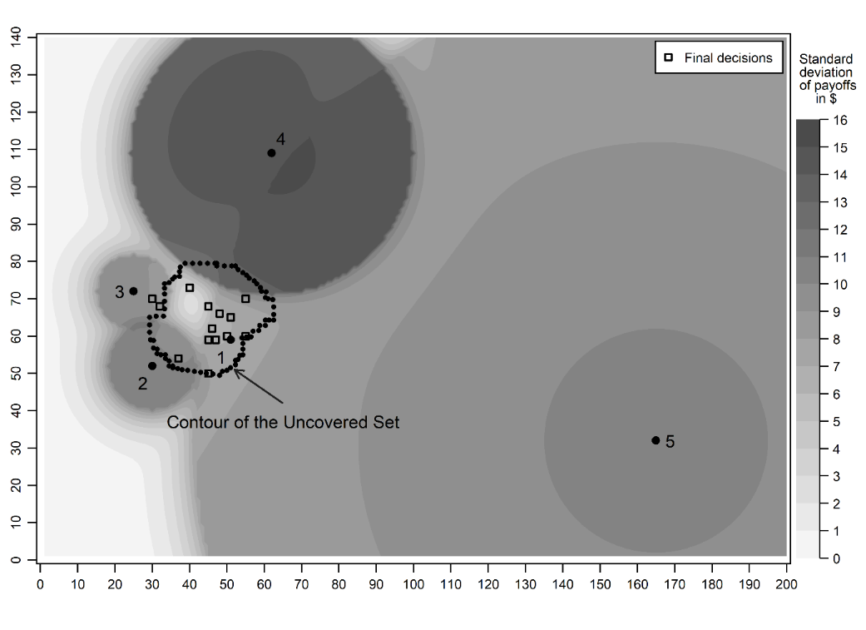
Figure A2. Fiorina and Plott (1978), Series 3

Figure A2 illustrates my argument using experimental evidence from Series 3 of Fiorina and Plott’s (1978) study. The figure shows the location of the UCS, the fairness properties of the policy space measured by the standard deviation of payouts, and the final committee decisions. It demonstrates that the UCS offers a very efficient prediction of final outcomes. Although it is quite small, occupying only about 12 percent of the Pareto set, it contains 80 percent (12 out of 15) of all final decisions. However, Figure A2 also reveals that all alternatives from the Pareto set which offer an equal distribution of payoffs also lie within the UCS, to the top left of Voter 1’s ideal point, and committee choices cluster in this region of fair alternatives. Hence, it is unclear whether fairness considerations or the UCS best explains behavior in this situation.

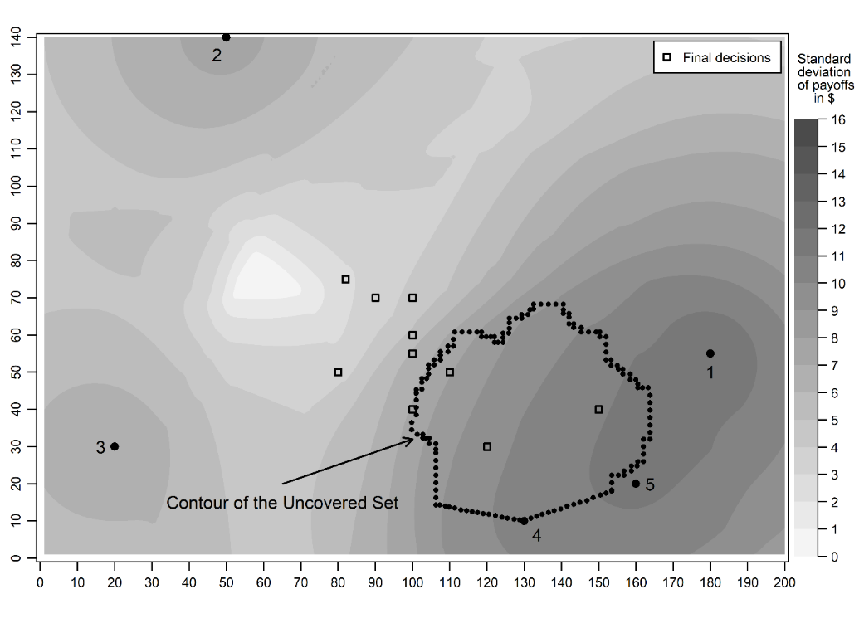
Figure A3. Eavey (1991), Skew Star Design

Figure A3 shows another example from Eavey (1991). In her “Skew Star” treatment, the UCS comprises 22 percent of the Pareto set. The success rate of the UCS in this experiment is low: only three out of ten committee decisions end up within the UCS and one decision is a close miss. Fairness considerations provide a possible explanation for the low success rate of the UCS in the treatment. In her description of behavioral patterns in the experiment, Eavey (1991, 466) notes that most committees formed larger than minimum winning coalitions and chose alternatives which they deemed fair. Figure A3 supports this explanation. The UCS, which is located near the ideal points of voters 1, 4, and 5, comprises rather unequally distributed alternatives. However, to the top left of the UCS is a region containing alternatives that guarantee fair payoffs for all group members. As Figure A3 shows, committee decisions are systematically drawn in the direction of more equally distributed alternatives.

References
Bauer-Bir, Jacob, William T. Bianco, Nicholas D'Amico, Christopher Kam, Itai Sened, and Regina Smyth. 2015. 'Predicting Majority Rule: Evaluating the Uncovered Set and the Strong Point.' Journal of Theoretical Politics 27 (4): 650-72.
Bianco, William T., Christopher Kam, Itai Sened, and Regina A. Smyth. 2015. 'The Uncovered Set and Its Applications.' In Jac C. Heckelman and Nicholas R. Miller (eds.), Handbook of Social Choice and Voting, 347-66. Cheltenham, UK: Edward Elgar.
Bianco, William T., Michael S. Lynch, Gary J. Miller, and Itai Sened. 2006. '"A Theory Waiting to Be Discovered and Used": A Reanalysis of Canonical Experiments on Majority Rule Decision-Making.' Journal of Politics 68 (4): 838-51.
Bianco, William T., Michael S. Lynch, Gary J. Miller, and Itai Sened. 2008. 'The Constrained Instability of Majority Rule: Experiments on the Robustness of the Uncovered Set.' Political Analysis 16 (2): 115-37.
Bianco, William T., and Itai Sened. 2005. 'Uncovering Evidence of Conditional Party Government: Reassessing Majority Party Influence in Congress and State Legislatures.' American Political Science Review 99 (3): 361-71.
Cox, Gary W. 1987. 'The Uncovered Set and the Core.' American Journal of Political Science 31 (2): 408-22.
Eavey, Cheryl L. 1991. 'Patterns of Distribution in Spatial Games.' Rationality and Society 3 (4): 450-74.
Eavey, Cheryl L., and Gary J. Miller. 1984. 'Fairness in Majority Rule Games with a Core.' American Journal of Political Science 28 (4): 570-86.
Endersby, James W. 1993. 'Rules of Method and Rules of Conduct: An Experimental Study on Two Types of Procedure and Committee Behavior.' Journal of Politics 55 (1): 218-36.
Feld, Scott L., Joseph Godfrey, and Bernard Grofman. 2014. 'The Shapley–Owen Value and the Strength of Small Winsets: Predicting Central Tendencies and Degree of Dispersion in the Outcomes of Majority Rule Decision-Making.' In Rudolf Fara, Dennis Leech and Maurice Salles (eds.), Voting Power and Procedures. Essays in Honour of Dan Felsenthal and Moshé Machover, 289-308. Geneva, Switzerland: Springer International.
Fiorina, Morris P., and Charles R. Plott. 1978. 'Committee Decisions under Majority Rule: An Experimental Study.' American Political Science Review 72 (2): 575-98.
Jeong, Gyung-Ho. 2008. 'Testing the Predictions of the Multidimensional Spatial Voting Model with Roll Call Data.' Political Analysis 16 (2): 179-96.
Jeong, Gyung-Ho, William Lowry, Gary J. Miller, and Itai Sened. 2014. 'How Preferences Change Institutions: The 1978 Energy Act.' Journal of Politics 76 (2): 430-45.
Jeong, Gyung-Ho, Gary J. Miller, and Itai Sened. 2009. 'Closing the Deal: Negotiating Civil Rights Legislation.' American Political Science Review 103 (4): 588-606.
Jeong, Gyung-Ho, Gary J. Miller, and Andrew C. Sobel. 2009. 'Political Compromise and Bureaucratic Structure: The Political Origins of the Federal Reserve System.' Journal of Law, Economics, & Organization 25 (2): 472-98.
Kam, Christopher, William T. Bianco, Itai Sened, and Regina A. Smyth. 2010. 'Ministerial Selection and Intraparty Organization in the Contemporary British Parliament.' American Political Science Review 104 (2): 289-306.
King, Ronald R. 1994. 'An Experimental Investigation of Super Majority Voting Rules: Implications for the Financial Accounting Standards Board.' Journal of Economic Behavior and Organization 25 (2): 197-217.
Laing, James D., and Scott Olmsted. 1978. 'An Experimental and Game-Theoretic Study of Committees.' In Peter C. Ordeshook (ed.) Game Theory and Political Science, 215-81. New York: New York University Press.
McKelvey, Richard D. 1986. 'Covering, Dominance, and Institution-Free Properties of Social Choice.' American Journal of Political Science 30 (2): 283-314.
McKelvey, Richard D., and Peter C. Ordeshook. 1983. 'Some Experimental Results That Fail to Support the Competitive Solution.' Public Choice 40 (3): 281-91.
McKelvey, Richard D., and Peter C. Ordeshook. 1984. 'An Experimental Study of the Effects of Procedural Rules on Committee Behavior.' Journal of Politics 46 (1): 182-203.
McKelvey, Richard D., Peter C. Ordeshook, and Mark D. Winer. 1978. 'The Competitive Solution for N-Person Games without Transferable Utility, with an Application to Committee Games.' American Political Science Review 72 (2): 599-615.
Miller, Gary J. 2011. 'Legislative Voting and Cycling.' In James N. Druckman, Donald P. Green, James H. Kuklinski and Arthur Lupia (eds.), Cambridge Handbook of Experimental Political Science, 353-68. Cambridge: Cambridge University Press.
Miller, Nicholas. 1980. 'A New Solution Set for Tournament and Majority Voting.' American Journal of Political Science 24 (1): 68-96.
Sauermann, Jan. 2016. 'Committee Decisions under Majority Rule Revisited.' Journal of Experimental Political Science 3 (2): 185-96.
Sauermann, Jan. 2018. 'Do Individuals Value Distributional Fairness? How Inequality Affects Majority Decisions.' Political Behavior 40 (4): 809-29.
Sauermann, Jan. 2020. 'On the Instability of Majority Decision Making – Testing the Implications of the ‘Chaos Theorems’ in a Laboratory Experiment.' Theory and Decision doi:10.1007/s11238-019-09741-4 (online first).
Sauermann, Jan, and André Kaiser. 2010. 'Taking Others into Account: Self-Interest and Fairness in Majority Decision Making.' American Journal of Political Science 54 (3): 667-85.
Tsebelis, George. 2002. Veto Players: How Political Institutions Work. Princeton: Princeton University Press.
Wilson, Rick K. 1986. 'Forward and Backward Agenda Procedures: Committee Experiments on Structurally Induced Equilibrium.' Journal of Politics 48 (2): 390-409.
Wilson, Rick K., and Roberta Herzberg. 1987. 'Negative Decision Powers and Institutional Equilibrium: Experiments on Blocking Coalitions.' The Western Political Quarterly 40 (4): 593-609.

Supplementary Materials B

Induced Incentives in the Experiment

Besides constant ideal points, induced payout functions share some additional common features throughout the experiment. Figure B1 shows a representative payout function. Payout functions induce Euclidean preferences and consist of two parts. For alternatives within a certain distance g from the player’s ideal point, payouts decrease linearly with increasing distance from the ideal point. For points outside the radius g, payout functions exhibit an exponential form. All payout functions share a common maximum. When a committee selects a player’s ideal point, the player earns 1,000 tokens. With increasing distance to a player’s ideal point, payoffs converge towards 0 tokens, yet never become negative. Hence, committee members cannot incur monetary losses in the experiment. By varying the parameters g and k in the exponential part of the payout functions, the experiment systematically manipulates the fairness properties of the policy space. In particular, using different parameterizations of the payout functions shifts the region of the policy space that contains equally distributed alternatives guaranteeing substantial payoffs for all committee members. However, the concrete parameterization does not affect the location of the UCS.

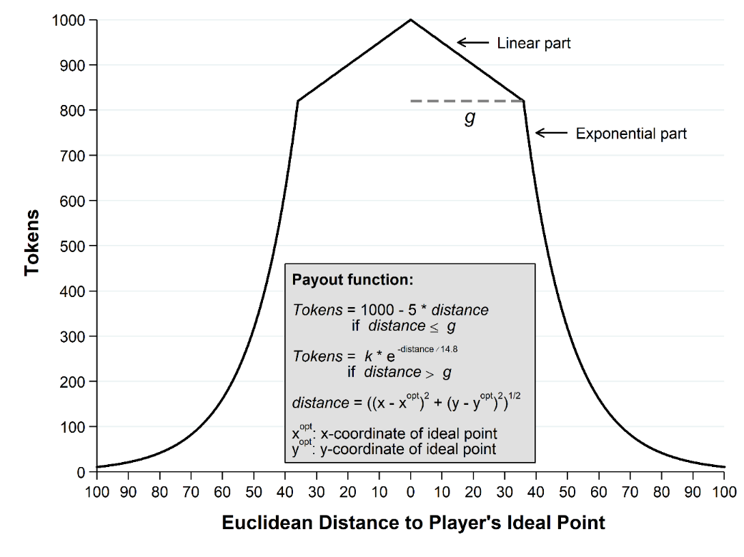
Figure B1. Representative payout function
Table B1 shows the payout functions for all five group members in the three settings of the experiment and Figure B2 displays them graphically.
Table B1. Payout Functions
 | Setting A | Setting B | Setting C
Player A  Ideal point:  (22|35) | $$\text{Tokens}=1000-5*distance$$  $$\text{if} distance≤36$$  $$\text{Tokens}=9320*e^{- \frac{distance}{14.8}}$$  $$\text{if} distance>36$$ | $$\text{Tokens}=1000-5*distance$$  $$\text{if} distance≤50$$  $$\text{Tokens}=22000*e^{- \frac{distance}{14.8}}$$  $$\text{if} distance>50$$ | $$\text{Tokens}=1000-5*distance$$  $$\text{if} distance≤10$$  $$\text{Tokens}=1865*e^{- \frac{distance}{14.8}}$$  $$\text{if} distance>10$$
Player B  Ideal point:  (17|45) | $$\text{Tokens}=1000-5*distance$$  $$\text{if} distance≤36$$  $$\text{Tokens}=9320*e^{- \frac{distance}{14.8}}$$  $$\text{if} distance>36$$ | $$\text{Tokens}=1000-5*distance$$  $$\text{if} distance≤55$$  $$\text{Tokens}=29800*e^{- \frac{distance}{14.8}}$$  $$\text{if} distance>55$$ | $$\text{Tokens}=1000-5*distance$$  $$\text{if} distance≤12$$  $$\text{Tokens}=2110*e^{- \frac{distance}{14.8}}$$  $$\text{if} distance>12$$
Player C  Ideal point:  (49|51) | $$\text{Tokens}=1000-5*distance$$  $$\text{if} distance≤36$$  $$\text{Tokens}=9320*e^{- \frac{distance}{14.8}}$$  $$\text{if} distance>36$$ | $$\text{Tokens}=1000-5*distance$$  $$\text{if} distance≤36$$  $$\text{Tokens}=9320*e^{- \frac{distance}{14.8}}$$  $$\text{if} distance>36$$ | $$\text{Tokens}=1000-5*distance$$  $$\text{if} distance≤36$$  $$\text{Tokens}=9320*e^{- \frac{distance}{14.8}}$$  $$\text{if} distance>36$$
Player D  Ideal point:  (82|45) | $$\text{Tokens}=1000-5*distance$$  $$\text{if} distance≤36$$  $$\text{Tokens}=9320*e^{- \frac{distance}{14.8}}$$  $$\text{if} distance>36$$ | $$\text{Tokens}=1000-5*distance$$  $$\text{if} distance≤12$$  $$\text{Tokens}=2110*e^{- \frac{distance}{14.8}}$$  $$\text{if} distance>12$$ | $$\text{Tokens}=1000-5*distance$$  $$\text{if} distance≤55$$  $$\text{Tokens}=29800*e^{- \frac{distance}{14.8}}$$  $$\text{if} distance>55$$
Player E  Ideal point:  (80|36) | $$\text{Tokens}=1000-5*distance$$  $$\text{if} distance≤36$$  $$\text{Tokens}=9320*e^{- \frac{distance}{14.8}}$$  $$\text{if} distance>36$$ | $$\text{Tokens}=1000-5*distance$$  $$\text{if} distance≤10$$  $$\text{Tokens}=1865*e^{- \frac{distance}{14.8}}$$  $$\text{if} distance>10$$ | $$\text{Tokens}=1000-5*distance$$  $$\text{if} distance≤50$$  $$\text{Tokens}=22000*e^{- \frac{distance}{14.8}}$$  $$\text{if} distance>50$$
Use | Treatment 1, Period 1 & 2  Treatment 2, Period 1  Treatment 3, Period 1 | Treatment 2, Period 2 | Treatment 3, Period 2
$$distance= \sqrt{{\left(x-x^{opt}\right)}^{2}+{\left(y-y^{opt}\right)}^{2}}$$
$x^{opt}$: x-coordinate of player’s ideal point
$y^{opt}$: y-coordinate of player’s ideal point

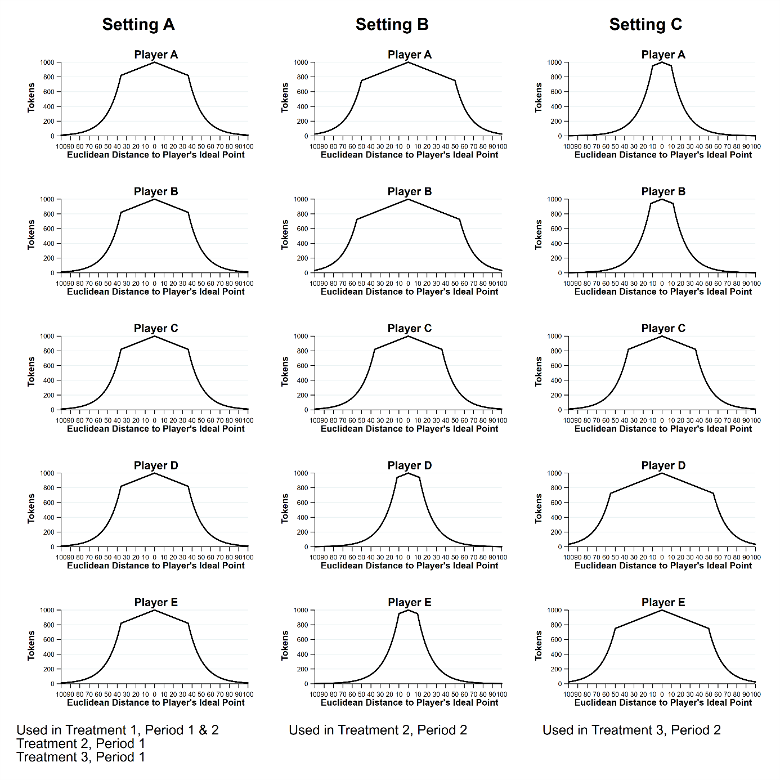
Figure B2. Payout Functions

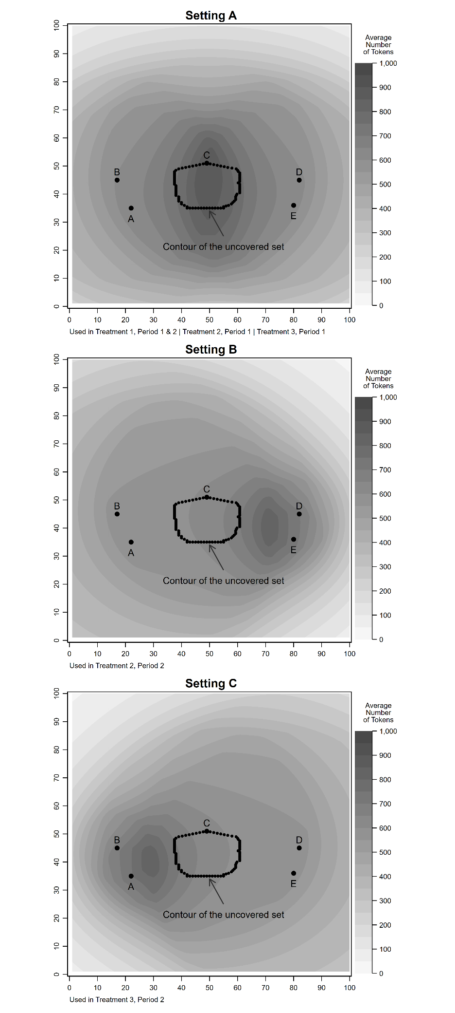
Figure B3. Average Payouts
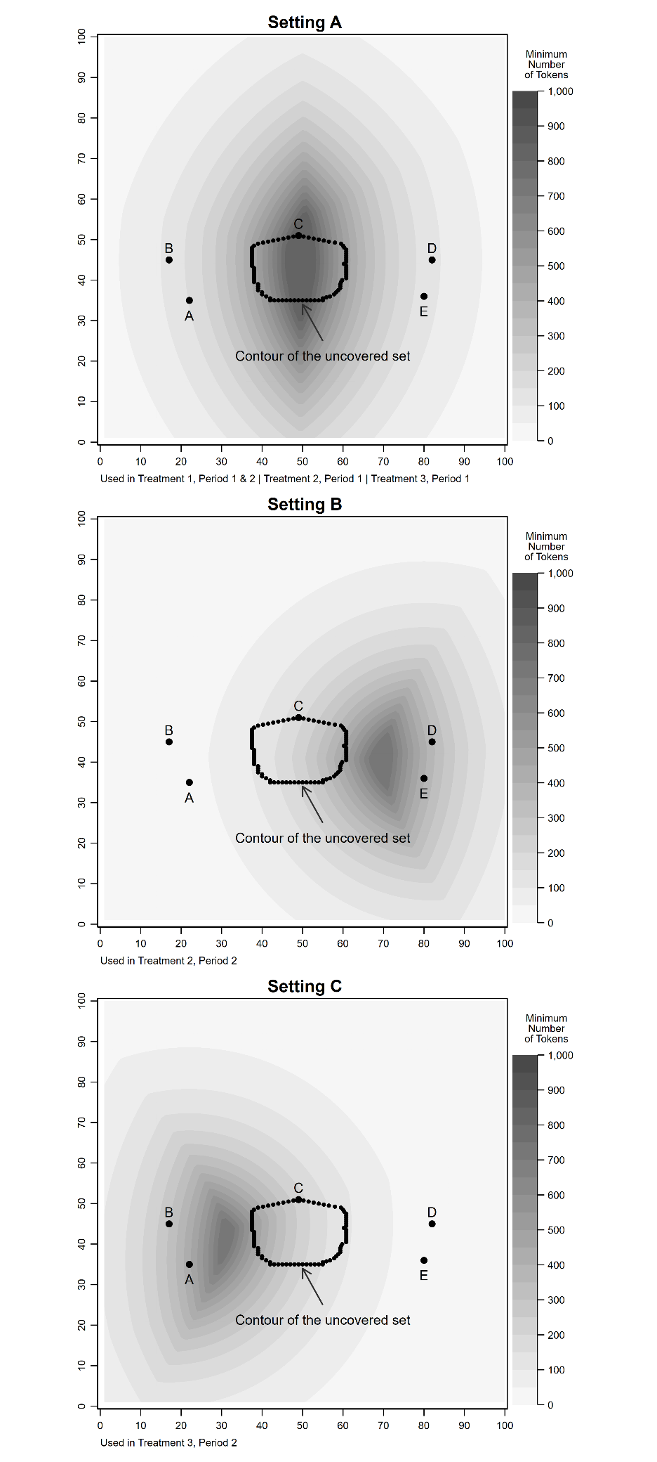
Figure B4. Minimum payouts
Reference
Fiorina, Morris P., and Charles R. Plott. 1978. "Committee Decisions under Majority Rule: An Experimental Study." American Political Science Review 72 (2): 575-598.

Supplementary Materials C

Outcomes of Group Decisions

Treatment 1, Period 1
Group | Coordinates of group decision | Group decision inside UCS | Resulting distribution of tokens |  |  |  |  | Time spent in group decision | Number of agenda setters
 |  |  | A | B | C | D | E
1 | 49 | 34 | no | 865* | 831* | 915* | 826* | 845* | 139.3 | 3
2 | 50 | 40 | yes | 858* | 833* | 945* | 838* | 849* | 247.5 | 5
3 | 48 | 40 | yes | 868* | 843 | 945* | 828* | 839 | 197.9 | 3
4 | 50 | 40 | yes | 858* | 833* | 945* | 838* | 849* | 150.7 | 2
5 | 50 | 40 | yes | 858* | 833* | 945* | 838* | 849* | 202.2 | 4
6 | 50 | 40 | yes | 858* | 833* | 945* | 838* | 849* | 155.8 | 3
7 | 47 | 41 | yes | 871* | 849* | 949* | 824 | 833* | 85.3 | 2
8 | 43 | 44 | yes | 886* | 870* | 954* | 668 | 722 | 230.8 | 5
9 | 49 | 43 | yes | 859* | 840* | 960* | 835* | 841 | 223.2 | 5
10 | 46 | 36 | yes | 880* | 848* | 924* | 759 | 830* | 164.3 | 4
11 | 50 | 44 | yes | 853* | 835* | 965* | 840* | 845* | 425.2 | 6
12 | 48 | 43 | yes | 864 | 845 | 960* | 830* | 836* | 204.6 | 3
Note: * indicates that the group member supported the group decision in the final vote to adjourn.

Treatment 1, Period 2
Group | Coordinates of group decision | Group decision inside UCS | Resulting distribution of tokens |  |  |  |  | Time spent in group decision | Number of agenda setters
 |  |  | A | B | C | D | E
1 | 51 | 39 | yes | 854* | 827* | 939* | 842* | 854* | 78.6 | 2
2 | 50 | 40 | yes | 858* | 833* | 945* | 838* | 849* | 50.7 | 2
3 | 48 | 42 | yes | 865* | 844* | 955* | 829* | 837 | 248.4 | 6
4 | 50 | 40 | yes | 858* | 833* | 945* | 838* | 849* | 92.3 | 2
5 | 50 | 43 | yes | 854* | 835 | 960* | 840* | 846* | 119.9 | 3
6 | 50 | 42 | yes | 856* | 834* | 955* | 839* | 847 | 105.1 | 2
7 | 49 | 40 | yes | 863* | 838* | 945* | 833* | 844* | 241.6 | 4
8 | 50 | 44 | yes | 853* | 835* | 965* | 840* | 845* | 137.4 | 3
9 | 49 | 36 | yes | 865* | 834 | 925* | 829* | 845* | 117 | 2
10 | 49 | 40 | yes | 863 | 838* | 945* | 833* | 844* | 73.8 | 2
11 | 50 | 43 | yes | 854* | 835 | 960* | 840* | 846 | 178.3 | 3
12 | 50 | 43 | yes | 854* | 835* | 960 | 840* | 846 | 637.7 | 11
Note: * indicates that the group member supported the group decision in the final vote to adjourn.

Treatment 2, Period 1
Group | Coordinates of group decision | Group decision inside UCS | Resulting distribution of tokens |  |  |  |  | Time spent in group decision | Number of agenda setters
 |  |  | A | B | C | D | E
1 | 50 | 40 | yes | 858 | 833* | 945* | 838* | 849* | 369.9 | 7
2 | 48 | 39 | yes | 868* | 842* | 940* | 827 | 839 | 147.6 | 3
3 | 50 | 37 | yes | 860 | 830 | 930* | 835* | 850* | 338.8 | 5
4 | 58 | 45 | yes | 746 | 584 | 946* | 880* | 881* | 483.6 | 10
5 | 51 | 37 | yes | 855 | 825* | 929 | 840* | 855* | 209 | 3
6 | 53 | 45 | yes | 837* | 820 | 964* | 855* | 858 | 157.1 | 3
7 | 49 | 40 | yes | 863* | 838* | 945* | 833 | 844* | 510.5 | 8
8 | 52 | 39 | yes | 849* | 822 | 938 | 847* | 859* | 261.7 | 7
9 | 49 | 40 | yes | 863* | 838 | 945* | 833* | 844* | 124.5 | 2
10 | 50 | 44 | yes | 853 | 835* | 965* | 840* | 845* | 176.5 | 3
11 | 35 | 44 | no | 921* | 910* | 922* | 389 | 425 | 126.4 | 2
12 | 48 | 37 | yes | 870* | 840 | 930* | 825* | 840 | 241.6 | 3
Note: * indicates that the group member supported the group decision in the final vote to adjourn.

Treatment 2, Period 2
Group | Coordinates of group decision | Group decision inside UCS | Resulting distribution of tokens |  |  |  |  | Time spent in group decision | Number of agenda setters
 |  |  | A | B | C | D | E
1 | 67 | 40 | no | 774 | 749* | 895* | 725* | 744* | 460 | 9
2 | 65 | 39 | no | 784* | 758* | 900* | 624* | 663* | 331.7 | 6
3 | 63 | 40 | no | 793* | 769* | 911* | 559 | 573 | 595.2 | 8
4 | 67 | 42 | no | 772* | 750 | 899* | 751* | 709* | 69.3 | 2
5 | 68 | 41 | no | 768 | 744* | 893 | 789* | 775* | 217.8 | 3
6 | 36 | 48 | no | 904* | 904* | 933* | 94 | 86 | 97.2 | 2
7 | 67 | 40 | no | 774* | 749* | 895* | 725* | 744* | 335.3 | 6
8 | 44 | 48 | yes | 872* | 864* | 971* | 161 | 144 | 70.2 | 2
9 | 69 | 40 | no | 764* | 739 | 886 | 823* | 846* | 134.4 | 2
10 | 68 | 37 | no | 770 | 742 | 882* | 710* | 827* | 233.2 | 4
11 | 70 | 40 | no | 759 | 734 | 881* | 877* | 901* | 252.5 | 6
12 | 67 | 40 | no | 774* | 749 | 895* | 725 | 744* | 227.3 | 3
Note: * indicates that the group member supported the group decision in the final vote to adjourn.

Treatment 3, Period 1
Group | Coordinates of group decision | Group decision inside UCS | Resulting distribution of tokens |  |  |  |  | Time spent in group decision | Number of agenda setters
 |  |  | A | B | C | D | E
1 | 53 | 33 | no | 845* | 718 | 908* | 843* | 864* | 171.8 | 3
2 | 50 | 42 | yes | 856* | 834* | 955* | 839* | 847* | 194.3 | 3
3 | 48 | 44 | yes | 862* | 845* | 965* | 830* | 835* | 612.1 | 9
4 | 49 | 35 | yes | 865* | 832* | 920* | 828* | 845* | 106.8 | 3
5 | 50 | 38 | yes | 859* | 831* | 935 | 836* | 850* | 134.7 | 2
6 | 49 | 40 | yes | 863* | 838 | 945* | 833* | 844 | 461.3 | 11
7 | 50 | 46 | yes | 850* | 835* | 975* | 840* | 842 | 290 | 5
8 | 48 | 35 | yes | 870* | 837* | 920* | 823* | 840* | 113.8 | 2
9 | 47 | 38 | yes | 874* | 846* | 934* | 822 | 835* | 124 | 3
10 | 50 | 40 | yes | 858* | 833* | 945* | 838* | 849* | 248.9 | 4
11 | 47 | 40 | yes | 873* | 848* | 944* | 823* | 834 | 286 | 6
12 | 45 | 43 | yes | 878* | 860* | 955* | 762 | 822 | 367.7 | 5
Note: * indicates that the group member supported the group decision in the final vote to adjourn.

Treatment 3, Period 2
Group | Coordinates of group decision | Group decision inside UCS | Resulting distribution of tokens |  |  |  |  | Time spent in group decision | Number of agenda setters
 |  |  | A | B | C | D | E
1 | 31 | 46 | no | 714 | 817* | 907* | 745* | 750 | 107.5 | 2
2 | 32 | 38 | no | 921 | 690* | 897* | 748* | 760* | 939.8 | 14
3 | 35 | 44 | no | 641 | 624 | 922* | 765* | 771* | 339.3 | 6
4 | 32 | 34 | no | 946* | 600 | 880* | 744 | 760* | 358.4 | 7
5 | 32 | 44 | no | 751* | 764 | 908* | 750* | 757 | 100.1 | 2
6 | 32 | 43 | no | 785* | 759 | 906* | 750* | 757 | 488.8 | 12
7 | 32 | 43 | no | 785* | 759* | 906* | 750* | 757 | 324.2 | 6
8 | 32 | 40 | no | 876* | 725* | 899* | 749* | 759* | 189.9 | 4
9 | 32 | 42 | no | 817* | 751* | 904* | 750* | 758 | 292.3 | 5
10 | 32 | 45 | no | 717* | 766* | 910* | 750* | 756* | 132.3 | 2
11 | 30 | 44 | no | 827* | 874* | 899* | 740 | 719* | 116.9 | 2
12 | 32 | 40 | no | 876* | 725 | 899* | 749* | 759 | 112 | 2
Note: * indicates that the group member supported the group decision in the final vote to adjourn.

Supplementary Materials D

Reporting standards
A. Hypotheses
State specific objectives or hypotheses.
The study examines the influence of prosocial motivations in majority decisions. In particular, it tests the robustness of the prediction of the uncovered set. For further details please see section “Predictions”

B. Subjects and Context
The experiments were conducted in the Cologne Laboratory for Economic Research (CLER) at the University of Cologne. Subjects were recruited from CLER’s existing subject pool comprising about 4,000 registered subjects at the time of the experiment. Recruitment was conducted using ORSEE. A randomly drawn subset of the members of the subject pool (about 1,800) received an email invitation about 1-2 weeks before the experiment. Invited subjects could register for the experiment until sessions were full. The sessions of the experiment were conducted in July and October 2016 (For further information please see section “Procedures”).

C. Allocation Method
The experiment consists of three treatments. Subjects received an email invitation with the dates of all sessions and could register until all sessions were fully booked. Each session contained 30 participants out of which 10 participants were randomly assigned to Treatment 1, 10 to Treatment 2, and 10 to Treatment 3 at the beginning of the session.

 |  | Date | Starting time | Number of participants
 | Session 1 | 07/11/2016 | 12:00 | 30
 | Session 2 | 07/11/2016 | 14:00 | 30
 | Session 3 | 07/11/2016 | 16:00 | 30
 | Session 4 | 07/13/2016 | 14:00 | 30
 | Session 5 | 07/13/2016 | 16:00 | 30
 | Session 6 | 10/06/2016 | 10:00 | 30

D. Treatments
Please confer Section “Experimental treatments”

E. Results
1. Outcome Measures and Covariates
Please confer Section “Experimental results”

2. CONSORT Participant Flow Diagram
There was no attrition, exclusions, or noncompliance of subjects during the experiment.

3. Statistical Analysis
Please confer Section “Experimental results”

F. Other Information
Was the experiment reviewed and approved by an IRB?
The experiments took place in July and December 2016 in the Cologne Laboratory for Economic Research (CLER) at the University of Cologne. CLER does not require IRB approval for individual experimental studies as long as experimenters comply with a general set of rules.
In particular, before participating in their first experiment in CLER, all potential subjects have to sign a form informing them about CLER’s rules. Thus, subjects receive monetary payouts for their participation in experiments. They are paid privately and in cash directly after experiments. All interactions during the experiments occur via a computer network. Moreover, CLER strictly prohibits using deception. Hence, all procedures performed in this study involving human participants were in accordance with the ethical standards of the University of Cologne and with the 1964 Helsinki declaration and its later amendments or comparable ethical standards.

What was the source of funding? What was the role of the funders in the analysis of the experiment?
The project has received generous funding from the Center for Social and Economic Behavior (C-SEB) at the University of Cologne. Financial support from the German Research Foundation (DFG) for the Cologne Laboratory for Economic Research is also gratefully acknowledged.

Were there any restrictions or arrangements regarding what findings could be published? Are there any funding sources where conflict of interest might be an issue?
No.

Translated Experimental Instructions

Instructions
Welcome to today’s experiment. In the course of the experiment, you have the opportunity to earn money. How much you earn depends on your decisions during the experiment. Your decisions remain anonymous to the other participants in the experiment.
In any case, every participant will receive a lump sum payment (referred to as „Show-up-fee” from here on) amounting to € 4.00. Moreover, you can earn tokens in the individual decision periods of the experiment. These tokens are converted into EURO at a ratio of 1.1:100 at the end of the experiment. For instance, if you earn 100 tokens, you will receive € 1.10 in addition to the Show-up-fee of € 4.00. The money will be handed out in cash at the end of the experiment.
Direct verbal communication between participants is not allowed during the experiment. Please do not ask questions aloud! If something is unclear, please raise your hand. We will then attend to your questions in private.

The experiment in detail
During the experiment you will be member of a group of 5 participants. The members of your group will be called Participant A, Participant B, Participant C, Participant D and Participant E. You will not get to know the identity of the other participants in your group. The experiment takes 2 periods. Both periods follow the same procedure. We will explain the details below. During the experiment, the composition of the groups will not change. You will be in the same group with the same 4 participants for all 2 periods of the experiment.

The task
In each of the 2 periods your group will have to select a point from a decision space by voting. The picture on the following page displays a decision space. The space is 100 units wide (x-axis) and 100 units high (y-axis). Each participant in your group has an ideal point in the decision space. The amount of tokens you earn in a period depends on the outcome chosen by your group. The smaller the distance between the point chosen by your group and your own ideal point, the more tokens you earn. Thus, you earn the highest amount of tokens if the group chooses exactly your ideal point. In that case, you earn 1,000 tokens.
Please have a look at the decision space below on the next page and imagine you were Participant E. Your ideal point is point E. The ideal points of the other 4 participants of your group are A, B, C and D. In the situation shown below you receive more tokens if the group chooses P1 than if it chooses P2, because P1 is closer to your ideal point, E, than P2. Conversely, Participant B receives more tokens if the group chooses P2 instead of P1 because P2 is closer to B’s ideal point than P1.
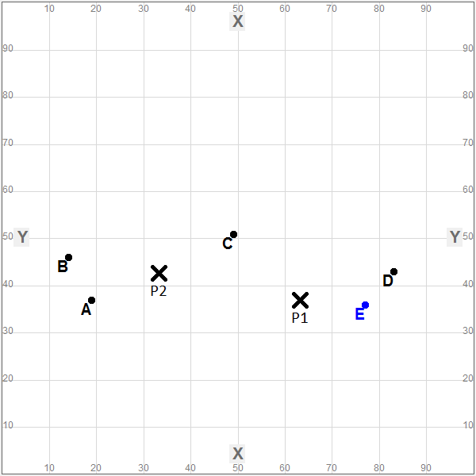

The course of the decision-making process in your group
Below we will explain to you the details of the decision-making process in your group. The sheet “Process of group decision making”, which we handed out to you as well, shows the decision-making process graphically.
Your group must choose a point from the decision space by majority rule. The decision-making process proceeds as follows:
First of all, each group member has the possibility to explore the decision space for 90 seconds. If you click on a point in the decision space with your mouse, in the table below the decision space you can see how many tokens you and the other group members would receive, if the group would choose this point in the following decision as the final result.
The real decision-making process begins after 90 seconds. The computer assigns the right to make a proposal randomly to one of the 5 members of your group with a time limit of 60 seconds. If you have been assigned the right to make a proposal you will then see the screen shown below:
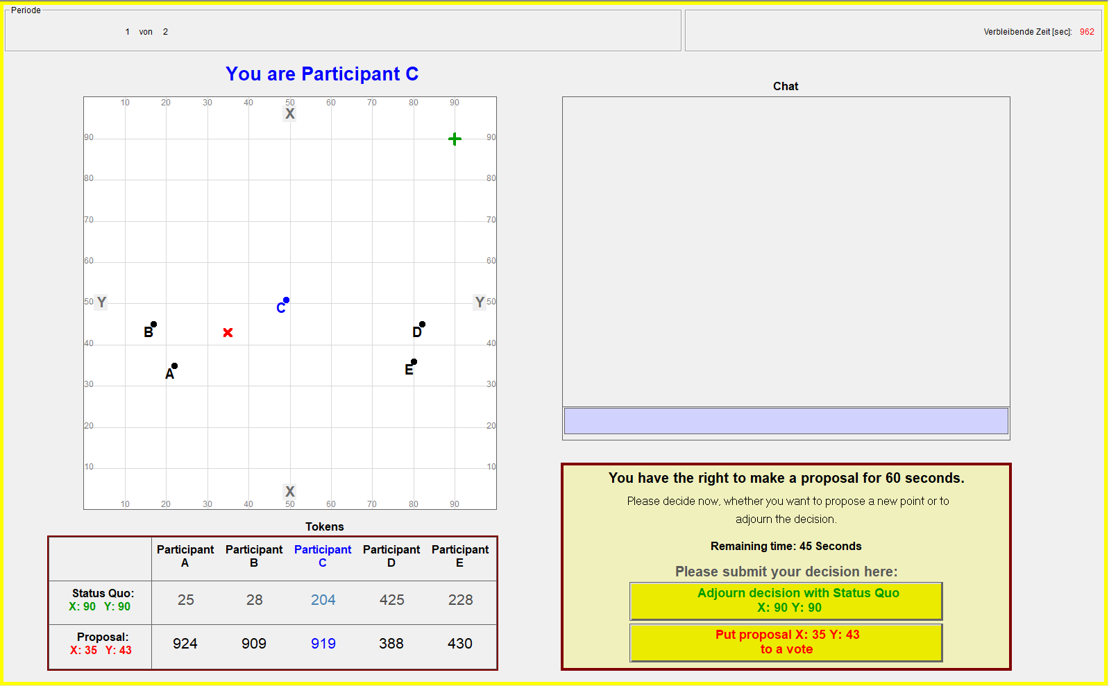
In every period there is a status quo point. At the beginning of each period, the status quo is located at the top right margin of the decision space and has the coordinates 90 units on the x-axis and 90 units on the y-axis. The status quo is represented in the decision space with a green ‚+‘. Your group can change the location of the status quo point during the experiment. The coordinates of the status quo at the end of a period become the final outcome of this period. The amount of tokens you will earn only depend on the final location of the status quo at the end of the period.

If you have the right to make a proposal, you have two options:
- You can propose to replace the current status quo by another point to your group.
- You can move to adjourn the decision-making process with the current status quo.
In the table below the decision space you can see how many tokens you and your group members would earn if the decision-making process would end up with the current status quo (in the example shown above 25 tokens for Participant A, 28 tokens for Participant B, 204 tokens for Participant C, etc.).
If you have the right to make a proposal you can click on any point in the decision space with the computer mouse. The point will then be marked with a red “X” in the decision space. In the table below the decision space you can see how many tokens you and your group members would earn if your group chooses the currently marked point as the final outcome (in the example shown above 924 tokens for Participant A, 909 tokens for Participant B, etc.).
If you want to propose to replace the status quo by the point with the red marked “X”, please click on the yellow button “Put proposal X:.. Y:.. to a vote”.
If you want to move to adjourn the decision-making process with the current status quo, please click on the yellow button “Adjourn decision with Status Quo X:.. Y:..”.
If you don’t use the right to make a proposal within 60 seconds, the computer will randomly choose another group member and assigned him the right to make a proposal within the next 60 seconds.
If the group member proposes to put a proposal to a vote, the group has to decide between the proposal and the current status quo. You will then see the following screen:
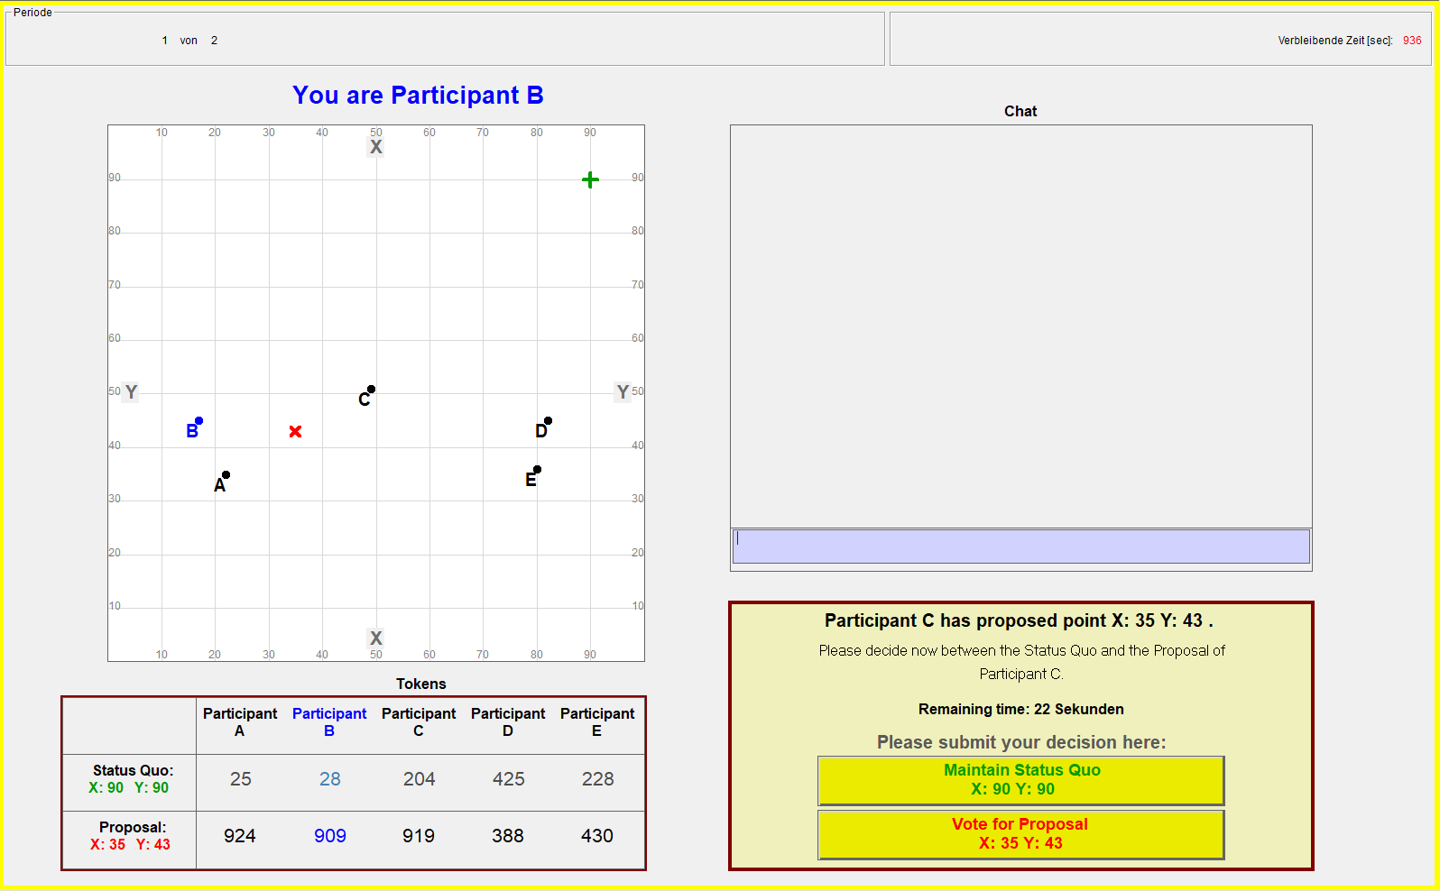
On the left you can see the decision space with the ideal points of all group members. The status quo is marked with a green ‚$+$‘. The proposal is marked with a red ‚X‘. The table below the decision space shows how many tokens you and your fellow group members would receive, if the group votes for the status quo as the final outcome of this period quo (in the example shown above: 25 tokens for Participant A, 28 tokens for Participant B, etc.). The row below shows the resulting distribution of tokens if the group would vote for the proposal as the final outcome (in the example shown above: 924 tokens for Participant A, 909 tokens for Participant B, etc.).
The voting procedure works as follows: Each group member has one vote. However, only the 4 group members without the right to propose do effectively vote. The vote of the participant who made the proposal will automatically be counted in favor of his own proposal. You can submit your choice with the yellow buttons to the right side of the table.
- If you want your group to maintain the status quo, please click the yellow button „Maintain Status Quo X:.. Y:..“.
- If you want your group to choose the current proposal as the result of the period, please click the yellow button „Vote for Proposal X:.. Y:..“.
All group members vote simultaneously. As long as you have not made a decision you will not get to know the decisions of the other group members in the current ballot.
Your group decides by majority rule. The alternative which gets 3 or more votes from the 5 members of the group wins. The group members have 30 seconds to vote. If a group member does not make a choice within the 30 seconds, his vote will automatically be counted to maintain the status quo.
The result of the voting procedure:
- If the majority of the group votes for the proposal, the proposal will become the new status quo.
- If the majority of the group votes for the status quo, the current status quo is maintained.
After the voting procedure the computer again assigns the right to make a proposal randomly to one of the group members. Again, the participant with the right to make a proposal has the possibility to propose either a new point or move to adjourn the period with the current status quo.

If the participant with the right to make a proposal proposes to adjourn the period with the current status quo, the group has to decide if the decision-making process shall end or not. In that case you will see the following screen:
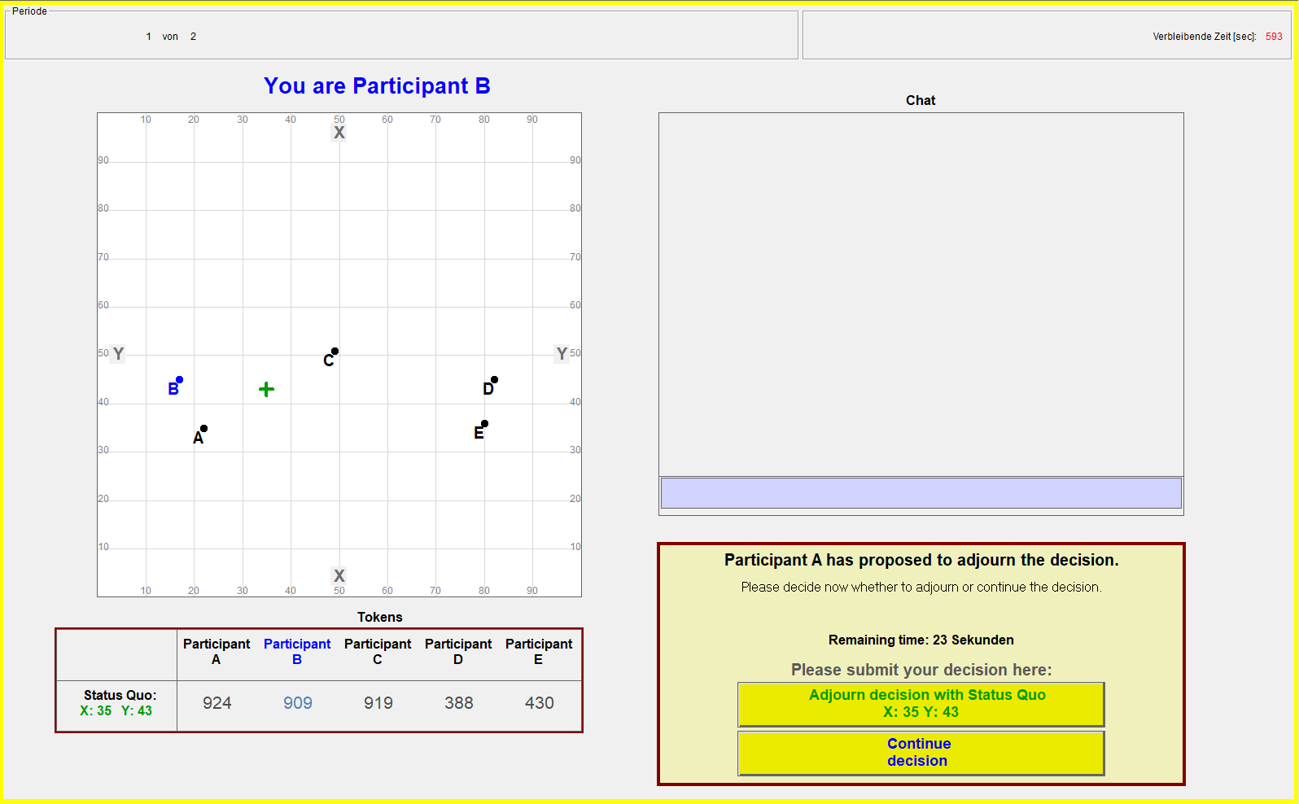
In the table below the decision space you can see how many tokens you and your fellow group members would earn if the decision-making process would conclude with the current status quo.
The voting procedure works as follows: Each of the group members has one vote. But only the 4 group members without the right to propose do actually vote. The vote of the participant who proposed to adjourn will automatically be counted to adjourn the decision with the current status quo. You can make your choice with two yellow buttons on the right side of the table.
- If you want your group to adjourn the decision with the current status quo, please click the yellow button „Adjourn decision with Status Quo X:.. Y:..“.
- If you want your group to continue the decision, please click the yellow button “Continue decision”.
All group members vote simultaneously. As long as you have not made a decision you will not get to know the decisions of the other group members in the ballot.
Your group decides by majority rule. The alternative which gets 3 or more votes from the 5 members of the group wins. Group members have 30 seconds to vote. If a member of the group does not make a choice within the 30 seconds, his vote will automatically be counted to continue the decision.
The result of the voting procedure:
- If the majority of the group votes to continue the decision, the process will be continued with the current status quo. A randomly chosen group member receives the right to make a proposal. Again, the participant with the right to make a proposal has the possibilities to propose either a new point or to move to adjourn the decision with the current status quo.
- If the majority of the group votes to adjourn the decision with the current status quo, the period ends. The status quo is the final result of the period, and all group members receive the amount of tokens that the current status quo promises to them.

Your group has 20 minutes to make a decision in a period. That means, a period ends either if a majority of group members votes to adjourn the decision – or the time limit of 20 minutes is reached.
Once all groups in the experiment finish the first period, the experiment will continue. It is possible that you have to wait a few moments until all of the other groups finish the first period.

Chat
During the decisions you have the possibility to communicate with the other members of your group via chat. You can type in your message in the grey chat window. The message will be sent by pushing the enter-key of your keyboard.
You are not allowed to reveal your identity while chatting with other group members. That means, you are not allowed to tell them your real name or the number of your cubicle. Furthermore, you are not allowed to insult or threaten other group members.

The end of the experiment
The computer will choose one of the two periods randomly at the end of the Experiment. The amount of tokens you have earned in that period are converted into EURO at a ratio of 1,1:100 (€1,10 per 100 tokens). Your total payment consists of the payment resulting from your tokens plus the „show-up-fee” of € 4.00.
Part of the experiment is a questionnaire which will start after the decision-making periods of the experiment. We guarantee that any information you enter there is treated anonymously and that your data will not be passed on to third parties.

In case you have questions, please raise your hand. We will come over to answer your question then.
Process of group decision-making
(1) The agenda setter has 60 seconds to either make a proposal or propose to adjourn decision making. If the agenda setter does not make a decision within 60 seconds the computer randomly recognizes a new group member as agenda setter.
(2) Group members have 30 seconds to make a decision. If a group member does not vote within 30 seconds her vote will automatically counted in favor of the status quo.
(3) Group members have 30 seconds to make a decision. If a group member does not vote within 30 seconds her vote will automatically counted against the move to adjourn.

Decision making starts
Status Quo: (90|90)
Status quo is the final result of the period

Period ends
► Majority votes in favor of proposal
► Majority votes in favor of status quo
► Majority rejects move to adjourn
► Majority approves move to adjourn
Group members decide between proposal and current status quo: ⁽²⁾
Group members vote on move to adjourn: ⁽³⁾
Proposal becomes new status quo
Current status quo is maintained
Computer randomly recognizes group member as agenda setter
Agenda setter ⁽¹⁾
► moves to adjourn
► makes new proposal

Please answer the following questions.

- How many members does your group have in total? ___

- What is the maximum number of points you can earn in one decision? ___

- Please have a look at the decision field on page 2 in the instructions of the experiment and imagine you are Participant A. Please have a look at P1 and P2.

  - The choice of which of the two points would earn you more points? ___

  - The choice of which of the two points would earn Participant D more points? ___

Please mark with a cross if the following statements are right or wrong.

- The composition of your group changes between periods.

right wrong

- The participant who has the right to make a proposal is always the same person.

right wrong

- If the group member with the right to make a proposal proposes a new point, and a majority of group members agree with that, the proposal becomes the new status quo.

right wrong

- The amount of points you will earn in one period depends only on the location of the status quo at the end of the period.

right wrong

The Competitive Solution (McKelvey, Ordeshook, and Winer 1978) and the Strong Point (Feld, Godfrey, and Grofman 2014) are examples of alternative preference-based constraints on majority rule. However, both concepts either fail experimental tests (McKelvey and Ordeshook 1983) or the predictive power of the UCS proves to be higher (Bauer-Bir et al. 2015).
Applying the same method as Bianco et al. (2006) for testing the predictive power of the UCS to the “Skew Star” treatment reveals that the UCS does not predict outcomes significantly better than just assuming that groups choose points randomly from the Pareto set (p=0.465; 2-sided binomial test.). Interestingly, Bianco et al. exclude Eavey’s (1991) study from their analysis, because it “examines fairness and universalism and therefore manipulates cardinal payoffs in unusual (nonsmooth) ways” (Bianco et al. 2006, 841-842). In comparison with other committee decision-making experiments, there is nothing “unusual” about Eavey’s (1991) induced payoffs. In fact, Eavey uses exactly the same functional form for inducing payoffs as Fiorina and Plott (1978), generally regarded as the standard-setting study for all committee decision-making experiments (see Grelak and Koford 1997, 579-580).
Note that Fiorina and Plott (1978) use very similar payout functions in Series 1 and 3 of their study.

