Supplementary Material for “If We Build It, Only Some Will Come: An Experimental Study of Mobilization for Seattle’s Democracy Voucher Program

Appendix A: Pre-Analysis Plan
We registered a pre-analysis plan for this research with Open Science Framework on August 17th, 2017. The pre-analysis plan can be accessed here.
The pre-analysis plan did not specify that heterogeneous treatment effects (HTEs) would be estimated for each voting history category. In the article, we estimate HTEs on voucher use and voting for high-propensity voters, medium-high-propensity voters, medium-low-propensity voters, and low-propensity voters. While these estimates offer corroborating evidence, they are not intended as the primary means of testing our hypotheses. We test Hypothesis 3 (shown as H2 in the paper, as the paper does not examine the effect of treatment assignment on voter turnout), which posits that there will be a positive interaction between treatment assignment and voting history, using Models 3 and 4 reported in Table 2. Rather, the HTEs by voting history are included in a descriptive figure (see Figure 2). The purpose of including this figure in the article is to visually demonstrate that the treatment effect is strongest among voters with the most robust voting histories.

Appendix B: Description of Experimental Universe
Table AB1. Description of Sample
Demographics | Percent of Experimental Universe
Asian/Pacific Islander | 30.88
Black | 21.63
Latinx | 8.24
White | 34.18
Under 35 | 59.69
Voting History
Unregistered | 8.87
New registrant | 6.22
Low propensity | 22.81
Medium low propensity | 48.50
Medium high propensity | 19.38
High propensity | 9.31
Note: The categories in the last four rows are calculated only for voters 22 and above, as younger voters were ineligible to vote in at least one of the four general elections we use to operationalize voting history.

Appendix C: Digital Advertisements
The digital advertisements that formed part of the treatment in this study included two videos and five graphics, each shared with voters in the treatment group via Facebook. Below are the links to the two videos:
Video 1, “What are Democracy Vouchers?” https://www.facebook.com/honestelectionsseattle/videos/1913314798943766/
Video 2, “Did you lose your Democracy Vouchers?”
https://www.facebook.com/honestelectionsseattle/videos/1938321756443070/
Below are the five graphics:
Figure AC1. Digital Advertisements
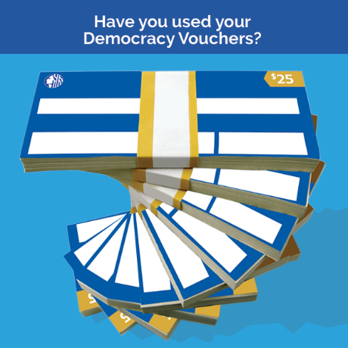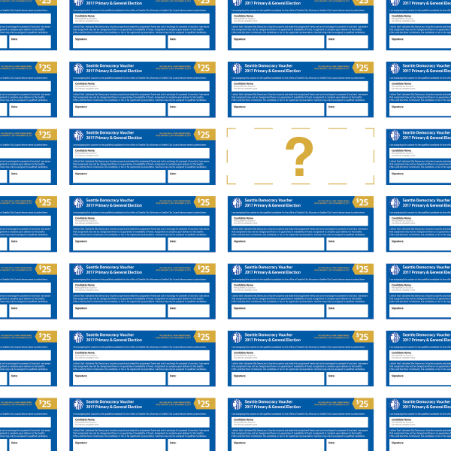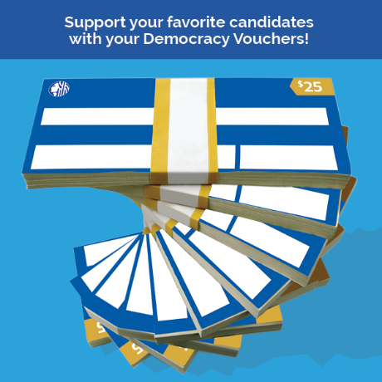
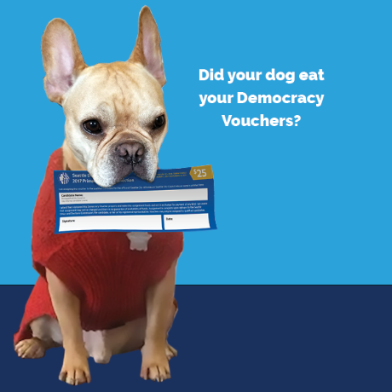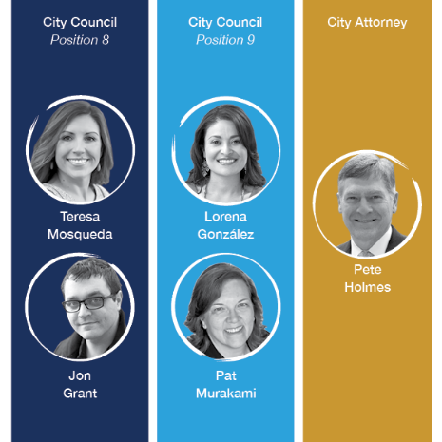

Appendix D: Door-to-Door Canvassing Script
Canvasser: Hi – Is BLANK home?
Hi BLANK, my name is BLANK. I’m with Washington Community Action Network. We’re talking to folks about using their democracy vouchers for Seattle City Council elections.
Have you received your democracy vouchers?
Yes or No
If YES, they have received their vouchers
Canvasser: That’s awesome! The general election is here – so if you want to support a candidate to help them win their elections, now is the time to send them in. Have you sent in your voucher yet?
Yes or No
If yes, they’ve received their voucher AND turned them in
That’s great! Have you ever given to a candidate before?
Yes or No
If yes, they’ve received their voucher, but have NOT turned them in
Do you know where your vouchers are right now?
When do you plan on filling it out and turning them in?
Do you know where to send them to?
Have you ever given to a candidate before?
Yes or No
If NO, they have not heard of/received vouchers
Canvasser: That’s ok. All registered voters and legal-permanent residents in Seattle are eligible to receive four $25 democracy vouchers. You can give the vouchers to the candidate of your choice running for local office to help fund their campaign. The idea is that people in our community, no matter how big their wallets are, should be able to contribute to campaigns, and that elected officials should be accountable to us – not just wealthy special interests that make big donations.
I can help you get your vouchers right now if you’ve misplaced them or direct you to the application form if you are not a registered voter.
Canvasser: If need replacement vouchers: legibly fill out form with name, date of birth, address, email, phone number, and preferred language.
If need to apply: Direct them to http://www.seattle.gov/democracyvoucher or call 206-727-8855

You can get more information on how to receive your vouchers by going online to this website (on lit), and I’m happy to answer any questions and help get you signed up now.
Conclusion
Canvasser – Thanks for taking the time – are there any more questions you have before I go?
Great! Have a great night and remember to use your vouchers AND to send in your ballot!

Appendix E: Sample text messages
Hey [name]! This is [name] a volunteer for Honest Elections Seattle. Elections are coming up...do you know about Democracy Vouchers? I'm here to help.

Appendix F: Sample e-mail messages
Figure AF1. Sample e-mail message
Subject: Use your Democracy Vouchers before November 7th

Dear [BLANK]

Seattle’s new Democracy Voucher program saw its first round of elections with the August 1st primary after being overwhelmingly approved by voters in 2015. The program, meant to counter the influence of big money in politics, empowered many Seattle voters to donate to the candidate of his or her choice for the first time. And get this -- they’re working. Several of the top candidates in this summer’s primary opted into the voucher program and centered their campaigns around the voices of everyday voters like you and me instead of powerful special interests.

Five candidates made it through the primary election and are eligible to receive your Democracy Vouchers. If you haven’t used your vouchers yet, now is the time!
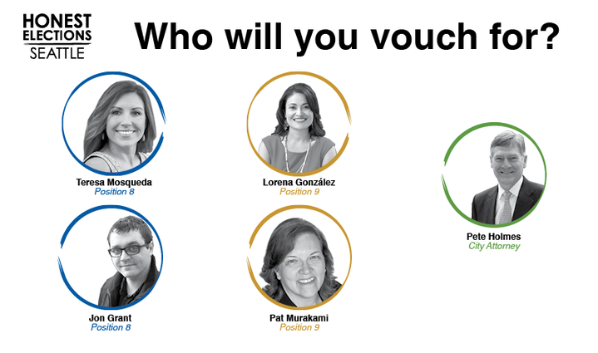
City Council At-Large Position 8

Jon Grant, People for Jon Grant

Teresa Mosqueda, People for Teresa

City Council At-Large Position 9

Lorena González, Elect Lorena

Pat Murakami, Pat Murakami for Seattle

City Attorney

Pete Holmes, Holmes for Seattle

You and every registered voter and legal permanent resident in Seattle should have four, $25 Democracy Vouchers. You should have received these vouchers in your mailbox.

If you’re vouchers never arrived or you need to request replacement vouchers, visit: http://www.seattle.gov/democracyvoucher/i-am-a-seattle-resident/voucher-replacement.

Real democracy is built on the participation of ordinary people working together to hold government accountable. With Democracy Vouchers, we can fund candidates from our communities who are accountable to us, not wealthy special interests.

SIGNATURE

Appendix G: Measurement of covariates
Educational attainment is a discrete, ordinal variable produced by recoding continuous educational attainment scores obtained from a voter database constructed by the company Catalist.
Income is a discrete, ordinal variable obtained from a voter database constructed by the company Catalist.
Age is measured as a discrete ordinal variable indicating the number of years since a voter’s birth, rounded down.
Female is measured as a binary variable with a value of 1 for women and a value of 0 otherwise.
African American is measured as a binary variable with a value of 1 for voters who identify as African American and 0 otherwise.
Asian is measured as a binary variable with a value of 1 for voters who identify as Asian and 0 otherwise.
Latino is measured as a binary variable with a value of 1 for voters who identify as Latino and 0 otherwise.

Appendix H: Randomization inference
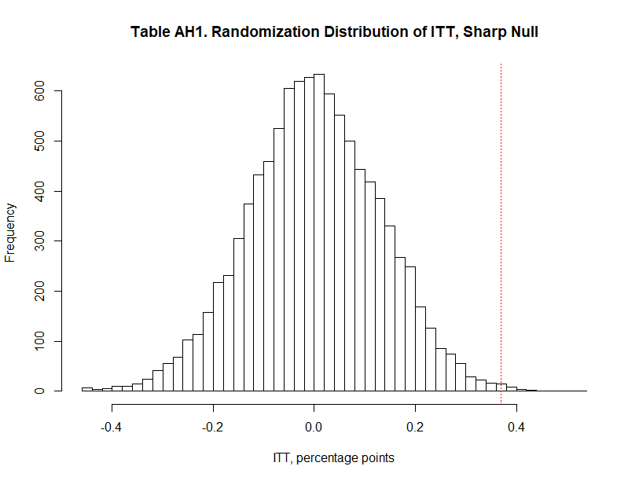

Point estimate (without block fixed effects): 0.003697596

P-value: 0.0026
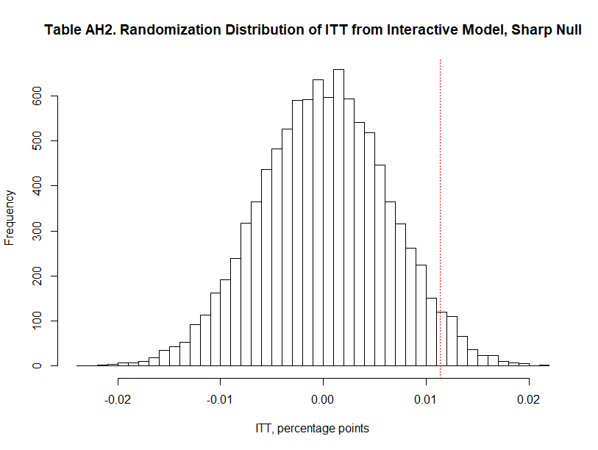
Point estimate (without block fixed effects): 0.011381598
P-value: 0.0366
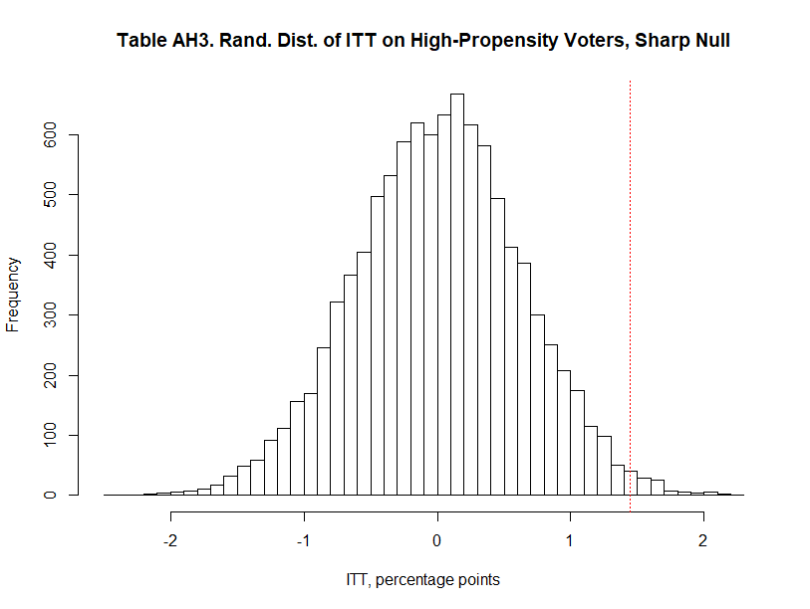
Point estimate (without block fixed effects): 0.01441675
P-value: 0.0107
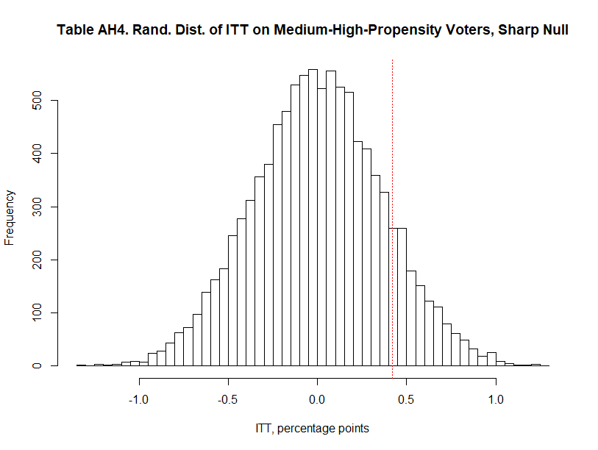
Point estimate (without block fixed effects): 0.004176003
P-value: 0.1269
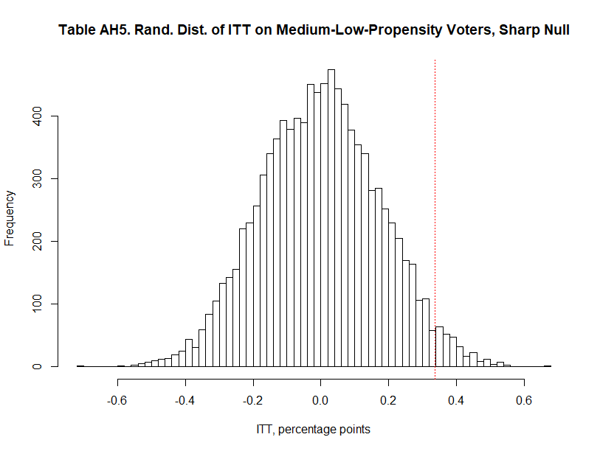
Point estimate (without block fixed effects): 0.003376291
P-value: 0.0284
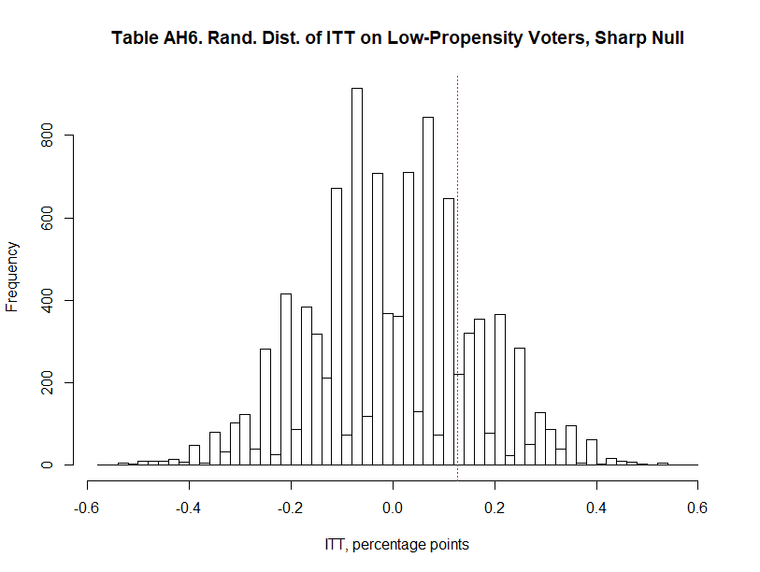
Point estimate (without block fixed effects): 0.001265398
P-value: 0.1994

Appendix I: Heterogeneous treatment effects shown in Figure 2
Table AI1. Heterogeneous Treatment Effects on Voucher Use by Voting History
Dependent variable: Voucher use
 | (5)  Low Propensity | (6)  Medium Low Propensity | (7)  Medium High Propensity | (8)  High Propensity
Treatment assignment | 0.002  (0.002) | 0.003**  (0.002) | 0.005  (0.004) | 0.015**  (0.006)
Block FEs | Yes | Yes | Yes | Yes
Constant | -0.001  (0.001) | 0.040  (0.027) | 0.047*  (0.028) | 0.070*  (0.037)
N | 8,697 | 18,495 | 7,391 | 3,552
R² | 0.033 | 0.009 | 0.029 | 0.035
Voucher use and treatment assignment are operationalized as dummy variables. In this analysis, we first create a separate sample for each vote history category. For each category, we fit a linear probability model to estimate intent-to-treat (ITT) effect, the effect of treatment assignment (rather than receipt of the treatment) on the likelihood of voucher use. Effects are expressed in percentage points. We cluster standard errors by household and add block fixed effects to account for the treatment assignment process, which randomized households within blocks. ***p<0.01; **p<0.05; *p<0.1, two-tailed test.

Appendix J: Results from analysis of voter turnout
Table AJ1. ITT Effects of Voter Mobilization on Voter Turnout
Dependent variable: Voter turnout
 | (9)  No covariates | (10)  With covariates | (11)  No covariates | (12)  With covariates
Treatment assignment | 0.002  (0.005) | 0.003  (0.005) | -0.002  (0.005) | -0.002  (0.006)
High-propensity voter |  |  | 0.173***  (0.014) | 0.171***  (0.014)
Win/Win organization member |  |  | 0.072***  (0.012) | 0.067***  (0.012)
Treatment assignment*High-propensity voter |  |  | 0.039**  (0.018) | 0.039**  (0.019)
Treatment assignment*Win/Win organization member |  |  | 0.000  (0.013) | 0.001  (0.013)
Educational attainment |  | 0.025***  (0.003) |  | 0.020***  (0.003)
Income |  | 0.031***  (0.003) |  | 0.028***  (0.003)
Age |  | 0.002***  (0.000) |  | 0.001***  (0.000)
Female |  | -0.001  (0.004) |  | -0.003  (0.004)
Asian |  | -0.075***  (0.007) |  | -0.080***  (0.007)
Black |  | -0.065***  (0.007) |  | -0.072***  (0.007)
Latinx |  | -0.077***  (0.009) |  | -0.077***  (0.009)
Block fixed effects | Yes | Yes | Yes | Yes
Constant | 0.534***  (0.046) | 0.344***  (0.046) | 0.468***  (0.044) | 0.324***  (0.045)
N | 41,414 | 37,511 | 38,135 | 34,737
R² | 0.107 | 0.125 | 0.129 | 0.140
We fit four linear probability models to estimate intent-to-treat (ITT) effects—the effects of treatment assignment (rather than receipt of the treatment) on the likelihood of voting. Effects are expressed in percentage points. We cluster standard errors by household and add block fixed effects to account for the treatment assignment process, which randomized households within blocks. Models 11 and 12 exclude voters below the age of 22, as these voters were ineligible to vote in at least one of the elections that we use to operationalize the high-propensity voter variable. ***p<0.01; **p<0.05; *p<0.1, two-tailed test.

Appendix K: Heterogeneous treatment effects shown in Figure 2
Table AK1. Heterogeneous Treatment Effects on Voter Turnout by Voting History
Dependent variable: Voter turnout
 | (13)  Low Propensity | (14)  Medium Low Propensity | (15)  Medium High Propensity | (16)  High Propensity
Treatment assignment | 0.001  (0.006) | -0.002  (0.007) | -0.001  (0.012) | 0.037**  (0.018)
Block FEs | Yes | Yes | Yes | Yes
Constant | 0.800***  (0.180) | 0.355***  (0.083) | 0.574***  (0.072) | 0.713***  (0.071)
N | 8,697 | 18,495 | 7,391 | 3,552
R² | 0.128 | 0.023 | 0.041 | 0.040
Voter turnout and treatment assignment are operationalized as dummy variables. In this analysis, we first create a separate sample for each vote history category. For each category, we fit a linear probability model to estimate intent-to-treat (ITT) effect, the effect of treatment assignment (rather than receipt of the treatment) on the likelihood of voting. Effects are expressed in percentage points. We cluster standard errors by household and add block fixed effects to account for the treatment assignment process, which randomized households within blocks. ***p<0.01; **p<0.05; *p<0.1, two-tailed test.

