Appendix for Measuring Simultaneous Emotions: Existing Problems and A New Way Forward
A.1: Measurement model estimation results.
The following tables present the parameter estimate and goodness of fit statistics for the measurement models related to our discrete emotions for all three studies. Factor variances were fixed at 1 for identification purposes.
Study 1
 | Fear |  |  | Anger |  |  | Negative Affect
Factor Loadings | Est. | SE | p-value | Est. | SE | p-value | Est. | SE | p-value | Intercept | Variance
Anxious | .720 | .025 | .000 | - | - | - | - | - | - | 1.64 | .481
Afraid | .781 | .023 | .000 | - | - | - | - | - | - | 1.56 | .388
Angry | - | - | - | .788 | .025 | .000 | - | - | - | 1.48 | .377
Hostile | - | - | - | .746 | .026 | .000 | - | - | - | 1.50 | .441
Upset | - | - | - | - | - | - | .706 | .024 | .000 | 1.69 | .501
Ashamed | - | - | - | - | - | - | .590 | .029 | .000 | 1.49 | .652
Distressed | - | - | - | - | - | - | .789 | .022 | .000 | 1.65 | .378
Variances and  Covariances | Est. | SE | p-value
Angry and upset | .274 | .050 | .000
Angry and ashamed | .246 | .054 | .000
Hostile and ashamed | .357 | .049 | .000
Afraid and ashamed | .243 | .044 | .000
Anger and fear | .720 | .034 | .000
Anger and negative  affect | .782 | .030 | .000
Fear and negative  affect | .889 | .026 | .000
Anger | 1.000 | - | -
Fear | 1.000 | - | -
Negative Affect | 1.000 | - | -
Goodness of fit  Statistic | Est. | p-value
Chi-square | 13.72 | .056
RMSEA | .035 | .769
CFI | .997 | -

Note: results included are for the pooled sample. Goodness of fit statistics and parameter estimates did not differ significantly by PANAS version.

Study 2
 | Fear |  |  | Anger |  |  | Negative Affect
Factor Loadings | Est. | SE | p-value | Est. | SE | p-value | Est. | SE | p-value | Intercept | Variance
Anxious | .755 | .017 | .000 | - | - | - | - | - | - | 1.05 | .430
Afraid | .871 | .014 | .000 | - | - | - | - | - | - | .893 | .242
Angry | - | - | - | .884 | .014 | .000 | - | - | - | .890 | .219
Hostile | - | - | - | .729 | .018 | .000 | - | - | - | .776 | .469
Upset | - | - | - | - | - | - | .799 | .017 | .000 | 1.13 | .361
Distressed | - | - | - | - | - | - | .755 | .016 | .000 | 1.10 | .429
Disturbed | - | - | - | - | - | - | .817 | .016 | .000 | 1.00 | .333
Variances and  Covariances | Est. | SE | p-value
Anxious and distressed | .193 | .038 | .000
Upset and disturbed | -.120 | .060 | .044
Anger and fear | .815 | .021 | .000
Anger and negative  affect | .863 | .078 | .000
Fear and negative  affect | .867 | .018 | .000
Anger | 1.000 | - | -
Fear | 1.000 | - | -
Negative Affect | 1.000 | - | -
Goodness of fit  Statistic | Est. | p-value
Chi-square | 66.050 | .000
RMSEA | .063 | .003
CFI | .985 | -
Note: results included are for the pooled sample. Goodness of fit statistics and parameter estimates did not differ significantly by PANAS version. Goodness of fit statistics indicate moderately good fit; stats for each PANAS version individually indicated excellent fit.

A.2: OLS regression analysis
Multigroup SEM allows us, using Wald tests, to compare the effects of treatments across PANAS versions in the way we find most intuitive. That said, intuitiveness is inherently subjective and many scholars may prefer results from more typically used analytical techniques, such as OLS regression. This poses a challenge because OLS does not allow for multigroup analysis. However, we can closely (but not entirely) replicate the analyses presented in Table 2 using OLS techniques by including PANAS version as a predictor variable, interacted with treatment. Results of analyses of the effect so these variables on anger and fear are presented in the figures below.
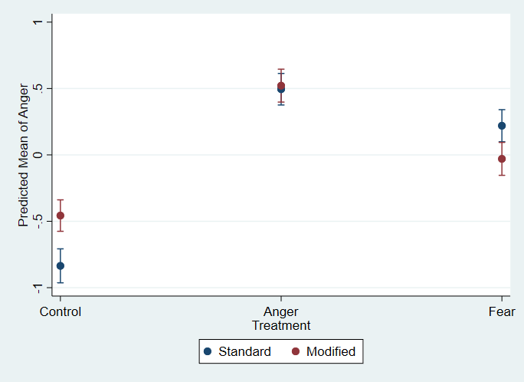

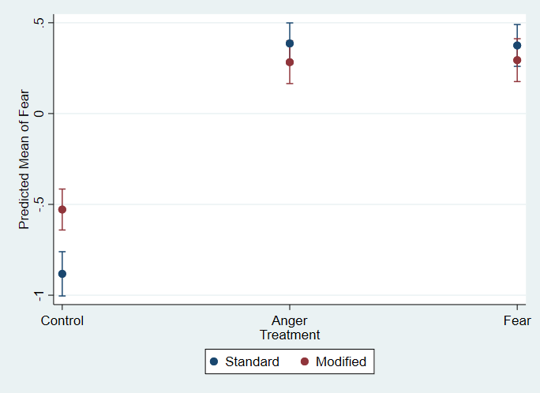
The results of these analyses were very similar to those obtained when using multigroup SEM. In no case does the PANAS-V perform worse than the PANAS-M. It does perform better in one instance: the fear treatment produced less anger when using the PANAS-M then when using the PANAS-S. The PANAS-M does seem to produce a higher level of “baseline” emotional arousal; i.e. respondents in the control group reported stronger emotional arousal when using the PANAS-M. Yet, given the overall similarity between the performance of each version, and the substantially lower correlations between anger and fear when using the PANAS-M, these results support the use of our measure.
A.3: Correlations of anger and fear with popularism
In the table below, we produce bivariate correlations of anger and fear, by PANAS version, with popularism. A regression based on the same data is presented in Table 1 of the manuscript.
Correlation with  popularism | Rho
PANAS-S
Anger | -.1084
Fear | -.0759
PANAS-M
Anger | .0841
Fear | .0402

These results further underline the importance of precise measurement. Despite the similarity of the two PANAS versions, they produce emotional measures with opposite correlations with an important independent variable.
A.4: Balance Statistics
The following tables display balance statistics for each study included in the manuscript. Statistics are displayed by gender and region (percentages) and by ideology, age, education, income (means). Balance statistics are important because, even with a perfect method of randomizing treatment assignment, demographic imbalances can occur by chance, and these imbalances can contaminate estimation of treatment effects. We did not detect any significant imbalances in any of our studies.
Study 1
Gender | Control | Anger,  Video | Fear,  Video | Anger,  Text | Fear,  Text
Male | 62.09 | 56.21 | 54.25 | 56.83 | 56.59
Female | 37.25 | 43.15 | 45.10 | 42.45 | 43.41
Other/Nonbinary | .65 | .65 | .65 | .72 | .00
Person Chi-square | 3.05
p-value | .931

Region | Control | Anger,  Video | Fear,  Video | Anger,  Text | Fear,  Text
Southeast | 34.00 | 29.61 | 28.29 | 32.61 | 33.07
Northeast | 24.67 | 20.39 | 25.66 | 25.36 | 19.69
Midwest | 22.67 | 23.03 | 20.39 | 15.94 | 22.83
West | 9.33 | 16.54 | 10.53 | 15.22 | 8.66
Southwest | 8.67 | 10.53 | 14.47 | 10.87 | 15.75
Outide Continental US | .67 | .00 | .66 | .00 | .00
Person Chi-square | 18.36
p-value | .564
Means (Standard Error) | Control | Anger,  Video | Fear,  Video | Anger,  Text | Fear,  Text
Ideology | 3.31  (.147) | 3.43  (.147) | 3.53  (.147) | 3.54  (.154) | 3.46  (.160)
Education | 4.30  (.106) | 4.43  (.106) | 4.25  (.106) | 4.42  (.111) | 4.40  (.115)
Income | 5.93  (.242) | 5.69  (.242) | 5.84  (.242) | 5.53  (.254) | 5.53  (.626)
Age | 37.10  (.908) | 35.75  (.908) | 37.88  (.911) | 35.64  (.952) | 35.67  (.992)

Study 2
Gender | Control | Anger | Fear
Male | 51.69 | 52.99 | 51.38
Female | 47.69 | 47.01 | 48.32
Other/Nonbinary | .62 | .00 | .31
Person Chi-square | 2.2
p-value | .698
Region | Control | Anger | Fear
Southeast | 34.77 | 31.44 | 27.83
Northeast | 20.92 | 19.76 | 19.57
Midwest | 23.69 | 20.36 | 22.63
West | 12.31 | 15.27 | 18.04
Southwest | 8.00 | 11.98 | 11.93
Outide Continental US | .31 | 1.20 | .00
Person Chi-square | 15.3
p-value | .121
Means (Standard Error) | Control | Anger | Fear
Ideology | 3.53  (.104) | 3.65  (.103) | 3.46  (.103)
Education | 4.18  (.073) | 4.22  (.072) | 4.20  (.073)
Income | 5.61  (.171) | 5.89  (.168) | 6.13  (.170)
Age | 36.60  (.615) | 36.67  (.607) | 36.66  (.612)

A.5: Treatment video links and discussion
In this study, participants were assigned to three groups. The first was a control group, which watched a video, similar in length to the treatment videos, of a man making a sandwich wrap. This control was chosen to create an experience for participants of watching a video that was not expected to cause an emotional response, so we could isolate the effects of video content from the simple experience of watching a 3 (in Study 1) or 2 (in Study 2) minute long video.
The treatment videos for anger and fear featured the same general video clip of a family devastated by the 2008-2009 global financial crisis. This video, made available by CBS news, shows a family who went from distinctly middle class (earing $85,000 a year) to lower class (earning $22,000 per year). The differences between the anger and fear conditions were text placards we added to this video. The fear group received text designed to de-emphasize blame attributions, describing the crisis as unavoidable, and noting that it was likely to happen again in the near future. The anger group received text noting that wealthy interests were responsible for the crisis, and that they have not been punished for their actions. This was done to allow for blame attribution, and to minimize the risk of future crises.
Study 1
Control: https://youtu.be/pXe_Wt-Qu4E
Anger: https://youtu.be/A_Wf5xHxifc
Fear: https://youtu.be/gZW68yk_rbs
Study 2
Control: https://youtu.be/pXe_Wt-Qu4E
Anger: https://youtu.be/mVzaR5vFeHE
Fear: https://youtu.be/Tp8Kj1F_u7k

