Supplementary Material for an Online Appendix

Appendix
Table A1 – Saliency and Downstream Effects in Existing Studies
Original Study | Context | Downstream Effects
Gerber et al., 2008 | Series of experiments conducted in August 2006 primaries, Michigan. | Mixed. Some effects continued at Nov 2006 general election, Jan 2008 primaries, and August 2008 primaries. Effects decayed at Nov 2008 presidential election.
John and Brannan, 2007/Cutts et al., 2009
Gerber et al., 2010 | Nov 2007 municipal election and August 2008 primaries. | Effects disappear at November 2008 presidential election.
Mann, 2010 | 2007 gubernatorial | Effects continued at both high (Nov 2008 general election) and low (June 2008 primaries) turnout elections.
Panagopoulos, 2010 | Nov 2007 municipal elections | Effects mostly persisted at November 2008 presidential election.
Davenport, 2010 | Nov 2007 municipal elections | Effects persist at the 2008 presidential primaries, but not at the September 2008 primary or the 2008 general election.
Hill and Kouser, 2015 | 2014 California presidential primary | Effects do not persist at the November presidential election.

Table A2 – Turnout Effects of Treatment at Election 1 (May 2018)
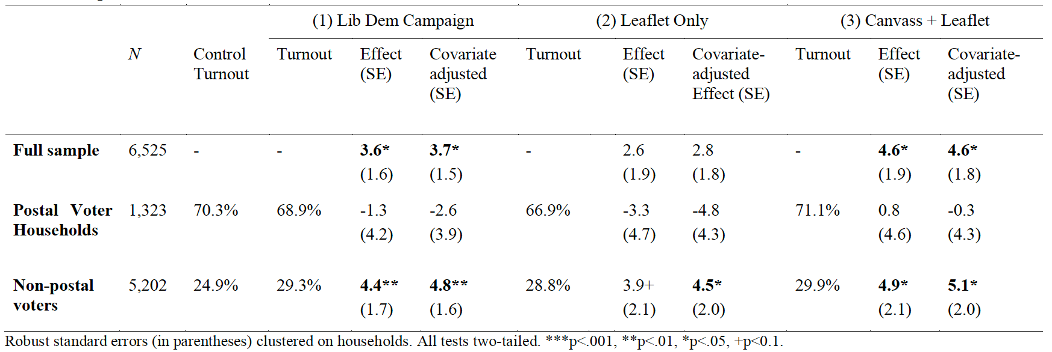

Figure A1. Liberal Democrat Leaflet Delivered in April/May 2018

Figure A2. Canvass script for postal voter households
“Hello, my name is ______, I am a volunteer for the local Liberal Democrats. I’m just calling round to remind you that the Suffolk County Council elections are coming up, and that it’s important that you have your say in how our area is run.

The local Lib Dem candidate, Jon James, will be a strong voice for our area, and will fight to improve local transport and health services.

According to our records, you are registered for a Postal Vote. Your Postal Vote papers should be arriving over the next few days, so just keep an eye out for those, then you can vote, send it off, and you’ve had your say.

Thank you for your time, have a good day”

Figure A3. Canvass script for non-postal voter households
“Hello, my name is ______, I am a volunteer for the local Liberal Democrats. I’m just calling round to remind you that the Suffolk County Council elections are coming up, and that it’s important that you have your say in how our area is run.

The local Lib Dem candidate, Jon James, will be a strong voice for our area, and will fight to improve local transport and health services.

Your local polling station is located at ____________.

Thank you for your time, have a good day”

Table A3. Sample size and contact rates by treatment group
 | Registered Voters | Leaflet Contact Rate | Canvass Contacts achieved | Canvass Contact Rate
Postal Voter Households
Canvass + Leaflet | 515 | 100% | 143 | 28%
Letter only | 541 | 100% | - | -
Control | 269 | - | - | -
Non-Postal Voter Households
Canvass + Leaflet | 1,095 | 100% | 302 | 28%
Leaflet only | 1,136 | 100% | - | -
Control | 2,969 | - | - | -
N | 6,525

Attrition and Balance Checks
First, because the analysis is essentially a panel design, it is necessary to examine if there has been any attrition in the sample of voters between the May and June elections. We would expect a proportion of subjects from the experiment to fall off the electoral register between May and June due to ineligibility, deceases, or moving away from the area. However, given the short space of time between the May local election, and the June general election, the rate of attrition was relatively low. After the marked electoral registers were checked after the June general election, 253 voters from the original sample of 6,525 voters could not be found. Following the June general election, the overall sample size therefore fell from 6,525 to 6,272, representing a total attrition rate of 3.9%. Furthermore, the rate of attrition between the treatment and control groups are broadly similar. The rates of attrition in each experimental component, and each treatment/control group separately are presented in the table below.

Table A4. Rates of Attrition in Treatment and Control Groups
Assigned Group | Attrition Rate
Full Sample | 3.9%
Non-Postal Voter Groups | 3.3%
Control | 2.7%
Leaflet | 3.8%
Leaflet + Canvass | 4.4%
Postal Voter Groups | 6.1%
Control | 4.5%
Leaflet | 6.7%
Leaflet + Canvass | 6.4%

We can examine whether, following attrition between May and June, the balance of pre-treatment covariates between assignment groups does not differ substantially. Randomisation ensures that observable and unobservable characteristics of the experimental subjects should be balanced between treatment and control groups (Gerber and Green, 2012). However, given that there are small differences in the rates of attrition between the assignment groups, we can check again for balance between pre-treatment covariates among those subjects for whom data is available in June. Table A5 presents the balance of available individual-level characteristics across the treatment and control groups. This data was obtained through the local Liberal Democrats’ voter ID database. As Table A5 shows, the covariates do not vary appreciably between assignment groups. To verify the randomisation statistically, I follow the procedure outlined by Gerber and Green to test whether imbalances are larger than one would expect from chance alone (2012: 109). I run a multinomial logistic regression model (Table A6) to test whether assignment to treatment groups is significantly related to available individual-level covariate data. The results show that all covariates taken together do not significantly predict assignment to treatment conditions, increasing confidence that attrition did not affect the initial randomisation process. The pre-treatment covariate data is also used in the subsequent analysis, as per the pre-registration and pre-analysis plan, and includes sex, party support based on previous canvass analysis, ward, previous turnout, and age group.

Table A5. Balance of Pre-Treatment Covariates between Assignment Groups, % (n)
 | Postal Voter Households |  |  | Non-Postal Voter Households
 | Control | Leaflet Only | Canvass + Leaflet | Control | Leaflet Only | Canvass + Leaflet
Lib Dem | 7.4  (19) | 8.3  (42) | 7.1  (34) | 11.3  (326) | 11.1  (121) | 10.4  (109)
Women | 50.2  (129) | 52.7  (266) | 54.4  (262) | 51.4  (1,485) | 50.7  (554) | 50.8  (532)
Voted ‘09 | 49.8  (128) | 46.9  (237) | 46.5  (224) | 25.9  (747) | 23.9  (261) | 24.3  (254)
Age 60+ | 8.2  (21) | 10.5  (53) | 7.5  (36) | 7.8  (226) | 7  (76) | 7.8  (82)
Age 35-59 | 4.3  (11) | 2.8  (14) | 2.5  (12) | 2.7  (77) | 2.4  (26) | 2.2  (23)
Age Under 35 | 8.2  (21) | 7.1  (36) | 8.3  (40) | 7.9  (227) | 8.8  (96) | 5.6  (59)
Voted in 2009 most recent turnout data available in Thedwastre North. While more recent turnout data would be preferable, it is the balance between the groups that is crucial.

Table A6 – Multinomial regression of assigned on pre-treatment covariates after attrition
N=5,028 | LR chi2=18.54 | Prob > chi2=0.1003 | Pseudo R2=0.002
assigned group |  | Coefficient | SE | P>|z|
NPV Control (base outcome)
NPV Leaflet
 | attrition | 0 | (omitted)
 | partysupport | 0.118808 | 0.0728863 | 0.103
 | woman | -0.0332255 | 0.0711473 | 0.641
 | votedin09 | -0.0644537 | 0.0859393 | 0.453
 | pvhousehold | 0 | (omitted)
 | age60 | -0.0726262 | 0.1412698 | 0.607
 | age3559 | -0.0911274 | 0.2309003 | 0.693
 | ageunder35 | 0.0706419 | 0.1296399 | 0.586
 | _cons | -1.150081 | 0.1466865 | 0
NPV Leaflet + Canvass
 | attrition | 0 | (omitted)
 | partysupport | -0.0818554 | 0.0672394 | 0.223
 | woman | -0.0293899 | 0.0723056 | 0.684
 | votedin09 | -0.1303804 | 0.0868751 | 0.133
 | pvhousehold | 0 | (omitted)
 | age60 | -0.0220448 | 0.1379297 | 0.873
 | age3559 | -0.2292053 | 0.2415814 | 0.343
 | ageunder35 | -0.3759909 | 0.1529143 | 0.014
 | _cons | -0.7900643 | 0.135432 | 0
N=1,244 | Lr chi2=14.33 | Prob>chi2=0.426 | Pseudo R2=0.005
assigned group |  | Coefficient | SE | P>|z|
PV Control
 | attrition | 0 | (omitted)
 | partysupport | -0.016164 | 0.1555752 | 0.917
 | woman | -0.1060192 | 0.1540374 | 0.491
 | votedin09 | 0.1700647 | 0.1624194 | 0.295
 | pvhousehold | 13.03161 | 960.846 | 0.989
 | age60 | -0.314935 | 0.2777899 | 0.257
 | age3559 | 0.4090657 | 0.41367 | 0.323
 | ageunder35 | 0.1938702 | 0.2938457 | 0.509
 | _cons | -13.7033 | 960.8461 | 0.989
PV Leaflet (base outcome) |  | outcome)
PV Leaflet + Canvass
 | attrition | 0 | (omitted)
 | partysupport | 0.297865 | 0.1476941 | 0.044
 | woman | 0.057098 | 0.1284203 | 0.657
 | votedin09 | 0.0818927 | 0.1353326 | 0.545
 | pvhousehold | 13.06282 | 701.6121 | 0.985
 | age60 | -0.3569237 | 0.2329295 | 0.125
 | age3559 | -0.0882777 | 0.4022902 | 0.826
 | ageunder35 | 0.1165607 | 0.2450439 | 0.634
 | _cons | -13.70249 | 701.6121 | 0.984

