APPENDIX A: Study Information and Models Referenced in the Manuscript

Table A1: Sample Demographics
Age | Mean=46  Range=19-83
Gender* | 66% Female  34% Male
Race | 74.5% White  8.4% Black  6.4% Hispanic  .4% American or Alaskan Native  7.7% Asian  .5% Native Hawaiian or Pacific Islander  2.1% Other
Income | Mean=$50,000-$59,000  1.5% Declined to State
Partisanship | 25.7% Strong Democrat  19.3% Democrat  13..0% Lean Democrat  9.8% Pure Independent  6.6% Lean Republican  14.4% Republican  11.0% Strong Republican
Ideology | 13.5% Very Liberal  25.3% Liberal  14.5% Somewhat Liberal  19.6% Moderate; Middle of the Road  11.5% Somewhat Conservative  10.6% Conservative  5.1% Very Conservative
In addition, there was at least one subject from every U.S. state except Vermont.
Percentages may not add to 100 due to rounding.
*For more on this imbalance, see Table A8.
Results from the Pretest of the Candidate Pictures

We gathered 10 stock photos – 5 male and 5 female – from the internet and pretested them on a convenience sample of students in February 2017. For each photo, respondents were asked to rate:
Attractiveness: 7-point scale ranging from “far above average” to “far below average.”
Age: 7-point scale ranging from “18-24” to “75 or above”
Race: Scale with choices for White, Black, Hispanic, American or Alaskan Native, Asian, Hawaiian Native or Pacific Islander, and Other
Competence: 7-point scale ranging from “extremely competent” to “extremely incompetent”
Professionalism: 7-point scale ranging from “extremely professional” to “extremely unprofessional”
Overall Likability: 7-point scale ranging from “like a great deal” to “dislike a great deal”

80 students completed the survey. We chose the two pictures that received the most similar ratings.

Table A2: Pretest Ratings of the Male and Female Picture Treatments
 | Male Picture | Female Picture | Diff. | Scale
Attractiveness | 3.96 (1.28) | 4.28 (1.18) | .32 NS | 4=ave.
Age | 4.48 (.80) | 4.53 (.09) | .05 NS | 4=45-54,  5=55-64
Race | 1.24 (1.00) | 1.28 (1.20) | .04 NS | 1=white
Competence | 2.50 (1.27) | 2.69 (1.15) | .19 NS | 2=moderately, 3=slightly
Professionalism | 2.35 (1.25) | 2.66 (1.09) | .31 NS | 2=moderately, 3=slightly
Likability | 2.59 (1.38) | 3.14 (1.26) | .55 p<.01 | 2=moderately, 3=slightly

Although there was a significant difference on likability, an experiment run in March 2017 utilized these same pictures and statements. Respondents in this experiment used the same 5-point scale used in the experiment presented in this manuscript.

Table A3: Likability Ratings from a March 2017 Experiment
Male Picture | Female Picture | Difference
3.39  (.89)  N=401 | 3.48  (.88)  N=401 | .09 NS

Table A4: Factor Loadings of Candidate Traits

 | Integrity | Ability | Performance
Likable | .60
Competent |  | .76
Sincere | .70
Qualified to Mayor |  |  | .63
Stable |  |  | .69
Dependable in a Crisis |  |  | .66
Trustworthy | .60
Intelligent |  | .55

Table A5: Regression Analyses of Change in Trait Ratings by Candidate Sex and Party
McKinley as a Democrat
 | Integrity | Ability | Performance
Female Candidate | .03  (.11) | .02  (.12) | .07  (.11)
Opposite Party of McKinley | .54  (.13) | .64**  (.14) | .51**  (.14)
Female X Opposite Party | -.27  (.19) | -.45**  (.20) | -.41**  (.20)
Constant | -1.22**  (.08) | -1.16**  (.08) | -1.12**  (.08)
N | 531
McKinley as a Republican
Female Candidate | .14  (.14) | .10  (.16) | .27*  (.15)
Opposite Party of McKinley | .21  (.13) | .09  (.14) | .08  (.13)
Female X Opposite Party | -.46**  (.18) | -.34*  (.20) | -.49  (.19)
Constant | -1.07**  (.10) | -1.04**  (.11) | -.99**  (.10)
N | 535
**=p<.05; *=p<.10
Table A6: Candidate Preference after Exposure to Article; Model Used to Generate Figure 4

 | Coefficient (Standard Error)
Opposite Party of McKinley | .67 (.37)
McKinley as a Woman | .97* (.30)
1st Preference for McKinley | 1.44* (.28)
Opposite Party X Woman | -.53 (.49)
Opposite Party X 1st Preference | .35 (.45)
Woman X First Preference | -.68 (.38)
Opposite Party X Woman X 1st Preference | .02 (.61)
Constant | -1.59* (.23)
N | 1,055
*=p<.05

Table A7: Ordinal Logit Analyses of Agreement with Statements about Candidate McKinley
 | McKinley Intentionally Lied | McKinley Should Not be Punished
McKinley as a Woman | -.50*  (.15) | .38*  (.15)
Subject Opposite Party of McKinley | .07  (.15) | -.10  (.15)
McKinley Woman X Opposite Party | .72*  (.22) | -.83*  (.22)
Cutpoint 1 | -3.34*  (.19) | -1.96*  (.13)
Cutpoint 2 | -1.52*  (.12) | -.39*  (.11)
Cutpoint 3 | -.17  (.11) | 1.07  (.11)
Cutpoint 4 | 1.20*  (.12) | 2.70*  (.16)
N | 1,058
*=p<.05
Table A8: Inparty 2nd Preference for McKinley when 1st Preference was Campbell by Subject Sex and Partisanship

Though only the results for Democratic women are significant, this is likely due to the smaller Ns of the other groups. We point to this table as evidence for the claim that although there is a sex imbalance in our sample, this does not appear to drive the results presented in the paper.

 | McKinley as a Woman | McKinley as a Man | Difference
Democratic Women | .22 (.42)  N=112 | .11 (.31)  N=137 | .11*
Republican Women | .23 (.43)  N=47 | .17 (.38)  N=53 | .06
Democratic Men | .20 (.40)  N=56 | .10 (.31)  N=49 | .10
Republican Men | .29 (.46)  N=38 | .16 (.37)  N=43 | .13
Entries are means with standard deviations in parentheses. *=p<.05

APPENDIX B: Additional Study Information and CONSORT Participant Diagram

            - Hypotheses
              - H1: Following a factually dubious claim, female candidates will be penalized more than male candidates when they are from the opposite party of the citizen.
              - H2: Following a factually dubious claim, inpartisans’ evaluations of female candidates will be equal to or higher than those given to male candidates.
            - Subjects and Context
              - Participants were recruited from Amazon’s Mechanical Turk (MTurk).
              - MTurkers were eligible to participate if they had a U.S. IP address and a reputation ranking of ≥90%.
              - All responses were gathered online via Qualtrics.
              - The study took place between June 27 and July 4, 2017.
            - Allocation Method
              - Subjects were randomized at the individual level using Qualtrics software.
4. Treatments
a. Treatment texts are available in Figures 1 and 2 of the manuscript.
b. All treatments were delivered through MTurk.
5. Results
a. All measures are included in Appendix C.
b. Information of the construction of the trait indices can be found in Table A4.
c. Partisan and gender subgroup analyses can be found in Tables A5 and A8.
d. The consort flow diagram and attrition by condition can be found below.
6. Other Information
a. IRB approval obtained from the University of Houston.
b. Data available at: https://doi.org/10.7910/DVN/GE3E8RResults

Figure B1: CONSORT Flow Diagram
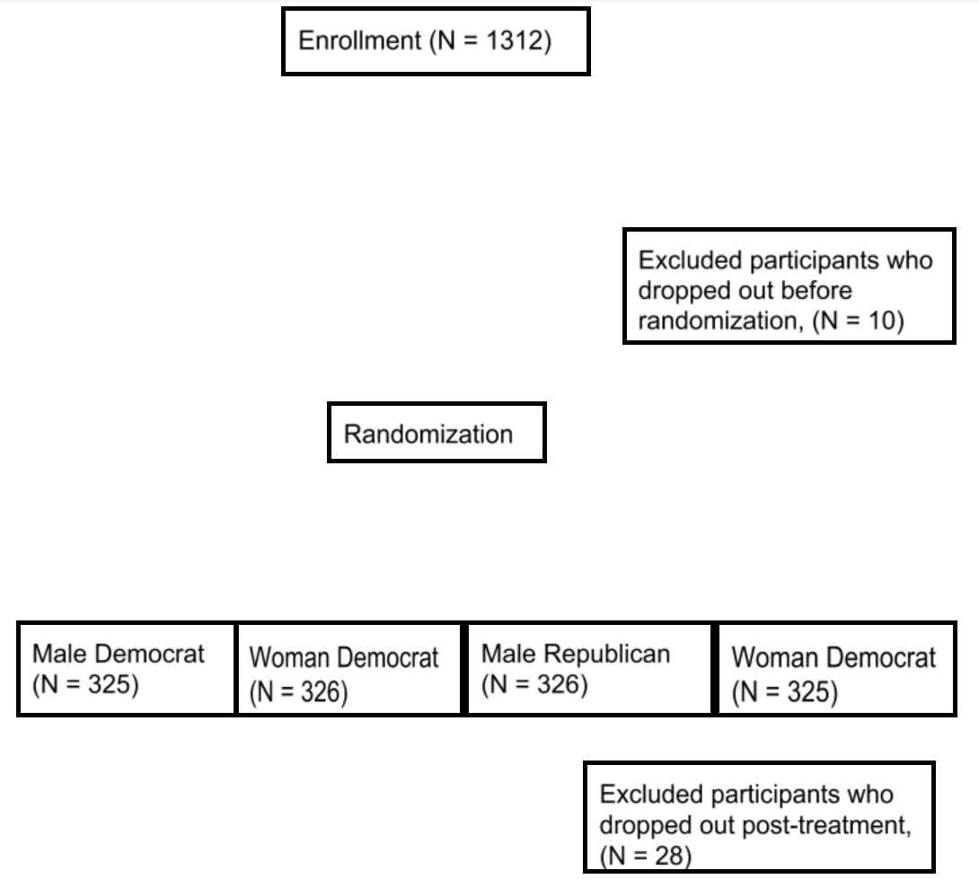

Table B1: Attrition by Condition

Treatment | Assigned to Treatment | 2nd Integrity Score | 2nd Performance Score | 2nd Ability Score | 2nd Vote | Intentionally Lied | Should not be Punished
Democratic Woman | 326 | 301 | 301 | 301 | 298 | 299 | 299
Democratic Man | 325 | 306 | 306 | 306 | 302 | 302 | 302
Republican Woman | 325 | 309 | 309 | 309 | 306 | 307 | 307
Republican Man | 326 | 311 | 311 | 311 | 308 | 309 | 309
Total | 1302 | 1227 | 1227 | 1227 | 1214 | 1217 | 1217

APPENDIX C: Question Wording

This study was part of a longer survey. We include only those questions utilized in our analyses or included in Appendix information.

Generally speaking, do you think of yourself as a Democrat, Republican, Independent, or something else?
- Democrat (1)
- Republican (2)
- Independent (3)
- Other (4)

Display This Question:
If Generally speaking, do you think of yourself as a Democrat, Republican, Independent, or something... Democrat Is Selected
Do you consider yourself a strong Democrat or not a strong Democrat?
- Strong Democrat (1)
- Not a strong Democrat (2)

Display This Question:
If Generally speaking, do you think of yourself as a Democrat, Republican, Independent, or something... Republican Is Selected
Do you consider yourself a strong Republican or not a strong Republican?
- Strong Republican (1)
- Not a strong Republican (2)

Display This Question:
If Generally speaking, do you think of yourself as a Democrat, Republican, Independent, or something... Independent Is Selected
Or Generally speaking, do you think of yourself as a Democrat, Republican, Independent, or something... Other Is Selected
Do you consider yourself closer to Democrats, closer to Republicans, or neither?
- Closer to Democrats (1)
- Closer to Republicans (2)
- Neither (3)

Generally speaking, how liberal or conservative do you consider yourself?
- Very liberal (1)
- Liberal (2)
- Slightly liberal (3)
- Moderate (4)
- Slightly conservative (5)
- Conservative (6)
- Very conservative (7)

How well do each of the folllowing words or phrases describe Carl/Carla McKinley?
 | Extremely well (1) | Very well (2) | Somewhat well (3) | Not too well (4) | Not well at all (5)
Likable (1)
Competent (2)
Sincere (3)
Qualified to be mayor (4)
Stable (5)
Dependable in a crisis (6)
Trustworthy (7)
Intelligent (8)

On the next screen, you will be asked to decide which candidate you prefer. After you answer this question, you will be given the chance to explain why you selected one candidate over the other, though you certainly do not have to offer any reason for your choice.
If you were a resident of this city, which mayoral candidate would you prefer?
- Candidate Campbell (1)
- Candidate McKinley (2)

If you would like to explain your vote choice, please do so in the box below.

Please rate your agreement with the following statements
 | Strongly agree (1) | Somewhat agree (2) | Neither agree nor disagree (3) | Somewhat disagree (4) | Strongly disagree (5)
Candidate McKinley intentionally lied (1)
Political candidates are generally honest (2)
The media cannot be trusted to report on such matters fairly (3)
Candidate McKinley should not be penalized (4)

Did the schools in Candidate McKinley's city face a significant threat last October?
- Yes, there was an October threat (1)
- No, there was a not an October threat (2)
- I am not sure if there was an October threat or not (3)

What is your gender?
- Male (1)
- Female (2)

Which best describes your background?
- White (1)
- Black or African American (2)
- Hispanic (3)
- American Indian or Alaska Native (4)
- Asian (5)
- Native Hawaiian or Pacific Islander (6)
- Other (7)

Which best describes your annual household income?
- Less than $10,000 (11)
- $10,000 - $19,999 (12)
- $20,000 - $29,999 (13)
- $30,000 - $39,999 (14)
- $40,000 - $49,999 (15)
- $50,000 - $59,999 (16)
- $60,000 - $69,999 (17)
- $70,000 - $79,999 (18)
- $80,000 - $89,999 (19)
- $90,000 - $99,999 (20)
- $100,000 - $149,999 (21)
- More than $150,000 (22)
- Decline to state (23)

Name varied based on random assignment.
Asked immediately following the candidate statement and again after the news article.
Asked following both ratings.

