Online Appendix A
Full Experimental Manipulations

Corresponding author: Frank Peters
petersf@DailyNetwork.journal.com, 814-415-5679
Over the past year, a few Pennsylvania residents decided to mount national campaigns for Congressional seats. The Daily Network has been doing its best to follow the lives and positions of these candidates so that citizens can make informed decisions. This week we are focusing on Ronald Furman, a real estate lawyer who runs a mid-size law firm in Crawford County.

[Positive Condition] Furman has accumulated an impressive resume throughout the course of his personal and professional life. A trusted legal publication’s annual rankings of real estate lawyers in Pennsylvania ranked him highly. He also received positive reviews from clients regarding his professionalism. Our interviews with Furman’s friends, colleagues and acquaintances highlighted some of his traits and characteristics, specifically his generosity. He donated a significant portion of his deceased father's fortune to charities for children with leukemia, diabetes and autism. He is also in the process of setting up scholarships for disabled children who want to attend overnight camp. When we inquired about his generous contributions he was humble and answered all of our questions. Furman was described by others as “approachable” and “easy to talk to”.
[Neutral Condition] No paragraph
[Negative Condition] Furman has accumulated a questionable resume throughout the course of his personal and professional life. In a trusted legal publication’s annual ranking of real estate lawyers in Pennsylvania, he was ranked poorly. He also received negative reviews from clients regarding his professionalism. Our interviews with Furman’s friends, colleagues and acquaintances illuminated some of his traits and characteristics, specifically his stinginess. A significant portion of his deceased father's fortune was intended to go to charities for children with leukemia, diabetes and autism as well as overnight camp scholarships for disabled children. Somehow Furman was able to access the money for himself and denied these charities of funds they believed they would be receiving. When we inquired about his decision to take this money, he was dismissive and tried to avoid the questions. Furman was described by others as “unapproachable” and “difficult to talk to”.
[Held constant in each condition listed above] Furman's policy plans for promoting economic growth include ending tax loopholes for large corporations and providing tax cuts to all individual Americans and small businesses. Furman has stated a number of times that we need to reduce the welfare state but must invest more federal money in the infrastructure and school systems of “at-risk” communities to do so. He intends to increase funding for intelligence operations to ensure that we are doing everything possible to prevent terrorist attacks. He has also advocated trying terrorism suspects in civilian courtrooms instead of military courts. Should he be elected, one of his principle goals would be reducing the number of nuclear weapons by both the United States and other nations through nuclear arms treaties. Though he believes in the right to bear arms and is a member of the NRA, he supports strengthening background checks and lengthening waiting periods in order to obtain a gun.
Political Sophistication Question Battery:
Note: Multiple Choice answers were provided and included a “Don’t Know” response option
- Who is the current Secretary of State?
- How many years is one Senate term?
- Who appoints Supreme Court justices?
- How many years is one term in the House of Representatives?
- Which woman is running for President in the Republican primaries in 2016?
- What is it called when a prolonged speech on the floor of the Senate tries to prevent a vote on a piece of legislation?
- What is the official name of the major piece of healthcare legislation signed into law by Barack Obama in March of 2010?
- What party does Elizabeth Warren belong to?
- How many Senators are there for each state?
Ideological Sophistication Question Battery:
Note: Multiple Choice answers were provided and included a “Don’t Know” response option
- Generally speaking, which party is associated with modern day political conservatism?
- Generally speaking, is raising taxes more economically liberal or more economically conservative?
- Generally speaking, which political philosophy promotes the idea of less centralized government and more political power in the hands of the individual states?

CONSORT Experimental Flow Diagram
Note: N sizes are for models that keep the Attention Check Failures in the sample
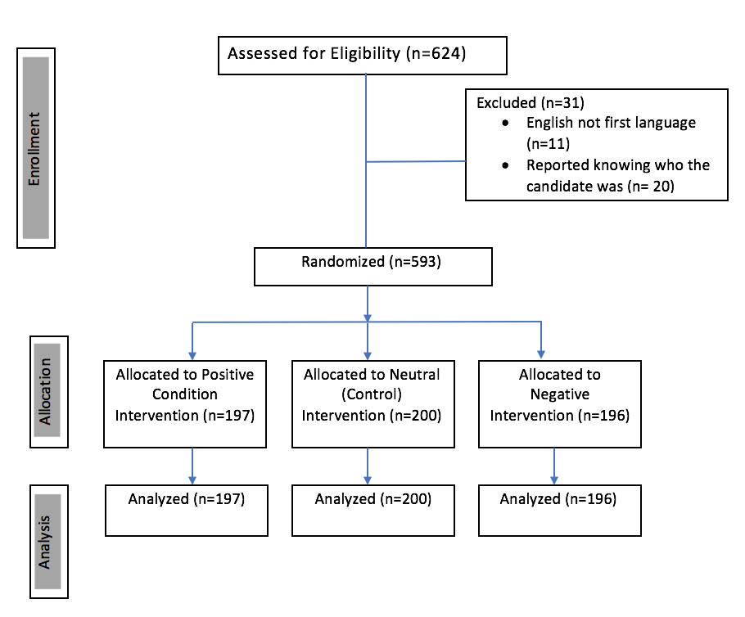

Online Appendix B

Table 1: Demographics for Mechanical Turk Sample

Variable
Sex | Male | 46%
 | Female | 53%
Race | White | 80%
 | Black | 8%
 | Hispanic/Latino | 6%
 | Asian | 4%
 | Other | 2%
Education | Less than college | 45%
 | BA or higher | 55%
Age | 18-30 | 29%
 | 31-40 | 25%
 | 41-50 | 17%
 | 55 and up | 29%
Partisanship | Dem or Leaning | 55%
 | Independent | 16%
 | Rep. or Leaning | 29%
Ideology | Liberal | 49%
 | Moderate | 24%
 | Conservative | 27%
N |  | 620

Table 2: Demographic Balance Across Experimental Conditions

Variable | Positive Condition | Negative Condition | Control Condition
Male | 47% | 49% | 43%
White | 80% | 82% | 80%
BA or Higher | 55% | 54% | 55%
Democrat | 56% | 58% | 54%
Independent | 13% | 15% | 19%
Republican | 31% | 27% | 27%
Liberal | 54% | 48% | 46%
Moderate | 18% | 25% | 28%
Conservative | 27% | 26% | 26%
Note: In order to further ensure random assignment was successful, an unordered logistic regression was performed in which the Dependent Variable was the 3 levels of the experimental conditions (Positive, Negative and the Control as the excluded category). All demographic variables and knowledge variables had highly insignificant relationships with the levels of the DV, indicating that randomization worked.

Figure 1: Interactive Effect of Self-Placement (Collapsed into a 3-Point Variable) and Positive Condition on Perceived Candidate Ideology
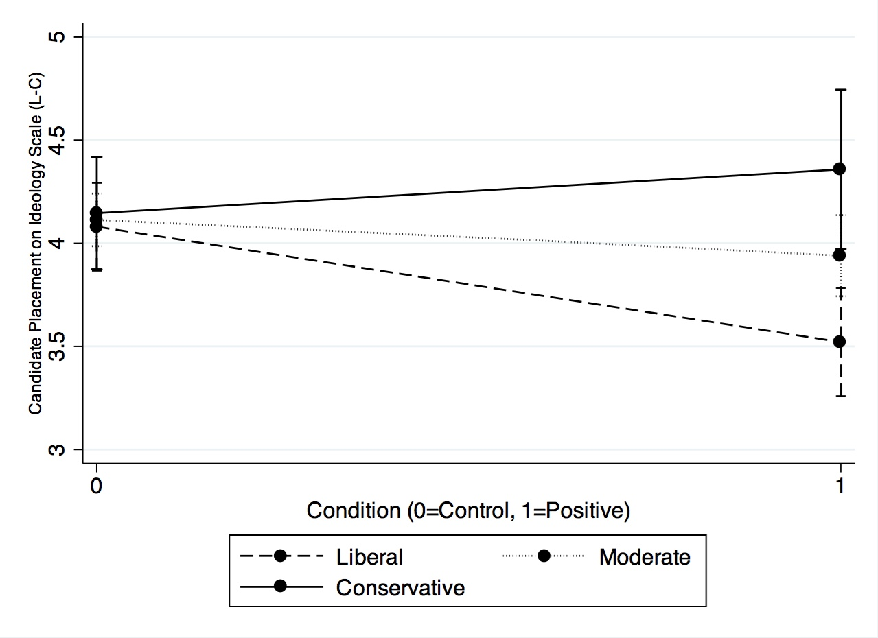
Note: Ideological Self-Placement has been collapsed into a three-point variable such that all liberals are categorized together, moderates are categorized together and all conservatives are categorized together.

Table 3: Interactive Effect of Treatment Conditions with Self Placement on
Candidate Perception Using Two Sample Versions

Variables | Scale Placement
 | With Attention Check Failure Subjects Dropped | Controlling for Attention Check Failures
Positive Condition | -.652 (.278)* | -.805 (.273)**
Negative Condition | .620 (.284)* | .565 (.273)*
Self-Placement (L-C) | .068(.063) | .030 (.060)
Pos*Self-Placement | .113 (.071) | .152 (.070)*
Neg*Self-Placement | -.128(.073)+ | -.117 (.071)
Party ID (D-R) | .018 (.042) | .021 (.040)
Dem. Party Placement | .140 (.046)** | .118 (.044)**
Rep. Party Placement | .231 (.044)*** | .201 (.014)***
Political Soph. | -.038 (.025) | -.038 (.024)
Ideological Soph. | .000 (.070) | .036 (.067)
Attention Check Scale | - | .066 (.148)
Constant | 2.29 (.392)*** | 2.57 (.373)***
R² | .096 | .093
N | 541 | 586
Note: The “Attention Check Scale” variable is coded as 0 for passing both questions, 1 for failing 1 question and 2 for failing both questions. The results do not change when each attention check is made into its own dummy variable. The interactions between the Positive Condition and Self-Placement are graphed in Figures 2 and 3 below. It may be important to recognize that the first model produces marginal significance on the negative condition*self-placement interaction, which is in-line with Hypothesis 2. This provides an avenue that might be worth exploring.
Significance codes: p<.10 +, p<.05 *, p<.01** , p<.001 ***

Figures 2 and 3: Interactive Effect of Self-Placement and Positive Condition
on Perceived Candidate Ideology Using Different Attention Check Specifications

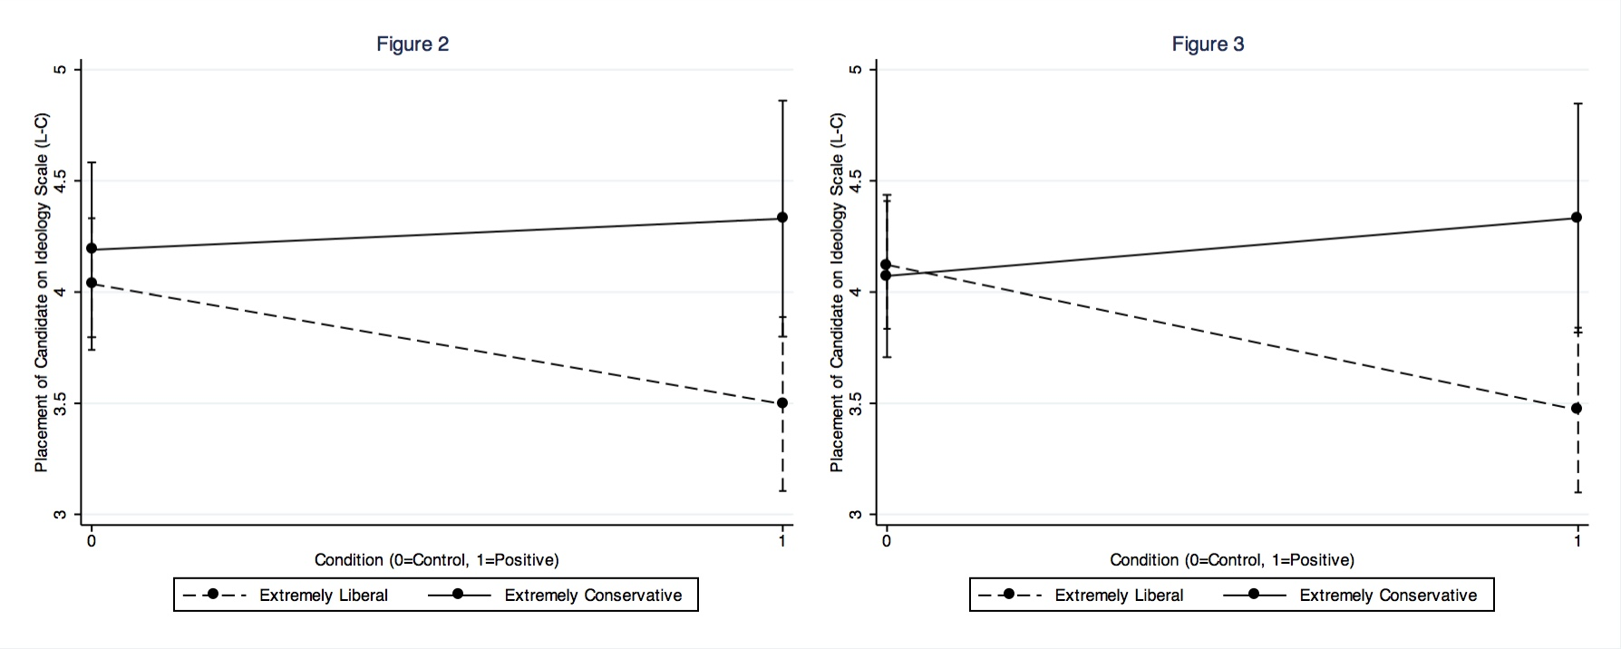

Figure 4: Kernel Density Plot of How Far Subjects Placed the Positive Candidate
from Own Position: Liberals Vs. Conservatives
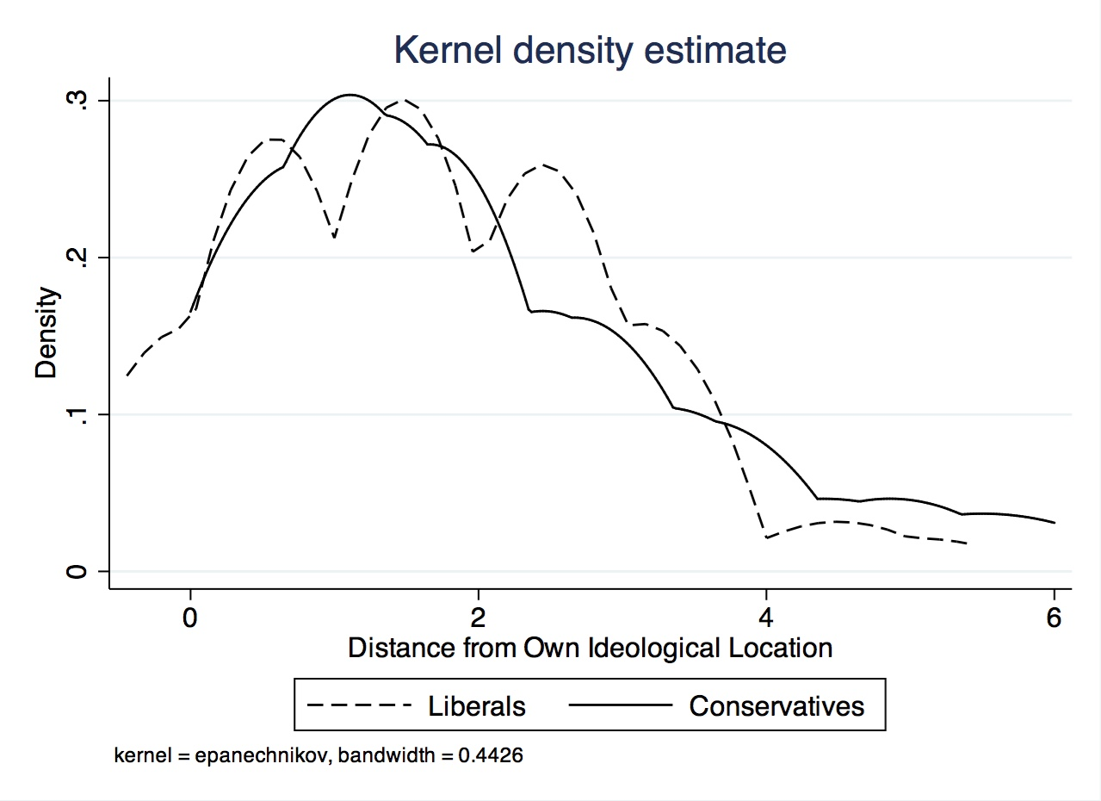
Note: The Two-Sample Kolmogorov-Smirnov test for equality of distributions indicates null results; there are no significant differences between the liberal and conservative distributions. A Levene’s test of equal variances also did not reach standard levels of statistical significance, further indicating that the variances between the two groups are the same.

