Supplementary Information

Table of Contents
Sample ...............................................................................................................................21
Table S1. Characteristics of experimental samples................................................21
Table S2. Climate opinions of national samples regarding public spending.........22
Table S3. Climate opinions of national samples regarding climate harm..............23
Table S4. Treatment Assignments in Experiment 1...............................................24
Table S5. Treatment Assignments in Experiment 2...............................................24
Experimental Design and Analysis Procedures.................................................................24
Further explanation of behavioral outcomes..........................................................24
MTurk recruitment script for all studies................................................................25
Consent script for all studies..................................................................................26
Imputation procedure for Donation Experiment 1.................................................26
Table S6. Treatment Assignment in Donation Experiment 1 for subject who state an unwillingness to consider donating to WRI......................................................27
Donation Experiment 1 treatment script and behavioral prompt...........................28
Donation Experiment 2 treatment script and behavioral prompt...........................29
Public Spending Experiment 1 treatment script and behavioral prompt...............31
Public Spending Experiment 2 treatment script and behavioral prompt...............32
Additional Analyses...........................................................................................................34
Manipulation Checks.............................................................................................34
Table S7. Manipulation checks for cost-effectiveness treatments.........................34
Table S8. Manipulation checks for cost-effectiveness treatments among non-college graduates............................................................................................36
Public Spending Experiment 1 with outcome of writing to...................................36
discourage spending
Figure S1. Proportion of subject who wrote to discourage....................................37
public spending in Public Spending Experiment 1
Multinomial nature of split donation outcome in Experiment 2............................37
Table S9. Treatment effects on whether and how much to donate in Experiment 2 among subjects hypothetically willing to support action on climate change.........38
Table S10. Multinomial regression on the probability of being part of discrete donation groups......................................................................................................39
Table S11. Proportion of donation directed to US in Experiment 2......................40
Home Preference by Political Party Alignment.................................................................40
Figure S2. Proportion of self-described Democrats supporting.............................41
climate change mitigation by program location.
Figure S3. Proportion of self-described Republicans supporting..........................42
climate change mitigation by program location.
Figure S4. Proportion of self-described Independents supporting.........................43
climate change mitigation by program location.
Statements Discouraging Public Spending........................................................................43

SAMPLE

Table S1. Characteristics of experimental samples
Demographic Variables | Donation Experiment 1 | Donation Experiment 2 | Pew National
Female (%) | 51.6 | 39.9 | 49.5
College Graduates (%) | 50.9 | 50.8 | 40.6
Unemployed (%) | 11.2 | 8.0 | - -
White (%) | 73.7 | 75.6 | 60.6
Political Party
Democrat (%) | 45.4 | 47.1 | 47.9
Republican (%) | 14.7 | 14.3 | 36.8
Independent (%) | 36.4 | 34.9 | - -
Note: Pew National representative sample characteristics based on random digit dial.

One potential concern about the attitudinal data that we use for the outcome related to public spending in Experiment 2 is that our sample has much higher support for government action to address climate change than the general population. On this point, we make several observations. First, based on a comprehensive search of polls conducted during 2014 and 2015 and available for review in the Roper Center for Public Opinion Research archive, we identified several similar polling questions in nationally-representative samples that show large majority support for government action on climate change among all Americans. Second, all of our primary analyses operate on the subset of respondents who do not dismiss climate change entirely, so it is likely that the percentages displayed in Table S2 would show even larger support in similar subsamples. Third, differences in item wording make direct comparison difficult. We asked US-based subjects about support for public spending in the context of negotiations over the Paris Agreement, which none of the surveys displayed below directly address. Fourth, we did not ask whether subjects desired more or less action on climate change, which would be anchored in current beliefs about the level of spending. This makes it difficult to interpret opposition to “more” action in some of the items below, which would likely result in even higher levels of support had an analogous question been posed in those surveys. While we cannot rule out that the attitudes of our subject pool is not representative of the target population, other polling does not point to immediate concerns.

Table S2. Climate opinions of national samples regarding public spending
Item | Poll | Percentages
Would you like to see the next President support policies to combat climate change, or oppose policies to combat climate change? | Quinnipiac University Polling Institute, December 16 - December 20, 2015 and based on 1,140 telephone interviews. Sample: National registered voters. [USQUINN.122315.R53] | 69% support;  23% oppose;  8% don’t know / no answer;
In general, do you support or oppose the US government doing more to reduce the type of activities that cause climate change and sea level rise? | Monmouth University Polling Institute, December 10 - December 13, 2015 and based on 1,006 telephone interviews. Sample: National adult. [USMONM.010516.R07] | 64% support;  26% oppose;  4% depends;  7% don’t know / no answer;
(Now, as I read some statements on a few different topics, please tell me if you completely agree, mostly agree, mostly disagree or completely disagree with each one.)...The US government needs to do more to address the issue of climate change | Public Religion Research Institute, August 5 - August 11, 2015 and based on 1,331 telephone interviews. Sample: National adult with an oversample of Catholics. [USPRRI.082515R.R15C] | 33% completely agree;  33% mostly agree;  14% mostly disagree;  14% completely disagree;  5% don’t know / no answer;
All else equal, would you like the next president (2016) to be someone who favors government action to address climate change, or someone who opposes such action? | ABC News/Washington Post, March 26 - March 29, 2015 and based on 1,003 telephone interviews. Sample: National adult. [USABCWP.040315.R18C] | 59% favors gov’t action;  31% opposes gov’t action;  10% no opinion;
(Now how important is each of those issues to you?) Electing someone (for president in 2016) who...favors government action to address climate change? Would you say that's extremely important, very important, somewhat important or not so important to you? | ABC News/Washington Post, March 26 - March 29, 2015 and based on 1,003 telephone interviews. Sample: National adult. [USABCWP.040315.R19C1] | 31% extremely important;  37% very important;  29% somewhat important;  4% not so important;

We further examine data from the Yale Program on Climate Change Communication, which fields questions about climate change to a nationally representative sample (see Howe et al. 2015). We compare opinion estimates on two similar questions across both surveys. Like the nationally-representative surveys above, these estimates indicate that the subset of individuals who are likely to have similar opinions to subjects in our samples have strong beliefs about harm. It is possible that our sample is composed of individuals who believe that climate change is more of a problem than more representative samples, but differences in the wording of items makes it difficult to make strong conclusions. Again, although on average our sample may be more likely to view climate change as a problem, we are not aware of a reason why, conditional on viewing it as a problem (or causing harm), individuals would have different views about the location of programs or react differently to the cost-effectiveness and provisioning benefits treatments.

Table S3. Climate opinions of national samples regarding climate harm
Yale Item | Yale | Our item | Ex1 | Ex2
Estimated percentage who think global warming will harm people in the US a moderate amount/a great deal | 64.1% | How serious of a problem do you think global climate change is for people in the United States? (very or somewhat serious) | 84.4% | 83.3%
Estimated percentage who think global warming will harm people in developing countries a moderate amount/a great deal | 67.8% | How serious of a problem do you think global climate change is for people in foreign countries? (very or somewhat serious) | 86.9% | 90.2%

Turning to the issue of sample size, the sample sizes of experimental groups for Experiment 1 are displayed in Table S4 and for Experiment 2 in Table S5, with d denoting the sample for donations and l denoting the sample for letter writing.The sample size for the letter writing outcome was slightly reduced, though still balanced across conditions, at 990 subjects because of a quickly-corrected programming error that affected our ability to track the click-through behavior of early subjects.

Table S4. Treatment Assignments in Experiment 1 among effective sample
 | No  Information | Cost-Effectiveness Information
Domestic | Mitigation in U.S.  d = 194  l = 158 | Mitigation in U.S., Low C-E  d = 186  l = 147
Friendly | Mitigation in India  d = 179  l = 144 | Mitigation in India,  Medium C-E  d = 211  l = 170
Adversary | Mitigation in China  d =186  l = 159 | Mitigation in China, High C-E  d = 184  l = 153

Table S5. Treatment Assignments in Experiment 2 among effective sample
Pure Control
n = 534 | No Cost-Effectiveness  Information | Cost-Effectiveness Information
No Provisioning Benefit Prompt | n = 535 | n = 533
Provisioning  Benefit Prompt | n = 522 | n = 532

EXPERIMENTAL DESIGN AND ANALYSIS PROCEDURES

Further explanation of behavioral outcomes
We focus on two behaviors available to individuals to support the mitigation of climate change. First, we ask subjects to make a real donation to a private, non-profit organization that pursues similar climate programs in many countries. As individuals, a donation to support climate mitigation is a common way to support the provision of a global public good. Second, we ask subjects to write to elected officials in support of climate change programming funded through public spending. Since the tax system is the mechanism most often used to provide public goods and the mechanism that individuals often use to seek public goods, it again offers a chance to understand how the distribution of benefits affects support for the public provision of global public goods.
In both experiments, the program for which a donation is solicited is the Greenhouse Gas Protocol program of the World Resources Institute (WRI). The program works with governments and businesses around the world, including in the United States, India, and China, to account for and then reduce greenhouse gas emissions. In Experiment 1, the outcome of interest is the proportion of subjects who chose to donate an unexpected $0.50 bonus to the WRI’s Greenhouse Gas Protocol program in the randomly assigned country. In Experiment 2, individuals were told (truthfully) that they had a chance to win a $20 participation bonus, with at least 20 individuals selected randomly for the bonus after the survey. In Experiment 2, the outcome of interest is the pre-committed split of the potential $20 bonus between a donation to WRI programs in the United States, a donation to WRI programs in rapidly-developing countries, and the amount kept by the subject.
We also asked subjects to write a letter to public officials expressing approval or disapproval of U.S. public spending for climate change mitigation at home and abroad. In Experiment 1, subjects were asked to write elected officials in support of or opposition to U.S. government spending on climate change mitigation programs being considered as part of the United Nations Climate Summit in September 2014. In Experiment 2, we asked respondents whether they supported or opposed U.S. government spending on programs that mitigate climate change inside the U.S. and in rapidly developing foreign countries as part of the 2015 UNFCCC Conference in Paris. In both experiments, subjects were given an opportunity to submit a note through real web pages of the U.S. President and relevant Congressional representatives. In both cases, the primary outcome of interest is completing all parts of the behavior: stating a position, writing a note, and clicking on links to the website of officials where they could submit the note. In Experiment 2, uptake of the behavioral measure for public spending was very low (~4% in the sample) and we were often not able to distinguish between support for domestic and foreign programing in the general letters written by subjects, so we report on stated preferences.

MTurk recruitment script for all studies
The recruitment script for the experiment on the MTurk platform advertised the opportunity to comment on current public events as part of a survey that would take 5-10 minutes to complete, with $0.50 provided as compensation. The subjects were not alerted to the fact that they would be given the opportunity to perform supportive behaviors related to climate change, so we do not expect the subject pool to have been screened on such willingness. The exact recruitment script is as follows:
Give your Opinion about Current Events!
Answer a short survey
We are looking for individuals to take a 5-10 minute survey on a variety of issues. All answers are confidential and will help scholars with cutting edge research.

Consent script for all studies
The following consent script was used to inform potential subjects about all studies reported in this paper. Again, subjects were not alerted to the fact that they would be given the opportunity to perform supportive behaviors related to climate change, so we do not expect the subject pool to have been screened on willingness to perform these behaviors:
You are invited to participate in a survey conducted by researchers at Institute 1 and Institute 2. The goal of the survey is to understand preferences of Americans about policies and programs that aim to limit climate change. The survey will present opportunities to express your preferences regarding different policies and programs.

The survey takes 5-10 minutes to complete. As indicated on MTurk, you will be paid $0.50 if you complete the survey. You can skip questions that you do not want to answer, but you must complete the survey to receive payment.

There are no risks associated with this study. Your responses will be kept completely anonymous by the research team. Your participation is voluntary. You have the right to discontinue participation at any time.

If you have any questions or concerns about this research, please contact Author 1 or Author 2.

This research has been approved by committees that oversee research with human subjects at Institute 1 and Institute 2. If you have questions or concerns about the conduct of this research, these offices can be reached at:

Institute 1 Phone Number
Institute 2 Phone Number

If you voluntarily agree to participate in this survey, please click the button to continue.

Imputation procedure for Donation Experiment 1
Before presenting subjects with the opportunity to donate a bonus to the World Resources Institute in Donation Experiment 1, we first asked subjects whether they would be willing to consider donating their own money to the WRI program described according to the treatment condition. For subjects who responded affirmatively, a $0.50 unexpected bonus was automatically delivered and then the subject was asked to donate it as described above. Due to resource constraints, we did not automatically provide the bonus to subjects who responded negatively. Since we expected (and confirmed) that a small minority of subjects who stated that they would not be interested in donating their own money would actually donate an unexpected bonus, we economized on available resources by only providing a randomly selected subset of these subjects with the bonus. Specifically, each subject who responded negatively about donating their own money had an independent and randomly-drawn 10% probability of receiving the bonus and then being asked to donate it.
As expected, only a small minority of subjects who stated they would be unwilling to consider donating their own money to the WRI donated the unexpected bonus that they received. Table S6 shows the descriptive data about the responses and behavior of the subjects for whom the partial selection into the behavioral outcome is relevant.

Table S6. Treatment Assignment in Donation Experiment 1 for subject who state an unwillingness to consider donating to WRI
 | Domestic (US) | Friendly (India) | Adversary (China)
No  Information | [total = 194]  “no” stated = 142  bonus = 10  donated = 1 | [total = 179]  “no” stated = 127  bonus = 16  donated = 2 | [total = 186]  “no” stated = 141  bonus = 16  donated = 1
Cost-Effectiveness Information | [total = 186]  “no” stated = 122  bonus = 13  donated = 2 | [total = 211]  “no” stated = 158  bonus = 23  donated = 3 | [total = 184]  “no” stated = 137  bonus = 10  donated = 1

To account for the unequal sampling into an opportunity to perform our behavioral measure, we impute the donation behavior for the subjects who did not receive the bonus using a random draw with replacement from the subset of observed subjects who said they would not donate their own money and who shared the same treatment condition as the unobserved subject in question. We exploit the fact that within each treatment condition, the subjects who said they would not be willing to donate their own money but then who were still provided an unexpected bonus are a random sample of all subjects in that treatment condition. Thus, the donation behavior of this randomly selected subset of subjects within each treatment condition is representative of the full set of subjects within each treatment condition in expectation. This means that if the donation decision of each subject who is unobserved is imputed through a random draw of the outcomes from the randomly selected subjects in that treatment condition whose behaviors are observed, the resulting imputed dataset will be representative of the full sample in expectation.
To account for uncertainty introduced by imputation, we draw a new imputation for each trial conducted as part of our randomization inference procedure. The following steps are completed for the full analysis: (1) a randomly drawn imputation of behaviors from the relevant treatment condition is produced for all unobserved subjects; (2) a full schedule of potential outcomes is specified for that imputation under the sharp null hypothesis assumption; (3) the subjects in that trial are assigned to treatment replicating our randomization procedure; (4) the difference in means between treatment and control groups are recorded for that individual trial. We repeat this loop 10,000 times to form a sampling distribution used to compute p-values of the actual imputed difference between treatment and control subjects over that same set of trials, accounting for uncertainty in imputation by drawing a new imputation for each trial. Our estimates of treatment effect are averaged across these imputations. Of the 1214 subjects in our study, around 25% said they would be willing to donate. Of the 412 subjects given the opportunity to donate, 41% actually chose to donate their bonus.

Donation Experiment 1 treatment script and behavioral prompt

Preamble: On the next screen, you will find information about a nonprofit organization that works to limit global climate change by reducing greenhouse gas emissions. Greenhouse gas emissions trap solar energy within the Earth’s atmosphere. Scientists have concluded that greenhouse gas emissions are changing the world’s climate. Please click the arrow to read about the organization and some of its program highlights.

Fact Sheet:
Organization | World Resources Institute (WRI)
Organizational Mission | WRI’s mission is to move human society to live in ways that protect Earth’s environment and its capacity to provide for the needs and aspirations of current and future generations.
Featured Program | The Greenhouse Gas Protocol
Program Country | [Image of flag] [China OR India OR The United States]
Program Details | The Greenhouse Gas Protocol is an accounting tool that government and business leaders can use to manage and reduce greenhouse gas emissions. The World Resources Institute helps implement the GHG Protocol in order to reduce greenhouse gas emissions that lead to global climate change.

Cost-effectiveness prompt:
If in cost-effectiveness treatment group, the cost-effectiveness prompt is matched to treatment country as follows:
Now we would like to give you some information about the cost-effectiveness of environmental programs. [Environmental programs in China, like the Greenhouse Gas Protocol, are the most cost-effective: the same reductions in greenhouse gases cannot be achieved in other countries at a lower cost.]
OR
[Environmental programs in India, like the Greenhouse Gas Protocol, are somewhat cost-effective: the same reductions in greenhouse gases can be achieved in some countries at a lower cost and some other countries at a higher cost.]
OR
[Environmental programs in the United States, like the Greenhouse Gas Protocol, are the least cost-effective: the same reductions in greenhouse gases can be achieved in most other countries at a lower cost.]

Stated outcome: At this time, the World Resources Institute is asking individuals for a small donation to support its efforts to reduce greenhouse gas emissions like the Greenhouse Gas Protocol. Would you be willing to donate your money to the World Resources Institute?

Behavioral outcome: You will receive a $0.50 bonus for taking this survey. Would you donate your $0.50 bonus to the World Resources Institute? You will have a chance to confirm your donation on the next screen.

Donation Experiment 2 treatment script and behavioral prompt

Preamble: Now we would like to give you some general information about programs that aim to reduce climate change. Please click the arrow after reading the text below carefully.

- Baseline prompt (everyone): When one country reduces its greenhouse gas emissions, all countries benefit from less climate change in the future. Because everyone in the world benefits, some people argue that it makes sense to carry out these programs where they are the most cost-effective, i.e. where the greatest reductions in greenhouse gas emissions can be achieved at the lowest cost.
- Nonpublic benefits treatment (randomized): In addition to the benefits shared by all countries, climate change reduction programs can provide important benefits that are exclusive to the country where the program is located, such as the creation of local jobs, new industries, and a reduction in local air pollution.
- Cost-effectiveness treatment (randomized): Programs to reduce climate change implemented in rapidly developing countries are more cost-effective than programs in the United States. For the same price, more reductions in greenhouse gas emissions can be achieved by locating programs to reduce climate change in rapidly developing countries than in the U.S.
Fact Sheet: At the conclusion of this survey you will be entered into a drawing to receive a $20 bonus to your MTurk account. At least twenty participants in this survey will receive the $20 bonus. At this time, the World Resources Institute is asking individuals for a donation to support its efforts to reduce greenhouse gas emissions through its program called the Greenhouse Gas Protocol. This is a real organization and a real program. To learn more about the World Resources Institute, click the below link. (link will open in a new window)

For your convenience, we have also provided below a brief fact sheet about WRI and the Greenhouse Gas Protocol.

Organization | World Resources Institute (WRI)
Featured Program | The Greenhouse Gas Protocol
Countries Involved | The United States and rapidly developing countries like India, China, Brazil, Philippines, and Mexico.
Program Details | The Greenhouse Gas Protocol is an accounting tool that government and business leaders can use to manage and reduce greenhouse gas emissions.

Behavioral outcome: If you win the drawing, what portion of the $20 bonus would you like to donate to the World Resources Institute programs in the United States and rapidly developing foreign countries, and how much would you prefer to keep for yourself? Change the numbers to the right of the grid to adjust the amounts in each category or click on the grid itself.

Public Spending Experiment 1 treatment script and behavioral prompt

Preamble: On the next screen, you will find information about the Climate Summit, a meeting of world leaders in New York City this September. The Climate Summit aims to promote agreement among different countries about steps that can be taken to limit global climate change. Please click the arrow to read about a commitment the United States government may make at the meeting and answer a few questions about it.

Climate Summit Vignette: International climate change negotiations have focused on determining which countries should reduce their emissions of greenhouse gases and which countries should help pay for those reductions. To promote international agreement and action, [the U.S. government may agree to give money to China for programs that reduce inefficient energy use and promote wind and solar power.]
OR
[the U.S. government may agree to give money to India for programs that reduce inefficient energy use and promote wind and solar power.]
OR
[the U.S. government may agree to spend money in the United States on programs that reduce inefficient energy use and promote wind and solar power.]

Cost-effectiveness prompt
If in cost-effectiveness treatment group, the cost-effectiveness prompt is matched to treatment country as follows:
Now we would like to remind you about the cost-effectiveness of environmental programs. [Environmental programs in China, like the Greenhouse Gas Protocol, are the most cost-effective: the same reductions in greenhouse gases cannot be achieved in other countries at a lower cost.]
OR
[Environmental programs in India, like the Greenhouse Gas Protocol, are somewhat cost-effective: the same reductions in greenhouse gases can be achieved in some countries at a lower cost and some other countries at a higher cost.]
OR
[Environmental programs in the United States, like the Greenhouse Gas Protocol, are the least cost-effective: the same reductions in greenhouse gases can be achieved in most other countries at a lower cost.]

Attitudinal outcome: Do you think think the U.S. government should make the commitment to fund environmental programs in [country] or should not make this commitment?
- The U.S. government should make this commitment.
- The U.S. government should not make this commitment.

Behavioral outcome: Would you be willing to contact any of your elected officials to encourage/discourage the U.S. government to make/from making this commitment?
- Yes
- No
if Yes: Please write a short statement to share with your elected officials. Then below you can select the elected officials to whom you would like to send your message.

Please select all the possible officials to whom you would like to send your statement. The contact information you requested and a copy of your statement will be given to you at the end of the survey.
- U.S. President
- U.S. Senator
- U.S. Representative
- I do not want to contact my elected officials.

Public Spending Experiment 2 treatment script and behavioral prompt

Preamble: Now we would like to remind you of the general information about programs that aim to reduce climate change. Please click the arrow after reading the text below carefully.
- Baseline prompt (everyone): When one country reduces its greenhouse gas emissions, all countries benefit from less climate change in the future. Because everyone in the world benefits, some people argue that it makes sense to carry out these programs where they are the most cost-effective, i.e. where the greatest reductions in greenhouse gas emissions can be achieved at the lowest cost.
- Nonpublic benefits treatment (randomized): In addition to the benefits shared by all countries, climate change reduction programs can provide important benefits that are exclusive to the country where the program is located, such as the creation of local jobs, new industries, and a reduction in local air pollution.
- Cost-effectiveness treatment (randomized): Programs to reduce climate change implemented in rapidly developing countries are more cost-effective than programs in the United States. For the same price, more reductions in greenhouse gas emissions can be achieved by locating programs to reduce climate change in rapidly developing countries than in the U.S.

Climate Change Conference Vignette: On this screen, you will find information about the 2015 United Nations Climate Change Conference, a meeting of world leaders in Paris this coming December. The Climate Conference aims to promote agreement among different countries about steps that can be taken to limit global climate change. To promote international agreement and action, the United States government is considering spending money on programs to reduce climate change both at home and in foreign countries.

Attitudinal outcomes:
Do you think the U.S. government should make the commitment to fund climate change programs in the U.S.?
- The U.S. government should make this commitment.
- The U.S. government should not make this commitment.

Do you think the U.S. government should make the commitment to fund climate change programs in rapidly developing foreign countries like India, China, Brazil, Philippines, and Mexico.
- The U.S. government should make this commitment.
- The U.S. government should not make this commitment.

Behavioral outcome:
Would you be willing to contact any of your elected officials to share your position? If so, please write the note that you would like to send to your elected officials and check the boxes for whom you would like to receive your note. If not, leave the text box blank and click the arrow button to proceed.

Please select all the possible officials to whom you would like to send your statement. The contact information you requested and a copy of your statement will be given to you at the end of the survey.
- U.S. President
- U.S. Senator
- U.S. Representative
- I do not want to contact my elected officials.

ADDITIONAL ANALYSES

Manipulation Checks
At the end of each study, respondents were asked a question about the cost-effectiveness of programs to check their understanding of the cost-effectiveness treatment. We report in Table S7, the percentage of respondents who gave us the correct response about the cost-effectiveness of programs located in the treatment country. For example, only 14.4% of respondents in the control group answered that programs located in the U.S. are the least cost-effective. The percentage who answered that programs located in the U.S. are the least cost-effective rose substantially to 77.9% in the cost-effectiveness treatment group. Similar increases can be seen for the other treatment countries in Study 1 and can also be seen for Study 2, though the question was asked slightly differently because the implementing country was not randomized.

Table S7. Manipulation checks for cost-effectiveness treatments
 | Control Group | Treatment Group
Study 1: Cost-effectiveness is the ability to produce good results at the lowest feasible cost. Compared to programs in other countries, how cost-effective do you think programs are that aim to lower greenhouse gas emissions in <<Country>> ?
Note: percent of subjects providing the answer aligned with the treatment prompt
U.S. | 14.4% | 77.9%
India | 47.2% | 82.2%
China | 12.9% | 72.7%
Study 2: Cost-effectiveness is the ability to produce good results at the lowest possible cost. In terms of limiting climate change and reducing greenhouse gases, how cost-effective are programs carried out in the United States and in countries that are developing rapidly like India, China, and Brazil?
Neither cost-effective | 6.9% | 3.0%
Programs in rapidly developing countries are more cost-effective | 27.2% | 66.4%
Programs in U.S. are more cost-effective | 19.5% | 10.8%
Both kinds of programs equally cost-effective | 15.4% | 7.4%
Not sure | 30.9% | 12.2%

We also use these results reported in Table S7 to check a related explanation for the location results, which could be that individuals believe the U.S. has a greater ability to implement programs than do some foreign countries. We do not have evidence that the effect of location is driven by the perceived ability of countries to implement mitigation programs. Take for example the results from our cost-effectiveness manipulation check reported in Table S7. These results show that participants in the control group for Experiment 2 did not perceive significant differences in cost-effectiveness between the U.S. and rapidly developing countries: 26 percent of participants viewed programs in rapidly-developing countries as more cost-effective than programs implemented in the U.S. versus only 19 percent of participants who viewed programs in the U.S. as more cost-effective. Around 14 percent of participants thought mitigation programs implemented in the U.S. and rapidly developing countries were equally cost-effective. Thus, absent information about cost-effectiveness, subjects on average believe programs in rapidly developing countries are just as cost-effective as domestic programs. This finding would not obtain if subjects had concerns that programs abroad would not be implemented well as effective implementation is an essential factor in estimating cost-effectiveness.
Additionally, we check for differences in responses to the cost-effectiveness condition by level of education. As can be seen in Table S8, the results of the cost-effectiveness manipulation check for non-college graduates look remarkably similar to the results that include the full sample. For Study 1, a similar proportion of respondents is able to accurately recall the information regarding cost-effectiveness for their country treatment arm. Similarly, for Study 2, non-college graduates are only four percentage points less likely to pass the manipulation check as compared to the full sample. These findings suggest that non-college graduates did not have any extra difficulties understanding the cost-effectiveness treatment. Thus, although our MTurk sample skews towards college graduates, the findings should not be biased relative to a nationally representative sample on the basis of treatment comprehension.

Table S8. Manipulation checks for cost-effectiveness treatments among non-college graduates
 | Control Group | Treatment Group
Study 1: Cost-effectiveness is the ability to produce good results at the lowest feasible cost. Compared to programs in other countries, how cost-effective do you think programs are that aim to lower greenhouse gas emissions in <<Country>> ?
Note: percentages are proportion of subjects providing the answer aligned with the treatment prompt
U.S. | 16.3% | 67.8%
India | 47.7% | 80.0%
China | 14.0% | 71.9%
Study 2: Cost-effectiveness is the ability to produce good results at the lowest possible cost. In terms of limiting climate change and reducing greenhouse gases, how cost-effective are programs carried out in the United States and in countries that are developing rapidly like India, China, and Brazil?
Neither cost-effective | 7.5% | 3.7%
Programs in rapidly developing countries are more cost-effective | 24.1% | 61.2%
Programs in U.S. are more cost-effective | 19.4% | 12.7%
Both kinds of programs equally cost-effective | 16.5% | 8.6%
Not sure | 32.5% | 13.5%

Public Spending Experiment 1 with outcome of writing to discourage spending
Like the results for Public Spending Experiment 1 that are based on the outcome of writing to encourage public spending, we find significant support for the hypothesis that subjects want to discourage funding programs to mitigate climate change outside the US (Figure S1). We first test the country effect by analyzing the behavioral responses of subjects who did not receive the cost-effectiveness treatment. While only 1.3% of subjects assigned to the U.S. condition wrote to oppose public spending for mitigation programs located in the U.S., 5.0% of subjects chose to write to discourage U.S. public spending on energy efficiency programs located in China (te = 0.04, p = 0.03). The evidence is not as strong for subjects who are prompted to write about their opposition to program in India, but it nevertheless aligns to average favorability ratings in our sample (te = 0.02, p = 0.30).
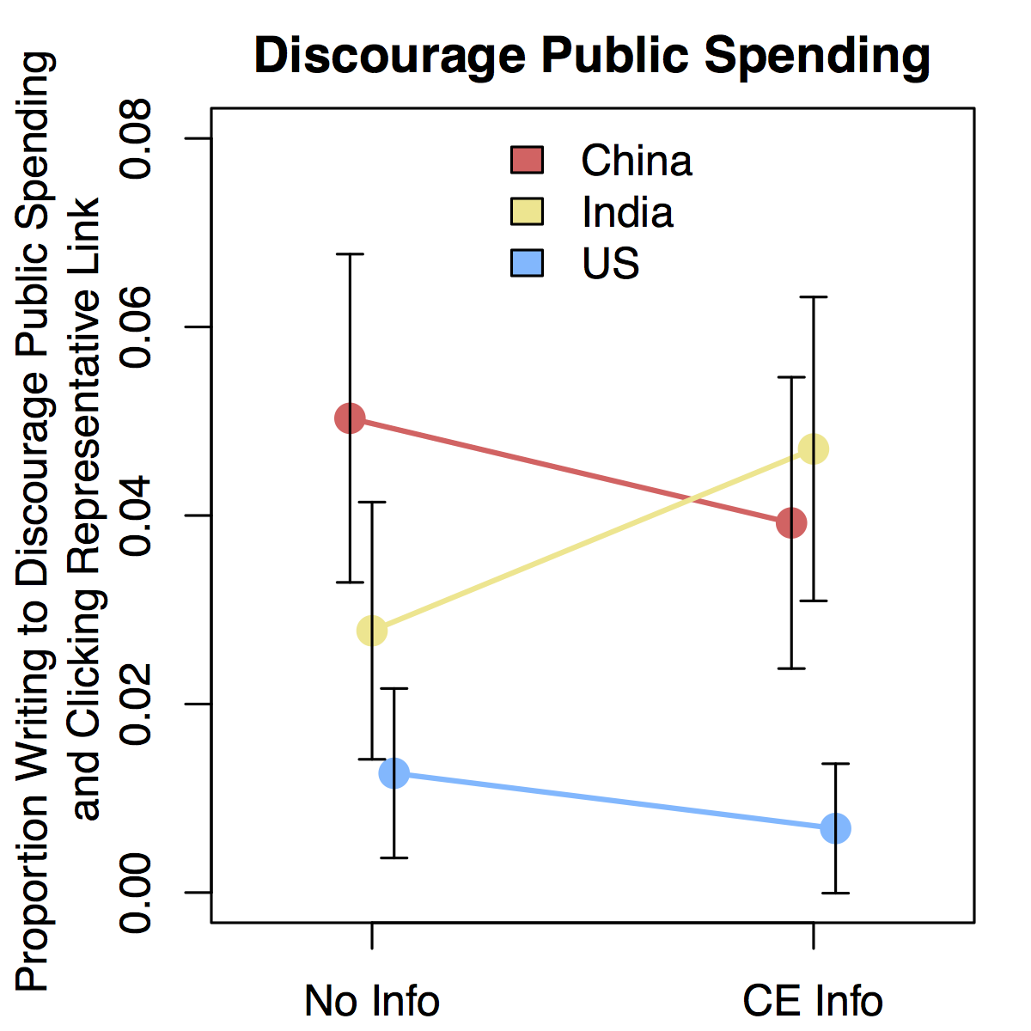
Figure S1. Proportion of subject who wrote to discourage public spending in Public Spending Experiment 1

Turning to cost-effectiveness, although we prompted subjects in the U.S. treatment condition with information about the cost-ineffectiveness of programs in the U.S., this did not increase their likelihood of writing to discourage spending at home (te = -0.01, p = 0.53). For subjects in the India treatment condition, we did not have strong directional expectations about how information that programs are “somewhat” cost-effective would affect behavioral support. In a two-tailed test, the proportion writing to discourage spending increases from 2.8% to 4.7% of subjects (te = 0.02, p = 0.24). We expected that subjects in the China treatment condition who receive information about the cost-effectiveness of programs in China at mitigating climate change would be less likely to write to discourage spending, but we find only suggestive evidence for an effect that could have likely emerged from random chance (te = -0.01, p = 0.42).

Multinomial nature of split donation outcome in Experiment 2
One challenging aspect about the donation outcome that we use as part of Experiment 2 is that it provides a number of dimensions on which to make choices about whether, how much, and what proportion to donate to domestic and foreign programs. The treatments might affect each of these outcomes in interrelated ways, so we consider them in order to aid interpretation of the results reported in the main text.
We first consider whether the cost-effectiveness and provisioning benefits treatments affect the binary choice of making any donation and the choice about the total amount to donate (including when subjects did not donate). As displayed in Table S9, we fail to find evidence inconsistent with random chance that the treatments affected the choice about whether to donate. We find evidence that being treated with information about provisioning benefits in the absence of the cost-effectiveness treatment decreases the total amount donated. This helps us interpret the main results displayed in Figure 3: information about provisioning benefits does not cause a reallocation of a fixed donation amount in favor of domestic programs; it rather decreases asymmetrically the propensity to support foreign programs without similar increases in donations for domestic programs. Highlighting non-shared benefits decreases overall financial support for climate change mitigation, perhaps because it introduces a zero-sum logic into the decision about making a donation, which may have more expressive benefits to subjects when it is perceived entirely as other-regarding.

Table S9. Treatment effects on whether and how much to donate in Experiment 2 among subjects hypothetically willing to support action on climate change.
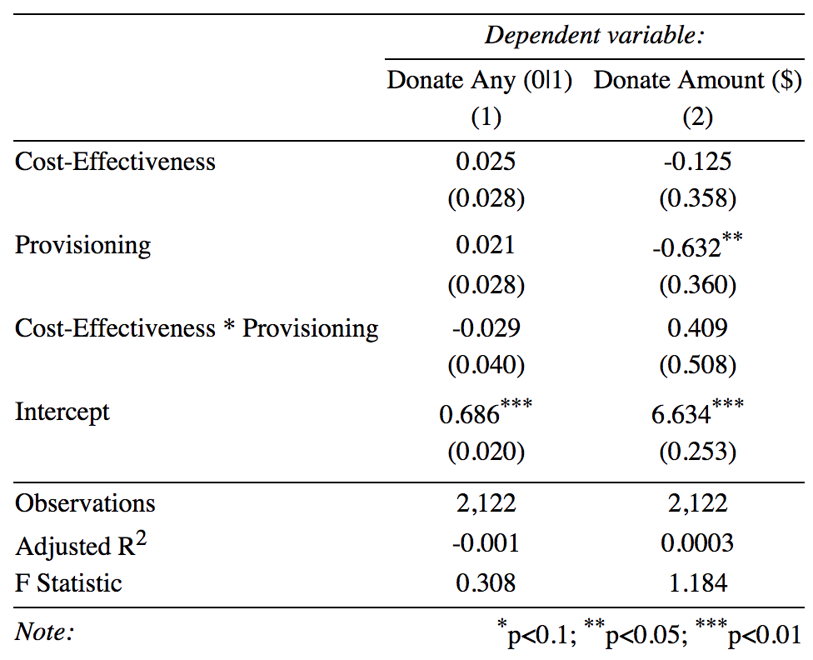

We next investigate how treatment affected the discrete outcomes of donating to both foreign and domestic programs, US-based programs only, foreign-based programs only, and not making a donation to any kind of program. Descriptively across all observations (including those treated), we observe that the majority of subjects donate to both domestic and foreign programs (1189), while the next largest subset of subjects does not make any donation (633). We observe that a slightly larger subset of subjects makes a donation only to foreign-based programs (156), as compared to the subset of subjects that makes a donation only to US programs (144), which is expected given that half of the sample is treated with information about cost-effectiveness. To understand how the cost-effectiveness and provision benefits treatments affect the probability of choosing these discrete outcomes, we estimate a multinomial logistic regression model with the largest group (donate to both) as the baseline condition. The resulting coefficients in Table S10 should be interpreted as the change in the probability of being part of the labeled subset as compared to the baseline group.

Table S10. Multinomial regression on the probability of being part of discrete donation groups
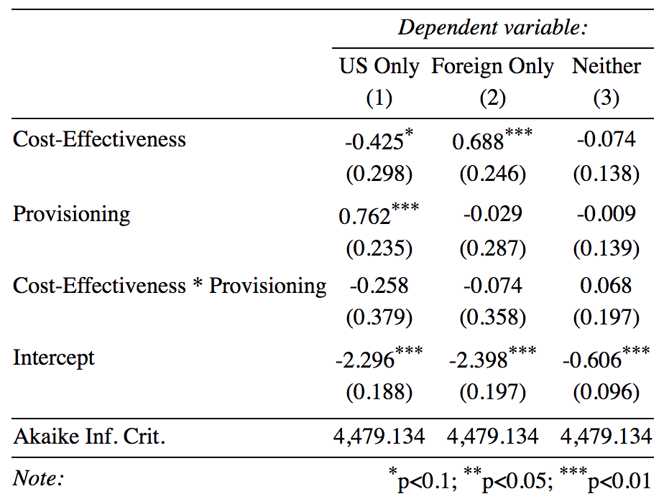

As reported in the main text, learning about comparative cost effectiveness decrease the probability of splitting a donation to both US and foreign programs, in favor of donating only to foreign programs. The effect is asymmetric, however, with a larger proportion of subject being moved toward foreign-only donation than the proportion being moved away from domestic-only donation. This indicates that the treatment was most effective among individuals who are flexible in the location of their donation, but that might not have sufficient information to make the allocation that matches their preference for cost-effectiveness. The rate of making no donation does not change relative to the baseline of donating to both, indicating that there is likely to be little switching between these categories of outcomes. Receiving information that highlights the provisioning benefits of climate mitigation program increases the probability of a US-only donation as compared to baseline, but does not decrease the probability of a foreign-only donation as compared to baseline. This indicates that treatment increases switches into US-only donations from all other categories, which do not change relative to each other.
Finally, we explore the proportion the total donation made to the US, conditional on a subject making any donation. This specification provides a finer test than the discrete measures used as outcome measures (see Table S11). Among those subjects who make a donation (which we find in Table S6, Model 1 is a subset not significantly associated with treatment), receiving information about cost-effectiveness shifts donations away from US-based programs and receiving information about provisioning benefits shifts donations toward US-based programs, with cost-effectiveness information having a greater effect in absolute magnitude. These results confirm the interpretation of the findings reported in the main text.

Table S11. Proportion of donation directed to US in Experiment 2
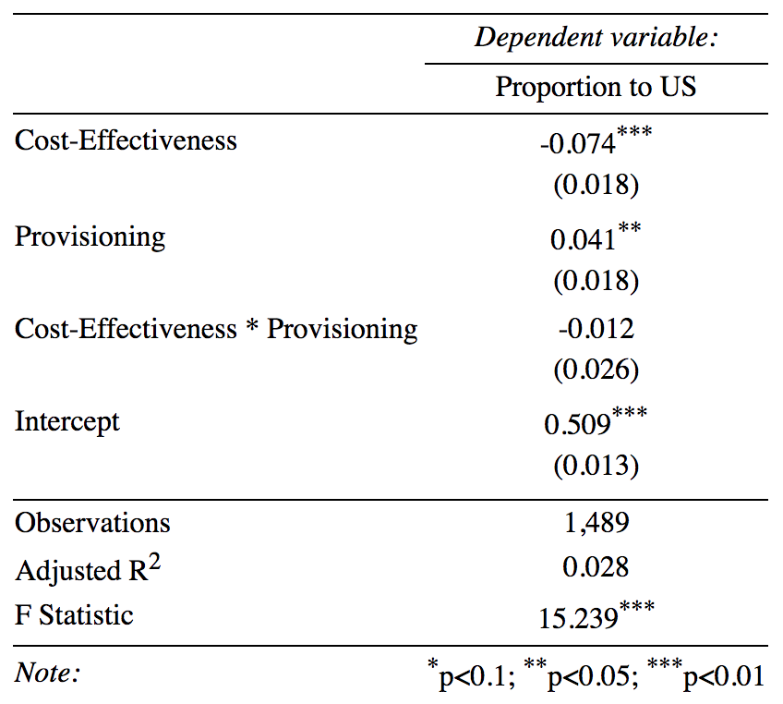

HOME PREFERENCE BY POLITICAL PARTY ALIGNMENT

To probe the consistency of a home preference for climate programming across respondents with different party alignments, we present the results from Figure 1 broken down into three political groupings: Democrats, Republicans, and Independents. As with the main text, the results displayed in Figures S2-4 are for subjects who recognize climate change as at least a minor problem for either the US or foreign countries (~95% of both recruited samples). Including subjects who never support mitigation in the party subsets does not substantively alter any of the conclusions. Like Figure 1 which reports the pooled results, all results displayed in Figures S2-4 pertain to the subjects who did not receive any treatment and represents a baseline level of home preference. Table 1 above displays the proportion of subjects who report various party alignments across our two experiments.
For self-described Democrats (Figure S2), a finding of the home preference is largely consistent with with the pooled results described in the main text. The one exception is for private donations in Experiment 2, where subjects were presented with an opportunity to split their donation between US and foreign programs, if they chose to make a donation. In this case, the difference between donations to domestic programs and foreign programs is no longer statistically significant and the difference is smaller substantively (diff=-$0.23, versus -$0.45 in the pooled results). For all other outcomes, the home preference persists as expected among Democrats.

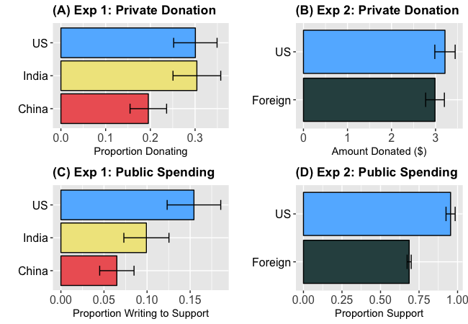
Figure S2. Proportion of self-described Democrats supporting climate change mitigation by program location.

For self-described Republicans (Figure S3), we do not find a strong home preference in Experiment 1 (n=77 Republicans who do not totally dismiss climate change in the control condition), but we do find a strong home preference in Experiment 2 (n=74 Republicans who do not totally dismiss climate change in the pure control condition). In Panel A, we display the proportion of Republican subjects stating that they would be willing to donate their own money to the WRI as the outcome for Experiment 1. The behavioral outcome of donating a bonus is observed for only 11 subjects, since the large majority of Republicans stated that they were unwilling to donate their own money and only 10% of these subjects were provided a bonus (see above for the sampling design). This leaves only enough observations to explore stated preferences, which do not reveal a home preference. Likewise in Panel C, which displays the proportion of Republicans writing a letter in support of public spending in Experiment 1, we are not able to reject the null of no home preference. For Experiment 2 displayed in Panel D, however, we find a consistent home preference in both outcome measures, which mirrors the results in the main text.

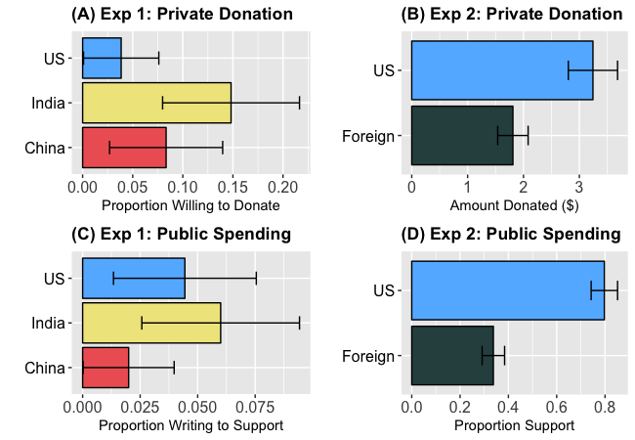
Figure S3. Proportion of self-described Republicans supporting climate change mitigation by program location.

Finally, when considering self-described Independents (Figure S4), the results are consistent with those reported in the main text, with treatment effects that are larger than the pooled results in many cases. For Experiment 1, our sample included 197 Independents in the cost-effectiveness control condition who did not dismiss climate change. For Experiment 2, our sample included 196 Independents in the pure control condition who did not dismiss climate change.

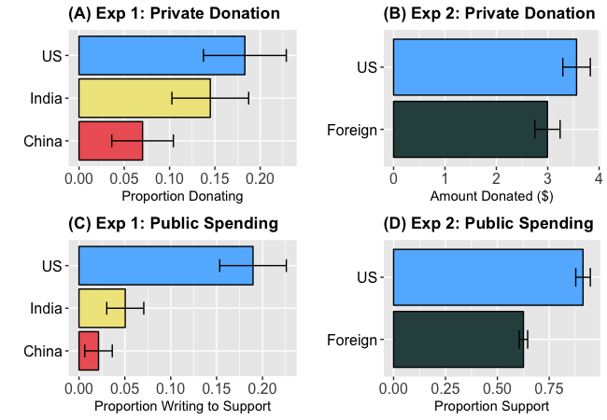
Figure S4. Proportion of self-described Independents supporting climate change mitigation by program location.

STATEMENTS DISCOURAGING PUBLIC SPENDING

These statements are from respondents who wrote to their representatives to discourage public spending in Experiment 1. There were 142 respondents who wrote statements. The 93 statements recorded below represent those that either mention that other governments should fund their own programs or that the U.S. government should spend that money at home. The remaining statements either gave no reason for opposing spending or opposed it on the grounds that they did not believe in climate change.

1 | Please do not offer money to China to encourage alternate forms of energy. They are a stable, self efficient nation and should do it on their own. American dollars should be spend here in America.
2 | I do not think providing this kind of funding to other countries is a good idea as it may hurt our own economy here.I understand there is good reason for this but these countries need to fund this themselves.
3 | In my opinion, each country should take care of their own emissions problems. For some countries, there may have to be a sharing from the more prosperous countries, but not a full commitment from only one. The feel the US should take care of their own problems first.
4 | Dear Sir or Madam, / While I agree that reducing gas emissions is a major concern, I do not agree that the United States should have any part in funding methods to reduce gases in foreign countries, especially China. There is no reason China cannot pay for it by itself. Instead, I would advocated for collaboration in the actual execution of reduction methods. If the United States is going to spend money on alternative energies, it should spend it domestically first. / / Sincerely, / / A concerned citizen who for the purposes of MechanicalTurk will not reveal her name
5 | Aside from the fact that we already owe China money, I believe that we are perfectly capable of putting the money to good use reducing emissions in our own back yard.
6 | Good afternoon. While I understand finding alternate sources of renewable energy is a huge concern not just nationally, but globally, I think there are many programs within our own country which need funding. Prior to giving money to other countries, I feel it is necessary for the United States to take care of its own citizens first and foremost. The United States economy is still incredibly fragile, with large number of people still unable to find jobs. I think money allocated for India's use of alternate energy funding and research would be better spent within our own borders.
7 | I do not want any money to go towards making other countries less energy dependent. We need to first reflect on the horrible condition of our own society. Once renewable resources become a major player here then we can focus on helping others. Until that time we need to work on solving economic debt and get a surplus back. We need to work on exporting more goods in order to bring up this owed money..
8 | I think China should be responsible for their own funding on things like this. They are a rich country. They can pay for it themselves.
9 | Dear Sirs and Madams, / It has come to my attention that the U.S. government is considering funding China, for programs to reduce energy use and to promote wind and solar power. I as a tax payer do not want to fund other countries for such programs. As an American citizen I think it is important to look out for our countries energy programs first. China is more than capable of funding their own such energy programs.
10 | I know the effects of global warming affect us all but it is not our responsibility to pay another country to reduce their emissions.
11 | Please keep Government money away from these environmental programs. By increased government spending you are just encouraging corruption. The free market will determine which of these programs can be efficient and which the public will support. The government has no right to be involved. Let the free market carry the burden.
12 | Because China's solutions to environmental problems are the most cost-effective, there is no need to subsidize their environmental intiatives. We would benefit, instead, by learning how to reduce our own impact on the environment. Although the environment is global, our money would be better put to work in our own communities as we still have quite a long ways to go to prevent environmental catastrphe.
13 | Please do not fund the efforts to reduce greenhouse gases. There are much better uses for my tax dollars, as these programs focus on hurting industry and reducing production/quality.
14 | I feel we should help other countries with information but not money.
15 | I might suggest that money they would give to China could be used in our own country. I feel that sometimes the United States is too concerned with helping everyone else that we neglect the needs we have in our own country.
16 | There are many more problems here in the US that our own government should focus on rather than promoting the wellbeing of another country- we should focus on taking care of home- the US.
17 | We have a lot of issues right here in the United States dealing with unemployment and pure poverty these should be issues that should be addressed when it comes to the people of the United States.
18 | Based on what I have read, I wouldn't want the US governemnt to fund programs that doesn't have to do with the United States. We have a lot of inner problems that we should fund instead of the international ones.
19 | The US does not have to help foreign countries with their difficulties. The US should instead focus on their own energy programs instead. Money on foreign aid is a waste of resources. Improve the USA energy infrastructure before aiding other countries.
20 | Hi, / / I do not think we should be funding India for reduction in greenhouse emissions. If they want to reduce greenhouse emissions they need to fund it themselves. / / Thanks.
21 | Sending any money to China to fund anything, even something worthwhile, is not in the best interest of the financial house the USA currently lives in. China can and should fund it's own environmental actions.
22 | I think China has the financial means of its own to help reduce greenhouse emissions and would not need to rely on the financial means of the United States.
23 | It is not our responsibility to handle the issues of other nations, and the very notion that we should pay China, to whom we owe trillions to in the first place, is absolutely absurd. Our tax dollars should not be used to fund projects in nations that are already well off enough to fund the aforementioned projects on their own.
24 | Dear Elected Official, / / I have recently been made aware that we are considering giving money to China to help them explore expanding their use of Solar Power. I strongly encourage you not to support this measure. As you are aware, we are deeply indebted to China. I would much rather see the funds go towards reducing that debt, rather than giving them more resources. Furthermore, they have significant funding to support their own usage of solar power. / / Sincerely, / /
25 | China needs no aid from the United States in reducing the effects of climate change. China is a strong country and should be able to aid other countries in reducing the effects of climate change instead of being the one to receive aid.
26 | The USA cannot be the banker for the world when it comes to climate change. Hell, we wouldn't even be the banker because we never get any of our money back. India does not need any of our capital, they've been growing their economy better than we for the past several years. If they can afford to buy the kind of metric tonnes of gold they've been reported to, then they can fund their own climate programs. Besides, most of this is propaganda anyway, climate change is not going to be stopped or effectively influenced by ANY nation on earth. All that will happen is to further bankrupt the USA. We CANNOT afford this.
27 | Please do not agree to send money to India to help them reduce greenhouse gas emissions. Our country already carries an enormous debt burden and runs a budget deficit. Further, US government investment in energy companies and initiatives is costly and has provided no known benefits. Let India deal with its own environmental issues, and keep US dollars here.
28 | China needs to take responsibility for its own actions! The US economy and its citizens cannot continue to support all the other nations to the extent it has in the past. More focus needs to be spent on the homeland and a national summit should pressure China to invest its own money in the cleanup effort.
29 | It is not our responsibility to fund environmental programs in other countries. First and foremost your duty is to the people of the United States. You should be serving them first before the citizens of other countries.
30 | I think it is a terrible waaste of American dollars to give China money for this project. The project is a very good one but China should support it's own program. We already do not have enough money for the programs that need to be taken care of here in the Untied States not to mention the defienct we are facing. I can not believe the US would even consider such an agreement .
31 | India is a major world power. They do not need American largesse. The money we would send could be put to much better use here in America.
32 | I do not support the US funded China's reduction of greenhouse gases. China has enough money of their own to find their own efforts.
33 | i every countries responsibility to handle this situation on their own. every country should focus on whatever they need to do to fund it themselves and do whats best for the world.
34 | The United States should NOT send funding to China to aid in promoting the use of green technology to reduce greenhouse gases. It is the responsibility of every individual on this planet to respect the environment in which they live. In order to do this we must ALL take personal responsibility for how we treat it. With that said, China should take personal responsibility for the manner in which they use materials and exisiting technology. THEY should make a commitment to improving their direct environment, thereby improving the global environment. Their commitment to such a cause should begin with a MONETARY pledge to invest in green technologist to be used in their country. It is NOT the responsibility of the United States to pay for such technology for a country that has the ability to provide for itself.
35 | China is responsible for itself. It should take care of it's own emissions. All developed countries should take care of something like this on their own. We have enough problems here at home that aren't being dealt with. Before sending monies to other countries to help reduce something they themselves did, we should take care of our own issues first. Furthemore, we shouldn't be giving China money in the first place based on previous findings in human rights actions. Please vote not to send funds to China.
36 | Dear Sir and/or Madam, / / China is well equipped to make its own investments in lowering its greenhouse gas emissions. I would rather we share technology instead of simply throwing money at them and hope that they will use it for their environmental programs. Funds are fungible and governments are corrupt. I would also hope there is a timetable in place for implementing such technology and trade/economic consequences for failing to do so. / / Thank you for your time.
37 | I do not think it is in our best interest to fund this.Let each country deal with their own issues.
38 | China is a communist dictatorship. We should not be giving them any of our wealth to do what they should already be doing: taking care of their own environment so that there people have clean air to breathe. Quit throwing away the wealth of our nation on solving other nations' problems. We have our own problems to solve.
39 | I would prefer that the U.S. government not aid other nations at the moment. It seems that the economy is hurting and the people are poor.
40 | Research has shown that environmental programs in the USA are not cost effective. It does not seem prudent to spend anymore money on something that can be accomplished more effectively in other countries for a lower cost. I encourage you to vote against this initiative.
41 | We spend too much money in other countries when we are way in debt and we have our own problems like people starving in our streets. Yall need to chill the fuck out.
42 | To whom it may concern, / I urge you to please not fund energy in China. I know that there are controversies about China and America is in deb to them. However, Americans are struggling and starving. How about we use the money to help Americans? I am going to school and I expect to get my BA sometime next year. Wouldn't it be great if I could get a job that contributes toward our society? There are many Americans out there like that and we would like to continue helping our country. This is why I urge you to please keep our money in our country.
43 | I think it is absurd to fund these programs in India considering much work needs to be done at home first. The deficit is another key issue as to why I think this is ludicrous.
44 | To whom it may concern: / The United States should NOT be funding alternative energy sources in foreign countries. / Instead, they should be funding alternative energy sources in the United States.
45 | would rather the money stay in the u.s to help support our own research
46 | Although reducing greenhouse gas emission and finding cleaner fuels is important to keeping our world functioning and healthy, we have an obligation to keep things going in our own country first. India has a robust economy and the means to fund its own healthy fuel initiatives, so we should keep our opinions, input and money here at home where it can be better used for our own clean fuel goals.
47 | I do not believe that it is currently in the best interest of the United States to spend any amount of time working on projects out side of our country. We need to focus on the home front.
48 | PLEASE TO DO NOT HELP INDIA LET THEM FIGURE THINGS OUT FOR THEMSELVES, TAKE CARE OF OUR NATION
49 | I would like to start a petition to discourage the assistance in helping China with this issue. it seems all of our help that goes to China is untoiced. they tend to never appreciate or realize what do as a nation to help all countries across the world.
50 | I do not believe we should in any way give any money o China becasue we are already in dbt to them too much and we need to build up our own economy
51 | Please focus on prioritizing US spending. I think our money could be better spent domestically instead of helping India's somewhat efficient greenhouse reduction programs.
52 | We should not be using our finances to encourage china to use more wind and solar energy when that money could be used to move our own use of wind and solar energy forward and reduce our use of fossil fuels.
53 | Please do not send money to other countries. We have our own problems here in the united States we nee to take car of. We need to quit trying to protect and feed the wrld when we cannot even take care of the problems here in our own country. TAKE CARE OF YOUR PEOPLE
54 | There is no need to fund programs in India. I feel our resources should be going to such efforts in the USA.
55 | It is very important that we protect our environment, but we should not assist China in reducing their carbon foot print. Their government is not dedicated to reducing pollution, they are more concerned with economic advancement. It would be more beneficial to use the money here at home. We can use it to help our businesses develop better environmental technology.
56 | I feel that the United States should take care of their own country and affairs before sending money to another country. Our country is far from perfect, we have so many issues to deal with at home. Our country's own impact on the environment is far from perfect and unnoticed. When we have achieved it ourselves, than we can share our knowledge and our money with another country.
57 | I feel that US government funds should not be used for solar and wind power in India. Firstly, there are better options to improve energy efficiency, which is the best option to reduce consumption. Secondly, government funding should not be used for this in India.
58 | we need to stop giving other countries funding and jobs and start giving more to our own people here in the US.
59 | We are already in debt, no need to support environmental programs in China!
60 | I would like to voice my opinion on the the fact that the USA is going to send money to China to help the implement solar and wind power in an effort to combat climate change. First I would like us to solve problems in our own country before sending money to China, China is doing quite well economically and can solve it's own problems.Second China is the biggest source of emmissions that hurt the atmosphere and are unlikey to care enough to do anything about it. third I am not convinced that we should even be spending money here on this problem. I am not convinced that solar and wind power will make any difference and will just cost us more money and put many people out of jobs. In order to keep my vote and the vote of my friends you will address this problem
61 | Please do not support sending funds to India to promote greener energy - the money for this initiative would be better used to help people in the United States who are suffering.
62 | Dear Elected Official, / / I understand that you are considering giving funding to India to aid them in funding programs that will reduce greenhouse gas emissions. I believe this money could be better spend on the same programs in our own country. I encourage you to vote against funding this program.
63 | Greenhouse gas emissions have not been proven to be made by mankind. If India has a problem with this then they need to pay for it. It is not the United States problem to help every country in the world solve their greenhouse emission problems.
64 | We should not fund this because we fund enough as it is let some of the other countries fund some of this we have enough to fund as it is. Everyone will get something out of it so they should put some of if not all of the money up to fund this. let some of the oil rich countries fund this instead of funding terroiest like Saudi Arabia. / Send this to Mary Landrieu
65 | The US should not be in the business of providing "charity" of any sort to other nations. It has far too many negative consequences, but first and foremost it forcibly takes money from US taxpayers who may be unwilling to pay for any of these initiatives if they had a choice. The US badly needs to focus on its own problems, which are more than enough to account for all public funds.
66 | This country is suffering economically. We spent too much on other countries, rather than helping ourselves. While I agree with foreign aid in general, I cannot back this new idea.
67 | this idea is not one that should be using tax payer dollars. the us should work on reducing emissions in smart ways. signing off on treaties with other countries is not the way to do this.
68 | Dear elected official of United States of America, / / While I share the goal of reducing greenhouse gas emission , I strongly disagree with paying India in order to achieve this. Our country is one the biggest consumers of fossil fuel. We should look to reduce our own emission first by investing in alternative, clean, and green energy. Not only is this solution more practical and effective, it also create jobs in new, untapped market and stimulate economy in communities that produce and develop these technology.
69 | We need to invest in the GHS within our own country. How can we continue to give monies elsewhere and neglect the United States of America. I think that it would not be in our best interest to give monies to India.
70 | The United States should not give money to China to help them reduce their emissions. This country is in too much debt to make this commiment. I am tried of elected officials destroying my children's future spending money we do not have. It is insane to me that this country would consider borrowing money to give to another country when we cannot even fund our own country without borrowing money.
71 | The US gets blamed for enviromental problems when many other counties simply refuse to do anything. The US does more harm than good with a politically, but scientifically bankrupt ideology of manmade climate change. Please do not help fund gas emission or other climate change programs in other countries when our government isn't even solvant. We need to tighten out belts, stop spending money except for absolute needs and balance the budget.
72 | Support the countries which cannot afford to reduce their gas emission and switch to clean energy is important and must be done, i believe to start such programe we need to make USA an example the world of clean and green energy. Before funding countries like india where the rate of corruption is one of the highest in the world, we cannot afford to fund and be sure that those funds will be used in right place.
73 | Why would we give money to china for environmental changes when we continue to borrow money from china to fund our own activities?
74 | Our nation is in a time of need. Our government is losing loyalty because they are focusing more on other nations then they are about our own. All money should be donated to in state contracts that would develop wind, solar and geothermal energy methods and give jobs to Americans.
75 | Dear Sir, / Greetings. I do not want money going to China in order to reduce gas house emissions. We have enough debt on our hands. Let's start with America first and see how it goes. If successful, I would be open to such a change. Thank you.
76 | There are far too many environmental issues and needs in the US that could use funding. Please use our tax payer money to focus on the problems at home.
77 | We have too many people here in our own coountry needing help that they can't get. I think we should help them first
78 | I do not support the proposal that the U.S. give money to China to reduce their emissions of greenhouse gases.We need to focus on using wind and solar power in the U.S. before we help other industrial nations.
79 | Conservation is a project we can all get behind, but to force other countries to follow suit is not up to us to dictate such policy but to encourage other countries to do so. We have many more problems here, at home that deserve more attention than sending foreign aid to countries to help conservation.
80 | I would write: I feel the use of public funds should be kept in America for our own energy technologies. I would like to see our country become more efficient in the way that we do things and conserve our resources.
81 | We, as a country, are in debt. We shouldn't be sending money anywhere because it's money that we don't have and is only increasing the national debt.
82 | At a time when the U.S. is already in such substantial National debt, funding alternative energy consumption projects for China will only add to that debt without directly benefitting our homeland and economy. It is not wise at this point in time to fund these projects and I strongly advocate against it. The only way it would be possible or advisable would be if the funding for the projects somehow reduced the debt we already owe China.
83 | china is our enemy why should we help them? that is ridiculous.
84 | I think we should give money to our own country before sharing with others. There are several industries in this country that are hurting for money. We should help them out and make this country better.
85 | I do not believe we should be funding projects in different countries when there is still work to be done in our own country.
86 | Government money needs to be spent here in the USA. Money should not be given to fund foreign counties no matter what the benefits.
87 | Dear Obama, I don't think we need to give money to other countries to help them. We need to spread the money throughout the United States and help make our own emissions better and safer. Invest in our own country not others. We are the #1 nation so why do we need to give money away the we the tax payers give you?
88 | Keep tax money in the States
89 | With all of our real problems facing our nation and world right now such as terrorism, Americans who can't find decent jobs, our national debt and spending, it makes no sense for us to be giving money to any nations, particularly the nation of India that is one of the biggest offenders when it comes to greenhouse gas emissions. We should be focused on real issues, not these made up "threats". We have real threats to face at this time. Why should we borrow more money from China to give to India when both of those nations aren't cutting back on their "greenhouse gas emissions".
90 | the U.S. government should not agree to give money to India for programs that reduce inefficient energy use and promote wind and solar power. The money should be used in the UNited States to support the same movement.
91 | I believe the money of this country should be spent on this country. Keep the money in America and employ (LEGAL) Americans!
92 | The United States should not take on more debt at this time to fund projects in foreign countries that so not directly impact our way of life.
93 | We should not benefit China in any way other than just supporting them in the future. Almost everything we come across in the UNITED STATES is made in CHINA. Senators, representatives, and most of all Mr. President, how do you expect to have a booming economy when everything in the economy is imported from another country? This is causing unemployment within our own country! Lets turn the US economy into a manufacturing economy once more!

