Supplementary material C:
Statistical analysis of experimental results in Fiorina & Plott (1978) ‘Series 1’ and Eavey (1978) ‘Fiorina-Plott Inside Player Core Design’

Fiorina & Plott (1978), Series 1, High Payoff

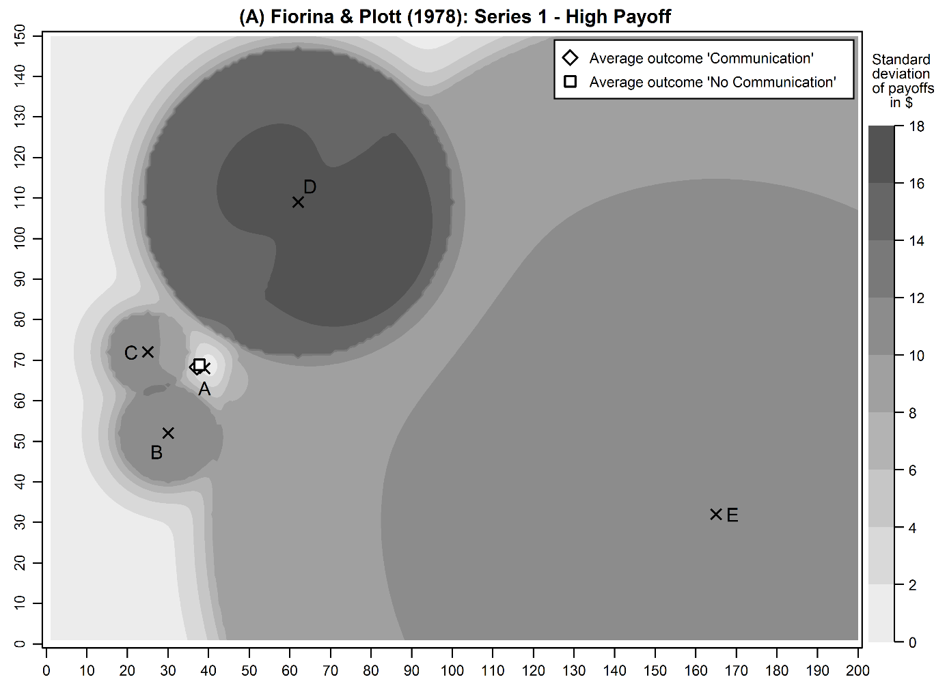
Coordinates of the core: 39|68

Communication
Outcomes: (34|69); (36|66); (32|65); (40|70); (46|68); (39|68); (34|69); (37|70); (43|70); (30|68)
Source: Fiorina & Plott (1978, 584)

Average outcome: (37.1|68.3)
H₀: x-coordinate average outcome = 39: p=0.240; 2-sided Wilcoxon Test.
H₀: y-coordinate average outcome = 68: p=0.464; 2-sided Wilcoxon Test.

No Communication
Outcomes: (37|72); (39|68); (55|71); (32|70); (40|71); (40|67); (40|67); (25|65); (30|70); (39|68)
Source: Fiorina & Plott (1978, 584)

Average outcome: (37.7|68.9)
H₀: x-coordinate average outcome = 39: p=0.681; 2-sided Wilcoxon Test.
H₀: y-coordinate average outcome = 68: p=0.257; 2-sided Wilcoxon Test.
Fiorina & Plott (1978), Series 1, Low Payoff

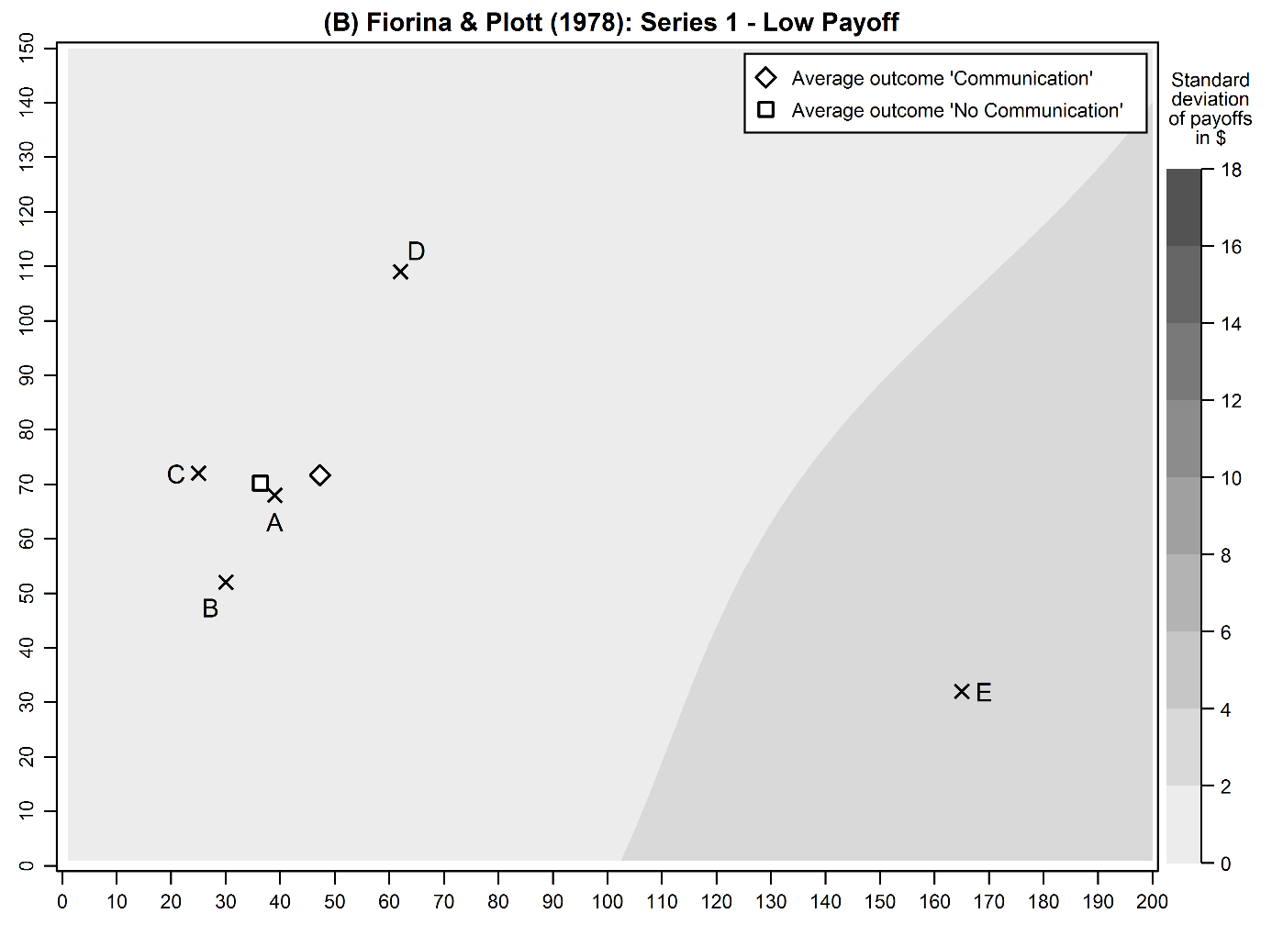
Coordinates of the core: 39|68

Communication
Outcomes: (50|70); (60|80); (39|66); (39|68); (39|68); (25|72); (40|68); (100|70); (50|85); (31|70)
Source: Fiorina & Plott (1978, 584)

Average outcome: (47.3|71.7)
H₀: x-coordinate average outcome = 39: p=0.232; 2-sided Wilcoxon Test.
H₀: y-coordinate average outcome = 68: p=0.047; 2-sided Wilcoxon Test.

No Communication
Outcomes: (62|109); (30|52); (45|68); (39|68); (39|68); (30|60); (33|70); (30|65); (30|70); (25|72)
Source: Fiorina & Plott (1978, 584)

Average outcome: (36.3|70.2)
H₀: x-coordinate average outcome = 39: p=0.196; 2-sided Wilcoxon Test.
H₀: y-coordinate average outcome = 68: p=0.876; 2-sided Wilcoxon Test.

Eavey (1991)

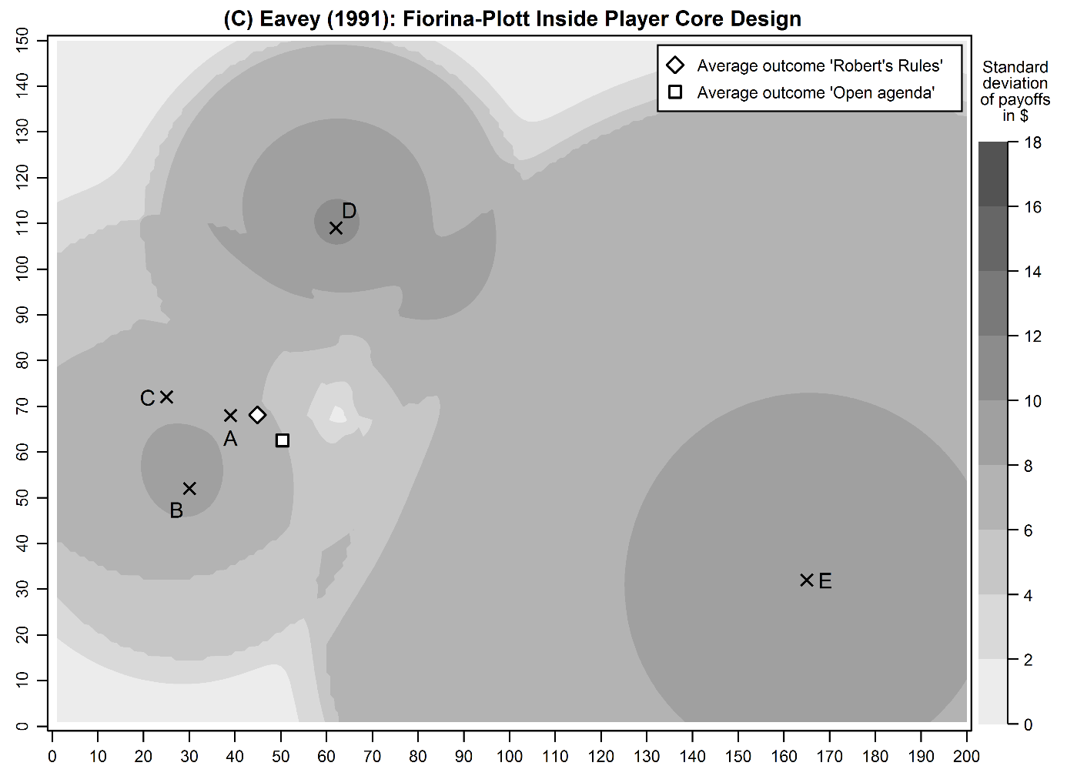
Coordinates of the core: 39|68

Robert’s Rules
Outcomes: (39|68); (40|60); (40|70); (40|72); (40|73); (40|75); (40|70); (50|68); (60|55); (60|70)
Source: Eavey (1991, 461)

Average outcome: (44.9|68.1)
H₀: x-coordinate average outcome = 39: p=0.005; 2-sided Wilcoxon Test.
H₀: y-coordinate average outcome = 68: p=0.472; 2-sided Wilcoxon Test.

Open agenda
Outcomes: (30|50); (40|40); (50|50); (75|66); (35|54); (39|68); (40|80); (50|80); (80|70); (64|67)
Source: Eavey (1991, 461)

Average outcome: (50.3|62.5)
H₀: x-coordinate average outcome = 39: p=0.066; 2-sided Wilcoxon Test.
H₀: y-coordinate average outcome = 68: p=0.201; 2-sided Wilcoxon Test.

