Supplementary material B:
Success of the uncovered set in Treatment 2

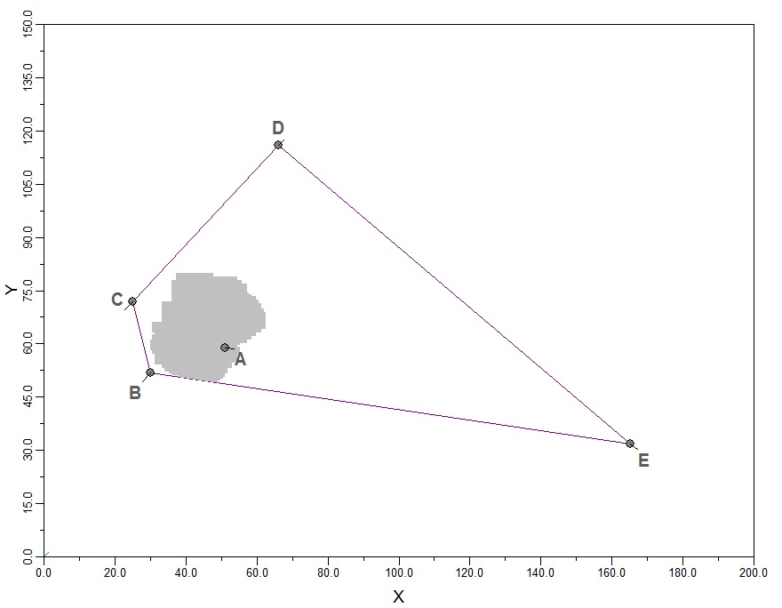
Uncovered set and Pareto set in Treatment 2

Size uncovered set: 716.25 units
Size Pareto set: 5201 units
Expected share of outcomes in uncovered set if committees randomly choose points from the Pareto set: 13.8%

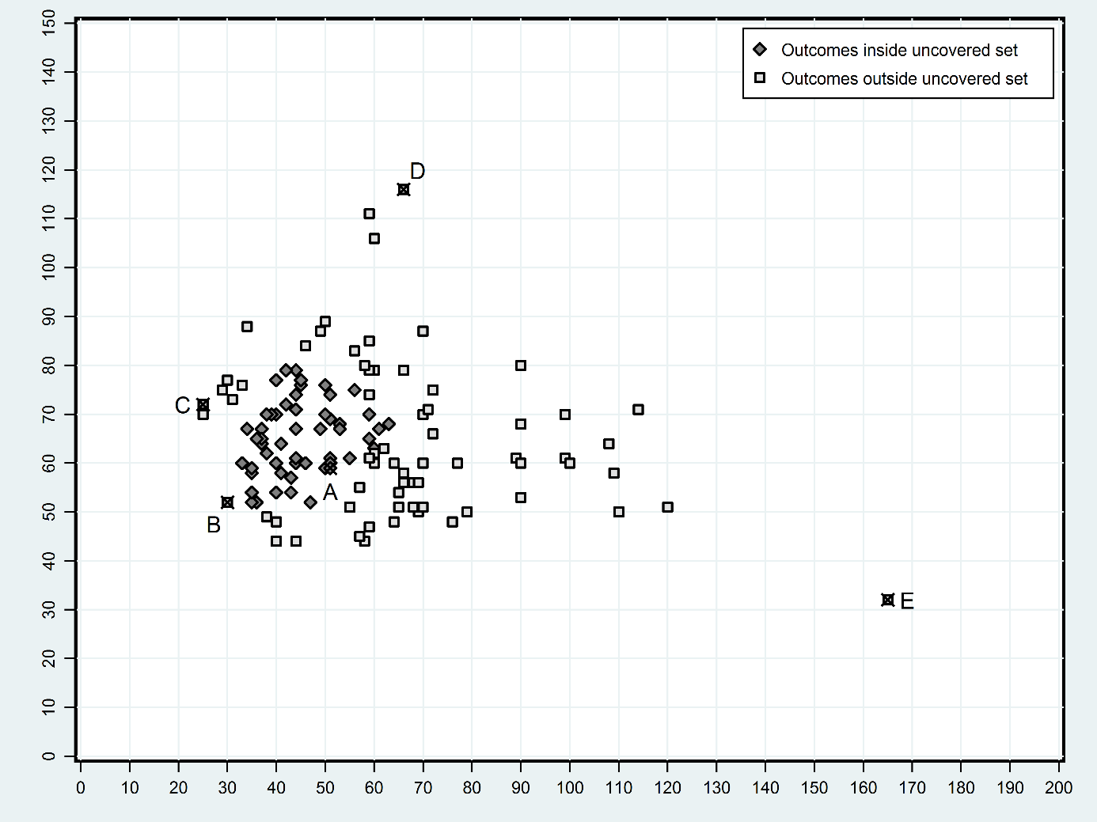
Committee decisions in Treatment 2 inside and outside of the uncovered set

Decisions inside uncovered set: 113 (47.08%)
Decisions outside uncovered set: 127 (52.92%)
Percentage of outcomes occurring in the uncovered set: 47.08%

H_{0:} Share of outcomes in the uncovered set = Expected share of outcomes in uncovered set if committees randomly choose points from the Pareto set: p<0.000; 2-sided binomial test.

Note: The uncovered set was calculated using the software CyberSenate by Joseph Godfrey. Cybersenate employs the grid-search computational algorithm by Bianco, Jeliazkov, and Sened (2004)

Bianco, William T., Ivan Jeliazkov, and Itai Sened. 2004. The Uncovered Set and the Limits of Legislative Action. Political Analysis 12 (3): 256-76.

