Online Appendix
CCES Sample Information
The CCES uses an internet-based survey platform to field a 30,000+ person national stratified survey, drawing a matched sample from a pool of internet users to approximate nationally representative sample obtained through random-digit dialing (Vavreck and Rivers 2008; Gerber and Huber 2010). Research that has used data from the CCES in the past has reported its sample to be consistent with other national surveys, particularly where party identification and ideology are concerned (Ansalaobehere and Persily 2007, 1743).

CCES 2011 Sample Question Wording

E-Voting Treatments
In an election for the US House of Representatives in 2010 a nearby state used electronic voting machines for the first time. The Republican candidate in that state, who had been trailing in public opinion polls, ended up winning the election. How likely do you think do you think it is that fraud was committed in this case?

In an election for the US House of Representatives in 2010 a nearby state used electronic voting machines for the first time. The Democratic candidate in that state, who had been trailing in public opinion polls, ended up winning the election. How likely do you think do you think it is that fraud was committed in this case?

Voters Turned Away Treatments
In an election for the US House of Representatives in 2010 many voters were turned away from the polls in a nearby state. The Republican candidate in that state, who had been trailing in public opinion polls, ended up winning the election. How likely do you think do you think it is that fraud was committed in this case?

In an election for the US House of Representatives in 2010 many voters were turned away from the polls in a nearby state. The Democratic candidate in that state, who had been trailing in public opinion polls, ended up winning the election. How likely do you think do you think it is that fraud was committed in this case?

Registering Ineligible Voters Treatments
In an election for the US House of Representatives in 2010 there were rumors in a nearby state of community organizations attempting to register ineligible voters. The Republican candidate in that state, who had been trailing in public opinion polls, ended up winning the election. How likely do you think do you think it is that fraud was committed in this case?

In an election for the US House of Representatives in 2010 there were rumors in a nearby state of community organizations attempting to register ineligible voters. The Democratic candidate in that state, who had been trailing in public opinion polls, ended up winning the election. How likely do you think do you think it is that fraud was committed in this case?

TESS Sample information
TESS survey experiments are administered by GfK (formerly Knowledge Networks) that maintains a “Knowledge Panel” of respondents that is representative of the US population. Panel members are recruited through an “address-based sample frame”, which allows GfK to reach more individuals who do not have home phones. Internet access and computers are provided for those households that do not currently have them.

TESS 2013 Sample Question Wording
Polarization Treatment
Election fraud has been a hot topic in recent elections, and Democrats and Republicans are intensely divided, both on the sources of fraud and appropriate policy solutions.

Scenario Controls
In the last election for the U.S. House of Representatives (2012) in a nearby state the candidate in that state who had been trailing in public opinion polls ended up winning the election.

In the last election for the U.S. House of Representatives (2012) in a nearby state the Democratic candidate in that state, who had been trailing in public opinion polls ended up winning the election.

In the last election for the U.S. House of Representatives (2012) in a nearby state the Republican candidate in that state, who had been trailing in public opinion polls, ended up winning the election.

E-Voting Treatments
In the last election for the U.S. House of Representatives (2012) in a nearby state they used electronic voting machines for the first time. The candidate in that state who had been trailing in public opinion polls ended up winning the election.

In the last election for the U.S. House of Representatives (2012) in a nearby state they used electronic voting machines for the first time. The Democratic candidate in that state, who had been trailing in public opinion polls, ended up winning the election.

In the last election for the U.S. House of Representatives (2012) in a nearby state they used electronic voting machines for the first time. The Republican candidate in that state, who had been trailing in public opinion polls, ended up winning the election.

Voters Turned Away Treatments
In the last election for the U.S. House of Representatives (2012) in a nearby state many voters were turned away from the polls. The candidate in that state who had been trailing in public opinion polls ended up winning the election.

In the last election for the U.S. House of Representatives (2012) in a nearby state many voters were turned away from the polls. The Democratic candidate in that state, who had been trailing in public opinion polls, ended up winning the election.

In the last election for the U.S. House of Representatives (2012) in a nearby state many voters were turned away from the polls. The Republican candidate in that state, who had been trailing in public opinion polls ended up winning the election.

Registering Ineligible Voters Treatments
In the last election for the U.S. House of Representatives (2012) in a nearby state there were rumors of community organizations attempting to register ineligible voters. The candidate in that state who had been trailing in public opinion polls ended up winning the election.

In the last election for the U.S. House of Representatives (2012) in a nearby state there were rumors of community organizations attempting to register ineligible voters. The Democratic candidate in that state, who had been trailing in public opinion polls, ended up winning the election.

In the last election for the U.S. House of Representatives (2012) in a nearby state there were rumors of community organizations attempting to register ineligible voters. The Republican candidate in that state, who had been trailing in public opinion polls, ended up winning the election.

CONSORT Statement Flow Diagram CCES 2011
Assessed for eligibility (n=1,000)
Allocated to voters turned away intervention (n = 345)
Turned-away lost to follow-up (n = 3)
Refused to answer
Analyzed (n = 342)
Allocated to registering ineligible intervention (n = 312)
Analyzed (n =308 )
Registering lost to follow-up (n = 4)
Refused to answer
Randomized (n= 1,000)
Analyzed (n = 342)
E-voting lost to follow-up (n = 1)
Refused to answer
Allocated to E-voting intervention (n = 343)
Also included, though not presented here for analysis
Allocated to Democrat Candidate intervention (n = 507)
Allocated to Republican Candidate intervention (n = 493)
Excluded (n = 0)

CONSORT Statement Flow Diagram TESS 2013
Assessed for eligibility (n=3,840)
Analyzed
(n = 475)
Analyzed
(n = 457)
Lost to follow-up (n = 8)
Refused to answer
Analyzed
(n = 485)
Lost to follow-up (n = 11)
Refused to answer
Lost to follow-up (n = 6)
Refused to answer
Polarization; Allocated to registering ineligible intervention
(n = 496)
Polarization; Allocated to voters turned away intervention
(n = 481)
Analyzed
(n =484)
Lost to follow-up (n =5)
Refused to answer
Polarization; Scenario Control Group
(n =489 )
Allocated to Polarization intervention (n = 1,931)
Polarization; Allocated to E-voting intervention (n = 465)
Randomized (n= 3,840)
Excluded(n = 0)
CONSORT Statement flow diagram TESS 2013 (continued)
Allocated to Partisan Control Group (n = 1279)
Allocated to Republican Candidate intervention (n = 1289)
Analyzed
(n = 466)
Analyzed
(n = 455)
Lost to follow-up (n =10)
Refused to answer
Lost to follow-up (n = 12)
Refused to answer
No Polarization; Allocated to voters turned away intervention
(n = 478)
No Polarization; Scenario Control Group
(n =465)
Polarization Control
(n = 1,909)
Analyzed
(n = 476)
Lost to follow-up (n = 13)
Refused to answer
No Polarization; Allocated to registering ineligible intervention
(n = 489)
No Polarization; Allocated to E-voting intervention
(n = 477)
Lost to follow-up (n = 6)
Refused to answer
Analyzed
(n = 471)
Allocated to Democrat Candidate intervention (n = 1272)
Also included, though not presented here for analysis
Table 3M Sample Summary Statistics

 | CCES  (N = 996) | TESS (Polarization0)  (N = 1672) | TESS (Polarization1)  (N = 1696)
Fraud likely | .58 | .50 | .52
Education | Some College, no degree (3.4) | Some College, no degree (10.5) | Some College, no degree (10.5)
Gender  1=male; 2=female | 1.5 | 1.5 | 1.5
Political interest | Some of the time  (4-1; 1.7) | Somewhat interested (1-4; 2.2) | Somewhat interested  (1-4; 2.2)
Age | 50.3 | 50.8 | 50.4
Republican | .25 | .27 | .28
Democrat | .37 | .36 | .33
Copartisan | .31 | .32 | .32
Voted in last presidential election | .84 | .86 | .86

Balance across Treatment Groups for CCES 2011
 | E-voting Treatment | Registering treatment | Turned-Away treatment
Education | Some College, no degree (3.37) | Some College, no degree (3.4) | Some College, no degree (3.43)
Gender  1=male; 2=female | 1.5 | 1.6 | 1.5
Interest  (4-1) | Some of the time  (1.77) | Some of the time  (1.7) | Some of the time  (1.72)
Age | 50.8 | 50.2 | 50
Voted | .84 | .84 | .84
Republican | .28 | .21 | .26
Democrat | .34 | .40 | .38

Balance across Treatment Groups for TESS 2013

 | No Polarization |  |  |  | Polarization
 | E-Voting | Registering | Turned-Away | Control | E-Voting | Registering | Turned-Away | Control
Education | Some College, no degree (10.3) | Some College, no degree (10.4) | Some College, no degree (10.3) | Some College, no degree (10.3) | Some College, no degree (10.5) | Some College, no degree (10.4) | Some College, no degree (10.5) | Some College, no degree (10.4)
Gender  1=male; 2=female | 1.5 | 1.5 | 1.5 | 1.5 | 1.5 | 1.5 | 1.5 | 1.5
Interest  1-4 | Somewhat interested  (2.3) | Somewhat interested (2.4) | Somewhat interested (2.4) | Somewhat interested 2.4) | Somewhat interested (2.3) | Somewhat interested  (2.3) | Somewhat interested  (2.4) | Somewhat interested  (2.4)
Age | 50 | 49 | 50 | 49 | 50 | 49 | 49 | 49
Voted | .85 | .86 | .87 | .89 | .87 | .86 | .86 | .88
Republican | .29 | .23 | .26 | .23 | .28 | .26 | .26 | .28
Democrat | .34 | .35 | .34 | .34 | .34 | .34 | .29 | .32

Extended Discussion of Table 1 Results

The negative estimated coefficient associated with Education indicates that more educated individuals are less likely to be suspicious of fraud, while the positive estimated coefficient associated with Gender indicates that women are more likely to suspect fraud. The estimated coefficient associated with Education attains conventional levels of statistical significance across all three models, while the Gender estimates are significant in 2 of the 3 models. The estimated coefficient for Age is positive and attains conventional levels of statistical significance in one model. However, since Age is used in two interaction terms care must be taken when interpreting this coefficient—The probability of finding fraud likely increases with age, among those individuals who received either the voter suppression treatment, or were in the control category. The negative coefficient associated with Voting in the most recent presidential election (Voted Presidential Election) suggests that voters are less likely to suspect election fraud, but these estimates only attain conventional levels of statistical significance in one model.

Given the inclusion of the Co-Partisans variable, the positive coefficients associated with individuals party-ID (Democrat and Republican) suggest that Republicans who receive a treatment where the candidate does not share their partisan identity are more likely to suspect fraud—a relationship that attains or approaches conventional levels of statistical significance in all three models. For similar Democrats, however, the pattern is not as straightforward. In the CCES survey, Democrats who received a Republican candidate treatment had similar responses to Republicans. In the TESS survey, however the estimated coefficients are negative—suggested a decreased suspicion of fraud—but only one of these estimates attains conventional levels of statistical significance. While the negative estimated coefficient for Co-Partisans indicates that those who receive a scenario where the winning candidate shares their partisan identity are less likely to suspect fraud. The estimates for Co-Partisans consistently attain conventional levels of statistical significance across all three models.

Table 2: Replication of Table 1 results on sub-sample of voters only
 |  | CCES 2011 | TESS 2013  Polarization=0 | TESS 2013  Polarization=1
Individual Variables
 | Education | -0.134**  (0.0537) | -0.185**  (0.033) | -0.118**  (0.033)
 | Gender | 0.510**  (0.161) | 0.180  (0115) | 0.271*  (0.114)
 | Interest in Politics | 0.040  (0.096) | -0.053  (0.064) | 0.054  (0.065)
 | Age | -0.008  (0.010) | 0.002  (0.004) | 0.014**  (0.005)
 | Republican | 1.178**  (0.232) | 0.242†  (0.146) | 0.468**  (0.140)
 | Democrat | 1.144**  (0.220) | -0.239†  (0.134) | -0.132  (0.135)
Treatment Variables
 | Control | N/A | -0.988**  (0.235) | -0.435†  (0.231)
 | E-voting first time | -2.586**  (0.767) | -0.177  (0.464) | -1.069*  (0.473)
 | Voters Turned Away | 0.255  (0.761) | 0.434  (0.458) | 0.378  (0.455)
 | Registering Ineligible | (Reference) | (Reference) | (Reference)
 | Dem. Candidate | 0.110  (0.157) | 0.125  (0.168) | 0.139  (0.168)
 | Rep. Candidate | (Reference) | -0.064  (0.161) | 0.077  (0.163)
 | Co-partisans | -1.939**  (0.207) | -1.374**  (0.142) | -1.094**  (0.138)
Interactions
 | Age*E-voting | 0.029**  (0.013) | -0.011  (0.008) | 0.009  (0.008)
 | Age*Voters Turned Away | -0.008**  (0.013) | -0.005  (0.008) | -0.001  (0.008)
 | Constant | 0.738  (0.683) | 2.319**  (0.561) | 0.362  (0.555)
 | N | 840 | 1433 | 1445
 | LR Chi²(12, 14 ,14) | 160.46 | 199.70 | 173.62
 | Prob > Chi² | 0.000 | 0.000 | 0.000
 | Pseudo R² | 0.140 | 0.100 | 0.086

Figure 3a: CCES 2011

Figure 3b: TESS (no polarization)
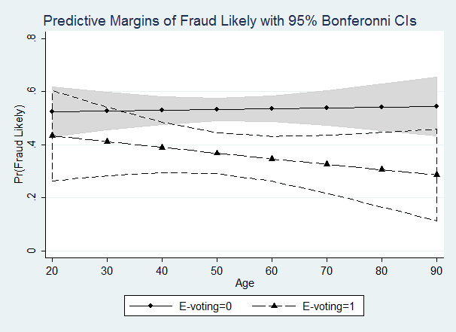

Figure 3c: Tess (Polarization)
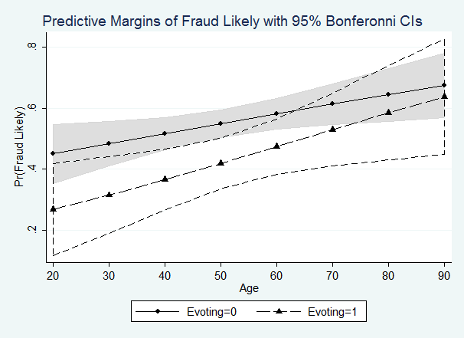

Table 3: Table 1 Results Replication using O-Logit
 |  | CCES 2011 | TESS 2013  Polarization=0 | TESS 2013  Polarization=1
Individual Variables
 | Education | -0.138**  (0.042) | -0.127**  (0.025) | -0.110**  (0.026)
 | Gender | 0.412**  (0.122) | 0.204*  (0.091) | 0.211*  (0.091)
 | Interest in Politics | -0.050  (0.064) | -0.068  (0.051) | -0.025  (0.051)
 | Age | 0.009  (0.007) | 0.000  (0.003) | 0.007†  (0.003)
 | Voted Presidential Election | -0.053  (0.065) | -0.326**  (0.139) | -0.048  (0.137)
 | Republican | 1.082**  (0.177) | 0.206†  (0.117) | 0.335**  (0.113)
 | Democrat | 0.963** | -0.337* | -0.237*
 |  | (0.161) | (0.107) | (0.108)
Treatment Variables
 | Control | N/A | -0.824**  (0.187) | -0.398*  (0.190)
 | E-voting first time | -1.345**  (0.497) | -0.216  (0.354) | -0.851*  (0.354)
 | Voters Turned Away | 0.253  (0.474) | 0.685†  (0.363) | -0.075  (0.358)
 | Registering Ineligible | (Reference) | (Reference) | (Reference)
 | Dem. Candidate | 0.170  (0.118) | 0.180  (0.135) | 0.172  (0.134)
 | Rep. Candidate | N/A | -0.098  (0.130) | 0.063  (0.129)
 | Co-partisans | -1.711**  (0.158) | -1.182**  (0.115) | -0.942**  (0.112)
Interactions
 | Age*E-voting | 0.005  (0.009) | -0.010  (0.006) | 0.009  (0.006)
 | Age*Voters Turned Away | -0.008  (0.009) | -0.008  (0.006) | 0.007  (0.006)
 | Cut 1 | -1.725  (0.502) | -3.780  (0.435) | -2.786  (0.446)
 | Cut 2 | -0.326  (0.498) | -2.125  (0.428) | -0.986  (0.441)
 | Cut 3 | 1.382  (0.501) | -0.168  (0.426) | 0.956  (0.441)
 | N | 988 | 1652 | 1681
 | LR Chi²(13, 15 ,15) | 212.35 | 255.03 | 181.44
 | Prob > Chi² | 0.000 | 0.000 | 0.000
 | Pseudo R² | 0.079 | 0.058 | 0.041

Figure 4a: CCES 2011
Probability of finding fraud “Very Likely”
Figure 4b: TESS 2012 (Polarization=0)
Probability of finding Fraud “Very Likely”
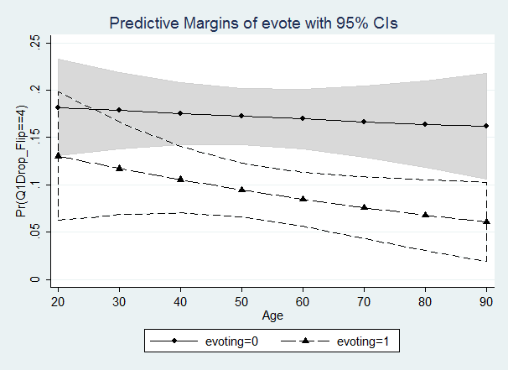

Figure 4c: TESS 2012 (Polarization =1)
Probability of Finding Fraud “Very Likely”
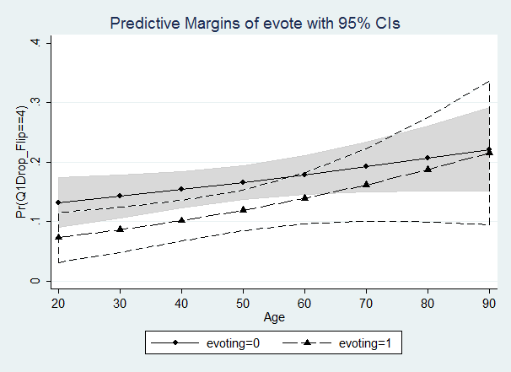
References
Beaulieu, Emily. 2014. From Voter ID to Party ID: How political parties affect perceptions of
election fraud in the U.S. Electoral Studies 35: 24-32.

Gerber, Alan S. and Gregory A. Huber. 2010. Partisanship, Political Control, and Economic
Assessments. American Journal of Political Science 54(1): 153-173.

Vavreck, Lynn, and Douglas Rivers. 2008. The 2006 Cooperative Congressional Election Study.
Journal of Elections, Public Opinion and Parties 18:355-66.

For a more in-depth discussion of the partisan results in the CCES survey, see Beaulieu 2014.

