Online Appendices

Appendix A: Procedures and subject recruitment
Study 1
The survey was live April 1–April 12, 2011. The participant pool, though selected for convenience, included both at a distance and on-campus students; this increases the regional and demographic diversity included in the sample as distance students are often non-traditional. Students were offered extra credit for their participation in the study for various courses ranging from modern history to sociology to criminology to statistics. Participants were recruited via email and in-class announcements by colleagues during the last two weeks of March 2011. No participants were excluded unless determined not to be a student of the university. Students interested in receiving extra credit were instructed to email the PI and request a unique URL; only participants with valid university email addresses whom could identify the course they were receiving credit for were included; although this exclusion criteria did not prove to be an issue as no one outside of the university population within the selected courses contacted the PI. All participants completed the task as assigned. Students that expressed interest in participating were emailed directions and a unique URL so that they could receive extra credit for their participation. Upon receipt of the URL, students were instructed to turn-off any pop-up blocking software.
We rely on Remark Web Survey software (4.0) to build and maintain the survey. Use of this software is beneficial for several reasons. First, this software generates professional online survey shells which can be customized by the user. Second, this software allows for live statistical analysis and extensive reliability checks. Third, participants can be provided with unique URLs so as to diminish the likelihood a survey will be forwarded on, taken multiple times, or accessed by someone outside of the student population. Fourth, all data is housed by WSU’s College of Liberal Arts Server which ensures the security and confidentiality of participant responses long-term. The authors thank the Division of Governmental Studies and Services for access to Remark, and administrative support. Both question choices and question orders were randomized (by Remark) within blocks prior to treatment, and within blocks following treatment. Also, induction treatments were randomly assigned by participant using Remark’s built-in randomization feature. Participants were blinded to treatment conditions. The survey questions can be found in Appendix D.

Study 2
The survey was live March 18–March 21, 2014. Participants for this online survey were recruited via Amazon.com’s Mechanical Turk (MTurk, www.mturk.com) service. In general, online survey methodology has become increasingly popular in the social sciences due to the ease and accessibility of format. Also, an online survey approach avoids artificial settings, enables access to a broader sample, and is often more cost-efficient.
Mturk is an online marketplace for short-duration temporary work, and is used for a wide variety of business tasks from audio transcription to detailed research. Its chief benefits are on-demand work and scalability. Rather than hiring a large temporary work force, one can post the tasks—called Human Intelligence Tasks (HITs) on MTurk—avoiding much of the expensive and time-consuming recruitment phase. Payments are generally inexpensive and given to the workers only upon successful completion of the HITs. For many of the same reasons, MTurk has rapidly gained traction in the research community (e.g., Huber and Lenz 2012; Chandler and Kapelner 2010), as it provides an inexpensive yet reliable means of subject recruitment for experiments.
Though online panels are a newer survey mode, recent research demonstrates that the estimates of the opt-in Internet panel are just as accurate as estimates from the more traditional telephone mode utilizing a national RDD sample of cell and landlines (Ansolabehere and Schaffner 2011). Investigations in psychology (Buhrmester, Kwang and Gosling 2011), economics (Horton, Rand, and Zeckhauser 2010) and political science (Berinsky, Huber, and Lenz 2012) have shown support for using MTurk workers as a convenience sample. For example, Berinsky and colleagues (2012) find that MTurk samples are a good substitute for other convenience samples (such as college students), that Mturk samples are more representative of the U.S. population than standard Internet samples, and that data obtained from MTurk samples are very similar to the unweighted probability sample obtained by the American National Election Studies (ANES) 2008 Panel Study using random digit dialing; they also successfully replicate important published experimental work using MTurk samples. These authors suggest Mturk should be limited to Internet-based experiments drawing from the U.S. population, which is appropriate for this project.
Workers who clicked on the HIT for this project were offered $0.75 to complete a 15-minute survey on political attitudes in which their responses would be anonymous. Upon completion of the study workers would be given a code to submit to receive payment. The HIT was restricted to workers who were 18 years or older, were citizens of the United States, and who had completed at least 500 HITS with at least a 95% approval rating. Also, limits were placed on the HIT so that workers were unable to complete the task more than once. Implied consent was given by agreeing to participate in the task after selecting the HIT from the list of available tasks on MTurk. After agreeing, participants were redirected to a window within MTurk which featured the survey linked from Qualtrics framed directly in their browser. We then approved payment for all workers unless they met one of the following exclusion criteria: survey was not completed, completion code was not entered, completion code was incorrect, responses were incomplete or resembled a non-random pattern (e.g. all A’s selected), or duration of task was substantially less than half of the average duration time (average was 17 minutes).
First, participants answered a screening question which prompts them to select the last, unrelated option “Airport” (see online appendix D for the complete survey). This manipulation check is based on a question tested by Downs and colleagues (2010) for the purpose of screening Mechanical Turk (MTurk) participants. Participants who correctly answered the question were allowed to proceed; participants who incorrectly answered the question were prompted, “It is very important to read the instructions thoroughly and answer questions thoughtfully, please read the prompt one more time and answer again.” This loop continued until participants answered correctly. In this way, we ensured that participants were engaging in effortful processing throughout the task. After the screening question, participants answered pre-treatment questions, including queries on the most important issues, trust, political knowledge, demographics, partisan and ideological identification, media exposure, news preferences, efficacy, and political attitudes. Participants were then randomly assigned to one of 4 conditions: control, political scenario, non-political scenario, and campaign advertisement. The campaign video was embedded in the page for participant ease while the video itself was hosted on YouTube so as to avoid potential issues with video player compatibility. To ensure participants in the political and non-political scenario were thoughtful in their consideration of the scenarios we added a stop mechanism which for two minutes concealed the button used to continue to the next screen. We selected two minutes for the sake of comparability as it approximates the duration of time participants assigned to the campaign ad treatment spent on the page. Asking participants to read and think about a vignette such as this is common when using guided imagery in psychology, though other studies find that the exact timing makes little difference (Mayer et al. 1990).
After the treatment all participants were provided with a text box and directed to write about how the scenario or ad (depending on the condition) made them feel for at least three minutes. The writing prompt is used to motivate participants to thoughtfully engage with their feelings and reflect upon their feelings in a thoughtful way (Keltner et al. 1993). As some works find that answering semantic prompts immediately after an induction results in self-regulation of feelings (Berkowitz et al. 2000), the writing prompt is used to reinforce the intended affect induction. Much like the scenario condition, we added a stop mechanism until the two minute time limit was up to ensure participants actually took time to write. Participants in the control condition do not receive a treatment nor do they receive any writing prompt. All participants then responded to semantic prompts which asked about their emotional state for 14 different emotions, mainly to identify variation in three dimensions of interest: Anger (angry, hateful, bitter, upset), Anxiety (uneasy, worried, scared), and Enthusiasm (proud, enthusiastic).

Appendix B: Additional Details on Induction Methods for Study 1
1: Self-statements
This approach is often preferred by affective researchers because in addition to being a limited intrusion, it allows an individual to voice affirmations of anger with increasing intensity. Additionally, a meta-analysis found that studies using self-statements had larger effect sizes than studies using other inductions (Larsen and Sinnett 1991), and given it is one of the few induction techniques in which guided imagery is not used to manipulate foreground attention, it is an appropriate comparison to the other two inductions used herein. However, the downside of the self-statements technique is that when it is used in a non-laboratory setting, participants may not take the time to read through each statement, diminishing their overall effect. Also, the effects are short-lived (Larsen and Sinnett 1991). Thus, while self-statements are a common technique and useful for comparison, we are skeptical that it is the ideal approach for political scientists. For this reason, our first expectation is that the self-statements induction will have the smallest effect on anger levels of the three inductions.
Here, we utilize the list developed by Engebretson and colleagues (1999), which as written is designed for researchers using student samples, as in our Study 1. To create this list, the authors first drew 72 anger items from other measurement instruments, then asked twenty-three psychologists to rank the items using a three-point scale for intensity, and finally comprised the list of items for which there was high agreement. The format of this method, called a self-description approach, is based on the Velten Mood Induction Procedures for depression (VMIP-D), and elation (VMIP-E) (Velten 1968). The instructions from Study 1 are included below.

For this next segment of the survey we would like you to read aloud each statement, think about how it makes you feel for approximately 20 seconds, and then proceed to the next statement. Proceed in this manner until you reach the end of the list.

1. Today is neither better nor worse than any other day.
2. However, I do feel a little irritated today.
3. If someone isn’t being logical, I don’t just let it go by.
4. There have been times when I’ve been criticized unjustly.
5. I can be impatient with foolish people.
6. I’ve worked under people who take credit for good work but pass off mistakes on to those under them.
7. Some of my family and friends have habits that bother and annoy me very much.
8. I know what it feels like to be cheated.
9. At times, I’ve been deceived by others.
10. No one cares much what happens to anyone but themselves.
11. Some of the policies at school make me indignant.
12. Sometimes I think people do things just to irritate me.
13. I’ve been bad-tempered at times in my life and I can recapture those feelings easily.
14. Few things make me more bitter than being taken for granted.
15. I feel like being sarcastic with someone who has angered me.
16. I can become quick-tempered if the situation provokes me enough.
17. There are occasions when I’m hot-headed.
18. I get angry when I think about the creeps that make it unsafe to walk alone at night.
19. It’s maddening the way people don’t really listen to me.
20. I feel rather aggravated now.
21. There are people who I thought I could trust who betrayed me.
22. I feel grouchy and spiteful.
23. Members of my family have treated me poorly at times and made me very angry.
24. If someone mistreats me, I can really harbor a grudge.
25. It makes me bitter to think of the way so-called friends have sometimes treated me.
26. Although it is probably irrational, I can’t help but see red when someone insults me.
27. Some of the things that go on at school make me downright angry and resentful.
28. I feel vindictive.
29. I can feel my body getting tense with anger.
30. I can be incredibly bitchy at times. In fact I’m feeling that way now.
31. The cruelty that goes on in the world often incenses and even enrages me.
32. I feel angry at the whole world.
33. I can be confronting with people who are rude or annoying. They piss me off!
34. I feel rebellious and ready to fight.
35. I’m not going to take any mistreatment from anyone. Just let someone even try to take advantage of me today!
36. I feel vicious.
37. There have been days when I feel hostile and bitter and unable to control those feelings.
38. To make this anger go away would be nearly impossible.
39. I feel like striking out at someone who has angered me.
40. I’ve lain awake at night so mad that I couldn’t stop thinking about what made me feel that way.
41. Sometimes I seem to go blind with rage.
42. I’m so hostile, I could easily lose control.
43. I’ve been so angry I could have bashed someone’s head in!
44. I can feel my fists clenched in fury.
45. I feel like I could explode.
46. I want to yell and scream. That’s how upset I feel.
47. I couldn’t stay calm now no matter what. I’m to incensed.
48. My heart is pounding and I’m boiling inside.
49. I am consumed with hatred.
50. I’m livid with rage.

2: Non-political Scenario
For the second induction condition, “scenario” we utilize a common technique in which participants are asked to imagine themselves in a scenario which makes them angry (Bower 1981; Suarez and Williams 1989; Keltner et al. 1993; Valentino et al. 2008, 2011; Lerner and Keltner 2001; for overview see Ahsen 1989). Participants are instructed to “imagine the following scenario,” in which a student wakes up late for an exam and after searching endlessly, finds a parking spot only to have it stolen by a careless peer. This guided scene is preferred because it draws on multiple senses to elicit physiological markers of emotions by placing participants in recognizable, affectively-charged situations (Ekman 1992). This scenario is also appropriate for Study 1 given the university population from which we draw, and it is advantageous because such a scenario is almost universally relatable—nearly all of us have experienced the frustrations of waking up late for an important event only to be foiled by transportation woes. For these reasons, this task should be more engaging than the self-statements, and thus our second expectation is that the scenario induction will have a larger effect on subjects’ anger levels.
We base this scenario on a similar anger induction used by Keltner and colleagues (1993) which asks participants (also drawn from a student sample) to imagine a situation where they work very hard in a course, but receive a “C” because they do not get along with the teaching assistant. This scenario is designed with characteristics of anger as dictated by cognitive appraisal theory (Clore et al., 1993) including an environment in which external conditions and a target are to blame for behavioral consequences (Smith and Ellsworth 1988). In this induction scenario, the environment (lack of parking under a time crunch) paired with the target (inconsiderate peer) makes blame attribution more salient and action readiness more likely (Keltner et al. 1993). The instructions from Study 1 are included below.

For this next segment of the survey we would like you to imagine the following scenario.
Today you woke up thirty minutes late and you are now late for a mid-term exam. You hurriedly drive to class and as you pull into the parking lot you breathe a sigh of relief as you spot a parking spot convenient to the classroom where the exam is being given. All of the sudden a car pulls out in front of you, cutting you off and stealing your parking spot.
You quickly feel your face get hot and your blood surge as you yell at the person that stole your parking spot. You glare at the driver of the offending car as they gather their things and happily exit the car.
Now you must drive around for another five to ten minutes in search of a parking spot, and you are already late for your mid-term. You frown and hit the steering wheel as you think, "Today of all days!"

Take a second to think about how the scenario above makes you feel, and if applicable, how you felt when something similar happened to you. With these feelings in mind please answer the questions below.

3: Images
For the third induction condition, “images,” we use images from the International Affective Picture System (IAPS; Lang et al. 1999), a database of static images which have been assigned a corresponding discrete emotional state (Mikels et al. 2005). We selected five images with the highest mean anger response and lowest mean response on other emotions: an attack scene, mutilation, dead animals, pollution, and cross-burning. The use of images is a favored induction technique for several reasons: each image is subjected to extensive reliability and validity testing before entry into the database and has shown to be invariant across cultures, the database is accessible to all researchers, and finally, the medium translates to many research designs. Given our desire to provide induction techniques which are suitable for a variety of studies, that is an attractive characteristic of the images induction. Furthermore, looking at images requires less effort than reading statements or imagining a scenario. On the downside, an important criticism of using images is that characteristics or “plot” effects from the visuals may have an effect on the induced emotional state. Regardless, manipulating imagery is quite common in politics—such as when trying to affect voters with campaign advertisements—so this induction should be familiar and practical for political scientists. For these reasons, our third expectation is that the images induction will have the largest effect on anger levels of the three inductions. As per Mikels and colleagues (2005), these images were formatted with pixel dimensions 400 x 300. The instructions and images from Study 1 are included below.

Next you will view a series of images. As you view each picture, we would like you to think about how the image makes you feel, then click the Next button. Do the same for each image.

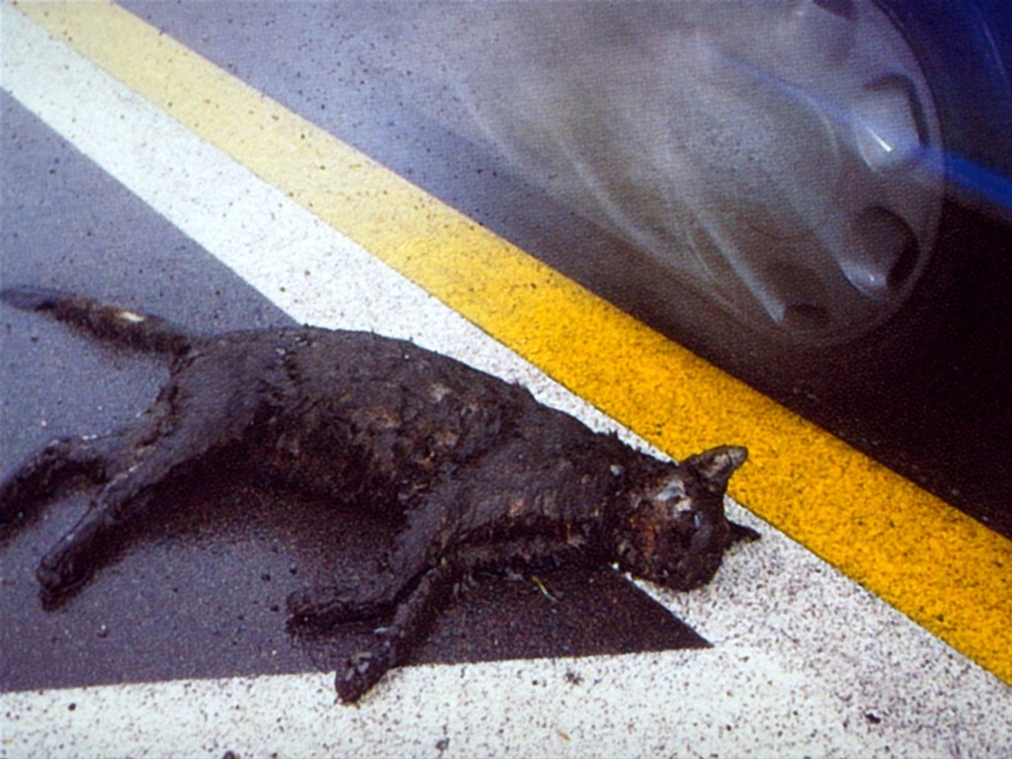

Appendix C: Additional Details on Induction Methods for Study 2
1: Non-political scenario
As in Study 1, participants are asked to imagine themselves in a scenario which makes them angry, the objective being to guide individuals into an affectively-charged situation that is personally recognizable (Ekman 1992). Since Study 2 draws on an adult sample, we revise the scenario slightly so that the participant is asked to envision a scenario in which they wake up late for an important meeting). Given the success of the scenario induction with the student sample we expect that again, the scenario induction will have a large and significant effect on subjects’ anger levels. The instructions from Study 2 are included below.

Please thoroughly read the scenario below. We will give you 2 minutes to do so. TAKE YOUR TIME. During this two minutes, please picture the details of the situation, imagine how you might feel if this situation were to happen to you, and react to the scenario as if it were real.
Today you woke up thirty minutes late and you are now late for an important meeting. You hurriedly drive there. When you pull into the parking lot, it looks full. You breathe a sigh of relief when you see the last open spot. All of the sudden a car pulls out in front of you, cutting you off and stealing your parking spot. You quickly feel your face get hot and your blood surge as you yell at the person that stole your parking spot. You glare at the driver of the offending car as they gather their things and happily exit the car. Now you must drive around for another five to ten minutes in search of a parking spot, and you are already late. You frown and hit the steering wheel as you think, "Today of all days!”

After two minutes and continuing on to the next page, participants are directed to:

In the box below, please write about how this scenario made you feel. We will give you 3 minutes to do so. TAKE YOUR TIME. Picturing the details of the situation, imagine what you might say; think about what you would hear, see, taste, and feel in that moment and write about it. We are not concerned with grammar or how well you can write, just your feelings.

2: Political scenario
As most political scientists are interested in how anger towards political objects affects attitudes and behaviors, in this study we introduce a political scenario induction so that we can better understand the generalizability of the non-political scenario and compare the effectiveness of both on an adult sample. In this treatment, participants are asked to imagine a situation in which they are discussing a preferred candidate for an upcoming election with a group of co-workers, and an inconsiderate co-worker interrupts the conversation and mocks their opinion. Here, the environment (a heated argument about candidate preference in the workplace) paired with the target (inconsiderate co-worker) makes blame attribution salient (Keltner et al. 1993). We intentionally leave out the level of the electoral race and partisan cues so as to increase applicability of the induction across a range of studies. While we have little to draw from in generating expectations about the effects of a political induction versus a non-political induction, there are some characteristics of anger which may inform our predictions. Much work in cognitive appraisal theory suggests anger states contain appraisals of control (Ellsworth and Smith 1988) and attributions of blame (Lerner and Keltner 2001). Affective Intelligence Theory posits that aversion is a result of familiar conflicts which threaten core values (Marcus 2002). Given the political scenario is characterized by an external target impending on deep-seated attitudes, we expect that political scenarios may generate higher levels of anger compared to non-political scenarios.
We design this scenario so as to have a target towards which participants can direct their anger, a personally-frustrated goal, and to draw on multiple senses so as to elicit a physiological anger response (Ekman 1992). Like the non-political scenario, we draw on characteristics of cognitive appraisal theory in crafting a vignette which is likely to evoke an anger state (Clore et al., 1993). The instructions from Study 2 are included below.

Please thoroughly read the scenario below. We will give you 2 minutes to do so. TAKE YOUR TIME. During this two minutes, please picture the details of the situation, imagine how you might feel if this situation were to happen to you, and react to the scenario as if it were real.
Imagine you are furious because your co-worker just made you look really stupid in front of everyone at your office. During a discussion about the election she interrupted you when you tried to tell everybody about the candidate you are supporting, and she openly mocked your choice. As she walked away you heard her tell another co-worker, “You have to be an idiot to support that guy.” To make matters worse, she is walking around the office bragging about how well the candidate she’s supporting is doing in the polls, and how your political views are “so dumb and so wrong.” The others in the office seem to believe her. But you know she doesn’t know anything.

After two minutes and continuing on to the next page, participants are directed to:

In the box below, please write about how this scenario made you feel. We will give you 3 minutes to do so. TAKE YOUR TIME. Picturing the details of the situation, imagine what you might say; think about what you would hear, see, taste, and feel in that moment and write about it. We are not concerned with grammar or how well you can write, just your feelings.

3: Campaign advertisement
Commonly in political science an emotional campaign ad is used to better understand the effects of affect on attitudes and behavior. For example, Brader (2006) manipulates the imagery and music in campaign ads to elicit anger, enthusiasm, fear, and pride (see also Albertson and Gadarian n.d.). For this induction we selected an ad previously shown to evoke anger, an actual 2010 negative ad in which a candidate for Alabama State Senate, Paul Bussman, is ruthlessly attacked for failing to pay child support. In a recent study on negative campaigning (Mattes and Redlawsk 2015), of twenty-one ads shown to participants this ad incited the highest level of anger and was considered to be the most negative and least appropriate. Notably, this advertisement does not mention political party nor contain partisan cues, so it is able to elicit anger equally across party lines. However, as the campaign ad is for an election in which the research participant has no stakes, it is less likely to engage action tendencies. The scenarios, on the other hand, are more relatable, so despite the inflammatory nature of the ad and our description of it as “negative”, we expect that there will be comparatively lower anger levels in response to the ad than the other two scenario inductions. Mattes and Redlawsk (2015) find that including the word “negative” in a description of a hypothetical attack ad results in a doubling (from 32% to 64%) of respondents who express anger toward the ad. To further elicit anger, our instructions specifically label the ad as “negative.” The instructions from Study 2 are included below.

Political candidates nowadays use more negative ads than ever. Watch this 30-second negative political advertisement very closely from beginning to end. Please be sure your volume is turned up to a reasonable level. Click PLAY on the video below. Please watch the advertisement once, from start to finish. When the clip is finished press the >> button below to continue. This should take you less than a minute. To keep the respondent time minimal, please watch the advertisement all the way through only one time. Please do not navigate to any other sites. Please do not watch any other advertisements at this time.

Voiceover script (on-screen text is shown in brackets): “We expect fathers to provide for their children. It’s what any dad should want to do, especially one who makes over [$200,000 per year]. But that’s not how state senate candidate Paul Bussman sees it. He [refused to pay thousands of dollars of family support] until a judge finally forced him to do so. Incredibly, the judge even had to force him to pay his children’s [medical bills]. [Paul Bussman failed his children] [Can we trust him] to represent us in the State Senate?”

After viewing the ad and continuing on to the next page, participants are directed to:

In the box below, please write about how watching this negative ad made you feel. We will give you 3 minutes to do so. TAKE YOUR TIME. Thinking again about the details of the ad—what you heard, felt, and saw during the ad. Imagine how you’d feel if someone put you in a similar situation and write about it. We are not concerned with grammar or how well you can write, just your feelings.
Ad screenshots
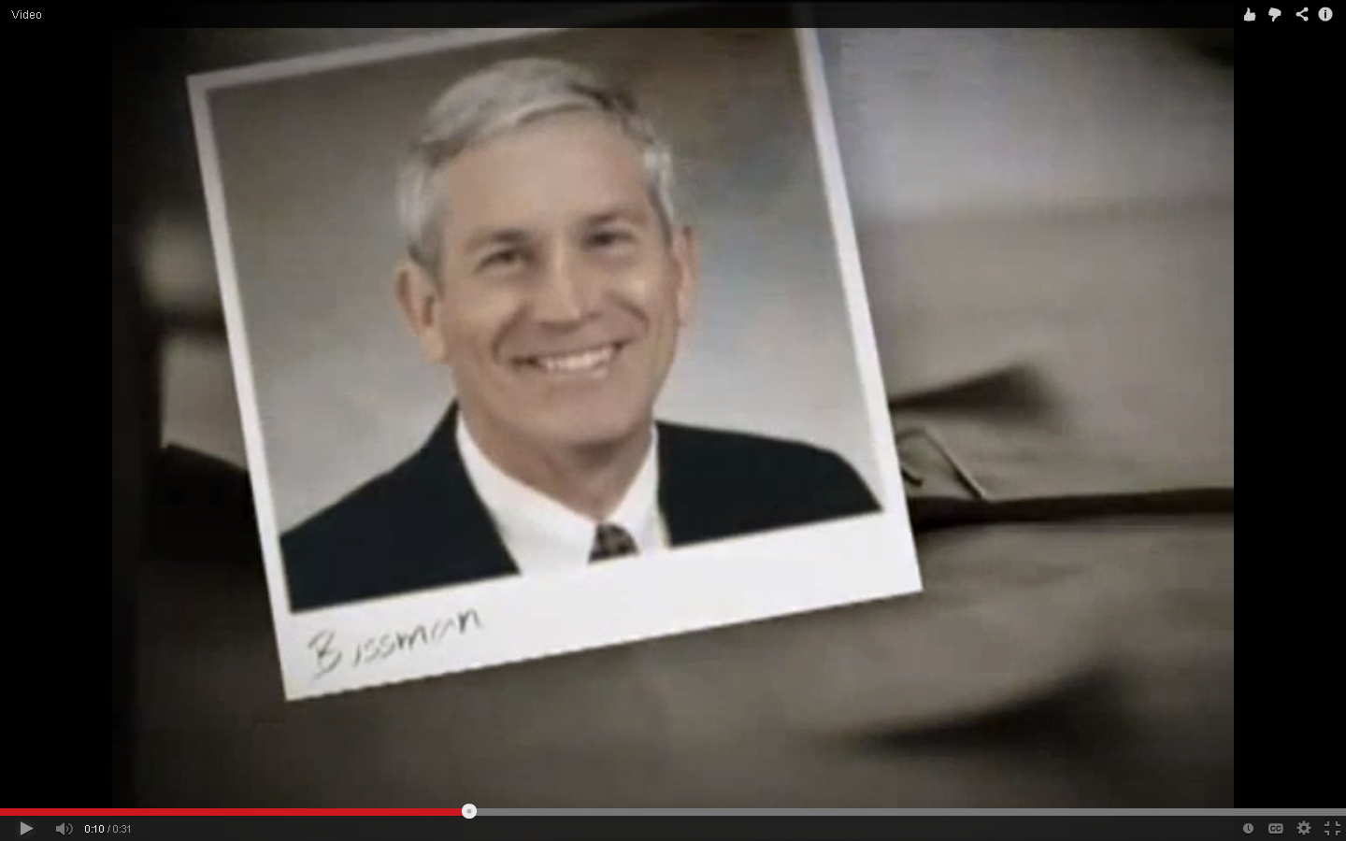
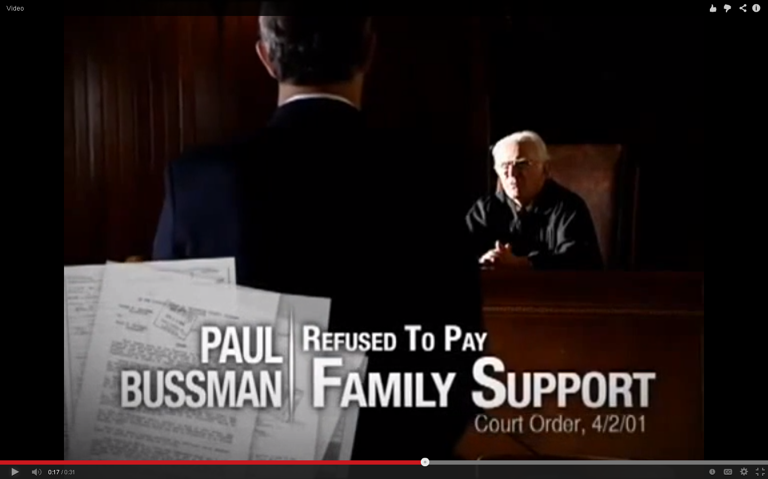
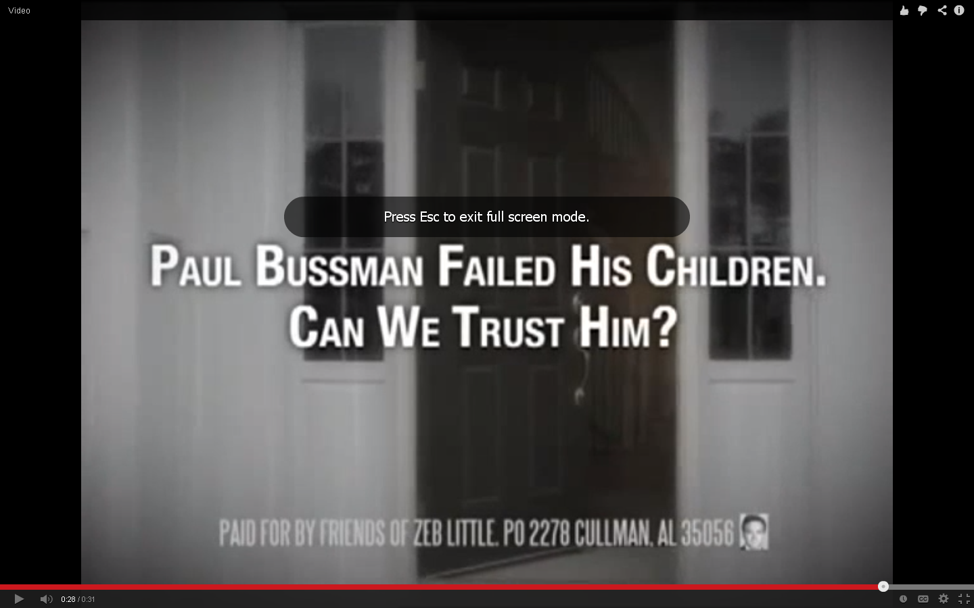

Appendix D: Survey for Study 1 and Study 2

[For Survey 2 only]
Welcome to our Survey on Political Attitudes HIT

In this HIT, you will answer some questions about politics and write about your feelings. You may also either watch a short ad or read a short story. Please read these instructions carefully and follow them throughout this HIT: Please turn-up the volume on your computer. Do NOT use your browser's back and forward navigation buttons. To move from one page to another, click on the buttons with the arrows ">>". Do NOT ask anyone for assistance, navigate to another web page, or use other sources for more information. It is very important that you go through the questions of this HIT on your own. If you are not sure, make a guess as best as you can. We are interested in what you think, not the "right" answer. There will be additional instructions on each page of this HIT. Make sure to read them carefully before answering questions. You can click on the ">>" button below once you have finished reading and responded to each question thoughtfully. You must accept the HIT before continuing.

What should you expect in this HIT?

You will proceed through this HIT as follows: On the following page, you will review the consent form for participating in this research and indicate your voluntary consent to participate. Next, you will answer questions on your political attitudes. After that, you may view a short ad or read a short story. Finally, you will answer a few more questions on your political attitudes. Press the >> button below to continue.

[Start of Survey 1, 2 shared content)

Consent Form (Please READ and SCROLL all the way to the bottom of this page): You are being invited to participate in a research project to study attitudes because of your membership in Mechanical Turk. It should take you about 15 minutes to complete. The results of this project will be used for research purposes only. I hope that the results of the survey will be useful for understanding attitudes. There are no known risks to you if you decide to participate in this survey. There is no direct benefit to you for participating in this study. The alternative would be not participating in the study. No identifying information is collected so all information is anonymous. All data is stored in a password protected electronic format. The results of this study will be used for scholarly purposes only. The researcher will retain the data for approximately one year; researcher will dispose of the data by March 31, 2015. I hope you will take the time to complete this questionnaire; however, if you agree to complete the survey you are not required to answer all the questions or complete it. Your participation is voluntary. If you have any questions or concerns about completing the questionnaire, about being in this study, or to receive a summary of my findings you may contact the Principal Investigator.

Note: as there may be a multimedia element to this survey you must have the capacity to hear audio. Thank you for your participation! We value your input. Clicking on the ">>" button below indicates that:
• you have read the above information
• you voluntarily agree to participate
• you are at least 18 years of age
• you are a US citizen

Most modern theories of decision making recognize the fact that decisions do not take place in a vacuum. Individual preferences and knowledge along with situational variables can greatly affect the decision process. In order to facilitate our research we are interested in knowing certain factors about you, the decision maker. Specifically, we are interested in whether you actually take the time to read the directions. So in order to demonstrate that you have read these instructions, please ignore the sports items below. Instead, simply select the last option (i.e., “Airport”), and then click to the next screen. Thank you very much. Which of these activities do you engage in regularly?
❍ Skiing (1)
❍ Soccer (2)
❍ Snowboarding (3)
❍ Running (4)
❍ Hockey (5)
❍ Football (6)
❍ Tennis (7)
❍ Basketball (8)
❍ Airport (9)

Generally speaking, how interested would you say you are in politics? Would you say you are very interested, fairly interested, not very interested, or not at all interested?
❍ Very interested. (1)
❍ Fairly interested. (2)
❍ Not very interested. (3)
❍ Not at all interested. (4)

Select the news source you use the most:
❍ Local television. (1)
❍ Cable television. (2)
❍ National newspaper. (3)
❍ Local newspaper. (4)
❍ Internet news sites/Apps. (5)
❍ Social networking sites. (6)
❍ Radio. (7)
❍ Facebook. (8)
❍ Twitter. (9)
❍ Blogs. (10)

How many days in the last week have you read or watched the news?
❍ 0 (1)
❍ 1 (2)
❍ 2 (3)
❍ 3 (4)
❍ 4 (5)
❍ 5 (6)
❍ 6 (7)
❍ 7 (8)

Gender (select one):
❍ Male (1)
❍ Female (2)

Please indicate the year of your birth in the following blank (YYYY):

Marital status (select one):
❍ Single (1)
❍ Married (2)
❍ Domestic partnership (3)
❍ Divorced (4)

Political identity (select one):
❍ Strongly liberal. (1)
❍ Moderately liberal. (2)
❍ Slightly liberal. (3)
❍ Neutral. (4)
❍ Slightly conservative. (5)
❍ Moderately conservative. (6)
❍ Strongly conservative. (7)

What is your present occupation? Please indicate in the following blank:

What is your current income:
❍ Less than $10,000 (1)
❍ $10,000 - $19,999 (2)
❍ $20,000 - $29,999 (3)
❍ $30,000 - $39,999 (4)
❍ $40,000 - $49,999 (5)
❍ $50,000 - $59,999 (6)
❍ $60,000 - $69,999 (7)
❍ $70,000 - $79,999 (8)
❍ $80,000 - $99,999 (9)
❍ $100,000 - $119,999 (10)
❍ $120,000 - $149,999 (11)
❍ $150,000 - $199,999 (12)
❍ $200,000 - $249,999 (13)
❍ $250,000 - $349,999 (14)
❍ $350,000 - $499,999 (15)
❍ $500,000 or more (16)
❍ Prefer not to say (17)

What is your employment status?
❍ Full-time. (1)
❍ Part-time. (2)
❍ Temporarily laid off. (3)
❍ Unemployed. (4)
❍ Retired. (5)
❍ Permanently disabled. (6)
❍ Homemaker. (7)
❍ Student. (8)
❍ Other. (9)

What is your current state of residence? Select one:
❍ AL (1)
❍ AK (2)
❍ AZ (3)
❍ AR (4)
❍ CA (5)
❍ CO (6)
❍ CT (7)
❍ DE (8)
❍ FL (9)
❍ GA (10)
❍ HI (11)
❍ ID (12)
❍ IL (13)
❍ IN (14)
❍ IA (15)
❍ KS (16)
❍ KY (17)
❍ LA (18)
❍ ME (19)
❍ MD (20)
❍ MA (21)
❍ MI (22)
❍ MN (23)
❍ MS (24)
❍ MO (25)
❍ MT (26)
❍ NE (27)
❍ NV (28)
❍ NH (29)
❍ NJ (30)
❍ NM (31)
❍ NY (32)
❍ NC (33)
❍ ND (34)
❍ OH (35)
❍ OK (36)
❍ OR (37)
❍ PA (38)
❍ RI (39)
❍ SC (40)
❍ SD (41)
❍ TN (42)
❍ TX (43)
❍ UT (44)
❍ VT (45)
❍ VA (46)
❍ WA (47)
❍ WV (48)
❍ WI (49)
❍ WY (50)
❍ District of Columbia (51)

Are you registered to vote?
❍ Yes. (1)
❍ No. (2)
❍ Don't know. (3)

Do you consider religion to be an important part of your life, or not?
❍ Very important. (1)
❍ Somewhat Important. (2)
❍ Neither Important nor Unimportant. (3)
❍ Very Unimportant. (4)
❍ Not at all Important. (5)

Thinking about religion, what do you consider yourself?
❍ Catholic (1)
❍ Evangelical (2)
❍ Protestant (3)
❍ Jewish (4)
❍ Muslim (5)
❍ Other (6)
❍ Not religious (7)

How often do you attend church?
❍ More than once a week. (1)
❍ Once a week. (2)
❍ Once or twice a month. (3)
❍ A few times a year. (4)
❍ Seldom. (5)
❍ Never. (6)
❍ Don't know. (7)

Ethnic background (select one):
❍ Asian/Pacific Islander (1)
❍ Black/African American (2)
❍ Hispanic American (3)
❍ American Indian/Native Alaskan (4)
❍ Non-Hispanic white (5)
❍ Other/Mixed (6)

Generally speaking, do you usually think of yourself as a strong Republican, moderate Republican, weak Republican, weak Democrat, moderate Democrat, strong Democrat, Independent, or what?
❍ Strong Republican. (1)
❍ Moderate Republican. (2)
❍ Weak Republican. (3)
❍ Weak Democrat. (4)
❍ Moderate Democrat. (5)
❍ Strong Democrat. (6)
❍ Independent. (7)

Answer If Generally speaking, do you usually think of yourself as a strong Republican, moderate Republican,... Independent. Is Selected
As of today, do you lean more towards the Democratic Party or the Republican Party?
❍ Lean Democratic (1)
❍ Lean Republican (2)

We’d like to ask you a few questions about the 2012 Presidential Election. In 2012 Mitt Romney ran on the Republican ticket against Barack Obama for the Democrats.

Do you remember for sure whether or not you voted in that election?
❍ Yes, voted. (1)
❍ No, didn't vote. (2)
❍ Don't know. (3)

Answer If &nbsp;Do you remember for sure whether or not you voted i... Yes, voted Is Selected
Which one did you vote for?
❍ Barack Obama (1)
❍ Mitt Romney (2)
❍ Other (3)
❍ Don’t know (4)

Here are some questions about U.S. politics. These questions are very difficult for most people so it is fine if you do not know the correct answer. If you aren’t sure of the answer at this time, please feel free to select “don’t know.” Please do not navigate to any other website or consult any other sources while answering these questions. We are interested in what you think, not the “right” answer.

How many candidates are elected to the United States Senate from your state?
❍ 1 (1)
❍ 2 (2)
❍ 3 (3)
❍ 4 (4)
❍ Don't know (5)

Who is currently serving as Vice President of the United States?
❍ Al Gore (1)
❍ Joe Biden (2)
❍ Nancy Pelosi (3)
❍ Dick Cheney (4)
❍ Don't know (5)

What government position does John Kerry currently hold?
❍ Democratic Chairperson (1)
❍ Vice President (2)
❍ Secretary of State (3)
❍ Senate Majority Leader (4)
❍ Don't know (5)

How many justices are on the U.S. Supreme Court?
❍ 9 (1)
❍ 12 (2)
❍ 6 (3)
❍ 4 (4)
❍ Don't know (5)

Who holds the position of Speaker of the House?
❍ Michael Steele (1)
❍ John Boehner (2)
❍ Nancy Pelosi (3)
❍ Harry Reid (4)
❍ Don't know (5)

Which political party controls the U.S. Senate right now?
❍ Democratic Party (1)
❍ Republican Party (2)
❍ Don't know (3)

The next few questions ask you to say whether you think a politician from a certain party (Democrat or Republican) is more likely to favor a certain policy. If you’re not sure how to answer, please give us your best estimate, even if you are not completely sure.

Would a Democrat or Republican be more likely to favor an amendment to the U.S. Constitution banning marriage between two people who are the same sex?
❍ Democrat (1)
❍ Republican (2)

Citizens of others countries who have come to live in the United States without permission of the U.S. government are called “illegal immigrants.” Would a Democrat or Republican be more likely to favor allowing illegal immigrants to work in the United States for up to three years, after which they would have to go back to their home country?
❍ Democrat (1)
❍ Republican (2)

Would a Democrat or Republican be more likely to favor the U.S. government making it possible for illegal immigrants to become U.S. citizens?
❍ Democrat (1)
❍ Republican (2)

Would a Democrat or Republican be more likely to support comprehensive health care reform?
❍ Democrat (1)
❍ Republican (2)

Would a Democrat or Republican be more likely to support the decision of Roe v. Wade regarding a woman’s right to choose to have an abortion?
❍ Democrat (1)
❍ Republican (2)

Would a Democrat or Republican be more likely to support the government taking measures against global warming?
❍ Democrat (1)
❍ Republican (2)

Please tell us more about the emotions you feel right now. Select the option that best fits the extent to which you feel each emotion currently.
Extremely (1) Very (2) Moderately (3) Slightly (4) Not at all (5)
Angry     
Worried     
Sad     
Proud     
Relaxed     
Uneasy     
Outraged     
Annoyed     
Scared     
Enthusiastic     
Fearful     
Upset     
Bitter     
Hateful     
Hopeful     
Anxious     

People think differently about political issues. Please indicate how much you agree with each statement by selecting extremely true, very true, moderately true, slightly true, or not at all true.

Most political issues and events provide no room for compromise. This statement is:
❍ Extremely true (4)
❍ Very true (5)
❍ Moderately true (6)
❍ Slightly true (7)
❍ Not at all true (8)

I am certain that my point of view on most political issues and events is the right one. It's time to move on. This statement is:
❍ Extremely true (4)
❍ Very true (5)
❍ Moderately true (6)
❍ Slightly true (7)
❍ Not at all true (8)

Most political issues and events have two sides and I prefer to look at both of them. This statement is:
❍ Extremely true (4)
❍ Very true (5)
❍ Moderately true (6)
❍ Slightly true (7)
❍ Not at all true (8)

Most political issues and events are best resolved by listening to everyone’s concerns. This statement is:
❍ Extremely true (4)
❍ Very true (5)
❍ Moderately true (6)
❍ Slightly true (7)
❍ Not at all true (8)

To what extent do you agree with the following statements?

“I often get angry at those who commit crimes.’’
❍ Strongly Agree (4)
❍ Agree (5)
❍ Neither Agree nor Disagree (6)
❍ Disagree (7)
❍ Strongly Disagree (8)

‘‘My family really makes me mad sometimes.’’
❍ Strongly Agree (4)
❍ Agree (5)
❍ Neither Agree nor Disagree (6)
❍ Disagree (7)
❍ Strongly Disagree (8)

‘‘I often feel sorry for homeless people.’’
❍ Strongly Agree (4)
❍ Agree (5)
❍ Neither Agree nor Disagree (6)
❍ Disagree (7)
❍ Strongly Disagree (8)

‘‘I often worry that something will happen to my family.’’
❍ Strongly Agree (4)
❍ Agree (5)
❍ Neither Agree nor Disagree (6)
❍ Disagree (7)
❍ Strongly Disagree (8)

‘‘I often worry that I will fall victim to crime.’’
❍ Strongly Agree (4)
❍ Agree (5)
❍ Neither Agree nor Disagree (6)
❍ Disagree (7)
❍ Strongly Disagree (8)

‘‘I often feel angry at work.’’
❍ Strongly Agree (4)
❍ Agree (5)
❍ Neither Agree nor Disagree (6)
❍ Disagree (7)
❍ Strongly Disagree (8)

‘‘It makes me mad that so many people take advantage of Welfare.’’
❍ Strongly Agree (4)
❍ Agree (5)
❍ Neither Agree nor Disagree (6)
❍ Disagree (7)
❍ Strongly Disagree (8)

When people think about politicians and policies, they often use different words to describe how they feel about them. Below we’ve included some pairs of words. For each pair, one indicates the lowest possible rating and seven is the highest possible rating.

How enthusiastic would you say each of the following makes you feel? One would be unenthusiastic and seven would be the most enthusiastic rating.
______ Barack Obama (1)
______ Republican Party (2)

How angry would you say each of the following makes you feel? One would be not at all angry and seven would be extremely angry.
______ Barack Obama (1)
______ Republican Party (2)

How fearful would you say each of the following makes you feel? One would be not at all afraid and seven would be extremely afraid.
______ Barack Obama (1)
______ Republican Party (2)

How anxious would you say each of the following makes you feel? One would be not at all anxious and seven would be extremely anxious.
______ Barack Obama (1)
______ Republican Party (2)

How satisfied are you with the way things are going in the country today? Are you very satisfied, somewhat satisfied, not very satisfied or not at all satisfied?
❍ Very satisfied (4)
❍ Somewhat satisfied (5)
❍ Not very satisfied (6)
❍ Not at all satisfied (7)
❍ Unsure (8)

Please tell us which of the two statements below comes closest to your opinion. You might agree to some extent with both, but we want to know which one is closer to your views.
❍ The less government, the better. (4)
❍ There are more things the government should be doing. (5)

Do you think politicians are primarily “in it for themselves" or do you think their primary concern is the “public good”?
❍ In it for themselves. (1)
❍ Public good. (2)

To what extent do you agree with the following statement: “People like me don't have any say about what the government does.”
❍ Disagree strongly (1)
❍ Disagree somewhat (2)
❍ Neither agree nor disagree (3)
❍ Agree somewhat (4)
❍ Agree strongly (5)

People have different ideas about the government. These ideas don’t refer to Democrats or Republicans in particular, but just to the government in general. How much of the time do you think you can trust the government to do what is right?
❍ None of the time. (1)
❍ Only some of the time. (2)
❍ Most of the time. (3)
❍ Just about always. (4)

Now we’d like to get your feelings towards some people and policies. Please rate each using something we call the feeling thermometer. Ratings between 50 degrees and 100 degrees mean that you feel favorable and warm toward the person or policy. Ratings between 0 degrees and 50 degrees mean that you don’t feel favorable toward the person or policy. You would rate the person at the 50 degree mark if you feel neither warm nor cold toward the person. Otherwise slide the marker to any number from 0 to 100, indicating how you feel about the person.
______ President Barack Obama (1)
______ Vice President Joe Biden (2)
______ Republican Party (3)
______ Democratic Party (4)
______ Congress (5)
______ Democrats in Congress (6)
______ Republicans in Congress (7)
______ Media (8)

Generally speaking, would you say that most people can be trusted, or that you can’t be too careful in dealing with people?
❍ Can’t be too careful. (1)
❍ Most people can be trusted. (2)

People often feel they can put more trust in some institutions than others. In general, how much do you trust the institutions or people listed below? Please indicate by selecting a number between 1 and 7 where “1” means distrust completely and “7” means trust completely. Slide the marker over for each of the following:
______ The media. (1)
______ Public schools. (2)
______ Courts. (3)
______ Police. (4)
______ Elected officials. (5)

Please indicate whether you agree or disagree with the following statement. “Sometimes politics and government seem so complicated that a person like me can’t really understand what’s going on.”
❍ Strongly Agree (1)
❍ Agree (2)
❍ Neither Agree nor Disagree (3)
❍ Disagree (4)
❍ Strongly Disagree (5)

With which ONE of the following statements do you agree more? If a candidate tells a lie in a political ad:
❍ It would be easy for me to find out. (4)
❍ It would be very hard for me to find out. (5)

With which ONE of the following statements do you agree more? If a candidate tells a lie in a political ad:
❍ Other candidates should point it out in their ads. (6)
❍ Other candidates should leave it to the media to point out. (7)

With which ONE of the following statements do you agree more? If a candidate tells a lie in a political ad:
❍ I can usually tell just from watching it. (6)
❍ I usually need someone else to point it out to me. (7)

With which ONE of the following statements do you agree more? If a candidate tells a lie in a political ad:
❍ The media can be trusted to report when candidates lie. (6)
❍ I cannot rely on the media to tell me about it. (7)

Thank you for participating in this survey, your opinion is valued! The researcher is actually interested in how anger affects attitudes towards political objects. You may have watched a video or read a scenario that sometimes makes people feel anger for a brief moment, and this research uses those anger responses to better understand emotion and politics. Much like you may feel a pang of sadness after watching a Hallmark card, the emotional response resultant from the scenario (or video) you saw today should be fleeting and thus, pose no long-term risks and only minimal short-term discomfort. If you have any questions or concerns about completing the questionnaire, about being in this study, or to receive a summary of my findings you may contact the Principal Investigator.

Appendix E: Supplementary References

Ahsen, A. (1989). Guided Imagery: The quest for a science. Part 1: Imagery origins. Education, 110, 2-16.
Albertson, B & Shana Kushner Gadarian. Forthcoming. “Who’s Afraid of Immigration? The
Effects of Pro- and Anti-Immigrant Threatening Ads among Latinos, African Americans and Whites.” Immigration and Public Opinion in the Liberal Democracies. Gary Freeman, Randall Hansen, and David Leal, eds. Routledge Press.
Ax, A. F. (1953). The physiological differentiation between fear and anger in humans. Psychosomatic Medicine, 15, 433–442.
Burns, J. W., Kubilus, A., & Bruehl, S. (2003). Emotion induction moderates effects of anger management style on acute pain sensitivity. Pain, 106, 109-18.
Clore, G. L., Ortony, A., Dienes, B., & Fujita, F. (1993). Where does anger dwell? In R. S. Wyer & T. K. Srull (Eds.), Advances in social cognition (Vol. 6, pp. 57-87). Hillsdale, NJ: Lawrence Erlbaum.
Ellsworth, P. C., & Smith, C. A. (1988). Shades of joy: Patterns of appraisals differentiating among pleasant emotions. Cognition and Emotion, 2, 301-331.
Gilbert, S., & Thompson, J. K. (1999). Winning or losing against an opposite-sex peer in a gender-based competitive task. Sex Roles, 41, 875_899.
Gross, J.J., &Levenson, R.W. (1995). Emotion elicitation using films. Cognition and Emotion, 9, 87-108.
Kern, M. (1989). 30-second politics: Political advertising in the eighties. New York, NY: Praeger.
Kimbrell T.A., George M.S., Parekh P.I., Ketter TA., & Herscovitch P. (1995). Regional brain activity during self-induced anger and anxiety. Biological Psychiatry, 37.
Laird JD, Wagener JJ, Halal M, Szegda M. (1982). Remembering what you feel: effects of emotion on memory. Journal of Personality and Social Psychology, 4,646–657.
Larsen, R.J., & Sinnett, L.M. (1991). Meta-Analysis of experimental manipulations: some factors affecting the Velten Mood Induction Procedure. Personality and Social Psychology Bulletin, 17, 323-334.
Lerner, J., Goldberg, J., & Tetlock, P. (1998). Sober second thought: Effects of accountability, anger, and authoritarianism on attributions of responsibility. Personality and Social Psychology Bulletin, 563-574.
Lobbestael, J., van Vreeswijk, M.F., & Amtz, A. (2008). An empirical test of schema mode conceptualizations in personality disorders. Behaviour Research and Therapy, 46, 854-860.
Marcus, G.E., Neuman, W.R., & MacKuen, M. (2010). Measuring subjective emotional responses: Testing the validity of two approaches to measurement. Presented at the annual meeting of the Midwestern Political Science Association.
Marcus, G.E., W.R. Neuman & MacKuen, M. (2000). Affective intelligence and political judgment. Chicago: University of Chicago Press.
Mattes, K., and Redlawsk, D. (2014). The Positive Case for Negative Campaigning. Chicago: University of Chicago Press.
Mayer, J.D., Gayle, M., Meehan, M.E. & Haarman, A.K. (1990). Toward better specification of the mood-congruency effect in recall. Journal of Experimental Social Psychology, 26, 465-480
Quigley, B. & Tedeschi, J. (1996). Mediating effects of blame attributions on feelings of anger. Personality and Social Psychology Bulletin, 22, 1280-1288.
Sinha R, Lovallo WR, & Parsons OA. (1992) Cardiovascular differentiation of emotions. Psychosom Med ,54:422–435.
Small, D., Lerner, J.S., & Fischhoff, B. (2006). Emotion Priming and Attributions for Terrorism: Americans’ Reactions in a National Field Experiment. Political Psychology, 27, 298-299.
Suarez, E.C. &Williams Jr., RB. (1989). Situational determinants of cardiovascular and emotional reactivity in high and low hostile men. Psychosom Med, 51:404–418.
Valentino, N. A., Hutchings, V.L., Banks, A.J., & Davis, A.K. (2008). Is a worried citizen a good citizen? Emotions, political information seeking, and learning via the internet." Political Psychology, 29, 247-273.
Watson, D., & Walker, L. M. (1996). The long-term temporal stability and predictive validity
of trait measures of affect. Journal of Personality and Social Psychology, 70,567-577.
Weber, C. (2007). Exploring the role of discrete emotions in political campaigns. Paper presented at the annual meeting of the American Political Science Association, Chicago, IL.

Prior to fielding the experiment we conducted a pilot test using Washington State University students recruited for course credit. The purpose of the pre-experiment was to vet the reliability and validity of each induction, the survey platform, and questions. The survey was conducted live and online in a computer laboratory on campus. Students were offered extra credit to participate. Following their completion of the survey, students were debriefed individually and exit interviewed. Exit interviews and analyses of the pilot data demonstrated that the inductions were effective in eliciting anger.
Both surveys were reviewed and assigned exempt status by the Washington State University Institutional Review Board for Human Subjects. Some deception was necessary as participants were asked to participate in a survey for researchers interested in political attitudes. At the conclusion of the survey participants were debriefed as to the researchers’ intent, and invited to follow-up with questions or comments. All comments received by the authors were positive; mostly participants found the project to be interesting.
Both question choices and question orders were randomized (by Qualtrics) within blocks prior to treatment, and within blocks following treatment. Also, induction treatments were randomly assigned by participant. Participants were blinded to treatment conditions. Using Qualtrics we ensure participants do not take the survey multiple times and that the url is not shared. Data is housed by Washington State University’s College of Liberal Arts Server which ensures the security and confidentiality of participant responses long-term.
A dedicated YouTube.com account called, “Americans for a Brighter Future” was created to host the ad. Comments were disabled as well as recommended ads on the sidebar.
Participants are asked to take their time and to, “(think) again about the details of the ad—what you heard, felt, and saw during the ad. Imagine how you’d feel if someone put you in a similar situation and write about it. We are not concerned with grammar or how well you can write, just your feelings.”
Bussman is a Republican who was opposed by Democrat Zeb Little, though Little’s name nor his partisan affiliation is mentioned in the ad.

