Online Appendices for Changing Stereotypes of Partisans in the Trump Era
Contents
- Hand-Coding Analyses
- Comparison of Panels
- Comparison of Panels Using Attention Check Items
- Analysis of Other Prevalence Covariates
- Alternative Displays of Main Results
- Exemplar Documents by Topic
- Checking for Insincere Respondents
- Additional Topic Modeling Details
Appendix A: Hand-Coding Analyses
In addition to the STM results presented in the main text, we conducted several analyses that compare the raw frequencies of descriptors used and that use hand-coding to classify the type of stereotype reflected in each participant’s responses. Before conducting these analyses, we performed a limited amount of strict synonym recoding, as in Rothschild et al. (2019). This process is restricted to harmonizing terms that are clear and unambiguous equivalents—such as replacing “Whites”, “White people”, and “people who are White” with “Whites” or collapsing “President Trump”, “President Donald Trump”, and “Donald Trump” to “Donald Trump”. Merging synonyms in this way enables us to gauge the prevalence of discrete ideas among respondents, not just particular word choices. This process uses the list of synonyms used in Rothschild et al (2019) with some additional terms (agreed upon by all three authors) based on a reading of samples from the text data.
A.1 Analyses of Word Frequency
First, we list the most frequent words from each year for stereotypes of Republicans and stereotypes of Democrats and then break these out by the partisanship of the respondent. We next test for descriptors whose frequency is significantly more or less common in the 2021 sample. We limit this test to descriptors that are listed by 10 or more respondents across the two samples. Following the logic of Lijffijt et al. (2016), we conduct a difference of proportion test to compare the proportion of respondents in each sample who list each word for each party, and list those words whose frequency is significantly different (α = .05), as well as those words whose frequency is significantly different between years among subsamples of Democrats, Republicans, and Independents. To see if the overall affective charge of these descriptors has changed over time, we calculate the mean positivity rating for each respondent for each party, and then compare the mean respondent-level positivity towards Republicans and Democrats across time, and among partisan sub-samples across time.
Table A1 shows the descriptors used by the highest percentage of respondents for Republicans and Democrats in the two samples. Tables A2 and A3 repeat this for the most frequently used descriptors used by Democrats to describe the two parties (Table A2) and by Republicans to describe the two parties (Table A3). In general, there is a great deal of overlap between the two lists of frequent words.
Tables A1-A3 also show the mean positivity of descriptors in each year for each stereotype. In the full sample (Table A1), positivity ratings were not significantly different across years, (d = .04, p = .39 for descriptors of Democrats; d < .01, p = .948 for descriptors of Republicans). However, this obscures changes among partisan groups. Democrats’ rating of their descriptors of Democrats increased significantly (d = .22, p < .001), while Republicans’ rating of their descriptors of Democrats decreased by a similar amount (d = .21, p = .004). Democrats’ ratings of their descriptors of Republicans were largely unchanged (d = .04, p = .468), but Republicans’ ratings of their descriptors of Republicans were significantly more positive (d = .36, p < .001). This provides further evidence of increased polarization in partisans’ stereotypes of each other.

Descriptors used by Full Sample | Descriptors of Democrats |  | Descriptors of Republicans
 | 2016 Sample | 2021 Sample | 2016 Sample | 2021 Sample
Most frequent response (% of respondents) | <Non-Response>  (50.4%) | <Non-Response>  (25.1%) | <Non-Response>  (50.0%) | <Non-Response>  (25.0%)
2nd | Liberal  (33.8%) | Liberal  (22.4%) | Conservative  (30.4%) | Conservative  (17.1%)
3rd | Caring  (7.0%) | Caring  (11.0%) | Rich  (16.5%) | Rich  (8.7%)
4th | Open Minded  (6.4%) | Smart  (7.9%) | White  (10.2%) | Smart  (7.6%)
5th | Poor  (5.8%) | Ignorant  (6.9%) | Prejudiced  (7.1%) | Ignorant  (7.4%)
6th | Minorities  (4.7%) | Open-Minded  (6.3%) | Religious  (5.8%) | Prejudiced  (7.0%)
7th | Ignorant  (4.6%) | Good  (5.5%) | Senior Citizens  (5.1%) | Self-Interested  (6.8%)
8th | Youth  (3.9%) | Friendly  (5.0%) | Ignorant  (4.9%) | Mean  (5.2%)
9th | Smart  (3.5%) | Honest  (3.9%) | Closed-Minded  (3.6%) | Good  (5.0%)
10th | Educated  (3.4%) | Equality  (3.5%) | Self-Interested  (3.5%) | Patriotism  (4.8%)
Mean Positivity  (95% Conf Int) | 4.55  (4.41, 4.67) | 4.64  (4.52, 4.75) | 4.36  (4.23, 4.50) | 4.36  (4.24, 4.47)
Table A1. Most Frequent Descriptors of Partisans by Sample

Descriptors Used by Democrats | Descriptors of Democrats |  | Descriptors of Republicans
 | 2016 Sample | 2021 Sample | 2016 Sample | 2021 Sample
Most frequent response (%) | <Non-Response>  (47.8%) | <Non-Response>  (25.9%) | <Non-Response>  (47.5%) | <Non-Response>  (28.2%)
2nd | Liberal  (35.4%) | Liberal  (19.1%) | Conservative  (29.1%) | Conservative  (13.2%)
3rd | Caring  (13.0%) | Caring  (18.1%) | Rich  (22.6%) | Ignorant  (12.0%)
4th | Open-Minded  (13.0%) | Smart  (12.8%) | White  (14.3%) | Prejudiced  (10.8%)
5th | Smart  (6.7%) | Open-Minded  (10.0%) | Prejudiced  (13.9%) | Self-Interested  (10.7%)
6th | Equality  (6.5%) | Good  (9.3%) | Ignorant  (9.4%) | Rich  (9.0%)
7th | Educated  (6.5%) | Friendly  (7.8%) | Closed-Minded  (7.2%) | Mean  (7.4%)
8th | Minorities  (4.9%) | Honest  (6.4%) | Self-Interested  (7.0%) | Dishonest  (6.8%)
9th | Youth  (4.3%) | Equality  (5.3%) | Senior-Citizens  (5.6%) | Good  (5.3%)
10th | Middle-Class  (4.3%) | Educated  (4.6%) | Religious  (5.6%) | Bad  (4.5%)
Mean Positivity  (95% Conf Int) | 5.59  (5.45, 5.73) | 5.90  (5.79, 6.00) | 3.46  (3.28, 3.64) | 3.55  (3.39, 3.72)
Table A2. Democrats’ Most Frequent Descriptors of Partisans by Sample

Descriptors Used by Republicans | Descriptors of Democrats |  | Descriptors of Republicans
 | 2016 Sample | 2021 Sample | 2016 Sample | 2021 Sample
Most frequent response (%) | <Non-Response>  (47.9%) | Liberal  (28.0%) | <Non-Response>  (46.8%) | Conservative  (22.8%)
2nd | Liberal  (37.5%) | <Non-Response>  (18.9%) | Conservative  (38.0%) | <Non-Response>  (17.9%)
3rd | Ignorant  (10.5%) | Ignorant  (16.6%) | Rich  (10.2%) | Smart  (17.9%)
4th | Poor  (6.9%) | Socialists  (8.5%) | Smart  (7.4%) | Patriotism  (12.6%)
5th | Lazy  (6.6%) | Dishonest  (8.0%) | Religious  (6.6%) | Caring  (10.1%)
6th | Dishonest  (6.1%) | Mean  (6.4%) | White  (6.1%) | Honest  (9.7%)
7th | Socialists  (5.2%) | Self-Interested  (6.2%) | Honest  (6.1%) | Rich  (7.6%)
8th | Minorities  (5.0%) | Unrealistic  (5.5%) | Educated  (6.1%) | Good  (6.0%)
9th | Unrealistic  (4.1%) | Lazy  (4.8%) | Patriotism  (5.0%) | Strong  (5.7%)
10th | Youth  (3.6%) | Rich  (3.9%) | Individualist  (4.4%) | American  (5.5%)
Mean Positivity  (95% Conf Int) | 3.40  (3.20, 3.61) | 2.98  (2.78, 3.18) | 5.46  (5.30, 5.62) | 5.96  (5.82, 6.09)
Table A3. Republicans’ Most Frequent Descriptors of Partisans by Sample
Note that the percentages in these tables occur at the word level and not at the respondent level. This means, for example, that a respondent who skips all four boxes is counted four times in the non-response category. When we consider the respondent level, about 65% of respondents provided at least one word for every box they were provided, about 4% left one box blank, about 5% left two boxed blank, 7 percent left three blank, and 18 percent left all four blank.
We next examine descriptors that are used more frequently in one of the two samples. Lijffijt et al. (2016) argue that when comparing the frequency in words across conditions, the set of words within a document should not be seen as independent. Thus, instead of comparing the frequency of each descriptor as a proportion of total words, we compare the proportion of participants in each sample who employ the descriptor.
Table A4 and A5 show the descriptors of Democrats and Republicans that were used statistically significantly more often in one of the two samples (α = .05) for the full sample or one of the partisan subsamples sorted by the overall frequency of the descriptor. In general, we see an increase in personal-trait words (e.g caring, smart, ignorant) and a decrease in words describing groups (e.g. poor, youth, minorities for Democrats, rich, white, senior citizens for Democrats) and issues (e.g. abortion).

 | All |  |  | Dems Only |  |  | Reps Only
Descriptor | 2016 | 2021 | p | 2016 | 2021 | p | 2016 | 2021 | p
liberal | 0.338 | 0.224 | 0.000 | 0.354 | 0.191 | 0.000 | 0.375 | 0.280 | 0.006
caring | 0.070 | 0.110 | 0.001 | 0.130 | 0.181 | 0.027 | 0.011 | 0.034 | 0.053
smart | 0.035 | 0.079 | 0.000 | 0.067 | 0.128 | 0.001 | 0.003 | 0.023 | 0.033
ignorant | 0.046 | 0.069 | 0.021 | 0.009 | 0.007 | 0.970 | 0.105 | 0.166 | 0.017
poor | 0.058 | 0.029 | 0.001 | 0.040 | 0.019 | 0.053 | 0.069 | 0.037 | 0.060
good | 0.008 | 0.055 | 0.000 | 0.013 | 0.093 | 0.000 | 0.000 | 0.023 | 0.010
friendly | 0.008 | 0.050 | 0.000 | 0.011 | 0.078 | 0.000 | 0.000 | 0.018 | 0.025
honest | 0.011 | 0.039 | 0.000 | 0.025 | 0.064 | 0.004 | 0.000 | 0.005 | 0.560
youth | 0.039 | 0.015 | 0.000 | 0.043 | 0.006 | 0.000 | 0.036 | 0.021 | 0.279
minorities | 0.047 | 0.008 | 0.000 | 0.049 | 0.006 | 0.000 | 0.050 | 0.005 | 0.000
rich | 0.011 | 0.025 | 0.024 | 0.007 | 0.010 | 0.830 | 0.011 | 0.039 | 0.025
self interested | 0.009 | 0.024 | 0.010 | 0.000 | 0.004 | 0.441 | 0.019 | 0.062 | 0.005
biden | 0.001 | 0.028 | 0.000 | 0.002 | 0.042 | 0.000 | 0.000 | 0.014 | 0.067
mean | 0.002 | 0.026 | 0.000 | 0.000 | 0.004 | 0.441 | 0.006 | 0.064 | 0.000
abortion | 0.025 | 0.010 | 0.004 | 0.022 | 0.007 | 0.045 | 0.028 | 0.016 | 0.384
great | 0.000 | 0.025 | 0.000 | 0.000 | 0.046 | 0.000 | 0.000 | 0.002 | 1.000
middle class | 0.023 | 0.008 | 0.002 | 0.043 | 0.010 | 0.000 | 0.006 | 0.005 | 1.000
unions | 0.026 | 0.004 | 0.000 | 0.018 | 0.004 | 0.040 | 0.033 | 0.005 | 0.005
cool | 0.001 | 0.021 | 0.000 | 0.000 | 0.036 | 0.000 | 0.000 | 0.002 | 1.000
blue collar | 0.021 | 0.006 | 0.002 | 0.020 | 0.010 | 0.219 | 0.028 | 0.005 | 0.018
supportive | 0.005 | 0.015 | 0.032 | 0.009 | 0.021 | 0.187 | 0.003 | 0.002 | 1.000
women | 0.017 | 0.005 | 0.005 | 0.029 | 0.001 | 0.000 | 0.006 | 0.007 | 1.000
happy | 0.004 | 0.013 | 0.040 | 0.009 | 0.019 | 0.243 | 0.000 | 0.009 | 0.184
responsible | 0.003 | 0.013 | 0.018 | 0.004 | 0.025 | 0.017 | 0.000 | 0.000 | NA
radical | 0.002 | 0.013 | 0.007 | 0.000 | 0.003 | 0.699 | 0.003 | 0.023 | 0.033
idiots | 0.005 | 0.011 | 0.180 | 0.000 | 0.003 | 0.699 | 0.006 | 0.028 | 0.036
trustworthy | 0.001 | 0.013 | 0.003 | 0.002 | 0.025 | 0.006 | 0.000 | 0.000 | NA
crazy | 0.001 | 0.012 | 0.004 | 0.000 | 0.004 | 0.441 | 0.000 | 0.028 | 0.004
patriotism | 0.002 | 0.010 | 0.042 | 0.004 | 0.017 | 0.114 | 0.000 | 0.000 | NA
sheep | 0.002 | 0.009 | 0.059 | 0.000 | 0.000 | NA | 0.003 | 0.025 | 0.021
awesome | 0.000 | 0.010 | 0.003 | 0.000 | 0.019 | 0.007 | 0.000 | 0.002 | 1.000
urban | 0.010 | 0.002 | 0.016 | 0.009 | 0.000 | 0.043 | 0.008 | 0.002 | 0.493
Table A4. Descriptors of Democrats Significantly Different Between Samples

 | All |  |  | Dem Only |  |  | Rep Only
Descriptor | 2016 | 2021 | p | 2016 | 2021 | p | 2016 | 2021 | p
conservative | 0.304 | 0.171 | 0.000 | 0.291 | 0.132 | 0.000 | 0.380 | 0.228 | 0.000
rich | 0.165 | 0.087 | 0.000 | 0.226 | 0.090 | 0.000 | 0.102 | 0.076 | 0.242
white | 0.102 | 0.039 | 0.000 | 0.143 | 0.042 | 0.000 | 0.061 | 0.034 | 0.114
ignorant | 0.049 | 0.074 | 0.016 | 0.094 | 0.120 | 0.210 | 0.006 | 0.009 | 0.850
smart | 0.034 | 0.076 | 0.000 | 0.004 | 0.018 | 0.083 | 0.074 | 0.179 | 0.000
self interested | 0.035 | 0.068 | 0.001 | 0.070 | 0.107 | 0.041 | 0.003 | 0.011 | 0.312
mean | 0.021 | 0.052 | 0.000 | 0.040 | 0.074 | 0.029 | 0.003 | 0.009 | 0.485
senior citizens | 0.051 | 0.028 | 0.004 | 0.056 | 0.015 | 0.000 | 0.041 | 0.025 | 0.284
patriotism | 0.021 | 0.048 | 0.001 | 0.000 | 0.010 | 0.089 | 0.050 | 0.126 | 0.000
religious | 0.058 | 0.022 | 0.000 | 0.056 | 0.019 | 0.001 | 0.066 | 0.018 | 0.001
good | 0.006 | 0.050 | 0.000 | 0.000 | 0.053 | 0.000 | 0.014 | 0.060 | 0.002
caring | 0.011 | 0.041 | 0.000 | 0.002 | 0.010 | 0.254 | 0.028 | 0.101 | 0.000
dishonest | 0.010 | 0.040 | 0.000 | 0.016 | 0.068 | 0.000 | 0.003 | 0.007 | 0.748
trump | 0.006 | 0.036 | 0.000 | 0.011 | 0.040 | 0.007 | 0.000 | 0.028 | 0.004
closed minded | 0.036 | 0.015 | 0.001 | 0.072 | 0.026 | 0.000 | 0.006 | 0.000 | 0.401
hardworking | 0.012 | 0.025 | 0.039 | 0.002 | 0.008 | 0.357 | 0.030 | 0.053 | 0.163
angry | 0.010 | 0.022 | 0.039 | 0.018 | 0.036 | 0.106 | 0.000 | 0.009 | 0.184
loyal | 0.004 | 0.023 | 0.000 | 0.002 | 0.011 | 0.180 | 0.008 | 0.051 | 0.001
friendly | 0.004 | 0.023 | 0.000 | 0.000 | 0.019 | 0.007 | 0.006 | 0.030 | 0.024
abortion | 0.025 | 0.008 | 0.001 | 0.022 | 0.007 | 0.045 | 0.030 | 0.009 | 0.054
bad | 0.002 | 0.023 | 0.000 | 0.002 | 0.045 | 0.000 | 0.003 | 0.000 | 0.928
american | 0.004 | 0.022 | 0.001 | 0.002 | 0.006 | 0.703 | 0.008 | 0.055 | 0.001
men | 0.019 | 0.008 | 0.029 | 0.031 | 0.006 | 0.001 | 0.008 | 0.011 | 0.921
great | 0.001 | 0.020 | 0.000 | 0.000 | 0.017 | 0.015 | 0.003 | 0.032 | 0.005
freedom | 0.006 | 0.016 | 0.046 | 0.000 | 0.006 | 0.288 | 0.017 | 0.039 | 0.092
equality | 0.005 | 0.016 | 0.024 | 0.002 | 0.004 | 0.974 | 0.011 | 0.044 | 0.011
economy | 0.016 | 0.007 | 0.046 | 0.004 | 0.003 | 1.000 | 0.036 | 0.011 | 0.039
rural | 0.012 | 0.006 | 0.120 | 0.018 | 0.001 | 0.005 | 0.006 | 0.011 | 0.602
trustworthy | 0.001 | 0.012 | 0.004 | 0.000 | 0.004 | 0.441 | 0.003 | 0.030 | 0.008
cool | 0.001 | 0.012 | 0.004 | 0.000 | 0.019 | 0.007 | 0.000 | 0.005 | 0.560
business | 0.015 | 0.003 | 0.001 | 0.007 | 0.004 | 0.864 | 0.025 | 0.000 | 0.003
middle class | 0.012 | 0.004 | 0.042 | 0.000 | 0.000 | NA | 0.030 | 0.005 | 0.010
awesome | 0.000 | 0.012 | 0.002 | 0.000 | 0.008 | 0.130 | 0.000 | 0.023 | 0.010
immoral | 0.000 | 0.011 | 0.002 | 0.000 | 0.019 | 0.007 | 0.000 | 0.000 | NA
wrong | 0.001 | 0.010 | 0.016 | 0.002 | 0.014 | 0.091 | 0.000 | 0.000 | NA
boring | 0.000 | 0.010 | 0.005 | 0.000 | 0.013 | 0.043 | 0.000 | 0.002 | 1.000
like | 0.000 | 0.008 | 0.010 | 0.000 | 0.010 | 0.089 | 0.000 | 0.011 | 0.110
irresponsible | 0.001 | 0.008 | 0.048 | 0.000 | 0.013 | 0.043 | 0.000 | 0.002 | 1.000
fun | 0.001 | 0.008 | 0.048 | 0.000 | 0.004 | 0.441 | 0.003 | 0.011 | 0.312
supportive | 0.000 | 0.008 | 0.015 | 0.000 | 0.006 | 0.288 | 0.000 | 0.007 | 0.315
brave | 0.000 | 0.008 | 0.015 | 0.000 | 0.004 | 0.441 | 0.000 | 0.018 | 0.025
Table A5. Descriptors of Republicans Significantly Different Between Samples
A.2 Analysis of Stereotype Content Using Hand-Coding
As a confirmation of these analyses, we conducted an inductive coding of the descriptors listed by respondents. A research assistant unaware of the other results from this paper generated a list of six categories of descriptors: Personal Traits, Ideological Labels, Demographic Groups, Values, Issues, and Symbols and Party Leaders, and then applied these to all descriptors used by at least three respondents. A second coder, one of the authors of this study, double-coded 59 randomly selected descriptors, which produced agreement on 54 of 59 descriptors for a Krippendorff’s alpha (nominal) of .86. We apply these codes to respondents’ descriptors from the two years and for each category compare the proportion who use at least one descriptor from that category. Tables A6 and A7 show the results overall, and within each partisan sub-group. In line with the STM results presented in the main text, the proportion of respondents listing at least one personal trait increased for descriptors of each party and for each partisan subsample of respondents. In most of these analyses, the proportion using ideological labels, demographic groups, and issues decrease, the exception being no statistically significant change in Republicans’ use of ideological labels and demographic groups to describe Democrats or in Democrats’ use of issues to describe themselves.

 | All |  |  | Dems Only |  |  | Reps Only
Category | 2016 | 2021 | p | 2016 | 2021 | p | 2016 | 2021 | p
Personal Traits | 0.412 | 0.673 | 0.00 | 0.439 | 0.677 | 0.00 | 0.449 | 0.703 | 0.00
Ideology | 0.352 | 0.263 | 0.00 | 0.361 | 0.217 | 0.00 | 0.397 | 0.343 | 0.13
Demo Groups | 0.239 | 0.143 | 0.00 | 0.287 | 0.129 | 0.00 | 0.190 | 0.145 | 0.11
Values | 0.071 | 0.083 | 0.29 | 0.117 | 0.114 | 0.97 | 0.025 | 0.39 | 0.35
Issues | 0.109 | 0.071 | 0.00 | 0.092 | 0.063 | 0.08 | 0.138 | 0.080 | 0.01
Symbols/Leaders | 0.01 | 0.02 | 0.10 | 0.020 | 0.025 | 0.74 | 0.008 | 0.014 | 0.67
Table A6. Respondents Describing Democrats with One or More of the Category’s Descriptors

 | All |  |  | Dems Only |  |  | Reps Only
Category | 2016 | 2021 | p | 2016 | 2021 | p | 2016 | 2021 | p
Personal Traits | 0.397 | 0.671 | 0.00 | 0.464 | 0.663 | 0.00 | 0.377 | 0.731 | 0.00
Ideology | 0.321 | 0.207 | 0.00 | 0.305 | 0.163 | 0.00 | 0.399 | 0.267 | 0.00
Demo Groups | 0.346 | 0.212 | 0.00 | 0.386 | 0.171 | 0.00 | 0.333 | 0.255 | 0.02
Values | 0.091 | 0.116 | 0.05 | 0.031 | 0.039 | 0.61 | 0.176 | 0.257 | 0.01
Issues | 0.089 | 0.048 | 0.00 | 0.070 | 0.033 | 0.01 | 0.124 | 0.062 | 0.00
Symbols/Leaders | 0.019 | 0.056 | 0.00 | 0.029 | 0.061 | 0.02 | 0.008 | 0.041 | 0.01
Table A7. Respondents Describing Republicans with One or More of the Category’s Descriptors

Finally, we evaluate the main finding that character-focused stereotypes of the two parties have become more common by assigning each respondent a “type” corresponding to the category of descriptor they used most frequently. Respondents who listed the same number of more than one category (e.g. two “Personal Traits” and two “Issues”) were categorized as both types. Respondents who listed no descriptors are listed as “NA.” Tables A8 and A9 show a similar result to the analysis in the main text. The proportion of respondents using primarily Personal Trait terms to describe partisans increases between the two samples, while the proportion using demographic groups decreases. The proportion using primarily ideological terms also decreases, though the difference is only statistically significant for descriptors of Republicans. The percent primarily using other terms changes little or is extremely small in both samples.

 | All |  |  | Dems Only |  |  | Reps Only
Category | 2016 | 2021 | p | 2016 | 2021 | p | 2016 | 2021 | p
Personal Traits | 0.356 | 0.627 | 0.00 | 0.368 | 0.640 | 0.00 | 0.388 | 0.653 | 0.00
Ideology | 0.191 | 0.166 | 0.12 | 0.179 | 0.128 | 0.02 | 0.240 | 0.225 | 0.69
Demo Groups | 0.160 | 0.084 | 0.00 | 0.182 | 0.071 | 0.00 | 0.129 | 0.101 | 0.25
Values | 0.033 | 0.047 | 0.13 | 0.056 | 0.058 | 0.97 | 0.011 | 0.025 | 0.22
Issues | 0.059 | 0.047 | 0.23 | 0.047 | 0.040 | 0.69 | 0.080 | 0.057 | 0.27
Symbols/Leaders | 0.009 | 0.015 | 0.26 | 0.013 | 0.019 | 0.59 | 0.008 | 0.005 | 0.84
NA | 0.411 | 0.187 | 0.00 | 0.383 | 0.211 | 0.00 | 0.380 | 0.110 | 0.00
Table A8. Respondents’ Type for Descriptors of Democrats.
Note: Rows add up to more than 1 because respondents could be categorized as more than one type

 | All |  |  | Dems Only |  |  | Reps Only
Category | 2016 | 2021 | p | 2016 | 2021 | p | 2016 | 2021 | p
Personal Traits | 0.335 | 0.629 | 0.00 | 0.395 | 0.630 | 0.00 | 0.317 | 0.676 | 0.00
Ideology | 0.157 | 0.116 | 0.00 | 0.119 | 0.089 | 0.12 | 0.226 | 0.133 | 0.00
Demo Groups | 0.245 | 0.129 | 0.00 | 0.240 | 0.106 | 0.00 | 0.264 | 0.159 | 0.00
Values | 0.052 | 0.071 | 0.07 | 0.016 | 0.025 | 0.39 | 0.102 | 0.159 | 0.02
Issues | 0.059 | 0.038 | 0.02 | 0.047 | 0.028 | 0.12 | 0.074 | 0.048 | 0.16
Symbols/Leaders | 0.010 | 0.043 | 0.00 | 0.013 | 0.045 | 0.01 | 0.003 | 0.032 | 0.01
NA | 0.405 | 0.186 | 0.00 | 0.390 | 0.225 | 0.00 | 0.366 | 0.092 | 0.00
Table A9. Respondents’ Type for Descriptors of Republicans
Note: Rows add up to more than 1 because respondents could be categorized as more than one type
Appendix B: Comparison of Panels
As noted in the main text, we considered carefully the reasons for the shift in the nonresponse and generic topics across years. Our primary concerns about this change were that (1) this change was the product of systematic differences between the panel in 2016 and the panel in 2021 and (2) these types of differences would influence or distort the changes in time presented in the main analyses. To evaluate these issues, we conducted a series of supplemental analyses in addition to the results presented in the article.
Regarding systematic differences between the two online panels, Table B1 gives the demographic breakdown of the sample in 2016 and the sample in 2021. This table indicates that there are some differences between the two surveys, although these differences tend to be relatively small. As noted in the discussion of the main analyses, we included all of the variables in Table B1 as covariates in our STM to account for the fact that these kinds of respondents might use topics in different amounts. The degree to which the surveys differ on these demographic variables, then, should not confound the results presented in the main text.
To further address this point, and as briefly noted in the main text, we considered alternative methods of estimating the changes in topic use across years that incorporate survey weights to weight the samples in both years to be more comparable to one another. To do this, we create sampling targets based on the U.S. Census’s 2017-2021 5 year population estimates from the American Community Survey. We create weights based off on benchmarks from the Census on age, income, education, race, ethnicity, and gender. These are implemented in R using the anesrake package, as shown in our replication files. We structured these weights such that no observation could receive a weight larger than 5 (which is the default for this package). We constructed these weights separately for the 2016 and 2021 surveys, as our objective was to reweight the surveys from both years so that they would be more comparable to each other rather than to produce a combined dataset that was more reflective of the American population. Examining the unweighted and weighted demographic characteristics of these surveys suggests that the samples are much more comparable to each other and dramatically closer to the Census benchmarks after weighting.
With these weights, we replicated the analysis behind Figure 1 in the main text in different ways. First, we calculated weighted and unweighted averages of the prevalence of each topic. These are presented in Figures B.1 and B.2, respectively. The main takeaway from these figures is that although there are some small differences between these graphs and Figure 1, the patterns, especially with respect to change over time, mirror those discussed in the main text. This is especially true of the weighted means, which is some evidence that the differences between years are not a product of the different compositions of the samples and data sources in 2016 and 2021. We also replicate these estimates using regressions that predict topic prevalence as a function of the covariates used in the STM procedures - these are shown in Figure B.3 and lead to the same conclusions as the other weighted and unweighted analyses.

 | 2016 Research Now sample | 2021 Lucid sample
Percent female | 50.7 | 53.4
Percent Republican | 37.0 | 30.0
Percent Democrat | 45.5 | 49.5
Percent White | 80.4 | 73.9
Percent Hispanic | 8.0 | 11.1
Average age | 43.6 | 45.5
Average income | $75.000-$100,000 | $50,000-$75,000
Average education | Bachelor’s degree | Associate’s degree
Average political interest (1-7) | 4.5 | 4.8
Average political knowledge (0-4) | 2.5 | 2.0
Table B1. Demographics across waves

Figure B.1: Weighted mean estimates of topic prevalence
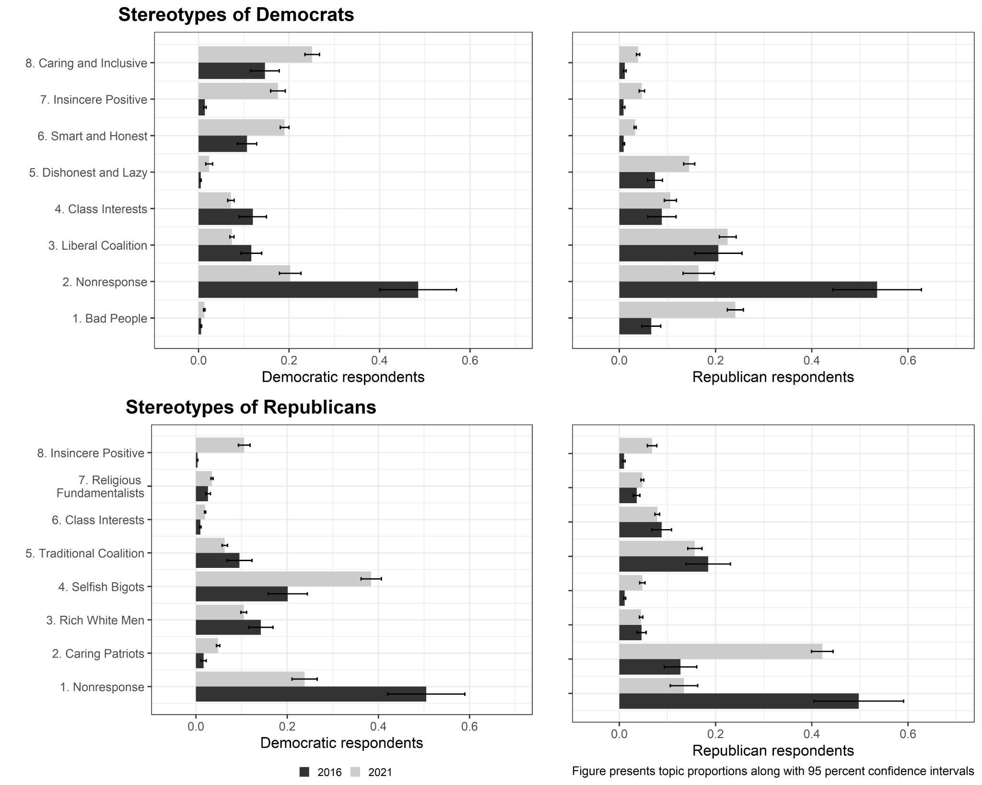

Figure B.2: Unweighted mean estimates of topic prevalence
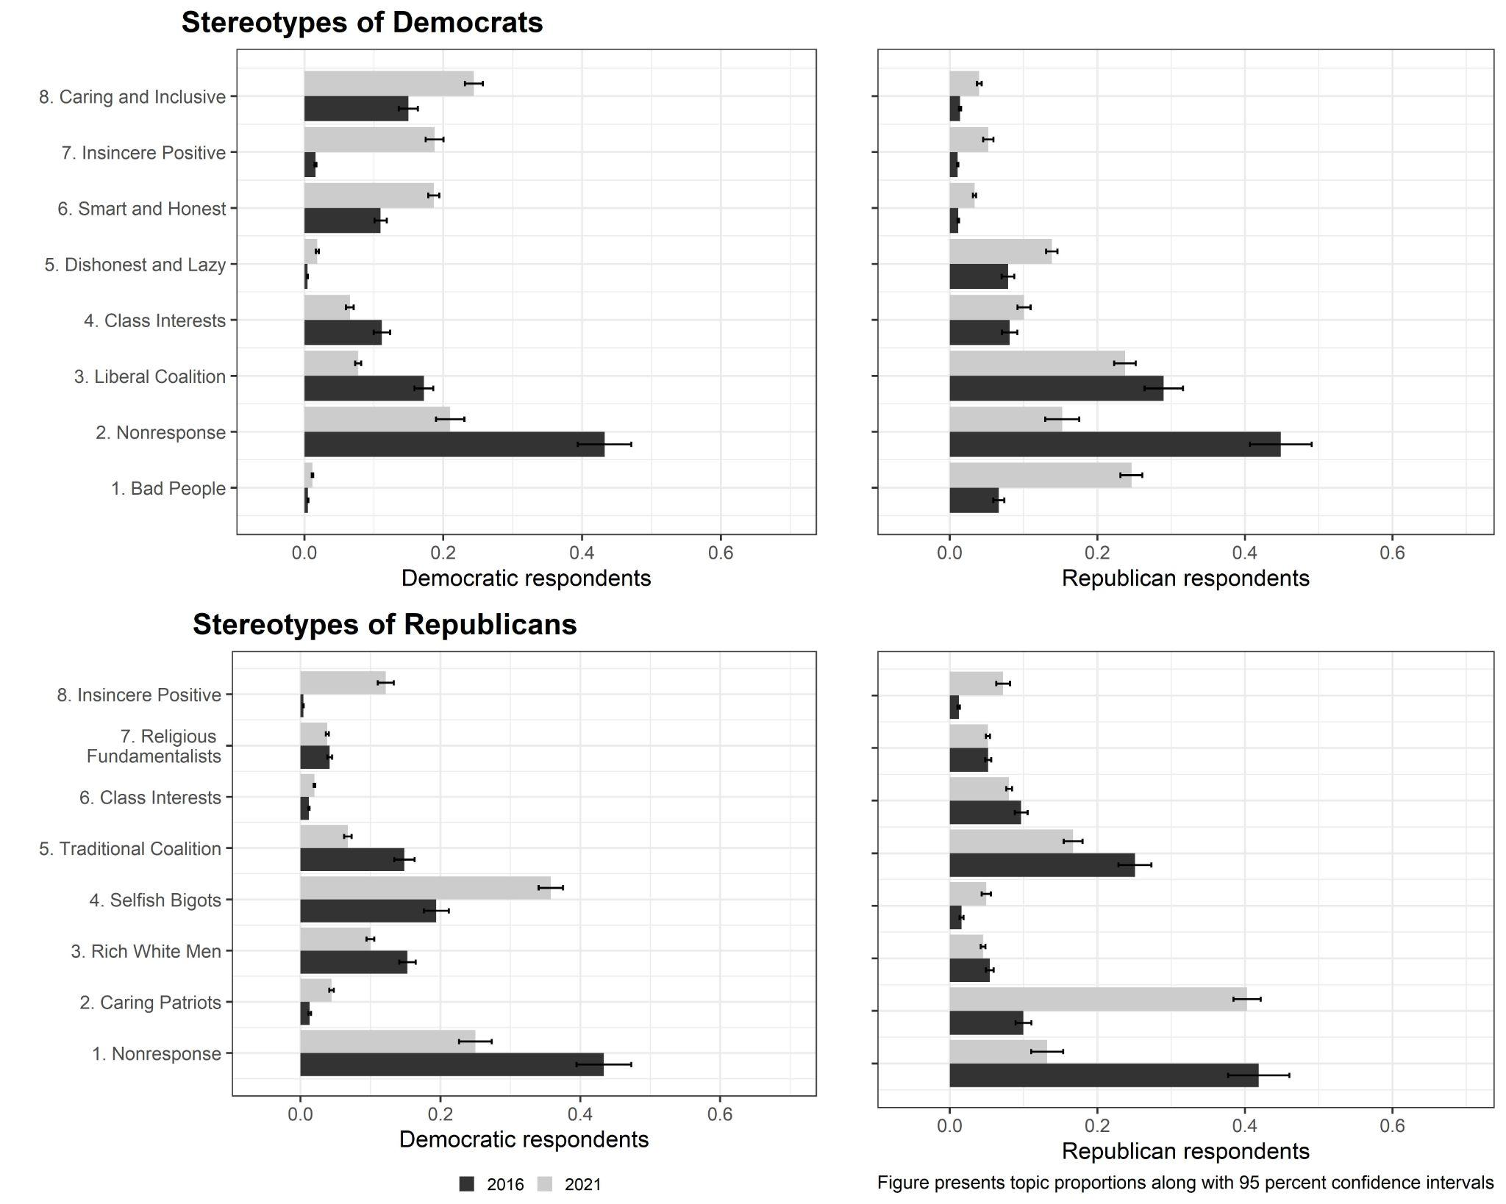

Figure B.3: Weighted regression predictions of topic prevalence
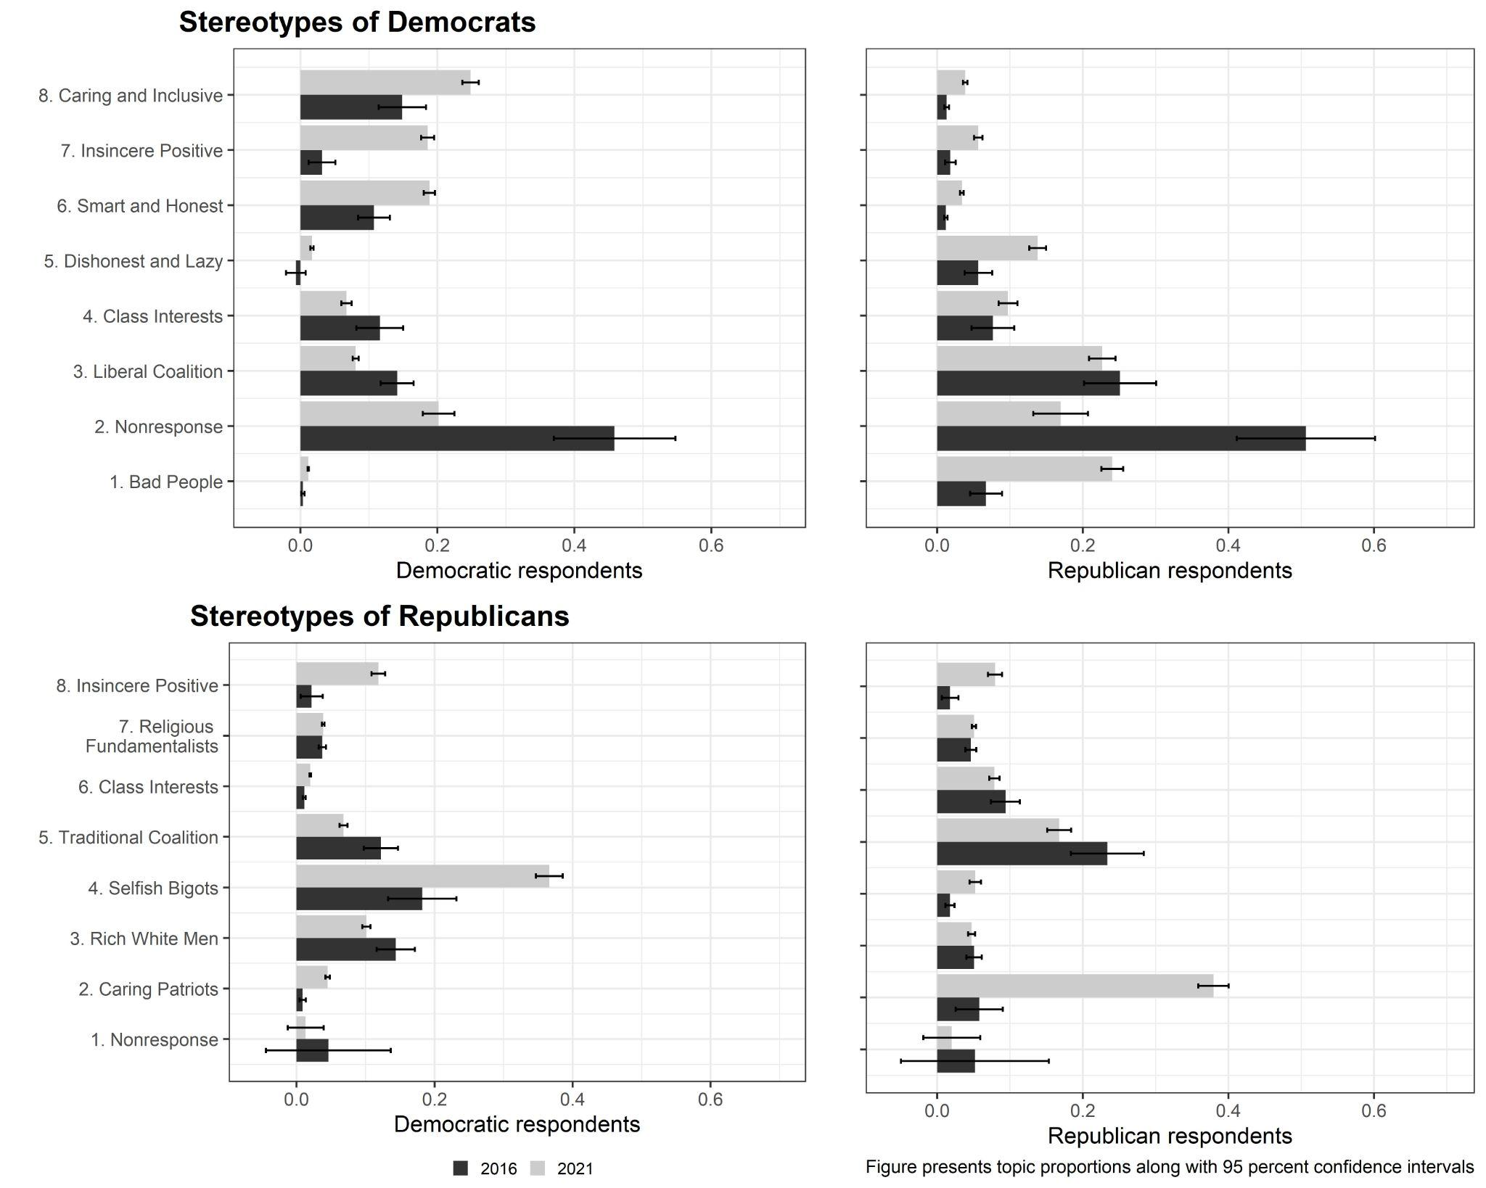

Appendix C: Comparison of Panels Using Attention Check Items
In a related way, we were also concerned that differences in attentiveness and survey quality might correlate with year, produce the shifts we see in the nonresponse topics, and confound the other differences in topic use by year. To evaluate this possibility, we considered our attention check item, which asked respondents to choose a specific answer combination to a question about media consumption (see Berinsky, Margolis, and Sances 2014). Respondents who chose the correct answer choice combination were allowed to proceed; those who did not were shown an error message and asked to complete the item again. At this point, respondents were allowed to proceed even if they failed a second time, creating an attention check variable with three values—passed on first attempt, failed once, and failed twice. Table C1 shows the distribution of attentiveness for both years on this variable.

 | 2016 sample | 2021 sample
Passed on first attempt | 312 (31.6%) | 441 (30.4%)
Failed on first attempt | 362 (36.6%) | 484 (33.3%)
Failed both attempts | 314 (31.8%) | 527 (36.3%)
N | 988 | 1452
Table C1. Attention check results by year

A chi-squared test of the independence of these variables gives a p-value of 0.061, indicating some suggestive evidence that failing the attention check may be related to the year of survey. Transforming this to a binary variable where 1 is passing on the first attempt gives an insignificant difference between the years (p=0.556). This seems to suggest some small changes by year, although the general distribution seems quite similar.
With this attention check variable, we next ran versions of the analyses in the main text separately for those who passed on the first attempt, failed once, and failed twice. In other words, we ran separate models for each topic for Democrats who passed the attention check, Democrats who failed once, Democrats who failed twice, Republicans who passed, Republicans who failed once, and Republicans who failed twice. Figures C1-C4 compare each version of the models to the original STM results. These figures indicate that there are only very small, if any, differences between the models using respondents with different levels of attention. This suggests to us that the shifts we observe in the topics across the survey years do not seem to be confounded with differences in attention/quality of responding.
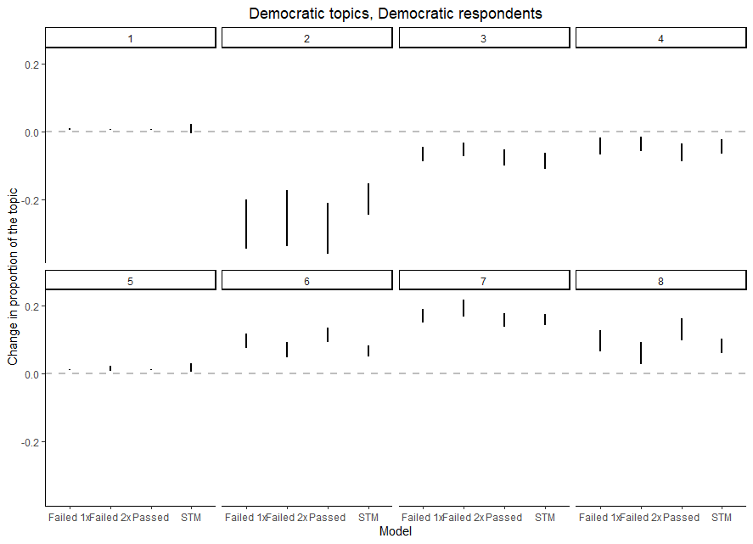
Figure C1. Democratic topics, Democratic respondents, different levels of attentiveness

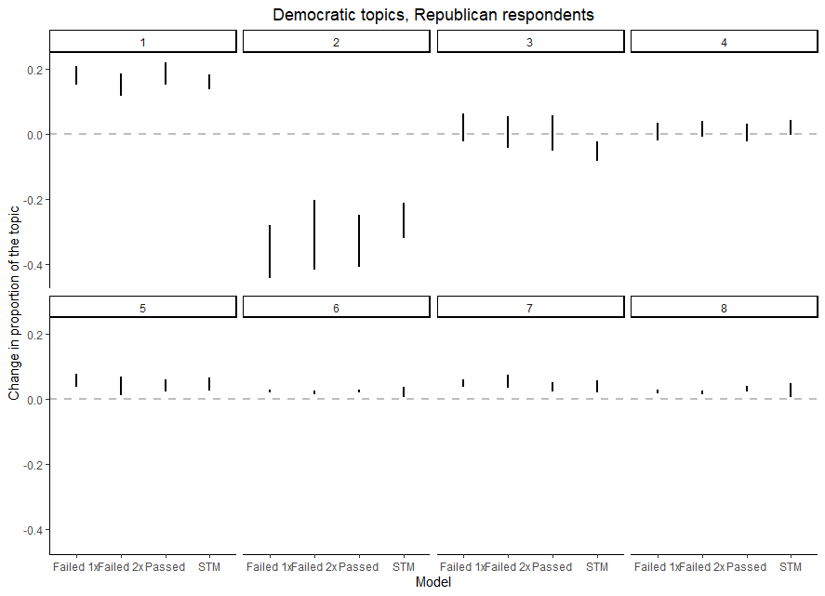
Figure C2. Democratic topics, Republican respondents, different levels of attentiveness

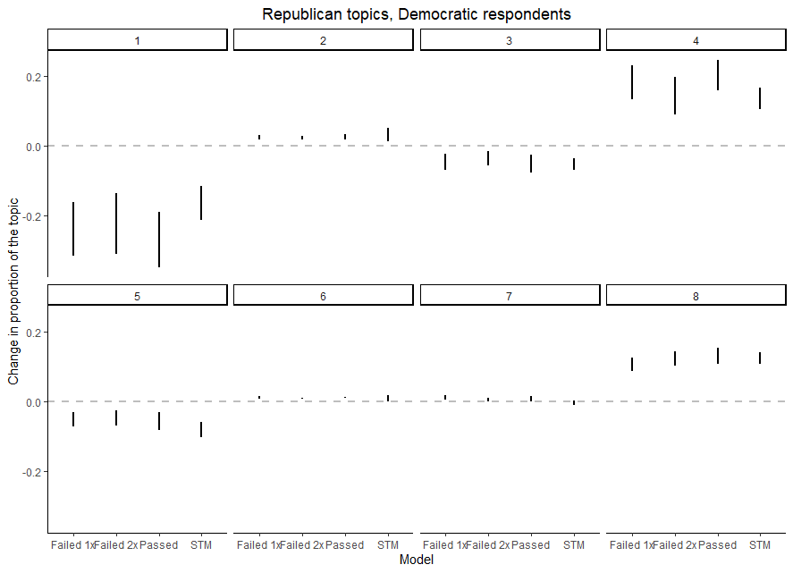
Figure C3. Republican topics, Democratic respondents, different levels of attentiveness

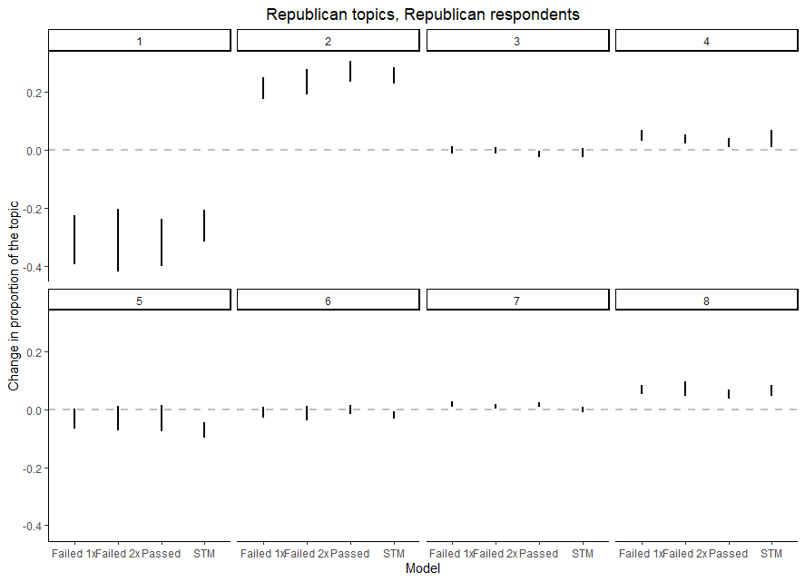
Figure C4. Republican topics, Republican respondents, different levels of attentiveness

Appendix D: Analysis of Other Prevalence Covariates and Alternative Displays of Main Results
Given our focus on year and partisanship, we do not discuss the influence of the other covariates on topic use in the main article. Tables D1 and D2 present a summary of the relationship between the various topics and the other covariates we use in our STM approach. A positive sign indicates that the variable positively predicted that topic’s use in a statistically significant way (p<0.10), and a negative sign suggests a statistically significant, negative connection between the covariate and topic use.
 | Topic 1 | Topic 2 | Topic 3 | Topic 4 | Topic 5 | Topic 6 | Topic 7 | Topic 8
Income |  | - |  | - |  | + | +
Gender | - |  | + | + | + | + |  | -
White |  | + | - | - | + | + | + | +
Interest | - | + | - |  | - |  | - | +
Education | + | - |  |  | + | - | -
Hispanic |  |  |  | + | - |  | - | +
Age | - | + | + |  | + | + |  | -
Political knowledge | - | - | + |  | + | + | + | -
Table D1. Predictors of Republican topics
 | Topic 1 | Topic 2 | Topic 3 | Topic 4 | Topic 5 | Topic 6 | Topic 7 | Topic 8
Income |  |  | + |  | - | - | + | -
Gender | + | + |  |  |  | + | - | +
White | + |  | + |  | + | - |  | -
Interest | - | - | - | - | - |  | + | +
Education | - | - | + |  | -
Hispanic |  |  |  |  |  |  | +
Age | + | - | + | + | + |  | - | +
Political knowledge |  | - | + | + | - | + | - | +
Table D2. Predictors of Democratic topics
Appendix E: Alternative Displays of Main Results
In the main text, Figure 1 presents the proportions of each topic used by Republicans and Democrats in each survey. Alternative versions of these figures are presented in figures E1 and E2 that directly show the shifts (rather than the underlying proportions). We ultimately prefer the version in Figure 1 as it provides additional information, but figures E1 and E2 focus more directly on change between the surveys. These figures are completely consistent with our discussion in text about changes over time.
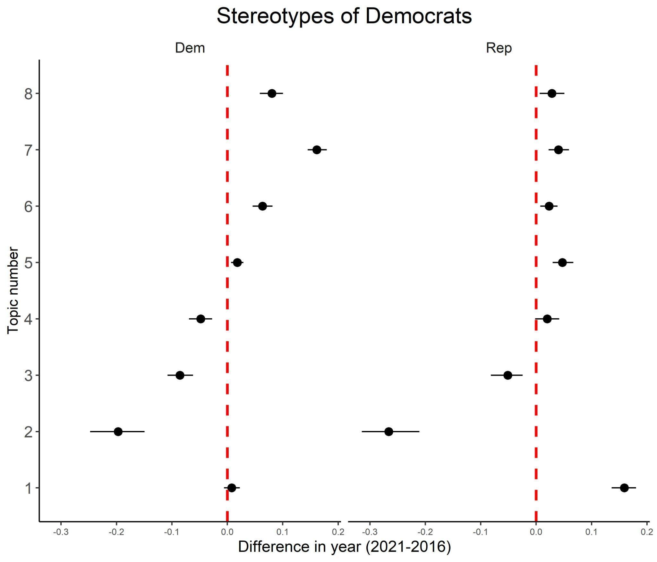
Figure E1: Stereotypes of Democrats, changes over time
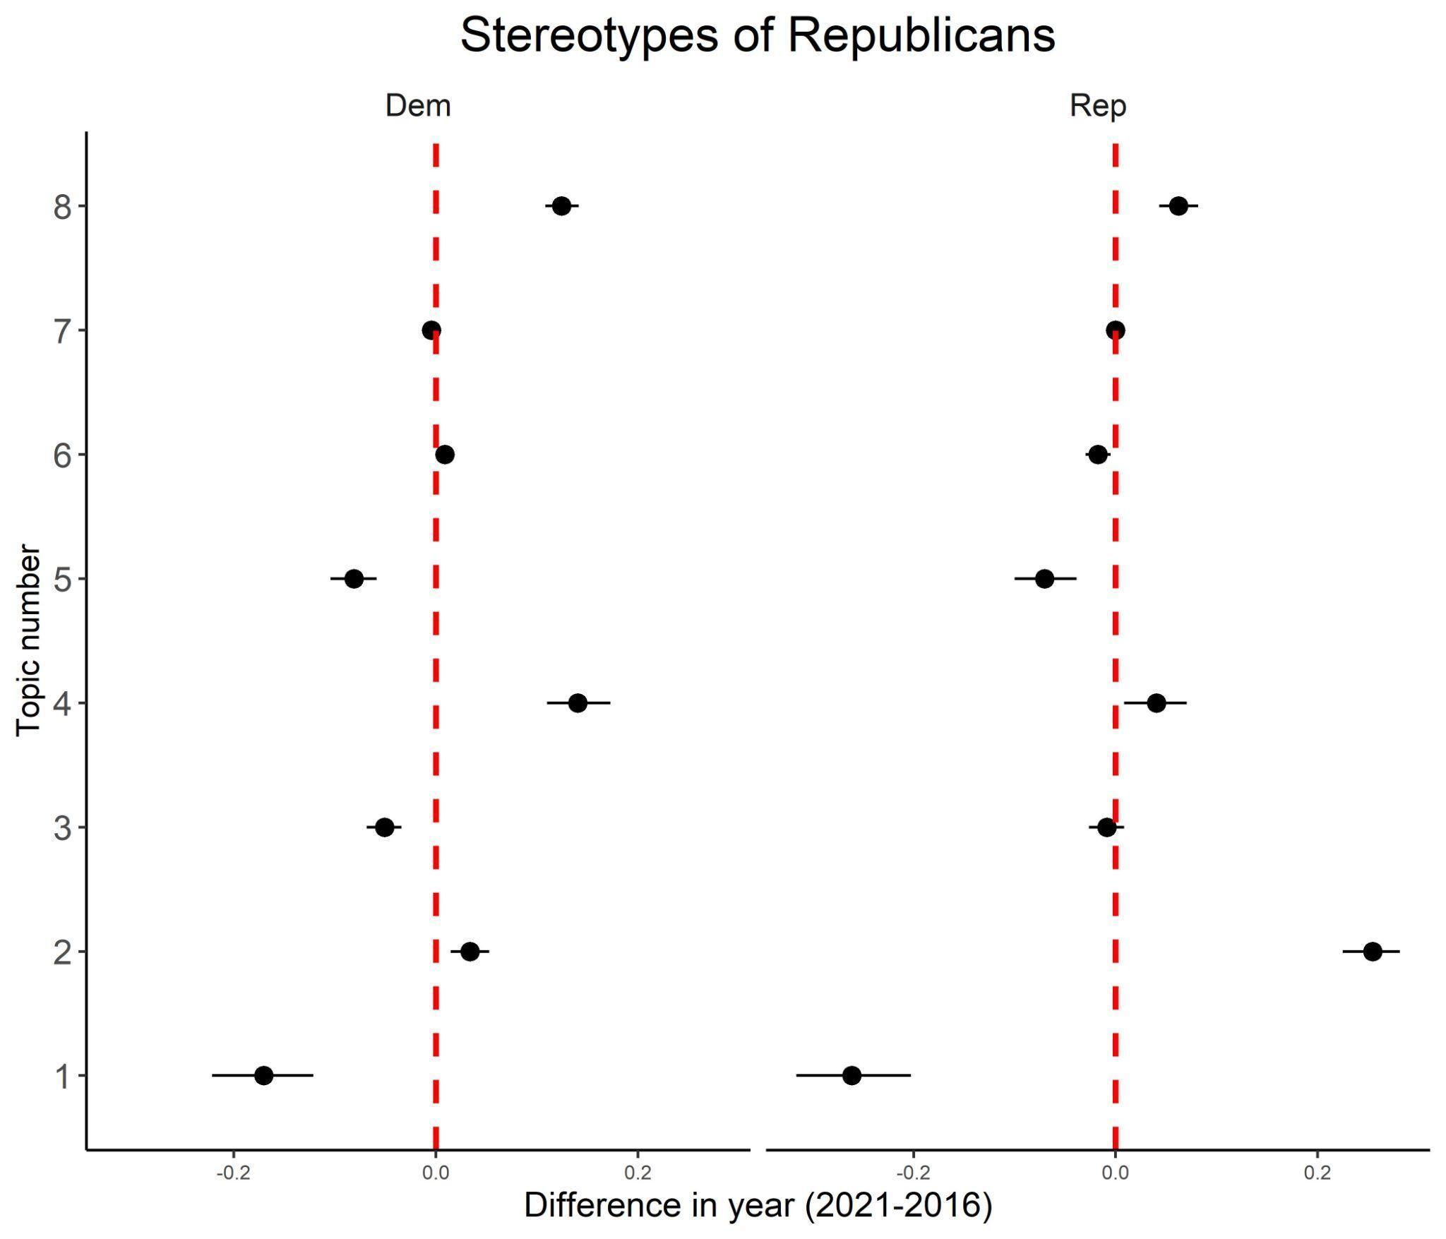
Figure E2: Stereotypes of Republicans, changes over time

Appendix F: Exemplar Documents by Topic
As noted in the text, one important part of the STM process is referring to documents high in a given topic to help determine what that topic’s meaning is. These documents are referred to as exemplar documents, and we considered ten such texts for each topic. The figures below present those exemplar texts for each of the topics we analyze.
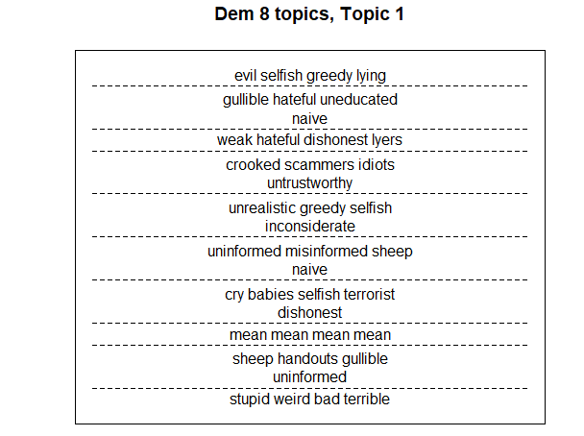
Figure F1. Democratic topics exemplars, Topic 1
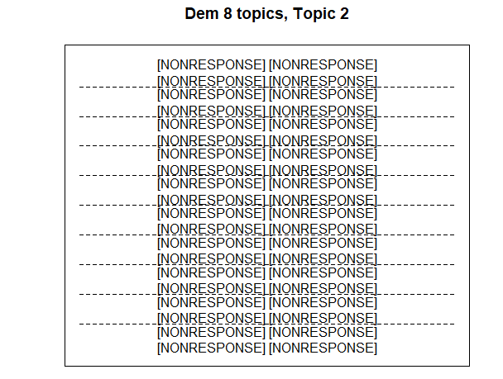
Figure F2. Democratic topics exemplars, Topic 2
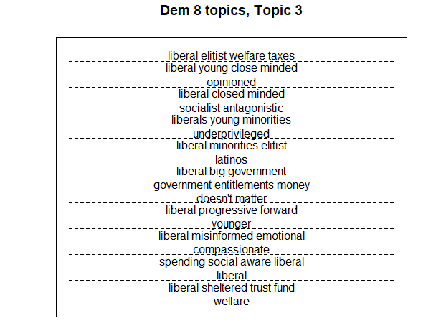
Figure F3. Democratic topics exemplars, Topic 3
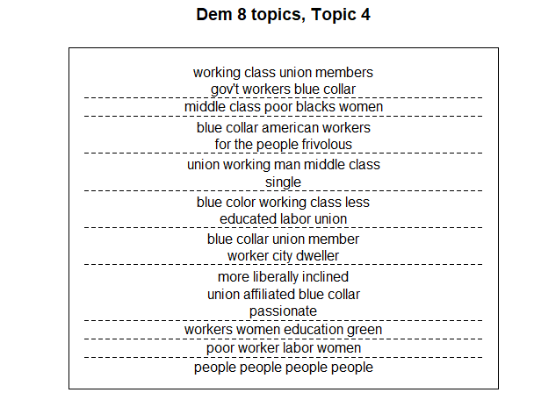
Figure F4. Democratic topics exemplars, Topic 4
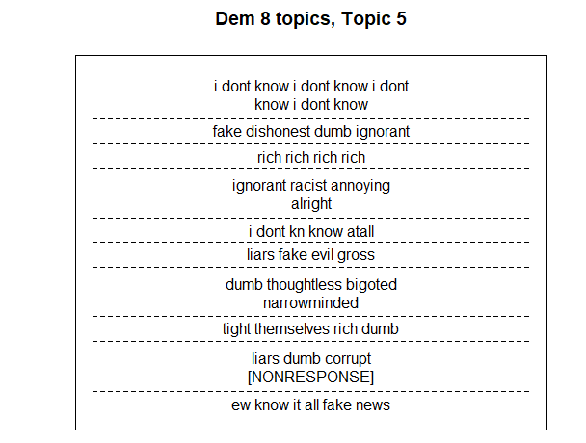
Figure F5. Democratic topics exemplars, Topic 5
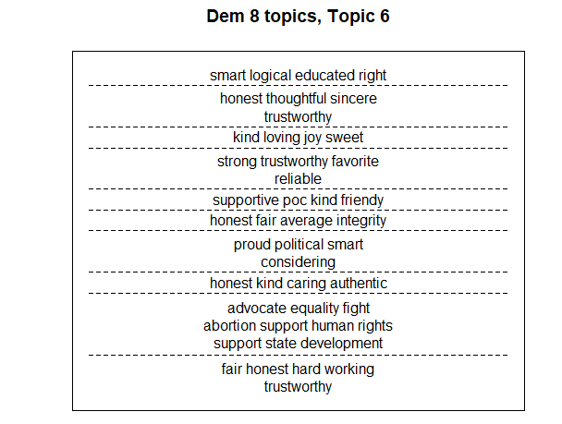
Figure F6. Democratic topics exemplars, Topic 6
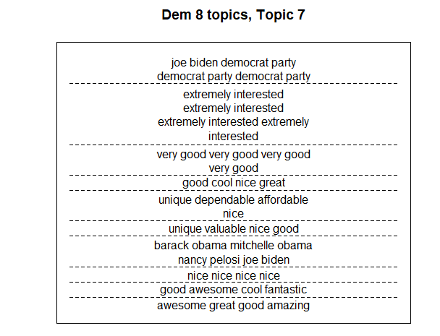
Figure F7. Democratic topics exemplars, Topic 7
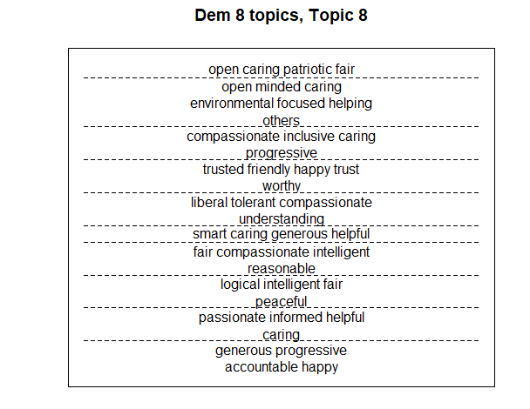Figure F8. Democratic topics exemplars, Topic 8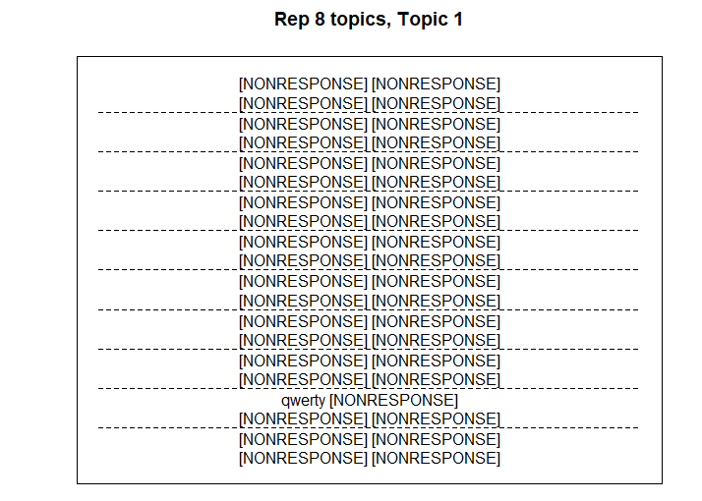
Figure F9. Republican topics exemplars, Topic 1
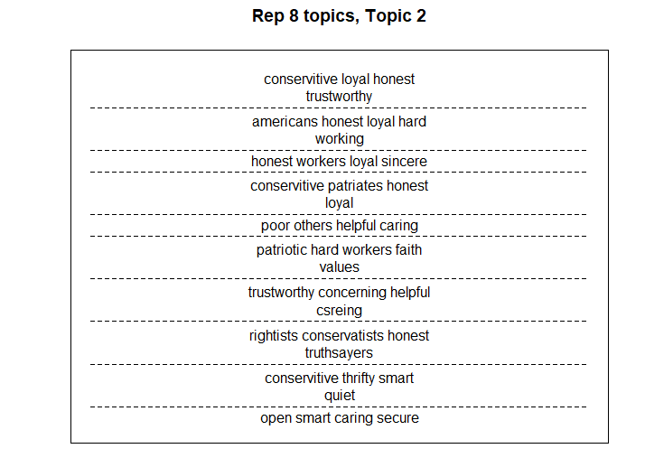
Figure F10. Republican topics exemplars, Topic 2
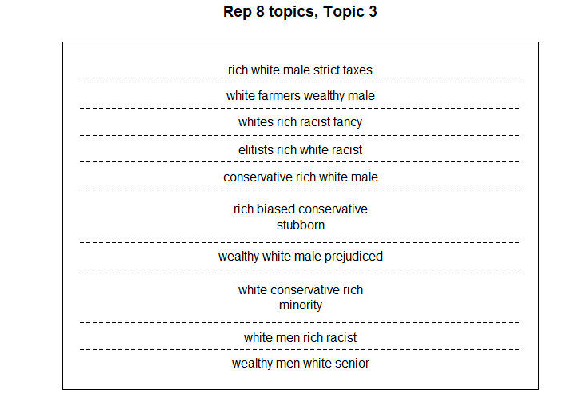
Figure F11. Republican topics exemplars, Topic 3
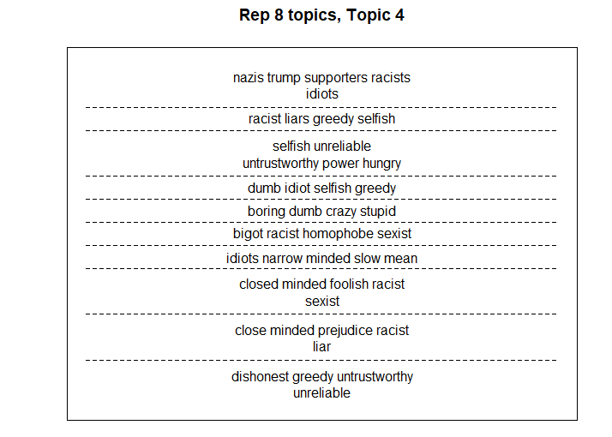
Figure F12. Republican topics exemplars, Topic 4
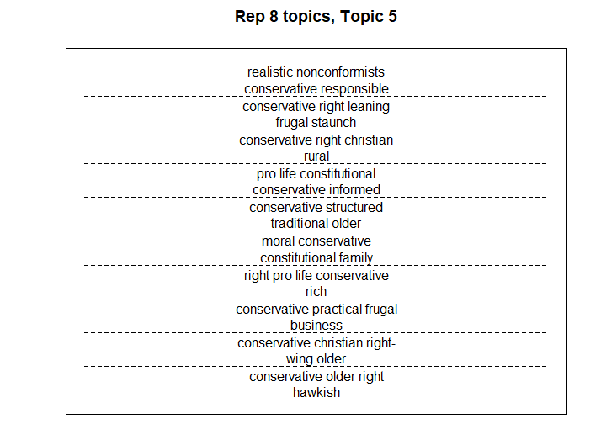
Figure F13. Republican topics exemplars, Topic 5
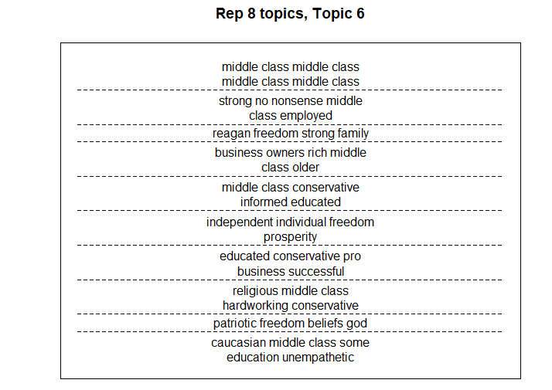
Figure F14. Republican topics exemplars, Topic 6
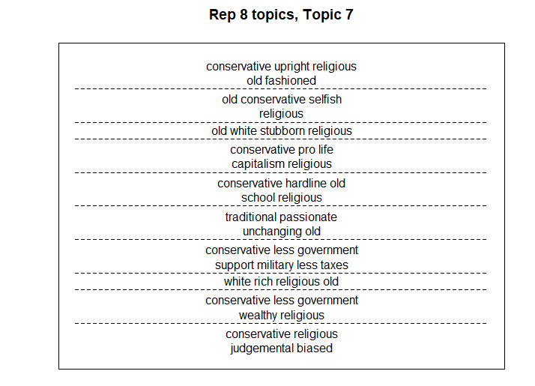
Figure F15. Republican topics exemplars, Topic 7
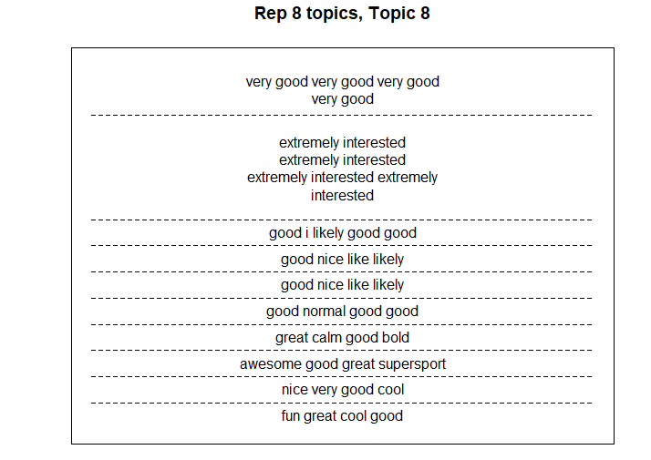
Figure F16. Republican topics exemplars, Topic 8

Appendix G: Checking for Insincere Respondents
Some researchers have noted an increase in what Kennedy et al. (2021) term “insincere” responses on representative non-probability panels like those we use to recruit responses. Troublingly, Kennedy et al. (2021)’s extensive study of these responses finds that standard closed-ended attention checks appear to do a poor job at detecting these responses. This type of low-quality responses are potentially problematic for structural topic models because such responses often include responses to open-ended questions that are not blank and not gibberish, but also not responsive to the question. For example, Kennedy et al. (2021) coded responses to a series of open-ended questions and found that between two and four percent of respondents from what they term “Opt-in panels'' gave multiple “non-sequitur” - that is, answers that were lexical but were not plausible answers to the question asked - answers to a series of open-ended questions. If the proportion of respondents giving this type of response changed from 2016 to 2021, then some of the change in topics that we interpret as change in stereotypes may in fact be an increase in these kinds of responses.
We investigated this possibility using an open-ended question that asked “Who is the current Secretary of State?” This was part of the political knowledge battery, which appeared after the stereotype questions in the survey. We identify insincere responses as Kennedy et al. (2021) code as “Gibberish” or “Non-sequiturs,” and follow their general coding rules for these responses:
- Responsive: Answers that included something that could be interpreted as a name (even if an incorrect name) or a description of a person. Examples: “John Kerry”, “Hillary Clinton”, “gates”, “The lying Clinton scum.”, “Blinken”, “Nancy Pelosi”, “A Communist”.
- Don’t Know/refused: Answers that indicated the respondent did not know or chose not to provide an answer. Examples: “Don’t Know,” “idk,”, “n/a”, “Don’t care”, “?”
- Gibberish: These responses were numbers, letters, or just punctuation that did not form real words. Example: “77339”, “Ddf”, “wertyguhijio”.
- Non-Sequitur: Answers that were not blank but did not include a name, description of a person, a don’t know or refusal, or gibberish. Examples: “Baby love you too baby girl I love you too baby girl”, “good”, “Illinois”, “Taxes”, “yes”, “none”, “afw”.
Table G.1 shows the percentage of answers that fell into each category in each sample. We do find a higher percentage of “insincere” responses in 2021, though these responses still make up a relatively small proportion of the overall sample. These respondents were disproportionately likely to be categorized in the “Insincere Positive” categories. 3% of insincere respondents in 2016 and 25% of insincere respondents in 2021 were categorized by the STM in the “insincere positive” for their responses about Democrats, and 1% of insincere respondents in 2016 and 18% of insincere respondents in 2021 were categorized in the “Insincere Positive” category for their responses about Republicans.
Response Type | 2016 Sample | 2021 Sample
Gibberish | 5 (0.6%) | 14 (1.2%)
Non-Sequitur | 6 (0.8%) | 52 (4.4%)
Insincere (Gibberish + Non-Sequitur) | 11 (1.4%) | 66 (5.6%)
Table G1. Insincere responses
However, the fact that even in 2021 these respondents made up only 5.6% of the sample means that removing them from the sample has relatively little impact on the overall results. Figure G1 replicates Figure G2 above with insincere respondents removed – the biggest change is 1.1 percentage points and most are significantly less than 1%.

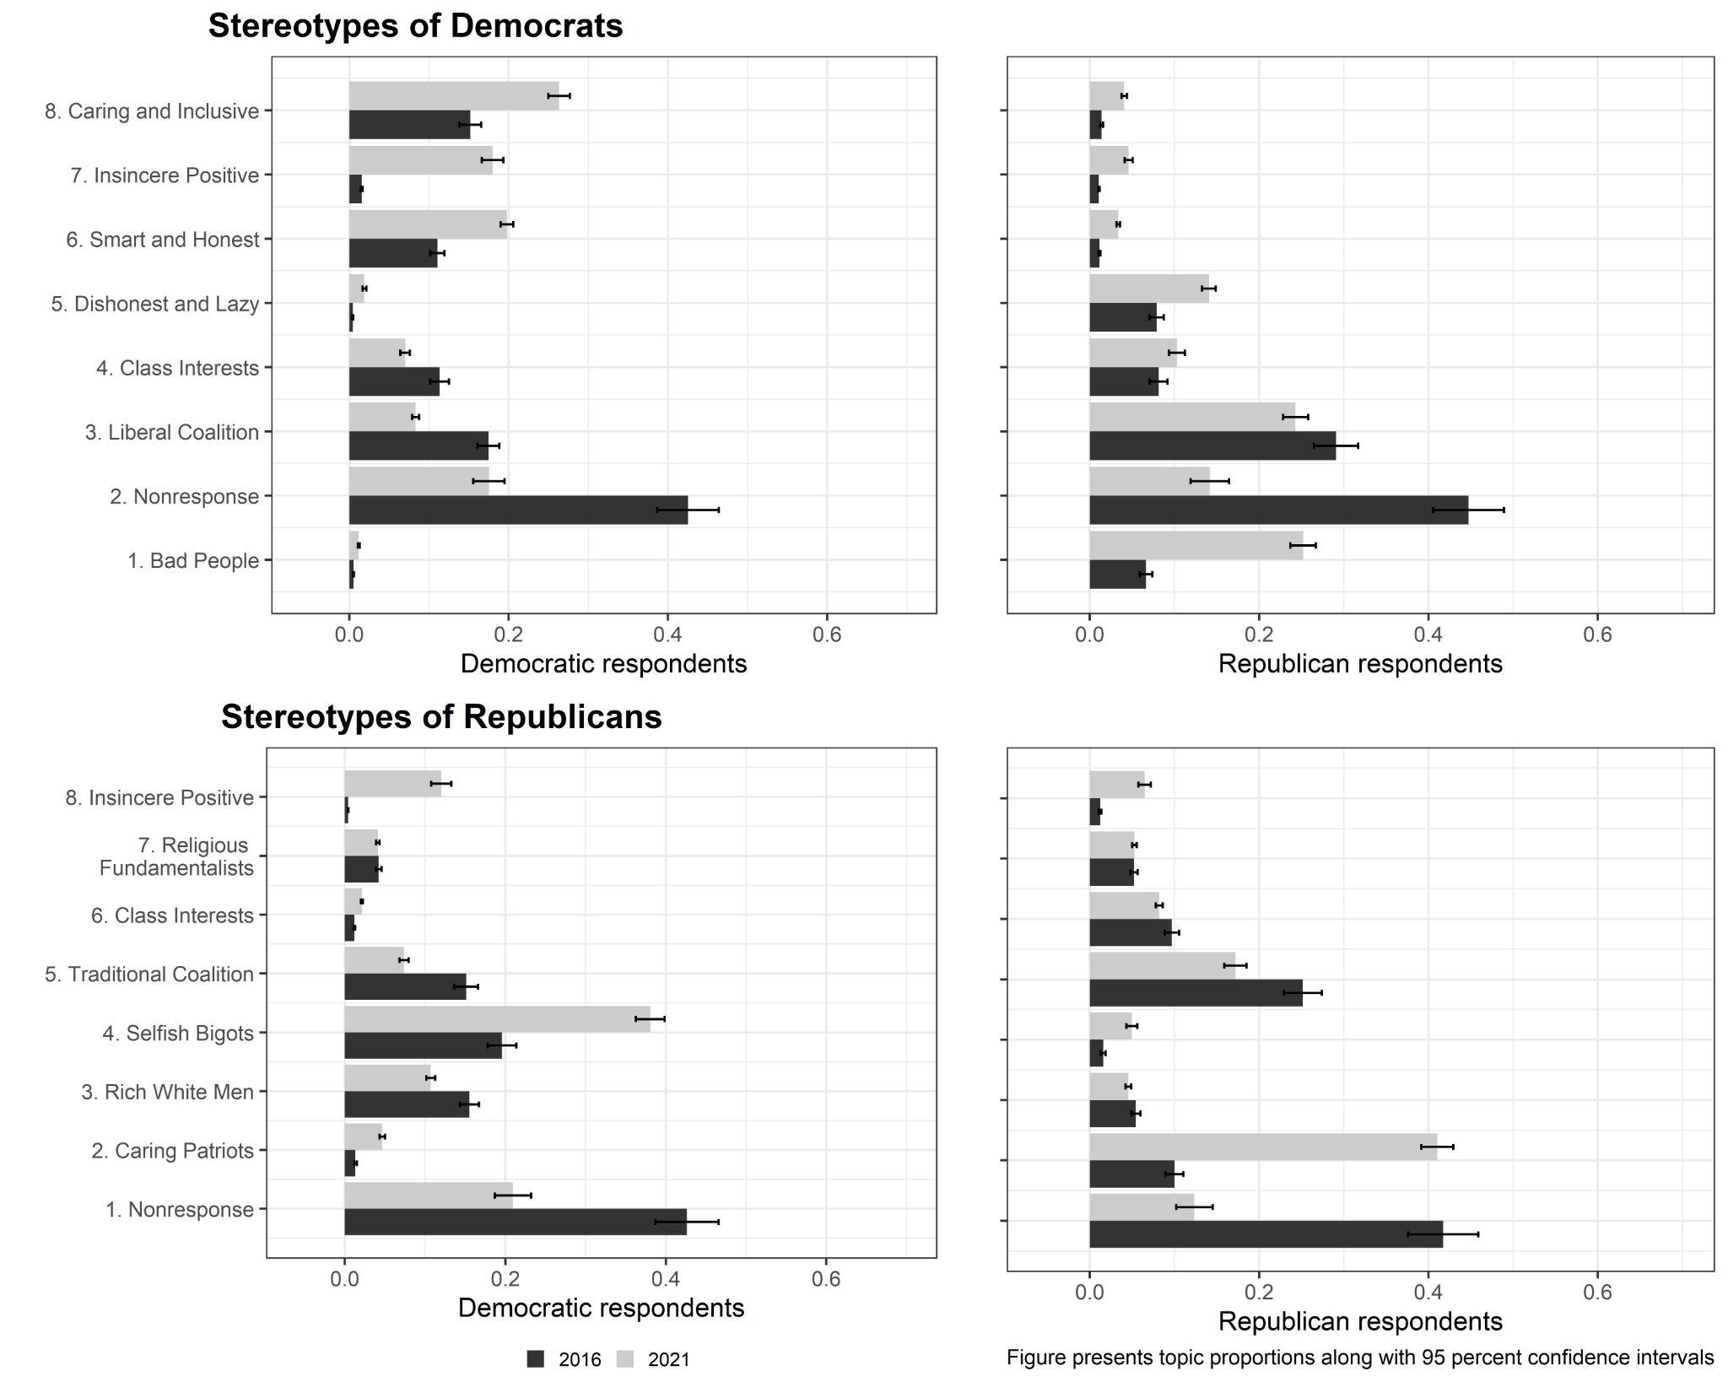
Figure G1: Unweighted mean estimates of topic prevalence with insincere responses removed.

Appendix H: Additional Topic Modeling Details
As discussed in the main text, we use structural topic modeling to analyses these open-ended stereotypes of Republicans and Democrats. This section contains detailed information that does not fit into the main text about how we used the open-ended texts in the STM process and the decisions that we made as we used these topic models. The steps described here are included in our pre-analysis plans. Before using any STM procedures, we recorded blank responses and statements like “don’t know”, “NA”, and “None” as the word “Nonresponse”. This allows us to examine instances and correlates of nonresponse in a way we could not do if we treated these data as missing. We did not employ any other recoding or modification of these open-ended texts.
Next, we followed the pre-processing steps recommended by the developers or STM and included as defaults in the STM package in R. This involves removing stop words, punctuation, and numbers from the text. It also puts the terms all in lowercase, drops words occurring less than 5 times, and stemming the words (as noted in the main text). Both of these steps—recoding nonresponse and using the pre-processing defaults from STM—parallel the approach used by Rothschild et al (2019) in their published work on this topic.
The process we used, which is described in our pre-analysis plan, involved considering topic models with between 5 and 75 topics. Using the statistical measures of model performance generated by the STM analysis (namely semantic coherence and exclusivity), we narrowed this larger range into a smaller range of topics and repeated the comparison of statistics. The following tables and figures provide the results of our model searches.

Figure H.1: Wide model search for stereotypes about Democrats:
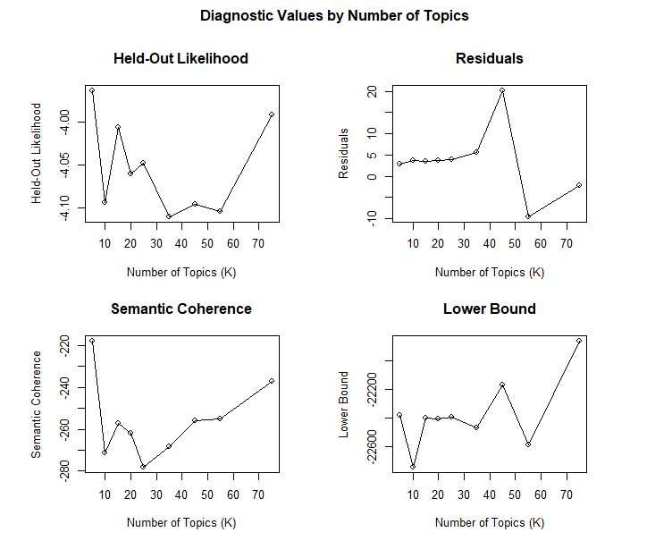
Table H.1: Wide model search for stereotypes about Democrats:
|K |exclus |semcoh |heldout |residual |bound |lbound |em.its |
|:--|:--------|:---------|:---------|:---------|:---------|:---------|:------|
|5 |9.355372 |-217.8014 |-3.96333 |2.90219 |-22389.83 |-22385.04 |106 |
|10 |9.733468 |-271.2521 |-4.094444 |3.621387 |-22764.52 |-22749.42 |85 |
|15 |9.252025 |-257.1203 |-4.006671 |3.504907 |-22425.81 |-22397.91 |103 |
|20 |9.212581 |-261.7928 |-4.060171 |3.717873 |-22451.03 |-22408.7 |145 |
|25 |8.869157 |-278.2303 |-4.048367 |3.962594 |-22454.75 |-22396.75 |109 |
|35 |8.423514 |-268.4229 |-4.110844 |5.660161 |-22562.22 |-22470.08 |75 |
|45 |8.270005 |-255.8361 |-4.096253 |20.17372 |-22298.75 |-22169.63 |161 |
|55 |8.404615 |-255.2349 |-4.104669 |-9.601161 |-22756.08 |-22587.75 |60 |
|75 |8.90323 |-237.1278 |-3.991842 |-2.291379 |-22109.67 |-21857.78 |254 |

Figure H.2: Wide model search for stereotypes about Republicans:

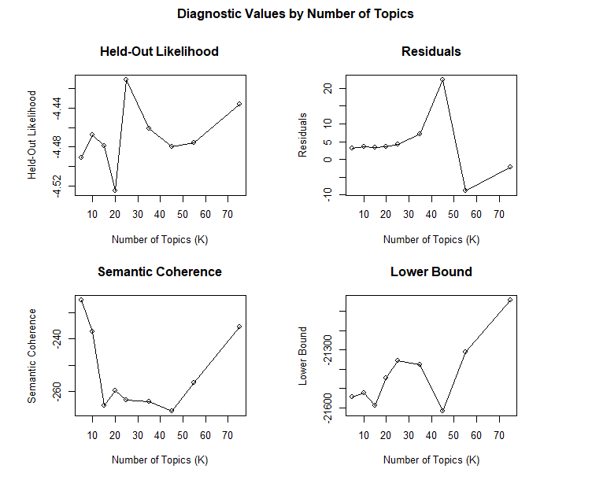
Table H.2: Wide model search for stereotypes about Republicans:
|K |exclus |semcoh |heldout |residual |bound |lbound |em.its |
|:--|:--------|:---------|:---------|:---------|:---------|:---------|:------|
|5 |9.294419 |-225.285 |-4.491272 |3.14817 |-21547.34 |-21542.55 |97 |
|10 |9.228187 |-237.0981 |-4.467293 |3.502442 |-21539.86 |-21524.76 |104 |
|15 |9.260182 |-265.2831 |-4.479219 |3.404675 |-21616.89 |-21588.99 |126 |
|20 |9.222685 |-259.7062 |-4.525082 |3.685663 |-21488.47 |-21446.13 |165 |
|25 |8.440863 |-263.0198 |-4.410724 |4.144744 |-21416.53 |-21358.53 |149 |
|35 |8.105933 |-263.8456 |-4.461295 |7.030996 |-21469.17 |-21377.03 |153 |
|45 |8.502273 |-267.3849 |-4.479738 |22.39683 |-21747.77 |-21618.64 |90 |
|55 |8.590143 |-256.6553 |-4.475865 |-8.81046 |-21479.99 |-21311.67 |221 |
|75 |8.684687 |-235.3049 |-4.435645 |-2.218952 |-21294.43 |-21042.54 |289 |

Figure H.3 Narrower model search about Democrats:
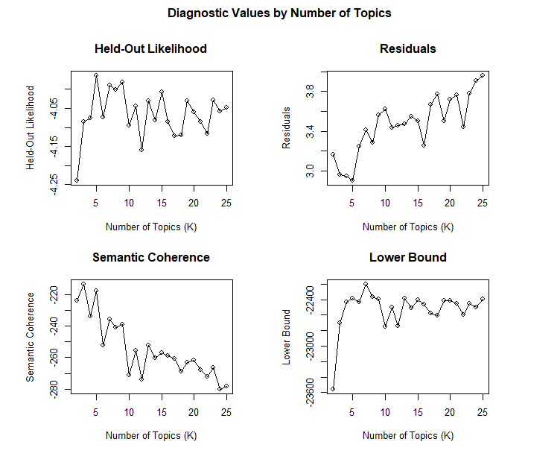

Table H.3 Narrower model search about Democrats:
|K |exclus |semcoh |heldout |residual |bound |lbound |em.its |
|:--|:--------|:---------|:---------|:--------|:---------|:---------|:------|
|2 |7.580747 |-223.8736 |-4.240252 |3.165941 |-23561.34 |-23560.65 |57 |
|3 |8.67842 |-213.4483 |-4.084918 |2.959621 |-22699.15 |-22697.35 |85 |
|4 |9.104238 |-233.5625 |-4.074698 |2.949556 |-22436.16 |-22432.98 |128 |
|5 |9.355372 |-217.8014 |-3.96333 |2.90219 |-22389.83 |-22385.04 |106 |
|6 |9.566438 |-252.1853 |-4.073577 |3.250509 |-22441.74 |-22435.16 |131 |
|7 |9.513211 |-235.7473 |-3.989879 |3.416323 |-22207.84 |-22199.32 |148 |
|8 |9.483365 |-241.0392 |-4.000278 |3.288967 |-22375.42 |-22364.81 |105 |
|9 |9.571426 |-239.1959 |-3.98088 |3.559753 |-22401.51 |-22388.71 |133 |
|10 |9.733468 |-271.2521 |-4.094444 |3.621387 |-22764.52 |-22749.42 |85 |
|11 |9.474708 |-255.6871 |-4.043618 |3.438872 |-22511.61 |-22494.11 |100 |
|12 |9.667229 |-274.0789 |-4.159213 |3.455844 |-22756.68 |-22736.7 |61 |
|13 |9.345763 |-252.3101 |-4.031022 |3.473467 |-22404.19 |-22381.63 |128 |
|14 |9.326149 |-260.0587 |-4.082203 |3.548987 |-22536.11 |-22510.92 |108 |
|15 |9.252025 |-257.1203 |-4.006671 |3.504907 |-22425.81 |-22397.91 |103 |
|16 |9.2868 |-258.8106 |-4.084817 |3.254658 |-22491.05 |-22460.38 |120 |
|17 |9.219304 |-260.596 |-4.122432 |3.669761 |-22613.12 |-22579.62 |89 |
|18 |8.85613 |-268.6785 |-4.11973 |3.770741 |-22639.7 |-22603.31 |135 |
|19 |9.158869 |-262.9235 |-4.030692 |3.503846 |-22454.53 |-22415.19 |103 |
|20 |9.212581 |-261.7928 |-4.060171 |3.717873 |-22451.03 |-22408.7 |145 |
|21 |9.15789 |-267.8363 |-4.08537 |3.764106 |-22499.42 |-22454.04 |185 |
|22 |9.225845 |-271.9836 |-4.117219 |3.444743 |-22641.74 |-22593.26 |56 |
|23 |8.850379 |-266.1925 |-4.028075 |3.779695 |-22497.57 |-22445.96 |95 |
|24 |8.587963 |-280.1748 |-4.058457 |3.905206 |-22550.07 |-22495.29 |98 |
|25 |8.869157 |-278.2303 |-4.048367 |3.962594 |-22454.75 |-22396.75 |109 |

Figure H.4 Narrower model search about Republicans:
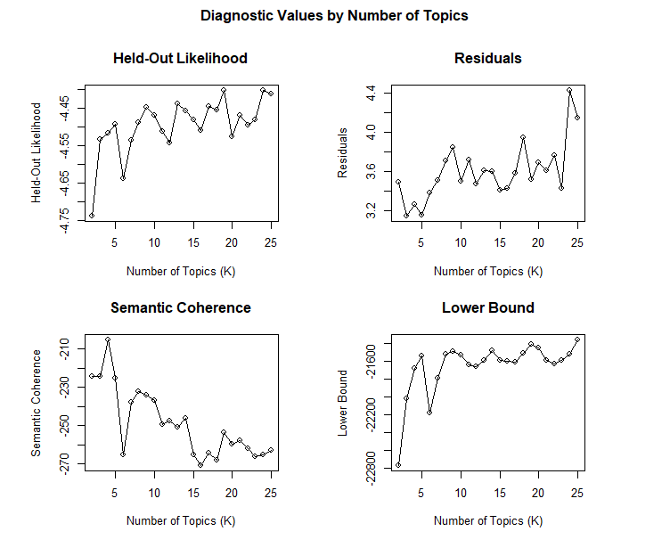

Table H.4 Narrower model search about Republicans:
|K |exclus |semcoh |heldout |residual |bound |lbound |em.its |
|:--|:--------|:---------|:---------|:--------|:---------|:---------|:------|
|2 |8.348247 |-224.6255 |-4.737577 |3.489559 |-22770.83 |-22770.13 |104 |
|3 |8.736587 |-224.4467 |-4.531954 |3.14186 |-22019.5 |-22017.71 |63 |
|4 |9.305584 |-205.2869 |-4.516483 |3.265302 |-21680.63 |-21677.46 |106 |
|5 |9.294419 |-225.285 |-4.491272 |3.14817 |-21547.34 |-21542.55 |97 |
|6 |9.547445 |-265.5072 |-4.638304 |3.381088 |-22181.47 |-22174.89 |80 |
|7 |9.572978 |-237.9758 |-4.53586 |3.504532 |-21794.43 |-21785.9 |101 |
|8 |9.560112 |-232.232 |-4.486697 |3.703398 |-21531.49 |-21520.89 |77 |
|9 |9.600207 |-234.259 |-4.446267 |3.84365 |-21497.73 |-21484.93 |133 |
|10 |9.228187 |-237.0981 |-4.467293 |3.502442 |-21539.86 |-21524.76 |104 |
|11 |9.668881 |-249.262 |-4.51076 |3.720642 |-21658.78 |-21641.28 |77 |
|12 |9.313972 |-247.4237 |-4.542033 |3.469484 |-21677.29 |-21657.3 |87 |
|13 |9.329244 |-250.8785 |-4.437765 |3.603558 |-21613.73 |-21591.18 |130 |
|14 |9.179891 |-246.2978 |-4.455608 |3.595163 |-21501.61 |-21476.41 |112 |
|15 |9.260182 |-265.2831 |-4.479219 |3.404675 |-21616.89 |-21588.99 |126 |
|16 |9.258675 |-270.9843 |-4.509263 |3.42735 |-21629.22 |-21598.55 |99 |
|17 |9.558545 |-264.3498 |-4.444655 |3.57956 |-21638.56 |-21605.05 |83 |
|18 |9.137396 |-267.9904 |-4.453078 |3.940965 |-21544.37 |-21507.97 |157 |
|19 |8.991857 |-253.899 |-4.40186 |3.520476 |-21451.66 |-21412.32 |98 |
|20 |9.222685 |-259.7062 |-4.525082 |3.685663 |-21488.47 |-21446.13 |165 |
|21 |9.065344 |-258.0628 |-4.46754 |3.60701 |-21630.49 |-21585.11 |114 |
|22 |8.677189 |-262.0905 |-4.494693 |3.766549 |-21679.71 |-21631.24 |113 |
|23 |8.852155 |-266.3465 |-4.480031 |3.425996 |-21642.25 |-21590.64 |75 |
|24 |8.477546 |-265.4178 |-4.400721 |4.43017 |-21570.4 |-21515.62 |131 |
|25 |8.440863 |-263.0198 |-4.410724 |4.144744 |-21416.53 |-21358.53 |149 |
At this stage, we selected a set of specific models to consider more closely. This first involved choosing models with a specific number of topics and running multiple iterations of that topic model. We selected the number of topics in these analyses based on which models seemed to perform best in the model searches above. We did not constrain this process to require models with the same number of topics for stereotypes of Republicans and Democrats. From this process, we then examined the semantic coherence and exclusivity of those models to determine what specific model (of each topic number) to evaluate. Because this process is still removed from the actual words and themes associated with these models, it allows us to choose a well-performing model without the temptation to select topic models that emphasize themes favorable to our theories and hypotheses. The figures below present the results of these analyses; in these figures, the numbers indicate the top performing models for each set.
Figure H.5, Democratic models with specific numbers of topics
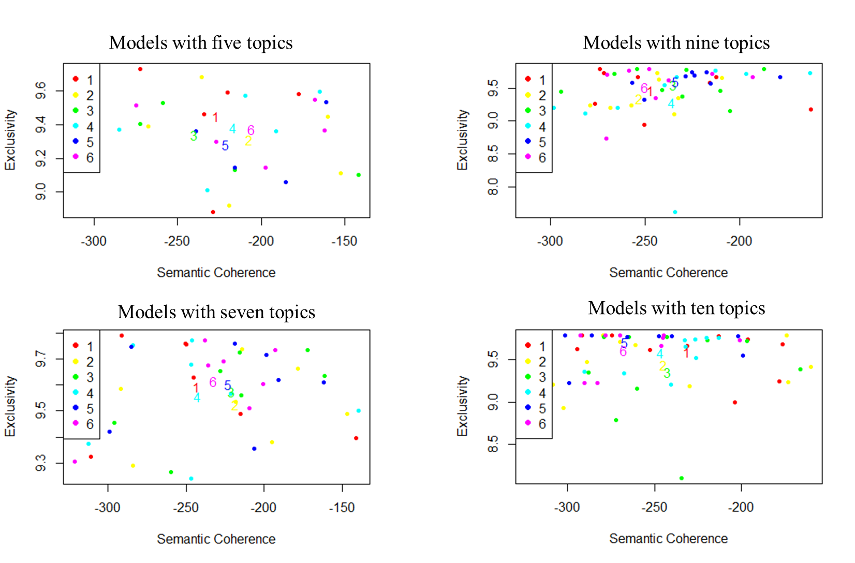
Next, we evaluated the specific results from the top models for each number of topics. We chose the specific versions of each number of topics that performed best in the analyses summarized in the figures above. It was at this stage that we first considered the specific themes and terms generated by the STM procedures. For stereotypes about Democrats, we considered three models with five topics, three models with seven topics, two models with nine topics, and one model with ten topics. For stereotypes about Republicans, we evaluated two models with four topics, three models with seven topics, two models with eight topics, one model with nine topics, and three models with eleven topics. The detailed model results follow in the tables below; the version numbers in these tables refer to the numbers in figures H.5 and H.6.
Figure H.6, Republican models with specific numbers of topics
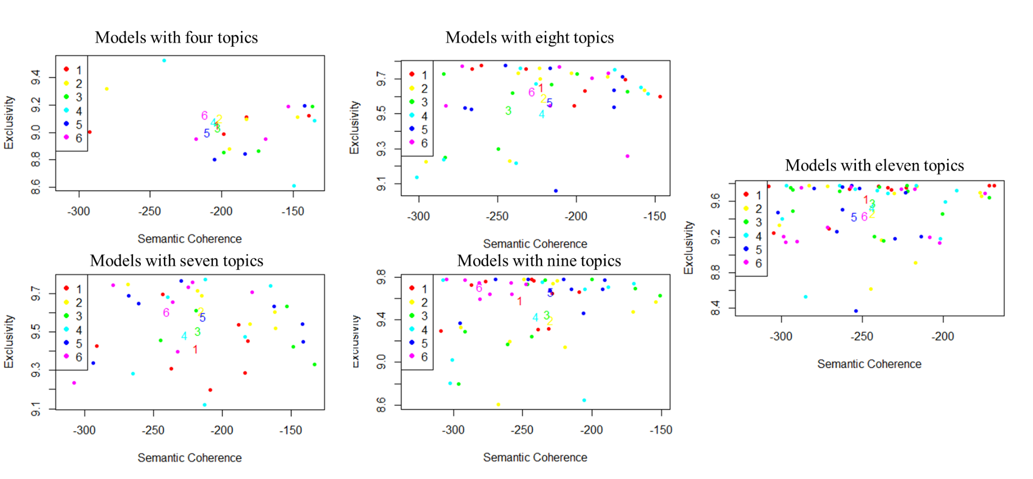
We then chose our final models - version five of the five topic model about Democrats and version six of the four topic model about Republicans - based on comparing the content of these models and exemplar documents for each. As shown in tables H.5 and H.6, most of the major themes in these topics are consistent across the different versions of these models, suggesting important core themes that are not contingent on our modeling choices. This also gives some evidence that the topic modeling works reasonably well for the number and length of documents we have here; if either length or the number of documents was causing problems for the topic modeling, we would expect to observe instability in the topic content and interpretation of the STM results from version to version. We also note that here we are using a comparable number of documents to many published, methodological discussions of structural topic modeling (Roberts et al. 2014).

Table H.5. Detailed topic model results for Democratic Stereotypes
Five topic models
Version 2:
Topic 1 Top Words:
Highest Prob: nonrespons, know, dont, money, conserv, moder, yes
FREX: nonrespons, dont, know, money, conserv, moder, yes
Lift: nonrespons, know, dont, donã¢â‚¬â„¢t, brave, get, just
Score: nonrespons, know, dont, ethnic, thiev, immor, awar
Topic 2 Top Words:
Highest Prob: good, nice, biden, great, cool, support, like
FREX: great, good, like, nice, cool, biden, awesom
Lift: amaz, awesom, joe, like, cool, great, good
Score: good, nice, great, biden, cool, like, joe
Topic 3 Top Words:
Highest Prob: care, smart, open, honest, fair, mind, help
FREX: honest, help, care, inclus, intellig, hope, thought
Lift: concern, thought, empathet, honest, toler, hope, inclus
Score: care, smart, honest, open, fair, help, intellig
Topic 4 Top Words:
Highest Prob: liber, poor, progress, left, minor, class, young
FREX: minor, class, pro, union, middl, young, liber
Lift: ethnic, women, pro, collar, union, minor, wing
Score: liber, poor, minor, left, class, young, progress
Topic 5 Top Words:
Highest Prob: socialist, lazi, stupid, dumb, liar, tax, rich
FREX: stupid, dishonest, lazi, idiot, selfish, unrealist, dumb
Lift: moron, evil, untrustworthi, cheat, crook, sad, rude
Score: socialist, lazi, stupid, dumb, liar, tax, ignor

Version 5:
Topic 1 Top Words:
Highest Prob: nonrespons, like, yes, stubborn, bad, conserv, big
FREX: nonrespons, like, yes, stubborn, bad, conserv, big
Lift: nonrespons, like, yes, awar, bad, best, chang
Score: nonrespons, like, yes, brave, just, real, argument
Topic 2 Top Words:
Highest Prob: care, good, smart, honest, nice, help, support
FREX: honest, good, great, help, nice, cool, intellig
Lift: reliabl, brave, great, awesom, real, amaz, cool
Score: good, care, smart, honest, nice, help, support
Topic 3 Top Words:
Highest Prob: liber, open, progress, mind, educ, poor, minor
FREX: open, educ, middl, mind, progress, class, minor
Lift: middl, women, urban, collar, worker, class, educ
Score: liber, open, progress, educ, mind, minor, class
Topic 4 Top Words:
Highest Prob: liber, ignor, mean, selfish, uninform, greedi, unrealist
FREX: selfish, greedi, mean, gullibl, ignor, sheep, uninform
Lift: arrog, sheep, misinform, gullibl, greedi, selfish, unrealist
Score: ignor, mean, selfish, uninform, unrealist, greedi, entitl
Topic 5 Top Words:
Highest Prob: liber, socialist, lazi, stupid, left, dumb, liar
FREX: lazi, dumb, stupid, welfar, socialist, liar, wrong
Lift: sad, wrong, welfar, argument, anti, evil, stupid
Score: socialist, lazi, stupid, dumb, liar, tax, left

Version 6:
Topic 1 Top Words:
Highest Prob: liber, socialist, left, poor, lazi, tax, minor
FREX: socialist, uninform, entitl, tax, unrealist, welfar, lazi
Lift: intoler, freeload, close, emot, entitl, unrealist, uninform
Score: liber, socialist, lazi, poor, tax, left, uninform
Topic 2 Top Words:
Highest Prob: care, good, smart, honest, nice, fair, help
FREX: honest, good, great, nice, cool, help, intellig
Lift: reliabl, amaz, awesom, real, great, brave, cool
Score: good, care, smart, honest, nice, fair, help
Topic 3 Top Words:
Highest Prob: nonrespons, know, like, dont, yes, rich, money
FREX: nonrespons, know, dont, like, yes, rich, money
Lift: nonrespons, know, dont, yes, like, donã¢â‚¬â„¢t, abort
Score: nonrespons, know, like, dont, yes, intoler, brave
Topic 4 Top Words:
Highest Prob: liber, open, progress, mind, educ, class, peopl
FREX: open, middl, class, educ, mind, progress, pro
Lift: middl, choic, women, class, inclus, open, divers
Score: liber, open, progress, educ, mind, class, middl
Topic 5 Top Words:
Highest Prob: stupid, dumb, biden, liar, ignor, mean, weak
FREX: stupid, ignor, dumb, crazi, idiot, joe, selfish
Lift: untrustworthi, evil, sad, crook, moron, fake, lie
Score: stupid, dumb, biden, liar, ignor, dishonest, selfish

Seven topic models
Version 2:
Topic 1 Top Words:
Highest Prob: care, liber, smart, open, mind, progress, fair
FREX: care, open, inclus, help, intellig, fair, mind
Lift: empathet, concern, averag, inclus, thought, help, care
Score: care, open, fair, smart, mind, help, progress
Topic 2 Top Words:
Highest Prob: liber, socialist, left, lazi, tax, poor, uninform
FREX: socialist, uninform, tax, left, unrealist, welfar, lazi
Lift: emot, unrealist, entitl, socialist, uninform, welfar, idealist
Score: liber, socialist, left, lazi, tax, uninform, welfar
Topic 3 Top Words:
Highest Prob: liber, educ, poor, peopl, class, middl, minor
FREX: class, educ, middl, peopl, pro, poor, women
Lift: choic, women, middl, class, pro, educ, work
Score: liber, educ, class, peopl, poor, middl, pro
Topic 4 Top Words:
Highest Prob: honest, biden, know, joe, dont, obama, inform
FREX: know, dont, honest, joe, biden, obama, inform
Lift: dont, know, joe, obama, biden, honest, inform
Score: honest, biden, know, joe, dont, obama, inform
Topic 5 Top Words:
Highest Prob: good, nice, great, cool, like, support, strong
FREX: cool, like, good, great, nice, awesom, yes
Lift: awesom, yes, like, great, cool, good, nice
Score: good, nice, great, cool, like, yes, support
Topic 6 Top Words:
Highest Prob: nonrespons, money, moder, abort, white, polit, posit
FREX: nonrespons, money, moder, abort, white, polit, posit
Lift: nonrespons, donã¢â‚¬â„¢t, argument, best, brave, chang, delusion
Score: nonrespons, averag, hate, untrustworthi, evil, sad, emot
Topic 7 Top Words:
Highest Prob: stupid, dumb, liar, rich, ignor, weak, mean
FREX: stupid, idiot, dishonest, ignor, liar, dumb, stubborn
Lift: untrustworthi, evil, sad, fake, hate, stupid, idiot
Score: stupid, dumb, liar, rich, ignor, idiot, dishonest

Version 3:
Topic 1 Top Words:
Highest Prob: care, smart, honest, fair, help, intellig, compassion
FREX: honest, care, help, fair, smart, thought, compassion
Lift: thought, honest, help, empathet, generous, care, fair
Score: care, smart, honest, fair, help, intellig, compassion
Topic 2 Top Words:
Highest Prob: open, progress, mind, peopl, biden, social, inclus
FREX: open, biden, inclus, joe, mind, obama, democrat
Lift: joe, obama, parti, open, toler, inclus, biden
Score: open, mind, progress, peopl, biden, inclus, democrat
Topic 3 Top Words:
Highest Prob: good, nice, great, cool, support, like, trustworthi
FREX: great, cool, good, nice, like, reliabl, trustworthi
Lift: awesom, great, cool, like, good, nice, reliabl
Score: good, nice, great, cool, like, trustworthi, support
Topic 4 Top Words:
Highest Prob: nonrespons, rich, money, conserv, yes, big, loud
FREX: nonrespons, rich, money, conserv, yes, big, loud
Lift: nonrespons, donã¢â‚¬â„¢t, argument, best, ethnic, fun, get
Score: nonrespons, hispan, close, awesom, arrog, old, self
Topic 5 Top Words:
Highest Prob: socialist, lazi, stupid, dumb, liar, tax, ignor
FREX: stupid, lazi, dishonest, ignor, unrealist, selfish, idiot
Lift: arrog, dishonest, gullibl, unrealist, stupid, selfish, idiot
Score: socialist, lazi, stupid, dumb, liar, tax, ignor
Topic 6 Top Words:
Highest Prob: left, black, work, american, know, crazi, dont
FREX: know, left, dont, black, american, wing, anti
Lift: dont, hispan, know, wing, anti, american, left
Score: left, black, work, american, know, crazi, dont
Topic 7 Top Words:
Highest Prob: liber, poor, minor, class, young, middl, pro
FREX: minor, pro, liber, middl, young, class, women
Lift: women, pro, minor, middl, hippi, young, class
Score: liber, minor, class, young, middl, pro, poor

Version 5:
Topic 1 Top Words:
Highest Prob: stupid, lazi, dumb, liar, ignor, mean, dishonest
FREX: stupid, ignor, dumb, dishonest, lazi, idiot, mean
Lift: moron, evil, hate, confus, stupid, ignor, dishonest
Score: stupid, dumb, ignor, dishonest, mean, lazi, idiot
Topic 2 Top Words:
Highest Prob: nonrespons, rich, democrat, like, crazi, white, abort
FREX: nonrespons, rich, democrat, like, white, abort, spender
Lift: nonrespons, like, donã¢â‚¬â„¢t, crazi, democrat, forward, fun
Score: nonrespons, donã¢â‚¬â„¢t, moron, hate, confus, evil, spend
Topic 3 Top Words:
Highest Prob: open, mind, left, liber, welfar, wing, close
FREX: mind, open, left, wing, welfar, close, self
Lift: wing, mind, open, close, left, welfar, handout
Score: open, mind, left, wing, close, welfar, liber
Topic 4 Top Words:
Highest Prob: black, blue, american, stubborn, uninform, collar, yes
FREX: stubborn, yes, collar, american, black, blue, loud
Lift: collar, stubborn, yes, loud, opinion, old, american
Score: black, blue, american, stubborn, collar, yes, loud
Topic 5 Top Words:
Highest Prob: liber, socialist, progress, minor, young, social, pro
FREX: pro, young, minor, socialist, govern, liber, free
Lift: pro, govern, spend, choic, free, young, tax
Score: liber, socialist, minor, young, progress, social, pro
Topic 6 Top Words:
Highest Prob: care, good, smart, honest, nice, fair, help
FREX: good, honest, great, help, nice, cool, care
Lift: great, cool, honest, trustworthi, good, thought, love
Score: good, care, smart, honest, nice, help, support
Topic 7 Top Words:
Highest Prob: poor, educ, peopl, class, middl, work, union
FREX: class, middl, educ, work, know, peopl, poor
Lift: middl, class, dont, know, work, worker, peopl
Score: poor, educ, class, peopl, middl, work, union

Nine topic models
Version 3:
Topic 1 Top Words:
Highest Prob: care, help, support, peopl, intellig, blue, collar
FREX: help, care, support, collar, blue, intellig, peopl
Lift: help, collar, care, blue, support, intellig, unbias
Score: care, help, support, blue, collar, intellig, peopl
Topic 2 Top Words:
Highest Prob: fair, class, biden, middl, work, equal, compassion
FREX: class, middl, biden, know, fair, equal, work
Lift: dont, know, middl, obama, class, joe, equal
Score: fair, class, biden, middl, work, equal, compassion
Topic 3 Top Words:
Highest Prob: poor, lazi, liar, black, tax, liber, radic
FREX: liar, lazi, tax, entitl, poor, black, radic
Lift: entitl, tax, liar, self, lazi, radic, black
Score: poor, lazi, liar, tax, black, entitl, radic
Topic 4 Top Words:
Highest Prob: good, nice, great, cool, like, democrat, interest
FREX: good, great, cool, like, nice, democrat, interest
Lift: like, cool, great, good, nice, interest, democrat
Score: good, nice, great, cool, like, interest, democrat
Topic 5 Top Words:
Highest Prob: open, smart, mind, kind, peac, hope, thought
FREX: open, mind, peac, smart, kind, think, hope
Lift: open, think, mind, peac, hope, kind, thought
Score: open, smart, mind, kind, peac, hope, think
Topic 6 Top Words:
Highest Prob: socialist, left, stupid, dumb, liber, ignor, mean
FREX: stupid, ignor, socialist, dumb, selfish, dishonest, left
Lift: gullibl, stupid, greedi, ignor, unrealist, selfish, dishonest
Score: socialist, stupid, left, dumb, ignor, mean, dishonest
Topic 7 Top Words:
Highest Prob: nonrespons, rich, conserv, yes, uneduc, fake, loud
FREX: nonrespons, rich, conserv, yes, uneduc, fake, loud
Lift: nonrespons, donã¢â‚¬â„¢t, argument, cheat, fake, fun, get
Score: nonrespons, truth, self, gullibl, reliabl, empathet, greedi
Topic 8 Top Words:
Highest Prob: honest, american, trustworthi, trust, reliabl, right, empathet
FREX: honest, trustworthi, trust, american, reliabl, right, truth
Lift: trustworthi, honest, truth, trust, reliabl, right, empathet
Score: honest, american, trustworthi, trust, reliabl, right, empathet
Topic 9 Top Words:
Highest Prob: liber, progress, educ, minor, young, social, pro
FREX: minor, young, liber, pro, educ, choic, progress
Lift: pro, choic, young, minor, social, educ, progress
Score: liber, minor, educ, progress, young, social, pro

Version 5:
Topic 1 Top Words:
Highest Prob: open, mind, smart, equal, blue, democrat, young
FREX: open, mind, equal, democrat, blue, smart, women
Lift: equal, open, mind, democrat, collar, blue, women
Score: open, mind, smart, equal, blue, democrat, women
Topic 2 Top Words:
Highest Prob: nonrespons, conserv, racist, uneduc, self, fake, loud
FREX: nonrespons, conserv, racist, uneduc, self, fake, loud
Lift: nonrespons, donã¢â‚¬â„¢t, delusion, fake, fun, get, hate
Score: nonrespons, arrog, wrong, sheep, empathet, think, yes
Topic 3 Top Words:
Highest Prob: support, understand, depend, liber, love, moder, peac
FREX: support, understand, depend, moder, love, peac, idealist
Lift: support, moder, understand, depend, love, peac, freedom
Score: support, understand, depend, moder, love, peac, liber
Topic 4 Top Words:
Highest Prob: good, nice, great, cool, like, interest, kind
FREX: great, good, like, cool, nice, yes, interest
Lift: yes, like, great, cool, good, interest, nice
Score: good, nice, great, cool, like, interest, yes
Topic 5 Top Words:
Highest Prob: socialist, lazi, stupid, left, dumb, liar, rich
FREX: stupid, ignor, lazi, socialist, dishonest, liar, wrong
Lift: wrong, dishonest, ignor, gullibl, stupid, idiot, mean
Score: socialist, lazi, stupid, liar, left, ignor, dishonest
Topic 6 Top Words:
Highest Prob: poor, educ, peopl, class, biden, middl, work
FREX: class, middl, poor, peopl, biden, work, joe
Lift: dont, joe, middl, obama, know, class, biden
Score: poor, educ, peopl, class, biden, middl, work
Topic 7 Top Words:
Highest Prob: liber, pro, uninform, selfish, weak, naiv, young
FREX: uninform, unrealist, pro, naiv, selfish, entitl, choic
Lift: arrog, sheep, unrealist, entitl, greedi, uninform, naiv
Score: pro, uninform, selfish, naiv, choic, unrealist, entitl
Topic 8 Top Words:
Highest Prob: liber, minor, social, free, govern, divers, welfar
FREX: minor, liber, social, govern, free, divers, welfar
Lift: minor, social, liber, govern, urban, divers, environmentalist
Score: liber, minor, social, govern, free, divers, welfar
Topic 9 Top Words:
Highest Prob: care, honest, smart, help, fair, progress, intellig
FREX: honest, help, care, thought, inclus, intellig, fair
Lift: thought, honest, help, empathet, inclus, friend, care
Score: care, honest, help, smart, fair, inclus, intellig

Ten topic models
Version 1:
Topic 1 Top Words:
Highest Prob: free, bad, gullibl, idealist, think, liber, sheep
FREX: free, gullibl, idealist, bad, think, sheep, forward
Lift: free, gullibl, idealist, think, bad, sheep, heart
Score: free, bad, gullibl, idealist, think, sheep, liber
Topic 2 Top Words:
Highest Prob: nonrespons, money, conserv, fake, loud, abort, posit
FREX: nonrespons, money, conserv, fake, loud, abort, posit
Lift: nonrespons, donã¢â‚¬â„¢t, argument, best, fake, fun, get
Score: nonrespons, donã¢â‚¬â„¢t, crazi, younger, yes, idealist, think
Topic 3 Top Words:
Highest Prob: liber, poor, minor, union, black, women, blue
FREX: minor, poor, liber, union, black, women, blue
Lift: minor, union, poor, liber, women, black, uneduc
Score: liber, poor, minor, union, black, women, blue
Topic 4 Top Words:
Highest Prob: good, nice, great, cool, interest, strong, happi
FREX: good, great, cool, nice, interest, happi, strong
Lift: cool, great, good, nice, interest, amaz, awesom
Score: good, nice, great, cool, interest, happi, strong
Topic 5 Top Words:
Highest Prob: care, smart, honest, fair, help, intellig, kind
FREX: honest, help, care, intellig, smart, hope, thought
Lift: honest, thought, trustworthi, help, hope, intellig, peac
Score: care, smart, honest, fair, help, intellig, kind
Topic 6 Top Words:
Highest Prob: educ, class, young, middl, work, equal, divers
FREX: class, educ, middl, work, young, divers, equal
Lift: middl, class, divers, work, worker, educ, equal
Score: educ, class, young, middl, work, equal, divers
Topic 7 Top Words:
Highest Prob: peopl, support, pro, rich, democrat, choic, polit
FREX: pro, peopl, choic, democrat, rich, support, polit
Lift: choic, democrat, pro, rich, peopl, polit, support
Score: peopl, support, pro, rich, democrat, choic, polit
Topic 8 Top Words:
Highest Prob: open, progress, mind, social, liber, govern, friend
FREX: open, mind, progress, social, govern, friend, liber
Lift: mind, open, progress, govern, social, friend, big
Score: open, progress, mind, social, govern, friend, liber
Topic 9 Top Words:
Highest Prob: biden, know, like, joe, dont, obama, yes
FREX: know, like, joe, biden, dont, yes, obama
Lift: joe, like, dont, yes, know, biden, obama
Score: biden, know, like, joe, dont, obama, yes
Topic 10 Top Words:
Highest Prob: socialist, lazi, stupid, left, dumb, liar, tax
FREX: stupid, lazi, dishonest, socialist, selfish, liar, uninform
Lift: dishonest, stupid, selfish, greedi, welfar, uninform, stubborn
Score: socialist, lazi, stupid, liar, dumb, dishonest, tax

Table H.6. Detailed topic model results for Republican Stereotypes
Four topic models
Version 2:
Topic 1 Top Words:
Highest Prob: conserv, white, religi, right, wealthi, old, christian
FREX: pro, religi, life, middl, educ, independ, conserv
Lift: fiscal, constitut, life, prolif, pro, rural, frugal
Score: conserv, religi, right, white, pro, educ, christian
Topic 2 Top Words:
Highest Prob: smart, good, patriot, honest, american, strong, care
FREX: great, loyal, kind, nice, good, help, awesom
Lift: correct, posit, hope, great, awesom, kind, humbl
Score: good, smart, honest, american, patriot, strong, care
Topic 3 Top Words:
Highest Prob: rich, racist, selfish, white, trump, ignor, mind
FREX: selfish, stupid, racist, dishonest, greedi, mean, uneduc
Lift: sexist, evil, ugli, unreli, uninform, dishonest, uneduc
Score: racist, rich, selfish, trump, ignor, liar, bad
Topic 4 Top Words:
Highest Prob: nonrespons, yes, peopl, liber, concern, republican, love
FREX: nonrespons, yes, peopl, liber, concern, republican, love
Lift: nonrespons, yes, blue, bold, calm, concern, constitutionalist
Score: nonrespons, yes, sure, dont, correct, prolif, hope

Version 6:
Topic 1 Top Words:
Highest Prob: smart, patriot, honest, american, strong, care, good
FREX: honest, patriot, american, freedom, smart, hardwork, loyal
Lift: correct, god, logic, leader, understand, freedom, knowledg
Score: smart, patriot, honest, american, strong, care, loyal
Topic 2 Top Words:
Highest Prob: conserv, rich, white, religi, wealthi, old, mind
FREX: religi, pro, old, wealthi, close, life, white
Lift: male, life, owner, fashion, rural, evangel, fiscal
Score: conserv, white, rich, religi, wealthi, old, mind
Topic 3 Top Words:
Highest Prob: racist, selfish, good, trump, liar, bad, stupid
FREX: dishonest, bad, dumb, selfish, stupid, hate, liar
Lift: sad, demand, ugli, evil, dishonest, unreli, negat
Score: racist, selfish, bad, liar, stupid, good, trump
Topic 4 Top Words:
Highest Prob: nonrespons, like, less, liber, red, follow, moder
FREX: nonrespons, like, less, liber, red, follow, moder
Lift: nonrespons, like, bold, calm, cold, constitutionalist, determin
Score: nonrespons, like, correct, demand, understand, moron, fashion
Seven topic models
Version 2:
Topic 1 Top Words:
Highest Prob: nonrespons, bore, liber, republican, moral, trust, law
FREX: nonrespons, bore, liber, republican, moral, trust, law
Lift: nonrespons, sure, aggress, bore, calm, dedic, faith
Score: nonrespons, unreli, close-mind, god, yes, bold, fiscal
Topic 2 Top Words:
Highest Prob: conserv, religi, wealthi, right, educ, pro, class
FREX: religi, pro, educ, middl, conserv, class, wealthi
Lift: fiscal, middl, govern, older, pro, life, religi
Score: conserv, religi, wealthi, educ, pro, class, right
Topic 3 Top Words:
Highest Prob: rich, white, gun, stubborn, money, old, anti
FREX: rich, white, gun, male, money, anti, men
Lift: men, rich, redneck, male, anti, money, white
Score: rich, white, gun, money, stubborn, anti, old
Topic 4 Top Words:
Highest Prob: smart, patriot, honest, american, care, strong, loyal
FREX: patriot, honest, smart, care, loyal, fair, american
Lift: god, freedom, patriot, honest, fair, loyal, care
Score: smart, patriot, honest, care, american, strong, loyal
Topic 5 Top Words:
Highest Prob: trump, stupid, dumb, crazi, dont, wrong, hard
FREX: stupid, dont, trump, dumb, donald, know, crazi
Lift: know, donald, dont, negat, trump, dumb, stupid
Score: trump, stupid, dumb, crazi, dont, wrong, donald
Topic 6 Top Words:
Highest Prob: racist, selfish, ignor, liar, bad, greedi, mind
FREX: selfish, racist, dishonest, greedi, bad, ignor, hate
Lift: unreli, hate, dishonest, uneduc, uncar, selfish, greedi
Score: racist, selfish, ignor, bad, liar, greedi, bigot
Topic 7 Top Words:
Highest Prob: good, nice, like, great, peopl, cool, help
FREX: good, like, great, nice, cool, awesom, yes
Lift: yes, like, awesom, cool, great, good, nice
Score: good, nice, like, great, cool, help, kind

Version 3:
Topic 1 Top Words:
Highest Prob: good, trump, nice, like, great, cool, donald
FREX: good, like, cool, nice, donald, trump, great
Lift: donald, like, cool, good, nice, great, trump
Score: good, trump, like, nice, great, cool, donald
Topic 2 Top Words:
Highest Prob: conserv, religi, right, educ, pro, christian, class
FREX: pro, educ, religi, life, conserv, middl, class
Lift: fiscal, life, pro, frugal, middl, militari, older
Score: conserv, religi, pro, educ, right, middl, life
Topic 3 Top Words:
Highest Prob: right, support, self, idiot, conserv, liber, awesom
FREX: support, idiot, self, liber, right, awesom, negat
Lift: support, idiot, liber, self, negat, awesom, evil
Score: right, support, self, idiot, liber, negat, conserv
Topic 4 Top Words:
Highest Prob: rich, white, racist, conserv, old, mind, ignor
FREX: racist, old, bigot, close, rich, white, ignor
Lift: close, bigot, know, male, uneduc, racist, old
Score: rich, white, racist, old, ignor, mind, bigot
Topic 5 Top Words:
Highest Prob: smart, patriot, honest, american, strong, care, loyal
FREX: honest, patriot, smart, fair, intellig, american, loyal
Lift: god, leader, honest, intellig, fair, thrifti, patriot
Score: smart, patriot, honest, american, care, loyal, strong
Topic 6 Top Words:
Highest Prob: nonrespons, peopl, rude, opinion, republican, red, concern
FREX: nonrespons, peopl, rude, opinion, republican, red, concern
Lift: nonrespons, sure, brave, cold, dedic, differ, faith
Score: nonrespons, unfair, unreli, leader, thrifti, god, hungri
Topic 7 Top Words:
Highest Prob: selfish, liar, bad, greedi, dumb, money, angri
FREX: bad, greedi, liar, selfish, dishonest, mean, wrong
Lift: unreli, dishonest, wrong, bore, bad, mean, unfair
Score: selfish, liar, bad, greedi, mean, dishonest, money

Version 5:
Topic 1 Top Words:
Highest Prob: smart, patriot, right, honest, american, care, strong
FREX: patriot, honest, smart, american, care, freedom, work
Lift: god, freedom, honest, patriot, american, care, work
Score: smart, patriot, honest, right, american, care, strong
Topic 2 Top Words:
Highest Prob: liar, stupid, dumb, crazi, dishonest, peopl, angri
FREX: liar, dishonest, dumb, stupid, crazi, non, peopl
Lift: non, dishonest, close-mind, liar, dumb, stupid, aggress
Score: liar, stupid, dumb, crazi, dishonest, bore, peopl
Topic 3 Top Words:
Highest Prob: conserv, religi, educ, wealthi, pro, class, white
FREX: pro, educ, religi, conserv, life, middl, class
Lift: fiscal, life, pro, middl, frugal, older, rural
Score: conserv, religi, educ, pro, wealthi, middl, life
Topic 4 Top Words:
Highest Prob: good, bad, nice, like, great, cool, awesom
FREX: like, good, cool, nice, bad, great, awesom
Lift: yes, like, cool, awesom, good, great, nice
Score: good, bad, like, great, nice, cool, awesom
Topic 5 Top Words:
Highest Prob: selfish, trump, ignor, stubborn, money, rude, idiot
FREX: trump, selfish, rude, ignor, idiot, donald, know
Lift: hungri, donald, know, rude, trump, idiot, unreli
Score: selfish, trump, ignor, stubborn, money, rude, idiot
Topic 6 Top Words:
Highest Prob: nonrespons, dont, opinion, loud, republican, moral, uninform
FREX: nonrespons, dont, opinion, loud, republican, moral, uninform
Lift: nonrespons, sure, blue, cold, dedic, differ, dont
Score: nonrespons, realist, god, non, hungri, unreli, close-mind
Topic 7 Top Words:
Highest Prob: rich, white, racist, conserv, mind, old, bigot
FREX: rich, racist, bigot, white, close, mind, old
Lift: close, bigot, redneck, racist, rich, mind, narrow
Score: rich, racist, white, bigot, mind, close, old

Eight topic models
Version 1:
Topic 1 Top Words:
Highest Prob: nonrespons, opinion, wrong, red, moral, cold, poor
FREX: nonrespons, opinion, wrong, red, moral, cold, poor
Lift: nonrespons, sure, blue, cold, dedic, differ, faith
Score: nonrespons, logic, negat, yes, evil, fiscal, knowledg
Topic 2 Top Words:
Highest Prob: trump, ignor, money, anti, uneduc, loud, liber
FREX: trump, ignor, loud, money, donald, uneduc, anti
Lift: donald, trump, loud, uneduc, ignor, money, liber
Score: trump, ignor, money, uneduc, loud, donald, anti
Topic 3 Top Words:
Highest Prob: conserv, religi, wealthi, right, educ, pro, old
FREX: religi, conserv, pro, educ, wealthi, life, right
Lift: fiscal, life, pro, older, religi, educ, conserv
Score: conserv, religi, wealthi, pro, educ, life, old
Topic 4 Top Words:
Highest Prob: smart, honest, american, strong, care, loyal, work
FREX: honest, care, smart, loyal, intellig, american, help
Lift: intellig, fair, care, honest, loyal, knowledg, help
Score: smart, honest, american, strong, care, loyal, work
Topic 5 Top Words:
Highest Prob: rich, white, racist, conserv, bigot, old, tradit
FREX: rich, racist, white, bigot, old, male, tradit
Lift: bigot, racist, rich, white, male, hypocrit, sexist
Score: rich, white, racist, bigot, old, conserv, male
Topic 6 Top Words:
Highest Prob: selfish, mind, liar, stupid, greedi, close, dumb
FREX: stupid, selfish, greedi, dishonest, liar, mean, mind
Lift: know, dishonest, dont, narrow, stupid, negat, greedi
Score: selfish, liar, stupid, greedi, close, mind, mean
Topic 7 Top Words:
Highest Prob: patriot, conserv, independ, realist, less, valu, law
FREX: patriot, realist, independ, logic, less, law, conserv
Lift: logic, realist, patriot, law, independ, less, valu
Score: patriot, independ, realist, less, law, conserv, logic
Topic 8 Top Words:
Highest Prob: good, bad, nice, like, great, cool, support
FREX: like, good, bad, cool, nice, great, awesom
Lift: yes, like, cool, awesom, good, great, bad
Score: good, bad, like, great, nice, cool, awesom

Version 5:
Topic 1 Top Words:
Highest Prob: nonrespons, peopl, dont, opinion, liber, polit, republican
FREX: nonrespons, peopl, dont, opinion, liber, polit, republican
Lift: nonrespons, sure, know, cold, dedic, demand, differ
Score: nonrespons, owner, god, constitut, hypocrit, fiscal, awesom
Topic 2 Top Words:
Highest Prob: smart, patriot, honest, american, care, loyal, help
FREX: care, smart, honest, loyal, help, patriot, american
Lift: help, care, loyal, honest, open, smart, american
Score: smart, patriot, honest, american, care, loyal, help
Topic 3 Top Words:
Highest Prob: rich, white, wealthi, stubborn, conserv, male, bias
FREX: rich, white, male, stubborn, wealthi, bias, self
Lift: male, bias, rich, white, stubborn, wealthi, uncar
Score: rich, white, wealthi, stubborn, male, bias, conserv
Topic 4 Top Words:
Highest Prob: racist, selfish, trump, ignor, liar, mind, greedi
FREX: greedi, selfish, racist, liar, stupid, dumb, ignor
Lift: uneduc, dumb, greedi, hate, mean, stupid, hypocrit
Score: racist, selfish, trump, ignor, liar, greedi, stupid
Topic 5 Top Words:
Highest Prob: conserv, right, christian, pro, gun, tradit, independ
FREX: pro, life, rural, gun, christian, conserv, govern
Lift: life, rural, pro, constitut, frugal, govern, fiscal
Score: conserv, pro, christian, gun, life, right, rural
Topic 6 Top Words:
Highest Prob: educ, strong, class, busi, middl, hardwork, freedom
FREX: middl, educ, class, hardwork, freedom, strong, busi
Lift: middl, freedom, hardwork, owner, class, educ, moral
Score: educ, class, middl, strong, busi, hardwork, freedom
Topic 7 Top Words:
Highest Prob: religi, old, conserv, less, law, upper, collar
FREX: old, religi, less, law, upper, collar, brainwash
Lift: old, religi, law, less, brainwash, upper, confid
Score: religi, old, less, conserv, law, upper, collar
Topic 8 Top Words:
Highest Prob: good, bad, nice, like, great, cool, awesom
FREX: good, like, bad, cool, awesom, nice, great
Lift: like, cool, awesom, great, good, bad, nice
Score: good, bad, like, great, nice, cool, awesom

Nine topic models
Version 5:
Topic 1 Top Words:
Highest Prob: selfish, liar, bad, greedi, angri, crazi, dishonest
FREX: bad, liar, selfish, dishonest, angri, greedi, crazi
Lift: dishonest, uninform, evil, bad, liar, selfish, angri
Score: selfish, liar, bad, greedi, angri, dishonest, hate
Topic 2 Top Words:
Highest Prob: nonrespons, liber, bore, republican, moral, know, love
FREX: nonrespons, liber, bore, republican, moral, know, love
Lift: nonrespons, brave, cold, dedic, faith, know, negat
Score: nonrespons, collar, uninform, evil, donald, upper, awesom
Topic 3 Top Words:
Highest Prob: patriot, educ, tradit, independ, conserv, work, respons
FREX: patriot, independ, freedom, educ, respons, realist, tradit
Lift: freedom, realist, independ, less, respons, patriot, hardwork
Score: patriot, educ, independ, tradit, work, respons, hardwork
Topic 4 Top Words:
Highest Prob: good, trump, nice, support, like, great, peopl
FREX: like, good, great, nice, cool, donald, trump
Lift: like, donald, cool, awesom, great, good, nice
Score: good, trump, like, nice, great, support, cool
Topic 5 Top Words:
Highest Prob: rich, white, wealthi, old, class, money, stubborn
FREX: white, class, old, male, rich, wealthi, money
Lift: male, upper, collar, old, class, white, wealthi
Score: rich, white, wealthi, old, class, money, male
Topic 6 Top Words:
Highest Prob: stupid, dumb, mean, rude, idiot, narrow, interest
FREX: stupid, dumb, mean, rude, idiot, interest, narrow
Lift: dumb, stupid, mean, rude, idiot, interest, narrow
Score: stupid, dumb, mean, rude, idiot, interest, narrow
Topic 7 Top Words:
Highest Prob: conserv, religi, right, gun, pro, life, older
FREX: pro, conserv, life, gun, religi, older, right
Lift: life, pro, rural, older, gun, conserv, religi
Score: conserv, religi, pro, gun, right, life, older
Topic 8 Top Words:
Highest Prob: racist, mind, ignor, bigot, close, uneduc, dont
FREX: racist, bigot, close, ignor, mind, uneduc, dont
Lift: close, bigot, racist, ignor, uneduc, mind, sexist
Score: racist, ignor, mind, bigot, close, uneduc, dont
Topic 9 Top Words:
Highest Prob: smart, honest, american, strong, care, loyal, right
FREX: honest, loyal, smart, care, intellig, american, fair
Lift: loyal, intellig, care, fair, help, honest, smart
Score: smart, honest, american, strong, care, loyal, intellig

Eleven topic models
Version 1:
Topic 1 Top Words:
Highest Prob: support, idiot, arrog, bias, radic, respect, militari
FREX: support, idiot, arrog, bias, radic, respect, brave
Lift: support, idiot, bias, arrog, gop, brave, radic
Score: support, idiot, arrog, bias, trustworthi, radic, respect
Topic 2 Top Words:
Highest Prob: smart, right, care, peopl, work, fair, wing
FREX: smart, care, work, fair, right, wing, peopl
Lift: wing, fair, work, care, smart, peopl, right
Score: smart, right, care, peopl, work, fair, wing
Topic 3 Top Words:
Highest Prob: conserv, religi, pro, gun, class, busi, middl
FREX: pro, conserv, life, class, middl, gun, religi
Lift: life, pro, middl, rural, class, conserv, gun
Score: conserv, religi, pro, class, gun, busi, middl
Topic 4 Top Words:
Highest Prob: white, wealthi, ignor, bad, bigot, uneduc, male
FREX: white, wealthi, bigot, ignor, male, uneduc, bad
Lift: male, bigot, white, wealthi, uneduc, bad, ignor
Score: white, wealthi, ignor, bigot, bad, male, uneduc
Topic 5 Top Words:
Highest Prob: liar, educ, rude, uncar, less, liber, unreli
FREX: liar, educ, less, uncar, rude, liber, unreli
Lift: liar, less, liber, uncar, educ, rude, unreli
Score: liar, educ, rude, uncar, less, liber, unreli
Topic 6 Top Words:
Highest Prob: rich, selfish, old, greedi, dishonest, mean, hate
FREX: selfish, greedi, rich, dishonest, old, hate, mean
Lift: selfish, greedi, dishonest, hate, rich, old, mean
Score: rich, selfish, old, greedi, dishonest, hate, mean
Topic 7 Top Words:
Highest Prob: nonrespons, opinion, concern, yes, law, cold, negat
FREX: nonrespons, opinion, concern, law, cold, negat, bold
Lift: nonrespons, sure, cold, differ, yes, negat, weird
Score: nonrespons, sure, kind, donald, rural, uncar, less
Topic 8 Top Words:
Highest Prob: trump, crazi, angri, dont, donald, know, follow
FREX: trump, dont, donald, angri, crazi, know, non
Lift: donald, dont, trump, angri, crazi, know, non
Score: trump, crazi, angri, dont, donald, know, non
Topic 9 Top Words:
Highest Prob: racist, mind, stupid, close, stubborn, dumb, narrow
FREX: racist, close, stupid, mind, narrow, dumb, stubborn
Lift: close, narrow, racist, bore, dumb, stupid, mind
Score: racist, mind, stupid, close, dumb, stubborn, narrow
Topic 10 Top Words:
Highest Prob: patriot, honest, american, strong, loyal, independ, christian
FREX: patriot, honest, hardwork, american, independ, loyal, freedom
Lift: freedom, hardwork, patriot, honest, loyal, independ, american
Score: patriot, honest, american, strong, loyal, independ, hardwork
Topic 11 Top Words:
Highest Prob: good, nice, like, great, cool, awesom, interest
FREX: good, like, nice, great, cool, awesom, interest
Lift: like, cool, good, great, nice, awesom, interest
Score: good, nice, like, great, cool, strong, awesom

Version 2:
Topic 1 Top Words:
Highest Prob: greedi, dishonest, dont, know, liber, untrustworthi, corpor
FREX: dishonest, dont, greedi, know, untrustworthi, liber, fanat
Lift: dont, dishonest, greedi, know, fanat, untrustworthi, gop
Score: greedi, dishonest, dont, know, liber, untrustworthi, corpor
Topic 2 Top Words:
Highest Prob: racist, pro, support, life, arrog, hypocrit, red
FREX: racist, life, pro, arrog, support, hypocrit, red
Lift: life, racist, arrog, pro, support, homophob, hypocrit
Score: racist, pro, life, arrog, support, hypocrit, red
Topic 3 Top Words:
Highest Prob: smart, patriot, honest, care, loyal, independ, work
FREX: honest, smart, loyal, patriot, intellig, work, independ
Lift: intellig, honest, loyal, work, smart, independ, patriot
Score: smart, patriot, honest, loyal, independ, care, work
Topic 4 Top Words:
Highest Prob: right, strong, wing, conserv, militari, trust, patriot
FREX: right, wing, strong, militari, trust, conserv, patriot
Lift: wing, right, strong, militari, trust, bias, patriot
Score: right, strong, wing, conserv, patriot, militari, trust
Topic 5 Top Words:
Highest Prob: nonrespons, money, opinion, bore, wrong, idiot, love
FREX: nonrespons, money, opinion, bore, wrong, idiot, love
Lift: nonrespons, sure, cold, differ, individu, negat, practic
Score: nonrespons, sure, kind, awesom, uncar, male, trustworthi
Topic 6 Top Words:
Highest Prob: white, rich, old, educ, class, tradit, busi
FREX: class, old, white, middl, rich, busi, educ
Lift: male, middl, class, older, old, white, busi
Score: white, rich, old, educ, class, tradit, busi
Topic 7 Top Words:
Highest Prob: trump, mind, stupid, close, dumb, angri, narrow
FREX: trump, close, mind, stupid, narrow, angri, dumb
Lift: close, narrow, trump, stupid, angri, mind, dumb
Score: trump, mind, stupid, close, dumb, angri, narrow
Topic 8 Top Words:
Highest Prob: american, crazi, peopl, mean, power, proud, crook
FREX: crazi, peopl, american, power, mean, proud, crook
Lift: peopl, crazi, power, american, mean, proud, confid
Score: american, crazi, peopl, mean, power, proud, crook
Topic 9 Top Words:
Highest Prob: good, nice, like, great, cool, awesom, yes
FREX: good, like, cool, nice, great, awesom, yes
Lift: like, awesom, cool, good, great, nice, yes
Score: good, nice, like, great, cool, awesom, kind
Topic 10 Top Words:
Highest Prob: conserv, religi, wealthi, anti, govern, respons, gun
FREX: religi, conserv, wealthi, anti, govern, respons, money
Lift: religi, wealthi, conserv, govern, anti, orient, respons
Score: conserv, religi, wealthi, anti, govern, respons, pro
Topic 11 Top Words:
Highest Prob: selfish, liar, bad, ignor, hate, stubborn, rude
FREX: bad, selfish, liar, hate, uncar, ignor, rude
Lift: uncar, hate, bad, selfish, liar, rude, ignor
Score: selfish, bad, liar, hate, ignor, uncar, hard

Version 3:
Topic 1 Top Words:
Highest Prob: ignor, selfish, stupid, greedi, crazi, dumb, power
FREX: stupid, ignor, greedi, crazi, selfish, dumb, evil
Lift: stupid, greedi, crazi, ignor, dumb, evil, fanat
Score: ignor, stupid, greedi, selfish, crazi, dumb, power
Topic 2 Top Words:
Highest Prob: right, old, support, wing, idiot, mean, conserv
FREX: right, old, wing, support, idiot, mean, parti
Lift: wing, right, old, support, idiot, fashion, parti
Score: right, old, support, wing, idiot, mean, parti
Topic 3 Top Words:
Highest Prob: nonrespons, dont, liber, bore, republican, concern, moral
FREX: nonrespons, dont, liber, bore, republican, concern, moral
Lift: nonrespons, sure, know, blue, bold, cold, dedic
Score: nonrespons, sure, know, great, dedic, rural, weird
Topic 4 Top Words:
Highest Prob: racist, good, bad, close, liar, like, mind
FREX: bad, racist, close, good, like, liar, nice
Lift: like, bad, close, racist, good, nice, homophob
Score: racist, good, bad, close, like, nice, great
Topic 5 Top Words:
Highest Prob: smart, patriot, honest, american, strong, care, loyal
FREX: honest, patriot, smart, american, loyal, strong, intellig
Lift: honest, loyal, intellig, patriot, american, smart, work
Score: smart, patriot, honest, american, strong, care, loyal
Topic 6 Top Words:
Highest Prob: trump, stubborn, rude, help, opinion, nice, wrong
FREX: trump, help, rude, opinion, stubborn, wrong, poor
Lift: trump, opinion, rude, help, stubborn, poor, differ
Score: trump, stubborn, rude, help, opinion, nice, wrong
Topic 7 Top Words:
Highest Prob: conserv, wealthi, white, religi, christian, male, rural
FREX: wealthi, conserv, rural, male, christian, religi, white
Lift: rural, wealthi, male, conserv, evangel, christian, big
Score: conserv, wealthi, white, religi, christian, male, rural
Topic 8 Top Words:
Highest Prob: educ, tradit, religi, conserv, respons, freedom, less
FREX: educ, tradit, respons, religi, freedom, less, fiscal
Lift: respons, freedom, educ, tradit, fiscal, success, less
Score: educ, tradit, religi, respons, freedom, conserv, less
Topic 9 Top Words:
Highest Prob: money, angri, self, hate, bias, hard, cool
FREX: angri, money, hate, bias, self, hard, cool
Lift: angri, hate, bias, money, self, uninform, sad
Score: angri, money, self, hate, bias, hard, cool
Topic 10 Top Words:
Highest Prob: gun, bigot, pro, class, busi, peopl, anti
FREX: pro, gun, class, bigot, middl, life, anti
Lift: life, middl, pro, anti, class, busi, gun
Score: gun, pro, class, bigot, busi, peopl, anti
Topic 11 Top Words:
Highest Prob: rich, white, selfish, arrog, uncar, close-mind, mind
FREX: rich, white, arrog, selfish, uncar, close-mind, moron
Lift: rich, arrog, uncar, white, close-mind, moron, selfish
Score: rich, white, selfish, arrog, uncar, close-mind, moron

Reference not cited in main text
Berinsky, Adam J., Michele F. Margolis, and Michael W. Sances. 2014. “Separating the Shirkers from the Workers? Making Sure Respondents Pay Attention on Self-Administered Surveys.” American Journal of Political Science 58(3): 739-753.

Political interest was asked with this question in both surveys: “Some people seem to follow what's going on in government and public affairs most of the time, whether there's an election going on or not. Others aren't that interested. Where you would place yourself on a scale from (1) you rarely follow what’s going on in government to (7) you follow what's going on in government and public affairs almost all of the time?” Respondents were then shown the numbers 1 through 7, with labels placed on 1 and 7 as described in the question stem.
Political knowledge was asked with the same battery of four questions in both surveys. The first asked “Do you happen to know which party currently has the most members in the House of Representatives in Washington, D.C.?” (Republicans, Democrats, Tie, Don’t know). The second asked “How much of a majority is required for the U.S. Senate and House to override a Presidential veto?” (Senate and House cannot override veto, ⅓, ⅔, ¾, Don’t know). The third asked “Whose responsibility is it to determine if a law is constitutional?” (President, Congress, Supreme Court, Don’t know). The fourth asked “Who is the current U.S. Secretary of State?” (Open-ended). For all four, don’t know and blank responses were coding as incorrect. Looking only at the more general political knowledge questions (about vetoes and constitutionality) creates an average of 1.4 out of 2 in 2016 and 1.1 out of 2 in 2021.
Available at https://osf.io/nyv6e/?view_only=120157aac70d49268fa038d2fdd8720e
We did not use the stereotype questions themselves for two reasons. First, the Secretary of State question is unrelated to our research question, so it provides a way to assess response quality that is independent of responses that form the main part of our analysis. Second, the stereotype questions are sufficiently open-ended that it is less clear whether responses are non-sequiturs. For example, “good” is obviously non-responsive to the question “Who is the current Secretary of State,” but could easily be a sincere response to the prompt to “list four words that typically describe people who support <Democrats/Republicans>.”

