Appendix 1: The Cases and Survey
We conducted two rounds of surveys in Canada, Germany, and the UK, and one survey in Denmark. The surveys were administered on the Qualtrics platform and samples were recruited from Qualtrics LLC’s online panels. Participants were not informed in advance that the survey was about politics and quotas were imposed on age and gender to match population targets in each country. Although there are some time gaps between the two rounds of surveys in Canada, Germany, and the UK, we prevented the same respondent from participating in both rounds of the survey.
We obtain participants’ consent online since the study is conducted in an online survey format. Once a participant is invited (by Qualtrics) and the respondent voluntarily access the survey page, the consent page is shown before the actual survey starts. On that very first page, agreement will be made voluntarily by ticking a box. Survey non-compliance was identified using a variety of strategies (e.g., straight-liners and speeders) and these respondents were excluded from the sample
Rewards for participation and completion of the survey was managed by the survey company. Qualtrics confirmed that their respondents received an incentive based on the length of survey, their specific panelist profile, and target acquisition difficulty. The specific types of rewards vary and may include cash, airline miles, gift cards, and vouchers. Tables A1.1 and A1.2 provide additional information on the surveys.
Table A1.1: Survey fieldwork and samples
 | Country | Fieldwork | Sample
First Round | Canada | Nov. 27 - Dec. 5, 2017 | 1105
 | Germany | Mar. 28 - Apr. 5, 2018 | 1039
 | United Kingdom | Nov. 27 - Dec. 5, 2017 | 1025
Second Round | Canada | Mar. 26 - May 1, 2019 | 1000
 | Denmark | Oct. 30 - Nov. 30, 2019 | 1278
 | Germany | Aug. 8 - Sep. 5, 2019 | 1017
 | United Kingdom | Jan. 24 - Feb. 5, 2019 | 995

Table A1.2: Descriptive statistics
 |  | First Round (2017-2018) |  |  |  |  | Second Round (2019)
 |  | Mean | SD | Min | Max | N | Mean | SD | Min | Max | N
Canada | Male | 0.506 | 0.5 | 0 | 1 | 1105 | 0.5 | 0.5 | 0 | 1 | 1000
 | Age | 49.083 | 15.61 | 18 | 76 | 1104 | 48.47 | 17.11 | 18 | 76 | 1000
 | Education | 6.767 | 1.4 | 2 | 9 | 1105 | 6.793 | 1.5 | 1 | 10 | 1000
 | Pol. Interest | 2.855 | 0.86 | 1 | 4 | 1105 | 2.857 | 0.89 | 1 | 4 | 1000
Germany | Male | 0.503 | 0.5 | 0 | 1 | 1041 | 0.502 | 0.5 | 0 | 1 | 1017
 | Age | 48.115 | 17.01 | 18 | 76 | 1041 | 48.143 | 16.47 | 18 | 76 | 1017
 | Education | 5.053 | 3.62 | 1 | 11 | 1041 | 5.695 | 1.572 | 1 | 10 | 1017
 | Pol. Interest | 3.307 | 0.73 | 1 | 4 | 1041 | 3.251 | 0.85 | 1 | 4 | 1017
UK | Male | 0.507 | 0.5 | 0 | 1 | 1025 | 0.501 | 0.5 | 0 | 1 | 995
 | Age | 47.401 | 16.23 | 18 | 76 | 1025 | 48.143 | 16.49 | 18 | 76 | 995
 | Education | 3.867 | 1.21 | 1 | 11 | 1025 | 3.887 | 1.2 | 1 | 6 | 995
 | Pol. Interest | 2.952 | 0.9 | 1 | 4 | 1025 | 2.975 | 0.85 | 1 | 4 | 995
Denmark | Male | NA |  |  |  |  | 0.481 | 0.5 | 0 | 1 | 1278
 | Age |  |  |  |  |  | 46.053 | 16.52 | 18 | 76 | 1278
 | Education |  |  |  |  |  | 5.686 | 2.27 | 1 | 10 | 1269
 | Pol. Interest |  |  |  |  |  | 2.927 | 0.85 | 1 | 4 | 1278

Appendix 2. Alternative Specifications of the Main and Interactive Models

Table A2.1: Drivers of perceptions of partisan conflict and cooperation (using events score = 0 when there is no reporting)
DV: R’s Perceived Level of Cooperation between parties i and j (avg:4.34, sd:2.5) | A | B | C | D | E | F
Events
Cooperative and Conflictual Events relevant to parties i and j over the last year  (avg: 0.027, sd: 0.39) | 0.185  (0.027) | 0.186  (0.027) | 0.183  (0.027) | 0.221  (0.031) | 0.225  (0.031) | 0.218  (0.031)
Ideological Distance
Avg. Perceived LR distance between parties i and j on a 0-10 scale (avg: 3.37, sd: 3.63) |  |  |  | -0.282  (0.003) | -0.274  (0.003) | -0.282  (0.003)
Comparative Manifesto Project (RILE) LR Distance between parties i and j (avg: 23.7, sd: 16.7) | -0.034  (0.008) | -0.032  (0.008) | -0.029  (0.007)
Joint Cabinet Membership
Current Cabinet Membership  (1 = parties i and j in current cabinet) | 2.304  (1.28) |  |  | 1.88  (1.11)
Current Perceived Cabinet Membership  (1 = R identified parties i and j as current cabinet members) |  | 0.766  (0.021) |  |  | 0.67  (0.021)
% months in previous 10 years that parties i and j have served in cabinet  (avg: 4.25, sd:13.1) |  |  | 0.05  (0.01) |  |  | 0.05  (0.009)
Constant | 4.98 | 4.79 | 4.68 | 5.11 | 4.96 | 4.95
 | (0.24) | (0.23) | (0.23) | (0.12) | (0.12) | (0.11)
Random Intercepts
Party Dyad | 1.61  (0.25) | 1.52  (0.23) | 1.32  (0.2) | 1.21  (0.19) | 1.12  (0.17) | 0.945  (0.146)
Individuals | 0.319  (0.016) | 0.3  (0.015) | 0.319  (0.016) | 0.322  (0.017) | 0.303  (0.016) | 0.322  (0.017)
Residuals | 4.88  (0.022) | 4.82  (0.022) | 4.88  (0.022) | 4.37  (0.021) | 4.32  (0.021) | 4.37  (0.021)
Shaded cells are statistically significant at the .05 level. Standard errors are in parentheses.

Table A2.2: Drivers of perceptions of partisan conflict and cooperation (using events score = average events score from all the dyad in that country at a specific year when there is no reporting)
DV: R’s Perceived Level of Cooperation between parties i and j (avg:4.34, sd:2.5) | A | B | C | D | E | F
Events
Cooperative and Conflictual Events relevant to parties i and j over the last year  (avg: 0.047, sd: 0.39) | 0.186  (0.027) | 0.188  (0.027) | 0.184  (0.027) | 0.215  (0.031) | 0.219  (0.031) | 0.211  (0.031)
Ideological Distance
Avg. Perceived LR distance between parties i and j on a 0-10 scale (avg: 3.37, sd: 3.63) |  |  |  | -0.281  (0.003) | -0.274  (0.003) | -0.282  (0.003)
Comparative Manifesto Project (RILE) LR distance between parties i and j (avg: 23.7, sd: 16.7) | -0.034  (0.008) | -0.032  (0.008) | -0.029  (0.008)
Joint Cabinet Membership
Current Cabinet Membership  (1 = parties i and j in current cabinet) | 2.303  (1.28) |  |  | 1.9  (1.11)
Current Perceived Cabinet Membership  (1 = R identified parties i and j as current cabinet members) |  | 0.766  (0.021) |  |  | 0.67  (0.021)
% months in previous 10 years that parties i and j have served in cabinet  (avg: 4.25, sd:13.1) |  |  | 0.05  (0.01) |  |  | 0.05  (0.009)
Constant | 4.98 | 4.79 | 4.68 | 5.11 | 4.96 | 4.95
 | (0.24) | (0.24) | (0.23) | (0.12) | (0.12) | (0.11)
Random Intercepts
Party Dyad | 1.62  (0.25) | 1.53  (0.24) | 1.34  (0.21) | 1.22  (0.189) | 1.13  (0.175) | 0.96  (0.148)
Individuals | 0.319  (0.016) | 0.3  (0.015) | 0.319  (0.016) | 0.323  (0.017) | 0.303  (0.016) | 0.323  (0.017)
Residuals | 4.88  (0.022) | 4.82  (0.022) | 4.88  (0.022) | 4.37  (0.021) | 4.32  (0.021) | 4.37  (0.021)
Shaded cells are statistically significant at the .05 level. Standard errors are in parentheses.

Table A2.3: Drivers of perceptions of partisan conflict and cooperation (using events score over the last 6 months)
DV: R’s Perceived Level of Cooperation between parties i and j (avg:4.34, sd:2.5) | A | B | C | D | E | F
Events
Cooperative and Conflictual Events relevant to parties i and j over the last 6 months  (avg: -0.001, sd: 0.55) | 0.099  (0.024) | 0.089  (0.023) | 0.099  (0.024) | 0.128  (0.024) | 0.127  (0.024) | 0.128  (0.024)
Ideological Distance
Avg. Perceived LR distance between parties i and j on a 0-10 scale (avg: 3.37, sd: 3.63) |  |  |  | -0.265  (0.004) | -0.258  (0.004) | -0.265  (0.004)
Comparative Manifesto Project (RILE) LR distance between parties i and j (avg: 23.7, sd: 16.7) | -0.037  (0.007) | -0.035  (0.008) | -0.033  (0.006)
Joint Cabinet Membership
Current Cabinet Membership  (1 = parties i and j in current cabinet) | 2.51  (0.676) |  |  | 2.07  (0.751)
Current Perceived Cabinet Membership  (1 = R identified parties i and j as current cabinet members) |  | 0.669  (0.027) |  |  | 0.611  (0.027)
% months in previous 10 years that parties i and j have served in cabinet  (avg: 4.25, sd:13.1) |  |  | 0.034  (0.007) |  |  | 0.034  (0.007)
Constant | 5.06 | 4.96 | 4.85 | 5.12 | 5.04 | 4.99
 | (0.19) | (0.20) | (0.172) | (0.134) | (0.136) | (0.121)
Random Intercepts
Party Dyad | 0.438  (0.109) | 0.518  (0.129) | 0.334  (0.083) | 0.544  (0.137) | 0.571  (0.144) | 0.396  (0.1)
Individuals | 0.438  (0.023) | 0.419  (0.022) | 0.438  (0.023) | 0.411  (0.022) | 0.394  (0.022) | 0.411  (0.023)
Residuals | 4.97  (0.029) | 4.92  (0.029) | 4.97  (0.029) | 4.52  (0.029) | 4.48  (0.029) | 4.52  (0.029)
Shaded cells are statistically significant at the .05 level. Standard errors are in parentheses.

Table A2.4: Drivers of perceptions of partisan conflict and cooperation (using events score over the last 6 Months and events Score = 0 when there is no reporting)
DV: R’s Perceived Level of Cooperation between parties i and j (avg:4.34, sd:2.5) | A | B | C | D | E | F
Events
Cooperative and Conflictual Events relevant to parties i and j over the last 6 months  (avg: 0, sd: 0.38) | 0.096  (0.023) | 0.083  (0.023) | 0.095  (0.023) | 0.128  (0.023) | 0.126  (0.023) | 0.127  (0.023)
Ideological Distance
Avg. Perceived LR distance between parties i and j on a 0-10 scale (avg: 3.37, sd: 3.63) |  |  |  | -0.282  (0.003) | -0.274  (0.003) | -0.282  (0.003)
Comparative Manifesto Project (RILE) LR distance between parties i and j (avg: 23.7, sd: 16.7) | -0.034  (0.008) | -0.032  (0.008) | -0.029  (0.007)
Joint Cabinet Membership
Current Cabinet Membership  (1 = parties i and j in current cabinet) | 2.51  (1.28) |  |  | 2.12  (1.11)
Current Perceived Cabinet Membership  (1 = R identified parties i and j as current cabinet members) |  | 0.764  (0.021) |  |  | 0.669  (0.021)
% months in previous 10 years that parties i and j have served in cabinet  (avg: 4.25, sd:13.1) |  |  | 0.051  (0.011) |  |  | 0.048  (0.009)
Constant | 4.98 | 4.80 | 4.68 | 5.11 | 4.97 | 4.95
 | (0.242) | (0.236) | (0.229) | (0.122) | (0.117) | (0.112)
Random Intercepts
Party Dyad | 1.62  (0.249) | 1.53  (0.237) | 1.32  (0.204) | 1.21  (0.187) | 1.13  (0.175) | 0.939  (0.145)
Individuals | 0.312  (0.016) | 0.298  (0.015) | 0.32  (0.016) | 0.323  (0.017) | 0.304  (0.016) | 0.324  (0.017)
Residuals | 4.88  (0.022) | 4.82  (0.022) | 4.88  (0.022) | 4.37  (0.021) | 4.32  (0.021) | 4.37  (0.021)
Shaded cells are statistically significant at the .05 level. Standard errors are in parentheses.

Table A2.5: Drivers of perceptions of partisan conflict and cooperation (using alternative measures of cooperation history in government)
DV: R’s Perceived Level of Cooperation between parties i and j (avg:4.34, sd:2.5) | C | F | C | F
Events
Cooperative and Conflictual Events relevant to parties i and j over the last year*  (avg: 0.048, sd: 0.52) | 0.19  (0.027) | 0.192  (0.027) | 0.231  (0.031) | 0.233  (0.031)
Ideological Distance
Avg. Perceived LR distance between parties i and j on a 0-10 scale (avg: 3.37, sd: 3.63) |  |  | -0.26  (0.004) | -0.26  (0.004)
Manifesto LR Distance between parties i and j (avg: 23.7, sd: 16.7) | -0.033  (0.009) | -0.028  (0.008)
Joint Cabinet Membership
% months in previous 20 years that parties i and j have served in cabinet  (avg: 3.32, sd:10.6) | 0.007  (0.008) |  | 0.007  (0.007)
% months in previous 30 years that parties i and j have served in cabinet  (avg: 3.21, sd:10.2) |  | 0.029  (0.008) |  | 0.029  (0.007)
Constant | 5.16 | 4.93 | 5.23 | 5.11
 | (0.253) | (0.227) | (0.143) | (0.124)
Random Intercepts
Party Dyad | 0.809  (0.235) | 0.61  (0.147) | 0.737  (0.22) | 0.53  (0.128)
Individuals | 0.387  (0.02) | 0.388  (0.021) | 0.364  (0.02) | 0.364  (0.02)
Residuals | 4.93  (0.027) | 4.93  (0.027) | 4.48  (0.027) | 4.48  (0.027)
Shaded cells are statistically significant at the .05 level. Standard errors are in parentheses.

Table A2.6: Drivers of perceptions of partisan conflict and cooperation (treating support party in Denmark as part of cabinet)
DV: R’s Perceived Level of Cooperation between parties i and j (avg:4.34, sd:2.5) | A | B | C | D | E | F
Events
Cooperative and Conflictual Events relevant to parties i and j over the last year*  (avg: 0.048, sd: 0.52) | 0.187  (0.027) | 0.188  (0.027) | 0.183  (0.027) | 0.226  (0.031) | 0.23  (0.031) | 0.221  (0.031)
Ideological Distance
Avg. Perceived LR distance between parties i and j on a 0-10 scale (avg: 3.37, sd: 3.63) |  |  |  | -0.26  (0.004) | -0.254  (0.004) | -0.26  (0.004)
Comparative Manifesto Project (RILE) LR distance between parties i and j (avg: 23.7, sd: 16.7) | -0.032  (0.009) | -0.035  (0.01) | -0.03  (0.006)
Joint Cabinet Membership
Current Cabinet Membership  (1 = parties i and j in current cabinet) | 1.74  (0.648) |  |  | 1.75  (0.614)
Current Perceived Cabinet Membership  (1 = R identified parties i and j as current cabinet members) |  | 0.654  (0.026) |  |  | 0.602  (0.025)
% months in previous 10 years that parties i and j have served in cabinet  (avg: 3.21, sd: 10.2) |  |  | 0.042  (0.005) |  |  | 0.038  (0.005)
Constant | 5.08 | 5.13 | 4.79 | 5.18 | 5.16 | 4.96
 | (0.244) | (0.252) | (0.168) | (0.138) | (0.146) | (0.109)
Random Intercepts
Party Dyad | 0.778  (0.176) | 0.879  (0.198) | 0.344  (0.078) | 0.709  (0.16) | 0.827  (0.187) | 0.374  (0.085)
Individuals | 0.387  (0.021) | 0.37  (0.02) | 0.387  (0.021) | 0.364  (0.02) | 0.35  (0.02) | 0.364  (0.02)
Residuals | 4.93  (0.027) | 4.88  (0.027) | 4.93  (0.027) | 4.48  (0.027) | 4.44  (0.027) | 4.48  (0.027)

Shaded cells are statistically significant at the .05 level. Standard errors are in parentheses.

Table A2.7: Drivers of perceptions of partisan conflict and cooperation with country-survey fixed effect
DV: R’s Perceived Level of Cooperation between parties i and j (avg:4.34, sd:2.5) | A | B | C | D | E | F
Events
Cooperative and Conflictual Events relevant to parties i and j over the last year  (avg: 0.048, sd: 0.52) | 0.125  (0.034) | 0.12  (0.033) | 0.12  (0.034) | 0.182  (0.045) | 0.189  (0.45) | 0.174  (0.044)
Ideological Distance
Avg. Perceived LR distance between parties i and j on a 0-10 scale (avg: 3.37, sd: 3.63) |  |  |  | -0.26  (0.004) | -0.25  (0.004) | -0.26  (0.004)
Comparative Manifesto Project (RILE) LR distance between parties i and j (avg: 23.7, sd: 16.7) | -0.037  (0.009) | -0.037  (0.01) | -0.033  (0.007)
Joint Cabinet Membership
Current Cabinet Membership  (1 = parties i and j in current cabinet) | 2.04  (0.827) |  |  | 2.01  (0.808)
Current Perceived Cabinet Membership  (1 = R identified parties i and j as current cabinet members) |  | 0.67  (0.025) |  |  | 0.6  (0.025)
% months in previous 10 years that parties i and j have served in cabinet  (avg: 3.21, sd: 10.2) |  |  | 0.041  (0.006) |  |  | 0.038  (0.006)
Country-Survey Fixed Effect | Included
Constant | 5.14 | 5.06 | 5.06 | 5.19 | 5.05 | 5.19
 | (0.328) | (0.334) | (0.238) | (0.244) | (0.25) | (0.186)
Random Intercepts
Party Dyad | 0.597  (0.145) | 0.64  (0.154) | 0.304  (0.075) | 0.579  (0.131) | 0.613  (0.136) | 0.331  (0.075)
Individuals | 0.382  (0.02) | 0.365  (0.02) | 0.382  (0.02) | 0.361  (0.02) | 0.347  (0.02) | 0.361  (0.02)
Residuals | 4.91  (0.027) | 4.87  (0.027) | 4.91  (0.027) | 4.47  (0.027) | 4.43  (0.027) | 4.47  (0.027)
Shaded cells are statistically significant at the .05 level. Standard errors are bootstrapped to fully account for the uncertainty in both our measure of the events data and manifesto data (both these are estimated quantities with associated measures of uncertainty available).

Table A2.8: Drivers of Perceptions of Partisan Conflict and Cooperation by Habitual News Reception (Using Events Score = 0 when There is no Reporting)
DV: R’s Perceived Level of Cooperation between parties i and j (avg:4.34, sd:2.5) | A | B | C | D | E | F
Events
Cooperative and Conflictual Events relevant to parties i and j over the last year  (avg: 0.027, sd: 0.39) | 0.026  (0.038) | 0.046 (0.037) | 0.025 (0.038) | 0.06  (0.04) | 0.081  (0.04) | 0.057  (0.04)
Habitual News Reception
(Base=Low Habitual News Reception)
Medium Habitual News Reception | -0.448  (0.019) | -0.42  (0.019) | -0.448  (0.019) | -0.334  (0.02) | -0.308  (0.02) | -0.334  (0.02)
High Habitual News Reception | -0.721  (0.019) | -0.657  (0.019) | -0.721  (0.019) | -0.577  (0.02) | -0.517  (0.02) | -0.577  (0.02)
Coop/Conf Events Score*Habitual News Reception
(Base=Low Habitual News Reception)
Coop/Conf Events Score*Medium Habitual News Reception | 0.146  (0.044) | 0.13  (0.04) | 0.146  (0.04) | 0.154  (0.038) | 0.142  (0.038) | 0.154  (0.04)
Coop/Conf Events Score*High Habitual News Reception | 0.275  (0.04) | 0.236  (0.04) | 0.275  (0.04) | 0.29  (0.038) | 0.254  (0.038) | 0.289  (0.039)
Ideological Distance
Avg. Perceived LR distance between parties i and j on a 0-10 scale (avg: 3.37, sd: 3.63) |  |  |  | -0.274  (0.003) | -0.268  (0.003) | -0.274  (0.003)
Comparative Manifesto Project (RILE) LR distance between parties i and j (avg: 23.7, sd: 16.7) | -0.034  (0.008) | -0.032  (0.008) | -0.028  (0.007)
Joint Cabinet Membership
Current Cabinet Membership  (1 = parties i and j in current cabinet) | 2.33  (1.27) |  |  | 1.9  (1.11)
Current Perceived Cabinet Membership  (1 = R identified parties i and j as current cabinet members) |  | 0.69  (0.021) |  |  | 0.611  (0.02)
% Months in previous 10 years that parties i and j have served in cabinet  (avg: 4.25, sd:13.1) |  |  | 0.05  (0.011) |  |  | 0.046  (0.009)
Constant | 5.39 | 5.19 | 5.09 | 5.41 | 5.25 | 5.25
 | (0.241) | (0.235) | (0.229) | (0.122) | (0.118) | (0.113)
Random Intercepts
Party Dyad | 1.6  (0.25) | 1.53  (0.235) | 1.32  (0.203) | 1.22  (0.188) | 1.14  (0.176) | 0.951  (0.147)
Individuals | 0.292  (0.015) | 0.277  (0.015) | 0.292  (0.015) | 0.3  (0.016) | 0.287  (0.015) | 0.3  (0.016)
Residuals | 4.81  (0.022) | 4.76  (0.022) | 4.81  (0.022) | 4.33  (0.021) | 4.288  (0.021) | 4.33  (0.021)

Shaded cells are statistically significant at the .05 level. Standard errors are in parentheses.

Table A2.9: Drivers of Perceptions of Partisan Conflict and Cooperation by Habitual News Reception (using events score = average events score from all the dyad in that country at a specific year when there is no reporting)
DV: R’s Perceived Level of Cooperation between parties i and j (avg:4.34, sd:2.5) | A | B | C | D | E | F
Events
Cooperative and Conflictual Events relevant to parties i and j over the last year  (avg: 0.047, sd: 0.39) | 0.074  (0.037) | 0.094 (0.037) | 0.072 (0.037) | 0.102  (0.04) | 0.122  (0.04) | 0.098  (0.04)
Habitual News Reception
(Base=Low Habitual News Reception)
Medium Habitual News Reception | -0.449  (0.019) | -0.422  (0.019) | -0.449  (0.019) | -0.336  (0.02) | -0.309  (0.02) | -0.336  (0.02)
High Habitual News Reception | -0.723  (0.019) | -0.658  (0.019) | -0.723  (0.019) | -0.579  (0.02) | -0.519  (0.02) | -0.579  (0.02)
Coop/Conf Events Score*Habitual News Reception
(Base=Low Habitual News Reception)
Coop/Conf Events Score*Medium Habitual News Reception | 0.105  (0.04) | 0.094  (0.039) | 0.105  (0.04) | 0.109  (0.04) | 0.097  (0.038) | 0.109  (0.04)
Coop/Conf Events Score*High Habitual News Reception | 0.18  (0.04) | 0.142  (0.04) | 0.18  (0.04) | 0.2  (0.038) | 0.165  (0.038) | 0.2  (0.039)
Ideological Distance
Avg. Perceived LR distance between parties i and j on a 0-10 scale (avg: 3.37, sd: 3.63) |  |  |  | -0.274  (0.003) | -0.267  (0.003) | -0.274  (0.003)
Comparative Manifesto Project (RILE) LR distance between parties i and j (avg: 23.7, sd: 16.7) | -0.034  (0.008) | -0.032  (0.008) | -0.028  (0.075)
Joint Cabinet Membership
Current Cabinet Membership  (1 = parties i and j in current cabinet) | 2.35  (1.28) |  |  | 1.92  (1.12)
Current Perceived Cabinet Membership  (1 = R identified parties i and j as current cabinet members) |  | 0.69  (0.021) |  |  | 0.612  (0.021)
% Months in previous 10 years that parties i and j have served in cabinet  (avg: 4.25, sd:13.1) |  |  | 0.05  (0.011) |  |  | 0.046  (0.009)
Constant | 5.39 | 5.19 | 5.09 | 5.41 | 5.25 | 5.25
 | (0.242) | (0.236) | (0.23) | (0.123) | (0.119) | (0.114)
Random Intercepts
Party Dyad | 1.62  (0.25) | 1.54  (0.238) | 1.33  (0.205) | 1.23  (0.19) | 1.15  (0.178) | 0.964  (0.149)
Individuals | 0.292  (0.015) | 0.277  (0.015) | 0.292  (0.015) | 0.3  (0.016) | 0.287  (0.015) | 0.3  (0.016)
Residuals | 4.81  (0.022) | 4.77  (0.022) | 4.81  (0.022) | 4.33  (0.021) | 4.289  (0.021) | 4.33  (0.021)

Table A2.10: Drivers of perceptions of partisan conflict and cooperation by habitual news reception (using events score over the last 6 Months)
DV: R’s Perceived Level of Cooperation between parties i and j (avg:4.34, sd:2.5) | A | B | C | D | E | F
Events
Cooperative and Conflictual Events relevant to parties i and j over the last 6 months  (avg: -0.001, sd: 0.55) | -0.02  (0.035) | -0.025 (0.035) | -0.02 (0.035) | 0.01  (0.04) | 0.015  (0.035) | 0.009  (0.035)
Habitual News Reception
(Base=Low Habitual News Reception)
Medium Habitual News Reception | -0.513  (0.024) | -0.491  (0.024) | -0.513  (0.024) | -0.383  (0.026) | -0.361  (0.026) | -0.383  (0.026)
High Habitual News Reception | -0.787  (0.025) | -0.731  (0.025) | -0.787  (0.025) | -0.621  (0.027) | -0.565  (0.027) | -0.621  (0.027)
Coop/Conf Events Score* Habitual News Reception
(Base=Low Habitual News Reception)
Coop/Conf Events Score*Medium Habitual News Reception | 0.146  (0.038) | 0.148  (0.038) | 0.146  (0.04) | 0.127  (0.039) | 0.125  (0.039) | 0.127  (0.039)
Coop/Conf Events Score*High Habitual News Reception | 0.164  (0.039) | 0.154  (0.039) | 0.164  (0.04) | 0.181  (0.04) | 0.17  (0.039) | 0.182  (0.04)
Ideological Distance
Avg. Perceived LR distance between parties i and j on a 0-10 scale (avg: 3.37, sd: 3.63) |  |  |  | -0.256  (0.004) | -0.249  (0.004) | -0.255  (0.004)
Comparative Manifesto Project (RILE) LRD distance between parties i and j (avg: 23.7, sd: 16.7) | -0.037  (0.007) | -0.035  (0.008) | -0.032  (0.006)
Joint Cabinet Membership
Current Cabinet Membership  (1 = parties i and j in current cabinet) | 2.57  (0.69) |  |  | 2.12  (0.004)
Current Perceived Cabinet Membership  (1 = R identified parties i and j as current cabinet members) |  | 0.594  (0.027) |  |  | 0.556  (0.027)
% Months in previous 10 years that parties i and j have served in cabinet  (avg: 4.25, sd:13.1) |  |  | 0.036  (0.007) |  |  | 0.034  (0.007)
Constant | 5.5 | 5.39 | 5.28 | 5.45 | 5.36 | 5.32
 | (0.193) | (0.211) | (0.178) | (0.137) | (0.139) | (0.123)
Random Intercepts
Party Dyad | 0.459  (0.114) | 0.553  (0.137) | 0.353  (0.088) | 0.555  (0.14) | 0.594  (0.15) | 0.404  (0.102)
Individuals | 0.412  (0.022) | 0.4  (0.021) | 0.412  (0.022) | 0.386  (0.022) | 0.376  (0.021) | 0.386  (0.022)
Residuals | 4.89  (0.028) | 4.86  (0.028) | 4.89  (0.028) | 4.48  (0.029) | 4.44  (0.029) | 4.48  (0.029)

Shaded cells are statistically significant at the .05 level. Standard errors are in parentheses.

Table A2.11: Drivers of perceptions of partisan conflict and cooperation by habitual news reception (using events score over the last 6 months and using events score = 0 when there is no reporting)
DV: R’s Perceived Level of Cooperation between parties i and j (avg:4.34, sd:2.5) | A | B | C | D | E | F
Events
Cooperative and Conflictual Events relevant to parties i and j over the last 6 months  (avg: 0, sd: 0.38) | -0.029  (0.034) | -0.037 (0.034) | -0.03 (0.034) | 0.011  (0.034) | 0.016  (0.034) | 0.01  (0.035)
Habitual News Reception
(Base=Low Habitual News Reception)
Medium Habitual News Reception | -0.445  (0.019) | -0.417  (0.019) | -0.445  (0.019) | -0.334  (0.02) | -0.308  (0.02) | -0.334  (0.02)
High Habitual News Reception | -0.716  (0.019) | -0.652  (0.019) | -0.716  (0.019) | -0.573  (0.02) | -0.514  (0.02) | -0.573  (0.019)
Coop/Conf Events Score* Habitual News Reception
(Base=Low Habitual News Reception)
Coop/Conf Events Score*Medium Habitual News Reception | 0.157  (0.037) | 0.158  (0.037) | 0.157  (0.037) | 0.127  (0.038) | 0.125  (0.038) | 0.127  (0.038)
Coop/Conf Events Score*High Habitual News Reception | 0.169  (0.039) | 0.158  (0.039) | 0.169  (0.039) | 0.176  (0.039) | 0.159  (0.038) | 0.176  (0.039)
Ideological Distance
Avg. Perceived LR distance between parties i and j on a 0-10 scale (avg: 3.37, sd: 3.63) |  |  |  | -0.274  (0.003) | -0.268  (0.003) | -0.274  (0.003)
Comparative Manifesto Project (RILE) LR distance between parties i and j (avg: 23.7, sd: 16.7) | -0.034  (0.008) | -0.032  (0.008) | -0.028  (0.007)
Joint Cabinet Membership
Current Cabinet Membership  (1 = parties i and j in current cabinet) | 2.56  (1.28) |  |  | 2.17  (1.11)
Current Perceived Cabinet Membership  (1 = R identified parties i and j as current cabinet members) |  | 0.692  (0.021) |  |  | 0.613  (0.021)
% Months in previous 10 years that parties i and j have served in cabinet  (avg: 4.25, sd:13.1) |  |  | 0.051  (0.011) |  |  | 0.048  (0.009)
Constant | 5.39 | 5.2 | 5.09 | 5.41 | 5.25 | 5.25
 | (0.242) | (0.237) | (0.229) | (0.123) | (0.119) | (0.113)
Random Intercepts
Party Dyad | 1.61  (0.248) | 1.54  (0.238) | 1.31  (0.202) | 1.22  (0.189) | 1.15  (0.178) | 0.945  (0.146)
Individuals | 0.292  (0.015) | 0.278  (0.015) | 0.293  (0.015) | 0.302  (0.016) | 0.287  (0.015) | 0.302  (0.016)
Residuals | 4.82  (0.022) | 4.77  (0.022) | 4.82  (0.022) | 4.33  (0.021) | 4.29  (0.021) | 4.33  (0.021)

Shaded cells are statistically significant at the .05 level. Standard errors are in parentheses.

Table A2.12: Drivers of perceptions of partisan conflict and cooperation by habitual news reception (with country-survey fixed effect)
DV: R’s Perceived Level of Cooperation between parties i and j (avg:4.34, sd:2.5) | A | B | C | D | E | F
Events
Cooperative and Conflictual Events relevant to parties i and j over the last year*  (avg: 0.048, sd: 0.52) | -0.016  (0.045) | -0.005 (0.044) | -0.023 (0.044) | 0.028  (0.053) | 0.052  (0.052) | 0.025  (0.054)
Habitual News Reception
(Base=Low Habitual News Reception)
Medium Habitual News Reception | -0.439  (0.023) | -0.416  (0.023) | -0.439  (0.023) | -0.315  (0.025) | -0.293  (0.024) | -0.315  (0.025)
High Habitual News Reception | -0.703  (0.024) | -0.644  (0.023) | -0.703  (0.024) | -0.549  (0.025) | -0.492  (0.025) | -0.549  (0.025)
Coop/Conf Events Score* Habitual News Reception
(Base=Low Habitual News Reception)
Coop/Conf Events Score*Medium Habitual News Reception | 0.139  (0.043) | 0.13  (0.042) | 0.141  (0.043) | 0.147  (0.041) | 0.137  (0.041) | 0.149  (0.041)
Coop/Conf Events Score*High Habitual News Reception | 0.262  (0.049) | 0.228  (0.048) | 0.263  (0.049) | 0.272  (0.046) | 0.241  (0.045) | 0.276  (0.046)
Ideological Distance
Avg. Perceived LR distance between parties i and j on a 0-10 scale(avg: 3.37, sd: 3.63) |  |  |  | -0.252  (0.004) | -0.246  (0.004) | -0.252  (0.004)
Comparative Manifesto Project (RILE) LR distance between parties i and j (avg: 23.7, sd: 16.7) | -0.037  (0.01) | -0.037  (0.01) | -0.033  (0.007)
Joint Cabinet Membership
Current Cabinet Membership  (1 = parties i and j in current cabinet) | 2  (0.823) |  |  | 1.99  (0.81)
Current Perceived Cabinet Membership  (1 = R identified parties i and j as current cabinet members) |  | 0.595  (0.025) |  |  | 0.547  (0.025)
% Months in previous 10 years that parties i and j have served in cabinet  (avg: 4.25, sd:13.1) |  |  | 0.041  (0.006) |  |  | 0.038  (0.006)
Country-Survey Fixed Effect | Included
Constant | 5.51 | 5.41 | 5.42 | 5.46 | 5.31 | 5.46
 | (0.323) | (0.341) | (0.235) | (0.245) | (0.252) | (0.187)
Random Intercepts
Party Dyad | 0.592  (0.145) | 0.638  (0.154) | 0.303  (0.074) | 0.584  (0.132) | 0.62  (0.141) | 0.335  (0.076)
Individuals | 0.361  (0.019) | 0.349  (0.019) | 0.361  (0.019) | 0.341  (0.019) | 0.332  (0.019) | 0.341  (0.019)
Residuals | 4.85  (0.027) | 4.81  (0.027) | 4.85  (0.027) | 4.43  (0.027) | 4.4  (0.027) | 4.43  (0.027)
Shaded cells are statistically significant at the .05 level. Standard errors are bootstrapped to fully account for the uncertainty in both our measure of the events data and manifesto data (both these are estimated quantities with associated measures of uncertainty available).

Appendix 3: Distribution of Perceived Cooperation of Parties
The figures in this section provide the empirical distributions and means for each party dyad included in the analysis (separately for each survey). These distributions are quite sensible and suggest that our respondents have (on average) a clear view of the extent to which different pairs of parties tend to cooperate. Specifically, it is clear cabinet parties are seen as universally more cooperative with one another, though voters are suspicious that cabinet partners who are ideologically disparate are as cooperative as they otherwise would be. The most cooperative dyads in the whole sample are cabinet partners with similar ideologies while the least are strongly ideologically opposed parties that have never served in cabinet together.
In addition, for the countries in which we have two independent samples taken at different times, average scores (and even the whole distributions) are very similar over time, giving us some confidence in the test-retest validity of the questions.
Finally, the overall differences across countries correspond to what most students of these countries would likely expect: The most cooperative pairs of parties are those in the same party family in the continental systems of Germany and Denmark, while the highest levels of cooperation in the Westminster systems are considerably lower.

Figure A3.1: Distribution of perceived cooperation among parties in Canada 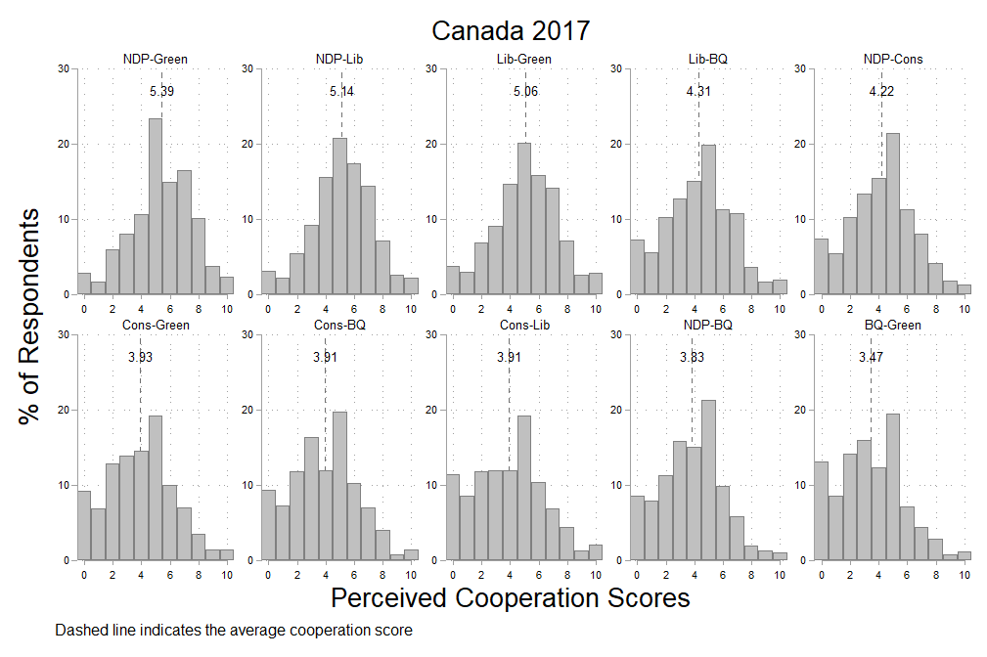
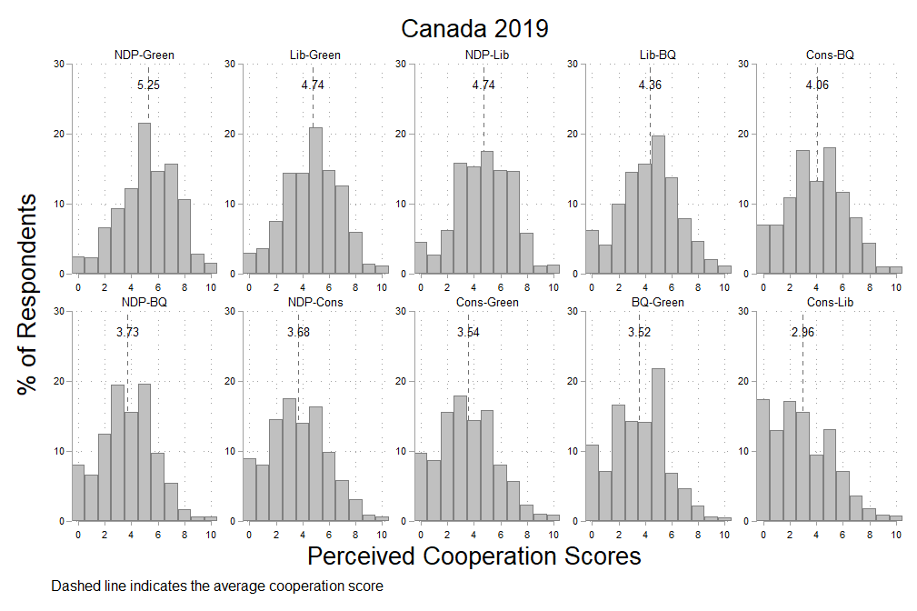

Figure A3.2: Distribution of perceived cooperation among parties in Denmark 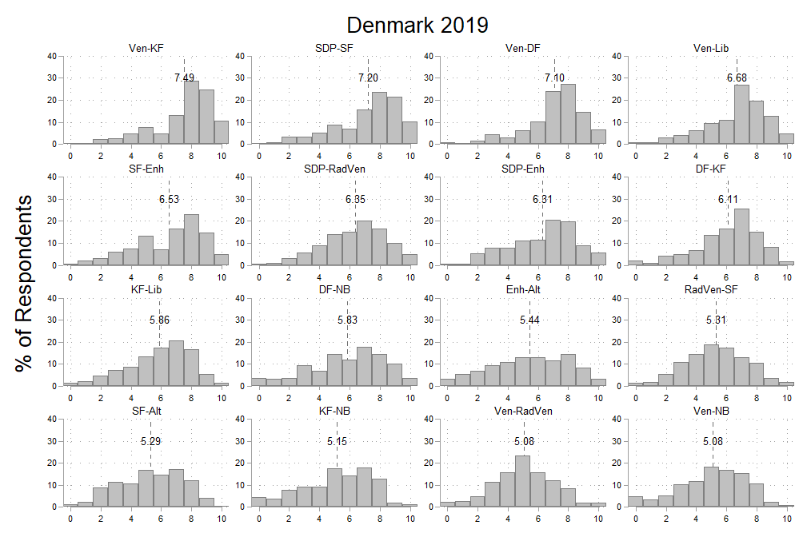 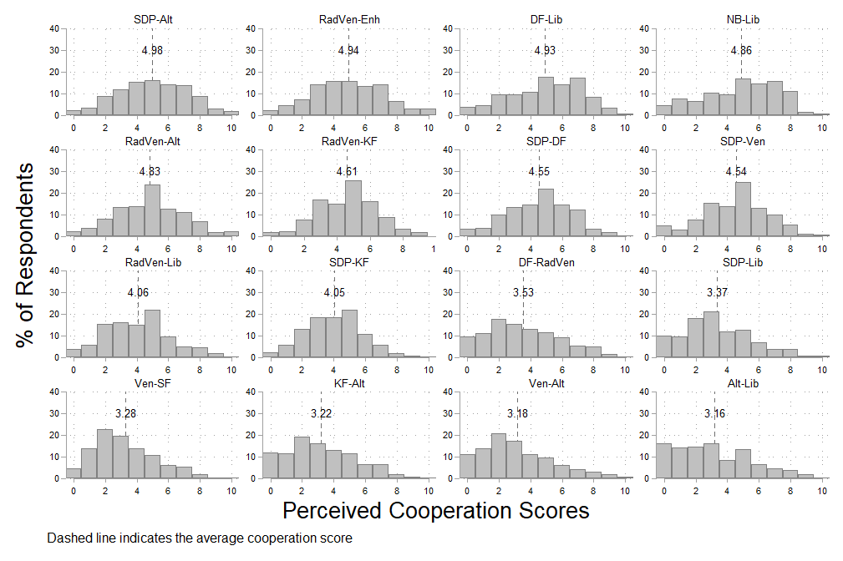
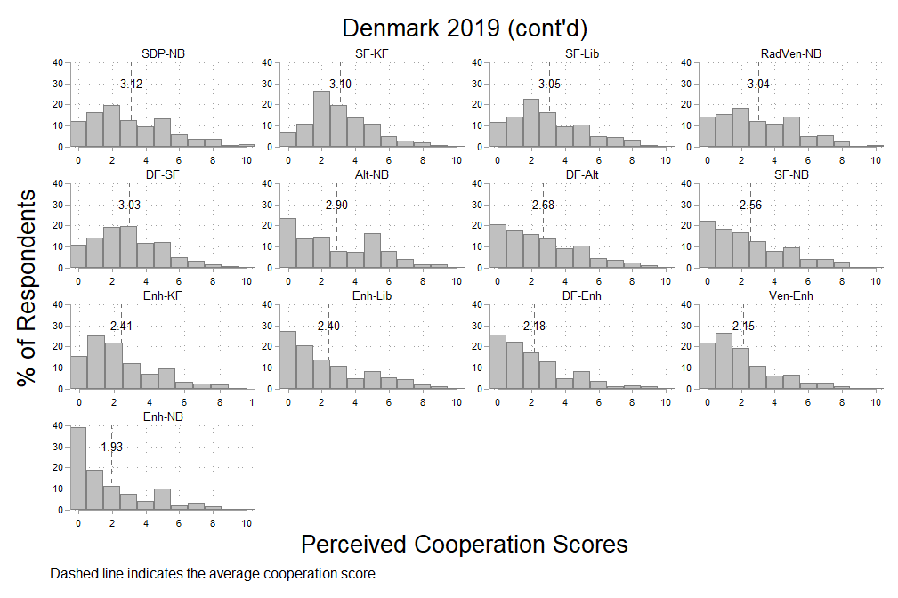

Figure A3.3: Distribution of perceived cooperation among parties in Germany 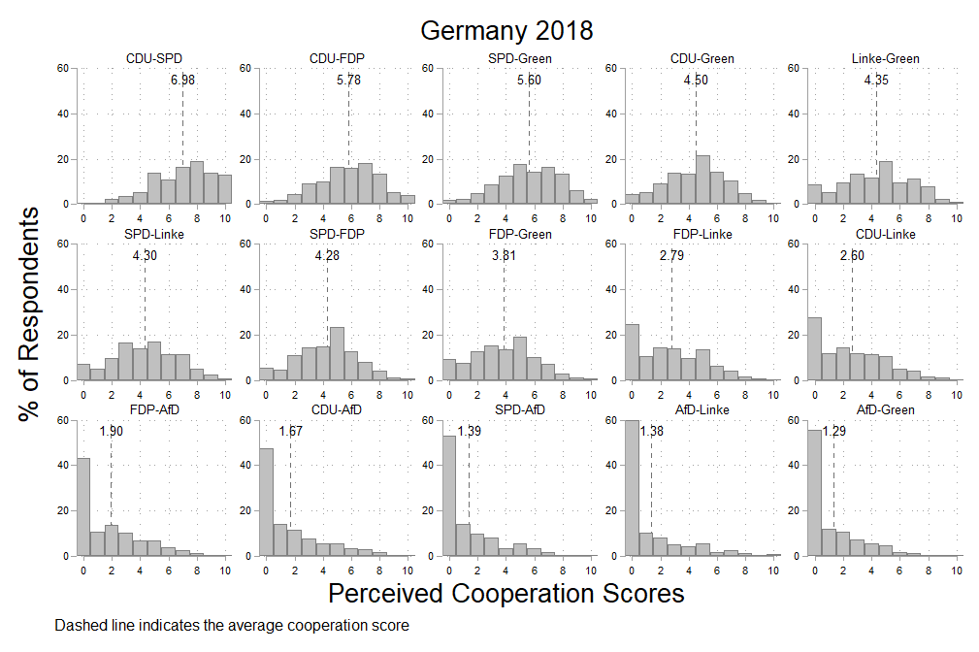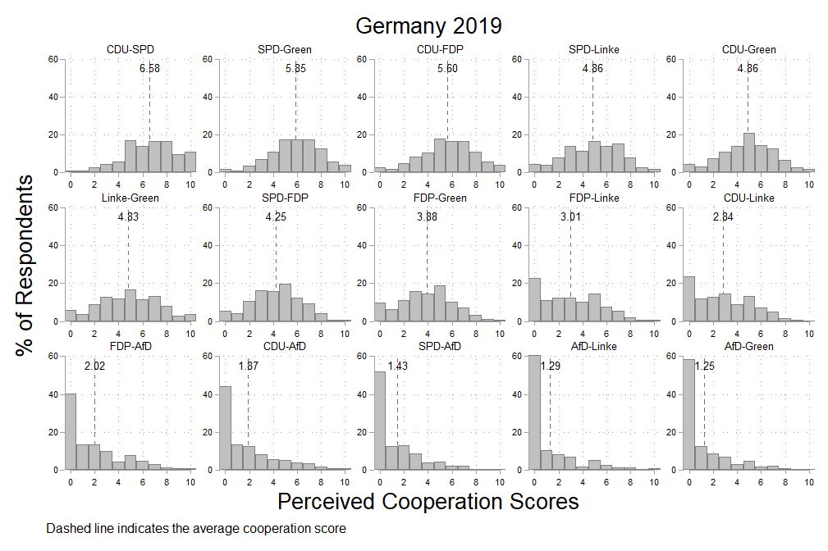
Figure A3.4: Distribution of perceived cooperation among parties in the UK 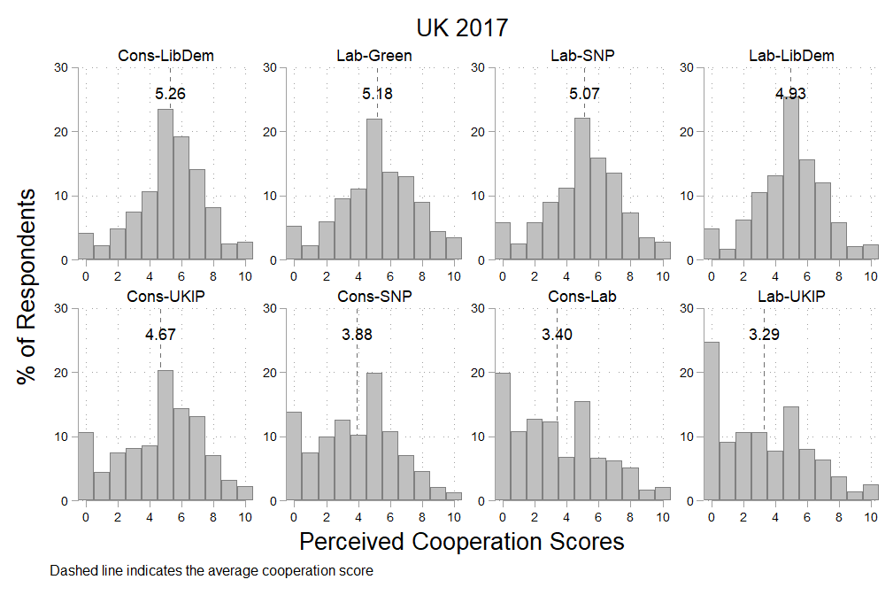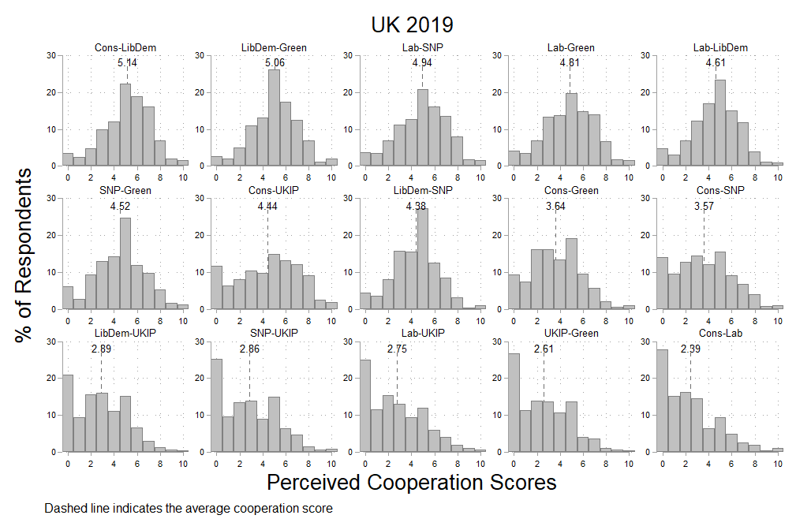
Appendix 4: Brief Explanation of Foundational Models of Attitude Formation
In online processing models, individuals are thought to have an on-line tally about a given concept that is stored in long-term memory (in this case, a feeling about how cooperative or conflictual two parties are). This tally gets updated each time the individual consumes a relevant piece of information (e.g., a relevant news story suggesting cooperation). The direction of the update depends on whether the event is cooperative or conflictual and the size depends on its emotional resonance). Thus, while the details of the event are quickly forgotten, the impact of the event on long-term feelings is preserved in the tally.
In memory-based models, when an individual is asked a survey question about the extent of cooperation between two parties, they give an opinion which is a direct function of any relatively information they have in memory. Thus, the more recent and the more pervasive information about partisan conflict and cooperation, the bigger its impact on perceptions. While the online processing model of perception formation strikes us as a better fit to the kind of perception formation we are describing, it is not at all necessary for us to take a position in the debate between online and memory-based processing since both could motivate our hypothesis (and we have no means to distinguish between them empirically given the structure of our data).
A useful review that combines the insights from both memory-based and online models of attitude formation and change is Taber and Young 2013. “Political Information Processing.” In the Oxford handbook of Political Psychology (2nd edition). Oxford University Press.

Appendix 5: Conditional Effect of Habitual News Reception on Parties’ Policy Profiles and Cabinet Participation

It is likely that individuals who follow the political news are also generally more interested in politics and (according to recent work by, for example, Prior 2019) have been interested in politics most of their lives. This means that these individuals likely learned and retained more information about the parties’ relative policy commitments and traditional patterns of cooperation in cabinet than other citizens – and, more generally, have better developed associative networks surrounding all political phenomena. Thus, we expect that these more politically interested and knowledgeable people will also evidence stronger associations between party ideologies and cabinet participation than their less interested counterparts. And, indeed, this is exactly what we find as shown in Tables A4.1 and A4.2, where we fully interact our empirical models with levels of habitual news reception. Given space constraints, however, we focus in the main text on the relationship most relevant for this paper: the robust connection between real world cooperative and conflictual partisan events and voters perceptions of partisan cooperation and conflict.

Table A5.1: Effect of ideological distance on perceived level of cooperation between parties by levels of habitual news reception
DV: R’s Perceived Level of Cooperation between parties i and j (avg:4.34, sd:2.5) | A | B | C | D | E | F
Events
Cooperative and Conflictual Events relevant to parties i and j over the last year  (avg: 0.048, sd: 0.52) | 0.179  (0.027) | 0.182  (0.027) | 0.178  (0.027) | 0.225  (0.031) | 0.23  (0.03) | 0.221  (0.03)
Habitual News Reception
(Base=Low Habitual News Reception)
Medium Habitual News Reception | -0.196  (0.031) | -0.19  (0.031) | -0.2  (0.031) | -0.26  (0.03) | -0.24  (0.03) | -0.26  (0.03)
High Habitual News Reception | -0.041  (0.031) | -0.012  (0.031) | -0.041  (0.031) | -0.24  (0.03) | -0.19  (0.03) | -0.24  (0.03)
Ideological Distance
Avg. Perceived LR distance between parties i and j on a 0-10 scale (avg: 3.37, sd: 3.63) |  |  |  | -0.235  (0.005) | -0.229  (0.005) | -0.235  (0.005)
Comparative Manifesto Project (RILE) LR distance between parties i and j (avg: 23.7, sd: 16.7) | -0.019  (0.008) | -0.018  (0.008) | -0.014  (0.007)
Ideological Distance*Habitual News Reception
(Base=Low Habitual News Reception)
Avg. Perceived LR distance between parties i and j *Middle Habitual News Reception |  |  |  | -0.025  (0.007) | -0.024  (0.007) | -0.025  (0.007)
Avg. Perceived LR distance between parties i and j *High Habitual News Reception |  |  |  | -0.1  (0.007) | -0.1  (0.007) | -0.096  (0.007)
Manifesto LR Distance between parties i and j *Middle Habitual News Reception | -0.011  (0.001) | -0.01  (0.001) | -0.011  (0.001)
Manifesto LR Distance between parties i and j *High Habitual News Reception | -0.029  (0.001) | -0.028  (0.001) | -0.03  (0.001)
Joint Cabinet Membership
Current Cabinet Membership  (1 = parties i and j in current cabinet) | 2.36  (1.28) |  |  | 1.91  (1.09)
Current Perceived Cabinet Membership  (1 = R identified parties i and j as current cabinet members) |  | 0.67  (0.021) |  |  | 0.614  (0.02)
% Months in previous 10 years that parties i and j have served in cabinet  (avg: 4.25, sd:13.1) |  |  | 0.05  (0.01) |  |  | 0.046  (0.009)
Constant | 5.05 | 4.88 | 4.76 | 5.28 | 5.12 | 5.13
 | (0.24) | (0.236) | (0.23) | (0.121) | (0.117) | (0.11)
Random Intercepts
Party Dyad | 1.6  (0.25) | 1.53  (0.236) | 1.32  (0.2) | 1.18  (0.18) | 1.1  (0.17) | 0.92  (0.14)
Individuals | 0.29  (0.015) | 0.28  (0.015) | 0.29  (0.015) | 0.3  (0.016) | 0.29  (0.015) | 0.3  (0.016)
Residuals | 4.78  (0.021) | 4.73  (0.021) | 4.78  (0.022) | 4.32  (0.021) | 4.28  (0.021) | 4.32  (0.021)

Shaded cells are statistically significant at the .05 level. Standard errors are in parentheses.

Table A5.2: Effect of cabinet participation on perceived level of cooperation between parties by levels of habitual news reception
DV: R’s Perceived Level of Cooperation between parties i and j (avg:4.34, sd:2.5) | A | B | C | D | E | F
Events
Cooperative and Conflictual Events relevant to parties i and j over the last year  (avg: 0.048, sd: 0.52) | 0.176  (0.027) | 0.177  (0.027) | 0.165  (0.027) | 0.222  (0.031) | 0.23  (0.03) | 0.211  (0.031)
Habitual News Reception
(Base=Low Habitual News Reception)
Medium Habitual News Reception | -0.459  (0.019) | -0.5  (0.021) | -0.505  (0.02) | -0.347  (0.02) | -0.385  (0.022) | -0.395  (0.021)
High Habitual News Reception | -0.74  (0.019) | -0.75  (0.021) | -0.817  (0.02) | -0.6  (0.02) | -0.611  (0.022) | -0.674  (0.02)
Ideological Distance
Avg. Perceived LR distance between parties i and j on a 0-10 scale (avg: 3.37, sd: 3.63) |  |  |  | -0.274  (0.003) | -0.267  (0.003) | -0.273  (0.003)
Comparative Manifesto Project (RILE) LR distance between parties i and j (avg: 23.7, sd: 16.7) | -0.034  (0.008) | -0.031  (0.008) | -0.028  (0.007)
Joint Cabinet Membership
Current Cabinet Membership  (1 = parties i and j in current cabinet) | 1.58  (1.28) |  |  | 1.09  (1.11)
Current Perceived Cabinet Membership  (1 = R identified parties i and j as current cabinet members) |  | 0.41  (0.032) |  |  | 0.367  (0.032)
% Months in previous 10 years that parties i and j have served in cabinet  (avg: 4.25, sd:13.1) |  |  | 0.035  (0.011) |  |  | 0.033  (0.009)
Joint Cabinet Membership*Habitual News Reception (Base=Low Habitual News Reception)
Current Cabinet Membership  *Middle Habitual News Reception | 0.776  (0.133) |  |  | 0.793  (0.128)
Current Cabinet Membership  *High Habitual News Reception | 1.22  (0.127) |  |  | 1.31  (0.121)
Current Perceived Cabinet Membership *Middle Habitual News Reception |  | 0.397  (0.045) |  |  | 0.333  (0.044)
Current Perceived Cabinet Membership *High Habitual News Reception |  | 0.559  (0.048) |  |  | 0.495  (0.047)
% Months in previous 10 years that parties i and j have served in cabinet*Middle Habitual News Reception |  |  | 0.015  (0.001) |  |  | 0.014  (0.001)
% Months in previous 10 years that parties i and j have served in cabinet*High Habitual News Reception |  |  | 0.026  (0.001) |  |  | 0.024  (0.001)
Constant | 5.4 | 5.24 | 5.14 | 5.42 | 5.31 | 5.3
 | (0.24) | (0.234) | (0.229) | (0.122) | (0.117) | (0.11)
Random Intercepts
Party Dyad | 1.6  (0.25) | 1.51  (0.232) | 1.32  (0.2) | 1.22  (0.188) | 1.11  (0.17) | 0.95  (0.147)
Individuals | 0.29  (0.015) | 0.28  (0.014) | 0.29  (0.015) | 0.3  (0.016) | 0.28  (0.015) | 0.3  (0.016)
Residuals | 4.81  (0.021) | 4.76  (0.022) | 4.8  (0.022) | 4.32  (0.021) | 4.28  (0.021) | 4.31  (0.021)

Shaded cells are statistically significant at the .05 level. Standard errors are in parentheses.

Appendix 6: Measurement Details
Cooperative and Conflictual Events in Media Reports
We start with the ICEWS event data (Boschee et al., 2015), which we modify in two ways. First, each actor is classified as partisan-political, nonpartisan-political, or societal; and all politicians from the same party are aggregated into a single partisan actor. Second, we dichotomize the event types (coded using the CAMEO scheme) into cooperative and conflictual. Below, we list all CAMEO event codes that are cooperative and conflictual. Note that many codes are irrelevant for domestic interactions in the countries we study, and do not show up in the data. However, we list them for the sake of completeness.

The QPR scores we use are based on all domestic events reported in the ICEWS data in the 12 months prior to the first day that a survey was in the field. Suppose these events involve a total of n actors, which includes political parties as well as other socio-political actors. The number of cooperative interactions between two actors i and j is denoted by $m_{ij}^{+},$and the number of conflictual interactions by $m_{ij}^{-}$. The set of all interactions is summarized in an $n ×n$ sociomatrix $Y$, where each entry $y_{ij}$ summarizes the direct dyadic interactions between i and j as follows: $y_{ij}=\ln\left(\frac{m_{ij}^{+}+1}{m_{ij}^{-}+1}\right)$. Interactions are treated as symmetric, so $y_{ij}=y_{ji}$.

We then estimate the following latent factor model on $Y$, with the idea that each actor can be represented through an unobserved, one-dimensional vector of characteristics $u_{i}$:
$$y_{ij}=α+a_{i}+a_{j}+ϵ_{ij}+u_{i}' Λ u_{j}$$
$$a_{1},…,a_{n}∼\text{i.i.d. }N\left(0,σ_{a}^{2}\right)$$
$$\{ϵ_{ij}\}∼\text{i.i.d. }N\left(0,σ_{e}^{2}\right)$$
where $α$ is the intercept, $a_{i}$ and $a_{j}$ are random effects that capture overall differences in the tone of interactions by actors i and j; $ϵ_{ij}$ is a random effects term that captures the correlation of actions between a dyadic pair of actors; and the remaining variance in $y_{ij}$ is absorbed by the multiplicative effects term $u_{i}' Λ u_{j}$. The terms in $u_{i}' Λ u_{j}$ are estimated using an eigenvalue decomposition (see Hoff 2005, 2015; Weschle 2018; Minhas et al. 2019). They capture latent nodal characteristics and thus summarize the nature of the direct and indirect public interactions involving i and j. We use the subset of scores that involve two political parties as our measures of public cooperation and conflict.

Cooperative Event Codes:
- Make optimistic comment
- Engage in symbolic act
- Make empathetic comment
- Express accord
- Make an appeal or request, not specified below
- Appeal for material cooperation, not specified below
- Appeal for economic cooperation
- Appeal for military cooperation
- Appeal for judicial cooperation
- Appeal for intelligence
- Appeal for diplomatic cooperation (such as policy support)
- Appeal for aid, not specified below
- Appeal for economic aid
- Appeal for military aid
- Appeal for humanitarian aid
- Appeal for military protection or peacekeeping
- Appeal to others to meet or negotiate
- Appeal to others to settle dispute
- Appeal to engage in or accept mediation
- Express intent to cooperate, not specified below
- Express intent to engage in material cooperation, not specified below
- Express intent to cooperate economically
- Express intent to cooperate militarily
- Express intent to cooperate on judicial matters
- Express intent to cooperate on intelligence
- Express intent to engage in diplomatic cooperation (such as policy support)
- Express intent to provide material aid, not specified below
- Express intent to provide economic aid
- Express intent to provide military aid
- Express intent to provide humanitarian aid
- Express intent to provide military protection or peacekeeping
- Express intent to institute political reform, not specified below
- Express intent to change leadership
- Express intent to change policy
- Express intent to provide rights
- Express intent to change institutions, regime
- Express intent to yield, not specified below
- Express intent to ease administrative sanctions
- Express intent to ease popular dissent
- Express intent to release persons or property
- Express intent to ease economic sanctions, boycott, or embargo
- Express intent to allow international involvement (non-mediation)
- Express intent to de-escalate military engagement
- Express intent to meet or negotiate
- Express intent to settle dispute
- Express intent to accept mediation
- Express intent to mediate
- Consult, not specified below
- Discuss by telephone
- Make a visit
- Host a visit
- Meet at a ``third'' location
- Mediate
- Engage in negotiation
- Engage in diplomatic cooperation, not specified below
- Praise or endorse
- Defend verbally
- Rally support on behalf of
- Grant diplomatic recognition
- Apologize
- Forgive
- Sign formal agreement
- Engage in material cooperation, not specified below
- Cooperate economically
- Cooperate militarily
- Engage in judicial cooperation
- Share intelligence or information
- Provide aid, not specified below
- Provide economic aid
- Provide military aid
- Provide humanitarian aid
- Provide military protection or peacekeeping
- Grant asylum
- Yield, not specified below
- Ease administrative sanctions, not specified below
- Ease restrictions on political freedoms
- Ease ban on political parties or politicians
- Ease curfew
- Ease state of emergency or martial law
- Ease political dissent
- Accede to requests or demands for political reform, not specified below
- Accede to demands for change in leadership
- Accede to demands for change in policy
- Accede to demands for rights
- Accede to demands for change in institutions, regime
- Return, release, not specified below
- Return, release person(s)
- Return, release property
- Ease economic sanctions, boycott, embargo
- Allow international involvement, not specified below
- Receive deployment of peacekeepers
- Receive inspectors
- Allow humanitarian access
- De-escalate military engagement
- Declare truce, ceasefire
- Ease military blockade
- Demobilize armed forces
- Retreat or surrender militarily

Conflictual Event Codes:
- Decline comment
- Make pessimistic comment
- Deny responsibility
- Appeal for political reform, not specified below
- Appeal for change in leadership
- Appeal for policy change
- Appeal for rights
- Appeal for change in institutions, regime
- Appeal to yield, not specified below
- Appeal for easing of administrative sanctions
- Appeal for easing of political dissent
- Appeal for release of persons or property
- Appeal for easing of economic sanctions, boycott, or embargo
- Appeal for target to allow international involvement (non-mediation)
- Appeal for de-escalation of military engagement
- Investigate, not specified below
- Investigate crime, corruption
- Investigate human rights abuses
- Investigate military action
- Investigate war crimes
- Demand, not specified below
- Demand material cooperation, not specified below
- Demand economic cooperation
- Demand military cooperation
- Demand judicial cooperation
- Demand intelligence cooperation
- Demand diplomatic cooperation (such as policy support)
- Demand material aid, not specified below
- Demand economic aid
- Demand military aid
- Demand humanitarian aid
- Demand military protection or peacekeeping
- Demand political reform, not specified below
- Demand change in leadership
- Demand policy change
- Demand rights
- Demand change in institutions, regime
- Demand that target yields, not specified below
- Demand easing of administrative sanctions
- Demand easing of political dissent
- Demand release of persons or property
- Demand easing of economic sanctions, boycott, or embargo
- Demand that target allows international involvement (non-mediation)
- Demand de-escalation of military engagement
- Demand meeting, negotiation
- Demand settling of dispute
- Demand mediation
- Disapprove, not specified below
- Criticize or denounce
- Accuse, not specified below
- Accuse of crime, corruption
- Accuse of human rights abuses
- Accuse of aggression
- Accuse of war crimes
- Accuse of espionage, treason
- Rally opposition against
- Complain officially
- Bring lawsuit against
- Find guilty or liable (legally)
- Reject, not specified below
- Reject material cooperation
- Reject economic cooperation
- Reject military cooperation
- Reject request or demand for material aid, not specified below
- Reject request for economic aid
- Reject request for military aid
- Reject request for humanitarian aid
- Reject request for military protection or peacekeeping
- Reject request or demand for political reform, not specified below
- Reject request for change in leadership
- Reject request for policy change
- Reject request for rights
- Reject request for change in institutions, regime
- Refuse to yield, not specified below
- Refuse to ease administrative sanctions
- Refuse to ease popular dissent
- Refuse to release persons or property
- Refuse to ease economic sanctions, boycott, or embargo
- Refuse to allow international involvement (non mediation)
- Refuse to de-escalate military engagement
- Reject proposal to meet, discuss, or negotiate
- Reject mediation
- Reject plan, agreement to settle dispute
- Defy norms, law
- Veto
- Threaten, not specified below
- Threaten non-force, not specified below
- Threaten to reduce or stop aid
- Threaten with sanctions, boycott, embargo
- Threaten to reduce or break relations
- Threaten with administrative sanctions, not specified below
- Threaten with restrictions on political freedoms
- Threaten to ban political parties or politicians
- Threaten to impose curfew
- Threaten to impose state of emergency or martial law
- Threaten with political dissent, protest
- Threaten to halt negotiations
- Threaten to halt mediation
- Threaten to halt international involvement (non-mediation)
- Threaten with repression
- Threaten with military force, not specified below
- Threaten blockade
- Threaten occupation
- Threaten unconventional violence
- Threaten conventional attack
- Threaten attack with WMD
- Give ultimatum
- Engage in political dissent, not specified below
- Demonstrate or rally, not specified below
- Demonstrate for leadership change
- Demonstrate for policy change
- Demonstrate for rights
- Demonstrate for change in institutions, regime
- Conduct hunger strike, not specified below
- Conduct hunger strike for leadership change
- Conduct hunger strike for policy change
- Conduct hunger strike for rights
- Conduct hunger strike for change in institutions, regime
- Conduct strike or boycott, not specified below
- Conduct strike or boycott for leadership change
- Conduct strike or boycott for policy change
- Conduct strike or boycott for rights
- Conduct strike or boycott for change in institutions, regime
- Obstruct passage, block, not specified below
- Obstruct passage to demand leadership change
- Obstruct passage to demand policy change
- Obstruct passage to demand rights
- Obstruct passage to demand change in institutions, regime
- Protest violently, riot, not specified below
- Engage in violent protest for leadership change
- Engage in violent protest for policy change
- Engage in violent protest for rights
- Engage in violent protest for change in institutions, regime
- Demonstrate military or police power, not specified below
- Increase police alert status
- Increase military alert status
- Mobilize or increase police power
- Mobilize or increase armed forces
- Mobilize or increase cyber-forces
- Reduce relations, not specified below
- Reduce or break diplomatic relations
- Reduce or stop material aid, not specified below
- Reduce or stop economic assistance
- Reduce or stop military assistance
- Reduce or stop humanitarian assistance
- Impose embargo, boycott, or sanctions
- Halt negotiations
- Halt mediation
- Expel or withdraw, not specified below
- Expel or withdraw peacekeepers
- Expel or withdraw inspectors, observers
- Expel or withdraw aid agencies
- Coerce, not specified below
- Seize or damage property, not specified below
- Confiscate property
- Destroy property
- Impose administrative sanctions, not specified below
- Impose restrictions on political freedoms
- Ban political parties or politicians
- Impose curfew
- Impose state of emergency or martial law
- Arrest, detain, or charge with legal action
- Expel or deport individuals
- Use tactics of violent repression
- Attack cybernetically
- Use unconventional violence, not specified below
- Abduct, hijack, or take hostage
- Physically assault, not specified below
- Sexually assault
- Torture
- Kill by physical assault
- Conduct suicide, car, or other non-military bombing, not specified below
- Carry out suicide bombing
- Carry out vehicular bombing
- Carry out roadside bombing
- Carry out location bombing
- Use as human shield
- Attempt to assassinate
- Assassinate
- Use conventional military force, not specified below
- Impose blockade, restrict movement
- Occupy territory
- Fight with small arms and light weapons
- Fight with artillery and tanks
- Employ aerial weapons, not specified below
- Employ precision-guided aerial munitions
- Employ remotely piloted aerial munitions
- Violate ceasefire
- Use unconventional mass violence, not specified below
- Engage in mass expulsion
- Engage in mass killings
- Engage in ethnic cleansing
- Use weapons of mass destruction, not specified below
- Use chemical, biological, or radiological weapons
- Detonate nuclear weapons

Objective differences in party policy positions:
To compute the objective differences in policy positions between any two parties, we rely on the Comparative Manifesto Project (CMP) and calculate the absolute value of the difference in their positions on the left-right scale (RILE score) using the CMP data from the election most proximate to the survey.
Subjective difference in parties’ policy positions:
We utilize a question from our seven original surveys to measure parties’ policy positions, which is then used to measure the differences between any two parties in each context. In each survey, respondents were asked to place 5 to 6 parties on a left-right scale. Specifically, they were asked the following question:
“In politics, people sometimes talk of “Left” and “Right”. Using the scale from 0 to 10, where would you place yourself and political parties listed below? Even if you are not completely sure, please give us your best guess.”
We simply measure the subjective difference in parties’ policy positions for a pair of party as the absolute difference in the answer respondents give to this question for the two parties in the dyad.
Objective measure of joint governance:
We create a dummy variable indicating whether the parties in each dyad were both in the cabinet at the time of the survey.
Subjective measure of joint governance:
Our measure of perceived joint cabinet membership is based on a survey question that asked respondents the role that each party in their respective context played in or out of cabinet at the time of our survey. The question asks:
“Please choose the option which best describes each party’s role in the current government.”
The respondents were then asked to choose whether the party holds the Prime Ministry position, holds a position in the cabinet but not the party of the Prime Minister, supports the cabinet (only in Denmark), is an opposition, or do not hold any seats in the parliament. We then create a dichotomous variable where we code the variable as “1” if a pair of party are both in the cabinet and “0” otherwise.
Historical measures of cooperation in cabinet
We measure this concept by calculating the percentage of months in the 10, 20, and 30 years before our survey, that the two parties in the dyad were in the same cabinet.
Habitual News Reception
We measure three levels of habitual news reception (low, medium, and high) based on our respondents’ number of correct answers to factual questions. We divide the respondents to three groups based on their answers to three general political knowledge questions and three current events questions (where we use an additive scale to produce a score). The three general political knowledge questions ask the name of the country’s Finance minister, current unemployment rate, and the name of foreign country’s important political figure (e.g., In the UK survey, we asked the name of the current leader of Germany’s SPD; the current leader of the UK’s Labour Party in Canadian and German surveys; the current Prime Minister of Sweden in our Danish survey). Meanwhile, for the current event questions, we simply look for international or domestic events that are covered by the country’s main media outlets at the time of the survey. The questions were chosen to include events that were very widely reported, less widely reported, and narrowly reported to get good discrimination across the scale. Below is the list of current event questions used in our surveys:

Canada 2017
- Quite recently (in November 2017) Prime Minister Justin Trudeau took a foreign trip to meet other world leaders. To which region of the world did he travel?
- Who is Canada’s new Governor General?
- On November 28th, Prime Minister Justin Trudeau will give a speech apologizing for the historical mistreatment of which group?
Canada 2019
- In which country did Donald Trump and Kim Jong Un meet during their summit in February 2019?
- Which two countries engaged in military conflicts over territorial disputes in late February 2019?
- Which former Canadian Minister of Justice accuses the Liberal government of intervening in an independent criminal prosecution of SNC-Lavalin?
Denmark 2019
- From which middle east country did President Trump recently order US troops to withdraw?
- Who is the new leader of Christian Democrats?
- The Danish government has recently notified the European Commission of its plan to reintroduce temporary checks along its border with Sweden. For how long would the temporary boarder checks be in place?
Germany 2018
- Who did Angela Merkel appoint to be the secretary general of CDU?
- Which country has denied entry to Lutz Bachmann, the founder of the German far-right group Pegida?
- Which German mayor has called for a basic income benefit for people who are unemployed?
Germany 2019
- Who is the current (new) leader of CDU?
- Who is the new prime minister of the UK?
- Who is the German politician who was elected to be the President of the European Commission in July 2019?
UK 2017
- In which country of the union is a minimum price for alcohol going to be introduced?
- Which politician has recently been accused of sexual harassment?
- Which city has the European Union chosen to replace London as the home of the European Banking Authority?
UK 2019
- Who is the former Nissan chairman who was arrested for financial misconduct?
- Which country recently granted asylum to a Saudi teenager, Rahaf Mohammed al-Qunun, who fled her family for fear of violence?
- In mid-January 2019, Prime Minister May’s proposed Brexit deal was rejected in the parliament. By about how many votes was the proposed deal rejected?
All questions (except for current unemployment rate) are multiple choice with four response options. Don’t Know option is not offered, but instead we encouraged respondents to make their best possible guess. That said, we use different criteria (i.e., number of correct answers) depending on the country to make three almost-equal sized groups based on the distribution of the political knowledge score. The distribution of the low, medium, and high level of habitual news reception groups across countries over time is in the table below.

Table A6.1: Distribution of levels of habitual news reception
Country | Year | Level of habitual news reception | Number of correct answers (out of 6) | Proportion
Canada | 2017 | Low | 0-2 | 35.5%
 |  | Medium | 3-4 | 34.25%
 |  | High | 5-6 | 30.25%
 | 2019 | Low | 0-2 | 30.9%
 |  | Medium | 3-4 | 35.9%
 |  | High | 5-6 | 33.2%
Denmark | 2017 | Low | 0-3 | 34%
 |  | Medium | 4 | 23.4%
 |  | High | 5-6 | 42.6%
Germany | 2018 | Low | 0-1 | 22.8%
 |  | Medium | 2-3 | 38.9%
 |  | High | 4-6 | 33.3%
 | 2019 | Low | 0-2 | 23.7%
 |  | Medium | 3-4 | 28.8%
 |  | High | 5-6 | 47.5%
UK | 2017 | Low | 0-2 | 35.7%
 |  | Medium | 3-4 | 43.2%
 |  | High | 5-6 | 21.1%
 | 2019 | Low | 0-1 | 27.7%
 |  | Medium | 2-3 | 44.5%
 |  | High | 4-6 | 27.7%

6.1: Alternative Measure of Habitual News Reception
To check the robustness of our findings in Models G to L of Table 1 in the main text, we re-construct our measures of habitual news reception using only the three current event questions. We categorized those that do not answer any of the questions correctly and answer only one question correctly as having low levels of habitual news reception, those that answer two questions correctly as the medium habitual news reception group, and those that answer all the three questions correctly as the high habitual news reception group. Table A5.2 replicates the findings of Models G to L of Table in the main text using this alternate construction. Clearly, using this measure do not change our substantive conclusion that the effect of conflictual and cooperative events between parties as reported in the news will be larger for respondents with increasingly higher levels of habitual news reception.

Table A6.2: Drivers of perceptions of partisan conflict and cooperation by habitual news reception (using only current event questions as a measure of habitual news reception)
DV: R’s Perceived Level of Cooperation between parties i and j (avg:4.34, sd:2.5) | G | H | I | J | K | L
Events
Cooperative and Conflictual Events relevant to parties i and j over the last year (avg: 0.048, sd: 0.52) | 0.119  (0.032) | 0.129  (0.031) | 0.116 (0.032) | 0.152  (0.036) | 0.163  (0.035) | 0.147  (0.035)
Habitual News Reception
(Base=Low Habitual News Reception)
Medium Habitual News Reception | -0.362  (0.022) | -0.338  (0.022) | -0.362  (0.022) | -0.257  (0.023) | -0.234  (0.023) | -0.257  (0.023)
High Habitual News Reception | -0.512  (0.023) | -0.465  (0.023) | -0.512  (0.023) | -0.371  (0.024) | -0.326  (0.024) | -0.371  (0.024)
Coop/Conf Events Score*Habitual News Reception (Base=Low Habitual News Reception)
Coop/Conf Events Score*Medium Habitual News Reception | 0.081  (0.037) | 0.072  (0.037) | 0.08  (0.037) | 0.088  (0.036) | 0.082  (0.036) | 0.088  (0.036)
Coop/Conf Events Score*High Habitual News Reception | 0.206  (0.04) | 0.176  (0.04) | 0.206  (0.04) | 0.216  (0.038) | 0.19  (0.038) | 0.215  (0.038)
Ideological Distance
Avg. Perceived LR distance between parties i and j on a 0-10 scale (avg: 3.37, sd: 3.63) |  |  |  | -0.255  (0.004) | -0.25  (0.004) | -0.255  (0.004)
Comparative Manifesto Project (RILE) LR distance between parties i and j (avg: 23.7, sd: 16.7) | -0.035  (0.01) | -0.034  (0.01) | -0.03  (0.007)
Joint Cabinet Membership
Current Cabinet Membership  (1 = parties i and j in current cabinet) | 2.08  (0.938) |  |  | 1.67  (0.916)
Current Perceived Cabinet Membership  (1 = R identified parties i and j as current cabinet members) |  | 0.61  (0.025) |  |  | 0.573  (0.025)
% Months in previous 10 years that parties i and j have served in cabinet  (avg: 4.25, sd:13.1) |  |  | 0.044  (0.007) |  |  | 0.041  (0.007)
Constant | 5.46 | 5.35 | 5.08 | 5.41 | 5.31 | 5.17
 | (0.249) | (0.254) | (0.192) | (0.147) | (0.145) | (0.119)
Random Intercepts
Party Dyad | 0.851  (0.192) | 0.889  (0.201) | 0.453  (0.102) | 0.812  (0.183) | 0.816  (0.184) | 0.449  (0.102)
Individuals | 0.376  (0.02) | 0.362  (0.02) | 0.376  (0.02) | 0.355  (0.02) | 0.344  (0.02) | 0.355  (0.02)
Residuals | 4.89  (0.027) | 4.85  (0.027) | 4.89  (0.027) | 4.46  (0.027) | 4.43  (0.027) | 4.46  (0.027)

Shaded cells are statistically significant at the .05 level. Standard errors are in parentheses.

Appendix 7: Details of the Bootstrap Procedure
We account for the uncertainty in the events data by randomly sampling 500 different event scores (with replacement) for a given pair of parties from a normal distribution that is centered on the average cooperation score with the relevant standard deviation. We also incorporate uncertainty in the party’s RILE score using the method developed by Benoit, Laver, and Mikhaylov (2009). For each party, we sample a simulated RILE score from a normal distribution with a given mean and standard deviation. We then calculate the absolute difference in the simulated RILE score for a given pair of parties to get a simulated value of the distance variable. We repeat this sampling procedure 500 times.
Once we have 500 different simulated values for events score and ideological distance based on the manifesto, we could now run the regression with bootstrap. Below are the steps that we take to obtain the bootstrapped coefficients and standard errors as reported in Tables 1 and 2 of the main text:
- Sample the events score and difference in the RILE score 500 times.
- Fit a regression model that include crossed random intercepts for respondent and dyad to each sample.
- Store the 500 coefficients and the standard errors
- Calculate the average of the 500 coefficients to get the bootstrapped coefficient
- For each of the 500 regressions, draw 500 coefficients from a normal distribution where the mean is the estimated coefficient, and the standard deviation is the standard error.
- Calculate the standard deviation of the 250,000 simulated coefficients to obtain the bootstrapped standard errors of the coefficients.

Prior, Markus. 2019. Hooked: How politics captures people’s interest. Cambridge, UK: Cambridge University Press.
Boschee, Elizabeth, Jennifer Lautenschlager, Sean O'Brien, Steve Shellman, James Starz, and Michael Ward. 2015. “ICEWS Coded Event Data. " https://doi.org/10.7910/DVN/28075.
Hoff, Peter D. 2005. “Bilinear Mixed Effects Models for Dyadic Data.” Journal of the American Statistical Association 100 (469): 286–95. Hoff, Peter D. 2015. “Dyadic Data Analysis with amen.” http://arxiv.org/abs/1506.08237.
Weschle, Simon. 2018. “Quantifying Political Relationships.” American Political Science Review 112(4): 1090-1095.
Minhas, Shahrya, Peter D. Hoff, and Michael Ward. 2019. Inferential Approaches for Network Analysis: AMEN for Latent Factor Models. Political Analysis, 27(2), 208-222.
Respondents in Canada were required to place 5 parties, while respondents in Denmark, Germany, and the UK were required to place 6 parties.
Since our theoretical concept is quite directly about paying attention to the news, we prefer this measure to more general measures like the respondent’s reported level of interest in politics.
Benoit, Kenneth., Laver, Michael., & Mikhaylov, Slava. 2009. “Treating Words as Data with Error: Uncertainty in Text Statements of Policy Positions.” American Journal of Political Science, 53(2), 495–513.

