Trade Politics at the Checkout Lane: Online Appendix

Table of Contents

Consent Form
Table A1 – Demographics of Bovitz Sample and Comparison Sample from the 2019 Cooperative Congressional Election Study
Ethnocentrism Scale Empirical Validation
Table A2 – Demographic Comparison of Wave 1 and Wave 2 Survey Completes
Conjoint Design Justification
Figure A1 – Example choice task
Table A3 – Product Categories Used in Conjoint Tasks
Figure A2 – Testing for product effects: Marginal Mean Probability of Selection by Experimental Attribute and Product Type
Figure A3 – Testing for order effects: Plot of Conjoint Attribute AMCE by Respondent Task Number
Figure A4 – Main Results Sub-Set by Product Type
Table A4 – Results Used in Main Paper and for Robustness Checks
Marginal Willingness to Pay Calculations
Figure A5 – Disaggregated Marginal Willingness to Pay Estimates
Pre-Registration for Conceptual Replication
Figure A6 – Results: Conceptual Replication
Figure A7 – MWTP estimates from conditional logit
Table A5 – MWTP Estimates by Respondent Education Level and Product Country of Origin
Table A6 – Country Feeling Thermometer Ratings (Wave 1)
Table A7 – Alternative Measures of Ethnocentrism
Table A8 – MWTP Estimates with Alternative Measures of Ethnocentrism

Consent Form
The following consent form was administered to potential participants before they began our survey.

Consent Form
American Politics Survey
You are invited to be in a research study of people’s beliefs about politics. Choosing to move on and complete the survey constitutes your consent to participate in this study. This study is being conducted by: [Information redacted for anonymous review].
Background Information
The purpose of this study is to learn what people think about American politics. You will have an opportunity to complete this survey as well as one follow-up survey, roughly 1 month apart.
Procedures
If you agree to be in this study, we would ask you to do the following things: proceed to the next page, answer the questions in the survey, and complete any tasks asked of you. It will take approximately 5 minutes to complete the study.
Risks and Benefits of Being in the Study
The study has no specific risks or benefits to you personally. Your participation will contribute to a better understanding of politics.
Compensation
If you choose to participate in this study, you will receive compensation according to the terms provided by Forthright/Bovitz Inc.
Confidentiality
The study is confidential and does not include questions that will allow us (or anybody else) to identify who you are. The records of this study will be kept private and will be stored securely. Other researchers may be granted access to the records in the future.
Internet Research
This research involves the transmission of data over the Internet. Every reasonable effort has been taken to ensure the effective use of available technology; however, confidentiality during online communication cannot be guaranteed
Voluntary Nature of the Study
Participation in this study is voluntary and you are free to withdraw at any time.
Contacts and Questions
The researcher conducting this study is: [Information redacted for anonymous review]. If you have questions later, you are encouraged to contact [Information redacted for anonymous review]. If you have any complaints or questions about your rights as a research volunteer, contact the [Information redacted for anonymous review] IRB at [Information redacted for anonymous review] or by email at [Information redacted for anonymous review].
Sample Demographics
Table A1 – Demographics of Bovitz Sample, Lucid Replication Sample, and Comparison Sample from the 2019 Cooperative Congressional Election Study.

Demographic variable | Bovitz Sample (N=996)  Primary Study | Lucid Sample (N = 1,025)  Replication | 2019 Cooperative Congressional  Election Survey (N=18,000, Weighted) Comparison
Gender
Male | 493 (49.50%) | 511 (49.85%) | 48.46%
Female | 498 (50.00%) | 512 (49.95%) | 51.54%
Other | 5 (0.50%) | 2 (0.20%) | -
Income
Less than $30,000 | 280 (28.11%) | 321 (31.32%) | 29.7%
Between $30,000 and $59,000 | 282 (28.31%) | 271 (26.44%) | 29.51%
Between $60,000 and $120,000 | 271 (27.21%) | 267 (26.05%) | 29.17%
More than $120,000 | 163 (16.37%) | 166 (16.20%) | 11.63%
Age
18–29 | 190 (19.08%) | 200 (19.51%) | 21.11%
30–39 | 212 (21.29%) | 226 (22.05%) | 16.32%
40–49 | 194 (19.48%) | 178 (17.37%) | 12.96%
50–59 | 193 (19.38%) | 145 (14.15%) | 16.89%
60–69 | 143 (14.36%) | 170 (16.59%) | 19.46%
70+ | 64 (6.43%) | 106 (10.34%) | 13.26%
Party ID (Leaners coded as partisan)
Democratic | 439 (44.08%) | 489 (47.71%) | 43.6%
Republican | 241 (24.20%) | 252 (24.59%) | 35.87%
Independent | 268 (26.91%) | 238 (23.22%) | 16.08%
Other/DK | 48 (4.82%) | 21 (2.05%) | 4.44%
Education
Less than high school | 25 (2.51%) | 26 (2.54%) | 9.14%
High school graduate | 210 (21.08%) | 228 (22.24%) | 28.6%
Some college | 226 (22.69%) | 219 (21.37%) | 20.72%
2-year degree | 113 (11.35%) | 111 (10.83%) | 11.06%
4-year degree | 286 (28.71%) | 244 (23.80%) | 19.24%
Post-Grad | 136 (13.65%) | 197 (19.22%) | 11.23%

Note – The percentages from the CCES were calculated using the common content data and the provided survey weight.

Ethnocentrism Scale
The original scale included six items, 1) “People in other cultures could learn a lot from people in my culture”, 2) “Lifestyles in other cultures are not as valid as those in my culture”, and 3) “Other cultures are smart to look up to my culture”, 4) “My culture is a poor role model for other cultures”, 5) “Most people in my culture just don't know what is good for them”, and 6) “I respect the values and customs of other cultures”. Kinder and Kam (2007) use the difference between the mean for positive-negative characteristics attributed to the racial or ethnic in-group and the same characteristics attributed to two out-groups. Since we are interested in the cultural components of ethnocentrism, we chose to rely on the empirically validated scale by Neuliep and McCroskey (1997).
A factor analysis revealed that items 1-4 loaded positively on a single dimension, which we combine to create our ethnocentrism scale. This scale forms a reliable instrument, with a Crombach’s Alpha of .60. The final variable is coded to run from 0-1, with a mean of .52 and standard deviation of .19.

Panel Completion Comparison
This table displays the attributes of respondents who only completed Wave 1 of our survey compared to those who completed Waves 1 and 2. The ethnocentrism score reported is the scaled to run from 0 to 1, with higher values corresponding to greater levels of ethnocentrism.

Table A2 – Demographic Comparison of Wave 1 and Wave 2 Survey Completes

Variable | Wave 1 Only (N=1,539) | Full Panel (N=996)
Party ID
% Democrat | 52.7 | 54.6
% Independent | 14.3 | 12.9
% Republican | 33.0 | 32.5
Demographics
% College or more | 38.2 | 42.4
% Female | 50.7 | 50.0
% White | 66.1 | 66.2
Ethnocentrism | Mean = .522, SD = .192 | Mean = .525, SD = .191

Justification of Conjoint Design
There are several strengths that come with relying on a conjoint experimental design like this. First, we have the strength of an experimental design, which allows us to make direct causal claims about the link between the factors we study and purchasing decisions. This design also has the advantage of allowing us to simultaneously examine many traits in a single study. As a consequence, our design makes explicit features of the purchasing decision that may be implicitly varied in a simpler design, such as one that only cues a product’s country of origin. In such a case, an observed preference for purchasing a product from the United States over China may be due to participants implicitly assuming that a product produced in China is of lower quality than the equivalent US-made product. Additionally, the wide variety of products (sold at differing price points) that we selected ensures that our results are not driven by the idiosyncrasies of a particular product category or price points. Finally, this design puts price, quality, and country of origin on the same scale, which allows us to directly assess the relative impact these factors have on purchasing decisions.

Figure A1 – Example Choice Task

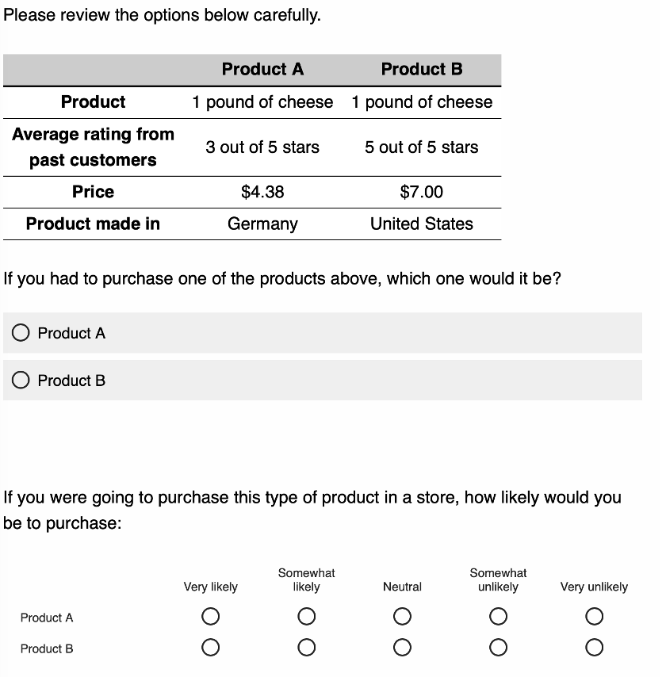

Products Used in Conjoint Tasks

Table A3 – Product Categories Used in Conjoint Tasks

Category | Baseline Price
Food
1 lb. butter | $3.00
1 lb. cheese | $3.50
1 lb. coffee | $7.00
Household Supplies
4-pack of paper towel | $4.00
96oz laundry detergent | $12.00
12-inch non-stick skillet | $30.00
Appliances
Toaster | $30.00
Microwave | $100.00
Washing machine | $500.00
Previous Research
Small bottle of super glue | $6.00
Roll of black duct tape | $7.50
Cell phone screen protector | $8.50

Note: Price reflects baseline. Markups of 0%, 25%, 50%, and 100% randomly varied across products.

Testing for product effects
Figure A2 displays the marginal mean probability of selection for products in each randomly assigned attribute level, sub-sampled by product type. For the most part, treatment effects are stable across categories. There are two exceptions. First, respondents were particularly skeptical of food products produced in China (butter, cheese, coffee). Second, respondents were sensitive to low consumer ratings for expensive durable consumer goods like (microwaves and washing machines). We find these differential effects encouraging because it suggests that respondents paid close attention to the choice tasks. In this case, the F-test returns p<.000.

Figure A2 – Marginal Mean Probability of Selection by Experimental Attribute and
Product Type

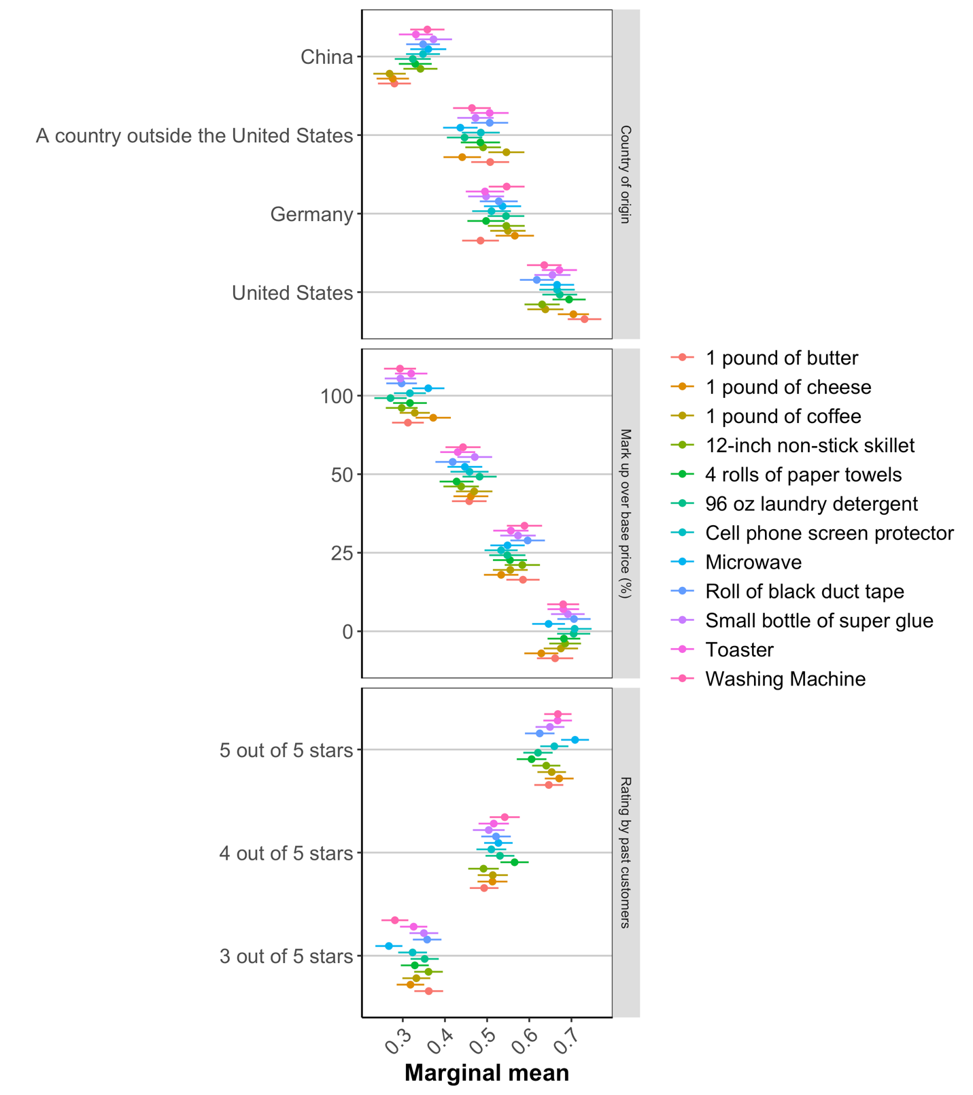

Testing for order effects
In the figure below, we present the marginal mean probability of selection for products in each randomly assigned attribute level, sub-sampled by task order. There are no discernable order effects. We can test this proposition more formally using an F-test between our model and a mode that includes a full set of interaction terms between task number and attribute levels, which returns a p-value of .85, indicating that the treatment effects did not depend on the number of tasks the respondent had already completed.
Figure A3 – Plot of Marginal Mean by Respondent Task Number

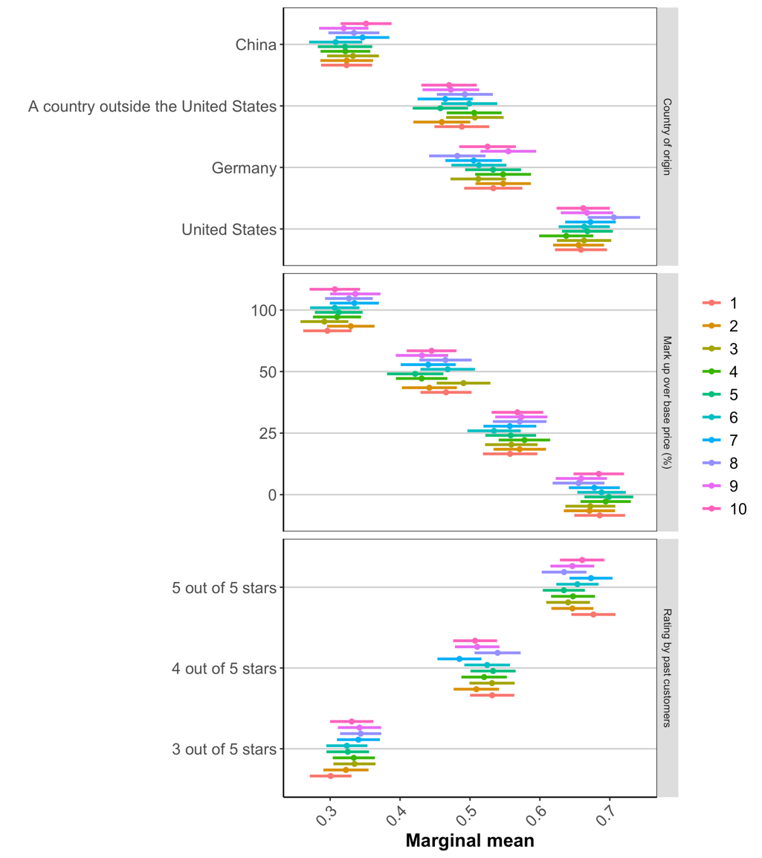

Figure A4 – Main Results Sub-Set by Product Type
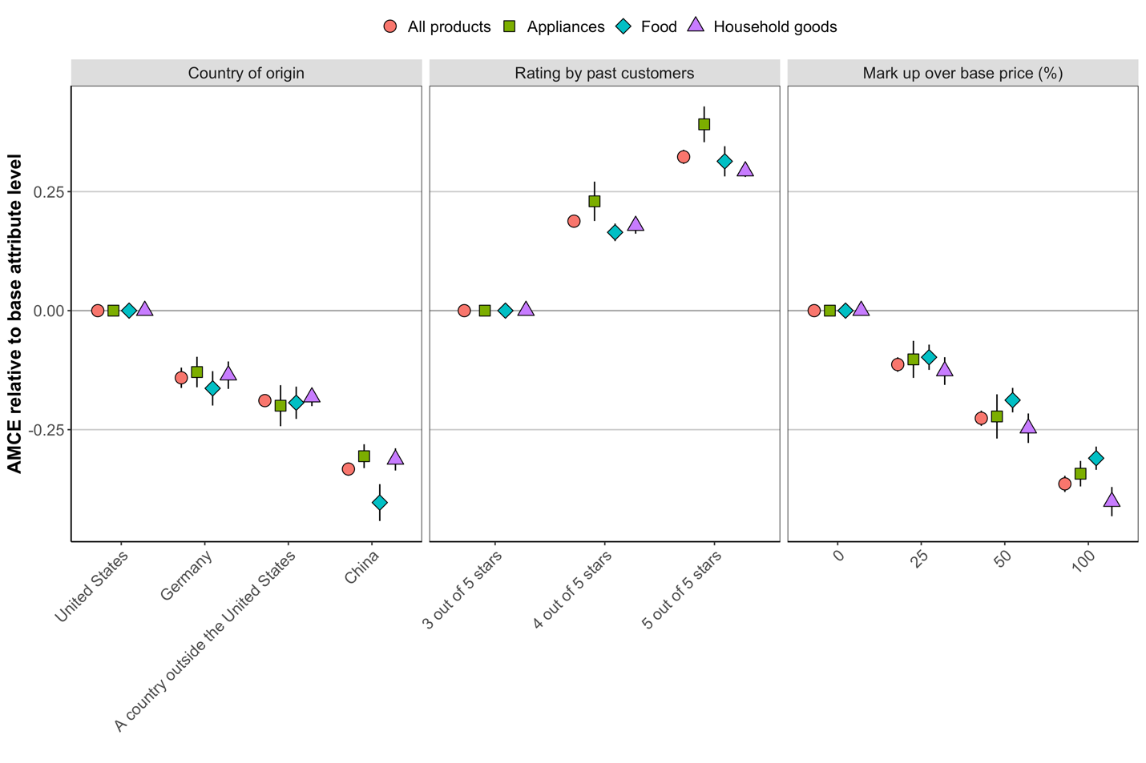

Results Used in Main Paper and for Robustness Checks
Table A4 displays the model used to generate the results presented in the paper as well as additional models with control variables. Model 1 displays results of the conjoint without additional controls. Model 2 displays the effect of three level ethnocentrism variable interacted with product country. These are the results used to generate the estimates reported in the paper. Model 3 replicates model 2 and includes controls for respondent party identification (base category = Democrat), age, race (base category is white), education (base category is non-college), income. Model 4 replicates model 3 while also interacting the ethnocentrism variables with the other randomized conjoint attributes (price mark up and quality).

Table A4 – Results Used in Main Paper and for Robustness Checks

 | Model 1 | Model 2 | Model 3 | Model 4
Country: Outside US | -0.189*** | -0.145*** | -0.145*** | -0.146***
 | (0.010) | (0.018) | (0.018) | (0.018)
Country: China | -0.333*** | -0.264*** | -0.265*** | -0.265***
 | (0.012) | (0.021) | (0.021) | (0.021)
Country: Germany | -0.141*** | -0.094*** | -0.094*** | -0.094***
 | (0.010) | (0.019) | (0.019) | (0.019)
Mark Up: 25% | -0.113*** | -0.114*** | -0.114*** | -0.103***
 | (0.009) | (0.009) | (0.009) | (0.019)
Mark Up: 50% | -0.226*** | -0.226*** | -0.226*** | -0.226***
 | (0.010) | (0.010) | (0.010) | (0.019)
Mark Up: 100% | -0.364*** | -0.364*** | -0.364*** | -0.395***
 | (0.011) | (0.011) | (0.011) | (0.021)
Rating: 4 stars | 0.188*** | 0.188*** | 0.188*** | 0.200***
 | (0.009) | (0.009) | (0.009) | (0.019)
Rating: 5 stars | 0.323*** | 0.323*** | 0.323*** | 0.360***
 | (0.010) | (0.010) | (0.010) | (0.019)
Ethno: Moderate |  | 0.023 | 0.023 | 0.041
 |  | (0.017) | (0.017) | (0.028)
Ethno: High |  | 0.078*** | 0.078*** | 0.090**
 |  | (0.017) | (0.017) | (0.028)
Outside X Ethno (Moderate) |  | -0.047 | -0.047 | -0.047
 |  | (0.025) | (0.025) | (0.025)
Outside X Ethno (High) |  | -0.074** | -0.074** | -0.074**
 |  | (0.026) | (0.026) | (0.026)
China X Ethno (Moderate) |  | -0.049 | -0.049 | -0.048
 |  | (0.028) | (0.028) | (0.028)
China X Ethno (High) |  | -0.144*** | -0.143*** | -0.144***
 |  | (0.029) | (0.029) | (0.029)
Germany X Ethno (Moderate) |  | -0.030 | -0.030 | -0.030
 |  | (0.025) | (0.025) | (0.025)
Germany X Ethno (High) |  | -0.105*** | -0.105*** | -0.105***
 |  | (0.026) | (0.026) | (0.026)
Independent |  |  | -0.005 | -0.005
 |  |  | (0.005) | (0.005)
Republican |  |  | -0.001 | -0.001
 |  |  | (0.004) | (0.004)
Age |  |  | 0.000 | 0.000
 |  |  | (0.000) | (0.000)
Race: Non-white |  |  | -0.001 | -0.001
 |  |  | (0.004) | (0.004)
College Education |  |  | -0.004 | -0.004
 |  |  | (0.003) | (0.003)
Income |  |  | -0.000 | -0.000
 |  |  | (0.000) | (0.000)
Markup X Ethno (Moderate) |  |  |  | -0.030
 |  |  |  | (0.023)
Markup X Ethno (High) |  |  |  | 0.005
 |  |  |  | (0.025)
Markup X Ethno (Moderate) |  |  |  | -0.031
 |  |  |  | (0.025)
Markup X Ethno (High) |  |  |  | 0.036
 |  |  |  | (0.026)
Markup X Ethno (Moderate) |  |  |  | 0.013
 |  |  |  | (0.026)
Markup X Ethno (High) |  |  |  | 0.075**
 |  |  |  | (0.028)
4 Star X Ethno (Moderate) |  |  |  | 0.003
 |  |  |  | (0.023)
4 Star X Ethno (High) |  |  |  | -0.042
 |  |  |  | (0.024)
5 Star X Ethno (Moderate) |  |  |  | -0.023
 |  |  |  | (0.024)
5 Star X Ethno (High) |  |  |  | -0.083***
 |  |  |  | (0.025)
Constant | 0.673*** | 0.638*** | 0.641*** | 0.629***
 | (0.011) | (0.015) | (0.016) | (0.021)
R² | 0.20 | 0.20 | 0.20 | 0.20
N | 19910 | 19910 | 19910 | 19910
Clusters | 996 | 996 | 996 | 996

Note: This table reports OLS coefficients with standard errors in parentheses. * p < 0.05, ** p < 0.01, *** p < 0.001, all two-sided.

Marginal Willingness to Pay Calculations (MWTP)
We calculate MWTP once for each markup relative to the base price, giving us a range of MWTP estimates over which we can average. To stay within the potential outcomes conjoint framework that has gained wide acceptance in political science in recent years (Hainmueller, Hopkins, Yamamoto 2014), our MWTP estimation departs from the approach used in the discrete choice conjoint literature in marketing which generally relies on non-linear models derived from random utility theory, though both approaches yield substantively similar results. In our case, the MWTP implied by each markup relative to the base price and for each foreign country is given by the following expression,
$$\text{MWTP}(country_{i},markup_{j})=-\frac{{\text{AMCE}}_{country_{i}}}{({\text{AMCE}}_{markup_{j}}/markup_{j})}$$

where i and j index the non-baseline levels of country (China, Germany, Outside the United States) and markup (25%, 50%, 100% over the baseline) respectively. Intuitively, the ratio of ${\text{AMCE}}_{country_{i}}$ and ${\text{AMCE}}_{markup_{j}}$ is the rate of substitution between a particular country of origin and a particular percentage point markup. We scale the markup by the percentage point change between the baseline and mark up level (${markup}_{j}$) to return an estimate of the marginal rate of substitution between a particular country of origin and a marginal percentage point increase in price. We calculate this quantity for each country and for each mark up. By averaging over the markup categories, we obtain a country-specific average marginal willingness to pay. We interact ethnocentrism with the product country of origin in order to generate MWTP estimates that are conditional on ethnocentrism. We present these quantities along with 95% confidence intervals in Figure 1 in the main text. We also present the disaggregated results in Figure A5. We generate confidence intervals with a non-parametric bootstrap clustered by respondent. We draw 3,000 samples, each time populating the data set with all observations from a random sample (with replacement) of respondents. We calculate MWTP for each of these draws, giving us a distribution of MWTP estimates which we use to construct point estimates and the upper and lower bounds of the 95% CI. By sampling respondents, rather than individual choice tasks, the resulting CI are clustered by respondent. Estimates from the random utility framework using conditional logit return higher precision estimates of similar magnitude (Figure A5).

Figure A5 – Disaggregated Marginal Willingness to Pay Estimates

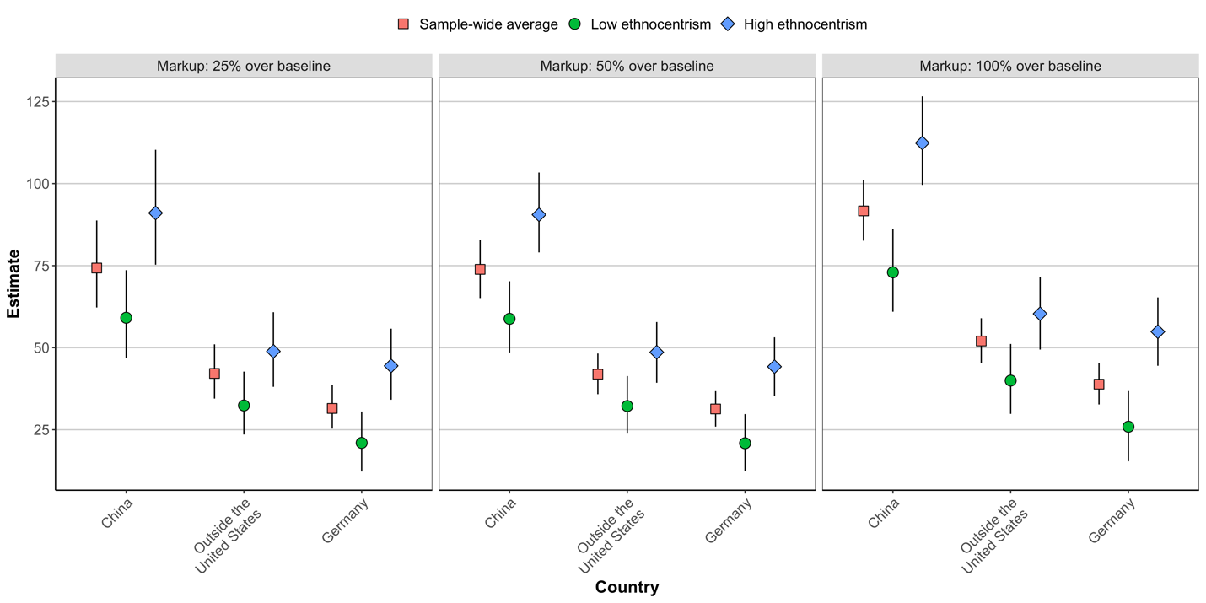

Copy of OSF Pre-Registration

Study Information
Hypotheses: First, when choosing between otherwise identical goods, consumers will have a “home bias” such that, on average, they will prefer goods produced in the United States to those produced abroad (H1). Second, we predict that ethnocentrism will moderate this preference, with those exhibiting relatively high levels of ethnocentrism having a greater home bias in consumption compared to those with relatively low levels of ethnocentrism (H2).

Design Plan
Study type: Experiment - A researcher randomly assigns treatments to study subjects, this includes field or lab experiments. This is also known as an intervention experiment and includes randomized controlled trials.
Blinding: For studies that involve human subjects, they will not know the treatment group to which they have been assigned.

Study design
We measure ethnocentrism with an abridged version of the instrument proposed and validated by Neuliep and McCroskey (1997). This scale included items such as “People in other cultures could learn a lot from people in my culture” and “Lifestyles in other cultures are not as valid as those in my culture”. Additionally, we measure political knowledge by asking four factual questions about American politics. Our study also contains a conjoint experiment to assess how ethnocentrism affects purchasing decisions. In estimating the conditional effect of ethnocentrism, we employ a binning estimator. The estimator relaxes the strong assumption of linear interaction effects by assigning respondents to bins based on which third of the ethnocentrism distribution they happen to fall into (low, medium, high) and interacting indicator variables for each bin with the treatment independently. Our approach is similar to Hainmueller, Mummolo, and Xu (2019). Respondents in the conjoint are randomly assigned to evaluate 12 pairs of products that randomly differ on country of origin, price, and a rating of quality/consumer satisfaction. Country of origin could be the United States, Germany, and China. We chose Germany as an example of a country that is culturally similar to the US, and China as an example of a culturally dissimilar country. We also included the more general category “a country outside of the United States” to obtain an estimate of the average effect for any foreign product rather than a country-specific effect. We replicate these analyses with three different countries, namely Canada, India, and Japan. We also include the U.S. and China again to replicate some of our earlier results with a different sample. Ethnocentrists should be sensitive to these nuances in cultural similarity. The quality/satisfaction rating could be three out of five, four out of five, or five out five stars. Our goal in randomizing this dimension was to break any ex-ante link between country or origin and perceptions of quality or reliability. Price markup could be 0%, 25%, 50%, or 100% above the baseline price of a product. We selected products from a variety of categories (e.g., food, household supplies, appliances, etc.) and within each category we identified products that differed in their average price. We restricted our design to allow a respondent to evaluate a given product, e.g., a microwave, only once. All product attributes were fully randomized. This design allows for a direct test of country-of-origin effects relative to other relevant product attributes and the extent to which ethnocentrism moderates the effect of a product’s country of origin. In each round, respondents were asked, “if you had to purchase one of the products above, which one would it be” and they selected between “Product A” and “Product B”.

Randomization: All product attributes were fully randomized. This design allows for a direct test of country-of-origin effects relative to other relevant product attributes and the extent to which ethnocentrism moderates the effect of a product’s country of origin.
Registration following analysis of the data
Explanation of existing data
We collected and analyzed data from a two-wave panel collected by the research firm Bovitz, Inc. Overall, our sample was a bit more educated, more Democratic, and younger than the national average. Wave 1 (N = 1,619) was fielded in early April 2020 and contained our key independent variable, namely ethnocentrism. Wave 2 (N=995) was fielded in early June 2020 and contained a conjoint experiment to assess how ethnocentrism affects purchasing decisions. We have already analyzed that data. This pre-registration deals with the replication of our initial results with a different set of countries of origin. In particular, we are interested in utilizing Canada as an example of a culturally similar country, and India, Japan, and China as examples of culturally dissimilar countries. All four countries are frequent trading partners of the U.S. Instead of using Bovitz, Inc, we use Lucid in the next round of data collection.

Data collection procedures
The pre-existing data was collected as a two-wave panel survey by the research firm Bovitz, Inc. Bovitz recruits and maintains an opt-in panel of potential survey participants, similar to firms like Qualtrics and YouGov. Participants who opt-in to a survey are compensated for their participation, and this compensation does not require them to complete the survey. Bovitz matched our sample to the United States population on the dimensions of race, ethnicity, gender, household income, and age. We utilize Lucid in the second round of data collection (N=1,000).
Sample size: We utilize Lucid in the second round of data collection (N=1,000).
Sample size rationale: We are limited by financial considerations in the determination of our sample size.
Stopping rule: Our data collection procedures gives us full control over the exact sample size.

Variables
Manipulated variables: Respondents in our initial conjoint were randomly assigned to evaluate 12 pairs of products that randomly differ on country of origin, price, and a rating of quality/consumer satisfaction. Country of origin could be the United States, Germany, China, or “a country outside of the United States.” We aim to replicate this procedure with three different countries, namely India, Japan, and Canada as well as two previously used countries, namely the U.S. and China.

Measured variables: We define ethnocentrism as cultural in-group favoritism, whereby ethnocentrists view their own culture as superior and assess out-groups based on their cultural proximity to the in-group (see Neuliep and McCroskey 1997). We measure ethnocentrism with an abridged version of the instrument proposed and validated by Neuliep and McCroskey (1997). This scale included items such as “People in other cultures could learn a lot from people in my culture” and “Lifestyles in other cultures are not as valid as those in my culture”. Our outcome variable measures respondents' purchasing decision. In each round, respondents are asked, “if you had to purchase one of the products above, which one would it be” and they selected between “Product A” and “Product B”.

Indices: We calculate MWTP (marginal willingness to pay) once for each markup relative to the base price, giving us a range of MWTP estimates over which we can average. To stay within the potential outcomes conjoint framework that has gained wide acceptance in political science in recent years (Hainmueller, Hopkins, Yamamoto 2014), our MWTP estimation departs from the approach used in the discrete choice conjoint literature in marketing which generally relies on non-linear models derived from random utility theory, though both approaches yield substantively similar results. We calculate the marginal mean or predicted probability that a respondent would choose a given product from a given country relative to all other potential countries of origin. We calculate this quantity for each country and for each price mark up. By averaging over the markup categories, we obtain a country-specific average marginal willingness to pay. We interact ethnocentrism with the product country of origin in order to generate MWTP estimates that are conditional on ethnocentrism.

Analysis Plan
Statistical models: We calculate the marginal mean or predicted probability that a respondent would choose a given product from a given country relative to all other potential countries of origin. We generate confidence intervals with a non-parametric bootstrap clustered by respondent. We draw 3,000 samples, each time populating the data set with all observations from a random sample (with replacement) of respondents. We calculate MWTP for each of these draws, giving us a distribution of MWTP estimates which we use to construct point estimates and the upper and lower bounds of the 95% CI. By sampling respondents, rather than individual choice tasks, the resulting CI are clustered by respondent. Main effects: Calculated from an OLS in which the product-choice is regressed on indicator variables for the three treatment conditions (country of origin, product rating, and product price). This model includes controls for the ethnocentrism scale and party identification Conditional effects of ethnocentrism: Calculated from an OLS in which product-choice is regressed on indicator variables for the three treatment conditions, each of which is interacted with ethnocentrism. We then use the previously described binning procedure to generate marginal mean and MWTP estimate for those low, moderate, and high on ethnocentrism. The model includes controls for party identification.

Transformations: We create a variable, reflecting the mean values of the ethnocentrism scale for each respondent as well as political knowledge variable that reflect the correct response to four factual questions about political knowledge. We use that variable only in supplementary analyses.

Inference criteria: We use conventional levels of statistical significance (i.e., p-values) and two-sided hypothesis tests.

Data exclusion: We use attention screeners pre-treatment and respondents who fail the screeners will not proceed to the experiment. We do not have a post-treatment screener or awareness check.

Pre-Registered Conceptual Replication
We conducted a conceptual replication of the Bovitz study from 2/17/2021 through 2/26/2021 with Lucid, another provider of online survey responses, which is frequently used in political science research. The design was preregistered at OSF (Citation Redacted). After eliminating participants who failed a pre-treatment attention check, the final sample size for the replication was 1,102. We relied on the same general framework as our primary study, though we made some important substantive changes to test the robustness of our findings. The countries from which a product could originate were the United States, Canada, Japan, China, and India. India was included because, like China, it is culturally dissimilar from the United States and is an increasingly significant producer of goods imported to the United States. We also worried that our strong findings related to ethnocentric driven decisions related to China could be partially explained by the on-going pandemic related to Covid-19, which was taking place while we fielded the first wave of our study. The price markups and ratings followed the same logic as in our first experiment. Thus, a product could have a three, four, or five-star rating. It could also have a baseline price, or be marked up 25%, 50% or 100%. We also included a more detailed preamble into the experiment which stated that “All products meet all relevant U.S. consumer product health and safety standards.” We hoped this would dissuade participants from inferring that certain types of products, like milk, were more dangerous when sourced to a particularly country. Finally, participants completed 12 rounds of the study, resulting an effective sample size of 26,456.
The replication was conducted on a single survey. Ethnocentrism, party identification, and ideology were measured pre-treatment. We then included a distraction task in the form of a political knowledge battery before participants began the conjoint task. The survey included the same six items to measure ethnocentrism and the scale used in these analyses was constructed from the same four items used in our main analysis. The scale constructed from these items has a reliability of alpha = .47. When rescaled to run from 0-1, the scale mean is .56, with a standard deviation of .19. We use the same binning strategy from the main text to estimate the interaction between treatments and ethnocentrism.

Figure A6 – Results: Conceptual Replication

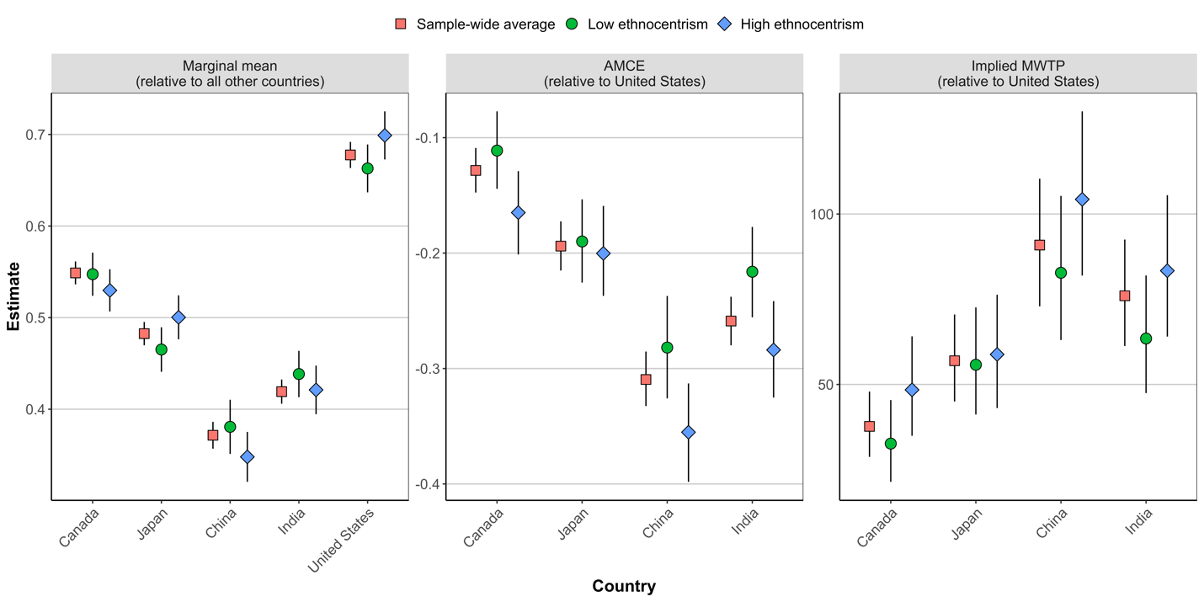

Beginning with the marginal means (the leftmost panel of Figure A6), we see that participants on average most preferred products from the United States, then, respectively, from Canada, Japan, India, and China. We also tend to find similar effects related to ethnocentrism. In particular, those high in ethnocentrism prefer products from the United States to a greater degree than do those who are low in ethnocentrism (diff = 0.03, p = 0.001). The AMCEs displayed in the center plot show that high ethnocentrists’ relative preference for products from the United States compared to India (-.28) and China (-.33) is stronger than for low ethnocentrists (India: -.24; China: -.28). Finally, the MWTP analyses show that high ethnocentrists are willing to pay a greater price premium for domestic products compared to those from China or India.
The results from this Lucid study confirm the primary findings from our original study. High ethnocentrists have a “home bias” in their purchasing decisions, and they are especially likely to have this home bias when the alternative is products produced in culturally dissimilar locations. These results also extend the results from our previous experiments in important ways. First, we replicated our initial findings related to China and also found similar, albeit slightly smaller, effects for India, which is similarly culturally dissimilar to China but was not negatively linked to the pandemic at the time of this replication.

Figure A7 –MTWP Estimates Generated from Conditional Logistic Regression Model

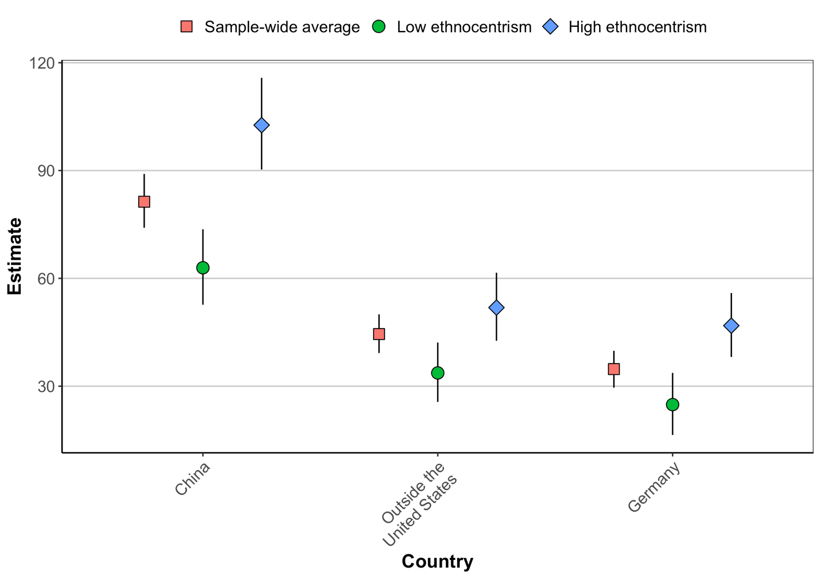

Robustness Check: Political Awareness

In this analysis we assess whether our results are driven by respondents who are politically aware. We use a respondent’s self-reported level of education to capture awareness. Results are calculated by splitting our sample into two groups, those who have a 4-year college degree or a professional degree/PhD (n = 410) and those who have a 2-year degree, some college, or a high school degree or less (n = 558). Table A5 displays the MWTP estimates for each group. These estimates are derived from a model reported in Figure 1 of the main text with the dataset subset by high (college education or greater) or low (less than college education) education respondents.
Table A5 – MWTP Estimates by Respondent Education Level and Product Country of Origin

Country of Origin | Low Awareness | High Awareness
Country=China
Low Ethnocentrism | 70.59 (50.79, 95.01) | 57.47 (34.61, 85.23)
Median Ethnocentrism | 77.36 (57.54, 101) | 74.36 (48.66, 105.11)
High Ethnocentrism | 101.04 (76.79, 131.36) | 96.75 (64.08, 135.33)
Country=Germany
Low Ethnocentrism | 30.1 (16.71, 46.78) | | 15.62 (3, 31.51)
Median Ethnocentrism | 34.74 (23.02, 48.67) | 22.6 (10.17, 39.12)
High Ethnocentrism | 53.6 (38.31, 71.87) | 41.79 (24.94, 63.32)
Country=Outside US
Low Ethnocentrism | 40.83 (26.67, 58.23) | 29.74 (15.41, 48.47)
Median Ethnocentrism | 51.75 (37.37, 68.97) | 39.32 (22.89, 61.12)
High Ethnocentrism | 62 (45.05, 82.94) | 42.33 (24.43, 64.62)

Note: Reported values are marginal willingness to pay point estimates for a product from the listed country relative to a product produced in the United States. Values in brackets are 95% confidence intervals.

The primary takeaway from these results is that we find no evidence that our results are driven by respondents who are either high or low levels of political awareness. Within levels of awareness, we do observe some differences in the magnitude of our effects, although the differences are not consistent across countries. For example, in the China vs. US comparison, the effect of going from low to high levels of ethnocentrism is stronger for those with high compared to low political awareness. However, the pattern is reversed in the country outside of the United States vs. US comparison. In general, we interpret the lack of differences as consistent with our claims that broad swaths of the American public can engage in these sorts of consumer behaviors.

Alternative Measures of Ethnocentrism
In this section, we use feeling thermometers to construct alternative measures of ethnocentrism and show that the results are substantively similar. We do so in two ways. First, we create a measure of ethnocentrism taking the average of respondent’s feeling thermometer ratings of the United Kingdom, Puerto Rico, German, Japan, Mexico, and China. Mean values for those ratings (and those of the United States) are displayed in Table A6. We then recode the variable to run from 0 to 1, with higher values corresponding to more negative ratings. The variable has a mean of .44 and standard deviation of .19.

Table A6– Country Feeling Thermometer Ratings (Wave 1)

Country | Mean (SD)
United States | 80.66 (22.56)
United Kingdom | 67.1 (23.86)
Puerto Rico | 62.25 (26.03)
Germany | 59.96 (24.47)
Japan | 59.81 (25.74)
Mexico | 50.94 (24.82)
China | 36.08 (25.76)

The weakness of this measure is that it only captures negative affect of foreign countries and not the preference for one’s own country relative to another country. We thus employ an alternative measure of ethnocentrism by constructing a variable that is the difference between a respondent’s rating of the United States and of Puerto Rico. The logic for this choice is that Puerto Rico is a part of the United States and that individuals who rate the United States more positively than Puerto Rico are doing so due to perceived cultural dissimilarities between the two. The variable is created by subtracting ratings of Puerto Rico from those of the United States, resulting in a variable that theoretically runs from -1 (relatively more positive ratings of Puerto Rico compared to the United States) to 1 (relatively more positive ratings of the United States compared to Puerto Rico). In practice, the range on this variable is -.86 to 1, with a mean of .19 and standard deviation of .30. Substituting these alternative measures of ethnocentrism results in substantively similar results, which are reported in Table A7.

Table A7 – Alternative Measures of Ethnocentrism

 | Model 1:  Average FT | Model 2:  Difference FT
Country: Outside US | -0.107*** | -0.157***
 | (0.0260) | (0.0123)
Country: China | -0.196*** | -0.287***
 | (0.0292) | (0.0137)
Country: German | -0.0284 | -0.106***
 | (0.0246) | (0.0117)
Ethnocentrism | 0.187*** | 0.150***
 | (0.0346) | (0.0211)
Outside X Ethnocentrism | -0.186*** | -0.177***
 | (0.0539) | (0.0340)
China X Ethnocentrism | -0.311*** | -0.261***
 | (0.0603) | (0.0368)
German X Ethnocentrism | -0.256*** | -0.189***
 | (0.0515) | (0.0331)
Price Markup | -0.360*** | -0.360***
 | (0.0104) | (0.0104)
Rating: 4 stars | 0.187*** | 0.187***
 | (0.00910) | (0.00911)
Rating: 5 stars | 0.323*** | 0.323***
 | (0.00970) | (0.00972)
Party: Independent | -0.00548 | -0.00467
 | (0.00509) | (0.00506)
Party: Republican | -0.000981 | 0.000593
 | (0.00337) | (0.00350)
Constant | 0.573*** | 0.628***
 | (0.0192) | (0.0113)
R2 | 0.201 | 0.203
Observations | 19830 | 19670
Clusters | 992 | 984

Note: This table reports OLS coefficients with standard errors in parentheses. * p < 0.05, ** p < 0.01, *** p < 0.001, all two-sided.

Table A8 – MWTP Estimates with Alternative Measures of Ethnocentrism

Country of Origin | Average FT Ethnocentrism | US-PR FT Difference Ethnocentrism
Country=China
Low Ethnocentrism | .72  [.61, .83] | .72  [.61, .82]
Median Ethnocentrism | .92  [.82, 1.01] | .90  [.81, .99]
High Ethnocentrism | 1.15  [1.01, 1.28] | 1.22  [1.09, 1.35]
Country=Germany
Low Ethnocentrism | .22  [.14, .31] | .24  [.16, .31]
Median Ethnocentrism | .38  [.32, .45] | .37  [.31, .43]
High Ethnocentrism | .58  [.48, .68] | .60  [.5, .7]
Country=Outside US
Low Ethnocentrism | .40  [.31, .50] | .38  [.30, .47]
Median Ethnocentrism | .52  [.45, .59] | .50  [.44, .57]
High Ethnocentrism | .66  [.55, .76] | .72  [.62, .82]

Note: Reported values are marginal willingness to pay point estimates for a product from the listed country relative to a product produced in the United States. Values in brackets are 95% confidence intervals. Estimates for each column of values are generated from the models in Table A7.

Lucid reports incomes at high end of distribution in $25,000 increments: 1) Less than $30,000, 2) Between $30,000 and $59,000, 3) Between $60,000 and $125,000, 4) More than $125,000
Trading Economics: India Exports to United States. Source: https://tradingeconomics.com/india/exports-to-united-states (last accessed 06/07/2021).

