Supplementary Information – Web Only

**Supplementary Information - Web**

In addition to the analyses presented within the main body of the manuscript, we conduct a number of additional analyses and checks to ensure that our results are robust to alternative specifications. These checks take the following forms: (1) changes in estimation, (2) changes in the number and types of controls, (3) alternative measure of balance, and (4) error structure of the data. We describe each of the checks in turn. When re-estimating the models that rely on triple interactions, we place greater emphasis on marginal effects plots, which are also included in the supplementary materials, than the coefficient on the triple interaction, which is difficult to interpret. We include the coefficients for results of all models that use triple interactions to demonstrate that the direction of the coefficient remains consistent, as does the effect of governmental balance, regardless of model specification.

**SI1. Relationship between Balance and Professionalism, additional specifications**

Our first supplementary analyses re-consider the specification of the relationship between balance and professionalism. This set of analyses relies on the data used in the manuscript; we present all of the results in SI Table 1.1. In Model 1 we present the in-text results, including the coefficient for the year controls that are not shown in Table 3 (in-text) due to space reasons. Model 2 shows the results without any additional adjustments to the standard errors (no year controls, robust standard errors, etc.). Our budgetary balance measure can potentially account for gubernatorial appointment power and gubernatorial veto power, so we want to make sure that our results are robust to the inclusion of those controls; Model 3 does so. Given the possibility that there are certain unobserved conditions across elections, Model 4 is estimated using a random effects approach. Next, given the possibility that our dependent variable can be considered censored at 0 and 100, we also estimate our results using tobit (Model 5). Finally, we also use robust standard errors, rather than controls by year (Model 6). All additional models reinforce the original results we present in the text.

In addition, in SI Figure 1.1 we present the effect of shifting from an unbalanced to a balanced government for each of the models in SI Table 1.1. Across all models, shifting to a balanced government decreases turnover as professionalism increases. As our theory predicts – and as we describe in the main text – the effect of balance reaches significance only at higher levels of professionalism. Importantly, each of the cells in SI Figure 1 represents the result from a different model, meaning that the results in the figure cannot be compared directly to each other. Rather, the figure suggests a pattern that reinforces the robustness of our results.

**SI2. Relationship among Balance, Professionalism, and Economic Conditions, additional specifications**

Just as we provide additional specifications for the models that rely on double interactions, we also consider additional approaches to the models that rely on a triple interaction to estimate the way the relationship among balance, professionalism, and economic conditions affect turnover. We present this set of supplementary analyses in SI Table 2.1. The first set of results in SI Table 2.1 (model 1) presents the coefficient estimates that produced the results we present graphically in the manuscript (Figures 2 and 3). Model 2 presents the results with additional controls for gubernatorial powers. Model 3 uses tobit.

The results of a triple interaction are difficult to interpret. Various scholars have suggested that we cannot rely on the significance of the triple interaction coefficient to judge the relationship between the factors in that interaction. Rather, we need to consider the marginal effects of the various factors within the interaction. We present the marginal effects plots associated with the results in SI Table 2.1 in SI Figure 2.1. These results plot the effect of moving to a balanced government as economic conditions move from growth to decline. In all cases, the results are shown for a legislature that is above a median level of professionalism. The results in SI Figure 2.1 are based on estimates from different models, so they cannot be compared directly. Rather, SI Figure 2.1 shows a pattern that reinforces the robustness of our results. In addition, we also present in SI Figure 2.2 the marginal effects of different levels of professionalism. This is presented as additional information for Figure 3 in the text.

|  |  |  |  |  |  |  |
| --- | --- | --- | --- | --- | --- | --- |
|  | Model 1  In-Text Results | Model 2  No Adjustment | Model 3  Additional Controls | Model 4 Random Effects | Model 5  Tobit | Model 6  Robust  SE |
| Balance | 0.31 | 0.27 | 0.28 | 0.27 | 0.31 | 0.27 |
| *(when professionalism = 0)* | (0.18) | (0.18) | (0.18) | (0.18) | (0.18) | (0.17) |
| Professionalism | -1.69 | -1.73 | -1.64 | -1.73 | -1.72 | -1.73 |
| *(when balance = 0)* | (0.31) | (0.32) | (0.32) | (0.32) | (0.31) | (0.31) |
| **Balance × Professionalism** | **-2.06** | **-1.81** | **-1.93** | **-1.81** | **-2.05** | **-1.81** |
|  | **(0.85)** | **(0.87)** | **(0.87)** | **(0.87)** | **(0.84)** | **(0.87)** |
| Term Limits | -0.01 | -0.10 | 0.001 | -0.10 | -0.01 | -0.10 |
|  | (0.14) | (0.13) | (0.14) | (0.13) | (0.14) | (0.14) |
| Term Limits in Effect | 0.00 | 0.00 | 0.00 | 0.00 | 0.00 | 0.00 |
|  | (0.00) | (0.00) | (0.00) | (0.00) | (0.00) | (0.00) |
| Redistricting | 0.22 | 0.88 | 0.21 | 0.88 | 0.22 | 0.88 |
|  | (0.15) | (0.10) | (0.15) | (0.10) | (0.15) | (0.12) |
| Multimember Districts | 0.23 | 0.23 | 0.24 | 0.23 | 0.23 | 0.23 |
|  | (0.09) | (0.09) | (0.09) | (0.09) | (0.09) | (0.10) |
| Partisan Climate | -0.26 | 1.09 | -0.33 | 1.09 | -0.26 | 1.09 |
|  | (0.42) | (0.27) | (0.43) | (0.27) | (0.43) | (0.26) |
| Fraction up for Reelection | -2.20 | -2.01 | -2.21 | -2.01 | -2.20 | -2.01 |
|  | (0.17) | (0.17) | (0.17) | (0.17) | (0.17) | (0.21) |
| Divided Government | -0.09 | -0.06 | -0.09 | -0.06 | -0.08 | -0.06 |
|  | (0.08) | (0.08) | (0.08) | (0.08) | (0.08) | (0.08) |
| Unemployment Change | 0.04 | 0.08 | 0.04 | 0.08 | 0.04 | 0.08 |
| *(increasing values = worsening conditions)* | (0.04) | (0.03) | (0.04) | (0.03) | (0.04) | (0.03) |
| Presidential Election | -0.48 | -0.20 | -0.48 | -0.20 | -0.50 | -0.20 |
|  | (0.16) | (0.08) | (0.16) | (0.08) | (0.16) | (0.08) |
| 1982 | 1.16 | --- | 1.20 | --- | 1.16 | --- |
|  | (0.26) | --- | (0.27) | --- | (0.26) | --- |
| 1984 | 0.96 | --- | 0.97 | --- | 0.98 | --- |
|  | (0.19) | --- | (0.19) | --- | (0.19) | --- |
| 1986 | 0.33 | --- | 0.34 | --- | 0.33 | --- |
|  | (0.18) | --- | (0.18) | --- | (0.17) | --- |
| 1988 | 0.55 | --- | 0.56 | --- | 0.57 | --- |
|  | (0.18) | --- | (0.18) | --- | (0.18) | --- |
| 1990 | 0.61 | --- | 0.63 | --- | 0.61 | --- |
|  | (0.17) | --- | (0.17) | --- | (0.17) | --- |
| 1992 | 1.60 | --- | 1.62 | --- | 1.62 | --- |
|  | (0.22) | --- | (0.22) | --- | (0.22) | --- |
| 1994 | 1.15 | --- | 1.17 | --- | 1.15 | --- |
|  | (0.24) | --- | (0.24) | --- | (0.24) | --- |
| 1996 | 0.86 | --- | 0.87 | --- | 0.89 | --- |
|  | (0.18) | --- | (0.18) | --- | (0.18) | --- |
| Gubernatorial Appointment Power |  | --- | -0.05 | --- | --- | --- |
|  |  | --- | (0.04) | --- | --- | --- |
| Gubernatorial Veto Power |  | --- | -0.01 | --- | --- | --- |
|  |  | --- | (0.03) | --- | --- | --- |
| Constant | 4.28 | 4.27 | 4.49 | 4.28 | 4.29 | 4.27 |
|  | (0.20) | (0.19) | (0.30) | (0.19) | (0.20) | (0.22) |
| Observations | 811 | 811 | 811 | 811 | 811 | 811 |
| R-squared | 0.40 | 0.34 | 0.40 | --- | --- | 0.344 |
| χ2 | --- | --- | --- | 418.59 | 413.60 | --- |

SI Table 1.1: Alternative Specifications of Model 1

SI Figure 1.1: Effect of Shifting from an Unbalanced to a Balanced Government, as Professionalism Increases

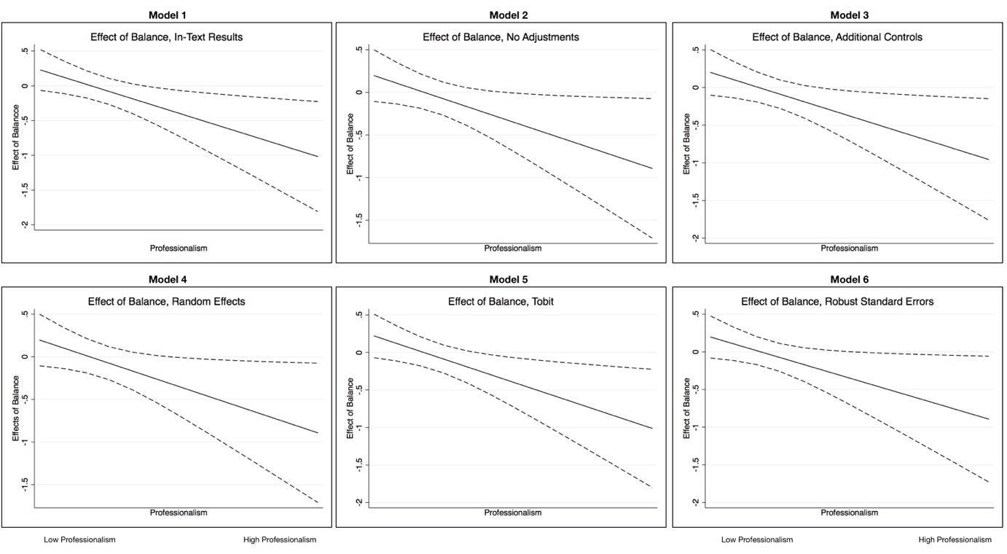

Results include 95% confidence intervals and are based on the models in SI Table 1.

SI Table 2.1: Relationship between Balance, Professionalism and Economic Conditions

|  |  |  |  |
| --- | --- | --- | --- |
|  | Model 1 | Model 2 | Model 3 |
|  | In-Text Results | Additional Controls | Tobit |
| Balance | 0.30 | 0.27 | 0.30* |
| *When Prof. and Unemp. =0* | (0.18) | (0.18) | (0.18) |
| Professionalism | -1.52 | -1.47 | -1.55 |
| *When Balance and Unemp =0* | (0.32) | (0.33) | (0.32) |
| Balance x Professionalism | -2.21 | -2.07 | -2.20 |
| *When Unemp = 0* | (0.85) | (0.87) | (0.84) |
| Unemployment Change | -0.02 | -0.02 | -0.02 |
| *When Balance and Prof = 0* | (0.06) | (0.06) | (0.06) |
| Balance x Unemployment Change | -0.16 | -0.16 | -0.17 |
| *When Prof. = 0* | (0.12) | (0.12) | (0.12) |
| Prof. x Unemployment Change. | 0.39 | 0.40 | 0.39 |
| *When Balance = 0* | (0.18) | (0.18) | (0.18) |
| Balance x Unemp. Change x Prof. | 0.20 | 0.17 | 0.20 |
|  | (0.51) | (0.51) | (0.50) |
| Term Limits | -0.04 | -0.03 | -0.04 |
|  | (0.14) | (0.14) | (0.14) |
| Term Limits in Effect | 0.00 | 0.00 | 0.00 |
|  | (0.00) | (0.00) | (0.00) |
| Redistricting | 0.22 | 0.21 | 0.22 |
|  | (0.15) | (0.15) | (0.15) |
| Multimember Districts | 0.23 | 0.23 | 0.23 |
|  | (0.09) | (0.09) | (0.09) |
| Partisan Climate | -0.41 | -0.48 | -0.41 |
|  | (0.42) | (0.43) | (0.42) |
| Fraction up for Reelection | -2.19 | -2.20 | -2.19 |
|  | (0.17) | (0.17) | (0.17) |
| Divided Government | -0.08 | -0.08 | -0.08 |
|  | (0.08) | (0.08) | (0.08) |
| Presidential Election | -0.47 | -0.47 | -0.49 |
|  | (0.16) | (0.16) | (0.16) |
| 1982 | 1.18 | 1.21 | 1.18 |
|  | (0.26) | (0.27) | (0.26) |
| 1984 | 0.94 | 0.95 | 0.96 |
|  | (0.19) | (0.20) | (0.19) |
| 1986 | 0.35 | 0.36 | 0.35 |
|  | (0.18) | (0.18) | (0.17) |
| 1988 | 0.57 | 0.57 | 0.58 |
|  | (0.18) | (0.18) | (0.18) |
| 1990 | 0.64 | 0.65 | 0.64 |
|  | (0.17) | (0.17) | (0.17) |
| 1992 | 1.60 | 1.62 | 1.62 |
|  | (0.22) | (0.22) | (0.22) |
| 1994 | 1.20 | 1.22 | 1.20 |
|  | (0.24) | (0.24) | (0.24) |
| 1996 | 0.89 | 0.89 | 0.91 |
|  | (0.18) | (0.18) | (0.18) |
| Gubernatorial Veto Power | --- | -0.01 | --- |
|  | --- | (0.03) | --- |
| Gubernatorial Appointment Power | --- | -0.05 | --- |
|  | --- | (0.04) | --- |
| Constant | 4.25 | 4.46 | 4.26 |
|  | (0.20) | (0.29) | (0.20) |
|  |  |  |  |
| Observations | 811 | 811 | 811 |
| R-squared | 0.41 | 0.41 |  |
| χ2 |  |  | 426.07 |

Standard errors in parentheses. Models 1 and 2 are OLS, Model 3 is tobit (upper and lower censoring).

SI Figure 2.1: Effect of Balance at Above Median Professionalism, as Economic Conditions Worsen

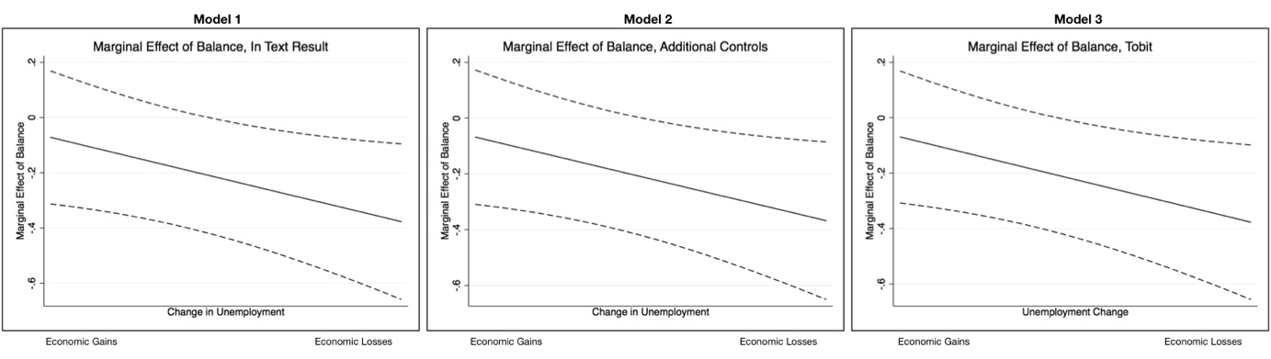

Figures based on models in SI Table 2. All confidence intervals are 95%.

SI Figure 2.2: Additional Levels of Balance (Additional Information for In-Text Figure 3)

|  |  |
| --- | --- |
| Bottom 10% of Professionalism (Least Professional) | Top 10% of Professionalism (Most Professional) |
| Replication%20SI%201%20and%202%20Done/figure23left.jpg | Replication%20SI%201%20and%202%20Done/figure23right.jpg |
| *Results based on Model 1 in SI Table 2, 95% Confindence Interval* | |

**SI3. Alternative Specification of Balance**

In the manuscript we derive our measure of governmental balance from an index that measures the extent to which the governor or the legislature has control over the state’s budget. This index is described in Krupnikov and Shipan (2011) and we describe the recoding of this index into the binary balance variable within the main manuscript. This score is beneficial in that it allows us to track pattern over two decades of elections. We do, however, want to ensure that our results are not simply a function of our particular measure. To do so, we rely on a different measure of budgetary control – Dometrius and Wright’s (2009) measure of the influence various institutions have on the budgets of state agencies. The measures come from the American State Administrator Project (ASAP), which conducted surveys with members of administrative agencies. Included in this survey are questions to gauge the extent to which the governor and the legislature can exercise control over the agency’s budget. These measures can be used to capture whether the government is balanced or unbalanced with respect to control over the budget.

To create an alternative measure of balance we use the following ASAP question:

*Generally speaking, do you find that the governor or the legislature exercises greater control and oversight over your agency?*

Since more than one state administrator is interviewed, responses to this question are then averaged within state. A score closer to 1 means that the governor has greater control, a score closer to -1 means that the legislature has greater control and a score of 0 means that both bodies exercise the same level of control. Due to the mean structure, the measure is continuous between 1 and -1. Given that our focus is on comparing the effect of balance, we take the absolute value of the scale and multiply the result by -1. This new recoding means that the higher the value on the scale (i.e., the closer to 0), the more balanced a state government. This leaves this measure comparable to the in-text measure, where the higher value of 1 also meant a more balanced government.

The ASAP surveys are not conducted each year, and not every question was asked every year of the survey. The ASAP question that is most beneficial to our analysis overlaps with our remaining data in four years: 1984, 1988, 1994, and 1998. As a result we are left with fewer cases in the analyses that rely on the ASAP measure, which means that the N is lower in these supplementary analyses than in the main results in-text.

We present the results of our analyses that include the ASAP measure of balance in SI Table 3.1. We rely on the same models that we present in the main manuscript: an interaction between the ASAP measure of balance and professionalism (Model 1) with controls for the year and the same model without controls for years (Model 2).

SI Table 3.1: Relationship Between Balance, Professionalism and Unemployment, ASAP Measures (Dometrius and Wright 2009)

|  |  |  |
| --- | --- | --- |
|  | Model 1 | Model 2 |
|  | No Year Controls | Year  Controls |
|  |  |  |
| ABS Index | 1.12 | 0.95 |
| *(when Prof. = 0 )* | (0.48) | (0.48) |
| Professionalism | -4.20 | -3.87 |
| *(when ABS Index = 0)* | (1.13) | (1.12) |
| Prof x ABS Index | -4.20 | -3.34 |
|  | (1.97) | (1.97) |
| Term Limits | 0.30 | 0.28 |
|  | (0.24) | (0.24) |
| Term Limits in Effect | 0.00 | 0.00 |
|  | (0.00) | (0.00) |
| Redistricting | 0.60 | 0.43 |
|  | (0.19) | (0.20) |
| Multi-Member Districts | 0.29 | 0.29 |
|  | (0.15) | (0.14) |
| Partisan Climate | 1.50 | -0.69 |
|  | (0.39) | (0.83) |
| Fraction Up for Reelection | -2.06 | -2.12 |
|  | (0.29) | (0.29) |
| Divided Government | -0.21 | -0.25 |
|  | (0.13) | (0.13) |
| Presidential Election | -0.17 | 0.17 |
|  | (0.16) | (0.21) |
| Unemployment | -0.16 | -0.11 |
|  | (0.09) | (0.11) |
| 1984 | --- | 0.15 |
|  | --- | (0.22) |
| 1994 | --- | 1.17 |
|  | --- | (0.38) |
| Constant | 4.58 | 4.69 |
|  | (0.37) | (0.36) |
|  |  |  |
| Observations | 324 | 324 |
| R-squared | 0.38 | 0.40 |

**SI 4. Additional Controls In Models**

As a final robustness check we re-estimate the main models in the manuscript with additional controls accounting for partisan conditions within the state legislature (results in SI Table 4.1). First, we control for polarization using the Shor and McCarty (2011) measure of polarization at the state level (Model 1). The Shor and McCarty data and our data only overlap in four years (1994, 1996, 1998 and 2000), which results in the lower N in SI Table 4. All results with these additional controls reinforce the findings in the main text.

Next, in SI Table 4.1 (Models 2, 3 and 4) we present the result with controls for partisan dynamics using the Ranney Index and the Holbrook and Van Dunk (HVD) data. We include these controls separately and jointly. Both controls are calculated by Klarner, using the six-year average.[1] There is more overlap between the available years in this data and our data, so the N remains largely the same as the N in the models included in the main text. Again, we estimate both the double and triple interaction models, as well as models that exclude our original partisanship control. Including these controls produces results that again reinforce our main conclusions. Finally, in SI Table 4.1 Model 5 we present our model without any additional controls for partisanship. All specifications reinforce our results.

SI Table 4.1: Main Model with Additional Controls for Partisan Dynamics

|  |  |  |  |  |  |
| --- | --- | --- | --- | --- | --- |
|  | Model 1 | Model 2 | Model 3 | Model 4 | Model 5 |
| Balance | 0.69 | 0.25 | 0.28 | 0.23 | 0.30 |
| *(When Prof = 0)* | (0.35) | (0.18) | (0.18) | (0.18) | (0.18) |
| Professionalism | -2.02 | -1.68 | -2.05 | -2.00 | -1.69 |
| *(When Balance = 0)* | (0.59) | (0.31) | (0.31) | (0.31) | (0.31) |
| Balance x Prof. | -4.04 | -1.90 | -1.90 | -1.81 | -2.04 |
|  | (1.93) | (0.85) | (0.83) | (0.83) | (0.85) |
| Unemployment | -0.06 | 0.03 | 0.05 | 0.05 | 0.04 |
|  | (0.17) | (0.06) | (0.06) | (0.06) | (0.04) |
| Term Limits | -18.20 | -0.003 | -0.02 | -0.03 | -0.002 |
|  | (60.16) | (0.15) | (0.14) | (0.14) | (0.14) |
| Term Limits in Effect | 0.01 | 0.00 | 0.00 | 0.00 | 0.00 |
|  | (0.03) | (0.00) | (0.00) | (0.00) | (0.00) |
| Redistricting | 0.64 | 0.21 | 0.20 | 0.21 | 0.22 |
|  | (0.48) | (0.15) | (0.15) | (0.14) | (0.15) |
| Multi-Member Districts | 0.24 | 0.24 | 0.09 | 0.11 | 0.23 |
|  | (0.18) | (0.09) | (0.09) | (0.09) | (0.09) |
| Fraction for Reelection | -2.45 | -2.17 | -2.16 | -2.18 | -2.21 |
|  | (0.28) | (0.17) | (0.17) | (0.16) | (0.17) |
| Divided Government | -0.31 | -0.10 | -0.15 | -0.17 | -0.08 |
|  | (0.13) | (0.08) | (0.08) | (0.08) | (0.08) |
| Presidential Elections | -0.46 | -0.48 | -0.42 | -0.43 | -0.47 |
|  | (0.15) | (0.16) | (0.16) | (0.16) | (0.16) |
| 1982 | --- | 1.25 | 1.10 | 1.14 | 1.11 |
|  | --- | (0.27) | (0.27) | (0.26) | (0.25) |
| 1984 | --- | 0.96 | 0.89 | 0.95 | 0.92 |
|  | --- | (0.21) | (0.21) | (0.20) | (0.19) |
| 1986 | --- | 0.34 | 0.30 | 0.33 | 0.30 |
|  | --- | (0.17) | (0.17) | (0.17) | (0.17) |
| 1988 | --- | 0.54 | 0.48 | 0.51 | 0.51 |
|  | --- | (0.17) | (0.17) | (0.17) | (0.17) |
| 1990 | --- | 0.64 | 0.64 | 0.65 | 0.59 |
|  | --- | (0.17) | (0.17) | (0.17) | (0.17) |
| 1992 | --- | 1.69 | 1.59 | 1.64 | 1.59 |
|  | --- | (0.21) | (0.21) | (0.21) | (0.22) |
| 1994 | 1.17 | 1.08 | 1.03 | 1.04 | 1.04 |
|  | (0.41) | (0.17) | (0.17) | (0.17) | (0.17) |
| 1996 | 0.89 | 0.85 | 0.74 | 0.76 | 0.81 |
|  | (0.16) | (0.16) | (0.16) | (0.16) | (0.16) |
| Ranney | --- | -0.46 | 0.49 | --- | --- |
|  | --- | (0.25) | (0.30) | --- | --- |
| Polarization (lower) | 0.43 | --- | --- | --- | --- |
|  | (0.24) | --- | --- | --- | --- |
| Polarization (upper) | 0.10 | --- | --- | --- | --- |
|  | (0.23) | --- | --- | --- | --- |
| HVD |  | --- | 0.02 | 0.02 | --- |
|  |  | --- | (0.00) | (0.00) | --- |
| Constant | 3.96 | 4.46 | 3.12 | 3.53 | 4.27 |
|  | (0.34) | (0.25) | (0.33) | (0.23) | (0.20) |
| Observations | 248 | 801 | 791 | 801 | 811 |
| R-squared | 0.41 | 0.40 | 0.42 | 0.43 | 0.40 |

**SI 5. Tests of Error Structure**

To consider the error structure of our data we estimate a model without any corrections and plot the residual errors (SI Table 1, Model 2). We plot them in two ways. First, we plot the errors by year and then we plot the errors by state. Within these plots we label the errors by the particular state and by the particular year. This allows us to observe several patterns:

1. Differences in error structure by year
2. Differences in error structure by state
3. Consistent outliers

We show the plots of the error structures in SI Figure 5.1a (scatterplot by year) and SI Figure 5.1b (residuals against a normal distribution by year). These plots demonstrate very few systematic patterns. As SI Figure 5.1a shows, the size of error per state differs across years. States that appear to have larger errors in some years, have relatively smaller errors in other years. Put another way, we see no evidence of systematic error differences by state.

SI Figure 5.1b demonstrates this pattern with even more clarity. In these panels we plot the residuals against the quantiles of the standard normal distribution. Here, we can observe the extent to which errors fit on the diagonal and whether there are any outliers. Again, we see no systematic patterns in state outliers.

SI Figure 5.1a: Error Patterns by Year

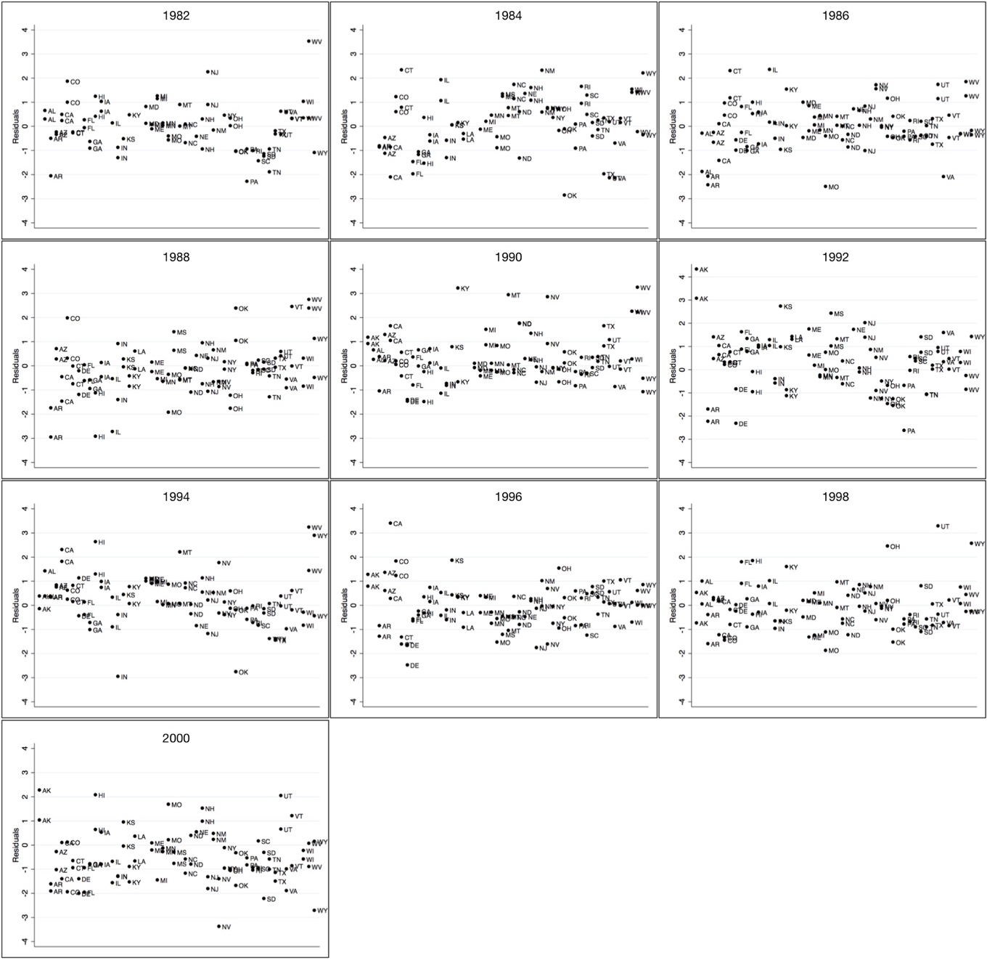

**SI Figure 5.1b: Errors Plotted Against Quantiles of the Normal Distribution**

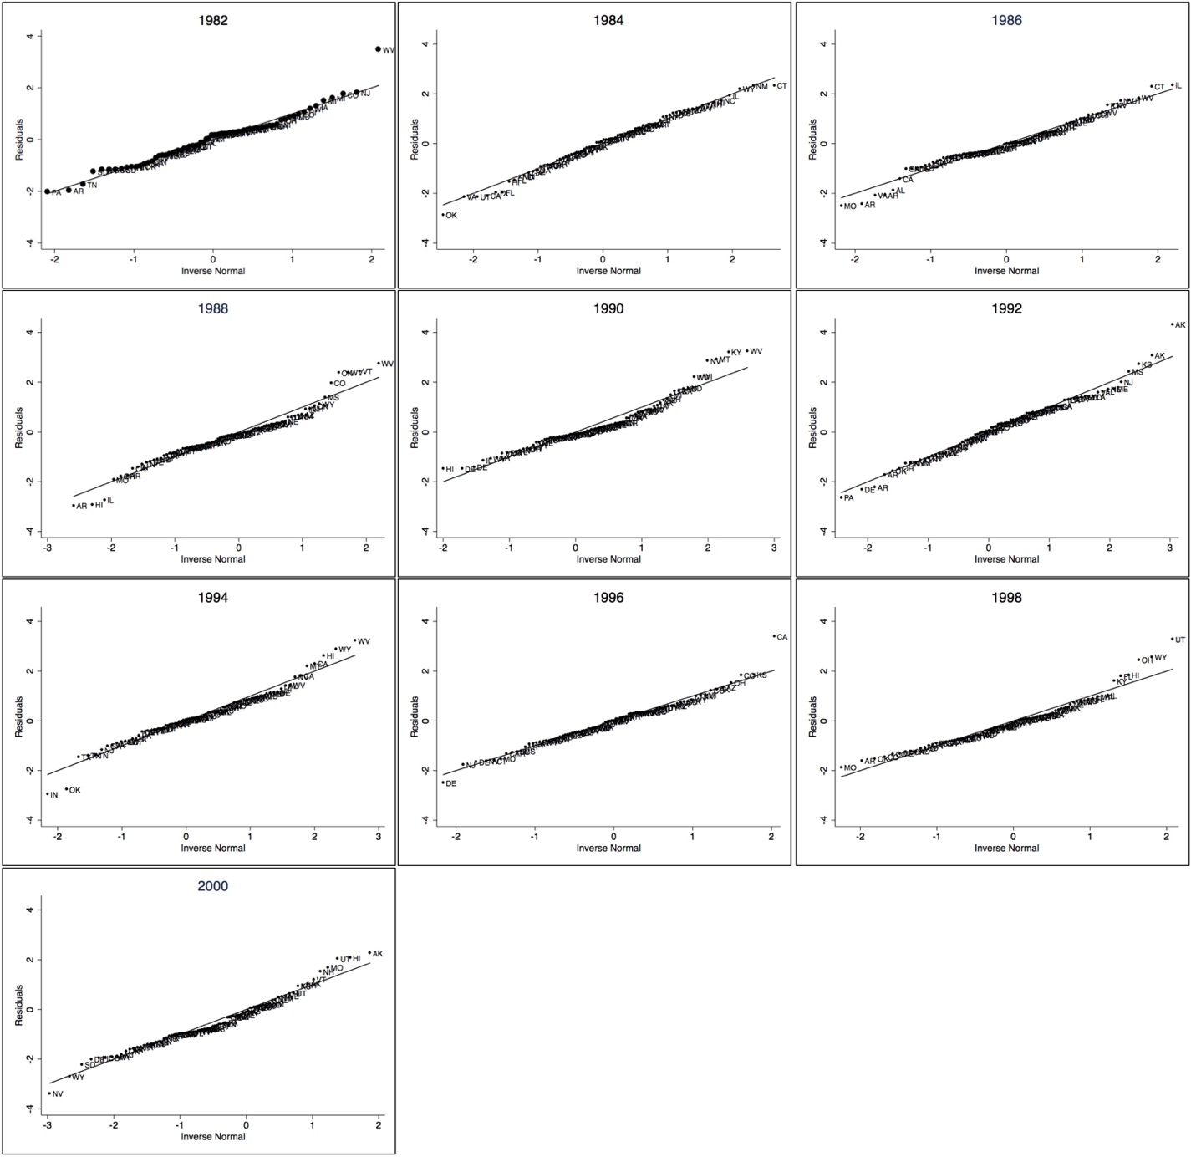

**SI 6. Alternative Measure of Legislative Capacity/Willingness to Use Power**

In order to ensure that our professionalism measure captures capacity and ability to use power – rather than power itself – we collected data about state governmental administration expenses. Although these expenses do form a component of the professionalism measure, they more closely speak to the willingness to use a power that has been institutionally granted to the legislature.

Our expenditures data was collected using the U.S. Census Bureau’s State Government Finances Database. Data is provided starting with 1992, so the addition of this measure does lead to a decline in the number of observations in our analysis.

The data provides both overall and per-capita expenditures and we rely on the per-capita expenditures. We present the results alongside the main results shown in the manuscript for comparison in SI Table 6.1 and SI Figure 6.1. In SI Table 6.2 and SI Figure 6.2 we present the results for the interaction with economic conditions.

|  |  |  |
| --- | --- | --- |
| SI Table 6.1: Models with Alternative Measures | | |
|  | Model 1:  In-Text | Model 2:  Alt Measure |
| Balance | 0.306 | 0.558 |
| (when prof/leg. exp. =0) | (0.178) | (0.253) |
| Professionalism | -1.689 | --- |
| (when balance =0) | (0.311) | --- |
| Balance x Professionalism | -2.059 | --- |
|  | (0.847) | --- |
| Legislative Expenses | --- | 0.003 |
| (when balance =0) | --- | (0.001) |
| Balance x Legislative Expenses | --- | -0.005 |
|  | --- | (0.002) |
| Term Limits | -0.006 | -0.539 |
|  | (0.142) | (0.306) |
| Term Limits in Effect | 0.000 | 0.000 |
|  | (0.000) | (0.000) |
| Redistricting | 0.218 | 0.526 |
|  | (0.148) | (0.194) |
| Multi-Member Districts | 0.235 | 0.406 |
|  | (0.091) | (0.142) |
| Partisan Climate | -0.259 | -0.652 |
|  | (0.421) | (0.593) |
| Fraction up | -2.201 | -1.966 |
|  | (0.168) | (0.238) |
| Divided Government | -0.087 | --- |
|  | (0.076) | --- |
| Unemployment | 0.039 | 0.105 |
|  | (0.040) | (0.075) |
| Presidential Election | -0.478 | -0.496 |
|  | (0.160) | (0.165) |
| 1982 | 1.163 | --- |
|  | (0.265) | --- |
| 1984 | 0.958 | --- |
|  | (0.195) | --- |
| 1986 | 0.325 | --- |
|  | (0.175) | --- |
| 1988 | 0.548 | --- |
|  | (0.182) | --- |
| 1990 | 0.614 | --- |
|  | (0.173) | --- |
| 1992 | 1.604 | 1.240 |
|  | (0.221) | (0.287) |
| 1994 | 1.148 | 1.283 |
|  | (0.243) | (0.299) |
| 1996 | 0.864 | 0.977 |
|  | (0.184) | (0.210) |
| Constant | 4.285 | 3.317 |
|  | (0.203) | (0.270) |
| *R*2 | 0.40 | 0.43 |
| *N* | 811 | 417 |

|  |  |
| --- | --- |
| SI Figure 6.1: Alternative Measure of Legislative Capacity to Exercise Power | |
| Model 1: Effects of Balance as Prof. Increases (In-Text) | Model 2: Effect of Balance as Leg. Exp. Increase |
| Replication%20SI%206%20Done/fig611.jpg | Replication%20SI%206%20Done/fig612.jpg |

|  |  |  |
| --- | --- | --- |
| SI Table 6.2: Alternative measure of capacity, economic conditions included | | |
|  | Model 1,  in text | Model 2 |
| Balance | 0.296 | 0.620 |
| (When prof, legislative expenses, economy =0) | (0.179) | (0.258) |
| prof | -1.522 | --- |
| (when balance, economy=0) | (0.318) | --- |
| Legislative Expenses | --- | 0.004 |
| (when balance, economy=0) | --- | (0.001) |
| Balance x Prof | -2.205 | --- |
| (when economy=0) | (0.846) | --- |
| Balance x Legislative Expenses | --- | -0.006 |
| (when economy=0) | --- | (0.002) |
| Economic Conditions | -0.021 | -0.063 |
| (when balance, prof, legislative expenses=0) | (0.059) | (0.112) |
| Balance x Economy | -0.164 | 0.125 |
| (when prof, legislative expenses=0) | (0.116) | (0.237) |
| Prof x Economy | 0.391 | --- |
| (when balance=0) | (0.179) | --- |
| Legislative Expenses x Economy | --- | 0.002 |
| (when balance=0) | --- | (0.001) |
| Balance x Prof x Economy | 0.199 | --- |
|  | (0.505) | --- |
| Balance x Legislative Expenses x Economy | --- | -0.004 |
|  | --- | (0.002) |
|  |  |  |
|  |  |  |
| Term Limits | -0.035 | -0.654 |
|  | (0.142) | (0.306) |
| Term Limits in Effect | 0.000 | 0.000 |
|  | (0.000) | (0.000) |
| Redistricting | 0.220 | 0.433 |
|  | (0.147) | (0.192) |
| Multi-member Districts | 0.231 | 0.398 |
|  | (0.090) | (0.140) |
| Partisan Changes | -0.411 | -0.688 |
|  | (0.424) | (0.589) |
| Fraction | -2.188 | -1.979 |
|  | (0.167) | (0.233) |
| Divided Government | -0.084 | -0.162 |
|  | (0.076) | (0.104) |
| Presidential Election | -0.471 | -0.444 |
|  | (0.159) | (0.163) |
| 1982 | 1.178 | --- |
|  | (0.264) | --- |
| 1984 | 0.941 | --- |
|  | (0.195) | --- |
| 1986 | 0.346 | --- |
|  | (0.175) | --- |
| 1988 | 0.565 | --- |
|  | (0.181) | --- |
| 1990 | 0.640 | --- |
|  | (0.172) | --- |
| 1992 | 1.602 | 1.371 |
|  | (0.219) | (0.286) |
| 1994 | 1.205 | 1.300 |
|  | (0.242) | (0.295) |
| 1996 | 0.890 | 0.943 |
|  | (0.184) | (0.206) |
|  |  |  |
|  |  |  |
| Constant | 4.253 | 3.349 |
|  | (0.203) | (0.271) |
| *R*2 | 0.41 | 0.46 |
| *N* | 811 | 417 |

|  |
| --- |
| SI Figure 6.2: Effect of Balance As the Economy Changes |
| Model 1 (In-text Model) |
| New%20Version%20Figure%202.jpg |
| Model 2 |
|  |

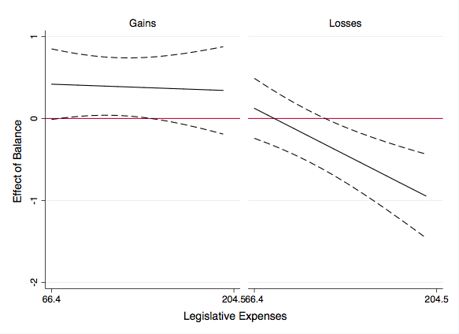

**SI 7. Strategic Entry and Exit in Elections**

In the next set of analyses we consider the extent to which our results change when we account for the possibility of strategic entry and exit in elections. In particular, we account for strategic retirements and non-electoral turnover.

We present all results alongside the in-text results in the manuscript.

The first additional tests we complete to account for strategic entry into elections relies on probabilities calculated by Carey, Niemi and Powell (2000). The Carey et al (2000) probabilities account for the probability of an incumbent retaining office based on state political culture. If challengers enter strategically, then states where incumbents have lower probabilities of retaining office should have more quality challengers. As a result, including the Carey et al (2000) probabilities should account for conditions that may be more likely to create strategic entry by quality challengers. We present these results in Model 2 in SI Table 7.1. Due to the years for which probabilities were calculated, the N is lower. We present the results, accounting for the effects of economic conditions, in SI Table 7.2, Model 2.

As a next step, we rely on a different dependent variable. The dependent variable we use in the main text is a measure of *electoral* turnover. An alternative specification is one that relies on *all* turnover. This dependent variable includes turnover that may have been due to strategic decisions not to run for re-election. We present these results in Model 3, SI Table 7.1. We present the results, accounting for the effects of economic conditions, in SI Table 7.2, Model 3.

The effect of balance, using these alternative model specifications, are shown in SI Figure 7.1.

|  |  |  |  |
| --- | --- | --- | --- |
| SI Table 7.1: Accounting for Strategic Exit and Entry | | | |
|  | Model 1:  In-Text | Model 2:  Incumbent Prob. | Model 3:  All Turnover |
| Balance | 0.306 | 0.416 | 0.426 |
| (when professionalism=0) | (0.178) | (0.195) | (0.146) |
| Professionalism | -1.689 | -1.308 | -0.864 |
| (when balance=0) | (0.311) | (0.334) | (0.255) |
| Balance x Professionalism | -2.059 | -2.497 | -2.565 |
|  | (0.847) | (0.932) | (0.709) |
| Term Limits | -0.006 | -0.132 | 0.500 |
|  | (0.142) | (0.137) | (0.117) |
| Term Limits in Effect | 0.000 | 0.000 | 0.000 |
|  | (0.000) | (0.000) | (0.000) |
| Redistricting | 0.218 | 0.889 | 0.282 |
|  | (0.148) | (0.127) | (0.114) |
| Multi-Member Districts | 0.235 | 0.281 | 0.239 |
|  | (0.091) | (0.094) | (0.075) |
| Partisan Climate | -0.259 | 0.967 | -0.070 |
|  | (0.421) | (0.281) | (0.348) |
| Fraction Up for Reelection | -2.201 | --- | 1.711 |
|  | (0.168) | --- | (0.095) |
| Divided Government | -0.087 | 0.029 | -0.061 |
|  | (0.076) | (0.084) | (0.062) |
| Unemployment | 0.039 | 0.064 | 0.015 |
|  | (0.040) | (0.033) | (0.031) |
| Presidential Election | -0.478 | -0.089 | -0.073 |
|  | (0.160) | (0.085) | (0.131) |
| 1982 | 1.163 | --- | 0.744 |
|  | (0.265) | --- | (0.212) |
| 1984 | 0.958 | --- | 0.385 |
|  | (0.195) | --- | (0.160) |
| 1986 | 0.325 | --- | 0.116 |
|  | (0.175) | --- | (0.143) |
| 1988 | 0.548 | --- | 0.094 |
|  | (0.182) | --- | (0.150) |
| 1990 | 0.614 | --- | 0.340 |
|  | (0.173) | --- | (0.140) |
| 1992 | 1.604 | --- | 0.776 |
|  | (0.221) | --- | (0.178) |
| 1994 | 1.148 | --- | 0.517 |
|  | (0.243) | --- | (0.198) |
| 1996 | 0.864 | --- | 0.164 |
|  | (0.184) | --- | (0.153) |
| Probability of re-election | --- | -0.001 | --- |
| (Carey et al 2000) | --- | (0.004) | --- |
| Constant | 4.285 | 2.023 | 0.418 |
|  | (0.203) | (0.130) | (0.137) |
| *R*2 | 0.40 | 0.32 | 0.43 |

|  |  |
| --- | --- |
| SI Figure 7.1: Accounting for Strategic Exit and Entry | |
| Model 1: Effects of Balance as Prof. Increases (In-Text) | Model 2: Effects of Balance, Controlling for Probability of Reelection |
| Replication%20SI%207%20Done/fig711.jpg | Replication%20SI%207%20Done/fig712.jpg |
| Model 3: Effects of Balance, Full Turnover |  |
| Replication%20SI%207%20Done/fig713.jpg |  |

|  |  |  |  |
| --- | --- | --- | --- |
| SI Table 7.2: Accounting for Strategic Entry and Exit, Triple Interaction | | | |
|  | Model 1  In Text | Model 2 | Model 3 |
| Balance | 0.296 | 0.461 | 0.421 |
| (when professionalism, economy =0) | (0.179) | (0.186) | (0.148) |
| Professionalism | -1.522 | -1.118 | -0.745 |
| (when balance=0) | (0.318) | (0.327) | (0.263) |
| Balance x Professionalism | -2.205 | -2.836 | -2.645 |
| (when economy=0) | (0.846) | (0.887) | (0.713) |
| Economy | -0.021 | -0.014 | -0.022 |
|  | (0.059) | (0.060) | (0.047) |
| Balance x Economy | -0.164 | -0.151 | -0.106 |
| (when professionalism=0) | (0.116) | (0.120) | (0.094) |
| Professionalism x Economy | 0.391 | 0.432 | 0.245 |
| (when balance =0) | (0.179) | (0.179) | (0.145) |
| Balance x Professionalism x Economy | 0.199 | 0.416 | 0.217 |
|  | (0.505) | (0.531) | (0.424) |
| Term Limits | -0.035 | -0.065 | 0.486 |
|  | (0.142) | (0.152) | (0.117) |
| Term Limits | 0.000 | 0.000 | 0.000 |
|  | (0.000) | (0.000) | (0.000) |
| Redistricting | 0.220 | 0.188 | 0.280 |
|  | (0.147) | (0.200) | (0.114)* |
| Multi-member Districts | 0.231 | 0.281 | 0.240 |
|  | (0.090) | (0.089) | (0.074) |
| Partisanship | -0.411 | -0.687 | -0.166 |
|  | (0.424) | (0.443) | (0.351) |
| Fraction | -2.188 | --- | 1.705 |
|  | (0.167) | --- | (0.095) |
| Divided Government | -0.084 | 0.018 | -0.055 |
|  | (0.076) | (0.079) | (0.062) |
| Presidential Election | -0.471 | -0.217 | -0.068 |
|  | (0.159) | (0.165) | (0.131) |
| 1982 | 1.178 | 1.142 | 0.757 |
|  | (0.264) | (0.299) | (0.212) |
| 1984 | 0.941 | 0.876 | 0.394 |
|  | (0.195) | (0.198) | (0.161) |
| 1986 | 0.346 | 0.423 | 0.132 |
|  | (0.175) | (0.179) | (0.143) |
| 1988 | 0.565 | 0.450 | 0.110 |
|  | (0.181) | (0.189) | (0.150) |
| 1990 | 0.640 | 0.537 | 0.346 |
|  | (0.172) | (0.176) | (0.139) |
| 1992 | 1.602 | 1.357 | 0.771 |
|  | (0.219) | (0.259) | (0.178) |
| 1994 | 1.205 | 1.268 | 0.557 |
|  | (0.242) | (0.245) | (0.199) |
| 1996 | 0.890 | 0.688 | 0.182 |
|  | (0.184) | (0.194) | (0.153) |
| Probability of re-election | --- | -0.002 | --- |
| (Carey et al 2000) | --- | (0.004) | --- |
| Constant | 4.253 | 1.863 | 0.406 |
|  | (0.203) | (0.153) | (0.137) |
| *R*2 | 0.41 | 0.42 | 0.44 |
| *N* | 811 | 415 | 881 |

|  |
| --- |
| **SI Figure 7.2: Effect of Balance, Accounting for Economics** |
| Model 1 |
| New%20Version%20Figure%202.jpg |
| Model 2 |
| **../../Supplementary%20Information/SI%20Strategic%20Exit/triple%20strategy%20prob%20reelect.jpg** |
| Model 3 |
|  |

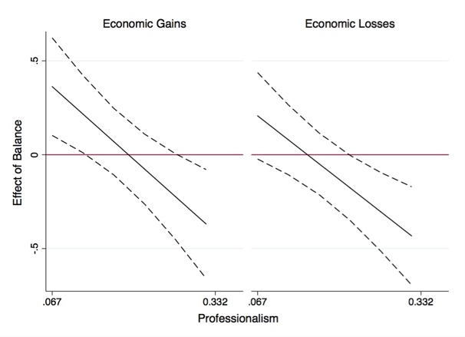

**SI 8. Joint Distribution of Key Factors**

We consider the joint distribution of balance, professionalism and economic conditions in order to ensure that our results are not due to a coincidental confluence of factors. To consider what type of distribution, we return to a version of Table 1 (in text). The new version of the table reports our results, rather than predictions. Our findings suggest that we find the lower levels of turnover under conditions of high ambiguity and economic losses. Since, however, our results are based on a triple interaction between professionalism, balance and economics, it is possible that our results may be a function of distributions of power, rather than our actual theoretic predictions.

To consider whether our results are function of distributions, we track the joint distribution of balance, unemployment and professionalism. If, for example, it just so happens that professionalism levels are higher in states that have balanced government and economic losses, the patterns of turnover may be a function of an incidental confluence of conditions. In SI Table 8.1 below we report actual average levels of professionalism by subgroup – balanced states with losses, balanced states with gains, etc. Losses and gains are defined at median point (above or below median). The patterns of average professionalism across subgroups demonstrate that we see virtually equivalent levels of professionalism across subgroups. In particular, we do not see higher levels of professionalism in the subgroup that presents the lowest level of turnover: economic losses with a balanced power distribution. [2]

|  |  |  |
| --- | --- | --- |
| **SI Table 8.1: Mean Values of Professionalism** | | |
| **Economics** | **Power Distribution** | **Mean Professionalism** |
| ***Losses*** | **Balanced** | 0.16 |
| *Gains* |  | 0.18 |
| *Losses* | **Unbalanced** | 0.19 |
| *Gains* |  | 0.22 |

We can consider these distributions though a correlation as well. In particular, we plot the correlation of professionalism and unemployment in both balanced and unbalanced conditions. We see that the correlation is not only very low, but that 95% confidence intervals around the correlation overlap when we compare balanced and unbalanced environments, suggesting that there is little likelihood of systematic patterns.[3] We present the patterns in SI Figure 8.1 below.

|  |
| --- |
| SI Figure 8.1: Correlations and Confidence Intervals by Government Type |
| ../../../../Downloads/Yanna%20Correlation.jpeg |

**SI 9. Divided Government**

To consider whether divided government moderates the effect of ambiguity, we estimate several models, presented in SI Table 9.1. First, we estimate a model that excludes ambiguity and simply considers divided government (Model 3). Second, we consider a model that relies on an interaction between divided government and our institutional balance measure (Model 4). We also estimate a model that relies on a tripe interaction between divided government, institutional balance and professionalism (Model 6).

We also estimated a model that relied on a quadruple interaction between divided government, institutional balance, professionalism (as a measure of capacity to exercise institutional power) and economic conditions (Model 5).

We want to note, however, that our dependent variable is a general measure of turnover. Though the patterns do hint that divided government may moderate the effects of ambiguity, we believe that a more precise model would include a measure of turnover by party. This type of variable would be more likely to capture the effects of unified government.

We present all the results in SI Table 9.1 below, with the in-text results for comparison.

|  |  |  |  |  |  |  |  |
| --- | --- | --- | --- | --- | --- | --- | --- |
| SI Table 9.1: Patterns in Divided Government | | | | | | | |
|  | Model 1:  In-Text | Model 2:  In-Text | Model 3 | Model 4 | Model 5 | Model 6 | Model 7 |
| Balance | 0.306 | 0.296 | --- | 0.072 | 0.558 | 0.020 | 0.498 |
| (when other factors =0) | (0.178) | (0.179) | --- | (0.142) | (0.268) | (0.144) | (0.271) |
| Professionalism | -1.689 | -1.522 | -1.912 | --- | -2.129 | --- | -2.103 |
| (when balance = 0) | (0.311) | (0.318) | (0.294) | --- | (0.617) | --- | (0.619) |
| Balance x Professionalism | -2.059 | -2.205 |  |  | -3.673 |  | -3.568 |
| (when other factors =0) | (0.847) | (0.846) |  |  | (1.620) |  | (1.620) |
| Divided government | --- | --- | --- | -0.054 | -0.171 | -0.045 | -0.218 |
| (when other factors =0) | --- | --- | --- | (0.084) | (0.156) | (0.085) | (0.159) |
| Balance x Divided Government | --- | --- | --- | -0.237 | -0.497 | -0.210 | -0.354 |
| (when some factors =0) | --- | --- | --- | (0.189) | (0.366) | (0.192) | (0.370) |
| Divided Government x Prof. | --- | --- | --- | --- | 0.565 | --- | 0.792 |
| (when some factors=0) | --- | --- | --- | --- | (0.714) | --- | (0.721) |
| Balance x Div. Gov x Prof | --- | --- | --- | --- | 2.602 | --- | 2.028 |
| (when some factors =0) | --- | --- | --- | --- | (1.932) | --- | (1.935) |
| Unemployment | --- | --- | --- | --- | --- | 0.045 | 0.042 |
| (interaction w/balance, div gov’t) | --- | --- | --- | --- | --- | (0.053) | (0.088) |
| Balance x Economics | --- | --- | --- | --- | --- | -0.158 | -0.114 |
| (interaction w/ div gov’t ) | --- | --- | --- | --- | --- | (0.079) | (0.156) |
| Div. Gov x Economics | --- | --- | --- | --- | --- | 0.043 | --- |
| (triple interaction) | --- | --- | --- | --- | --- | (0.056) | --- |
| Balance x DivGov x Econ | --- | --- | --- | --- | --- | 0.061 | --- |
| (when some factors =0) | --- | --- | --- | --- | --- | (0.117) | --- |
| Professionalism | --- | --- | --- | -1.916 | --- | -1.902 | --- |
| (not in interaction) | --- | --- | --- | (0.296) | --- | (0.295) | --- |
| Unemployment | 0.039 | -0.021 | 0.039 | 0.041 | 0.038 | --- | --- |
| (when some factors =0) | (0.040) | (0.059) | (0.040) | (0.040) | (0.040) | --- | --- |
| Balance x Economics | --- | -0.164 | --- | --- | --- | --- | --- |
| (when some factors =0) | --- | (0.116) | --- | --- | --- | --- | --- |
| Professionalism x Economics | --- | 0.391 | --- | --- | --- | --- | -0.007 |
| (when some factors =0) | --- | (0.179) | --- | --- | --- | --- | (0.357) |
| Balance x Prof. x Economics | --- | 0.199 | --- | ---- | --- | --- | -0.199 |
| (when some factors =0) | --- | (0.505) | --- | --- | --- | --- | (0.781) |
| Div. Gov x Economics | --- | --- | --- | --- | --- | --- | -0.093 |
| (quadruple interaction) | --- | --- | --- | --- | --- | --- | (0.106) |
| Balance x DivGov x Econ | --- | --- | --- | --- | --- | --- | -0.120 |
| (quadruple interaction ) | --- | --- | --- | --- | --- | --- | (0.259) |
| DivGov x Prof x Econ | --- | --- | --- | --- | --- | --- | 0.538 |
| (quadruple interaction ) | --- | --- | --- | --- | --- | --- | (0.419) |
| Balance x Div Gov x Prof x Econ | --- | --- | --- | --- | --- | --- | 0.791 |
| (quadruple interaction ) | --- | --- | --- | --- | --- | --- | (1.107) |
| Term Limits | -0.006 | -0.035 | -0.022 | -0.009 | -0.013 | -0.023 | -0.048 |
|  | (0.142) | (0.142) | (0.143) | (0.143) | (0.143) | (0.144) | (0.145) |
| Term Limits in Effect | 0.000 | 0.000 | 0.000 | 0.000 | 0.000 | 0.000 | 0.000 |
|  | (0.000) | (0.000 | (0.000) | (0.000) | (0.000) | (0.000) | (0.000) |
| Redistricting | 0.218 | 0.220 | 0.212 | 0.222 | 0.239 | 0.233 | 0.217 |
|  | (0.148) | (0.147) | (0.148) | (0.148) | (0.148) | (0.148) | (0.148) |
| Multi-Member Districts | 0.235 | 0.231 | 0.255 | 0.252 | 0.234 | 0.247 | 0.225 |
|  | (0.091) | (0.090) | (0.091) | (0.091) | (0.091) | (0.090) | (0.091) |
| Partisan Climate | -0.259 | -0.411 | -0.247 | -0.227 | -0.179 | -0.238 | -0.384 |
|  | (0.421) | (0.424) | (0.421) | (0.422) | (0.423) | (0.421) | (0.428) |
| Fraction up | -2.201 | -2.188 | -2.160 | -2.160 | -2.203 | -2.166 | -2.207 |
|  | (0.168) | (0.167) | (0.168) | (0.168) | (0.168) | (0.168) | (0.168) |
| Divided Government | -0.087 | -0.084 | -0.099 | --- | --- | --- | --- |
| (not in interaction) | (0.076) | (0.076) | (0.076) | --- | --- | --- | --- |
| Presidential Election | -0.478 | -0.471 | -0.471 | -0.473 | -0.460 | -0.474 | -0.456 |
|  | (0.160) | (0.159) | (0.161) | (0.161) | (0.161) | (0.160) | (0.160) |
| 1982 | 1.163 | 1.178 | 1.144 | 1.122 | 1.143 | 1.117 | 1.231 |
|  | (0.265) | (0.264) | (0.265) | (0.266) | (0.266) | (0.266) | (0.268) |
| 1984 | 0.958 | 0.941 | 0.922 | 0.923 | 0.919 | 0.869 | 0.925 |
|  | (0.195) | (0.195) | (0.194) | (0.195) | (0.196) | (0.195) | (0.197) |
| 1986 | 0.325 | 0.346 | 0.313 | 0.310 | 0.299 | 0.301 | 0.348 |
|  | (0.175) | (0.175) | (0.176) | (0.176) | (0.176) | (0.175) | (0.176) |
| 1988 | 0.548 | 0.565 | 0.526 | 0.521 | 0.497 | 0.537 | 0.540 |
|  | (0.182) | (0.181) | (0.182) | (0.182) | (0.184) | (0.182) | (0.184) |
| 1990 | 0.614 | 0.640 | 0.576 | 0.578 | 0.582 | 0.581 | 0.619 |
|  | (0.173) | (0.172) | (0.172) | (0.172) | (0.173) | (0.172) | (0.173) |
| 1992 | 1.604 | 1.602 | 1.602 | 1.584 | 1.553 | 1.562 | 1.573 |
|  | (0.221) | (0.219) | (0.221) | (0.222) | (0.222) | (0.221) | (0.223) |
| 1994 | 1.148 | 1.205 | 1.148 | 1.128 | 1.101 | 1.124 | 1.197 |
|  | (0.243) | (0.242) | (0.243) | (0.244) | (0.244) | (0.243) | (0.246) |
| 1996 | 0.864 | 0.890 | 0.857 | 0.859 | 0.824 | 0.856 | 0.873 |
|  | (0.184) | (0.184) | (0.185) | (0.185) | (0.185) | (0.185) | (0.186) |
| Constant | 4.285 | 4.253 | 4.292 | 4.283 | 4.355 | 4.295 | 4.365 |
|  | (0.203) | (0.203) | (0.203) | (0.204) | (0.221) | (0.204) | (0.221) |
| *R*2 | 0.40 | 0.41 | 0.40 | 0.40 | 0.40 | 0.40 | 0.42 |
| *N* | 811 | 811 | 811 | 811 | 811 | 811 | 811 |

As these results may be difficult to interpret we include the appropriate marginal effects plots. The plots present the of the effect of balance (SI Figure 9.1).

|  |  |  |
| --- | --- | --- |
| SI Figure 9.1: Effect of Balance | | |
| Model 4 | Model 5: Unified Government | Model 5: Divided Government |
| Replication%20SI%209/fig914.jpg | Replication%20SI%209/fig915u.jpg | Replication%20SI%209/fig915d.jpg |
| Model 6: Unified Government | Model 6: Divided Government | Model 7: Unified, Economic Losses |
| Replication%20SI%209/fig916u.jpg | Replication%20SI%209/fig916d.jpg | Replication%20SI%209/fig917u.jpg |
| Model 7: Divided, Economic Losses |  |  |
| Replication%20SI%209/fig917d.jpg |  |  |

**SI 10: Gubernatorial Capacity**

Our in-text results capture the capacity of the legislatures to use the powers granted to them when dealing with the budget. In this appendix we consider approaches to capturing the capacity of the governor to do so. Notably, it is more difficult to capture gubernatorial capacity as there is less variance in this factor. In particular, as Kousser and Phillips (2012) demonstrate, when it comes to the budgetary powers, there are relatively few systematic factors that seem to predict exercise of power. As a result, are approach here is somewhat limited. We present all the results on our different measures in SI Table 10.1.

First, we consider gubernatorial capacity using gubernatorial popularity (SI Table 10.1, Model 2 and 3); we use Beyle’s approval rating data.[4] This may seem like a reasonable approach, since a more popular governor may believe that he or she has more leeway to exercise power. Kousser and Phillips (2012) find *no evidence* that this is the case when it comes to the budget. In fact, they see a null relationship between popularity and success in budgetary powers. We find similar null results. The interaction between balance and gubernatorial popularity, and the triple interaction between balance, professionalism and popularity leads to null effects.

Second, we use a different measure of gubernatorial capacity. Woods and Baranowski (2007) suggest that governors generally are more willing to use powerful and behave in ways that make them appear more powerful if they have some extended capacity to affect agencies. Although this may be an indirect measure, we capture this capacity with a measure of appointment power. Presumably, governors who have higher levels of appointment power have a higher level of control over government agencies, giving them a higher capacity. We present the results in Model 4 and Model 5. Here we do see that as high levels of legislative capacity (measured as professionalism) and high level of gubernatorial proxy capacity (measured as appointment power) come together, balance further decreases turnover. In other words, accounting for gubernatorial capacity reinforces our previous findings.

As a third step, we use still another measure of capacity. Kousser and Phillips (2012) suggest that the longer the session, the more power the governor has over budgetary outcomes. In this case then, the length of session could again be a proxy for capacity. We test this possibility in Models 6 and 7. We find again that as professionalism and session length come together, balance decreases turnover.

We demonstrate the substantive effects across all models in SI Figure 10.1.

Although the results we present generally reinforce the findings in the manuscript, we want to note that these approaches to gubernatorial capacity are merely proxy measures. Moreover, given existent literature on gubernatorial capacity it is not clear that among governors there is as high a variance in capacity as a willingness to exercise power as exists among legislatures.

|  |  |  |  |  |  |  |  |
| --- | --- | --- | --- | --- | --- | --- | --- |
| Table 10.1: Addition of Gubernatorial Capacity Measures | | | | | | | |
|  | Model 1:  In-Text | Model 2 | Model 3 | Model 4 | Model 5 | Model 6 | Model 7 |
| Balance | 0.306 | -0.348 | 1.177 | 0.344 | 0.322 | 0.092 | 0.854 |
| (when factors=0) | (0.178) | (0.477) | (0.829) | (0.288) | (0.666) | (0.149) | (0.284) |
| Prof. | -1.689 | --- | 1.496 |  | -1.050 |  | -2.062 |
| (when factors =0) | (0.311) | --- | (1.465) |  | (1.064) |  | (0.526) |
| Balance x Prof. | -2.059 | --- | -7.561 | --- | -0.638 | --- | -3.811 |
| (when factors =0) | (0.847) | --- | (3.744) | --- | (3.180) | --- | (1.244) |
| Gubernatorial Approval | --- | -0.003 | 0.011 | --- | --- | --- | --- |
|  | --- | (0.004) | (0.007) | --- | --- | --- | --- |
| Balance x Gub. Approval | --- | 0.007 | -0.014 | --- | --- | --- | --- |
| (when factors =0) | --- | (0.008) | (0.015) | --- | --- | --- | --- |
| Gub Approval x Prof | --- | --- | -0.067 | --- | --- | --- | --- |
| (when factors =0) | --- | --- | (0.027) | --- | --- | --- | --- |
| Balance x Gub. App. x Prof | --- | --- | 0.102 | --- | --- | --- | --- |
|  | --- | --- | (0.073) | --- | --- | --- | --- |
| Appointment Power | --- | --- | --- | -0.028 | 0.006 | --- | --- |
| (when other vars. = 0) | --- | --- | --- | (0.040) | (0.074) | --- | --- |
| Balance x Appt. Power | --- | --- | --- | -0.126 | -0.014 | --- | --- |
| (when other vars. =0) | --- | --- | --- | (0.085) | (0.210) | --- | --- |
| Prof x Appoint. Power | --- | --- | --- | --- | -0.181 | --- | --- |
| (when other vars. =0) | --- | --- | --- | --- | (0.297) | --- | --- |
| Balance x Prof x Appt. Power | --- | --- | --- | --- | -0.362 | --- | --- |
|  | --- | --- | --- | --- | (0.939) | --- | --- |
| Length of Session | --- | --- | --- | --- | --- | 0.003 | 0.005 |
| (when vars =0) | --- | --- | --- | --- | --- | (0.001) | (0.001) |
| Balance x Length Session | --- | --- | --- | --- | --- | -0.002 | -0.010 |
| (when vars=0) | --- | --- | --- | --- | --- | (0.002) | (0.005) |
| Length of Session x Prof | --- | --- | --- | --- | --- | --- | -0.006 |
| (when vars =0) | --- | --- | --- | --- | --- | --- | (0.003) |
| Balance x Length x Prof | --- | --- | --- | --- | --- | --- | 0.029 |
|  | --- | --- | --- | --- | --- | --- | (0.012) |
| Prof |  | -2.243 |  | -1.863 |  | -2.915 |  |
| (not in interaction) |  | (0.355) |  | (0.297) |  | (0.385) |  |
| Term Limits | -0.006 | 0.194 | 0.189 | -0.018 | 0.007 | 0.022 | 0.025 |
|  | (0.142) | (0.173) | (0.174) | (0.143) | (0.143) | (0.142) | (0.142) |
| Term Limits in Effect | 0.000 | 0.000 | 0.000 | 0.000 | 0.000 | 0.000 | 0.000 |
|  | (0.000) | (0.000) | (0.000) | (0.000) | (0.000) | (0.000) | (0.000) |
| Redistricting | 0.218 | 0.266 | 0.261 | 0.202 | 0.209 | 0.206 | 0.212 |
|  | (0.148) | (0.179) | (0.178) | (0.148) | (0.148) | (0.147) | (0.146) |
| Multi-member Districts | 0.235 | 0.302 | 0.266 | 0.260 | 0.243 | 0.263 | 0.250 |
|  | (0.091) | (0.113) | (0.113) | (0.091) | (0.091) | (0.090) | (0.090) |
| Partisan Changes in State | -0.259 | -0.626 | -0.600 | -0.338 | -0.399 | -0.260 | -0.215 |
|  | (0.421) | (0.514) | (0.511) | (0.424) | (0.430) | (0.418) | (0.417) |
| Fraction up for reelection | -2.201 | -2.095 | -2.089 | -2.180 | -2.217 | -2.236 | -2.303 |
|  | (0.168) | (0.202) | (0.201) | (0.168) | (0.169) | (0.167) | (0.168) |
| Divided Government | -0.087 | -0.042 | -0.019 | -0.094 | -0.086 | -0.097 | -0.088 |
|  | (0.076) | (0.092) | (0.092) | (0.076) | (0.076) | (0.076) | (0.075) |
| Unemployment | 0.039 | 0.012 | -0.008 | 0.041 | 0.040 | 0.047 | 0.042 |
|  | (0.040) | (0.051) | (0.051) | (0.040) | (0.040) | (0.039) | (0.039) |
| Presidential Election | -0.478 | -0.471 | -0.467 | -0.469 | -0.475 | -0.498 | -0.510 |
|  | (0.160) | (0.186) | (0.185) | (0.161) | (0.160) | (0.159) | (0.159) |
| 1982 | 1.163 | 1.160 | 1.180 | 1.180 | 1.217 | 1.212 | 1.227 |
|  | (0.265) | (0.393) | (0.391) | (0.267) | (0.269) | (0.264) | (0.263) |
| 1984 | 0.958 | 0.978 | 0.987 | 0.950 | 0.995 | 1.056 | 1.079 |
|  | (0.195) | (0.282) | (0.281) | (0.195) | (0.197) | (0.196) | (0.195) |
| 1986 | 0.325 | 0.561 | 0.567 | 0.329 | 0.365 | 0.376 | 0.382 |
|  | (0.175) | (0.213) | (0.213) | (0.176) | (0.178) | (0.175) | (0.174) |
| 1988 | 0.548 | 0.639 | 0.633 | 0.539 | 0.571 | 0.628 | 0.641 |
|  | (0.182) | (0.234) | (0.233) | (0.182) | (0.183) | (0.183) | (0.182) |
| 1990 | 0.614 | 0.746 | 0.815 | 0.584 | 0.627 | 0.601 | 0.561 |
|  | (0.173) | (0.204) | (0.203) | (0.173) | (0.174) | (0.171) | (0.172) |
| 1992 | 1.604 | 1.683 | 1.739 | 1.619 | 1.621 | 1.637 | 1.633 |
|  | (0.221) | (0.266) | (0.265) | (0.221) | (0.221) | (0.219) | (0.218) |
| 1994 | 1.148 | 1.228 | 1.215 | 1.180 | 1.203 | 1.149 | 1.126 |
|  | (0.243) | (0.282) | (0.280) | (0.244) | (0.246) | (0.241) | (0.241) |
| 1996 | 0.864 | 0.948 | 0.953 | 0.864 | 0.880 | 0.876 | 0.877 |
|  | (0.184) | (0.212) | (0.210) | (0.185) | (0.186) | (0.183) | (0.182) |
| Constant | 4.285 | 4.374 | 3.544 | 4.404 | 4.279 | 4.309 | 4.175 |
|  | (0.203) | (0.331) | (0.454) | (0.238) | (0.316) | (0.202) | (0.220) |
| *R*2 | 0.40 | 0.39 | 0.40 | 0.40 | 0.40 | 0.41 | 0.42 |
| *N* | 811 | 573 | 573 | 811 | 811 | 811 | 811 |

|  |  |
| --- | --- |
| SI Figure 10.1: Substantive Effects with Measures of Gubernatorial Capacity | |
| Model 1: In Text | Model 2: Effect of Balance |
| ../fig1011.jpg | ../fig1012.jpg |
| Model 3: Effect of Balance, Low Prof | Model 3: Effect of Balance, High Prof |
| ../fig103low.jpg | ../fig1013high.jpg |
| Model 4: Effect of Balance | Model 5: Effect of Balance, Low Prof |
| ../fig1014.jpg | ../fig1015.jpg |
|  |  |
|  |  |
| Model 5: Effect of Balance, High Prof | Model 6: Effect of Balance |
| ../fig1015high.jpg | ../fig1016.jpg |
| Model 7: Effect of Balance, Low Prof | Model 7: Effect of Balance, High Prof |
| ../fig1017.jpg | ../fig1017high.jpg |

**SI 11. National Factors**

Our results focus on state-level conditions. In SI Table 11.1 we present our models with control for national-level conditions: national unemployment and Congressional turnover. As the inclusion of these factors affects our by-year controls, we also present the results without the by-year controls to ensure robustness (SI Table 11.2).

|  |  |  |  |  |  |  |
| --- | --- | --- | --- | --- | --- | --- |
| SI Table 11.1: National Controls | | | | | | |
|  | Model 1, text | Model 2 | Model 3 | Model 4 | Model 5 | Model 6 |
| Balance | 0.306 | 0.306 | 0.304 | 0.306 | 0.306 | 0.306 |
| (when prof=0) | (0.178) | (0.178) | (0.178) | (0.178) | (0.178) | (0.178) |
| Prof. | -1.689 | -1.689 | -1.700 | -1.689 | -1.689 | -1.689 |
| (when bal.=0) | (0.311) | (0.311) | (0.310) | (0.311) | (0.311) | (0.311) |
| **Balance x** | **-2.059** | **-2.059** | **-2.058** | **-2.059** | **-2.059** | **-2.059** |
| **Prof** | **(0.847)** | **(0.847)** | **(0.847)** | **(0.847)** | **(0.847)** | **(0.847)** |
| Term Lim. | -0.006 | -0.006 | -0.015 | -0.006 | -0.006 | -0.006 |
|  | (0.142) | (0.142) | (0.142) | (0.142) | (0.142) | (0.142) |
| Term. Lim. | 0.000 | 0.000 | 0.000 | 0.000 | 0.000 | 0.000 |
| in effect | (0.000) | (0.000) | (0.000) | (0.000) | (0.000) | (0.000) |
| Redist. | 0.218 | 0.218 | 0.222 | 0.218 | 0.218 | 0.218 |
|  | (0.148) | (0.148) | (0.148) | (0.148) | (0.148) | (0.148) |
| MMDs | 0.235 | 0.235 | 0.233 | 0.235 | 0.235 | 0.235 |
|  | (0.091) | (0.091) | (0.091) | (0.091) | (0.091) | (0.091) |
| Partisan | -0.259 | -0.259 | -0.229 | -0.259 | -0.259 | -0.259 |
| Climate | (0.421) | (0.421) | (0.419) | (0.421) | (0.421) | (0.421) |
| Fraction | -2.201 | -2.201 | -2.202 | -2.201 | -2.201 | -2.201 |
|  | (0.168) | (0.168) | (0.168) | (0.168) | (0.168) | (0.168) |
| Div. Gov. | -0.087 | -0.087 | -0.089 | -0.087 | -0.087 | -0.087 |
|  | (0.076) | (0.076) | (0.076) | (0.076) | (0.076) | (0.076) |
| State | 0.039 | 0.039 | --- | 0.039 | 0.039 | 0.039 |
| Unemp. | (0.040) | (0.040) | --- | (0.040) | (0.040) | (0.040) |
| 1982 | 1.163 | 5.229 | 5.237 | --- | --- | --- |
|  | (0.265) | (1.302) | (1.302) | --- | --- | --- |
| 1984 | 0.958 | -1.074 | -1.084 | --- | --- | --- |
|  | (0.195) | (0.620) | (0.619) | --- | --- | --- |
| 1986 | 0.325 | 0.804 | 0.796 | 1.230 | 1.442 | --- |
|  | (0.175) | (0.177) | (0.177) | (0.363) | (0.331) | --- |
| 1988 | 0.548 | -0.648 | -0.662 | 0.215 | 0.426 | 0.795 |
|  | (0.182) | (0.354) | (0.354) | (0.160) | (0.163) | (0.201) |
| 1990 | 0.614 | 1.809 | 1.806 | -0.122 | -0.125 | 1.024 |
|  | (0.173) | (0.355) | (0.355) | (0.201) | (0.210) | (0.273) |
| 1992 | 1.604 | 4.474 | 4.468 | 0.347 | 1.536 | -2.452 |
|  | (0.221) | (1.057) | (1.056) | (0.289) | (0.591) | (0.769) |
| 1994 | 1.148 | 0.550 | 0.531 | 0.062 | 1.351 | -2.666 |
|  | (0.243) | (0.356) | (0.356) | (0.263) | (0.446) | (0.678) |
| 1996 | 0.864 | 0.625 | 0.623 | -0.305 | 1.460 | -1.728 |
|  | (0.184) | (0.164) | (0.164) | (0.193) | (0.457) | (0.524) |
| Presidential | -0.478 | -- | --- | 0.153 | 0.240 | -0.248 |
| Election | (0.160) | --- | --- | (0.195) | (0.162) | (0.128) |
| National | --- | -1.196 | -1.166 | --- | --- | -0.558 |
| Unemp. | --- | (0.401) | (0.399) | --- | --- | (0.128) |
| House | --- | --- | --- | -11.282 | --- | --- |
| Reelect. | --- | --- | --- | (3.605) | --- | --- |
| Senate | --- | --- | --- | 6.611 | --- | --- |
| Reelect | --- | --- | --- | (2.150) | --- | --- |
| House | --- | --- | --- | --- | -5.108 | -35.078 |
| Turnover | --- | --- | --- | --- | (3.302) | (6.753) |
| Senate | --- | --- | --- | --- | 23.957 | 0.254 |
| Turnover | --- | --- | --- | --- | (4.865) | (2.608) |
| Constant | 4.285 | 3.209 | 3.210 | 9.446 | -13.153 | 35.155 |
|  | (0.203) | (0.333) | (0.333) | (4.783) | (6.262) | (7.505) |
| *R*2 | 0.40 | 0.40 | 0.40 | 0.40 | 0.40 | 0.40 |
| *N* | 811 | 811 | 811 | 811 | 811 | 811 |

|  |  |  |  |  |
| --- | --- | --- | --- | --- |
| SI Table 11.2: National Controls, No By-Year Controls | | | | |
|  | Model 1,  in text | Model 7 | Model 8 | Model 9 |
| Balance | 0.306 | 0.261 | 0.245 | 0.243 |
| (when prof=0) | (0.178) | (0.178) | (0.179) | (0.179) |
| Professionalism | -1.689 | -1.629 | -1.633 | -1.623 |
| (when balance =0) | (0.311) | (0.311) | (0.312) | (0.312) |
| **Balance x Professionalism** | **-2.059** | **-1.765** | **-1.703** | **-1.699** |
|  | **(0.847)** | **(0.848)** | **(0.852)** | **(0.852)** |
| Term Limits | -0.006 | -0.252 | -0.270 | -0.283 |
|  | (0.142) | (0.123) | (0.128) | (0.128) |
| Term Limits in Effect | 0.000 | 0.000 | 0.000 | 0.000 |
|  | (0.000) | (0.000) | (0.000) | (0.000) |
| Redistricting | 0.218 | 0.249 | 0.257 | 0.275 |
|  | (0.148) | (0.134) | (0.135) | (0.136) |
| Multi-Member Districts | 0.235 | 0.279 | 0.279 | 0.284 |
|  | (0.091) | (0.090) | (0.091) | (0.091) |
| Partisan Climate | -0.259 | -0.131 | 0.307 | 0.127 |
|  | (0.421) | (0.311) | (0.291) | (0.327) |
| Fraction | -2.201 | -2.189 | -2.197 | -2.183 |
|  | (0.168) | (0.168) | (0.169) | (0.169) |
| Divided Government | -0.087 | -0.089 | -0.086 | -0.081 |
|  | (0.076) | (0.076) | (0.076) | (0.076) |
| Unemployment | 0.039 | 0.012 | -0.004 | 0.026 |
|  | (0.040) | (0.030) | (0.031) | (0.040) |
| 1982 | 1.163 | --- | --- | --- |
|  | (0.265) | --- | --- | --- |
| 1984 | 0.958 | --- | --- | --- |
|  | (0.195) | --- | --- | --- |
| 1986 | 0.325 | --- | --- | --- |
|  | (0.175) | --- | --- | --- |
| 1988 | 0.548 | --- | --- | --- |
|  | (0.182) | --- | --- | --- |
| 1990 | 0.614 | --- | --- | --- |
|  | (0.173) | --- | --- | --- |
| 1992 | 1.604 | --- | --- | --- |
|  | (0.221) | --- | --- | --- |
| 1994 | 1.148 | --- | --- | --- |
|  | (0.243) | --- | --- | --- |
| 1996 | 0.864 | --- | --- | --- |
|  | (0.184) | --- | --- | --- |
| Presidential Election | -0.478 | -0.261 | -0.119 | -0.138 |
|  | (0.160) | (0.081) | (0.089) | (0.091) |
| House Reelection | --- | -12.648 | --- | --- |
|  | --- | (1.808) | --- | --- |
| Senate Reelection | --- | 0.730 | --- | --- |
|  | --- | (0.634) | --- | --- |
| House Turnover | --- | --- | -8.959 | -9.798 |
|  | --- | --- | (1.282) | (1.455) |
| Senate Turnover | --- | --- | 5.856 | 6.256 |
|  | --- | --- | (1.591) | (1.624) |
| National Economy | --- | --- | --- | -0.070 |
|  | --- | --- | --- | (0.057) |
| Constant | 4.285 | 16.151 | 7.093 | 7.463 |
|  | (0.203) | (1.986) | (1.242 | (1.279) |
| *R*2 | 0.40 | 0.39 | 0.38 | 0.38 |
| *N* | 811 | 811 | 811 | 811 |

|  |  |  |  |  |  |
| --- | --- | --- | --- | --- | --- |
| SI Table 11.3: National Effects, Triple Interaction | | | | | |
|  | Model 1, In Text | Model 2 | Model 3 | Model 4 | Model 5 |
| Balance | 0.296 | 0.296 | 0.296 | 0.296 | 0.296 |
| (when prof, economy=0) | (0.179) | (0.179) | (0.179) | (0.179) | (0.179) |
| Professionalism | -1.522 | -1.522 | -1.522 | -1.522 | -1.522 |
| (when balance, econ=0) | (0.318) | (0.318) | (0.318) | (0.318) | (0.318) |
| Balance x Professionalism | -2.205 | -2.205 | -2.205 | -2.205 | -2.205 |
| (when economy=0) | (0.846) | (0.846) | (0.846) | (0.846) | (0.846) |
| Economy | -0.021 | -0.021 | -0.021 | -0.021 | -0.021 |
| (when balance, prof=0) | (0.059) | (0.059) | (0.059) | (0.059) | (0.059) |
| Balance x Economy | -0.164 | -0.164 | -0.164 | -0.164 | -0.164 |
| (when prof=0) | (0.116) | (0.116) | (0.116) | (0.116) | (0.116) |
| Prof x Economy | 0.391 | 0.391 | 0.391 | 0.391 | 0.391 |
| (when balance =0) | (0.179) | (0.179) | (0.179) | (0.179) | (0.179) |
| Balance x | 0.199 | 0.199 | 0.199 | 0.199 | 0.199 |
| Economy x Prof | (0.505) | (0.505) | (0.505) | (0.505) | (0.505) |
| Term Limits | -0.035 | -0.035 | -0.035 | -0.035 | -0.035 |
|  | (0.142) | (0.142) | (0.142) | (0.142) | (0.142) |
| Term Limits in Effect | 0.000 | 0.000 | 0.000 | 0.000 | 0.000 |
|  | (0.000) | (0.000) | (0.000) | (0.000) | (0.000) |
| Redistricting | 0.220 | 0.220 | 0.220 | 0.220 | 0.220 |
|  | (0.147) | (0.147) | (0.147) | (0.147) | (0.147) |
| Multi-Member Districts | 0.231 | 0.231 | 0.231 | 0.231 | 0.231 |
|  | (0.090) | (0.090) | (0.090) | (0.090) | (0.090) |
| Partisan Climate | -0.411 | -0.411 | -0.411 | -0.411 | -0.411 |
|  | (0.424) | (0.424) | (0.424) | (0.424) | (0.424) |
| Fraction | -2.188 | -2.188 | -2.188 | -2.188 | -2.188 |
|  | (0.167) | (0.167) | (0.167) | (0.167) | (0.167) |
| Divided Government | -0.084 | -0.084 | -0.084 | -0.084 | -0.084 |
|  | (0.076) | (0.076) | (0.076) | (0.076) | (0.076) |
| Presidential Election | -0.471 | 1.309 | 0.135 | 0.235 | -0.251 |
|  | (0.159) | (0.328) | (0.195) | (0.162) | (0.127) |
| 1982 | 1.178 | 16.305 | --- | --- | --- |
|  | (0.264) | (3.184) | --- | --- | --- |
| 1984 | 0.941 | -6.622 | --- | --- | --- |
|  | (0.195) | (1.474) | --- | --- | --- |
| 1986 | 0.346 | 2.126 | 1.215 | 1.436 | --- |
|  | (0.175 | (0.429) | (0.364) | (0.332) | --- |
| 1988 | 0.565 | -3.884 | 0.246 | 0.455 | 0.822 |
|  | (0.181) | (0.837) | (0.159) | (0.163) | (0.200) |
| 1990 | 0.640 | 5.089 | -0.086 | -0.088 | 1.057 |
|  | (0.172) | (0.955) | (0.201) | (0.209) | (0.272) |
| 1992 | 1.602 | 12.280 | 0.325 | 1.472 | -2.501 |
|  | (0.219) | (2.300) | (0.288) | (0.590) | (0.769) |
| 1994 | 1.205 | -1.020 | 0.102 | 1.362 | -2.640 |
|  | (0.242) | (0.431) | (0.262) | (0.447) | (0.679) |
| 1996 | 0.890 | --- | -0.265 | 1.446 | -1.730 |
|  | (0.184) | --- | (0.192) | (0.457) | (0.524) |
| National Economy | --- | -4.449 | --- | --- | -0.556 |
|  | --- | (0.920) | --- | --- | (0.129) |
| House Reelection | --- | --- | -11.570 | --- | --- |
|  | --- | --- | (3.586) | --- | --- |
| Senate Reelection | --- | --- | 6.382 | --- | --- |
|  | --- | --- | (2.151) | --- | --- |
| House Turnover | --- | --- | --- | -5.430 | -35.287 |
|  | --- | --- | --- | (3.287) | (6.764) |
| Senate Turnover | --- | --- | --- | 23.534 | -0.080 |
|  | --- | --- | --- | (4.873) | (2.600) |
| Constant | 4.253 | 0.249 | 9.902 | -12.506 | 35.621 |
|  | (0.203) | (0.837) | (4.763) | (6.263) | (7.512) |
| *R*2 | 0.41 | 0.41 | 0.41 | 0.41 | 0.41 |
| *N* | 811 | 811 | 811 | 811 | 811 |

**SI 12: Additional Versions of Figures 1 and 2**

In text, Figures 1 and 2 rely on an x-axis that presents professionalism from the 10th percentile to the 90th percentile. We do so because at very low and very high levels of professionalism we have few cases and high levels of uncertainty. Nonetheless, we present the full scale versions of the figures below (indeed, the large confidence intervals demonstrate the levels of uncertainty).

These two figures point to the same conclusions as discussed in the text. The only difference is that we see that at very high levels of professionalism, there is a significant effect of ambiguity under economic gains as well. Nonetheless, only economic losses exacerbate the effect of ambiguity, and our remaining results (Figure 3) reinforce this point. Still, given that the the role of economics is a research question in our manuscript, it is possible that this version of the figure could somewhat temper the conclusion, assuming one is unconcerned by high levels of uncertainty.

|  |
| --- |
| SI Figure 12.1: In-Text Version of Figure 1, With Full Professionalism Scale |
| Replication%20SI%2012/fig121.jpg |
| *Dashed line represents a 95% confidence interval.* |

|  |
| --- |
| SI Figure 12.2: In-Text Version of Figure 2, With Full Professionalism Scale |
| new%20econ%20figure.jpg |
| *Dashed line represents a 95% confidence interval.* |

**References only for data included in the Supplementary Analyses:**

Dometrius, Nelson C. and Deil S. Wright. (2009). “State-Level Measures of Institutional Budgetary Influence From the American State Administrators Project (ASAP): 1964-1998. Paper Presented at the Ninth Annual Conference on State Politics and Policy, Chapel Hill, N.C., May 22-23, 2009.

Shor, Boris (2014), “July 2014 Update: Aggregate Data for Ideological Mapping of American Legislatures”, http://dx.doi.org/10.7910/DVN/26799 UNF:5:OVOSsr9rJl25lUk4Ck51TA== Harvard Dataverse Network [Distributor] V1 [Version]

Klarner, Carl. Competitiveness Measures. [http://www.indstate.edu/polisci/klarnerpolitics.htm](https://webmail.indstate.edu/owa/redir.aspx?C=c00ddd4393234b2db3b18571eb957140&URL=http%3a%2f%2fwww.indstate.edu%2fpolisci%2fklarnerpolitics.htm)

1. Data and codebook made available by Carl Klarner here: http://www.indstate.edu/polisci/klarnerpolitics.htm
2. Note that we obtain slightly different results if we use 0 (i.e. no change) as the break point between gains and losses. The results are as follows: balanced, losses: 0.19, balanced, gains: 0.17, unbalanced, losses: 0.2, unbalanced gains: 0.21. We use the median, rather than 0 because we use the median as a key point in our figures in text. The patterns that use 0 as a cut point, however, still do not suggest that there is some systematic confluence of factors that is leading to our results.
3. We could also consider these joint distributions using non-parametric tests. Specifically, we can use the Kolmogorov-Smirnov test for distribution comparisons. When we consider the difference in economic conditions at higher and lower levels of professionalism by balance, we see that there are no distributional differences. Specifically, results on the test are as follows: Low professionalism, D = 0.22 (p=0.358); high professionalism, D = 0.34, (p=0.177). When we do a similar test for professionalism, we do see distributional differences in the gains condition (D=0.20), though we do not see such differences in the losses condition (D=0.226). We do not see such differences when we rely on other tests of distributional differences (ANOVA). What these patterns suggest is that there are few systematic distributional differences between the balanced and unbalanced conditions.
4. Beyle’s approval rating data contains multiple polls per governor, by year. We use the poll that was most recently collected given the years of our dataset. Next, we further adjudicate between approval ratings by using polls conducted by universities. Beyle did not collect approval ratings for all the governors for every year, which results in the lower N.