It sounds like they’re moving: understanding and modelling emphasis-based policy change
Thomas M. Meyer & Markus Wagner, University of Vienna

Online Appendix

Appendix A. Estimating opinion- and emphasis-based change based on Lowe (2013)

Opinion- and emphasis-based change in an association model
The row and column effects (RC) association model
$\ln\left(μ_{ij}\right)= λ+ψ_{i}+η_{j}+βφ_{i}ν_{j}$ (A1)
with J=2 columns expresses party issue emphasis on left (L) and right (R) issue positions (Lowe 2013). Let each row represents a party’s issue emphasis on an issue for a specific point in time. We denote (i,t) instead of i to denote that row i captures a party’s issue emphasis on issue i at time t.
Lowe (2013) applies the association model in (A1) to party issue emphasis and policy positions. Thus, a party’s policy position can be expressed as
${position}_{it}=\ln\left(\frac{μ_{it,R}}{μ_{it,L}}\right)$
$=\ln\left(\frac{μ_{it,R}}{μ_{it,L}}\right)=\ln\left(μ_{it,R}\right)-\ln\left(μ_{it,L}\right)$
$=\left(λ+ψ_{it}+η_{R}+βφ_{it}ν_{R}\right)-(λ+ψ_{it}+η_{L}+βφ_{it}ν_{L})$
$=\left(η_{R}-η_{L}\right)+β\left(ν_{R}-ν_{L}\right)φ_{it}$ (A2)
and party issue salience on issue i as
$${salience}_{it}= μ_{it,L}+μ_{it,R}$$
$$=exp\left(λ+ψ_{it}+η_{L}+βφ_{it}ν_{L}\right)+exp(λ+ψ_{it}+η_{R}+βφ_{it}ν_{R})$$
$=exp(λ)∙exp(ψ_{it})∙\left[\exp\left(η_{L}+βφ_{it}ν_{L}\right)+\exp\left(η_{R}+βφ_{it}ν_{R}\right)\right]$ (A3)
When two rows capture a party’s policy position on issue i at t₀ and t₁, policy changes on specific issues can be modelled as
${∆position}_{i}={{position}_{it_{1}}-{position}_{it_{0}}}$
=$\left[\left(η_{R}-η_{L}\right)+βφ_{it_{1}}\left(ν_{R}-ν_{L}\right)\right]-[\left(η_{R}-η_{L}\right)+βφ_{it_{0}}\left(ν_{R}-ν_{L}\right)]$
$= β(ν_{R}-ν_{L})(φ_{it_{1}}-φ_{it_{0}})$ (A4)

and changes in issue salience, under the condition that there is no opinion change $(φ_{it_{1}}-φ_{it_{0}})$, using
${∆salience}_{i}=ln\left[\frac{{salience}_{it_{1}}}{{salience}_{it_{0}}}\right]$
$=ln\left[\frac{exp(ψ_{it_{1}})}{exp(ψ_{it_{0}})}\right]$
$= ψ_{it_{1}}-ψ_{it_{0}}$ (A5)

Because parameters $β$ and $ν$ do not vary across the rows (i.e. across issues and time) in (A4), opinion change on specific issues is captured in changes of $φ$. Similarly, pure emphasis change is captured in parameter $ψ$. Thus, pure opinion-based policy change from t₀ to t₁ for issue i is expressed using $φ_{it_{1}}-φ_{it_{0}}$ and pure emphasis change using $ψ_{it_{1}}-ψ_{it_{0}}$. For more details on this approach and how it relates to other scaling approaches, see Lowe (2013).

Figure A.1: Example: party statements on an issue area made up of two issues

We can illustrate the approach using example data from Figure 1 in the manuscript (reprinted above). For that purpose, we create an example dataset with two columns that contain the number of left (L) and right (R) statements, and eight rows, one for each issue, time point, and type of policy change. Thus, rows 1 and 2 in the dataset refer to a party’s issue emphasis on issue A and B at t₀. The third and fourth row denote the issue emphasis on both issues at t₁ after the opinion-based position change. Similarly, rows five and six contain the emphasis on both issues at t₀ (the identical values as in rows 1 and 2). Rows 7 and 8 denote the number of left and right statements for both issues after the emphasis-based change (at t₁). Thus, the dataset has the following form:
Table A.1: Results of the RC association model
Meta information |  |  |  | Dataset |  | Parameter estimates
Row | Time | issue | Type of policy change | L | R | $$λ$$ | $$β$$ | $$η_{L}$$ | $$η_{R}$$ | $$ν_{L}$$ | $$ν_{R}$$ | $$ψ$$ | $$φ$$
1 | t₀ | A | Opinion-based | 8 | 12 | 2.237 | 0.235 | -0.053 | 0.053 | -1.051 | 0.951 | 0.053 | 0.635
2 | t₀ | B |  | 12 | 8 |  |  |  |  |  |  | 0.032 | -1.084
3 | t₁ | A |  | 6 | 14 |  |  |  |  |  |  | -0.002 | 1.572
4 | t₁ | B |  | 12 | 8 |  |  |  |  |  |  | 0.032 | -1.084
5 | t₀ | A | Emphasis-based | 8 | 12 |  |  |  |  |  |  | 0.053 | 0.635
6 | t₀ | B |  | 12 | 8 |  |  |  |  |  |  | 0.032 | -1.084
7 | t₁ | A |  | 12 | 18 |  |  |  |  |  |  | 0.459 | 0.635
8 | t₁ | B |  | 6 | 4 |  |  |  |  |  |  | -0.661 | -1.084

We then estimate the association model following Lowe (2013). The estimated parameters (calculated based on A1) are also presented in the Table. For example, based on these estimated parameters, the predicted value for the number of left statements for issue A at t-1, the first entry in row 1, is
$$\ln\left({\hat{μ}}_{A,t_{0},L}\right)= λ+ψ_{A,t_{0}}+η_{L}+βφ_{A,t_{0}}ν_{L}$$
$$= 2.237+0.053+\left(-0.053\right)+0.235∙0.635∙\left(-1.051\right)$$
$$≈2.080$$
which is almost identical to the observed value (i.e. $ln⁡(8)≈2.079$).

Estimated opinion-based change in Figure 1
We can now estimate the degree of opinion-based policy change (${∆position}_{i}$, see A4) for both policy shifts. For the ideal-typical opinion-based policy change, we get
$${∆position}_{A}=β\left(ν_{R}-ν_{L}\right)\left(φ_{A,t_{1}}-φ_{A,t_{0}}\right)≈0.441$$
$${∆position}_{B}=β\left(ν_{R}-ν_{L}\right)\left(φ_{B,t_{1}}-φ_{B,t_{0}}\right)=0$$
and
$$∆{salience}_{A}=ψ_{A,t_{1}}-ψ_{A,t_{0}}=-0.055$$
$$∆{salience}_{B}=ψ_{B,t_{1}}-ψ_{B,t_{0}}=0$$
Thus, on issue A there is opinion-based policy change (to the right) while there is no opinion-based policy change on issue B (because $φ_{B,t,o}=φ_{B,t-1,o}$). Both estimates for emphasis-based policy change $∆{salience}_{i}$ are (close to) zero.
The overall opinion-based policy change in that issue area is the mean of opinion-based policy change on issues A and B (0.221 ≈ [0.441+0]/2). To calculate the overall emphasis-based policy change, we need to assess the party’s policy position on issues A and B. According to (A2), we get ${position}_{A,t_{0}}≈0.405$ and ${position}_{B,t_{0}}≈-0.404$. The (estimated) emphasis-based policy change is then based on the mean of the salience-induced changes in these positions: $\frac{\left({position}_{A,t_{0}}∙∆{salience}_{A}+{position}_{B,t_{0}}∙∆{salience}_{B}\right)}{2}≈-0.011$

Estimated emphasis-based change in Figure 1
For the ideal-typical emphasis-based policy change (rows 5 to 8), the estimates are as follows:
$${∆position}_{A}=β\left(ν_{R}-ν_{L}\right)\left(φ_{A,t_{1}}-φ_{A,t_{0}}\right)=0$$
$${∆position}_{B}=β\left(ν_{R}-ν_{L}\right)\left(φ_{B,t_{1}}-φ_{B,t_{0}}\right)=0$$
and
$$∆{salience}_{A}=ψ_{A,t_{1}}-ψ_{A,t_{0}}=0.459-0.053=0.406$$
$$∆{salience}_{B}=ψ_{B,t_{1}}-ψ_{B,t_{0}}=-0.661-0.032=-0.693$$
Thus, for this type of policy change, the estimates for opinion-based policy change are zero. In contrast, the changes in parameters $ψ$ show the changes in the issue salience on issues A and B: issue has been stressed more ($0.406)$, while issue B is emphasized less ($-0.693$) at t₁.
The overall opinion-based policy change, measured using the mean opinion-based policy change on both issues, is thus 0. The estimated emphasis-based policy change is again based on the mean of the salience-induced changes in these positions; that is: $\frac{\left({position}_{A,t_{0}}∙∆{salience}_{A}+{position}_{B,t_{0}}∙∆{salience}_{B}\right)}{2}=\frac{\left(0.405∙0.406+(-0.404)∙(-0.693)\right)}{2}≈0.223$. Note that this emphasis-based policy change (to the right) is due to a higher emphasis on issue A (where that party’s policy is closer to the right) and a de-emphasis of issue B (where that party’s policy position is closer to the left).

Appendix B: Data for analyzing party policy shifts in Western Europe

The empirical analysis is based on party manifesto data from ten West European countries (Austria, Belgium, Denmark, Finland, Ireland, France, Germany, Netherlands, Sweden, and the United Kingdom) from 1975 to 2003 (see Table B.2). Using data from the 1970s onwards limits the problem that some manifestos in earlier time periods are rather short (Pennings 2006). Moreover, the focus on policy shifts from the 1970s onwards allows us to capture changes in the left-right positions of the mean voter using Eurobarometer data (Adams et al. 2004; Schumacher, de Vries, and Vis 2013). The time series ends in 2003 as the data are from the Schumacher et al. (2013) replication file.

Table B.1: Policy issues and CMP/MARPOR categories on the economic left-right scale
Issue | Left | Right
Free trade vs. protectionism | per406: Protectionism: Positive | per407: Protectionism: Negative
Demand-led growth vs. Austerity-led growth | per409: Keynesian Demand Management | per414: Economic Orthodoxy
Employee power vs. union rights | per701: Labour Groups: Positive | per702: Labour Groups: Negative
Welfare state spending: increase vs. decrease | per504: Welfare State Expansion | Per505: Welfare State Limitation
Education spending: increase vs. decrease | per506: Education Expansion | Per507: Education Limitation
Free markets vs. state intervention | per403: Market Regulation  per404: Economic Planning  per412: Controlled Economy  per413: Nationalisation  per415: Marxist Analysis: Positive | Per401: Free Market Economy  Per402: Incentives

Using the CMP/MARPOR coding scheme, we distinguish six economic issues: free trade vs. protectionism; demand-led vs. austerity-led growth; employer power vs. union rights; free markets vs. state intervention; increases vs. decreases in welfare state spending; and increases vs. decreases in education spending. To each issue, we assign CMP/MARPOR categories that reflect favorable emphasis for the left and the right pole of each scale (see Table B.1). For example, ‘left’ statements on trade include (quasi-)sentences coded in ‘per406’ (protectionism: positive) when parties favor protection of national markets (e.g. with higher tariffs), while those in ‘per407’ (protectionism: negative) include favorable statements for open markets.

Table B.2: Data and country sample
Country | Elections | No. of elections | Parties | No. of policy shifts
Sweden | 1998 – 2002 | 2 | 7 | 14
Denmark | 1977 – 2001 | 10 | 9 | 52
Finland | 1995 – 2003 | 3 | 7 | 15
Belgium | 1977 – 2003 | 9 | 10 | 61
Netherlands | 1977 – 2002 | 8 | 4 | 29
France | 1978 – 2002 | 7 | 4 | 21
Germany | 1983 – 2002 | 6 | 4 | 22
Austria | 1999 – 2002 | 2 | 4 | 7
United Kingdom | 1979 – 2001 | 6 | 4 | 16
Ireland | 1977 – 2002 | 9 | 4 | 24
Total |  | 62 | 57 | 261

A common problem with manifesto data is the excessive number of categories with no statements (e.g. Lowe et al. 2011). To mitigate this problem, we exclude manifestos with less than 14 quasi-sentences on the economy (i.e. 10 percent of our sample) from the analysis. For the remaining manifestos, we standardize the text length so that the number of left and right statements on economic issues is the same for each party and election. Otherwise, the measure for salience-based policy change would capture changes in text length (devoted to the economy) over time. For example, increasing manifesto length would indicate that all issues become more salient. Yet, salience is a relative concept where increasing attention to one issue has to come at the expense of another, and this is captured by standardizing text length. We also need to deal with the remaining ‘zero’ cells in the data. Because the logarithm of zero is not defined, we estimate the model by replacing all zero counts with one statement. Dropping ‘estimated’ party policy programs and linking these data with our covariates (see below) leaves us with 261 observations of party policy change. Descriptive statistics for all covariates are presented in Table B.3.

Table B.3: Descriptive statistics (N = 261)
Variable | Mean | SD | Min | Max
Opinion-based policy change | 0.045 | 1.553 | -5.900 | 9.401
Opinion-based policy change_{t-1} | 0.211 | 1.774 | -5.900 | 9.901
Emphasis-based policy change | -1.517 | 6.214 | -26.281 | 17.123
Emphasis-based policy change _{t-1} | -1.504 | 7.606 | -41.043 | 22.138
|Opinion-based policy change| | 1.043 | 1.149 | 0 | 9.401
|Opinion-based policy change_{t-1}| | 1.133 | 1.380 | 0 | 9.901
|Emphasis-based policy change| | 4.595 | 4.441 | 0.021 | 26.281
|Emphasis-based policy change _{t-1}| | 5.464 | 5.490 | 0.029 | 41.043
Party system policy change | 0.011 | 1.274 | -4.554 | 4.190
Mean voter change | -0.054 | 0.178 | -0.433 | 0.388
Vote change_{t-1} | -0.246 | 4.061 | -17.517 | 13.781
Change in unemployment | 0.058 | 2.675 | -5.5 | 8.8
 | 0 | 1
Leader-centeredness | 17.2% | 82.8%

References:
Adams, James, Michael Clark, Lawrence Ezrow, and Garrett Glasgow. 2004. “Understanding Change and Stability in Party Ideologies: Do Parties Respond to Public Opinion or to Past Election Results?” British Journal of Political Science 34(4): 589-610.
Lowe, Will, Kenneth Benoit, Slava Mikhaylov, and Michael Laver. 2011. “Scaling Political Preferences from Coded Political Texts.” Legislative Studies Quarterly 36(1): 123-55.
Pennings, Paul. 2006. “An empirical analysis of the Europeanisation of national party manifestos, 1960-2003.” European Union Politics, 7(2): 257-70.
Schumacher, Gijs, Catherine E. de Vries, and Barbara Vis. 2013. “Why Political Parties Change Their Positions: Environmental Incentives and Party Organization.” Journal of Politics 75(2): 464-77.

Appendix C: Alternative economic indicators

Table C.1: Explaining why and how parties adapt their positions to rival parties (GDP growth)
 | (1) | (2)
 | Opinion-based policy change | Emphasis-based policy change
Party system policy change | -0.179 | 1.121*
 | (-1.16) | (2.17)
Leader-centeredness | -0.199 | 1.155
 | (-1.43) | (1.53)
Party system policy change X Leader-centeredness | 0.403* | -1.258⁺
 | (2.62) | (-1.81)
Mean voter change | 0.314 | -5.468**
 | (0.53) | (-3.25)
Policy shift_{t-1} | -0.275*** | -0.190**
 | (-6.79) | (-3.43)
Vote change _{t-1} | -0.008 | 0.136⁺
 | (-0.48) | (1.82)
Policy shift _{t-1} X Vote change _{t-1} | 0.039* | 0.007
 | (2.29) | (0.46)
GDP growth | -1.026** | -1.013
 | (-3.31) | (-0.63)
Country fixed effects | Yes | Yes
Constant | 1.160*** | -4.118⁺
 | (3.51) | (-1.68)
Observations | 261 | 261
Log Likelihood | -443.8 | -828.2
t statistics in parentheses; Country fixed effects not reported. Model estimates based on a linear regression model with standard errors clustered by parties.
⁺ p < 0.1, * p < 0.05, ** p < 0.01, *** p < 0.001

Table C.2: Explaining why and how parties adapt their positions to rival parties (inflation (CPI))
 | (1) | (2)
 | Opinion-based policy change | Emphasis-based policy change
Party system policy change | 0.022 | 1.336**
 | (0.14) | (2.69)
Leader-centeredness | -0.205 | 1.149
 | (-1.44) | (1.51)
Party system policy change X Leader-centeredness | 0.324⁺ | -1.350*
 | (1.93) | (-2.05)
Mean voter change | 0.096 | -5.689**
 | (0.17) | (-3.28)
Policy shift _{t-1} | -0.286*** | -0.192***
 | (-6.65) | (-3.49)
Vote change _{t-1} | -0.008 | 0.136⁺
 | (-0.44) | (1.84)
Policy shift _{t-1} X Vote change _{t-1} | 0.042* | 0.006
 | (2.43) | (0.40)
Inflation (Consumer prices) | 0.021 | 0.007
 | (0.88) | (0.06)
Country fixed effects | Yes | Yes
Constant | 0.403 | -4.849*
 | (1.55) | (-2.36)
Observations | 261 | 261
Log Likelihood | -449.5 | -828.5
t statistics in parentheses; Country fixed effects not reported. Model estimates based on a linear regression model with standard errors clustered by parties.
⁺ p < 0.1, * p < 0.05, ** p < 0.01, *** p < 0.001

Appendix D: Alternative model specifications for TSCS data

Table D.1: Explaining the magnitude of policy change (standard errors clustered by elections)
 | (1) | (2)
 | Opinion-based policy change | Emphasis-based policy change
Leader-centeredness | 0.399** | 0.879
 | (2.72) | (1.06)
|Policy shift_{t-1}| | 0.108⁺ | 0.116⁺
 | (1.98) | (1.68)
Vote change_{t-1} | 0.001 | 0.043
 | (0.08) | (0.72)
Country fixed effects | Yes | Yes
Constant | 0.324 | 4.470***
 | (0.92) | (5.28)
Observations | 261 | 261
Log Likelihood | -387.2 | -736.7
t statistics in parentheses; Country fixed effects not reported. Model estimates based on a linear regression model with standard errors clustered by parties.
⁺ p < 0.1, * p < 0.05, ** p < 0.01, *** p < 0.001

Table D.2: Explaining why and how parties adapt their positions to rival parties (standard errors clustered by elections)
 | (1) | (2)
 | Opinion-based policy change | Emphasis-based policy change
Party system policy change | -0.087 | 1.224⁺
 | (-0.48) | (1.86)
Leader-centeredness | -0.204 | 1.151
 | (-1.11) | (1.22)
Party system policy change X Leader-centeredness | 0.336⁺ | -1.324⁺
 | (1.82) | (-1.91)
Mean voter change | 0.459 | -5.370**
 | (0.96) | (-2.76)
Policy shift _{t-1} | -0.260*** | -0.192***
 | (-3.63) | (-3.64)
Vote change _{t-1} | -0.009 | 0.135
 | (-0.56) | (1.64)
Policy shift _{t-1} X Vote change _{t-1} | 0.042* | 0.006
 | (2.60) | (0.41)
Change in unemployment | 0.121* | 0.103
 | (2.30) | (0.71)
Country fixed effects | Yes | Yes
Constant | 0.553** | -4.737***
 | (2.97) | (-5.10)
Observations | 261 | 261
Log Likelihood | -444.0 | -828.2
t statistics in parentheses; Country fixed effects not reported. Model estimates based on a linear regression model with standard errors clustered by elections.
⁺ p < 0.1, * p < 0.05, ** p < 0.01, *** p < 0.001

Figure D.1: Marginal effect of party system policy change (based on Table D.2)
Notes: Estimates based on Models 1 and 2 in Table D.2. All remaining covariates held constant at their mean (continuous variables) or mode (categorical variables).

Table D.3: Explaining the magnitude of policy change (panel-corrected standard errors)
 | (1) | (2)
 | Opinion-based policy change | Emphasis-based policy change
Leader-centeredness | 0.351** | 0.320
 | (3.10) | (0.86)
|Policy shift_{t-1}| | 0.146** | 0.150**
 | (3.10) | (3.16)
Vote change_{t-1} | -0.001 | 0.065*
 | (-0.12) | (2.02)
Country fixed effects | Yes | Yes
Constant | 0.327** | 5.207***
 | (2.61) | (6.38)
Observations | 261 | 261
t statistics in parentheses; Country fixed effects not reported. Model estimates based on a linear regression model with standard errors clustered by parties.
⁺ p < 0.1, * p < 0.05, ** p < 0.01, *** p < 0.001

Table D.4: Explaining why and how parties adapt their positions to rival parties (panel-corrected standard errors)
 | (1) | (2)
 | Opinion-based policy change | Emphasis-based policy change
Party system policy change | -0.074 | 1.326*
 | (-0.74) | (2.42)
Leader-centeredness | -0.149 | 0.795
 | (-1.23) | (1.49)
Party system policy change X Leader-centeredness | 0.300** | -1.578**
 | (2.80) | (-2.73)
Mean voter change | 0.179 | -4.195**
 | (0.52) | (-3.05)
Policy shift _{t-1} | -0.314*** | -0.252***
 | (-7.49) | (-6.24)
Vote change _{t-1} | -0.009 | 0.090⁺
 | (-0.67) | (1.75)
Policy shift _{t-1} X Vote change _{t-1} | 0.022⁺ | 0.007
 | (1.77) | (0.59)
Change in unemployment | 0.099*** | 0.078
 | (4.44) | (0.90)
Country fixed effects | Yes | Yes
Constant | 0.272 | -3.429***
 | (1.24) | (-3.74)
Observations | 261 | 261
t statistics in parentheses; Country fixed effects not reported. Model estimates based on a linear regression model with panel-corrected standard errors.
⁺ p < 0.1, * p < 0.05, ** p < 0.01, *** p < 0.001

Figure D.2: Marginal effect of party system policy change (based on Table D.4)
Notes: Estimates based on Models 1 and 2 in Table D.4. All remaining covariates held constant at their mean (continuous variables) or mode (categorical variables).

Appendix E: Controlling for lagged party system policy change

Table E.1: Explaining why and how parties adapt their positions to rival parties (current and lagged party system policy change)
 | (1) | (2)
 | Opinion-based policy change | Emphasis-based policy change
Party system policy change | -0.089 | 1.412**
 | (-0.72) | (2.77)
Leader-centeredness | -0.207 | 1.060
 | (-1.57) | (1.39)
Party system policy change X Leader-centeredness | 0.470** | -1.589*
 | (3.22) | (-2.10)
Party system policy change_{t-1} | 0.0176 | 1.103⁺
 | (0.12) | (1.87)
Party system policy change_{t-1} X Leader-centeredness | 0.309⁺ | -1.301⁺
 | (1.91) | (-1.82)
Mean voter change | 0.469 | -5.200**
 | (0.77) | (-3.32)
Policy shift_{t-1} | -0.305*** | -0.194***
 | (-8.06) | (-3.51)
Vote change_{t-1} | -0.00995 | 0.123
 | (-0.57) | (1.66)
Policy shift_{t-1} X Vote change_{t-1} | 0.0414** | 0.00595
 | (2.75) | (0.37)
Change in unemployment | 0.107* | 0.110
 | (2.62) | (0.69)
Country fixed effects | Yes | Yes
Constant | 0.532* | -4.699*
 | (2.06) | (-2.22)
Observations | 261 | 261
Log Likelihood | -434.3 | -827.2
t statistics in parentheses; Country fixed effects not reported. Model estimates based on a linear regression model with standard errors clustered by parties.
⁺ p < 0.1, * p < 0.05, ** p < 0.01, *** p < 0.001

Figure E.1: Marginal effect of lagged party system policy change (based on Table E.1)

Notes: Estimates based on Models 1 and 2 in Table E.1. All remaining covariates held constant at their mean (continuous variables) or mode (categorical variables).

Appendix F: Continuous measures for party organization
Unlike previous research (Schumacher, de Vries, and Vis 2013; Wagner and Meyer 2014), we use a dichotomous measure rather than a continuous one because we do not expect a linear effect of a party’s leader-centeredness: the dominant distinction should be that between activist-dominated parties (where activists have greater influence over party policy) and leader-dominated parties (where party leaders have greater influence over party policy). In contrast, the degree of leader (or, less likely, activist) domination should be less relevant. Robustness checks (see Table F.1) appear to confirm this expectation.

Table F.1: Explaining the magnitude of policy change (continuous measures for party organization)
 | (1) | (2)
 | Opinion-based policy change | Emphasis-based policy change
Leader-centeredness | 0.0497** | 0.0657
 | (3.11) | (0.92)
Leader-centeredness X Leader-centeredness | -0.00296 | 0.00389
 | (-1.44) | (0.47)
|Policy shift _{t-1}| | 0.102 | 0.121*
 | (1.15) | (2.35)
Vote change _{t-1} | 0.001 | 0.051
 | (0.13) | (1.01)
Country fixed effects | Yes | Yes
Constant | 0.558* | 4.827**
 | (2.62) | (3.10)
Observations | 261 | 261
Log Likelihood | -386.2 | -735.6
t statistics in parentheses; Country fixed effects not reported. Model estimates based on a linear regression model with standard errors clustered by parties.
⁺ p < 0.1, * p < 0.05, ** p < 0.01, *** p < 0.001

Another concern in using the Laver-Hunt survey data is that its data collection dates back to the late 1980s while we study elections from the 1970s to the 2000s. While being an imperfect measure, we nevertheless believe that the Laver-Hunt expert data provides us with reasonable estimates for the parties’ organizational goals. The reason is that while party organizations may change, they do so rather rarely and slowly (Bille 2001; Lundell 2004). In fact, correlations between expert judgments of the power distribution within parties are rather high (Giger and Schumacher forthcoming), suggesting that while there are some changes over time, most of the variation is between rather than within parties. Moreover, we study a rather short time span of 15 years, and the data were collected near the middle of that period. The likelihood of major reforms for many parties within that period, and thus substantial measurement error, is rather small. Thus, with some notable exceptions of major intra-party reforms, we believe that the Laver-Hunt estimates serve as reasonable proxies for party organizational goals (see also Schumacher, de Vries, and Vis 2013).

References:
Bille, Lars. 2001. "Democratizing a Democratic Procedure: Myth or Reality?: Candidate Selection in Western European Parties, 1960-1990." Party Politics 7(3): 363-80.
Giger, Nathalie and Gijs Schumacher. N.d. “Do Leadership-Dominated Parties Change More?” Working paper. URL: https://dl.dropboxusercontent.com/u/53910985/Do%20Leadership-Dominated%20Parties%20Change%20More.pdf
Lundell, Krister. 2004. "Determinants of Candidate Selection: The Degree of Centralization in Comparative Perspective.” Party Politics 10(1): 25-47.
Schumacher, Gijs, Catherine E. de Vries, and Barbara Vis. 2013. “Why Political Parties Change Their Positions: Environmental Incentives and Party Organization.” Journal of Politics 75(2): 464-77.
Wagner, Markus and Thomas M. Meyer. 2014. “Which Issues do Parties Emphasise? Salience Strategies and Party Organisation in Multiparty Systems.” West European Politics 37(5): 1019-45.

Figure F.1: Marginal effect of leader-centeredness (based on Table F.1)
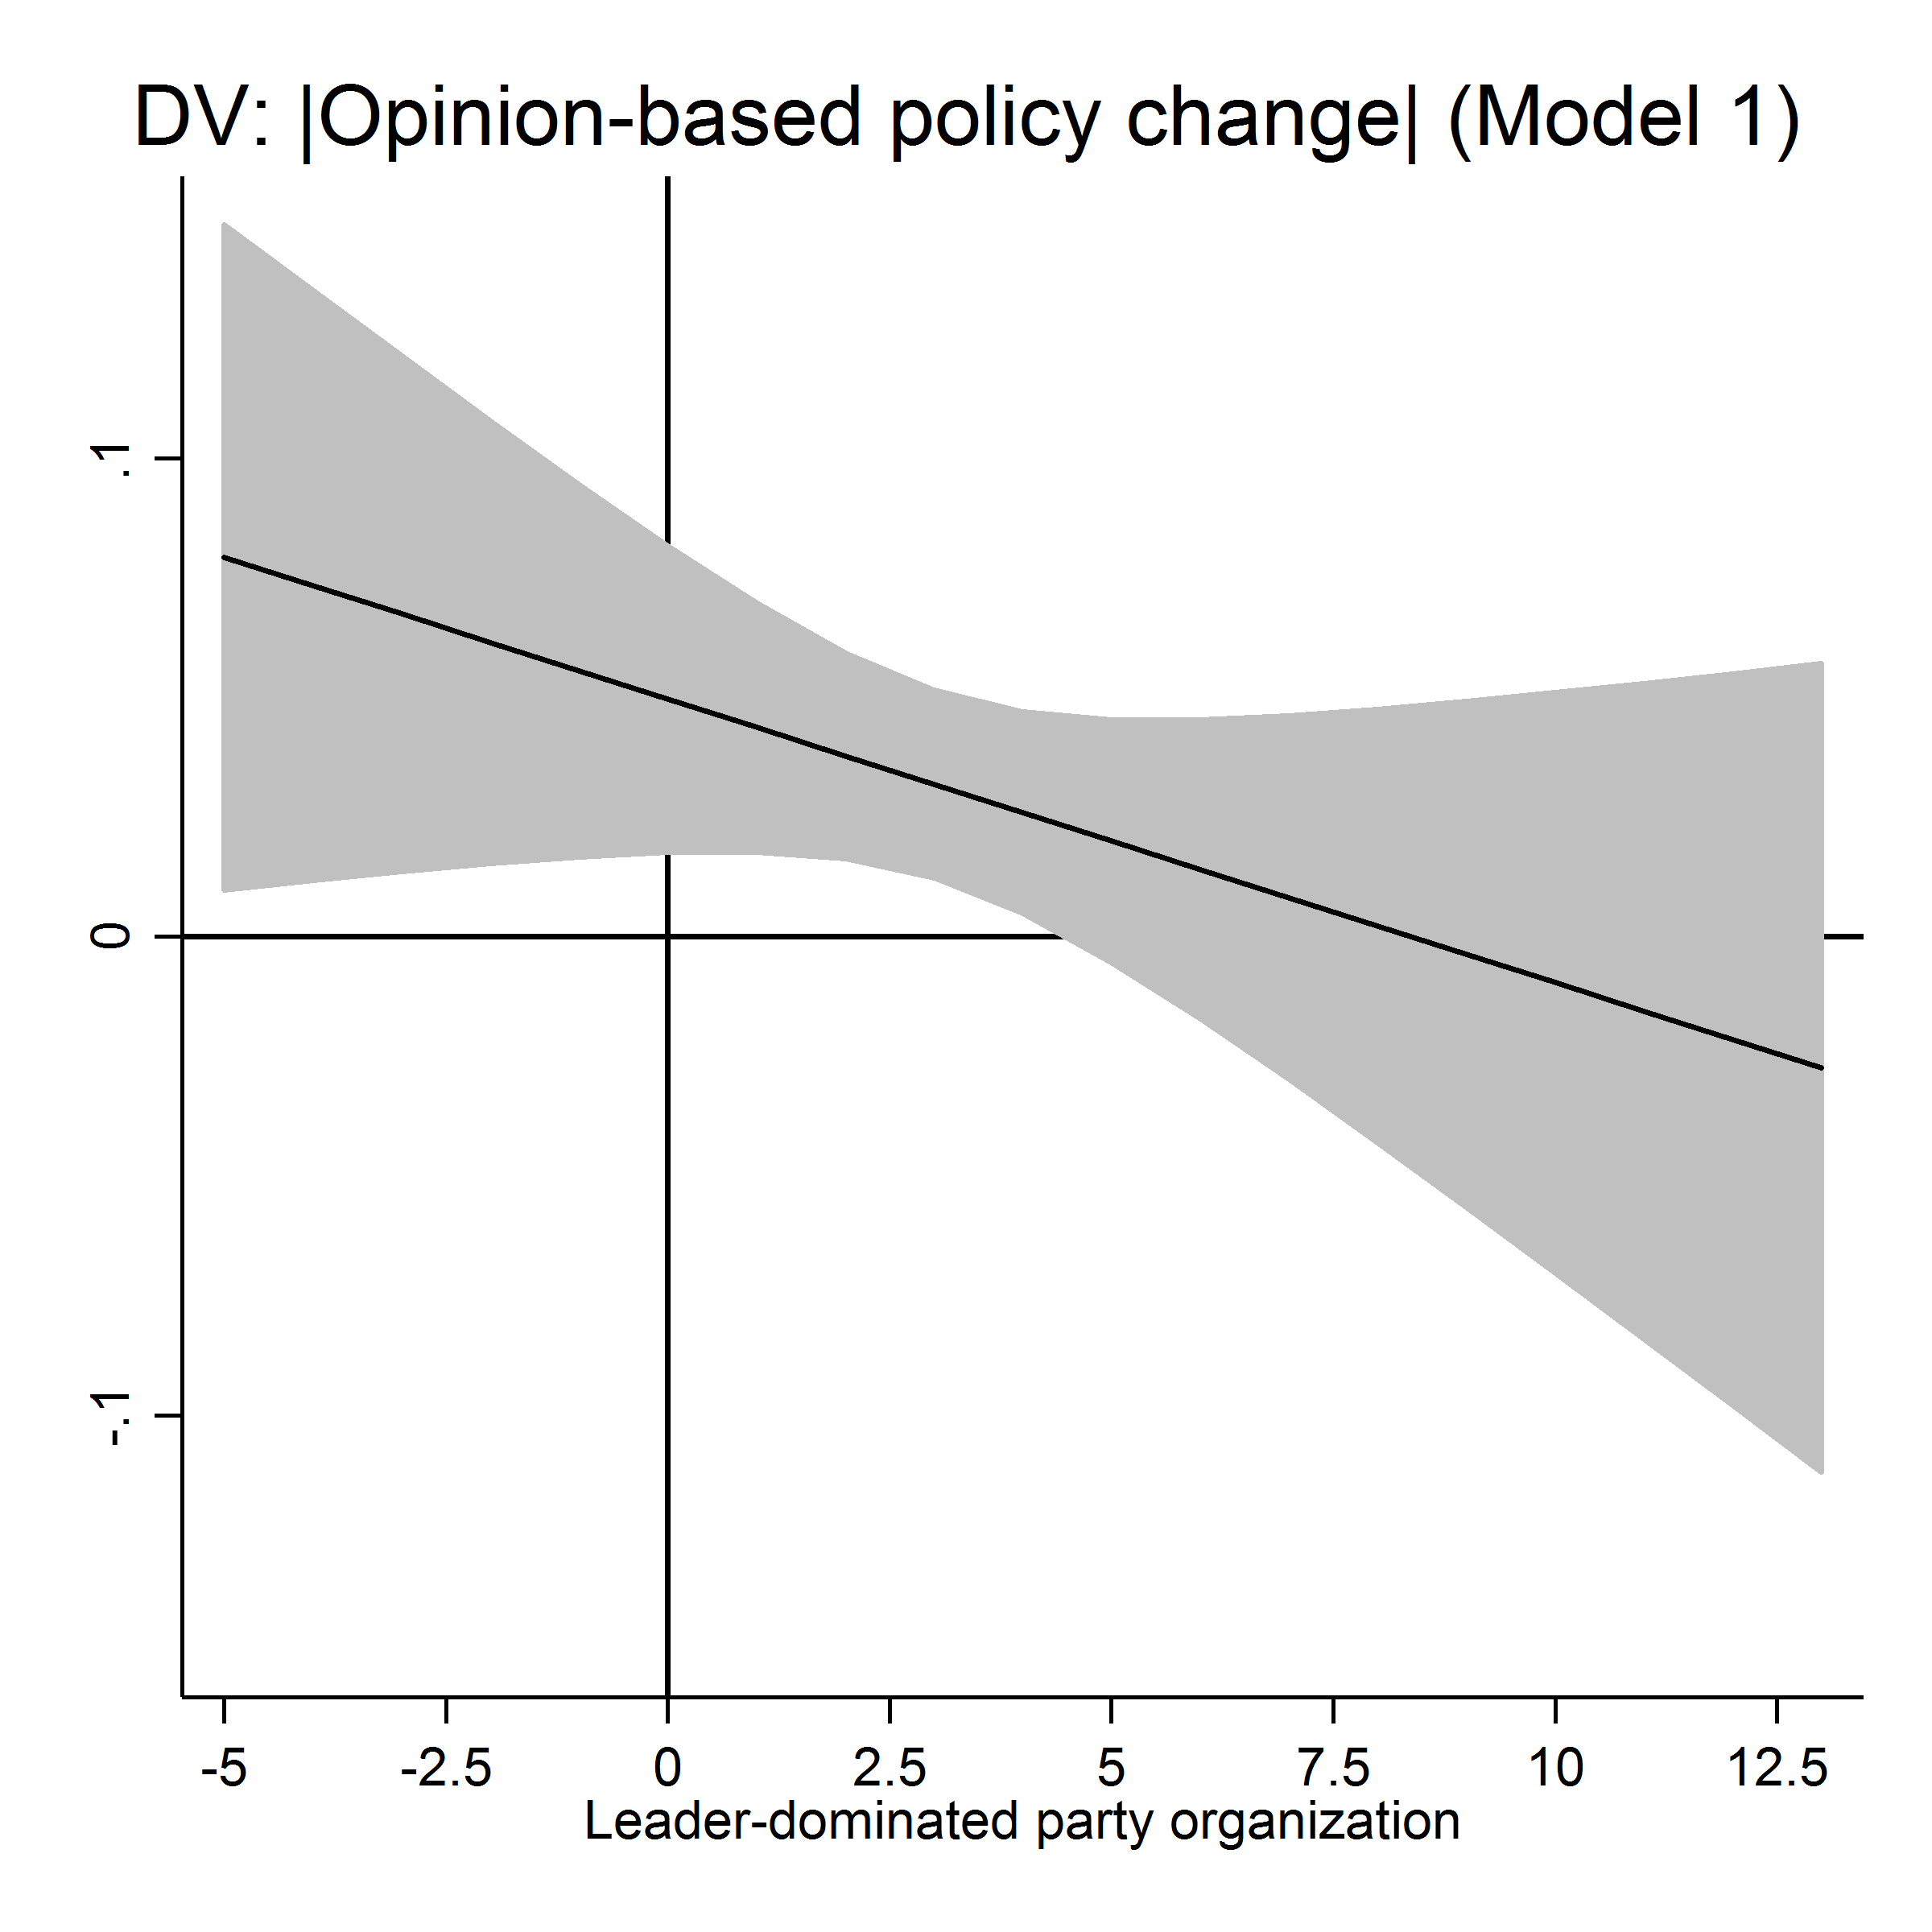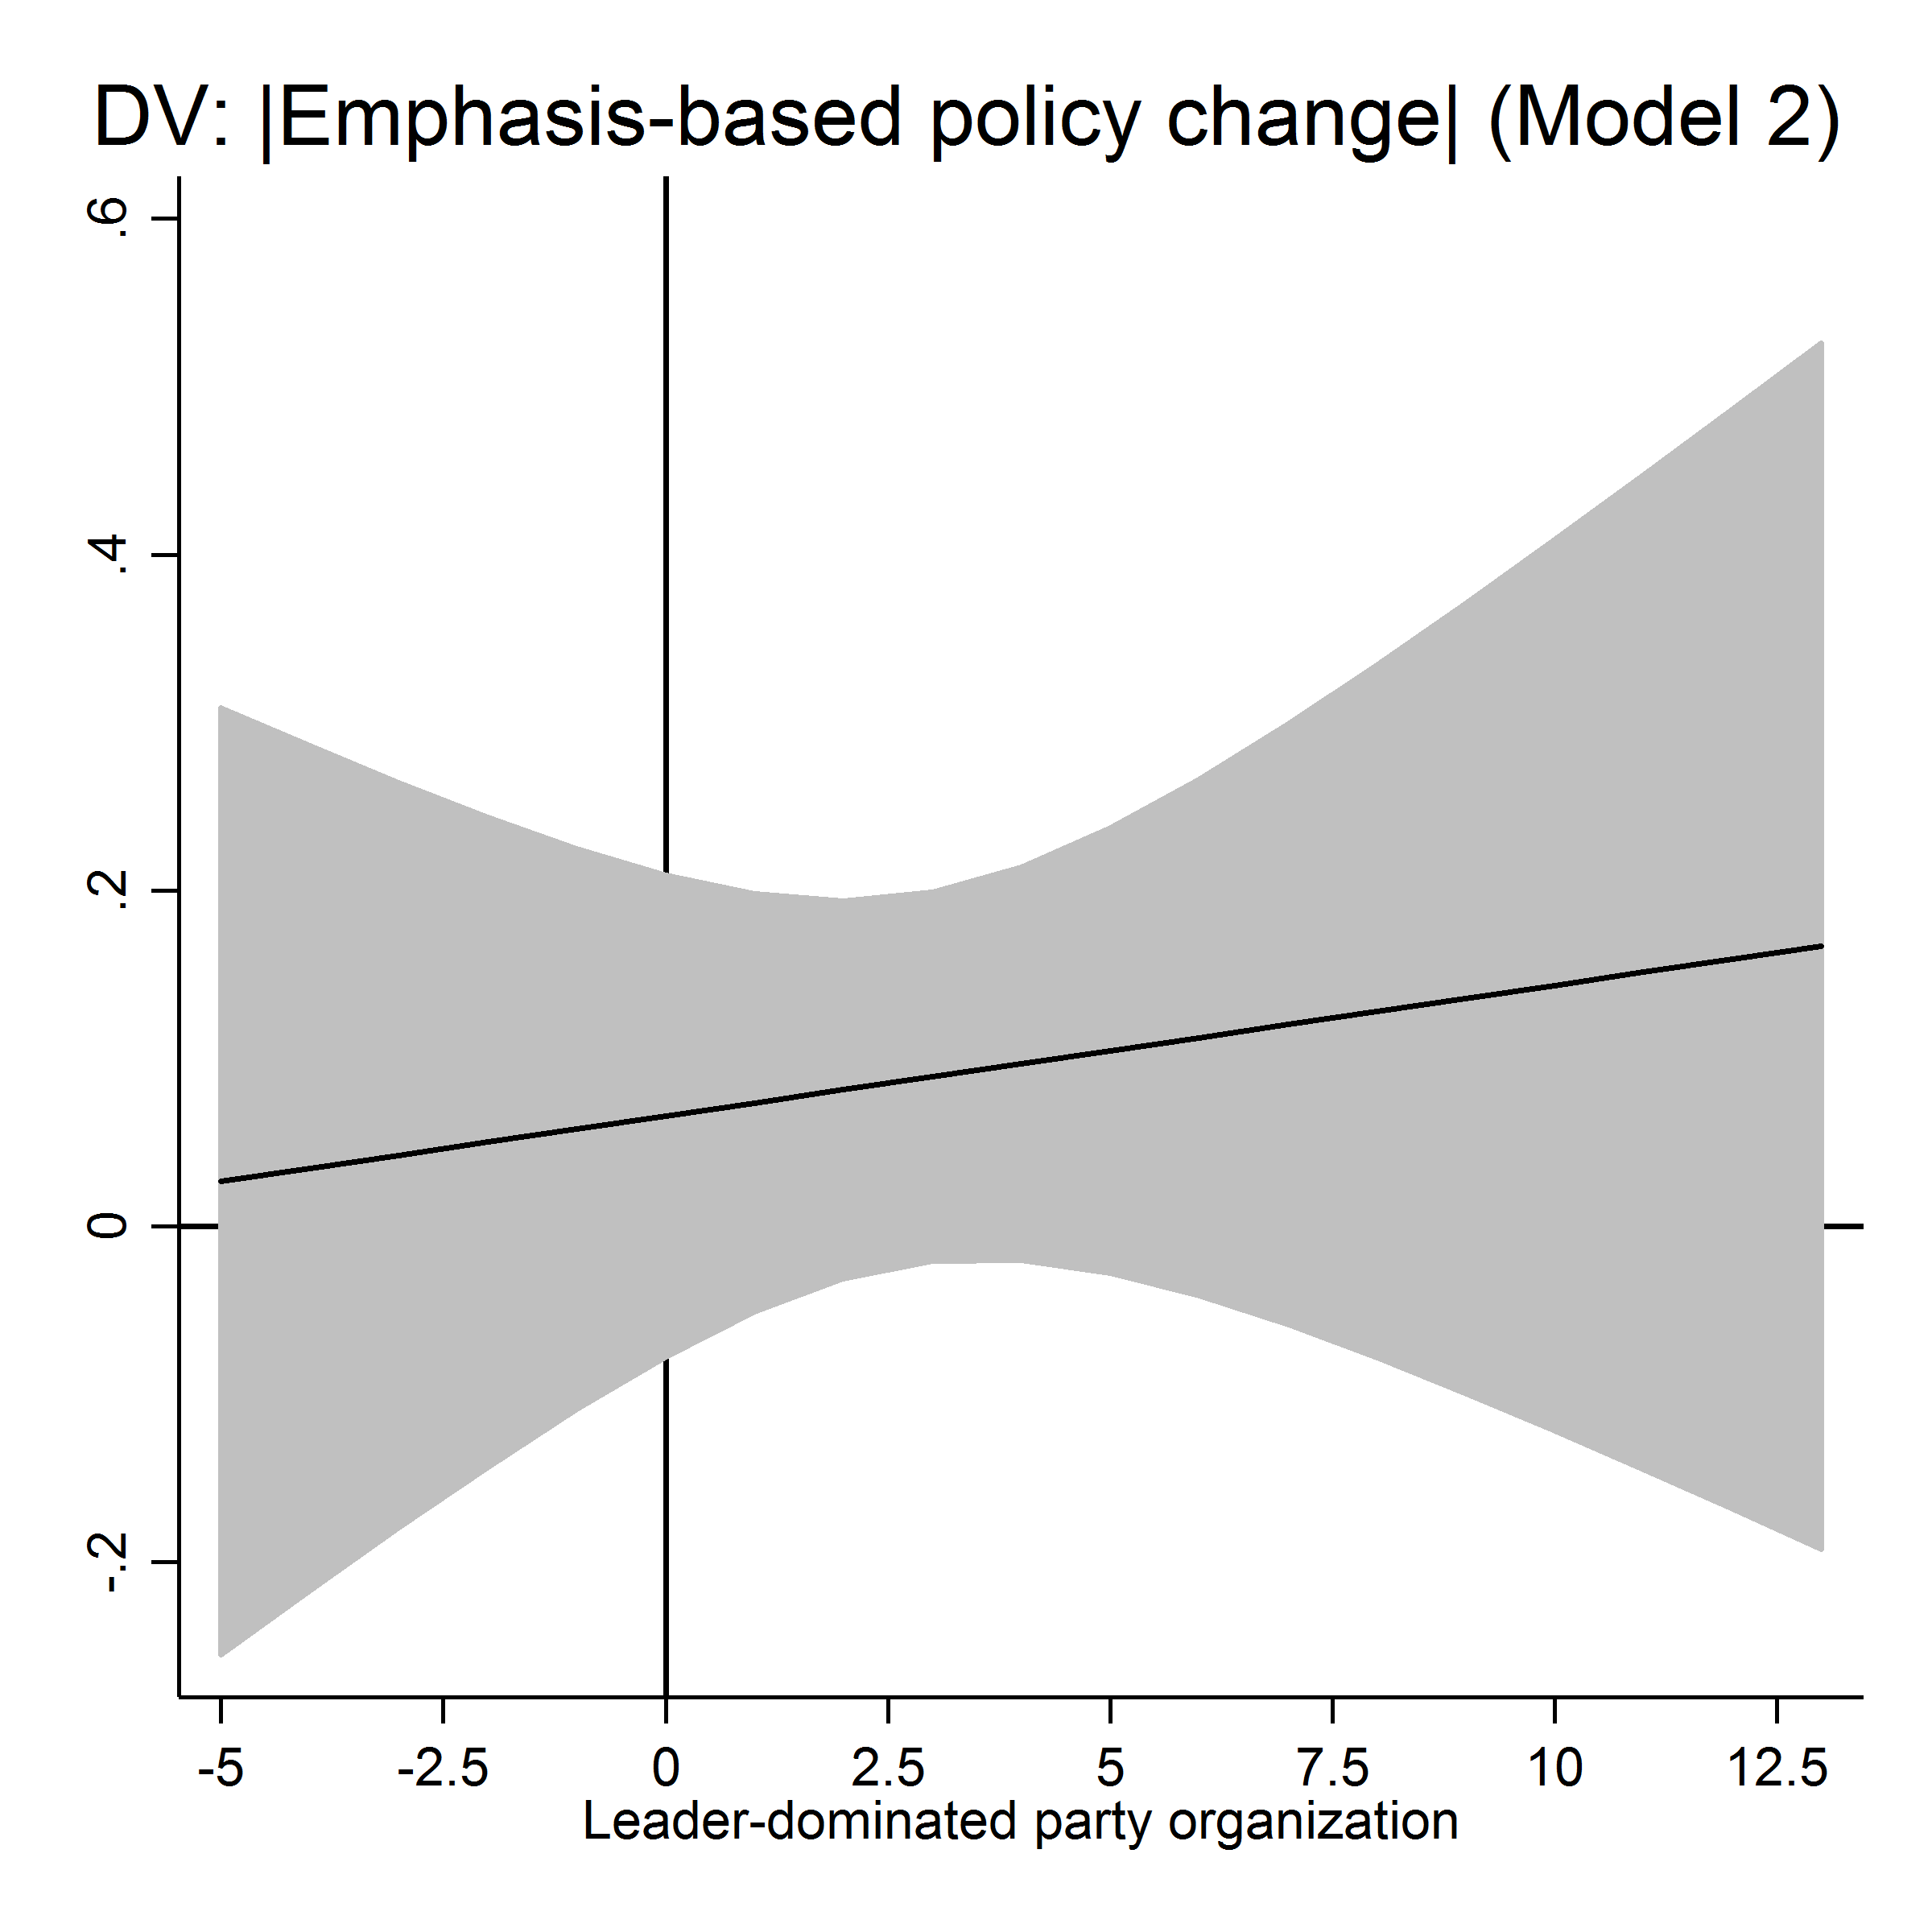
Notes: Estimates based on Models 1 and 2 in Table F.1. All remaining covariates held constant at their mean (continuous variables) or mode (categorical variables).

Table F.2: Explaining why and how parties adapt their positions to rival parties (continuous measures for party organization)
 | (1) | (2)
 | Opinion-based policy change | Emphasis-based policy change
Party system policy change | 0.006 | 0.461
 | (0.06) | (1.15)
Leader-centeredness | -0.001 | 0.0783
 | (-0.08) | (0.86)
Party system policy change X Leader-centeredness | 0.032 | -0.238*
 | (1.38) | (-2.53)
Leader-centeredness X Leader-centeredness | -0.000777 | -0.008
 | (-0.36) | (-0.77)
Party system policy change X Leader-centeredness X Leader-centeredness | -0.000148 | 0.018
 | (-0.06) | (1.38)
Mean voter change | 0.359 | -5.812**
 | (0.57) | (-3.18)
Policy shift _{t-1} | -0.251*** | -0.193***
 | (-5.28) | (-3.48)
Vote change _{t-1} | -0.008 | 0.132⁺
 | (-0.42) | (1.73)
Policy shift _{t-1} X Vote change _{t-1} | 0.043** | 0.007
 | (2.74) | (0.47)
Change in unemployment | 0.117** | 0.108
 | (2.74) | (0.68)
Country fixed effects | Yes | Yes
Constant | 0.327 | -3.883*
 | (1.32) | (-2.09)
Observations | 261 | 261
Log Likelihood | -443.5 | -827.9
t statistics in parentheses; Country fixed effects not reported. Model estimates based on a linear regression model with standard errors clustered by parties.
⁺ p < 0.1, * p < 0.05, ** p < 0.01, *** p < 0.001

Figure F.2: Marginal effect of party system policy change (based on Table F.2)
Notes: Estimates based on Models 1 and 2 in Table F.2. All remaining covariates held constant at their mean (continuous variables) or mode (categorical variables).

Appendix G: Alternative party characteristics

Table G.1: Explaining the magnitude of policy change (controlling for party characteristics)
 | (1) | (2)
 | Opinion-based policy change | Emphasis-based policy change
Leader-centeredness | 0.557** | 1.628⁺
 | (3.18) | (1.78)
Party size _{t-1} | -0.0109* | -0.0554*
 | (-2.09) | (-2.04)
Salience economy _{t-1} | -0.0138⁺ | -0.0574
 | (-1.76) | (-1.43)
|Policy shift _{t-1}| | 0.0919 | 0.0986⁺
 | (1.02) | (1.89)
Vote change _{t-1} | 0.008 | 0.076
 | (0.64) | (1.36)
Country fixed effects | Yes | Yes
Constant | 0.773* | 6.508**
 | (2.14) | (2.83)
Observations | 261 | 261
Log Likelihood | -384.5 | -732.7
t statistics in parentheses; Country fixed effects not reported. Model estimates based on a linear regression model with standard errors clustered by parties.
⁺ p < 0.1, * p < 0.05, ** p < 0.01, *** p < 0.001

Table G.2: Explaining why and how parties adapt their positions to rival parties (controlling for party characteristics)
 | (1) | (2)
 | Opinion-based policy change | Emphasis-based policy change
Party system policy change | 0.141 | 0.664
 | (0.59) | (0.79)
Leader-centeredness | -0.067 | 0.270
 | (-0.44) | (0.35)
Party system policy change X Leader-centeredness | 0.476** | -1.424⁺
 | (2.92) | (-1.90)
Party size _{t-1} | -0.011 | 0.070⁺
 | (-1.65) | (1.95)
Party system policy change X Party size _{t-1} | -0.016** | 0.014
 | (-2.96) | (0.53)
Salience economy _{t-1} | -0.011 | 0.067
 | (-1.14) | (1.00)
Party system policy change X Salience economy _{t-1} | -0.001 | 0.012
 | (-0.18) | (0.60)
Mean voter change | 0.131 | -4.322*
 | (0.23) | (-2.29)
Policy shift _{t-1} | -0.267*** | -0.206***
 | (-5.26) | (-3.75)
Vote change _{t-1} | -0.004 | 0.094
 | (-0.22) | (1.19)
Policy shift _{t-1} X Vote change _{t-1} | 0.043** | 0.004
 | (3.11) | (0.27)
Change in unemployment | 0.108** | 0.115
 | (2.93) | (0.74)
Country fixed effects | Yes | Yes
Constant | 0.980* | -7.095*
 | (2.28) | (-2.42)
Observations | 261 | 261
Log Likelihood | -438.4 | -825.1
t statistics in parentheses; Country fixed effects not reported. Model estimates based on a linear regression model with standard errors clustered by parties.
⁺ p < 0.1, * p < 0.05, ** p < 0.01, *** p < 0.001

Figure G.1: Marginal effect of party system policy change (based on Table G.2)

Notes: Estimates based on Models 1 and 2 in Table G.2. All remaining covariates held constant at their mean (continuous variables) or mode (categorical variables).

We estimate the association model using the gnm package in R.

