**Online Appendix**

**A general model of abstention under compulsory voting**

**Gabriel Katz and Ines Levin[1]**

**A.1. Coding and descriptive statistics for the variables included in the empirical analysis**

Individual-level variables - Source: Brazilian Electoral Study (ESEB) 2002, 2006, 2010.

The 2002 wave of the ESEB was administered between October and December 2002, following the lower house election held on October 6. The 2006 wave was administered in December 2006, two and a half months after the elections for the Chamber of Deputies (lower house). The 2010 wave was conducted in November 2010, roughly a month after the lower house election. All interviews were conducted face-to-face with a nationally representative sample of eligible voters under the supervision of the Centre for Public Opinion Research of the Campinas State University (UNICAMP). The individual-level variables were built from participants’ responses to the survey items included in these thre waves.

*Absenteeism*, *Invalid Voting* and *Valid Voting*: Indicators based on ESEB participants’ responses to two survey items: the first asking if they had voted in the corresponding lower house election and – in case of an affirmative answer – which candidate they had voted for. The three variables are incorporated into the trichotomous outcome used for the individual-level analysis.

*Age*: Natural logarithm of respondents’ age. Logging the age variable accommodates non-linear effects (Rosenstone and Hansen 1993) and facilitates distinguishing life-cycle effects from the influence of age-related exemptions to mandatory voting (coded as *Young* and *Seniors*; see below).

*Disatisfaction with Democracy*: Based on respondents’ answer to the question: “On the whole, are you very satisfied, fairly satisfied, not very satisfied, or not at all satisfied with the way democracy works in Brazil?” Coded on a 5-point ordinal scale with values: 1=“Very Satisfied”; 2 =“Fairly Satisfied”; 3 = “Neither Satisfied nor Dissatisfied”; 4 = “Not Very Satisfied”; 5 =“Not at all Satisfied”;

*Education* *– University*: 1 for respondents with university and post-graduate education, 0 otherwise.

*Education* *– Secondary*: 1 for respondents with (complete or incomplete) secondary school, 0 otherwise.

*Illiterates:* 1 for respondents who stated they could not read and/or write, 0 otherwise.

*Income:* 1 for respondents whose household income is above the median, 0 otherwise.

*No Political Representation*:Based on respondents’ answer to the question “Would you say that any of the parties in Brazil represents your views reasonably well? Coded as 1 for respondents who stated that no candidate represented their political views, 0 otherwise.

*Partisanship – PT:* 1if the respondent is politically close to the Workers’ Party (PT), 0 otherwise.

*Partisanship – PMDB:* 1if the respondent is politically close to the Brazilian Democratic Movement Party (PMDB), 0 otherwise.

*Partisanship – PSDB:* 1if the respondent is politically close to the Brazilian Social Democracy Party (PSDB), 0 otherwise.

*Political Inefficacy:* Based on respondents’ agreement with the statement “It does not make a difference who is in power”. Coded on a 5-point scale, ranging from 1=“It makes a difference who is in power” to 5=”It does not make a difference who is in power”.

*Political Knowlege*: Based on respondents’ answers to 3 political knowledge items included in each wave of the ESEB. For 2002, these items asked subjects to name the governor of their state, the major of the state’s capital city, and the candidate who received the largest share of the vote in the district during the recent lower house election. For 2006 and 2010, participants were asked whether the president of Brazil has a 4 year mandate (corrrect), whether a prominent politican (Geraldo Alckmin) belonged to the Brazilian Labout Party (PTB) (wrong), and whether lower house members are elected by a majoritarian system (wrong).

*Religion*: 1 for respondents affiliated with a religion, 0 otherwise.

*Seniors*: 1 for respondents aged 70 and over, 0 otherwise.

*Young*: 1 for respondents aged 16-17, 0 otherwise.

Dummies for *Female* and *Married* respondents and for *Union* members*.* We also estimated models including ideological self-placement - in addition to partisanship - among the regressors. Although the results are similar to those reported in the main text, more than 35% of the respondents in the sample stated that they “did not know what left and right” meant. This is consistent with Ames and Smith (2010), who conclude that self-reported ideological orientations do not represent enduring, meaningful dispositions in Brazil. Consequently, we decided not to include this variable among the predictors of the models presented in the paper.

Aggregate-level variables

*Absenteeism*, *Invalid Votes* and *Valid Votes*: expressed as percentages of the electorate in each state-year. Sources: Power (2009) and Brazilian Electoral Commission (*Tribunal Superior Eleitoral* 2015; www.tse.jus.br).

*Candidates*: Number of candidates in each state running for a seat in the Chamber of Deputies. Source: Power and Roberts (1995), Power (2009), and Brazilian Electoral Commission (2015).

*Clearance Rate*: Judicial efficiency score for the *Tribunal Regional Eleitoral* (TRE) of each state, calculated as the number of adjudicated cases as a fraction of all the justification forms for not voting received by the state electoral court during a year. Missing years were interpolated using cubic splines. We also used other indicators – caseload per judge, backlog rate – as proxies for the enforcement capacity and efficiency of the TREs, with little change in the main findings reported in the paper. Source: Power (2009) and National Justice Council *(Justiça em Números*, various issues).

*Competitiveness:* Calculated as the difference in votes between the first and second place-getters in each district, as percentage of the valid votes. As a robustness check, we also measured competitiveness as the vote-share difference between the least voted candidate among those who secured a seat in the lower house and the most voted unsuccessful contestant. The results are similar to those reported in the paper. Sources: Ipeadata (http://www.ipeadata.gov.br/) andBrazilian Electoral Commission (2015).

*Electronic Vote*: Percentage of the state’s electorate that cast a ballot using automated voting. This variable takes the value 0 for all districts before 1998 (when electronic voting was introduced in lower house elections) and 1 from 2002 onwards (when electronic voting replaced the paper-based system). Source: Power (2009).

*Growth*: Percentage change in Brazil’s real GDP in the year preceding each election. For robustness, we also estimated the models using the two-year moving average of the GDP growth. The results are virtually identical to those reported in the paper. Source: Ipeadata (http://www.ipeadata.gov.br/)

*Illiterates*: Percentage of registered voters unable to read and/or write. Sources: Power and Roberts (1995), Power (2009), Ipeadata andBrazilian Electoral Commission (2015).

*Income*: State per capita income, expressed in thousands of *reais* of the year 2010. Source: IBGE ([http://www.ibge.gov.br/](http://www.ibge.gov.br/home/estatistica/economia/contasregionais/2013/default.shtm) ) and Ipeadata (<http://www.ipeadata.gov.br/>).

*Inflation*:Change in the IPCA price index (“Índice de Preços ao Consumidor Ampliado”) in the year of the election. Due to the huge variation in inflation rates during the period under study – which ranged from almost 2,500% in 1993 to less than 2% in 1998 - we followed Power and Roberts (1995) and took the natural logarithm of the percentage change in the price index. Using the original – unlogged – series or a two-year moving average of the inflation rate does not alter the substantive findings reported in the paper. Source: Ipeadata (<http://www.ipeadata.gov.br/>).

*Seniors*: Percentage of registered voters aged 70 or older. Sources: Power (2009), Ipeadata andBrazilian Electoral Commission (2015).

*Urban*: Percentage of the state’s population residing in urban areas. Source: Power and Roberts (1995) and Brazilian Electoral Commission (2015).

*Young*:Percentage of registered voters aged 16 or 17. For 1986, all observations are scored as zero because these age groups were not awarded the suffrage until 1988. Since then, voting has been voluntary for these groups. Sources: Power (2009) andBrazilian Electoral Commission (2015).

**Table A.1: Summary statistics for absenteeism and invalid voting**

**1986 – 2014**

|  |  |  |  |  |  |  |  |
| --- | --- | --- | --- | --- | --- | --- | --- |
|  | **Absenteeism** | | | **Invalid voting** | | | |
|  | Mean | Std. dev. | Range | Mean | Std. dev. | | Range |
| By state (summary stats. across elections) |  |  |  |  |  | |  |
| Acre (AC) | 0.20 | 0.05 | 0.10, 0.25 | 0.14 | 0.11 | | 0.04, 0.33 |
| Alagoas (AL) | 0.19 | 0.06 | 0.07, 0.28 | 0.20 | 0.18 | | 0.04, 0.42 |
| Amazonas (AM) | 0.22 | 0.05 | 0.13, 0.29 | 0.12 | 0.12 | | 0.01, 0.29 |
| Amapá (AP) | 0.16 | 0.06 | 0.10, 0.28 | 0.09 | 0.08 | | 0.03, 0.23 |
| Bahia (BA) | 0.22 | 0.08 | 0.06, 0.32 | 0.19 | 0.15 | | 0.04, 0.40 |
| Ceará (CE) | 0.18 | 0.05 | 0.06, 0.23 | 0.16 | 0.12 | | 0.05, 0.33 |
| D. Federal (DF) | 0.13 | 0.03 | 0.06, 0.16 | 0.12 | 0.10 | | 0.04, 0.27 |
| E. Santo (ES) | 0.16 | 0.05 | 0.04, 0.22 | 0.18 | 0.15 | | 0.03, 0.44 |
| Goiás (GO) | 0.17 | 0.04 | 0.06, 0.21 | 0.17 | 0.13 | | 0.03, 0.34 |
| Maranhão (MA) | 0.24 | 0.06 | 0.12, 0.31 | 0.17 | 0.14 | | 0.04, 0.36 |
| M. Gerais (MG) | 0.16 | 0.05 | 0.05, 0.20 | 0.21 | 0.14 | | 0.07, 0.41 |
| M.G. Sul (MS) | 0.17 | 0.05 | 0.06, 0.21 | 0.16 | 0.13 | | 0.04, 0.37 |
| M. Grosso (MT) | 0.20 | 0.09 | 0.02, 0.29 | 0.18 | 0.13 | | 0.04, 0.35 |
| Pará (PA) | 0.23 | 0.08 | 0.12, 0.33 | 0.17 | 0.13 | | 0.05, 0.34 |
| Paraíba (PB) | 0.18 | 0.06 | 0.06, 0.25 | 0.20 | 0.13 | | 0.08, 0.38 |
| Pernambuco (PE) | 0.18 | 0.06 | 0.06, 0.26 | 0.20 | 0.14 | | 0.04, 0.38 |
| Piauí (PI) | 0.17 | 0.06 | 0.06, 0.24 | 0.16 | 0.11 | | 0.05, 0.29 |
| Paraná (PR) | 0.17 | 0.08 | 0.05, 0.33 | 0.18 | 0.13 | | 0.07, 0.42 |
| R. Janeiro (RJ) | 0.15 | 0.05 | 0.04, 0.20 | 0.18 | 0.11 | | 0.06, 0.35 |
| R.G. Norte (RN) | 0.15 | 0.05 | 0.04, 0.19 | 0.19 | 0.14 | | 0.04, 0.41 |
| Rondônia (RO) | 0.23 | 0.06 | 0.11, 0.31 | 0.16 | 0.12 | | 0.04, 0.33 |
| Roraima (RR) | 0.15 | 0.07 | 0.01, 0.22 | 0.08 | 0.06 | | 0.03, 0.19 |
| R.G. Sul (RS) | 0.12 | 0.04 | 0.03, 0.17 | 0.18 | 0.12 | | 0.06, 0.39 |
| S. Catarina (SC) | 0.13 | 0.04 | 0.04, 0.16 | 0.18 | 0.13 | | 0.06, 0.39 |
| Sergipe (SE) | 0.15 | 0.05 | 0.04, 0.22 | 0.21 | 0.12 | | 0.07, 0.39 |
| S. Paulo (SP) | 0.13 | 0.05 | 0.04, 0.20 | 0.20 | 0.12 | | 0.08, 0.39 |
| Tocantins (TO) | 0.22 | 0.05 | 0.18, 0.32 | 0.09 | 0.07 | | 0.04, 0.22 |
|  |  |  |  |  |  | |  |
|  | **Absenteeism** | | | **Invalid voting** | | | |
|  | Mean | Std. dev. | Range | Mean | Std. dev. | Range | |
| By election (summary stats. across states) |  |  |  |  |  |  | |
| 1986 | 0.07 | 0.03 | 0.03, 0.13 | 0.26 | 0.08 | 0.05, 0.40 | |
| 1990 | 0.18 | 0.06 | 0.09, 0.28 | 0.35 | 0.06 | 0.19, 0.44 | |
| 1994 | 0.21 | 0.06 | 0.11, 0.33 | 0.31 | 0.06 | 0.15, 0.42 | |
| 1998 | 0.23 | 0.06 | 0.14, 0.33 | 0.15 | 0.05 | 0.03, 0.24 | |
| 2002 | 0.18 | 0.03 | 0.13, 0.25 | 0.06 | 0.01 | 0.03, 0.08 | |
| 2006 | 0.17 | 0.02 | 0.14, 0.21 | 0.07 | 0.02 | 0.04, 0.12 | |
| 2010 | 0.17 | 0.05 | 0.01, 0.24 | 0.07 | 0.03 | 0.03, 0.13 | |
| 2014 | 0.18 | 0.03 | 0.10, 0.24 | 0.08 | 0.04 | 0.01, 0.16 | |

**Figure A.1: Invalid voting and absenteeism in Brazilian lower house elections, 1986 - 2014**

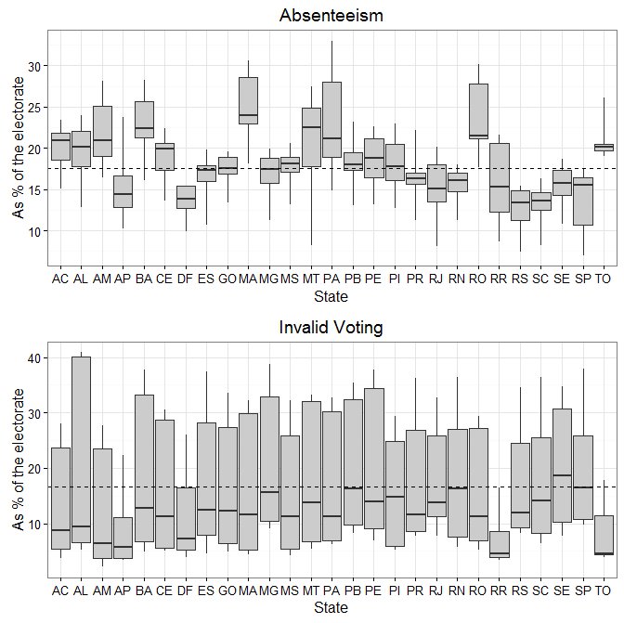

Note: Box plots summarize the variation – median, interquartile and interdecile range – in absenteeism and invalid votes for each state over time. Dashed horizontal lines give the mean value of each source of abstention across all elections and districts.

**Figure A.2: Comparison between the district-level rates of absenteeism and invalid voting**

**in the ESEB surveys against official election returns**

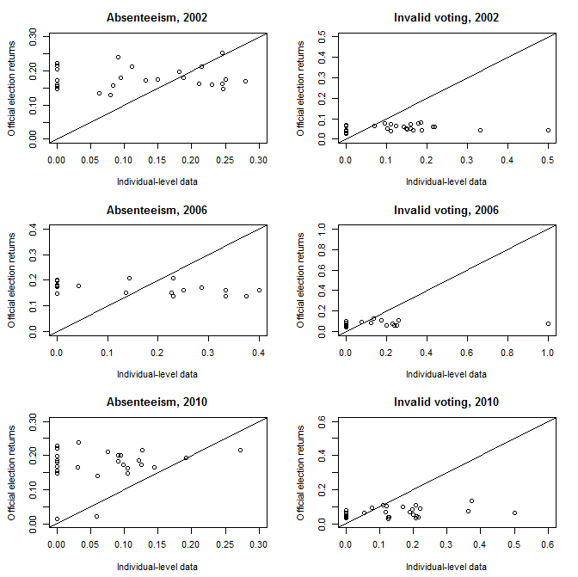

Note: Circles represent the proportion of illegal abstainers and spoiled ballots in each district. The solid 45-degree line represents the match between the survey data and the official election results.

**Table A.2: Summary statistics for the independent variables**

|  |  |  |  |
| --- | --- | --- | --- |
| **Variable** | **Mean** | **Std. Dev.** | **Range** |
| **Individual-level predictors** |  |  |  |
| *(Log) Age* | 3.59 | 0.39 | 2.77, 4.49 |
| *Dissatisfaction with Democracy* | 3.15 | 1.26 | 1, 5 |
| *Education: University* | 0.15 | 0.36 | 0, 1 |
| *Education: Secondary* | 0.36 | 0.48 | 0, 1 |
| *Female* | 0.48 | 0.50 | 0, 1 |
| *Illiterates* | 0.04 | 0.20 | 0, 1 |
| *Income* | 0.45 | 0.50 | 0, 1 |
| *Married* | 0.60 | 0.49 | 0, 1 |
| *No Political Representation* | 0.55 | 0.50 | 0, 1 |
| *Partisanship: PT* | 0.15 | 0.36 | 0, 1 |
| *Partisanship: PMDB* | 0.05 | 0.21 | 0, 1 |
| *Partisanship: PSDB* | 0.06 | 0.24 | 0, 1 |
| *Political Inefficacy* | 1.66 | 1.20 | 1, 5 |
| *Political Knowledge* | 1.63 | 0.87 | 0, 3 |
| *Religion* | 0.91 | 0.29 | 0, 1 |
| *Seniors* | 0.04 | 0.19 | 0, 1 |
| *Union Member* | 0.13 | 0.34 | 0, 1 |
| *Young* | 0.01 | 0.12 | 0, 1 |
|  |  |  |  |
| **State-level predictors** |  |  |  |
| *Candidates* | 166.02 | 212.69 | 12, 1,485 |
| *Clearance Rate* | 1.42 | 1.29 | 0.01, 12.87 |
| *Competitiveness* | 0.07 | 0.08 | 0.00, 0.34 |
| *Electronic Vote* | 0.57 | 0.47 | 0, 1 |
| *Illiterates* | 0.15 | 0.11 | 0.01 – 0.49 |
| *Income* | 13.66 | 9.25 | 4.03, 57.47 |
| *Seniors* | 0.05 | 0.02 | 0.01, 0.10 |
| *Urban* | 0.75 | 0.12 | 0.36, 0.98 |
| *Young* | 0.02 | 0.01 | 0.00, 0.06 |
|  |  |  |  |
| **Country-level predictors** |  |  |  |
| *Growth (%)* | 3.21 | 2.40 | -0.33, 7.85 |
| *(Log) Inflation* | -1.31 | 2.61 | -4.10, 2.79 |

**A.2. Additional estimation details**

Here we describe the Markov chain Monte Carlo (MCMC) algorithms used for estimating the individual- and district-level models presented in Section 4 of the paper.

Given that most of the parameters of the hierarchical multinomial logit model used for the individual analysis do not have closed form solutions, we updated the fixed-effects  and  and the district- and election-random effects  and  from their posterior distributions using random walk Metropolis steps with multivariate  proposals, using identity scale matrices and adjusting the scale parameter  to achieve an acceptances rate of between 25% and 50% (Robert and Casella 2010). The variance-covariance matrices of  and , in turn, were sampled from their full conditional Inverse-Wishart distributions:

~ (1)

and

~ (2)

with  and  in our empirical application.

In the case of the district-level models, specifying conjugate priors for the fixed effects and precision matrices

$$λ\sim N\left(λ_{0},Ω_{λ}\right)$$

$$θ\sim N\left(θ_{0},Ω_{θ}\right)$$

${ Σ}_{ω}^{-1}\sim Wishart\left(D_{ω},ρ_{ω}\right)$ (3)

$$Σ_{η}^{-1}\sim Wishart\left(D_{η},ρ_{η}\right)$$

$$Σ_{ε}^{-1}\sim Wishart\left(D_{ε},ρ_{ε}\right)$$

and assuming conditional independence throughout, the joint posterior density of the unknown parameters is given by:

 (4)

Given , the full conditional posterior densities are:

 (5)

 (6)

 (7)

 (8)

 (9)

 (10)

 (11)

To complete the specification for a MCMC sampling scheme, the full conditional posterior distributions of $τ$ and $υ$ are required. Assuming ~, these become:

 (12)

~ (13).

Note that, from (12),

 (14),

where  stands for conditioning on the data and the remaining model parameters. Therefore, for a large enough  , the posterior mean of the observation-specific weights approaches 1, and approximately normal tails are obtained for the errors. However, for low values of , the expected value of  decreases as  increases. In other words, ouliers are weighted by an inverse function of the Mahalanobis distance , adjusted by the degrees of freedom parameter .

Given the closed-form posteriors (5) – (12), Gibbs sampling can be used to obtain draws from all the paramters except for . Although equation (13) does not have a closed form, this conditional posterior distribution can be approximated by discretizing the density along a grid of values and then sampling from the resulting discrete distribution. When the points in the grid are spaced closely together, the discrete distribution of  provides an accurate approximation to the full conditional distribution (13) (Draper 2001; Seltzer et al. 2002).

For the individual-level model, the MCMC algorithm was implemented directly in R, running three parallel chains for 2,000,000 cycles after a 500,000 burn-in period. A thousand samples from each chain were pooled and used to summarize the posterior distributions of the parameters. The MCMC sampler for the compositional-hierarchical model applied to the district-level data was implemented in WinBUGS (Lunn et al., 2000) and called from R, running three chains for 15,000 iterations each, with a burn-in of 5,000 iterations. Samples were drawn using categorical, MVNLinear, MVNormal, discrete slice and Wishart updaters. Posterior summaries were again computed from the pooled convergent samples.

For both models, predictors were centered to speed convergence (Gelman and Hill 2007). All the hyper-parameters were assigned diffuse priors in order to let the data dominate the form of the posterior densities. To ensure that inferences are data dependent, several alternative values for the hyperparameters were tried, yielding essentially similar results. Convergence was assessed based on Gelman and Rubin (1992)’s diagnostic.

**A.3. Goodness of fit of the compositional-hierarchical district-level model and comparison with alternative approaches**

The upper panel of Figure A.3 plots the posterior distribution of , the parameter governing the weight assigned to each observation in calculating the posterior distribution of the regression coefficients of our district-level model. The posterior mean of  is 3.54 and, as seen in the figure, its marginal posterior density is concentrated around small values. This is indicative of a strong departure from the standard assumption of normally distributed errors, and supports our choice of a heavy-tailed distribution instead. The lower panel of Figure A.3 plots the posterior probability that the observation-specific weights  have degenerate distributions at 1, corresponding to normally distributed errors.  is less than 0.5 for almost half of the observations in the sample, providing again evidence in support of a heavy-tailed error distribution vis-à-vis the standard normality assumption (Rosa, Padovani and Gianola 2003).

In the same direction, Figure A.4 plots the standardized unweighted residuals from our district-level model. The upper panel displays the residuals from the equation for electoral absenteeism (left) and invalid voting (right). The lower panel shows the standardized unweighted bivariate residuals. The relatively large number of outliers that would result from assuming normal observation-specific errors – i.e., assuming that all the observation-specific weights are equal to 1 - indicates that the thick tailed distribution obtained in our analysis *via* the normal/independent mixture resulting from the inclusion of  in the model specification (Andrews and Mallows 1974) is well suited to this data.

**Figure A.3: Posterior summaries for  and **

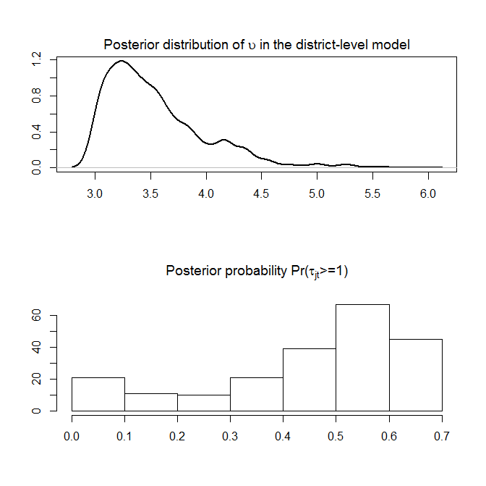

Note: The upper panel of the figure plots the posterior distribution of .The histogram in the

lower panel plots the posterior probability for all the the observations in our

district-level sample. Estimates based on the specification in columns (1)-(2) of Table 2 of hte

paper.

**Figure A.4: Posterior distributions for the (unweighted) observation-specific**

**residuals of the district-level model**

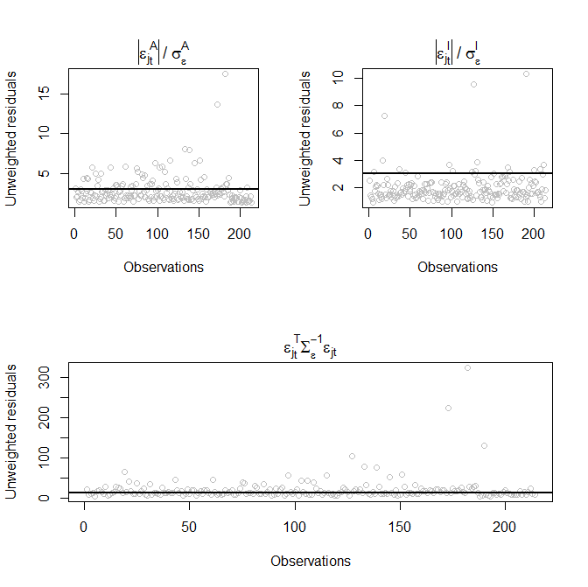

Note: The figure plots the standardized univariate (upper panel) and bivariate (lower panel)

residuals from the district-level model. Circles represent the posterior means of the

unweighted residuals. Solid horizontal lines in the upper panel correspond to the threshold

of 3, while in the lower panel they are drawn at the cutpoint (Weiss 1994).

Circles above the lines indicate (univariate and bivariate) outliers. Estimates based on

the specification in columns (1)-(2) of Table 2 of the paper.

Figure A.5, in turn, plots the predicted rates of electoral absenteeism and invalid voting obtained from standard regression-type models commonly used to study aggregate-level abstention (e.g., Power and Roberts, 1995; Panagopoulos 2008; Uggla 2008; Power 2009). The upper panel of the figure uses separate ordinary least squares (OLS) regressions for each form of non-voting, including the same set of predictors used in our aggregate-level model but assuming independence among observations and simply pooling the district- and country-level predictors. The lower panel of the figure adds district- and election-specific random effects, yielding two hierarchical linear regression models (HLM) fitted to each source of abstention. None of the models, though, account for the compositional nature of the data – i.e., they do not impose the non-negativity and unit-sum constraints incorporated in our ecological model (equations 7-8 of the paper).

As shown in Figure A.5, both models generate implausible predictions for the two sources of abstention. More than 7% of the rates of illegal abstention predicted by the pooled OLS regression models are negative, and more than 15% of the predicted values for invalid voting are below 0 as well. Furthermore, in 1% of the cases, this modeling approach predicts negative rates for both sources of abstention. The hierarchical linear models perform even worse, generating negative predicted values for absenteeism and invalid voting in almost 40% of the cases.

**Figure A.5: Predictions for absenteeism and invalid voting from standard**

**regression-type analyses commonly used to study aggregate-level abstention**

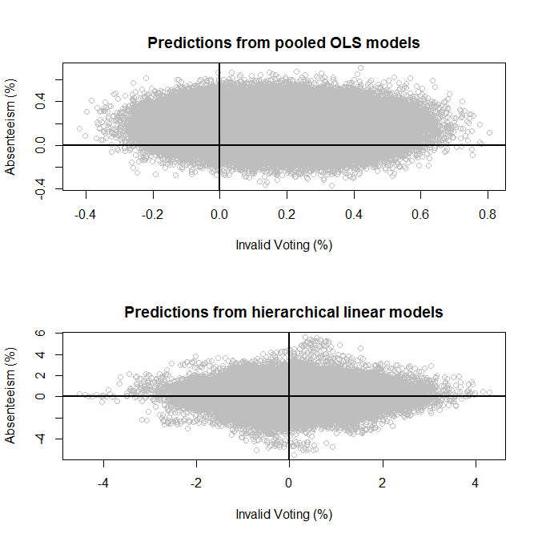

Note: The upper panel plots the predicted values for electoral absenteeism and invalid voting

obtained from pooled OLS regression models fitted to the Brazilian district-level electoral

returns. The lower panel reproduces this information, this time obtained from hierarchical

linear models (HLM) including election- and district-effects. To preserve comparability with

the compositional-hierarchical model used in the paper (equations 7 and 8), these alternative

specificactions were also estimated *via* Markov chain Monte Carlo (MCMC) simulations.

Predicted values are based on 1,000 posterior sample draws from each model.

The comparison between Table 2 (columns 1-2) of the paper and Table A.3 below, which reports the parameter estimates from the pooled OLS and HLM regression models, reveals that our approach also leads to different substantive conclusions regarding the determinants of both forms of abstention vis-à-vis these “standard” approaches. For instance, while our compositional-hierarchical model shows that the number of candidates running in a district is a strong predictor of both sources of abstention, neither of the regression-type approaches finds a systematic association between *Candidates* and either form of non-voting. Similarly, the 90% highest posterior density intervals for *Clearance Rate* always include zero under both regression-type analyses, contradicting the negative association between the degree of enforcement of compulsory voting provisions and illegal abstention found under our preferred specification. Also in contrast to the findings reported in the paper, the rate of urbanization has no systematic influence on either form of abstention when OLS or HLM models are fitted. The conclusions drawn about the impact of *Illiterates* and *Seniors* on one or the other form of non-voting differ between our compositional-hierarchical model and the regression analyses as well.

Failing to account for the clustered nature of the data would also lead a researcher fitting OLS regressions to conclude that higher inflation rates in Brazil are positively associated to invalid voting. The fact that *Inflation* loses significance once district and election random effects are included – both in the HLM regressions and in our compositional-hierarchical model – suggests that this is an example of a “spuriously significant” statistical effect (Antweiler 2001; Maas and Hox 2004) derived from the fact that pooled OLS regressions ignore the hierarchical nature of the data and neglect unobserved cross-sectional and temporal heterogeneity.

**Table A.3: Posterior summaries for the parameters of OLS and HLM models**

|  |  |  |  |  |  |  |
| --- | --- | --- | --- | --- | --- | --- |
|  |  | **OLS** | |  | **HLM** | |
|  |  | **(1)** | **(2)** |  | **(3)** | **(4)** |
| **Covariates** |  | **Absenteeism** | **Invalid Voting** |  | **Absenteeism** | **Invalid Voting** |
| Intercept |  | 0.32  (0.18, 0.47) | 0.20  (0.04, 0.34) |  | 0.28  (-0.21,0.76) | 0.27  (-0.09, 0.66) |
| Income |  | 0.00  (-0.01, 0.01) | 0.00  (-0.01, 0.01) |  | 0.00  (-0.04, 0.03) | -0.01  (-0.04, 0.03) |
| Urban |  | -0.19  (-0.36, 0.00) | 0.05  (-0.15, 0.22) |  | -0.16  (-0.57, 0.23) | -0.09  (-0.42, 0.31) |
| Candidates |  | 0.01  (-0.03, 0.04) | 0.03  (0.00, 0.06) |  | 0.04  (-0.04, 0.10) | 0.02  (-0.06, 0.08) |
| Electronic Vote |  | -0.05  (-0.13, 0.02) | -0.21  (-0.28, -0.14) |  | -0.02  (-0.18, 0.13) | -0.14  (-0.28, 0.02) |
| Clearance Rate |  | -0.01  (-0.02, 0.01) | 0.00  (-0.01, 0.01) |  | 0.00  (-0.02, 0.01) | 0.00  (-0.01, 0.01) |
| Illiterates |  | -0.15  (-0.29, 0.06) | 0.19  (0.03, 0.37) |  | -0.15  (-0.42, 0.19) | 0.28  (-0.05, 0.56) |
| Young |  | 1.10  (0.13, 2.14) | 0.04  (-0.91, 1.04) |  | -0.24  (-1.60, 1.05) | 0.19  (-1.24, 1.47) |
| Seniors |  | 0.73  (-0.09, 1.68) | 0.58  (-0.28, 1.50) |  | 0.55  (-0.71, 1.95) | -0.19  (-1.55, 0.98) |
| Growth |  | -0.05  (-0.09, 0.00) | -0.02  (-0.07, 0.02) |  | 0.00  (-0.85, 0.56) | -0.04  (-0.71, 0.67) |
| Inflation |  | -0.04  (-0.09, 0.01) | 0.06  (0.01, 0.10) |  | -0.02  (-0.83, 0.75) | -0.05  (-0.61, 0.64) |
| Competitiveness |  | 0.02  (-0.01, 0.05) | -0.02  (-0.05, 0.00) |  | 0.01  (-0.02, 0.05) | -0.01  (-0.05, 0.02) |

Note: The table reports point estimates – posterior means - and 90% highest posterior density intervals (in parenthesis) for the parameters of the ordinary (OLS) and hierarchical (HLM) linear regression models fitted to the district-level electoral returns. N=214 for both models.

However, as was shown in Figure A.5, simply accounting for the hierarchical structure of the data is not enough for a good model fit; taking into consideration the compositional nature of electoral returns is necessary as well. This is further illustrated in Table A.4, which compares the two random effects models – i.e., our compositional hierarchical model and the hierarchical linear regression modeling approach - using two measures of model fit based on the loss function proposed by Iyengar and Dey (2004). The first of these measures, , simply compares the discrepancies between the observed rates of absenteeism and invalid voting and the values fitted from each model:



where are the observed rates of absenteeism and invalid voting in district at election , and are the expected values of these quantities computed from the -th posterior draws under each modeling approach,  The second comparison criterion, , is similar to , but instead of contrasting the observed data against the fitted values from each model, we use posterior predictive simulations (Gelman and Hill 2007) and compared the observed data to the quantities replicated from the predictive distribution , where is the observed data and  includes the parameters of each model.  is thus more stringent than , as it requires resampling the election and district random effects – which are zero in expectation.

Table A.4 shows that our model exhibits much lower predictive losses – i.e., lower values of both  and – than the approach based on fitting multi-level linear regression models, highlighting the importance of incorporating the non-negativity and unit-sum constraints  and  into the statistical analysis along with unobserved district- and election-specific random effects.

**Table A.4: Comparison between hierarchical linear regressions and our compositional-hierarchical model, based on Iyengar and Dey (2004)’s**

**posterior loss criterion**

|  |  |  |
| --- | --- | --- |
| **Model** |  |  |
|  |  |  |
| Hierarchical linear models (HLM) | 57.62 | 260.66 |
|  |  |  |
| Compositional-hierachical model | 6.04 | 10.97 |

Note: The values of and for the compositional-hierarchical model

are based on the estimates reported in Table 2 (columns 1-2) of the paper.

**A.4. Additional estimation results**

**Table A.5: Posterior summaries for the control variables of the**

**individual-level model**

|  |  |  |  |  |
| --- | --- | --- | --- | --- |
|  | **Outcomes** | | | |
|  | **(1)** | | **(2)** | |
| **Covariates** | **Absenteeism** | | **Invalid Voting** | |
|  |  |  |  |  |
| (Log) Age | -0.26  (-0.51, 0.01) | | -0.08  (-0.29, 0.13) | |
|  |  |  |  |  |
|  |  | |  | |
| Female | -0.02  (-0.25, 0.20) | | -0.20  (-0.39, -0.01) | |
|  |  |  |  |  |
|  |  | |  | |
| Married | -0.21  (-0.44, 0.00) | | -0.07  (-0.27, 0.14) | |
|  |  | |  | |
|  |  | |  | |
| Religion | -0.57  (-0.91, -0.24) | | -0.13  (-0.44, 0.20) | |
|  |  |  |  |  |
|  |  | |  | |
| Union | -0.27  (-0.60, 0.13) | | 0.00  (-0.28, 0.31) | |
|  |  | |  | |
| PT | 0.06  (-0.36, 0.52) | | 0.18  (-0.23, 0.58) | |
|  |  | |  | |
| PMDB | 0.27  (-0.25, 0.78) | | -0.84  (-1.51, 0.02) | |
|  |  | |  | |
| PSDB | -0.29  (-0.87, 0.23) | | 0.44  (-0.02, 0.89) | |
|  |  |  |  |  |

Note: The table reports posterior means and 90% highest posterior density intervals (in

parenthesis) for the coefficients of the control variables of the individual-level model.

**Figure A.6: Expected change in the probabilities of non-voting associated with a**

**change in the controls of the individual-level model**

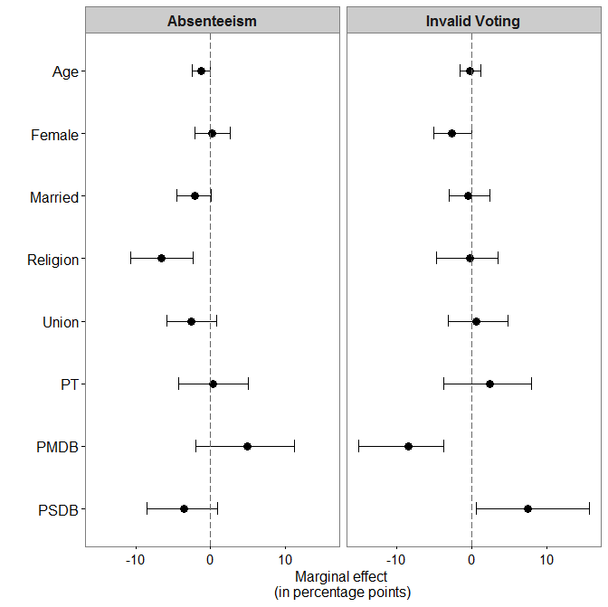

Note: The figure plots the expected change in associated with a

change in each control variable (a one-standard deviation increase in *Age*, a change from 0 to 1 in the case of the remaining binary variables). Solid circles represent point estimates (posterior means); horizontal lines give the 90% highest posterior density (HPD) intervals. Estimates for the partisanship dummies (*PT*, *PMDB* and *PSDB*) are expressed vis-à-vis the baseline category “no major party”. There are also some differences in the probabilities of non-voting between respondents identified with the three major parties. Holding everything else equal, the probability of failing to show up at the polls is 8.4 percentage points higher for a PMDB sympathizer than for a respondent affiliated with the PSDB (the 90% HPD interval for the difference in probabilities is [1.03, 16.08]). At the same time, PMDB supporters are almost 11 p. points less likely to annul their ballot than PT partisans, and more than 15 points less likely to do so than PSDB identifiers (90% HPD intervals [-17.97, -4.73] and [-24.78, -8.69], respectively).

**Table A.6: Differential effect of the covariates of the individual-level model on the probability of illegal abstention versus invalid voting**

|  |  |  |  |
| --- | --- | --- | --- |
|  |  | | |
|  | Point estimate | 90% credible interval | |
|  |  |  |  |
| **Education: University** | **-0.71** | **-1.42** | **-0.04** |
|  |  |  |  |
| Education: Secondary | 0.48 | -0.13 | 1.20 |
|  |  |  |  |
| Income | -0.32 | -0.84 | 0.18 |
|  |  |  |  |
| Political Knowledge | 0.07 | -0.22 | 0.43 |
|  |  |  |  |
| Urban | 0.04 | -0.16 | 0.27 |
|  |  |  |  |
| Candidates | 0.11 | -0.29 | 0.55 |
|  |  |  |  |
| Political Inefficacy | -0.02 | -0.21 | 0.17 |
|  |  |  |  |
| **No Political Representation** | **-0.91** | **-1.74** | **-0.18** |
|  |  |  |  |
| **Dissatisfaction with Democracy** | **-0.22** | **-0.44** | **-0.03** |
|  |  |  |  |
| Growth | 1.12 | -0.38 | 3.60 |
|  |  |  |  |
| Inflation | 0.59 | -0.54 | 2.16 |
|  |  |  |  |
| Clearance Rate | 0.38 | 0.00 | 0.88 |
|  |  |  |  |
| **Illiterates** | **2.18** | **0.25** | **5.08** |
|  |  |  |  |
| Young | 3.68 | -0.08 | 10.40 |
|  |  |  |  |
| **Seniors** | **21.06** | **8.93** | **40.53** |
|  |  |  |  |
| Competitiveness | 0.23 | -0.10 | 0.65 |
|  |  |  |  |
| (Log) Age | -0.15 | -0.41 | 0.13 |
|  |  |  |  |
| Female | 0.33 | -0.17 | 0.90 |
|  |  |  |  |
| Married | -0.26 | -0.84 | 0.24 |
|  |  |  |  |
| **Religion** | **-1.04** | **-2.35** | **-0.10** |
|  |  |  |  |
| Union | -0.42 | -1.10 | 0.24 |
|  |  |  |  |
| PT | -0.11 | -0.94 | 0.89 |
|  |  |  |  |
| **PMDB** | **3.83** | **0.44** | **9.98** |
|  |  |  |  |
| **PSDB** | **-0.78** | **-1.52** | **-0.01** |

Note: The table reports the relative change in the probabiliy of illegal abstention versus invalid voting associated with a change in each covariates. Variables for which the 90% posterior credible interval excludes zero are in bold. An increase in variabes measuring political protest or disaffection (e.g., *No Political Representation*, *Dissatisfaction with Democracy*) raises vis-à-vis. On the other hand, the marginal effect of variables capturing exemptions to the legal obligation to vote such as *Illiterates*and*Seniors* is to raise  relative to.

**Table A.7: Posterior Summaries for the Individual-Level Model with**

**Random Slopes**

|  |  |  |  |  |  |
| --- | --- | --- | --- | --- | --- |
|  | **(1)** | | **(2)** | | |
| **Covariates** | **Absenteeism** | | **Invalid Voting** | | |
|  |  |  |  | |  |
| Intercept | -1.58  (-2.46, -0.58) | | -1.16  (-2.24, -0.25) | | |
|  |  | |  | | |
| Education: University | -0.93  (-1.38, -0.46) | | -0.39  (-0.75, -0.03) | | |
|  |  |  |  | |  |
| Education: Secondary | 0.01  (-0.27, 0.30) | | -0.18  (-0.42, 0.06) | | |
|  |  |  |  | |  |
| Income | 0.00  (-0.26, 0.25) | | 0.15  (-0.08, 0.38) | | |
|  |  | |  | | |
| Political Knowledge | -0.28  (-0.42, -0.12) | | -0.34  (-0.47, -0.20) | | |
|  |  |  |  | |  |
| Candidates | 0.96  (0.48, 1.49) | | 0.80  (0.25, 1.39) | | |
|  |  | |  | | |
| Candidates * University Education | 0.03  (-0.78, 0.69) | | -0.16  (-0.74, 0.39) | | |
|  |  | |  | | |
| Candidates * Secondary Education | 0.44  (-0.08, 0.89) | | -0.05  (-0.46, 0.40) | | |
|  |  | |  | | |
| Candidates * Income | -0.33  (-0.77, 0.08) | | 0.08  (-0.29, 0.44) | | |
|  |  | |  | | |
| Candidates * Political Knowledge | -0.21  (-0.46, 0.05) | | -0.01  (-0.26, 0.25) | | |
|  |  | |  | | |
| Political Inefficacy | 0.09  (-0.55, 0.65) | | 0.12  (-0.10, 0.35) | | |
|  |  | |  | | |
| No Political Representation | 0.16  (-0.53, 0.85) | | 0.76  (0.42, 1.10) | | |
|  |  | |  | | |
| Dissatisfaction with Democracy | -0.13  (-0.98, 0.42) | | 0.18  (-0.39, 0.71) | | |
|  |  | |  | | |
| Growth | 0.18  (-0.96, 1.33) | | -0.10  (-1.07, 0.86) | | |
|  |  | |  | | |
| Growth * Political Inefficacy | -0.14  (-0.88, 0.62) | | 0.01  (-0.77, 0.66) | | |
|  |  | |  | | |
| Growth * No Representation | 0.37  (-0.43, 1.21) | | -0.11  (-0.85, 0.61) | | |
|  |  | |  | | |
| Growth * Dissatisfaction w. Democracy | 0.19  (-0.83, 1.21) | | 0.09  (-0.56, 0.77) | | |
|  |  | |  | | |
| Inflation | 0.26  (-0.65, 1.13) | | -0.75  (-1.91, 0.05) | | |
|  |  | |  | | |
| Inflation * Political Inefficacy | -0.24  (-1.16, 0.83) | | 0.33  (-0.29, 1.17) | | |
|  |  | |  | | |
| Inflation * No Representation | 0.17  (-0.75, 0.94) | | 0.01  (-0.67, 0.72) | | |
|  |  | |  | | |
| Inflation * Dissatisfaction w. Democracy | -0.02  (-0.78, 0.93) | | 0.22  (-0.63, 1.24) | | |
|  |  | |  | | |
| Urban | 0.61  (-0.55, 1.59) | | -0.46  (-1.46, 0.66) | | |
|  |  | |  | | |
| Clearance Rate | 0.04  (-0.03, 0.13) | | -0.07  (-0.16, 0.01) | | |
|  |  |  |  | |  |
| Illiterates | 0.80  (0.38, 1.24) | | -0.04  (-0.52, 0.42) | | |
|  |  |  |  | |  |
| Young | 0.81  (0.19, 1.41) | | -0.10  (-0.86, 0.70) | | |
|  |  |  |  | |  |
| Seniors | 2.14  (1.77, 2.52) | | -0.84  (-1.84, -0.06) | | |
|  |  |  |  | |  |
| Competitiveness | 0.39  (0.09, 0.68) | | 0.10  (-0.19, 0.38) | | |
|  |  | |  | | |
| (Log) Age | -0.26  (-0.50, 0.02) | | -0.09  (-0.32, 0.13) | | |
|  |  | |  | | |
| Female | -0.04  (-0.28, 0.19) | | -0.22  (-0.41, -0.02) | | |
|  |  | |  | | |
| Married | -0.23  (-0.44, 0.02) | | -0.08  (-0.28, 0.12) | | |
|  |  | | | | |
| Religion | -0.56  (-0.92, -0.24) | | -0.11  (-0.40, 0.23) | | |
|  |  | | | | |
| Union | -0.34  (-0.68, 0.00) | | | -0.02  (-0.31, 0.33) | |
|  |  | | |  | |
| PT | -0.10  (-0.58, 0.34) | | | 0.17  (-0.27, 0.57) | |
|  |  | | |  | |
| PMDB | 0.28  (-0.17, 0.73) | | | -0.76  (-1.31, -0.13) | |
|  |  | | |  | |
| PSDB | -0.35  (-0.92, 0.24) | | | 0.43  (-0.04, 0.88) | |
|  |  | | | | |
| Percent correctly predicted | 69.48 | | | | |
| goodness of fit test (p-value) | 0.78 | | | | |
| N | 2,362 | | | | |

Note: Table A.7 reports estimates – posterior means and 90% highest posterior density intervals (in parenthesis) from an individual-level model with random slopes.

Specifically, we modelled the individual-level correlates of voting costs and political dissatisfaction as functions of the number of *Candidates* in each district and of the election-specific macro-economic indicators (*Growth* and *Inflation*), respectively. The resulting hierarchical multinomial logit model is:

 (15)

 (16)

 (17)

 (18)

where  , are the individual correlates of cognitive and participation costs associated with the act of voting (e.g., *Education*, *Income*, *Political Knowledge)*;are the individual correlates of political dissatisfaction (*Political Inefficacy*, *No Political Representation*, *Dissatisfaction with Democracy*);  are other individual (control) variables;  are district-level predictors;  are national-level covariates; ~~ are district random effects; and ~, ~ are election random effects.

**Figure A.7: Expected change in the proportion of illegal abstainers and invalid votes associated with a change in the covariates of the district-level model**

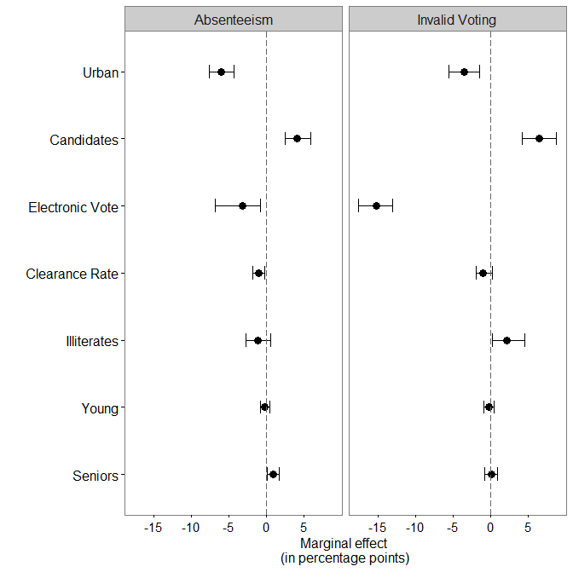

Note: The figure plots the expected change in absenteeism and invalid voting relative to valid votes associated with a standard deviation increase in selected predictors of the district-level model. Solid circles represent point estimates (posterior means, in percentage points), while horizontal lines give the 90% HPD intervals. These “marginal effects” or average predictive comparisons (Gelman and Hill 2007) are based on the estimates in Table 2 (columns 1-2) of the paper.

**Table A.8: Posterior summaries for the parameters of the district-level model**

**Including only elections between 2002 and 2014**

|  |  |  |
| --- | --- | --- |
|  | **Outcome** | |
| **Covariates** | **Absenteeism** | **Invalid Voting** |
| Intercept | -1.00  (-2.18, 0.66) | -0.93  (-2.27, 0.31) |
| Income | -0.04  (-0.10, 0.01) | 0.01  (-0.06, 0.09) |
| Urban | -0.26  (-1.02, 0.52) | -0.46  (-1.46, 0.56) |
| Candidates | 0.18  (0.04, 0.34) | 0.48  (0.25, 0.67) |
| Electronic Vote | -0.19  (-1.37, 1.22) | -0.98  (-2.38, 0.25) |
| Clearance Rate | -0.02  (-0.04, 0.01) | -0.04  (-0.09, 0.00) |
| Illiterates | 0.31  (-0.60, 1.04) | -0.07  (-1.24, 1.01) |
| Young | -0.01  (-1.65, 1.61) | -0.36  (-1.93, 1.36) |
| Seniors | 0.66  (-0.93, 2.18) | 0.31  (-1.21, 2.06) |

|  |  |  |
| --- | --- | --- |
| Growth | -0.07  (-0.84, 0.93) | 0.04  (-1.00, 0.89) |
| Inflation | -0.06  (-0.98, 0.81) | -0.09  (-1.08, 0.93) |
| Competitiveness | 0.03  (-0.06, 0.10) | 0.05  (-0.06, 0.18) |
| N | 108 | |

Note: The table reports point estimates – posterior means - and 90% highest posterior density

intervals (in parenthesis) for the parameters of the district-level model, fitted to data from the

2002-2014 lower house elections only.

**Figure A.8: Relationship between *Illiterates* and *Invalid Voting***

**before and after the introduction of *Electronic Vote***

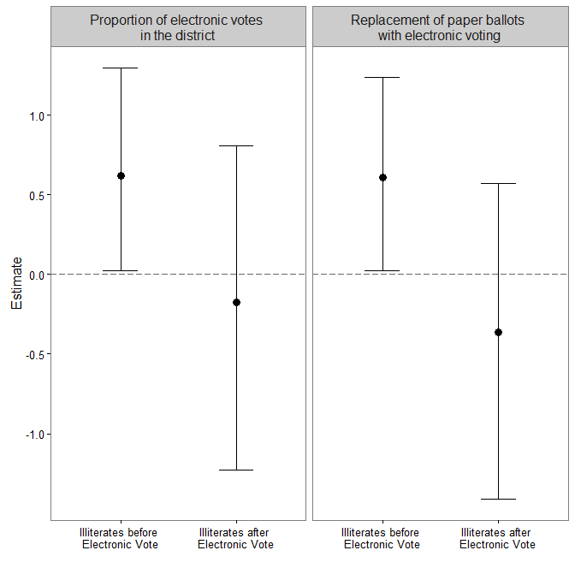 Note: The figure plots posterior summaries for the coefficients of *Illiterates* and the sum of the coefficients for *Illiterates* and the interaction between *Illiterates* and *Electronic Vote*. The left panel plots the posterior means (solid circles) and 90% HPD intervals (vertical lines) obtained from the specification in columns (3)-(4) of Table 2 in the paper. The right panel reproduces this information using an alternative operationalization for *Electronic Vote*, namely, an indicator for elections from 2002 on, when automated voting completely replaced the paper-based voting system in Brazil.

**Table A.9: Posterior summaries for a district-level model including a measure of political rights and civil liberties as predictor for elections between 1974 and 2014**

|  |  |  |  |
| --- | --- | --- | --- |
|  |  | **(1)** | **(2)** |
| **Covariates** |  | **Absenteeism** | **Invalid Voting** |
|  |  |  |  |
| Intercept |  | -0.06  (-0.59, 0.43) | -0.95  (-1.43, -0.53) |
|  |  |  |  |
| Urban |  | -1.61  (-2.09, -1.14) | -0.16  (-0.73, 0.35) |
|  |  |  |  |
| Candidates |  | 0.18  (0.09, 0.25) | 0.25  (0.14, 0.33) |
|  |  |  |  |
| Electronic Vote |  | -0.25  (-0.55, -0.03) | -1.48  (-1.78, -1.15) |
|  |  |  |  |
| Political Rights & Civil Liberties |  | 0.00  (-0.75, 0.75) | -0.65  (-1.26, -0.11) |
|  |  |  |  |
| Growth |  | -0.16  (-0.90, 0.63) | 0.53  (-0.03, 1.16) |
|  |  |  |  |
| Inflation |  | 0.00  (-0.66, 0.59) | 0.21  (-0.31, 0.74) |
|  |  |  |  |
| Illiterates |  | -0.16  (-0.58, 0.22) | 0.76  (0.27, 1.23) |
|  |  |  |  |
| Young |  | -0.84  (-2.32, 0.64) | -0.17  (-1.75, 1.37) |
|  |  |  |  |
| Seniors |  | 1.78  (0.38, 3.37) | 0.39  (-1.00, 2.04) |
|  |  |  |  |
| Competitiveness |  | 0.00  (-0.05, 0.04) | -0.04  (-0.10, 0.02) |
|  |  |  | |
| Deviance Information Criterion |  | -196.02 | |
| N |  | 284 | |

Note: The table reports point estimates – posterior means - and 90% highest posterior density intervals (in parenthesis) for the parameters of a district-level model that includes the annual percentage change in Freedom House inverse combined ratings for political rights and civil liberties (Vanhanen 2000) as a predictor. Results are analogous if the change in the average of both indices – rather than their sum – is used. Given that these indices have remained virtually constant since Brazil’s return to democracy, we fitted this model to data from all elections held between 1974 (the first legislative race for which the Freedom House indices are available) and 2014. Controls for household income and the degree of enforcement of compulsory voting are not included in this specification, as they are not readily available for the extended period covered in this analysis, while *Inflation* is operationalized as the (logarithm of the) change in the IGP-DI price index (“Índice Geral de Preços - Disponibilidade Interna”) in the year of the election (Source: Ipeadata).

The coefficient for *Political Rights & Civil Liberties* in column 2 implies that the proportion of blank and null ballots in the average Brazilian district is negatively correlated with political and civic freedom. This is consistent with the individual-level findings reported in Table 1 of the paper, indicating that discontent with political authorities and the democratic process – which was presumably widespread in periods of authoritarian intimidation and electoral manipulation (Power and Roberts 1995) – is a relevant determinant of invalid voting.

**Figure A.9: Joint impact of socio-demographic and politico-institutional factors**

**on district-level proportions of illegal abstention and invalid voting**

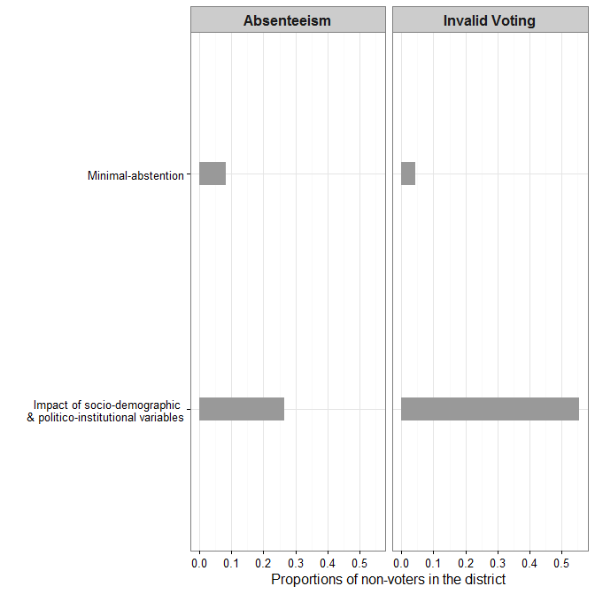

Note: The figure plots average proportions of illegal abstainers and invalid voting in a district, for alternative values of socio-demographic, electoral and institutional variables. The “minimal-abstention” scenario plots the predicted rates of absenteeism and ballot spoilage in a district where *Urban*, *Clearance Rate* and *Electronic Vote* are set at their largest sample values, whereas the number of *Candidates* and the proportion of *Illiterates* and *Seniors* are held at their minimum. The joint “impact of socio-demographic and politico-institutional variables” can be gauged by contrasting these baseline proportions against the prevalence of both forms of non-voting in a district in which *Urban*, *Clearance Rate* and *Electronic Vote* are held at their minimum, and *Candidates*, *Illiterates* and *Seniors* are set at their largest sample values. These proportions are all based on the estimates in columns (1)-(2) of Table 2 of the paper.

**Table A.10: Variance components for the individual and district-level models**

|  |  |  |  |
| --- | --- | --- | --- |
|  | **Individual-level model** |  | **District-level model** |
|  |  |  |  |
| **Observation-specific covariance matrix** |  |  |  |
|  |  |  | 0.03  (0.02, 0.04) |
|  |  |  | 0.04  (0.03, 0.05) |
|  |  |  | 0.01  (0.00, 0.01) |
|  |  |  | 0.26  (0.12, 0.41) |
|  |  |  |  |
| **District-specific covariance matrix** |  |  |  |
|  | 0.01  (0.00, 0.04) |  | 0.09  (0.05, 0.14) |
|  | 0.09  (0.00, 0.20) |  | 0.10  (0.05, 0.14) |
|  | 0.02  (-0.03, 0.08) |  | 0.00  (-0.03, 0.04) |
|  | 0.30  (-0.77, 0.99) |  | 0.01  (-0.44, 0.36) |
|  |  |  |  |
| **Election-specific covariance matrix** |  |  |  |
|  | 0.52  (0.06, 0.99) |  | 0.45  (0.10, 0.82) |
|  | 0.55  (0.07, 1.10) |  | 0.30  (0.08, 0.55) |
|  | 0.02  (-0.46, 0.48) |  | 0.10  (-0.17, 0.39) |
|  | 0.02  (-0.66, 0.78) |  | 0.27  (-0.38, 0.88) |

Note: The table reports posterior means and 90% highest posterior density intervals (in parenthesis) for the variance components of the individual and district-level models, along with the district- and election-specific correlations between absenteeism and invalid voting. In the case of the aggregate model, we also present the observation-specific covariance matrix and correlation between the two forms of abstention.

**Additional references**

Ames, Barry, and Amy E. Smith. 2010. ‘Knowing Left from Right: Ideological Identification in Brazil, 2002-20 06’. *Journal of Politics in Latin America* 2(3):3-38.

Andrews, David F., and Collin L. Mallows. 1974. ‘Scale mixtures of normality’. *Journal of the Royal Statistical Society* B(36):99-102.

Antweiler, Werner. 2001. ‘Nested random effects estimation in unbalanced panel data’. *Journal of Econometrics* 101(2):295 – 313.

Brazilian Electoral Commission. 2015. *Repositório de Dados Eleitorais*. Available at http://www.tse.jus.br/eleicoes/estatisticas/repositorio-de-dados-eleitorais, accessed 20 July 2015.

Draper, David. 2001. *Bayesian hierarchical modeling*. New York, NY: Springer.

Freedom House. 2016. *Freedom in the World Country Ratings, 1973-2016*. Available at <https://freedomhouse.org/report-types/freedom-world>, accessed 20 February 2016.

Gelman, Andrew, and Jennifer Hill. 2007. *Data Analysis Using Regression and Multilevel/Hierarchical Models*. New York, NY: Cambridge University Press.

Gelman, Andrew, and Donald B. Rubin. 1992. ‘Inference for iterative simulation using multiple sequences’. *Statistical Science* 7(4):457-472.

Iyengar, Malini, and Dipak K. Dey. 2004. ‘Bayesian analysis of compositional data’. In Dipak Dey, Sujit Ghosh and Bani Mallick (eds.), *Generalized linear Models: A Bayesian Perspective*. 349-364. New York, NY: Marcel Dekker.

Lunn, David J., Andrew Thomas, Nicky Best, and David Spiegelhalter. 2004. ‘WinBUGS-a Bayesian modelling framework: concepts, structure, and extensibility’. *Statistics and Computing* 10(4):325-337.

Maas, Cora J., and Joop J. Hox. 2004. ‘Robustness issues in multilevel regression

analysis’. *Statistica Neerlandica* 58(2):127–137.

Panagopoulos, Costas. 2008. ‘The Calculus of Voting in Compulsory Voting Systems’. *Political Behavior* 30(4):455-467.

Power, Timothy J., and Timmons Roberts. 1995. ‘Compulsory Voting, Invalid Ballots, and Abstention in Brazil’. *Political Research Quarterly* 48(4):795-826.

Power, Timothy J. 2009. ‘Compulsory for Whom? Mandatory Voting and Electoral Participation in Brazil, 1986-2006’. *Journal of Politics in Latin America* 1(1):97-122.

Robert, Christian P., and George Casella. 2010. *Introducing Monte Carlo Methods with R*. New York, NY: Springer.

Rosa, Guilherme J., Carlos R. Padovani, and Daniel Gianola. 2003. ‘Robust Linear Mixed Models with Normal/Independent Distributions and Bayesian MCMC Implementation’. *Biometrical Journal* 45(5): 573-590.

Rosenstone, Steven J., and John M. Hansen. 1993. *Mobilization, Participation, and Democracy in America*. New York, NY: MacMillan.

Seltzer, Michael, John Novak, Kilchan Choi, and Nelson Lim. 2002. ‘Sensitivity Analysis for Hierarchical Models Employing t Level-1 Assumptions’. *Journal of Educational and Behavioral Statistics* 27(2):181-222.

Uggla, Fredrik. 2008. ‘Incompetence, Alienation, or Calculation: Explaining Levels of Invalid and Extra-Parliamentary Votes’. *Comparative Political Studies* 41(8):1141–64.

Vanhanen, Tatu. 2000. ‘A New Dataset for Measuring Democracy, 1810-1998’. *Journal of Peace Research* 37(2):251-265.

Weiss, Robert E. 1994. ‘Residuals and Outliers in Repeated Measures Random Effects Models’. Unpublished Manuscript, University of California at Los Angeles. Available at <http://citeseerx.ist.psu.edu/viewdoc/summary?doi=10.1.1.52.1570>, accessed 20 July 2015.

1. Department of Politics, University of Exeter ([G.Katz@exeter.ac.uk](mailto:G.Katz@exeter.ac.uk)) and Department of Political Science, University of California, Irvine ([i.levin@uci.edu](mailto:i.levin@uci.edu)).