Online Appendix

- Data sources and coding

Individual-level variables - Source: BES, 1964-2010

New cohort: 1 for the first 3 elections in which the respondent was eligible to vote, 0 otherwise.

Young initiation: 1 if the respondent entered the electorate at 18 (i.e., after 1969), 0 otherwise.

Late Female Suffrage: Coded as 1 for women older than 21 before 1928, and 0 otherwise. A previous (1918) reform gave the vote to women over 30 who were householders, the wives of householders, occupiers of property with an annual rent of £5, and graduates of British universities (Parliamentary Archives, HL/PO/PU/1/1918/7&8G5c64). It is impossible to identify the set of women satisfying all these characteristics from the BES data. Nonetheless, coding Late Female Suffrage as 1 for all women older than 30 before 1918 or older than 21 before 1928 and 0 otherwise does not change the results.

Age: Natural logarithm of respondent’s age.

Education: 1 for respondents with university education, 0 otherwise.

Respondent’s occupation: 1 for manual workers, 0 otherwise.

Household occupation: 1 if the household’s head is a manual worker, 0 otherwise.

Urban: 1 if the respondent resides in an urban constituency, 0 otherwise. Based on the Office for National Statistics (wwww.ons.gov.uk/ons/guide-method/geography/products/area-classifications/rural-urban-definition-and-la/rural-urban-local-authority—la—classification-england-/parliamentary-constituencies.xls), DEFRA’s Rural Definition and Local Authority Classification (http://archive.defra.gov.uk/evidence/statistics/rural/rural-definition.htm), and the Scottish Government Urban/Rural Classification (http://www.scotland.gov.uk/resource/doc/933/0103167.pdf).

Religion: 1 for respondents self-identified as Christians, 0 otherwise.

Church attendance: 1 for respondents who attend at least once a week, 0 otherwise.

Perceived Party Differences. From 1964, after a series of questions specifically mentioning only Labour and the Conservatives: ‘Considering everything the parties stand for, would you say there is a good deal of difference between the parties (2), some difference (1), or not much difference (0)?’ From 1983, the Conservative and Labour parties were mentioned explicitly in the question itself.

Strength of party identification: 4=‘very strong’, 3=‘fairly strong’, 2 =‘not very strong’, 1=‘closer to one’, 0=‘no identification’. In earlier versions of the BES, only those identifying with a party were asked the strength of identification, omitting non-partisan respondents from the next question asking whether they were closer to one party than another. We have preserved this data structure for subsequent surveys, in which those answering ‘closer’ were asked the strength question. Hence we ignore the responses of these non-partisan subjects, coding all of them in the ‘closer’ category.

Civic duty: 1 for respondents stating that it is every citizen's duty to vote in an election, 0 otherwise. This variable is only available in BES surveys between 2001 and 2010, and for 1987. For 1997, this variable is coded from responses to the question “do you think people need not vote unless they really care who wins, or, is it everyone's duty to vote?” We used multiple imputation to fill the gaps for the remaining BES surveys.

Political Efficacy: 1 for respondents who disagree or strongly disagree with the statement “People like me have no say in what the government does”, and 0 otherwise. Using the original ordinal variable does not substantially change the results reported in the paper. This variable is only available for BES surveys between 1987 and 2001. Blais and Rubenson (2013) also measure external political efficacy based on agreements/disagreements with the statement: “I don’t think public officials care much what people like me think.” However, this item is included in even fewer British Election Studies, and thus virtually all the values would have required imputation.

Dummies for Female and Married respondents, for those who voted in the previous general election, and for Union members.

Aggregate-level variables

Lagged Seat Margin: calculated as the difference in the proportion of seats captured by the largest and second-largest party in each election. Sources: Craig (British Electoral Facts, 1832 – 1987, 1989, Aldershot: Gower), The Times, and Whitaker's Almanack. The Initial Seat Margin variable is calculated using the same sources.

Lagged Constituency Vote Margin: calculated as the difference in votes between the first and second place-getters in the previous local election, as percentage of the valid votes. These data are included in the 2001, 2005, 2010 study datasets.

For the other years, we relied on several sources:

- For 1992 (in 1997 boundaries) and 1997, Pippa Norris’ British Parliamentary Constituency database, 1992-2005, release 1.3 (http://www.pippanorris.com);

- From 1979 (in 1983 boundaries) to 1987: the United Kingdom Ecological Dataset, including 1979 results in 1983 boundaries (UKDA 2081).

- For 1974 to 1979: Electoral Dynamics Files, 1918-1979 (UKDA 1383), principal researcher William L. Miller.

- Data from 1959 to 1970: ‘UK General Election Results, 1955-1970 and Associated Information’ (UKDA 1799).

- 1970 election results translated into 1974 constituency boundaries come from a data set kindly supplied by Richard Topf, based on estimates generated by Michael Steed.

Initial Constituency Vote Margin was calculated using the same data sources.

The average differences in public support for the two leading parties in the Last Polls conducted prior to each election before 2010 were calculated from Craig (1989, Table 9.02, p. 111) and Rallings and Thrasher (British Electoral Facts 1832-2006, 2007, Aldershot: Ashgate, Table 24.02, p. 259). For 2010, we used data supplied by the polling companies (Ipsos MORI, YouGov, Harris Interactive, Populus, Angus Reid, Opinium, ComRes, ICM). The same sources were used to construct the Initial Poll Margin variable.

Right-Left Manifesto Differences are obtained from Lowe, Benoit, Mikhaylov and Laver (2012), http://thedata.harvard.edu/dvn/dv/Mikhaylov/faces/study/StudyPage.xhtml?globalId=hdl:1902.1/17073.

2. Additional Figures and Tables

Figure A.1 – ROC curves for the models in Table 2
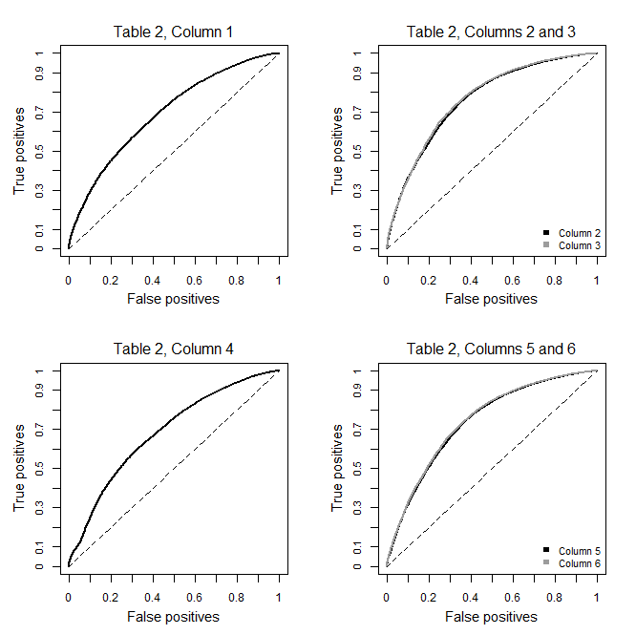
Notes: The figure plots the receiver operating characteristic (ROC) curves for the models in Table 2 of the paper. Solid lines represent predicted probabilities computed from the posterior means of the parameter estimates. The dashed 45-degree line corresponds to a random prediction model. “True positives” represent the proportion of correctly classified voters. “False positives” correspond to the proportion of incorrectly classified abstainers. The area under the curve varies between 0.69 and 0.76 across the specifications in Table 2.

Table A.1: Posterior summaries for the parameters of cross-classified random effects probit models, BES 1964-2010

Complete-case analysis
Covariate | Outcome: self-reported vote |  |  | Outcome: validated vote
 | (1) | (2) | (3) | (4) | (5) | (6)
New cohort | -0.34***  (-0.49, -0.20) | 0.02  (-0.14, 0.16) | 0.08  (-0.05, 0.20) | -0.15  (-0.36, 0.07) | 0.37***  (0.14, 0.59) | 0.24**  (0.04, 0.43)
Lagged Seat Margin | -0.29  (-0.80, 0.23) | -0.41  (-1.40, 0.53) | -0.57  (-1.45, 0.29) | 0.12  (-1.08, 1.39) | 0.15  (-1.52, 1.76) | 0.15  (-1.15, 1.47)
New cohort * Lagged Seat Margin | -0.41**  (-0.72, -0.10) | -0.47**  (-0.80, -0.16) | -0.74***  (-1.05, -0.44) | -0.64**  (-1.09, -0.19) | -0.90***  (-1.37, -0.43) | -0.94***  (-1.41, -0.46)
Lagged Constituency Vote Margin | -0.29***  (-0.41, -0.15) | -0.32***  (-0.46, -0.18) | -0.34***  (-0.48, -0.21) | -0.30**  (-0.48, -0.10) | -0.24**  (-0.43, -0.04) | -0.27**  (-0.46, -0.07)
New cohort * Lagged Constituency Vote Margin | -0.11  (-0.34, 0.14) | -0.15  (-0.41, 0.10) | -0.11  (-0.38, 0.14) | -0.19  (-0.55, 0.13) | -0.29  (-0.65, 0.08) | -0.25  (-0.61, 0.09)
Last Polls | -0.07**  (-0.13, -0.01) | -0.08  (-0.19, 0.04) | -0.08  (-0.17, 0.03) | -0.08**  (-0.19, 0.04) | -0.07*  (-0.25, 0.09) | -0.05  (-0.15, 0.06)
New cohort * Last Polls | -0.06***  (-0.09, -0.03) | -0.11***  (-0.14, -0.07) | -0.11***  (-0.14, -0.07) | -0.05**  (-0.19, -0.01) | -0.10***  (-0.15, -0.06) | -0.10***  (-0.13, -0.06)
Right-Left Manifesto Differences | 0.04  (-0.04, 0.11) | 0.04  (-0.11, 0.19) |  | -0.01  (-0.10, 0.20) | -0.08  (-0.35, 0.16)
New cohort * Right-Left Manifesto Differences | 0.14***  (0.09, 0.18) | 0.09***  (0.05, 0.14) |  | 0.07  (-0.01, 0.14) | 0.00  (-0.08, 0.08)
Perceived Party Differences |  |  | 0.34***  (0.29, 0.39) |  |  | 0.28***  (0.21, 0.35)
New cohort * Perceived Party Differences |  |  | 0.26***  (0.17, 0.36) |  |  | 0.18**  (0.04, 0.32)
Young Initiation | -0.32***  (-0.35, -0.28) | -0.19***  (-0.24, -0.13) | -0.17***  (-0.23, -0.11) | -0.23***  (-0.28, -0.19) | -0.17***  (-0.23, -0.10) | -0.17***  (-0.24, -0.10)
Late Female Suffrage | -0.07  (-0.15, 0.01) | -0.05  (-0.13, 0.05) | -0.05  (-0.13, 0.05) | -0.51***  (-0.73, -0.28) | -0.49***  (-0.71, -0.26) | -0.48***  (-0.72, -0.26)
(Log) Age |  | 0.05  (-0.03, 0.13) | 0.07  (-0.01, 0.15) |  | 0.10  (0.00, 0.21) | 0.09  (-0.01, 0.20)
Education |  | 0.21***  (0.15, 0.27) | 0.21***  (0.15, 0.27) |  | 0.23***  (0.17, 0.30) | 0.23***  (0.16, 0.30)
Female |  | 0.03  (0.00, 0.06) | 0.04  (0.00, 0.06) |  | 0.07***  (0.03, 0.11) | 0.07***  (0.03, 0.11)
Married |  | 0.15***  (0.12, 0.19) | 0.15***  (0.12, 0.18) |  | 0.26***  (0.21, 0.30) | 0.25***  (0.21, 0.30)
Respondent’s Occupation (manual) |  | -0.14***  (-0.18, -0.10) | -0.13***  (-0.17, -0.09) |  | -0.12***  (-0.17, -0.07) | -0.11***  (-0.16, -0.05)
Household Occupation (manual) |  | -0.07***  (-0.11, -0.03) | -0.06**  (-0.10, -0.02) |  | -0.06*  (-0.11, -0.01) | -0.06*  (-0.12, -0.01)
Urban |  | -0.05**  (-0.09, -0.01) | -0.05**  (-0.09, -0.01) |  | -0.07**  (-0.12, -0.02) | -0.07**  (-0.12, -0.02)
Union Member |  | 0.17***  (0.13, 0.20) | 0.17***  (0.13, 0.21) |  | 0.17***  (0.12, 0.22) | 0.16***  (0.11, 0.21)
Voted at Previous Election |  | 0.86***  (0.82, 0.90) | 0.83***  (0.79, 0.87) |  | 0.68***  (0.63, 0.72) | 0.66***  (0.61, 0.71)
Intercept | 1.35***  (1.14, 1.56) | 0.50*  (0.02, 0.98) | 0.36  (-0.01, 0.76) | 1.20***  (0.72, 1.73) | 0.23  (-0.64, 1.00) | -0.06  (-0.62, 0.52)
Deviance Information Criterion (DIC) | 63,174.9 | 58,428.9 | 57,899.77 | 38,249.5 | 35,947.88 | 35,795.34
N | 28,854 | 28,854 | 28,854 | 15,656 | 15,656 | 15,656
Notes: The table reports (fixed) coefficient estimates from hierarchical probit models using self-reported (columns 1-3) and validated (columns 4-6)
vote as outcome. All specifications include constituency- and election-specific random intercepts. Religion-related questions were not asked in every
survey, and were thus excluded to avoid losing elections; including these items would have further reduced N to 18,717 observations in columns 1-3,
and to 8,861 in columns 4-6 after list-wise deletion. The 90% highest posterior density credible intervals are reported in parenthesis. We also report the
significance levels from the likelihood-based estimation of the models: ***0.01, **0.05, *0.1.

Table A.2: Posterior summaries for the parameters of the cross-classified

probit models interacting individual-level controls with New cohort
Covariates | Outcome: self-reported vote |  | Outcome: validated vote
 | (1) | (2) | (3) | (4)
New cohort | 1.87***  (1.18, 2.60) | 1.89***  (1.21, 2.60) | 1.48***  (0.73, 2.17) | 1.43***  (0.74, 2.14)
Lagged Seat Margin | -0.55  (-1.53, 0.53) | -0.64  (-1.52, 0.30) | 0.20  (-0.63, 1.04) | 0.11  (-0.58, 0.85)
New cohort * Lagged Seat Margin | -0.44**  (-0.73, -0.16) | -0.62***  (-0.90, -0.33) | -0.69***  (-0.98, -0.42) | -0.83***  (-1.10, -0.55)
Lagged Constituency Vote Margin | -0.36***  (-0.48, -0.24) | -0.38***  (-0.50, -0.26) | -0.32***  (-0.44, -0.19) | -0.33***  (-0.45, -0.21)
New cohort* Lagged Constituency Vote Margin * New cohort | -0.11  (-0.33, 0.12) | -0.07  (-0.30, 0.16) | 0.00  (-0.21, 0.23) | 0.02  (-0.20, 0.24)
Last Polls | -0.07  (-0.19, 0.05) | -0.07  (-0.18, 0.04) | -0.05  (-0.15, 0.05) | -0.06  (-0.14, 0.03)
New cohort * Last Polls | -0.12***  (-0.15, -0.09) | -0.12***  (-0.15, -0.09) | -0.10***  (-0.13, -0.07) | -0.10***  (-0.13, -0.07)
Right-Left Manifesto Differences | 0.04  (-0.12, 0.20) |  | 0.04  (-0.09, 0.17)
New cohort * Right-Left Manifesto Differences | 0.08***  (0.04, 0.12) |  | 0.05**  (0.01, 0.09)
Perceived Party Differences |  | 0.33***  (0.29, 0.37) |  | 0.24***  (0.19, 0.28)
New cohort * Perceived Party Differences |  | 0.26***  (0.18, 0.34) |  | 0.23***  (0.13, 0.33)
Young Initiation | -0.16***  (-0.21, -0.11) | -0.15***  (-0.20, -0.10) | -0.13***  (-0.18, -0.08) | -0.12***  (-0.17, -0.07)
Late Female Suffrage | -0.08*  (-0.15, -0.01) | -0.08*  (-0.15, -0.01) | -0.06  (-0.15, 0.03) | -0.06  (-0.15, 0.03)
(Log) Age | 0.07  (0.00, 0.15) | 0.09**  (0.01, 0.16) | 0.08*  (0.01, 0.15) | 0.09**  (0.02, 0.16)
New cohort * (Log) Age | -0.52***  (-0.74, -0.30) | -0.52***  (-0.73, -0.30) | -0.39***  (-0.60, -0.16) | -0.38***  (-0.59, -0.16)
Education | 0.20***  (0.13, 0.26) | 0.20***  (0.14, 0.27) | 0.15***  (0.09, 0.21) | 0.16***  (0.10, 0.21)
New cohort * Education | -0.01  (-0.12, 0.11) | -0.03  (-0.14, 0.08) | 0.00  (-0.11, 0.11) | -0.01  (-0.11, 0.10)
Female | 0.01  (-0.03, 0.04) | 0.01  (-0.02, 0.05) | 0.03  (-0.01, 0.06) | 0.03  (0.00, 0.07)
New cohort * Female | -0.04  (-0.11, 0.03) | -0.04  (-0.11, 0.03) | -0.06  (-0.13, 0.00) | -0.06  (-0.13, 0.00)
Married | 0.17***  (0.13, 0.20) | 0.16***  (0.13, 0.20) | 0.19***  (0.16, 0.22) | 0.19***  (0.15, 0.22)
New cohort * Married | 0.01  (-0.06, 0.08) | 0.00  (-0.07, 0.08) | 0.01  (-0.07, 0.09) | 0.00  (-0.08, 0.08)
Respondent’s Occupation (manual) | -0.16***  (-0.19, -0.11) | -0.15***  (-0.19, -0.11) | -0.12***  (-0.16, -0.08) | -0.12***  (-0.16, -0.08)
New cohort * Respondent’s Occupation | 0.04  (-0.04, 0.12) | 0.05  (-0.03, 0.13) | 0.04  (-0.04, 0.12) | 0.05  (-0.03, 0.13)
Household Occupation (manual) | -0.07***  (-0.11, -0.03) | -0.06**  (-0.10, -0.02) | -0.06**  (-0.10, -0.01) | -0.05*  (-0.09, -0.01)
New cohort * Household Occupation (manual) | 0.00  (-0.08, 0.08) | 0.00  (-0.08, 0.08) | 0.00  (-0.08, 0.08) | 0.00  (-0.07, 0.08)
Urban | -0.03  (-0.07, 0.01) | -0.04  (-0.08, 0.00) | -0.04  (-0.07, 0.00) | -0.04*  (-0.07, -0.01)
New cohort * Urban | -0.01  (-0.08, 0.07) | -0.01  (-0.09, 0.06) | -0.02  (-0.09, 0.06) | -0.02  (-0.09, 0.05)
Religion | 0.15***  (0.11, 0.18) | 0.14***  (0.10, 0.17) | 0.12***  (0.08, 0.15) | 0.11***  (0.08, 0.15)
New cohort * Religion | -0.03  (-0.10, 0.04) | -0.03  (-0.11, 0.04) | -0.01  (-0.08, 0.06) | -0.01  (-0.08, 0.06)
Church Attendance | 0.06*  (0.01, 0.11) | 0.06*  (0.00, 0.11) | 0.03  (-0.02, 0.07) | 0.03  (-0.02, 0.07)
New cohort * Church Attendance | 0.03  (-0.09, 0.15) | 0.02  (-0.09, 0.15) | 0.03  (-0.08, 0.13) | 0.02  (-0.09, 0.12)
Union Member | 0.19***  (0.15, 0.23) | 0.19***  (0.15, 0.23) | 0.12***  (0.08, 0.16) | 0.12***  (0.08, 0.16)
New cohort * Union Member | -0.06  (-0.13, 0.02) | -0.06  (-0.14, 0.02) | -0.04  (-0.12, 0.03) | -0.04  (-0.12, 0.04)
Voted at Previous Election | 0.87***  (0.83, 0.91) | 0.85***  (0.81, 0.89) | 0.68***  (0.63, 0.72) | 0.66***  (0.62, 0.70)
New cohort * Voted at Previous Election | -0.12***  (-0.19, -0.05) | -0.12***  (-0.19, -0.05) | -0.08**  (-0.15, -0.02) | -0.09**  (-0.16, -0.02)
Intercept | 0.29  (-0.20, 0.80) | 0.15  (-0.21, 0.5) | -0.04  (-0.47, 0.39) | -0.12  (-0.43, 0.22)
Deviance Information Criterion (DIC) | 76,678.20 | 75,978.39 | 92,991.32 | 92,534.52
N | 37,529 | 37,529 | 37,529 | 37,529
Notes: The table reports parameter estimates (fixed effects) from alternative hierarchical probit models with self-reported (columns 1-2) and validated vote (columns 3-4) as the outcome. Columns 1 and 3 operationalize polarization by the right-left manifesto differences; columns 2 and 4 use the perceived policy differences between the major parties as an alternative measure. All specifications include constituency- and election-specific random intercepts. Estimates based on the sample with imputed missing values. The 90% highest posterior density credible intervals are reported in parenthesis. We also report significance levels obtained from the likelihood-based estimation: *** 0.01, **0.05, *0.1.

Figure A.2: Average predictive comparisons for the other covariates included in the hierarchical probit models of Table 2 (excluding competitiveness measures)
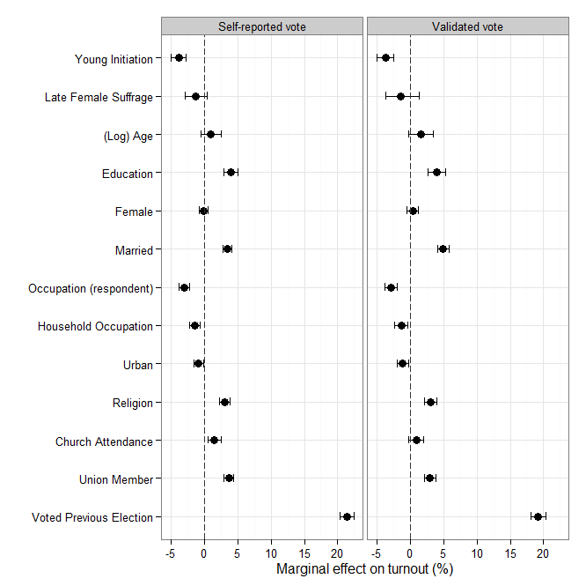
Notes: The figure plots the expected change in the probability of voting associated with a change in each predictor included in columns 3 and 6 of Table 2. Solid circles represent point estimates (in percentage points) associated with a unit change for categorical regressors and a one-standard deviation increase for continuous covariates. Horizontal lines give the 90% highest posterior density intervals.

Figure A.3: Average predictive comparisons for competitiveness measures

accounting for the long-term effect of rising seat margins

Complete-case analysis

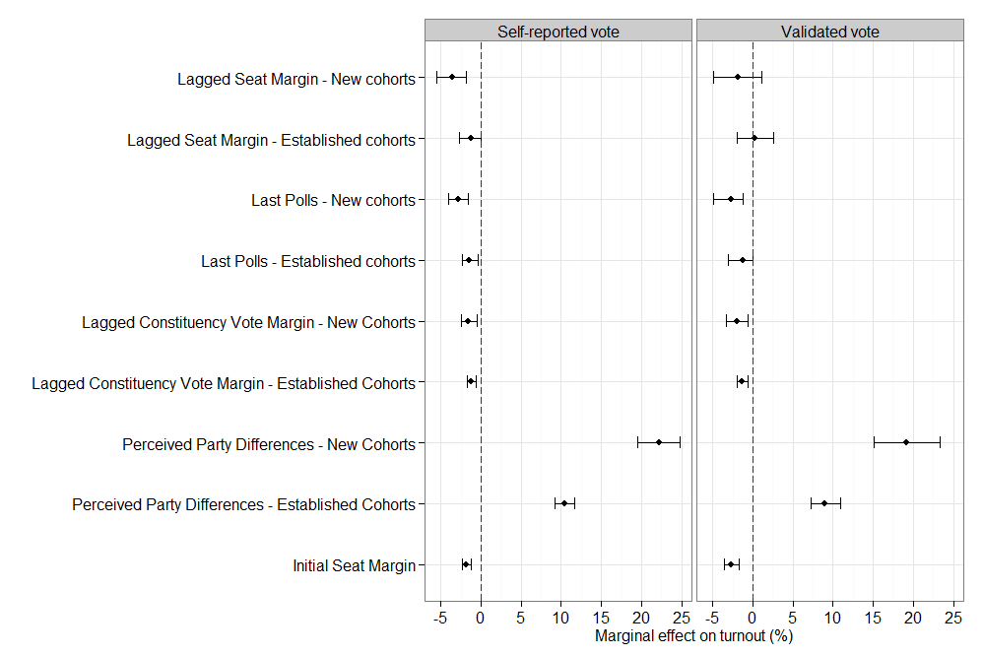

Notes: The figure plots the expected change in the probability of voting associated with a unit change in each predictor. Estimates based on the complete-case samples. Solid circles represent point estimates (in percentage points); horizontal lines give the 90% highest posterior density intervals.

Figure A.4: Posterior summaries for other measures of the competitive
environment prevailing during respondents’ first electoral experiences

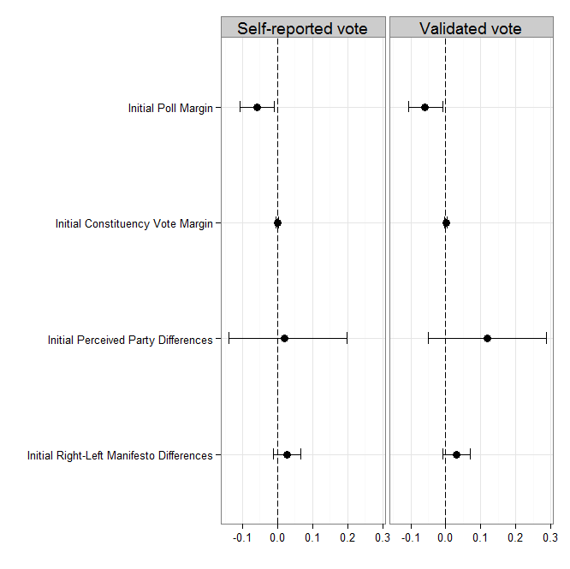

Notes: The figure plots posterior summaries for the coefficients of Initial Constituency Vote Margin, Initial Poll Margin, and the initial level of polarization. Estimates obtained

from models that add each of these variables to the specifications in Table 2 (columns 3 and 6), fitted to the samples with imputed missing values. Solid circles correspond to point estimates (posterior means), while horizontal lines give the 90% highest posterior density intervals.

Initial Constituency Vote Margin captures the average difference in popular support between the two most voted candidates in a respondent’s parliamentary constituency during the first three elections after she reached the minimum voting age. We restricted the analysis to those survey respondents who stated that they had been living in the same constituency at least since the year in which they reached the voting age.

Initial Poll Margin is the average difference in the expected vote-share of the two leading candidates in the last polls conducted before each of those three elections.

Finally, the initial level of polarization is alternatively operationalized by Initial Right-Left Manifesto Differences, the average right-left policy differences between the parties competing in those three elections, as emerging from their campaign manifestos; and by the Initial Perceived Party Differences, the mean assessments of the policy differences between the two major parties in the corresponding BES surveys. In the first case, the sample contains only respondents who entered the electorate in or after 1945 (the first year for which manifesto data are available). In the second case, only respondents who could start voting from 1964 onwards were retained.
Table A.3: Hierarchical models accounting for cohort-specific heterogeneity
and additional determinants of turnout change
Complete-case analysis and self-reported vote
Covariates | Validated vote | Self-reported vote
 | Complete-case | Complete-case | Multiple imputation
 | (1) | (2) | (3)
New cohort | 0.96**  (0.20, 1.83) | 1.50***  (0.64, 2.30) | 0.02  (-0.10, 0.14)
Lagged Seat Margin | 0.06  (-1.80, 2.02) | -0.06  (-1.93, 1.72) | -0.40  (-1.25, 0.55)
New cohort *  Lagged Seat Margin | -1.12***  (-1.76, -0.53) | -0.72**  (-1.32, -0.12) | -0.30**  (-0.62, 0.02)
Lagged Constituency Vote Margin | -0.31**  (-058, -0.04) | -0.28*  (-0.54, -0.02) | -0.44***  (-0.56, -0.31)
New cohort * Lagged Constituency Vote Margin | -0.40  (-0.91, 0.07) | -0.52*  (-0.99, -0.04) | -0.12  (-0.36, 0.11)
Last Polls | -0.31**  (-1.04, 0.38) | -0.13**  (-0.75, 0.53) | -0.07  (-0.17, 0.04)
New cohort * Last Polls | -0.28*  (-0.56, -0.01) | -0.55***  (-0.82, -0.24) | -0.10***  (-0.13, -0.06)
Perceived Party Differences | 0.10  (0.00, 0.21) | 0.19***  (0.08, 0.29) | 0.19***  (0.14, 0.23)
New cohort * Perceived Party Differences | 0.00  (-0.22, 0.22) | 0.04  (-0.17, 0.25) | 0.22***  (0.12, 0.30)
Young Initiation | -0.04  (-0.19, 0.11) | -0.15*  (-0.31, 0.01) | -0.11***  (-0.20, -0.03)
Late Female Suffrage | -0.22  (-0.57, 0.12) | -0.26  (-0.61, 0.08) | 0.07  (-0.02, 0.15)
(Log) Age | -0.14  (-0.36, 0.10) | -0.36**  (-0.58, -0.11) | -0.18  (-0.32, -0.05)
Education | 0.12*  (0.02, 0.23) | 0.20***  (0.09, 0.30) | 0.14***  (0.09, 0.20)
Female | 0.09**  (0.03, 0.15) | 0.11***  (0.05, 0.18) | -0.01  (-0.04, 0.02)
Married | 0.25***  (0.18, 0.31) | 0.18***  (0.11, 0.24) | 0.15***  (0.11, 0.18)
Respondent’s Occupation (manual) | -0.07  (-0.14, 0.01) | -0.06  (-0.14, 0.02) | -0.12***  (-0.16, -0.09)
Household Occupation (manual) | 0.00  (-0.07, 0.08) | 0.02  (-0.06, 0.10) | -0.05**  (-0.08, -0.01)
Urban | -0.04  (-0.11, 0.03) | -0.06  (-0.13, 0.01) | -0.05**  (-0.09, -0.02)
Religion |  |  | 0.09***  (0.06, 0.13)
Church Attendance |  |  | 0.08***  (0.03, 0.12)
Union member | 0.14***  (0.07, 0.22) | 0.14***  (0.07, 0.22) | 0.16***  (0.12, 0.20)
Voted at previous election | 0.49***  (0.41, 0.56) | 0.65***  (0.58, 0.73) | 0.65***  (0.61, 0.69)
Initial Seat Margin | -0.92*  (-1.52, -0.30) | -1.08***  (-1.82, -0.48) | -0.52***  (-0.77, -0.26)
Strength of Party ID | 0.64***  (0.41, 0.56) | 0.73***  (0.62, 0.86) | 0.76***  (0.71, 0.82)
Civic Duty | 0.62***  (0.54, 0.69) | 0.71***  (0.63, 0.77) | 0.64***  (0.60, 0.69)
Political Efficacy | 0.01  (-0.06, 0.08) | 0.04  (-0.03, 0.11) | 0.06**  (0.02, 0.11)
Intercept | 0.84  (-1.03, 2.74) | 1.22***  (-0.54, 3.18) | 0.45  (-0.02, 0.94)
DIC | 15,957.57 | 15,050.93 | 70,827.99
N | 7,202 | 7,883 | 37,529
Notes: The table reports (fixed) coefficient estimates from hierarchical probit models
analogous to the one in Table 4 (Column 3) of the paper, but using different
samples/outcomes. Column 1 presents results from the complete-case analysis of the
validated data; column 2 displays the results of the complete-case analysis of self-
reported vote; column 3 presents the results of the model fit to the self-reported vote
outcome in the sample with imputed missing values. Complete-case analyses must be
interpreted with caution and should be taken essentially as illustrative, though, since the
“duty” and “efficacy” questions were only asked in a small subset of the BES surveys
(see the “Data sources and coding” section of this Online Appendix). Religion-related
questions were not asked in every survey, and were thus excluded from columns 1 and 2
to avoid losing additional elections; including these items would have further reduced N to
3,955 observations in column 1 and 4,419 in column 2. The 90% highest posterior density
credible intervals are reported in parenthesis. We also report significance levels from the
likelihood-based estimation: ***0.01, **0.05, *0.1.

