ONLINE APPENDIX
Analyzing Manifestos in their Electoral Context: A New Approach Applied to Austria, 2002–2008 (Research Note)
Martin Dolezal, Laurenz Ennser-Jedenastik, Wolfgang C. Müller and Anna Katharina Winkler

Contents
1. Unitizing Procedure 2
2. Issue Categories 6
3. Organization of Coding 24
4. Uncertainty Measures 34
5. Information Gain of the Unitization Procedure 36
6. Coverage of Left–Right Scale 38
7. Reliability of Left–Right Scale 39
8. Calculation of Left–Right Scale 40
9. Wordscores and Wordfish 41
10. Correlations of AUTNES and Other Data 42
References 46

Unitizing Procedure
The AUTNES unitizing process bases on Chomsky’s (1957; 1965) idea of a phrase structure model. According to Chomsky, a grammatical sentence consists of one or more so-called kernel sentences, i.e. the shortest possible but nevertheless complete grammatical sentence.
Chomsky distinguishes between noun phrases and verbal phrases: A noun phrase consists of a noun (or pronoun) and of possible additions related to that noun, e.g. articles, adjectives, or relative clauses. A verbal phrase includes a verb (and proverbs) and a second noun phrase. Following Chomsky’s model, the smallest possible grammatical sentence – the so-called ‘kernel sentence’ – consists of one noun phrase and one verbal phrase (Chomsky 1957: 46), for instance, ‘we will cut taxes’. As a general rule, the AUTNES unitizing approach generates one unit of analysis (called ‘statement’) per verbal phrase.

Unitzing: Examples
Chomsky’s theory provides the basis for the grammatical rules along which the AUTNES coders unitize the manifesto’s sentences into statements. The following examples are derived from the Austrian parties’ election manifestos in 2006 and 2008:

Example 1: Austrian People’s Party (ÖVP) 2006
Sie [Anm.: die ÖVP] setzt sich dafür ein, dass Österreichs erfolgreiche Wirtschaft, die verlässliche soziale Sicherheit, die guten Bildungs- und Ausbildungschancen, gesunde Lebensmittel und eine intakte Natur auch für die Zukunft gesichert sind. (ÖVP 2006: 2)
Translation:
The Austrian People’s Party (ÖVP) commits itself to securing for the future the success of Austria’s economy, a reliable welfare regime, opportunities in learning and education, healthy food products and a healthy environment. (ÖVP 2006: 2)
This sentence contains seven nominal phrases (as underlined: the party’s name and each of the six policy proposals). Therefore from this sentence we derive six verbal phrases and consequently six kernel sentences:
The ÖVP commits itself to securing for the future the success of Austria’s economy.
The ÖVP commits itself to securing for the future a reliable welfare regime.
The ÖVP commits itself to securing for the future opportunities in learning.
The ÖVP commits itself to securing for the future opportunities in education.
The ÖVP commits itself to securing for the future healthy food products.
The ÖVP commits itself to securing for the future a healthy environment.
In order to facilitate coding, we now bring these kernel sentences into a standardized format – our statements. In doing so, we further reduce the content of information to its core, in the present example the party’s issue position:
Statement 1: ÖVP for success of Austria’s economy
Statement 2: ÖVP for a reliable welfare regime
Statement 3: ÖVP for opportunities in learning
Statement 4: ÖVP for opportunities in education
Statement 5: ÖVP for healthy food products
Statement 6: ÖVP for a healthy environment
Since all of these statements only include an actor and the actor’s issue position, these statements belong to the type of so-called actor–issue statements.

Example 2: Green Party 2008
Der Umwelt geht es dank SPÖ und ÖVP nicht gut in Österreich. (Greens 2008: 7)
Translation:
Thanks to SPÖ [the Social Democrats] and ÖVP [the Austrian People’s Party] the Austrian environment is not in a good condition. (Greens 2008: 7)
Here we have three noun phrases with the nouns SPÖ, ÖVP, and the Austrian environment respectively. Following Chomsky’s phrase structure model, we would obtain the following kernel sentences:
Thanks to SPÖ the Austrian environment is not in a good condition.
Thanks to ÖVP the Austrian environment is not in a good condition.
These kernel sentences would indicate a negative position of SPÖ and ÖVP towards the Austrian environment. Yet these parties do not position themselves but are blamed for the allegedly poor state of the Austrian environment by the manifesto’s author, the Green party. When adding the sentence’s source, we would obtain the following sentences:
The Green party states that thanks to SPÖ the Austrian environment is not in a good condition.
The Green party states that thanks to ÖVP the Austrian environment is not in a good condition.
From these we derive the following standardized statements that include the actor criticizing – in our example the Green party –, the criticized actors (in our example the SPÖ and the ÖVP) and the issue causing critique (here ‘environment is not in a good condition’, i.e. a lack of environmental protection).
Statement 1: The Green party criticizes the SPÖ concerning protection of the environment.
Statement 2: The Green party criticizes the ÖVP concerning protection of the environment.
Each of these statements include two actors – a subject and an object actor – and therefore belong to the group of actor–actor statements. As the object actors are criticized with regard to a certain issue – protection of the environment – they are part of the sub-group of actor–actor–issue statements.

Example 3: Freedom Party of Austria (FPÖ) 2008
Es gibt in Österreich mehr als 400.000 Personen, die Angehörige oder nahe Bekannte zu Hause pflegen. (FPÖ 2008: 9)
Translation:
In Austria, there are over 400,000 people who care for their relatives or close acquaintances at home. (FPÖ 2008: 9)
Here we have three nominal phrases: ‘400,000 people’, ‘their relatives’, and ‘close acquaintances’. Consequently, we obtain two kernel sentences:
400,000 people in Austria care for their relatives at home.
400,000 people in Austria care for close acquaintances at home.
Although it is not mentioned explicitly, as in the second example there is another actor present here: The FPÖ as the manifesto’s author. When adding this information, we obtain the following sentences:
The FPÖ states that 400,000 people in Austria care for their relatives at home.
The FPÖ states that 400,000 people in Austria care for close acquaintances at home.
Here the FPÖ does not praise or criticize another actor but refers to statistics concerning home care. In the sentence there is no indication whether the party regards this number as desirable or rather problematic. Therefore it is regarded as a simple report of facts (irrespective of the number’s actual correctness) but not as the party’s issue position. As a consequence, our standardized statements read:
Statement 1: FPÖ: 400,000 people in Austria care for their relatives.
Statement 2: FPÖ: 400,000 people in Austria care for close acquaintances.
As these statements neither indicate an issue position nor praise or criticism for another actor, they belong to the group of reality statements.

Issue Categories
The following Table A1 shows our full system of issue categories structured into three hierarchical levels. Level 1 (e.g. ‘10000 economy’) is always set in bold. All other codes in the first column refer to level 2 (e.g. ‘10100 economy (gen.)’) while the codes in the third column are the level 3 categories (e.g. ‘10101 economic policy (general)’). As explained in the main text, the actual coding is done only with level 3 codes.
The column ‘scales’ informs on the inclusion of level 3 issues into the scales used in the main article: These scales are an economic left–right scale (‘L-R (eco)’) and a cultural left–right scale (‘L-R (cult)’); together they build the general left–right scale. Furthermore we show an issue-specific scale concerning positions towards criminal punishment (‘Pun’). The last column (Direction) refers to the allocation of issues to the left (-1) or right pole (1) on the scales.

Table A1: Coding scheme and scales
 | Level 1 |  | Level 3 | Scale(s) | Direction
10000 | economy
10100 | economy (gen.) | 10101 | economic policy (general)
 |  | 10102 | economic growth
 |  | 10103 | structural reform (general) | L-R (eco) | 1
 |  | 10104 | balance in foreign trade / balance of payments
 |  | 10105 | combatting inflation / price increase; maintaining purchasing power / price stability | L-R (eco)
 |  | 10106 | interest rate | L-R (eco)
10200 | job market/unemployment | 10201 | unemployment (general) | L-R (eco) | 1
 |  | 10202 | unemployment: youth | L-R (eco) | 1
 |  | 10203 | unemployment: women | L-R (eco) | 1
 |  | 10204 | unemployment: elderly employees | L-R (eco) | 1
 |  | 10205 | unemployment: disabled / chronically ill | L-R (eco) | 1
 |  | 10206 | right to work | L-R (eco) | -1
 |  | 10207 | active employment policy | L-R (eco) | -1
10300 | market/liberalisation/deregulation | 10301 | capitalism / market economy / entrepreneurs / property (general) | L-R (eco) | 1
 |  | 10302 | social market economy | L-R (eco) | -1
 |  | 10303 | eco-social market economy (Austrian term) | L-R (eco) | -1
 |  | 10304 | role of the state in the economy (general) | L-R (eco) | -1
 |  | 10305 | government control of prices (general) | L-R (eco) | -1
 |  | 10306 | economic stimulus plan / public investment | L-R (eco) | -1
 |  | 10307 | (re-)nationalisation | L-R (eco) | -1
 |  | 10308 | (re-)nationalisation of banks (specific) | L-R (eco) | -1
 |  | 10309 | privatisation / liberalisation / deregulation (general) | L-R (eco) | 1
 |  | 10310 | privatisation / liberalisation / deregulation: rail traffic | L-R (eco) | 1
 |  | 10311 | privatisation / liberalisation / deregulation: air transport (incl. Austrian Airlines (AUA)) | L-R (eco) | 1
 |  | 10312 | privatisation / liberalisation / deregulation: telecommunication / mail services | L-R (eco) | 1
 |  | 10313 | privatisation / liberalisation / deregulation: water supply | L-R (eco) | 1
 |  | 10314 | privatisation / liberalisation / deregulation: power supply | L-R (eco) | 1
 |  | 10315 | liberalisation / competition in health care sector | L-R (eco) | 1
 |  | 10316 | liberalisation of shopping hours (general) | L-R (eco) | 1
 |  | 10317 | liberalisation of shopping hours (except sunday) | L-R (eco) | 1
 |  | 10318 | liberalisation of industrial code | L-R (eco) | 1
 |  | 10319 | competition / combatting cartels, monopolies, price agreements | L-R (eco) | 1
10400 | globalisation | 10401 | globalisation / reduction of tariffs / open world market | L-R (eco) | 1
 |  | 10402 | fair world trading system | L-R (eco) | -1
 |  | 10403 | national competitiveness | L-R (eco) | 1
 |  | 10404 | protection of domestic markets / protectionism | L-R (eco) | -1
 |  | 10405 | foreign investment by Austrian companies | L-R (eco) | 1
 |  | 10406 | Tobin tax / taxation of international monetary transactions | L-R (eco) | -1
10500 | financial sector/banks | 10502 | national government bailout fund / bad bank | L-R (eco) | -1
 |  | 10503 | liberalisation international capital movements | L-R (eco) | 1
 |  | 10505 | combatting world economic crisis / banking crisis | L-R (eco) | -1
 |  | 10506 | high salaries / executive bonuses | L-R (eco) | 1
 |  | 10507 | speculation / financial transactions / stock exchange | L-R (eco) | 1
 |  | 10508 | taxation of profits from financial speculation / stocks | L-R (eco) | -1
 |  | 10509 | Basel II directive | L-R (eco) | -1
 |  | 10510 | bank tax | L-R (eco) | -1
 |  | 10511 | supervision of financial markets | L-R (eco) | -1
10600 | economy: businesses | 10601 | promotion / measures for companies (general) | L-R (eco) | 1
 |  | 10602 | promotion / measures for small and medium sized companies (specific) | L-R (eco) | 1
 |  | 10603 | support for individual companies (bail out etc.) | L-R (eco) | 1
 |  | 10604 | private domestic investment / venture capital | L-R (eco) | 1
 |  | 10605 | support for tourism | L-R (eco) | 1
 |  | 10606 | support for self-employment / start-up enterprises (general) | L-R (eco) | 1
 |  | 10607 | new self-employed (specific) (Austrian term) | L-R (eco) | 1
 |  | 10608 | penalty tax on high commercial profits (specific) | L-R (eco) | -1
 |  | 10609 | supervision of companies (social dumping etc.) | L-R (eco) | -1
 |  | 10610 | high salaries / compensations for managers (private sector) | L-R (eco) | 1
10700 | economy: employees | 10701 | employment protection (general) | L-R (eco) | -1
 |  | 10702 | strict labor regulation / against flexible working environment | L-R (eco) | -1
 |  | 10703 | marginal / part-time employment (people) | L-R (eco) | -1
 |  | 10704 | marginal / part-time employment (labor contract) | L-R (eco) | 1
 |  | 10705 | 'black labor' / illicit work / illegal employment | L-R (cult) | -1
 |  | 10706 | (strong) protection from dismissals | L-R (eco) | -1
 |  | 10707 | short-time work (Austrian term) | L-R (eco) | -1
 |  | 10708 | collective labor contract | L-R (eco) | -1
 |  | 10709 | salaries / wages / earnings | L-R (eco) | -1
 |  | 10710 | minimum wage | L-R (eco) | -1
 |  | 10711 | 'combined wages' (Austrian term) / subsidized wages | L-R (eco) | 1
 |  | 10712 | mandatory dismissal pay | L-R (eco) | -1
 |  | 10713 | trade unions | L-R (eco) | -1
 |  | 10714 | codetermination / workers' participation / employee participation | L-R (eco) | -1
 |  | 10715 | strike | L-R (eco) | -1
 |  | 10716 | levelling of legal status of workers and employees | L-R (eco) | -1
 |  | 10717 | working hours | L-R (eco) | 1
 |  | 10718 | flexible working hours (general) | L-R (eco) | 1
 |  | 10719 | flexible working hours (except sunday) | L-R (eco) | 1
 |  | 10720 | paid vacation | L-R (eco) | -1
 |  | 10721 | safety and health in the workplace (noise / chemicals etc.) | L-R (eco) | -1
 |  | 10722 | employees as shareholders in their company | L-R (eco) | 1
 |  | 10723 | competition clauses in work contracts | L-R (eco) | 1
 |  | 10724 | commuters | L-R (eco) | -1
10800 | consumers/habitation | 10801 | consumer protection (general) | L-R (eco) | -1
 |  | 10803 | government control of gas prices / public access to government gas stations (specific) | L-R (eco) | -1
 |  | 10804 | car drivers
 |  | 10805 | rent/housing costs (general) | L-R (eco) | -1
 |  | 10806 | government control of rents / protection of tenants | L-R (eco) | -1
 |  | 10807 | public housing / social housing | L-R (eco) | -1
 |  | 10808 | subsidies for private housing | L-R (eco) | -1
 |  | 10809 | amnesty for private debtors | L-R (eco) | -1
 |  | 10810 | quality of food / nutrition / diet | L-R (eco) | -1
10900 | agriculure | 10901 | farming / agriculture / farmers (general)
 |  | 10902 | agricultural subsidies / direct payments (general)
 |  | 10903 | support for small and medium farms
 |  | 10904 | support for mountain farmers
 |  | 10905 | disclosure of agricultural subsidies | L-R (eco) | 1
 |  | 10906 | organic farming
 |  | 10907 | genetically-modified organisms (GMOs) / genetic engineering in agriculture
 |  | 10908 | mandatory labeling of GMOs
 |  | 10909 | industrial farming
 |  | 10910 | biofuels
 |  | 10911 | pesticides / colony collapse disorder (bees)
11000 | welfare state
11100 | welfare state (gen.) | 11101 | living standard / quality of life in Austria (general)
 |  | 11102 | living standard / quality of life in rural Austria
 |  | 11103 | social policy / welfare state (general) | L-R (eco) | -1
 |  | 11104 | social justice / equality / equal opportunities (general) | L-R (eco) | -1
 |  | 11105 | redistribution (specific) | L-R (eco) | -1
 |  | 11106 | against principle of indiscriminate all-round distribution (welfare state measures) | L-R (eco) | 1
 |  | 11107 | basic income | L-R (eco) | -1
 |  | 11108 | choice / individual responsibility / effort (general) | L-R (eco) | 1
 |  | 11109 | social security contributions / ancillary labor costs (general) | L-R (eco) | -1
 |  | 11110 | social security contributions / ancillary labor costs (employers) | L-R (eco) | -1
 |  | 11111 | social security contributions / ancillary labor costs (employees) | L-R (eco) | -1
 |  | 11112 | benefit fraud (general / Austrian natives) | L-R (eco) | -1
 |  | 11113 | poverty (general) | L-R (eco) | 1
 |  | 11114 | payments to the poor / social welfare benefits | L-R (eco) | -1
 |  | 11115 | five-point plan (2008 campaign, SPOE) | L-R (eco) | -1
 |  | 11116 | prohibition of begging | L-R (eco) | 1
 |  | 11117 | reform of/cut-backs in social insurance | L-R (eco) | 1
11200 | support of the unemployed | 11201 | support for unemployed / out-of-work benefits / unemployment pay | L-R (eco) | -1
 |  | 11202 | extension of unemployment insurance | L-R (eco) | -1
 |  | 11203 | improvement / acceleration of labor exchange / employment service | L-R (eco) | -1
 |  | 11204 | privatisation of employment agencies | L-R (eco) | 1
 |  | 11205 | cuts in unemployment benefits in case of turning down job offers | L-R (eco) | 1
 |  | 11206 | mandatory community service for unemployed | L-R (eco) | 1
11300 | health system | 11301 | health care system (general) | L-R (eco) | -1
 |  | 11302 | health care system reform (general) | L-R (eco)
 |  | 11304 | health care spending | L-R (eco) | -1
 |  | 11305 | improve quality of health care | L-R (eco) | -1
 |  | 11306 | merging of public health insurance agencies / economization of administration
 |  | 11307 | services for the health-insured | L-R (eco) | -1
 |  | 11308 | patient contributions / ambulance fees / prescription fees | L-R (eco) | 1
 |  | 11309 | health insurance contribution | L-R (eco) | -1
 |  | 11310 | (in part) financing by state / taxes / budget / subsidies (health care) | L-R (eco) | -1
 |  | 11311 | private health insurance | L-R (eco) | 1
 |  | 11312 | 'two-class' health care | L-R (eco) | 1
 |  | 11313 | supervision / quality control in the public health sector | L-R (eco) | -1
 |  | 11314 | service-orientation in the public health sector (e.g. opening times, waiting times) | L-R (eco) | -1
11400 | health: rights/duties of individuals | 11401 | individual patients' rights (e.g. patient's provision) | L-R (cult) | -1
 |  | 11402 | collective patients' rights (e.g. co-determination in health insurance companies)
 |  | 11403 | prevention / personal responsibility / healthy way of living (general) | L-R (eco) | 1
 |  | 11404 | non-smoker protection / smoking bans | L-R (cult) | 1
 |  | 11405 | organ donations
 |  | 11406 | sick pay | L-R (eco) | -1
11500 | nursing & care/disabled persons | 11501 | geriatric care (general) | L-R (eco) | -1
 |  | 11502 | care allowance (Austrian term) | L-R (eco) | -1
 |  | 11503 | constraints on care allowances / contribution by relatives | L-R (eco) | 1
 |  | 11504 | extension of geriatric care (retirement homes) | L-R (eco) | -1
 |  | 11505 | private / home care (e.g. financial support) | L-R (eco) | -1
 |  | 11506 | private / home care by illegal immigrants | L-R (cult) | -1
 |  | 11507 | legal guardianship / incapacitation | L-R (cult) | 1
 |  | 11508 | integration / support for disabled | L-R (eco) | -1
 |  | 11509 | care: financing by taxes / privatization gains | L-R (eco) | -1
 |  | 11510 | care: financing by social contributions / care insurance | L-R (eco) | -1
 |  | 11511 | hospice / terminal care / palliative medicine | L-R (cult) | 1
11600 | pension | 11601 | pensioners / elderly people (general) | L-R (eco) | -1
 |  | 11602 | pension reform (general) | L-R (eco) | 1
 |  | 11603 | uniform pension scheme | L-R (eco) | -1
 |  | 11604 | raise of retirement age / longer working life | L-R (eco) | 1
 |  | 11605 | partial retirement | L-R (eco) | -1
 |  | 11606 | early retirement | L-R (eco) | -1
 |  | 11607 | early retirement plan (Austrian term) | L-R (eco) | -1
 |  | 11608 | pension increase (general) | L-R (eco) | -1
 |  | 11609 | pension increase: small pensions / widows | L-R (eco) | -1
 |  | 11610 | pension financing: insurance contributions | L-R (eco) | -1
 |  | 11611 | pension financing: budget / taxes | L-R (eco) | -1
 |  | 11612 | taxation of pensions | L-R (eco) | 1
 |  | 11613 | company pension / private pension (via employer) | L-R (eco) | 1
 |  | 11614 | private pension | L-R (eco) | 1
 |  | 11615 | crediting periods of child/geriatric care for pensions / pension for mothers | L-R (cult) | 1
 |  | 11616 | pension scheme: pay-as-you-go scheme / intergenerational contract | L-R (eco) | -1
 |  | 11617 | pension scheme: three-pillar model | L-R (eco) | 1
11700 | family/children/adolescents | 11701 | families (social group / general) | L-R (cult) | 1
 |  | 11702 | support for families / family allowance | L-R (eco) | -1
 |  | 11704 | salary for mothers (Austrian term) | L-R (cult) | 1
 |  | 11705 | tax deduction for families with children | L-R (cult) | 1
 |  | 11706 | child care benefit / maternity pay / maternity leave (general) | L-R (eco) | -1
 |  | 11707 | income-related child care benefit / maternity pay (specific) | L-R (cult) | -1
 |  | 11708 | limits for additional income on parental leave/ child care payments (specific) | L-R (cult) | 1
 |  | 11709 | paternity leave (specific) | L-R (cult) | -1
 |  | 11710 | support for single parents (e.g. higher child care benefit) | L-R (cult) | -1
 |  | 11711 | right to part-time work for parents | L-R (cult) | -1
 |  | 11712 | children's rights in constitution | L-R (cult) | -1
 |  | 11713 | youth protection | L-R (cult) | 1
 |  | 11714 | youth protection (regulation at federal level, specific)
 |  | 11716 | children / youth (general) | L-R (eco) | -1
11900 | government aid in case of natural disasters/catastrophes | 11901 | government removal of war relics | L-R (eco) | -1
 |  | 11902 | government aid in case of natural disasters / flood protection | L-R (eco) | -1
 |  | 11903 | voluntary services / civil society
 |  | 11951 | doping | L-R (cult) | -1
11950 | sports/leisure | 11952 | amateur sports (masses) | L-R (eco) | -1
 |  | 11953 | professional sports (elites)
 |  | 11954 | clubs / associations / recreational facilities / leisure facilities
12000 | budget
12100 | budget, government debt | 12101 | financial policy (general) | L-R (eco)
 |  | 12102 | budget deficit | L-R (eco) | -1
 |  | 12103 | public debt | L-R (eco) | -1
 |  | 12104 | public expenditure quota | L-R (eco) | -1
 |  | 12105 | strong currency (schilling!) | L-R (eco)
 |  | 12106 | cuts in government expenditures | L-R (eco) | 1
 |  | 12107 | transfer of national bank profits to federal budget | L-R (eco) | -1
 |  | 12108 | outsourced company debts/holdings (OEBB, OEIAG, ASFINAG, …) | L-R (eco) | -1
12200 | taxes general | 12201 | tax policy (general) | L-R (eco)
 |  | 12202 | tax reform (general) | L-R (eco) | 1
 |  | 12203 | simplification of the tax code | L-R (eco) | 1
 |  | 12204 | tax reduction/ decrease of tax and contribution ratio (general) | L-R (eco) | 1
 |  | 12205 | tax increase (general) | L-R (eco) | -1
12300 | taxes for individuals | 12301 | value added tax / VAT (general) | L-R (eco) | -1
 |  | 12302 | value added tax / VAT (specific products) | L-R (eco) | -1
 |  | 12303 | income tax | L-R (eco) | -1
 |  | 12305 | tax exemption for small incomes | L-R (eco) | 1
 |  | 12306 | tax cut for small and medium incomes | L-R (eco) | 1
 |  | 12307 | tax cut for high incomes | L-R (eco) | 1
 |  | 12308 | tax increase for high incomes | L-R (eco) | -1
 |  | 12309 | progressive income tax | L-R (eco) | -1
 |  | 12310 | flat tax | L-R (eco) | 1
 |  | 12311 | taxation of vacation / christmas bonus (Austrian term) | L-R (eco) | -1
 |  | 12312 | taxation of overtime work, night-, sunday-, holiday shifts | L-R (eco) | -1
 |  | 12313 | capital gains tax / taxation of interest earnings | L-R (eco) | -1
 |  | 12315 | wealth tax | L-R (eco) | -1
 |  | 12316 | tax deductibility of domestic services (gardener, babysitter, ...) | L-R (eco) | 1
 |  | 12317 | land tax / property tax | L-R (eco) | -1
 |  | 12318 | inheritance tax | L-R (eco) | -1
 |  | 12319 | accessions tax / gift tax | L-R (eco) | -1
 |  | 12320 | church tax (Austrian term) | L-R (cult) | 1
 |  | 12321 | petroleum tax
 |  | 12322 | tax deductibility of charitable donations | L-R (eco) | 1
12400 | taxes for businesses | 12401 | business tax (general) | L-R (eco) | -1
 |  | 12402 | business tax: cut | L-R (eco) | 1
 |  | 12403 | business tax: increase | L-R (eco) | -1
 |  | 12404 | tax relief for small and medium businesses | L-R (eco) | 1
 |  | 12405 | corporate tax | L-R (eco) | -1
 |  | 12406 | industrial tax / license tax | L-R (eco) | -1
 |  | 12407 | sales tax | L-R (eco) | -1
 |  | 12408 | standardized business tax | L-R (eco) | 1
13000 | education and culture
13100 | education general | 13101 | education / education policy (general)
 |  | 13102 | equal opportunities in education
 |  | 13103 | support for achievement and performance in education policy
 |  | 13104 | training of teachers and pedagogues (kindergarten, school)
 |  | 13105 | payment of teachers and pedagogues (kindergarten, school)
 |  | 13106 | civic education
13200 | kindergarten | 13201 | kindergarten / child care / day care
 |  | 13202 | child care / day care for toddlers (nurseries, day care...) | L-R (cult) | -1
 |  | 13203 | extended opening times for kindergarten, nurseries, day care | L-R (cult) | -1
 |  | 13204 | cost-free kindergarten
 |  | 13205 | compulsory pre-school year | L-R (cult) | -1
 |  | 13206 | extension of domestic child care / childminders / nannies | L-R (cult) | 1
 |  | 13207 | education in kindergarten / early learning
13300 | school | 13301 | schools / school infrastructure (general)
 |  | 13302 | students / schoolchildren (social group)
 |  | 13303 | school autonomy
 |  | 13304 | comprehensive school for 10- to 14-year-olds
 |  | 13305 | after school care
 |  | 13306 | all-day school
 |  | 13307 | cost-free textbooks
 |  | 13308 | financial support for students / pupils / schoolchildren
 |  | 13309 | school fees
 |  | 13310 | private schools
 |  | 13311 | reduction of maximum number of students per class / small classes
 |  | 13312 | small schools / schools in rural areas / village schools
 |  | 13313 | centralized A-levels / central high school diploma
 |  | 13314 | grades / staying back a grade
 |  | 13315 | foreign languages / natural sciences / economics (as subjects in school)
 |  | 13316 | private lessons (to keep up in school)
 |  | 13317 | support for individual students/pupils
 |  | 13318 | teachers (social group)
13400 | university and college | 13401 | universities / technical colleges / higher education (general)
 |  | 13402 | science / development / innovation / research
 |  | 13403 | copyright / patents | L-R (eco) | 1
 |  | 13404 | university/college students (social group)
 |  | 13405 | researchers / scientists (social group)
 |  | 13406 | private universities
 |  | 13407 | admission tests / restriction of free university admission
 |  | 13408 | university fees / tuition fees / enrollment fees
 |  | 13409 | financial support for university students / grants / scholarships
 |  | 13410 | tuition fees for foreign students | L-R (cult) | 1
 |  | 13411 | restricted university admission for foreigners / quota | L-R (cult) | 1
 |  | 13412 | autonomy of universities
 |  | 13413 | democracy in universities
 |  | 13414 | practically oriented curricula / adaption of curricula to needs of businesses
 |  | 13415 | studying abroad
13500 | vocational training | 13501 | apprenticeship / vocational training / dual education (general)
 |  | 13502 | apprentices (social group)
 |  | 13503 | government financing of vocational training / support for apprentices
 |  | 13504 | free A-levels/high school diploma for apprentices
13600 | adult vocational training/education and occupation | 13601 | adult education / adult education centers / adult evening classes
 |  | 13602 | further education / qualification / on-the-job training / sabbatical
 |  | 13603 | trainee / intern / student apprentice (social group) | L-R (eco) | 1
 |  | 13604 | career counseling / vocational counseling
13700 | culture | 13701 | arts / culture (general)
 |  | 13702 | freedom of the arts | L-R (cult) | -1
 |  | 13703 | governernment financing of arts and culture
 |  | 13704 | private financing/sponsoring of arts and culture
 |  | 13705 | transparency in government financing of arts and culture
14000 | security
14100 | fight against crime (gen.) | 14101 | crime (general) | L-R (cult) | -1
 |  | 14102 | organised crime | L-R (cult) | -1
 |  | 14103 | 'mafia clause' (§278a StGB) (Austrian term) | L-R (cult) | 1
 |  | 14104 | juvenile delinquency | L-R (cult) | -1
 |  | 14105 | violation/abuse by police | L-R (cult) | 1
 |  | 14106 | police (general) | L-R (cult) | 1
 |  | 14107 | cyber crime | L-R (cult) | -1
14200 | criminal prosecution | 14201 | structural police reform / merging of police and gendarmerie
 |  | 14202 | government expenditure for police (money, staff) | L-R (cult) | 1
 |  | 14203 | police powers | L-R (cult) | 1
 |  | 14204 | international police cooperation | L-R (cult) | 1
 |  | 14206 | intelligence service powers | L-R (cult) | 1
 |  | 14207 | supervision of intelligence services | L-R (cult) | -1
 |  | 14208 | data protection/privacy | L-R (cult) | -1
14300 | degree of punishment/punishment | 14301 | more severe punishment (general) | L-R (cult), Pun | 1
 |  | 14302 | more severe punishment of juvenile delinquents | L-R (cult), Pun | 1
 |  | 14303 | more severe punishment of child abuse / sexual crimes / rape | L-R (cult), Pun | 1
 |  | 14304 | more severe punishment of property crimes | L-R (cult), Pun | 1
 |  | 14305 | more severe punishment of assault and battery | L-R (cult), Pun | 1
 |  | 14306 | death penalty | L-R (cult), Pun | 1
 |  | 14307 | mild penalties (restorative justice, amnesty) | L-R (cult), Pun | -1
 |  | 14308 | improving conditions of imprisonment | L-R (cult) | -1
 |  | 14309 | victim protection | L-R (cult) | 1
 |  | 14310 | compensation for crime victims (financial) | L-R (cult) | 1
 |  | 14311 | victims law | L-R (cult) | 1
 |  | 14312 | domestic violence | L-R (cult) | -1
 |  | 14313 | help / conseling in case of domestic violence (women's refuge etc.) | L-R (cult) | -1
14400 | prevention of crime | 14401 | crime prevention (general) | L-R (cult), Pun | -1
 |  | 14402 | crime prevention through education / welfare | L-R (cult), Pun | -1
 |  | 14403 | video surveillance / CCTV | L-R (cult), Pun | 1
 |  | 14404 | preventive custody / protective internment /paroles | L-R (cult), Pun | 1
 |  | 14405 | resocialisation / social reintegration | L-R (cult), Pun | -1
 |  | 14406 | drug liberalisation | L-R (cult) | -1
 |  | 14407 | help for drug addicts | L-R (cult) | -1
 |  | 14408 | private gun ownership | L-R (cult) | 1
 |  | 14409 | private crime prevention (vigilant groups / neighborhood watch) | L-R (cult) | 1
 |  | 14410 | commercial crime prevention (guard service / security firms) | L-R (cult) | 1
14500 | economic crime | 14501 | white-collar crime / business crime (general) | L-R (cult) | -1
 |  | 14502 | banking secrecy | L-R (cult) | -1
 |  | 14503 | tax evasion / trusts / foundations | L-R (eco) | 1
14600 | terrorism | 14601 | terrorism (general) | L-R (cult) | -1
 |  | 14602 | torture | L-R (cult) | 1
 |  | 14603 | cyber terrorism (specific) | L-R (cult) | -1
15000 | army
15100 | army: general and domestic missions | 15101 | Austrian Armed Forces / national defence / army (general)
 |  | 15102 | Austrian Armed Forces / national defence / army (budget)
 |  | 15103 | armament Austrian Armed Forces (interceptor planes / arms)
 |  | 15104 | infrastructure / manning level Austrian Armed Forces (barracks etc.)
 |  | 15105 | Austrian Armed Forces: border protection / border security deployment | L-R (cult) | 1
 |  | 15106 | domestic employment of Austrian Armed Forces: police function | L-R (cult) | 1
 |  | 15107 | Austrian Armed Forces: disaster control / civil protection
 |  | 15108 | re-negotiation of Eurofighter interceptor planes contract
15200 | army: reformation/structural change | 15201 | compulsory military service / conscription
 |  | 15202 | shortening of compulsory military service
 |  | 15203 | militia
 |  | 15204 | professional army/voluntary military service
 |  | 15205 | conscripts (social group)
 |  | 15206 | examination of 'conscience' reasons for denying military service
 |  | 15207 | alternative civilian service (general)
 |  | 15208 | persons performing alternative civilian service (social group) | L-R (eco) | -1
 |  | 15209 | women in the Austrian Armed Forces | L-R (cult) | -1
 |  | 15210 | alternative civilian service for women (voluntary) | L-R (cult) | -1
 |  | 15211 | reform of Austrian Armed Forces (general)
15300 | army: foreign countries | 15301 | Austrian Armed Forces: foreign assignment / un-assignment
 |  | 15302 | arms exports (general)
 |  | 15303 | supervision of arms exports
 |  | 15304 | disarmament / ban on certain arms (NBC-weapons, mines)
16000 | foreign policy
16100 | international cooperation | 16101 | international cooperation / international law (general)
 |  | 16102 | UN / Reform of UN / UN subdivisions (WHO, UNIDO, UNICEF etc.)
 |  | 16103 | WTO / GATT / IMF / World Bank / G7 / G8 / G20 | L-R (eco) | 1
 |  | 16104 | OSCE / CSCE
 |  | 16105 | Council of Europe
 |  | 16106 | NATO (general)
 |  | 16107 | Austrian accession to NATO
 |  | 16108 | neutrality
 |  | 16109 | foreign aid / development cooperation
16200 | bilateral relations | 16201 | protection of South Tyrol | L-R (cult) | 1
 |  | 16202 | relationship with individual countries
 |  | 16203 | recognition of former Yugoslavian states
16300 | war and peace | 16301 | war (general)
 |  | 16302 | sanctions against individual countries
17000 | europe
17100 | EU: general | 17101 | European integration (general)
 |  | 17102 | federal / strong EU / extension of powers
 |  | 17103 | Europe of nations
 |  | 17104 | subsidiarity principle in the EU
 |  | 17105 | 'core Europe' / Europe of different speeds
 |  | 17106 | EU centralism
 |  | 17107 | repatriation of EU powers
 |  | 17108 | Austrian EU-accession
 |  | 17109 | Austrian EU-membership
 |  | 17110 | Austrian influence in the EU
 |  | 17111 | influence of small / medium-sized member states in the EU
 |  | 17112 | EU-sanctions against Austria (year 2000)
17200 | EU: treaties/steps of integration/Euro | 17201 | European constitution (general)
 |  | 17202 | EU Reform Treaty / Lisbon Treaty (general)
 |  | 17203 | Nice Treaty (general)
 |  | 17204 | Amsterdam Treaty (general)
 |  | 17205 | Maastricht Treaty (general)
 |  | 17206 | European Economic Area (EEA)
 |  | 17207 | Single European Act (general)
 |  | 17208 | European Atomic Energy Community (EAEC) (general)
 |  | 17209 | Euro (ECU)
 |  | 17210 | stability pact (strict) / strong currency (euro)
 |  | 17212 | financial aid in national debt crisis (ESM; Greece, PIGS states)
17300 | EU: enlargement | 17301 | EU enlargement (general)
 |  | 17302 | EU northern enlargement
 |  | 17303 | EU eastern enlargement I
 |  | 17304 | EU eastern enlargement II (Bulgaria & Romania)
 |  | 17305 | EU-accession Balkan states
 |  | 17306 | EU-accession Hungary
 |  | 17307 | EU-accession Poland
 |  | 17308 | EU-accession Czech Republic
 |  | 17309 | EU-accession Slovakia
 |  | 17310 | EU-accession Romania
 |  | 17311 | EU-accession Bulgaria
 |  | 17312 | EU-accession Croatia
 |  | 17313 | EU-accession Serbia
 |  | 17314 | EU-accession Bosnia and Herzegovina
 |  | 17315 | EU-accession Turkey
 |  | 17316 | EU-accession Iceland
 |  | 17317 | EU-accession Israel
17400 | EU: participation/democracy | 17401 | democracy / participation in the EU
 |  | 17402 | increased powers for EU parliament
 |  | 17403 | direct election of European commission
 |  | 17404 | national referendum on EU treaties / enlargements (general)
 |  | 17405 | national referendum on EU-accession of Turkey
 |  | 17406 | EU-wide referendum on EU-treaties / enlargements (general)
 |  | 17407 | EU-wide referendum on EU-accession of Turkey
17500 | EU: policies | 17501 | EU budget (general)
 |  | 17502 | Austrian net contribution to EU
 |  | 17503 | EU: subsidies / regional policy (except agriculture)
 |  | 17504 | Common Agricultural Policy (CAP) / subsidies
 |  | 17505 | EU: transition period for access to the labor market
 |  | 17506 | EU-services directive / Bolkestein directive
 |  | 17507 | social Europe
 |  | 17508 | EU: cooperation justice / domestic policy / home affairs
 |  | 17509 | Schengen / Frontex
 |  | 17510 | European police
 |  | 17511 | European warrant
 |  | 17512 | EU: quotas for refugees / immigrants / asylum-seekers
 |  | 17513 | EU: common standards for refugees / asylum-seekers
 |  | 17514 | list of safe third countries
 |  | 17515 | Common Foreign and Security Policy (CFSP) (general)
 |  | 17516 | mutual defense of EU member states (specific)
 |  | 17517 | Bologna process / European Higher Education Area / BA-MA-system
 |  | 17519 | internal European market (policies; not EEA)
18000 | infrastructure
18100 | road traffic | 18101 | development of roads / transport infrastructure
 |  | 18102 | highway extensions (general)
 |  | 18103 | private financing of road construction / public-private partnerships | L-R (eco) | 1
 |  | 18104 | HGV-toll / toll for trucks
 |  | 18105 | road charge / road pricing
 |  | 18106 | policing of road traffic / punishment for traffic offense | L-R (cult) | 1
 |  | 18107 | cyclists / pedestrians
18200 | rail traffic | 18201 | extension of railroad network (general)
 |  | 18202 | extension of railroad network (specific projects)
 |  | 18203 | public transport
18300 | air traffic/shipping | 18301 | development of airports / air travel (general)
 |  | 18304 | taxation of aviation fuel / kerosine
 |  | 18305 | development of water routes
18400 | energy supply | 18401 | energy supply / power supply / energy policy (general)
 |  | 18403 | energy independence
 |  | 18404 | energy costs
 |  | 18405 | energy saving
 |  | 18406 | renewable energy (general)
 |  | 18407 | hydropower
 |  | 18408 | nuclear energy
 |  | 18409 | energy from fossile fuels
18500 | telecommunication | 18501 | telecommunications infrastructure
18600 | infrastructure (gen.) | 18601 | infrastructure (general)
 |  | 18602 | urban and regional planning / spatial development
 |  | 18603 | waste management / waste tourism / waste incineration
 |  | 18604 | traffic / mobility (general)
19000 | society
19100 | gender equality | 19101 | gender equality | L-R (cult) | -1
 |  | 19102 | social protection of women | L-R (cult) | -1
 |  | 19103 | protection against sexual harrassment | L-R (cult) | 1
 |  | 19105 | reconciliation of work and family life (general) | L-R (cult) | -1
 |  | 19106 | equal payment for men and women | L-R (cult) | -1
 |  | 19107 | support for women in the job/education (general) | L-R (cult) | -1
 |  | 19108 | preferential hiring of women with equal skills (specific) | L-R (cult) | -1
 |  | 19109 | quota for women in the public sector | L-R (cult) | -1
 |  | 19110 | quota for women in the private sector | L-R (cult) | -1
 |  | 19111 | harmonisation of retirement ages of men and women | L-R (cult) | 1
 |  | 19113 | gender mainstreaming / gender budgeting | L-R (cult) | -1
19200 | partnership and sexual orientation | 19201 | traditional marriage | L-R (cult) | 1
 |  | 19202 | equal treatment of traditional marriage and cohabitation / patchwork families | L-R (cult) | -1
 |  | 19203 | adoption rights for unmarried couples | L-R (cult) | -1
 |  | 19204 | simplification of the divorce law | L-R (cult) | -1
 |  | 19205 | alimony for divorced/kids/government maintenence payment advances | L-R (cult) | -1
 |  | 19206 | rights for divorced fathers | L-R (cult) | 1
 |  | 19207 | lowering the age of consent | L-R (cult) | -1
 |  | 19209 | support/equal rights for homosexuals | L-R (cult) | -1
 |  | 19210 | same-sex marriage | L-R (cult) | -1
 |  | 19211 | civil unions/civil partnerships (homosexuals) | L-R (cult) | -1
 |  | 19212 | adoption rights for homosexual couples | L-R (cult) | -1
19300 | abortion and bioetic questions | 19301 | abortion (general) | L-R (cult) | -1
 |  | 19302 | legal abortion within time limit | L-R (cult) | -1
 |  | 19303 | legal abortion based on medical, social, or ethical reasons | L-R (cult) | 1
 |  | 19304 | abortion counseling | L-R (cult) | 1
 |  | 19305 | late-term abortion | L-R (cult) | -1
 |  | 19306 | baby hatch / anonymous births | L-R (cult) | 1
 |  | 19307 | gene therapy / stem cell research | L-R (cult) | -1
 |  | 19308 | biological patent/gene patent | L-R (cult) | -1
 |  | 19309 | euthanasia / assisted suicide | L-R (cult) | -1
19400 | religion | 19401 | religion / religious beliefs / church (general) | L-R (cult) | 1
 |  | 19402 | separation of church and state (general) | L-R (cult) | -1
 |  | 19403 | Christian symbols in public buildings / schools | L-R (cult) | 1
 |  | 19404 | Christian religious education in state schools | L-R (cult) | 1
 |  | 19405 | legal recognition of new religions / churches / sects | L-R (cult) | -1
 |  | 19406 | ethics lessons in school (alternative) | L-R (cult) | -1
19500 | censorship | 19501 | censorship / restrictions of freedom of speech (general) | L-R (cult) | 1
 |  | 19502 | pornography | L-R (cult) | -1
 |  | 19503 | shooter-games / glorification of violence | L-R (cult) | -1
 |  | 19504 | gambling / betting / lottery | L-R (cult) | -1
 |  | 19505 | ban on advertising for ethical reasons (pornography, violence) | L-R (cult) | 1
 |  | 19506 | ban on advertising for health reasons (cigarettes, alcohol) | L-R (cult) | 1
 |  | 19507 | prostitution | L-R (cult) | -1
19600 | Nazi era/right-wing extermism | 19601 | support / compensation for victims of the Nazi regime | L-R (cult) | -1
 |  | 19602 | support / compensation for displaced persons / members of the German Wehrmacht | L-R (cult) | 1
 |  | 19603 | right-wing extremism / neo-Nazis | L-R (cult) | 1
 |  | 19604 | antisemitism | L-R (cult) | 1
 |  | 19605 | Austrofascism/corporative state/Dollfuss regime | L-R (cult) | 1
19700 | autochthonous minorities | 19701 | protection of autochthonous minorities (Slovenians in Carinthia, Croatians in Burgenland, Sinti and Romanies, ...) | L-R (cult) | -1
 |  | 19702 | multi-language town signs (autochthonous minorities) (Austrian term) | L-R (cult) | -1
 |  | 19703 | multi-language school lessons / cultural funding (autochthonous minorities) | L-R (cult) | -1
19800 | civil rights/human rights/constitutional rights | 19801 | civil rights / human rights / basic rights | L-R (cult) | -1
19900 | media | 19901 | press freedom / critical public | L-R (cult) | -1
 |  | 19902 | government subsidies for the press | L-R (cult) | -1
 |  | 19904 | ORF (Austrian broadcasting corporation): structural reform / reform decision-making bodies
 |  | 19905 | ORF (Austrian broadcasting corporation): fees / charges | L-R (eco) | -1
 |  | 19906 | ORF (Austrian broadcasting corporation): advertising in program | L-R (eco) | 1
 |  | 19907 | ORF (Austrian broadcasting corporation): influence of political parties
 |  | 19908 | private TV/radio stations | L-R (eco) | 1
 |  | 19909 | media diversity / media landscape | L-R (cult) | -1
 |  | 19910 | tabloids / Kronen Zeitung | L-R (cult) | 1
 |  | 19911 | public service broadcasting / Austrian public broadcaster (ORF) | L-R (eco) | -1
19950 | patriotism/nationalism/homeland | 19951 | patriotism / nationalism / home country | L-R (cult) | 1
 |  | 19953 | Austrian cultural identity / Leitkultur | L-R (cult) | 1
 |  | 19954 | national anthem | L-R (cult) | 1
20000 | environment protection
20100 | environmentalism (gen.) | 20101 | environmental protection/sustainability/conservation (general)
 |  | 20102 | stricter environmental regulations
 |  | 20103 | ministry of the environment / department of the environment
 |  | 20104 | conservation areas / national parks
20200 | measures against environmental burden | 20201 | gas price
 |  | 20202 | eco-tax / green tax
 |  | 20203 | deposit systems / recycling / waste avoidance / waste separation
 |  | 20204 | restriction of transit / local bans on truck driving
 |  | 20205 | protection from noise pollution
 |  | 20206 | environmental impact assessment
20300 | climate | 20301 | climate protection (general) / Kyoto Protocol
 |  | 20302 | emissions trading
 |  | 20303 | air pollution / particulate matter / fine dust
20400 | animal protection | 20401 | animal protection (general)
 |  | 20402 | national animal protection law (specific)
 |  | 20403 | livestock transport / battery cages / use of hormones in animal breeding
 |  | 20404 | animal experiments
21000 | reform of institutions
21100 | political system/governmental system | 21101 | institutional reform / constitutional reform (general)
 |  | 21102 | parliamentary system
 |  | 21103 | presidential system
 |  | 21104 | abolition/reduction of political institutions (President, Bundesrat)
 |  | 21105 | entrusting Federal Chancellor with power to give directives to ministers
 |  | 21106 | social partnership / corporatism / compulsory membership in chambers | L-R (eco) | -1
 |  | 21107 | third republic (FPOE concept 1990s) (Austrian term)
 |  | 21108 | reference to another land
 |  | 21109 | reference to another country
 |  | 21110 | democracy / participation (general)
 |  | 21111 | democracy / participation (specific groups)
 |  | 21112 | performance / efficiency in politics
 |  | 21113 | reform of chambers (Chamber of Labor, Austrian Economic Chambers, etc.)
21200 | behaviour of politians/corruption/scandals | 21201 | political culture / sense of decency in politics / modest behavior of politicians
 |  | 21203 | pay rise for politicians
 |  | 21204 | public disclosure of side jobs / income of politicians
 |  | 21205 | abuse of power by parties (general)
 |  | 21206 | patronage / proportional division of spoils
 |  | 21207 | legal party funding (e.g. public and donations)
 |  | 21208 | illegal party funding / corruption
 |  | 21209 | investigation of specific scandals and affairs (incl. Parliamentary committees)
 |  | 21210 | funding of political advertising by parliamentary party groups/ministries/state-owned enterprises
21300 | federalism | 21301 | federalism
 |  | 21302 | powers of the Laender
 |  | 21303 | merging of Laender/regional authorities
 |  | 21304 | reform of fiscal equalisation scheme
 |  | 21305 | taxing powers for the Laender
 |  | 21306 | federal supervision over Laender / municipalities
21400 | administration - public service | 21401 | public service / civil servants (general)
 |  | 21402 | economisation of the public service / reduction civil servants | L-R (eco) | 1
 |  | 21403 | reform / economisation / modernisation of the administration / reduction of bureaucracy | L-R (eco) | 1
 |  | 21404 | duty of disclosure/transparency in administration | L-R (cult) | -1
 |  | 21405 | privileges for civil servants
 |  | 21406 | service law for teachers
21500 | reform of parliament | 21501 | parliamentary reform (general)
 |  | 21503 | parliamentary minority rights: control / oversight / investigation committees
 |  | 21504 | deselection of the president of parliament
21600 | reform of political parties | 21601 | intra-party democracy / primaries
 |  | 21603 | public funding of parties
 |  | 21604 | public disclosure/restriction of campaign expenditures
 |  | 21605 | women in politics | L-R (cult) | -1
21700 | reform of voting rights | 21701 | personalisation of electoral system
 |  | 21702 | majoritarian electoral system
 |  | 21703 | proportional electoral system
 |  | 21704 | voting at 16
 |  | 21705 | easier voting for Austrian expats
 |  | 21706 | postal vote / absentee ballot
 |  | 21707 | election period
 |  | 21708 | department of electoral affairs: ballot decision in favour of FPOE
21800 | direct democracy | 21801 | direct democracy (general)
 |  | 21802 | people's initiative (draft legislation introduced with support of 1% of the electorate)
 |  | 21803 | referendum (binding)
 |  | 21804 | referendum (non-binding)
 |  | 21805 | referendum after a successful petition
21900 | judicial system | 21901 | judicial reform (general)
 |  | 21902 | directive authority of Minister of Justice over prosecutors
 |  | 21903 | Supreme Administrative Court / Constitutional Court
 |  | 21904 | equal access to courts (reducing fees etc.)
 |  | 21905 | accelleration of legal procedures
 |  | 21906 | amicable arrangement | L-R (cult) | -1
 |  | 21907 | rule of law
 |  | 21908 | judicial independence (general)
22000 | immigration
22100 | immigration general | 22101 | immigration / immigrants / foreigners (general) | L-R (cult) | -1
 |  | 22102 | restriction of number of foreigners | L-R (cult) | 1
 |  | 22103 | criteria for immigration (Green Card, credit system, skilled labor, ...) | L-R (cult) | 1
 |  | 22104 | residence permit for partners and children of immigrants | L-R (cult) | -1
22200 | asylum/refugees | 22201 | asylum / admission of refugees | L-R (cult) | -1
 |  | 22202 | admission of economic refugees | L-R (cult) | -1
 |  | 22203 | asylum seekers centers / pre-deportation detention centers | L-R (cult) | -1
 |  | 22204 | right to stay for asylum seekers | L-R (cult) | -1
 |  | 22206 | supervision of asylum seekers / pre-deportation detention / notification requirement | L-R (cult) | 1
 |  | 22207 | asylum fraud | L-R (cult) | -1
 |  | 22208 | asylum court | L-R (cult) | -1
 |  | 22209 | accelleration / improvement of asylum procedure | L-R (cult) | -1
 |  | 22210 | deporation of illegal immigrants / asylum seekers from third countries | L-R (cult) | 1
 |  | 22211 | work permit for asylum seekers | L-R (cult) | -1
22300 | integration of foreigners | 22301 | integration of immigrants (general) | L-R (cult) | -1
 |  | 22302 | integration of immigrants: support | L-R (cult) | -1
 |  | 22303 | integration of immigrants: compulsion / constraints / forced adaption | L-R (cult) | 1
 |  | 22304 | right to vote for immigrants (general) | L-R (cult) | -1
 |  | 22305 | extend right to vote for EU-citizens
 |  | 22306 | right to vote for non-EU-citizens | L-R (cult) | -1
 |  | 22307 | immigrants / second generation immigrants as candidates / voters | L-R (cult) | -1
 |  | 22308 | parallel society | L-R (cult) | -1
 |  | 22309 | multiculturalism / dialogue / acceptance of differences / pluralism | L-R (cult) | -1
22400 | citizenship | 22401 | jus soli (nationality by birthplace) | L-R (cult) | -1
 |  | 22402 | jus sanguinis (nationality by descent) | L-R (cult) | 1
 |  | 22403 | dual nationality | L-R (cult) | -1
 |  | 22404 | faciliation of naturalisation process | L-R (cult) | -1
 |  | 22405 | naturalisation for specific individuals | L-R (cult) | -1
22500 | Islam | 22501 | Islam / muslims (general) | L-R (cult) | -1
 |  | 22502 | mosques / minarets / Islamic institutions (general) | L-R (cult) | -1
 |  | 22503 | Islam in schools / in the Austrian Armed Forces | L-R (cult) | -1
 |  | 22504 | headscarf / burqua / niqab | L-R (cult) | -1
 |  | 22505 | forced marriage / genital mutilation / honor killing / cultural crimes | L-R (cult) | -1
 |  | 22506 | ritual slaughter (halal / kosher butchering) | L-R (cult) | -1
 |  | 22507 | Islamic terrorism / Islamism / fundamentalism / hatemongering | L-R (cult) | -1
22600 | foreigners and crime | 22601 | alien crime | L-R (cult) | -1
 |  | 22602 | deportation of alien criminals | L-R (cult) | 1
 |  | 22603 | deportation of relatives of alien criminals (collective punishment) | L-R (cult) | 1
 |  | 22604 | 'criminal tourism' (Austrian term) | L-R (cult) | -1
 |  | 22605 | human trafficking/people smugglers | L-R (cult) | -1
22700 | foreigners and health and welfare system | 22701 | welfare benefits only for Austrian citizens | L-R (cult) | 1
 |  | 22702 | special welfare system for foreigners | L-R (cult) | 1
 |  | 22703 | benefit fraud by foreigners | L-R (cult) | -1
 |  | 22704 | deportation of unemployed foreigners | L-R (cult) | 1
22800 | foreigners and school/education | 22801 | compulsory German language skills before school enrollment | L-R (cult) | 1
 |  | 22802 | fostering of German language acquisition (support) | L-R (cult) | -1
 |  | 22803 | instruction in native language | L-R (cult) | -1
 |  | 22804 | maximum share of foreigners per school class | L-R (cult) | 1
 |  | 22805 | segregation in schools (foreigners and Austrians) | L-R (cult) | 1
22900 | foreigners and job market | 22901 | priority for Austrian employees | L-R (cult) | 1
 |  | 22902 | temporary work permits (foreign workers / seasonal workers / fruit pickers) | L-R (cult) | 1
 |  | 22903 | illegal immigrant carers (specific) | L-R (cult) | -1
 |  | 22904 | work permit for legal immigrants | L-R (cult) | -1
22950 | (anti-)racism | 22951 | anti-racist initiatives (state, society) | L-R (cult) | -1
 |  | 22952 | racism / xenophobia | L-R (cult) | 1
23000 | formation of government
23100 | preference of coalition/formation of government | 23101 | government formation / coalition composition (general)
 |  | 23102 | own party's government participation
 |  | 23103 | Grand Coalition (general)
 |  | 23104 | SPOE-OEVP coalition (SPOE as chancellor party)
 |  | 23105 | OEVP-SPOE coalition (OEVP as chancellor party)
 |  | 23106 | SPOE-FPOE coalition
 |  | 23107 | OEVP-FPOE coalition
 |  | 23108 | SPOE-Greens coalition
 |  | 23109 | OEVP-Greens coalition
 |  | 23110 | OEVP-FPOE-BZOE coalition
 |  | 23111 | SPOE-FPOE-BZOE coalition
 |  | 23112 | coalition with the SPOE
 |  | 23113 | coalition with the OEVP
 |  | 23114 | coalition with the FPOE
 |  | 23115 | coalition with the BZOE
 |  | 23116 | coalition with the Greens
 |  | 23117 | SPOE-Greens-LIF coalition
 |  | 23118 | SPOE-LIF coalition
 |  | 23119 | OEVP-BZOE coalition
 |  | 23120 | SPOE-OEVP-Greens coalition
 |  | 23121 | OEVP-FPOE-Team Stronach coalition
 |  | 23122 | OEVP-Greens-Team Stronach coalition
 |  | 23123 | FPOE-Team Stronach coalition
23200 | special forms of government | 23201 | expert government
 |  | 23202 | all-party government
 |  | 23203 | minority government
 |  | 23204 | single party government
 |  | 23205 | three-party coalition government
24000 | ideology
24100 | party ideology | 24101 | Social Democratic
 |  | 24102 | Christian Democratic
 |  | 24103 | conservative
 |  | 24104 | political center
 |  | 24105 | liberal
 |  | 24106 | Freedom Party
 |  | 24107 | right-wing / nationalist
 |  | 24108 | green / alternative
 |  | 24109 | communist / socialist / leftist
 |  | 24110 | 'third way'

Organization of Coding
Recruiting Coders
Readers who have first-hand experience with coding political text will particularly appreciate the reliability values our double-coding has returned. To achieve such high-degrees of inter-coder reliability we have made full use of the conventional recipes in conducting content analyses. First, we have selected our coders carefully. For instance, in one of our first recruitment drives, we screened more than 130 applicants for the recruitment of seven coders. The selection process was organized in two steps: First, all candidates handed in a written application. Those with good grades in relevant subjects (especially mathematics and languages) in their final school certificate and excellent success in their university studies (with special attention to Methods, Austrian and Comparative Politics) were then invited to take part in the second step, consisting of a written test and individual interviews. In the written test the applicants were tested on their grammatical skills as well as their knowledge on Austrian politics and their ability to grasp a text’s content and to assign political measures to given topics.
The best applicants were finally recruited as coders. These were provided with a coding handbook for self-study before they were subjected to a thorough training stretching over several weeks. It included a couple of group sessions to discuss general questions as well as one-on-one meetings and individual feedback on test-coding from AUTNES researchers. Coders did not start with the actual coding until they had successfully completed the training process. Given the large amount of text to be coded in AUTNES the coders remain on their job and focused on this task for about two to three years.

Technical basics
As described in the paper, the AUTNES manifesto coding consists of two seperate steps: unitizing and coding. Both steps are carried out in MS Excel. As manifestos are usually available in print or – in more recent years – in pdf format, initially the manifestos’ texts are transformed into MS Word and subsequently in MS Excel format with each grammatical sentence occupying one row in the MS Excel sheet. During the process of unitizing, coders add as many rows as they derive statements from the grammatical sentence. Hence in the end each unit, i.e. each individual statement, occupies one row in the MS Excel sheet. Subsequently, these statements are coded. The coding is also carried out in MS Excel with an additional MS Visual Basic for Applications (VBA) coding form.
The coding takes place on the premise of AUTNES and coders are supervised by researchers. Coders are instructed not to discuss their coding with other coders. Double-coding is organized in a way to ensure rotating pairs of coders.

Coding actors
All actors – subject as well as object actors – are coded with two variables: One that indicates the actor’s organization (usually the party, but in general this variable is open to all sorts of organizations) and – in case of an individual – a second variable that records the individual’s name.
In our first example (see Appendix 1) there is only a subject actor, which in all six statements is the Austrian People’s Party (ÖVP). Thus for all statements ‘ÖVP’ is coded as organization while – due to the absence of an individual – the name variable is left blank. If the actor were an individual, e.g. the former Austrian chancellor Wolfgang Schüssel, his organization would be ‘ÖVP’ (since he is a member of the People’s Party) and his name would be coded in the standardized format of ‘last name, first name’, in this case ‘Schüssel, Wolfgang’.
Coding issues
For each statement we record one issue. Here coders revert to a given list of over 650 individual issues (see above, Appendix 2). Our list of issues is structured into three hierarchically nested levels, which we name issue categories (level 1), issue sub-categories (level 2), and issues (level 3). Coders are trained to allocate each statement into one of the more than 650 issues on level 3 (Müller et al. 2012: 15).
Allocating the issue observed in the statement on the issue list, coders face two possibilities: carrying out a full-text search or narrowing down the number of potential issues along the issue categories and sub-categories.
In some statements a specific term already indicates the suitable issue. In these cases coders may carry out a full-text search for the respective term in the list of issues. In most cases coders then find the correct issue and directly include it into their coding. In our first example for instance the People’s Party’s claim for ‘healthy food products’ (statement 5) falls into that category: When carrying out a full-text search for the term ‘food’ (German: ‘Lebensmittel’), in our issue list coders find one single issue – ‘10810 – quality of food / nutrition / diet’ (see Coding Sheet – Screenshot 1 on the following page).

Coding Sheet – Screenshot 1
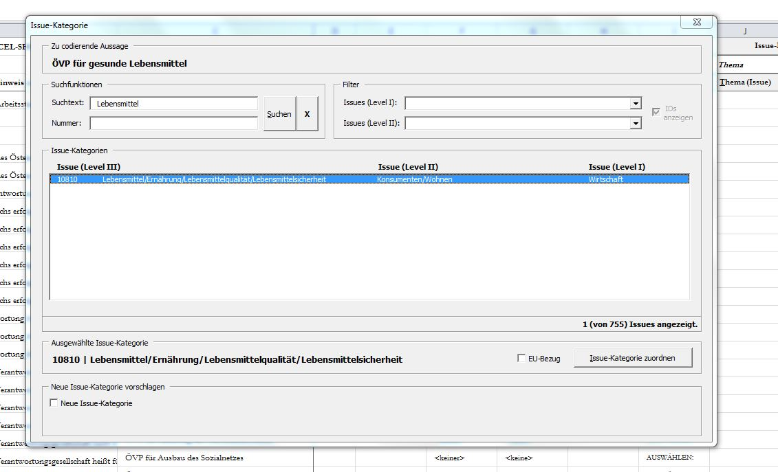
Search term („food“)
If coders are convinced they picked the most appropriate category, they click here to import the category into the coding file. This decision is reversible throughout the coding process
The selected issue appears here
Search result: just one issue matches the search term. If coders are convinced this result represents the statement’s content, they click on it
Statement („ÖVP for healthy food products“)

However, not all issues can be identified so clearly. In some cases a full text search comes up with several results. In these cases coders decide which of these issues fits best. In our first example, when searching for the term ‘education’ (statement 4), coders end up with more than ten issue labels that include the word ‘education’. Here coders opt for the issue that represents the statement’s content best: When claiming for ‘opportunities in education’ the People’s Party does not specifically refer to ‘civic education’ (issue 13106), ‘higher education’ (issue 13401), ‘crime prevention through education’ (issue 14402), or ‘support for women in education’ (issue 19107), but ‘opportunities in education’ in general. Due to this non-specified claim, from all issues including the term ‘education’ coders would opt for ‘13101 – education / education policy (general)’.
Yet there are cases when a full-text search is not a useful option – e.g. when coders end up without any results (e.g. when searching for the term ‘regime’), a high number of results (e.g. with a search for ‘welfare’) or when none of the results obtained seems to suit the statement’s content (e.g. when searching for the term ‘products’). Here coders take advantage of the list’s hierarchical structure: Reading the statement ‘Austrian People’s Party for success of Austria’s economy (example 1, statement 1), they know that ‘success of Austria’s economy’ is most likely related to ‘economy’ (but not, for instance, ‘immigration’) – one of the list’s 15 level-1-categories. This ‘economy’ category comprises of nine sub-categories (level 2): ‘economy (general)’, ‘job market / unemployment’, ‘market / liberalization / deregulation’, ‘globalisation’, ‘financial sector / banks’, ‘economy: businesses’, ‘economy: employees’, ‘consumers / habitation’, and ‘agriculture’. Here the most likely sub-categories are either ‘economy (general)’ or ‘economy: businesses’. As the People’s Party wants the Austrian economy to be successful, but does not further specify what ‘success’ means or hints to certain measures leading to the aspired success, the first, more generalized of these sub-categories most likely is the most appropriate one: Here coders find the issue ‘10102 – economic growth’ which of all issues captures the statement’s content best (see Coding Sheet – Screenshot 2 on the following page).
Coding Sheet – Screenshot 2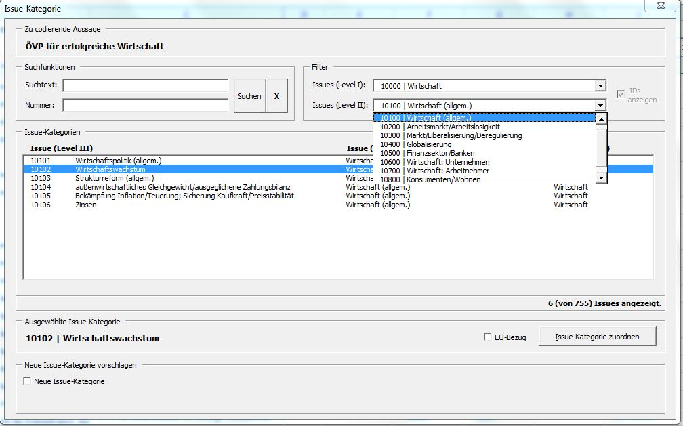
Coders import the selected issue into the coding file by clicking here; the decision is reversible throughout the coding process
In case no issue captures the statement’s content adequately, coders may come up with a new issue by clicking here
The selected issue appears here
All six issues on level 3 that belong to the selected category and sub-category on levels 1 and 2 are listed here. The issue “10102 – economic growth” is selected as the one that captures the statement’s content best
Filter 1:
level 1 category “Economy“
Filter 2:
subcategory (level 2) “Economy (general)”
Statement (“ÖVP for success of Austria’s economy”)

Coders are allowed to come up with new issues by simply adding them to the list when coding the manifestos. When creating a new issue, coders should also suggest the appropriate issue category (level 1) and sub-category (level 2). When merging the two coding files into the final dataset, the AUTNES researchers check each new issue and decide collectively on a definite inclusion of the new issue in the existing list. If the new issue is accepted, it is adopted for all cases in which coders opted for that issue; beyond that, all cases with inter-coder disagreement are checked on whether the new issue would fit in there as well. As the new issue is to be included in the general list of issues, it is available for future coding. Thus our system of issue categories is flexible enough for longitudinal analyses of party competition (Müller et al. 2012: 16).

Linking subjects and objects: the predicate
Most issue labels are non-directional – e.g. ‘immigration‘ rather than ‘pro-immigration’ and ‘anti-immigration’. In our relational method of content analysis, the party’s policy positions and relations to other actors are recorded by the predicate. This predicate is a numerical value that indicates a positive, negative, or neutral relationship between the subject and the object. Consequently, the predicate variable can have the following values:
1 = approval of an issue or praise of the object actor
0 = neutral issue position, neutral relation to the object actor, or reality statement
-1 = rejection of an issue or criticism of the object actor

The numerical value of zero is recorded in three different cases: A neutral issue position, a neutral relationship between the subject and the object actor, and for cases in which the subject describes ‘what is’ (reality statement). While an actor–actor statement can be clearly identified, it is not possible to distinguish between neutral actor–issue relations and reality statements, as both types include one subject actor and one issue that are both linked with a numerical value of zero. Therefore, in this case, a second dichotomous variable is coded that distinguishes between neutral issue positions and reality statements (Müller et al. 2012: 17-18).
Note that for actor–actor–issue statements the predicate captures the relationship between the two actors, but does not indicate the subject’s issue position. Consequently, the actor–actor–issue statements are included in the issue saliency measure, but excluded from the analysis of the issue position in the subsequent analysis (Müller et al. 2012: 18). The same applies to reality statements that are included in the saliency measure but do not contribute to a subject’s issue position.

Coding: Application
Above (Appendix 1) we demonstrated how we derive our units of coding – the statements – from the individual grammatical sentence. Now we proceed to the second step and demonstrate how these statements are coded.

Example 1: ÖVP 2008
Grammatical sentence:
The Austrian People’s Party (ÖVP) commits itself to securing for the future the success of Austria’s economy, a reliable welfare regime, opportunities in learning and education, healthy food products and a healthy environment. (ÖVP 2006: 2)
Statement 1: ÖVP for success of Austria’s economy

Subject actor: Organization: Austrian People’s Party (‘ÖVP’); (Name: -- )
Predicate: +1
Issue: 10102 Economic Growth
(Object Actor: --)

Statement 2: ÖVP for a reliable welfare regime

Subject actor: Organization: Austrian People’s Party (‘ÖVP’); (Name: -- )
Predicate: +1
Issue: 11103 social policy / welfare state (general)
(Object Actor: --)

Statement 3: ÖVP for opportunities in learning

Subject actor: Organization: Austrian People’s Party (‘ÖVP’); (Name: -- )
Predicate: +1
Issue: 13101 education / education policy (general)
(Object Actor: --)

Statement 4: ÖVP for opportunities in education

Subject actor: Organization: Austrian People’s Party (‘ÖVP’); (Name: -- )
Predicate: +1
Issue: 13101 education / education policy (general)
(Object Actor: --)

Statement 5: ÖVP for healthy food products

Subject actor: Organization: Austrian People’s Party (‘ÖVP’); (Name: -- )
Predicate: +1
Issue: 10810 quality of food / nutrition / diet
(Object Actor: --)

Statement 6: ÖVP for a healthy environment

Subject actor: Organization: Austrian People’s Party (‘ÖVP’); (Name: -- )
Predicate: +1
Issue: 20101 environmental protection / sustainability / conservation (general)
(Object Actor: --)

Example 2: Greens 2008
Grammatical Sentence:
Thanks to SPÖ [the Social Democrats] and ÖVP [the Austrian People’s Party] the Austrian environment is not well. (Greens 2008: 7).
Statement 1: The Green party criticizes the SPÖ concerning protection of the environment.
Subject actor: Organization: Greens; (Name: -- )
Predicate: -1
Issue: 20101 environmental protection / sustainability / conservation (general)
Object actor: Organization: SPÖ; (Name: -- )

Statement 2: The Green party criticizes the ÖVP concerning protection of the environment.
Subject actor: Organization: Greens; (Name: -- )
Predicate: -1
Issue: 20101 environmental protection / sustainability / conservation (general)
Object actor: Organization: ÖVP; (Name: -- )

Example 3: FPÖ 2008
In Austria, there are over 400,000 people who care for their relatives or close acquaintances at home. (FPÖ 2008: 9)
Statement 1: FPÖ: 400,000 people in Austria care for their relatives.
Subject actor: Organization: FPÖ; (Name: -- )
Predicate: 0
Predicate (specification): reality statement
Issue: 11505 private / home care (e.g. financial support)
(Object Actor: --)

Statement 2: FPÖ: 400,000 people in Austria care for close acquaintances.
Subject actor: Organization: FPÖ; (Name: -- )
Predicate: 0
Predicate (specification): reality statement
Issue: 11505 private / home care (e.g. financial support)
(Object Actor: --)

Uncertainty Measures
Reliability scores as shown in Table 3 of the main article are one important aspect in the handling of measurement error. In recent years manifesto researchers have discussed additional aspects and also attempted to quantify the amount of uncertainty attached to point estimates from single-coded documents (Klingemann et al. 2006: 90; McDonald and Budge forthcoming; Meyer and Jenny 2013). The most prominent approach to measuring uncertainty is the stochastic model by Benoit et al. (2009). While the AUTNES scheme systematically uses double-coding and therefore opens up genuinely new possibilities in estimating measurement error, it is also perfectly compatible with existing approaches. Applying the Benoit et al. (2009) methodology to our 2008 left–right scores, we obtain confidence intervals that are similar to those of the CMP data. However, given that the empirical CMP estimates are very concentrated in the center of the theoretical scale, the AUTNES approach is much better able to differentiate between parties.
Figures A1 and A2 display the uncertainty estimates for the AUTNES and CMP scores calculated with the bootstrapping approach proposed by Benoit et al. (2009). For each manifesto, 1000 random draws with replacement were taken from the distribution of the coded issues. The 0.975 and 0.025 percentiles from these distributions were taken as the 95-percent confidence interval for the original estimates. For the AUTNES scores, all issue-predicate combinations were assumed to be distinct items.

Figure A1 Benoit et al. uncertainty measures applied to AUTNES 2008 scores
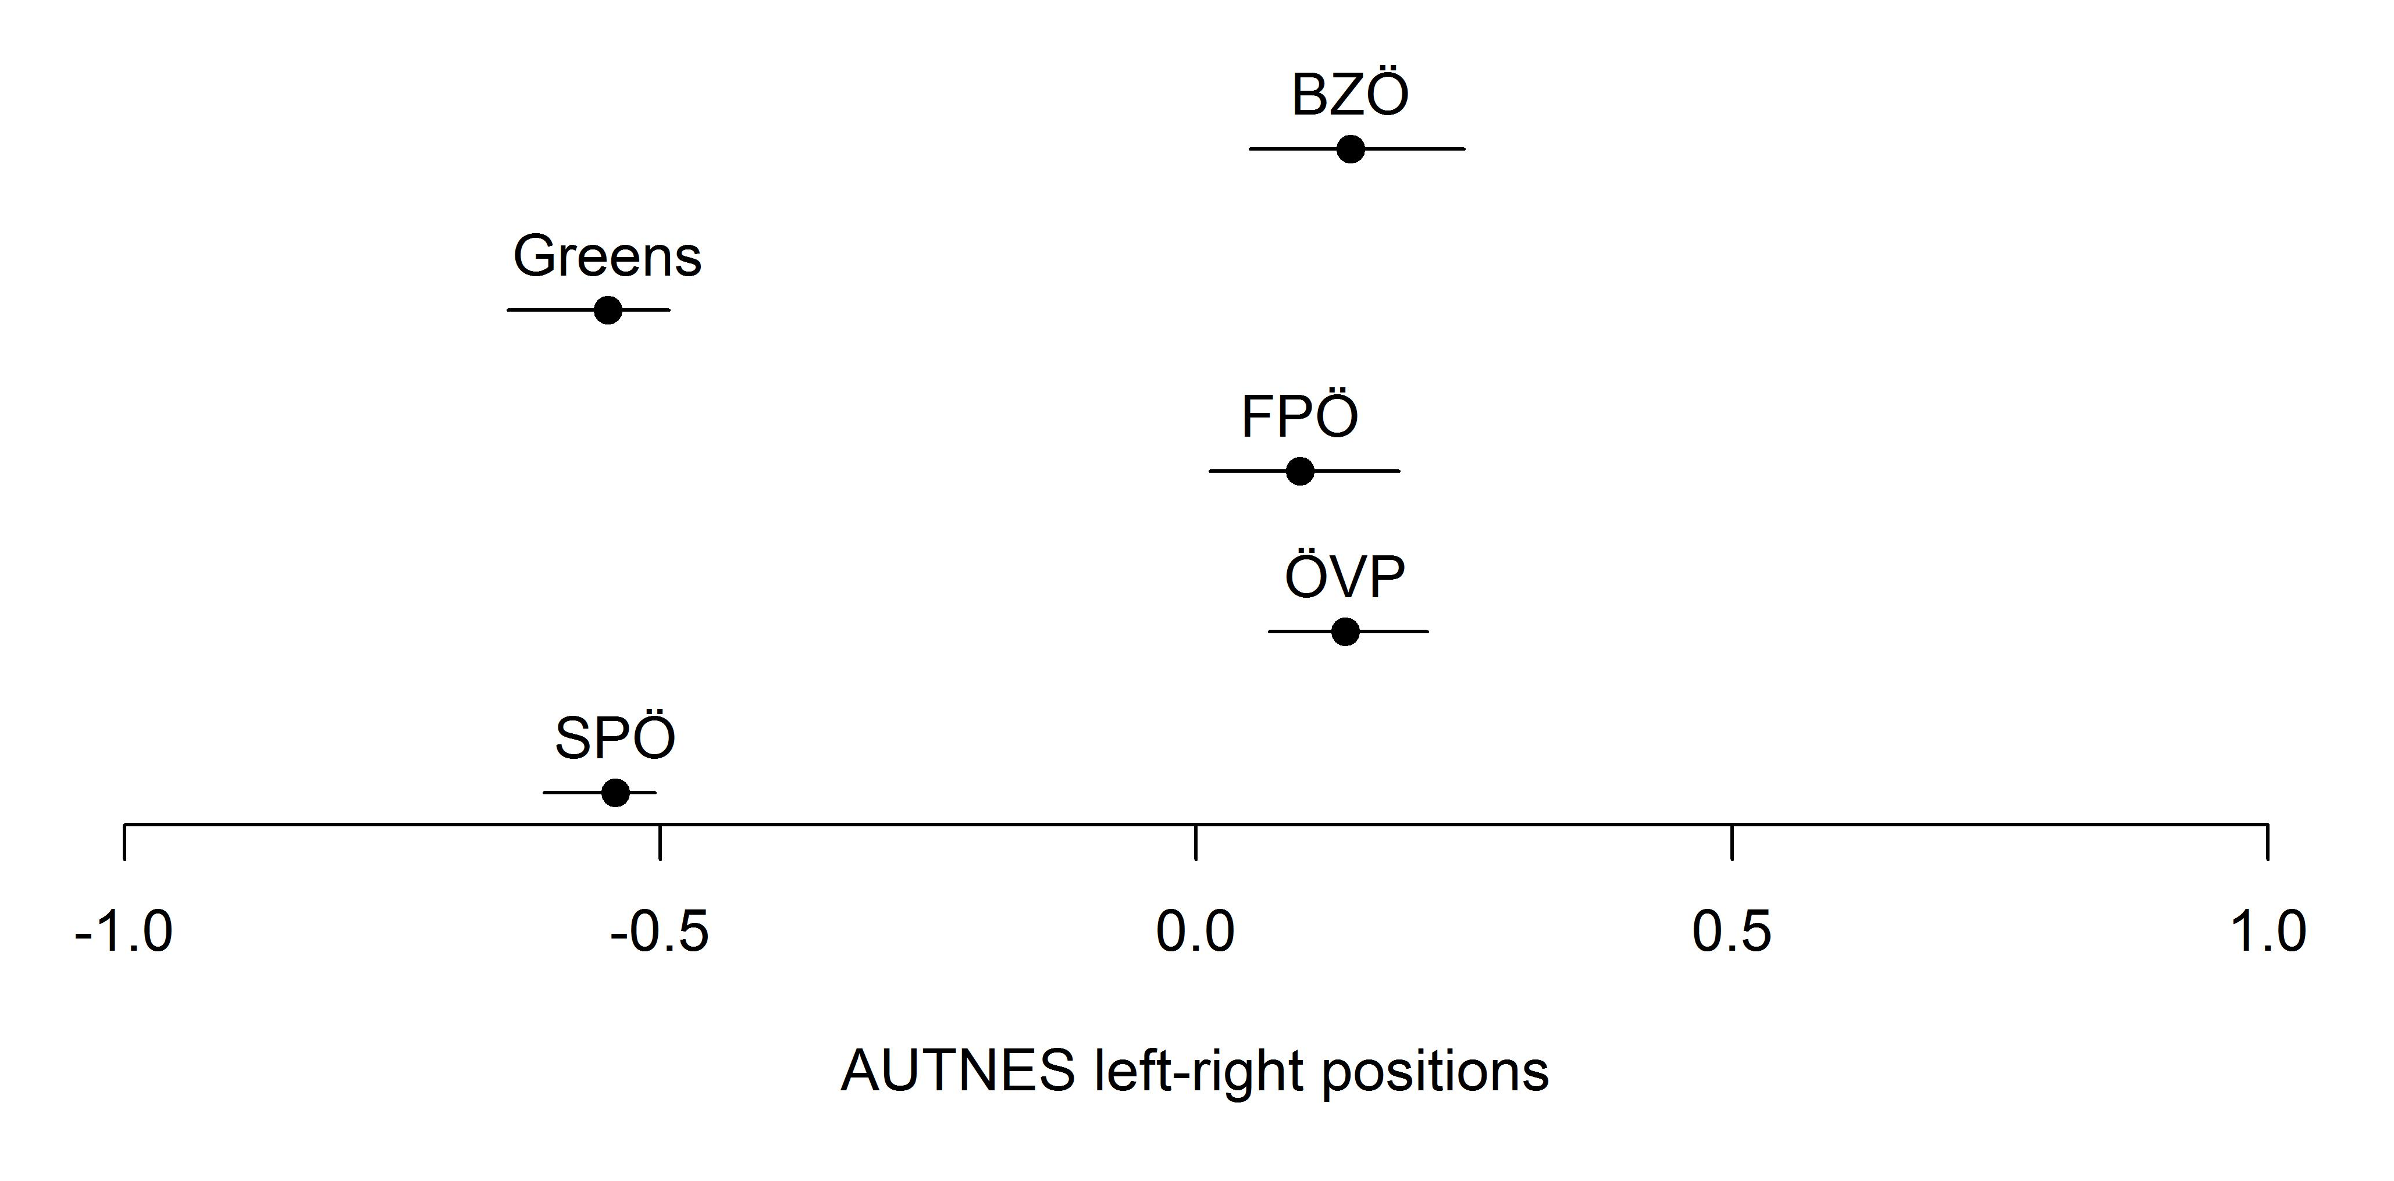

Figure A2 Benoit et al. uncertainty measures applied to CMP 2008 scores
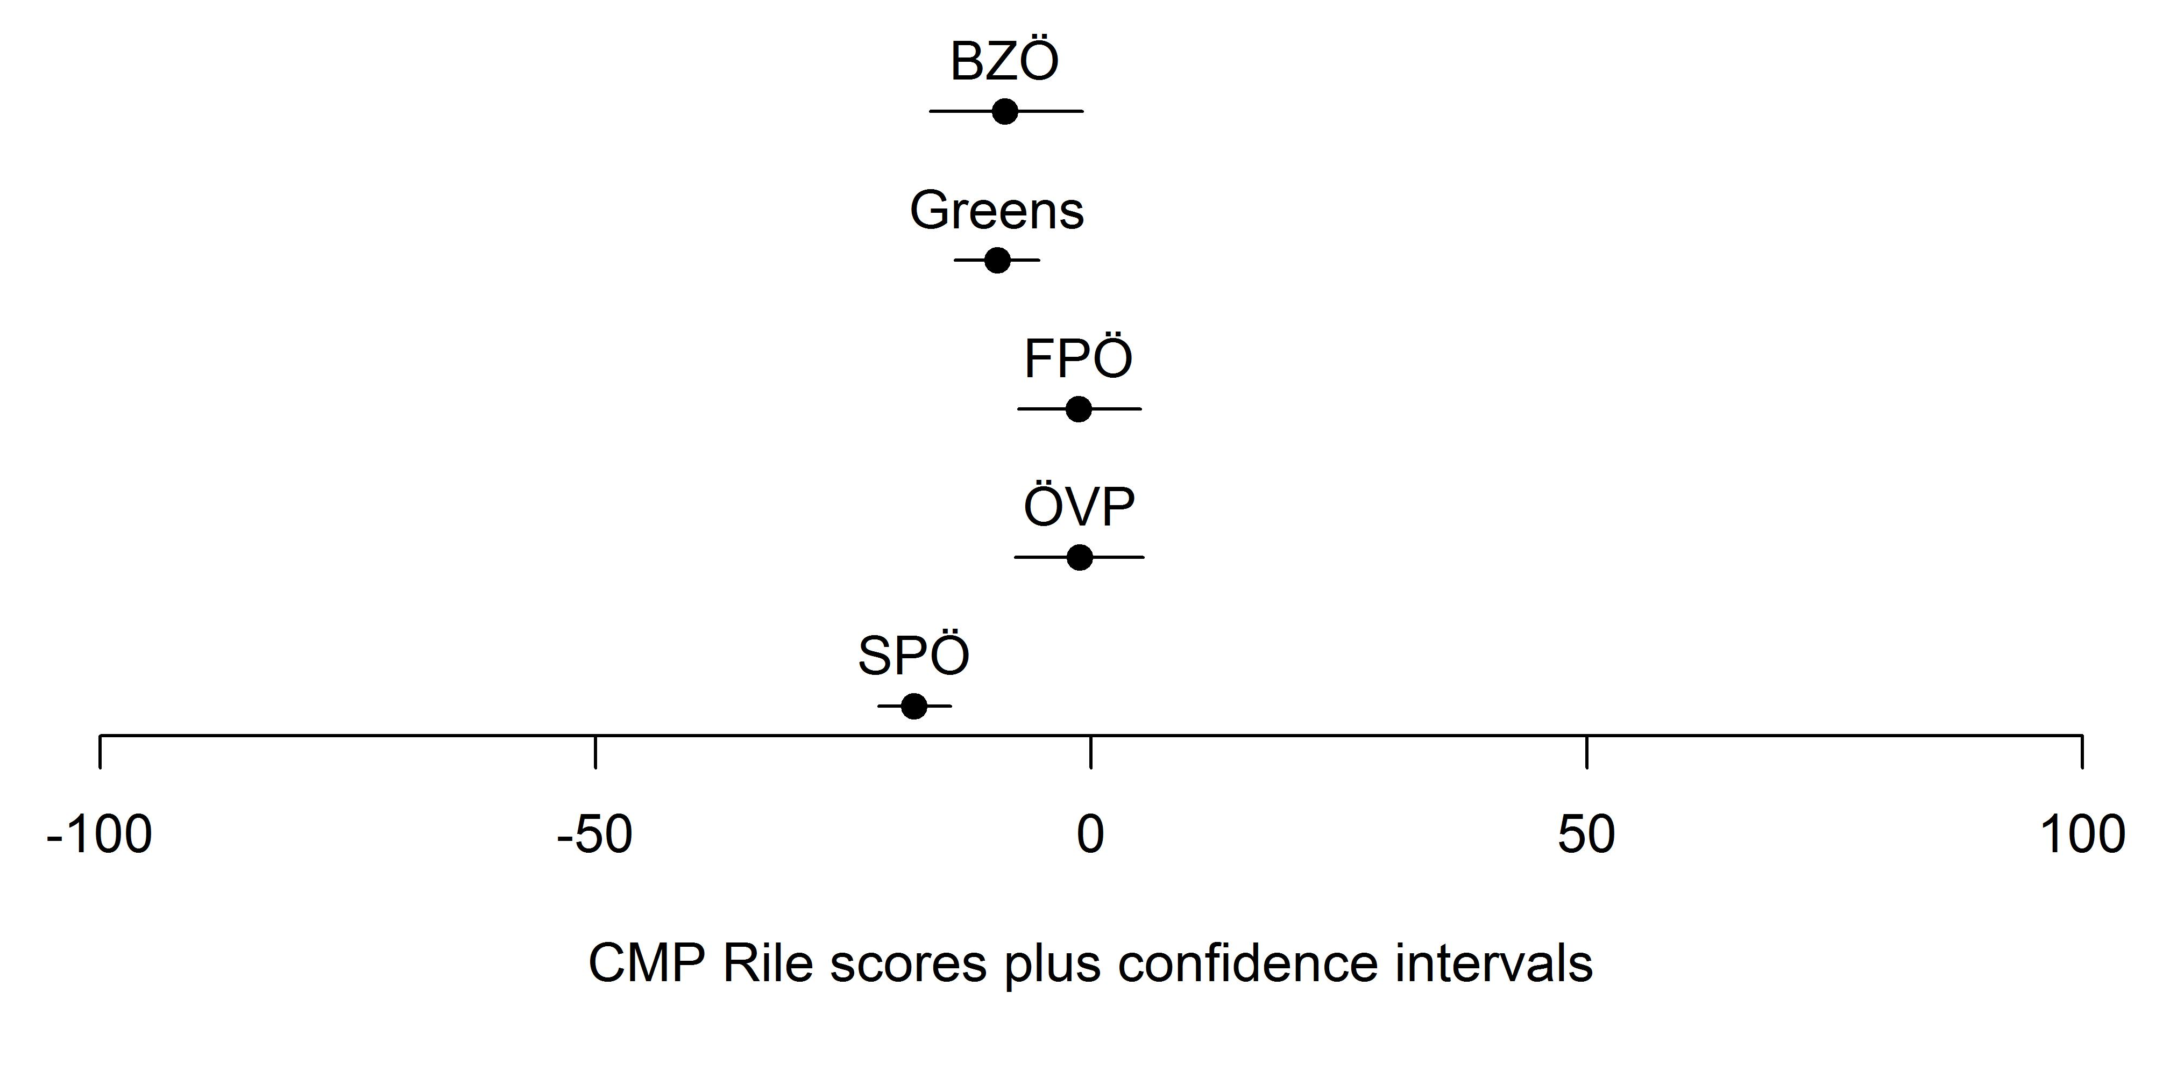

Information Gain of the Unitization Procedure
The usefulness of our unitizing procedure combined with the fine-grained system of issue categories is demonstrated by the figures reported in Table A2. These figures show the share of sentences with different issues. For example, of all the 6,278 natural sentences coded in the 2002 manifestos, 65.5 percent contain statements with only one issue coded at Level 3. Two different Level 3-issue codes can be found in 24.4 percent of all natural sentences, and 10.1 percent even have statements with three or more different codes. At higher levels of aggregation, the respective numbers are naturally somewhat lower. The distributions are quite similar for the other two elections. Given that the number of single-statement sentences is over a third in all three years, the majority of multiple-statement sentences display variation in the issue codes at level 3. These numbers suggest that a substantial amount of policy detail would be lost if coding were to be done at the level of natural sentences. Also, compare these numbers to the CMP approach for which Däubler et al. (2012) report that 84 percent of all natural sentences are not split into quasi-sentences, and no less 92 percent of all natural sentences contain only one coding category.

Table A2 Percentage of natural sentences with different codes at three levels
Year |  | Level 3  (650+ categories) | Level 2  (88 categories) | Level 1  (15 categories) | Share of single-statement sentences | N
2002 | One code | 65.5 | 73.6 | 82.9
 | Two different codes | 24.4 | 20.3 | 14.3 | 34.4 | 6,278
 | Three or more different codes | 10.1 | 6.0 | 2.8
2006 | One code | 68.0 | 77.1 | 84.3
 | Two different codes | 22.7 | 17.9 | 13.5 | 37.9 | 3,641
 | Three or more different codes | 9.4 | 4.9 | 2.2
2008 | One code | 68.6 | 76.1 | 83.1
 | Two different codes | 22.1 | 18.4 | 14.4 | 37.7 | 2,933
 | Three or more different codes | 9.3 | 5.5 | 2.5
Total | One code | 66.9 | 75.2 | 83.4
 | Two different codes | 23.4 | 19.2 | 14.1 | 36.1 | 12,852
 | Three or more different codes | 9.7 | 5.6 | 2.5

To be sure, the loss of information would most likely be tolerable if the purpose of the analysis was only to derive highly aggregated measures, such as left–right scores or issue saliencies for very broad categories. The correlation between statement-based saliencies and sentence-based saliencies (using the modal level-3 issue for each sentence, or the first issue in case of multiple modes) are above 0.97 for all three issue levels in all three election years (mean=0.988). This suggests that there are no systematic differences between the distribution of level-3 issues across statements and the distribution of modal level-3 issues across sentences. However, once researchers are interested in party preferences on more specific policy questions as they are likely in an electoral context, a unitizing scheme that allows for more detail to be picked up is clearly advantageous.

Coverage of Left–Right Scale
As explained in the main text, on average 55 per cent of the manifesto text is covered by our general left–right scale. Some lower scores can be explained by a high prevalence of statements featuring attacks on competitors (e.g. 20 percent of the statements of the Greens in 2008). Since the predicate in these statements captures the relation between two actors rather than between an actor and an issue, we discard them in the AUTNES left–right aggregation. Table A3 shows the coverage of the AUTNES left–right scale for each manifesto analysed.

Table A3 Coverage of the AUTNES general left–right scale
 | SPÖ | ÖVP | FPÖ | Greens | BZÖ | LIF
2002 | 55.5 | 53.1 | 60.9 | 48.5 |  | 54.9
2006 | 55.2 | 49.1 | 59.3 | 49.1 | 62.1
2008 | 50.2 | 67.4 | 63.2 | 41.9 | 64.8 | 38.9
Note: Entries are percentages of statements covered by the AUTNES left–right scale.

Reliability of Left–Right Scale
While our general left–right scale is not empirically derived, we can assess to some degree whether it is empirically meaningful by examining to what extent coders agree on whether an individual statement is coded as left, right, or other. Of course, during the coding process the coders are not aware of how statements are later classified into these categories. Yet, if the left–right scale is to be meaningful, there should be substantial agreement about the broad ideological thrust of a statement, even if there is disagreement as to the specific level-3-issue. Table A4 suggests that the AUTNES left–right scale is highly reliable, with most manifestos close to or above the 0.8 threshold. The average reliability score is 0.84 (standard deviation: 0.05).

Table A4: Reliability of AUTNES general left–right scale
 | SPÖ | ÖVP | FPÖ | Greens | BZÖ | LIF
2002 | 0.87 | 0.86 | 0.85 | 0.80 |  | 0.81
2006 | 0.83 | 0.92 | 0.92 | 0.80 | 0.75
2008 | 0.81 | 0.85 | 0.82 | 0.82 | 0.90 | 0.87
Note: Entries are Krippendorff’s alphas (nominal scale) of two independent coders identifying a statement as ‘left’, ‘right’, or ‘other’.

Calculation of Left–Right Scale
We prefer the $\frac{R-L}{R+L}$ aggregation method (Kim and Fording 1998) over the CMP’s $\frac{R-L}{N}$, because it is independent of the number of statements made that have no relation to the left–right scale.
Consider a manifesto with 10 left statements, 30 right statements, and 20 other statements. The $\frac{R-L}{N}$ aggregation would yield a left–right score of 0.33. However, if the manifesto contained 40 other statements instead of 20, the party’s position would be 0.25, without any changes in the left–right-relevant content of the manifesto. Using the $\frac{R-L}{R+L}$ formula, the estimate would be 0.5 in both cases. This suggests that dividing by the total number of statements introduces a centrist bias.
To be sure, there are other scaling methods, such as the log odds-based formula suggested by Lowe et al. (2011), or more sophisticated empirical approaches such as using item response models (Benoit and Däubler 2014) which we do not consider here.

Wordscores and Wordfish
Figures 1 and 2 in the main text include a comparison of left–right scores derived from several sources. Here, we explain how we conducted the computer-assisted content analyses using the two most widely used algorithms: Wordscores and Wordfish.
In preparing the manifesto texts for the automated analysis the following steps were taken: 1) All words were converted to lowercase; 2) stop words (common words in the German language such as articles, conjunctions, and prepositions) were removed; 3) German-language stemming was applied using the JFreq software (Lowe 2011b). All estimations were done using the implementation of Wordscores and Wordfish in the austin R package (Lowe 2011a).
Wordscores estimates the policy position of a manifesto based on word frequencies and scored reference texts. For the 16 documents in our sample, we used the SPÖ’s, ÖVP’s, FPÖ’s, Greens’, and LIF’s 1999 manifestos as reference texts and assigned scores from the 1999 Chapel Hill expert survey (Steenbergen and Marks 2007). We used the ‘lrgen’ variable for estimating the general left–right dimension, and the ‘lrecon’ and ‘galtan’ for the economic and cultural left–right scales.
Wordfish estimates the policy position of a text without the need for scored reference texts by assuming that word frequencies follow a Poisson distribution. The one-dimensional left–right scores were estimated straightforwardly from the full texts. For the two-dimensional representation, manifesto texts have to be divided into economic and cultural sections. Austrian party manifestos are typically organized into individual chapters that deal with one policy area. We used all chapters referring to economic policies (budget, taxes, growth, jobs, welfare, regulation, health, …) for the first dimension, and allocated all text in chapters referring to cultural issues (gender equality, immigration & integration, crime, law and order, gay rights, civic rights, …) to the second. The remaining sections were discarded.

Correlations of AUTNES and Other Data
In the main text we compared our measures with those from other sources by correlating the various left–right positions. Here, we present more details, including estimates based on concordance correlation.
Figure A3 presents scatterplots for all three types of left–right estimates (general, economic, and cultural scales). The AUTNES estimates compare well to the expert survey data, the elite survey data and the Wordscores estimates. The results from the Wordfish algorithm are more difficult to reconcile with established measures of party positions (and conventional wisdom). The CMP scores diverge somewhat from the AUTNES estimates, especially for the economic left–right scale.
Closer examination of Figure A3 also reveals that the regression lines often run above the dashed lines. This indicates that the AUTNES estimates are biased to the left when compared to the survey-based measures (including the Wordscores estimates which are partly based on expert survey data), especially when it comes to the economic left–right scale. Survey items present respondents (experts or party elites) a pre-defined scale and thus invite them to consider the distribution of all parties relative to each other in the ideological space. They therefore elicit placements that are more symmetrical. Yet, the manually coded manifesto measures (AUTNES and CMP), which represent the distribution of left and right codes in the manifestos, agree that Austrian parties cluster in the left half of the economic scale. While we cannot settle the discussion about which party position measurement is the most valid, we can at least validate that party manifestos (in Austria) yield more left-wing scores than other measurements of party positions.
Figure A3: Scatterplots of general, economic, and cultural left–right positions
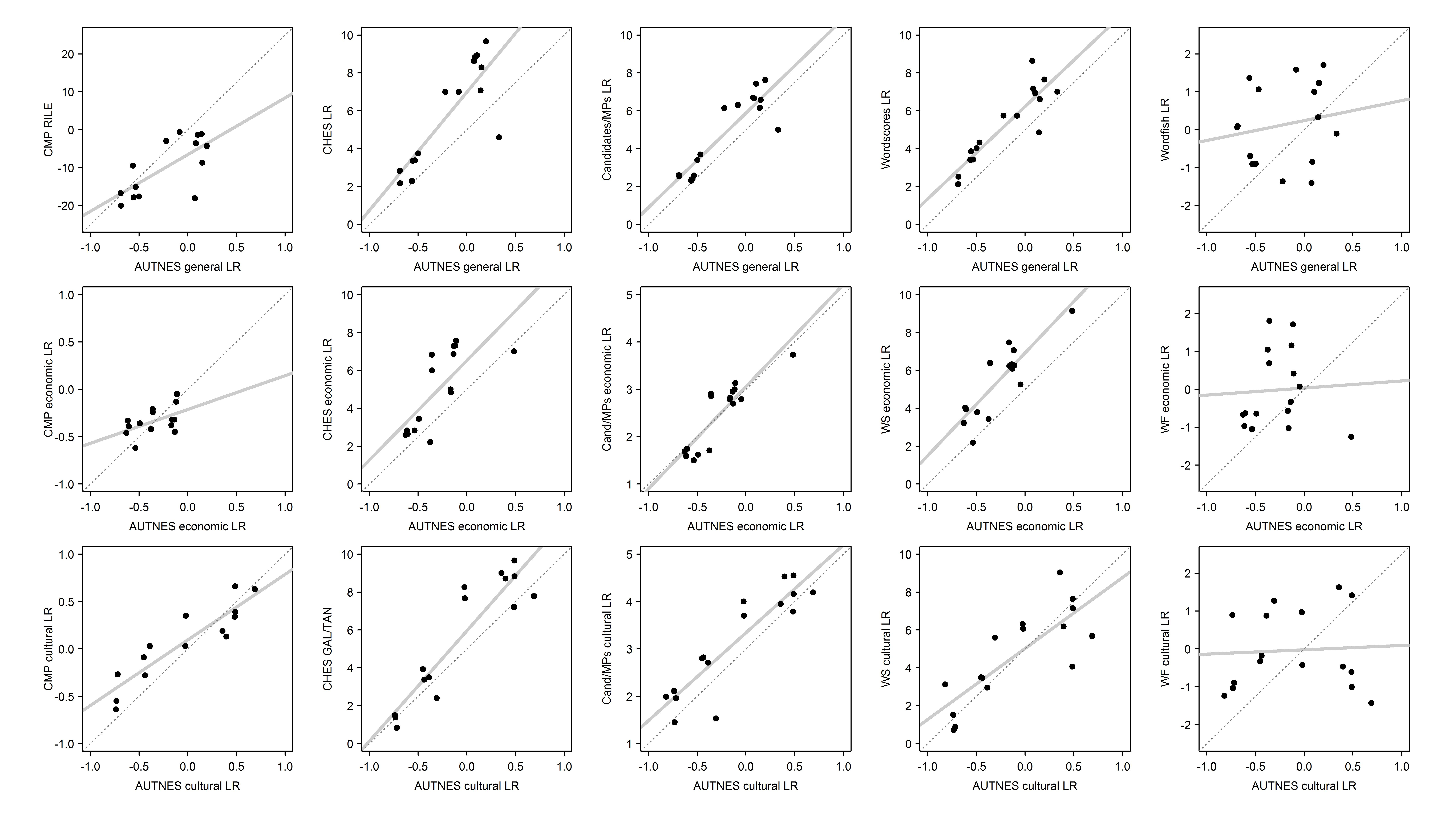
Note: Dashed lines indicate lines of perfect fit, solid lines indicate regression lines.

Since such systematic differences between different methods are not captured by conventional measures of correlation such as Pearson’s r (see Gemenis 2012), we also present Lin’s (1989) concordance correlation coefficient (CCC) for relationships between the AUTNES data and the other sources of party positions.

Figure A4: Concordance correlation coefficients (with 95 percent confidence intervals)
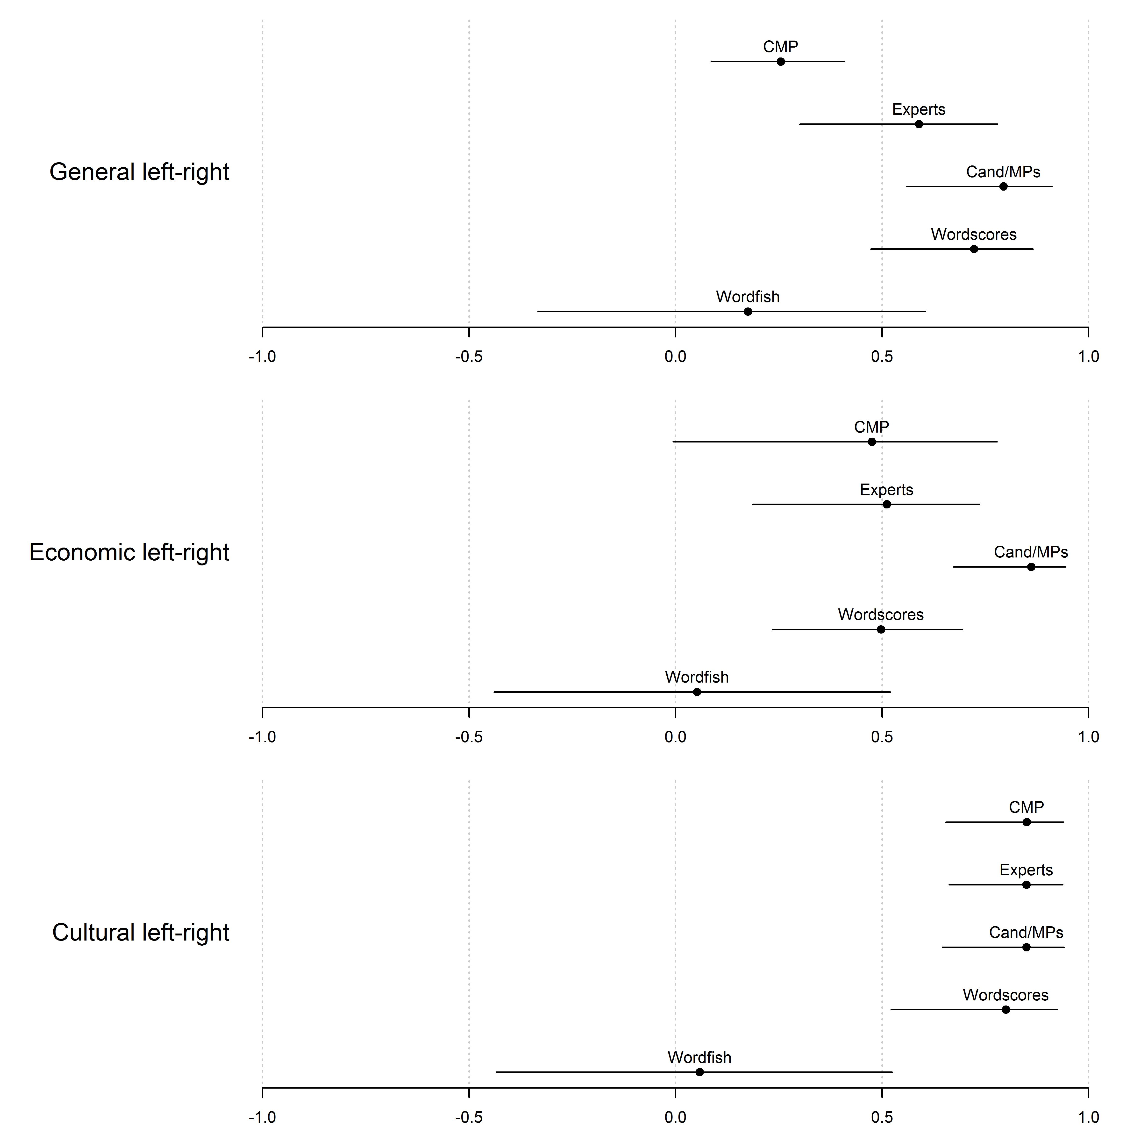
Note: All estimates have been rescaled to the range from -1 to 1, except for the Wordfish scores which come with no fixed scale but are standardized (mean=0, standard deviation=1). To ensure comparability, the Wordfish scores have been transformed to match the mean and standard deviation of the AUTNES estimates.

The figures confirm that agreement is highest for the cultural left–right scale, and that the Wordfish algorithm yields no valid measures for the 2002 to 2008 Austrian manifestos. For the general and the economic left–right scale, the results are mixed, although we are pleased to see the highest correlations with the candidate and elite survey data.

References
Benoit, Kenneth, and Thomas Däubler. 2014. Putting Text in Context: How to Estimate Better Left-Right Positions by Scaling Party Manifesto Data using Item Response Theory (Paper prepared for the ‘Mapping Policy Preferences from Texts’ Conference, May 15-16, 2014, Berlin).
Benoit, Kenneth, Michael Laver, and Slava Mikhaylov. 2009. Treating Words as Data with Error: Uncertainty in Text Statements of Policy Positions. American Journal of Political Science 53(2):495-513.
Chomsky, Noam. 1957. Syntactic Structures. The Hague: Mouton & Co.
———. 1965. Aspects of the Theory of Syntax. Cambridge, Massachusetts: The Massachusetts Institute of Technology Press.
Däubler, Thomas, Kenneth Benoit, Slava Mikhaylov, and Michael Laver. 2012. Natural Sentences as Valid Units for Coded Political Texts. British Journal of Political Science 42(4):937-951.
Gemenis, Kostas. 2012. Proxy documents as a source of measurement error in the Comparative Manifestos Project. Electoral Studies 31(3):594-604.
Kim, Heemin, and Richard C. Fording. 1998. Voter ideology in Western Democracies, 1946–1989. European Journal of Political Research 33(1):73–97.
Klingemann, Hans-Dieter, Andrea Volkens, Judith Bara, Ian Budge, and Michael McDonald. 2006. Mapping Policy Preferences II. Estimates for Parties, Electors, and Governments in Eastern Europe, European Union, and OECD 1990-2003. Oxford: Oxford University Press.
Lin, Lawrence I-Kuei. 1989. A Concordance Correlation Coefficient to Evaluate Reproducibility. Biometrics 45(1):255-268.
Lowe, Will. 2011a. ‘Austin: Do things with words’. R package version 0.2, https://r-forge.r-project.org/projects/austin.
———. 2011b. JFreq: Count words, quickly’. Java software version 0.5.4, http://www.conjugateprior.org/software/jfreq/.
Lowe, Will, Kenneth Benoit, Slava Mikhaylov, and Michael Laver. 2011. Scaling Policy Preferences from Coded Political Texts. Legislative Studies Quarterly 36(1):123-155.
McDonald, Michael D., and Ian Budge. forthcoming. Getting it (approximately) right (and center and left!): reliability and uncertainty estimates for the comparative manifesto data. Electoral Studies http://dx.doi.org/10.1016/j.electstud.2014.04.017.
Meyer, Thomas M., and Marcelo Jenny. 2013. Measuring error for adjacent policy positions estimates: Dealing with uncertainty using CMP data. Electoral Studies 32(1):174-185.
Müller, Wolfgang C., Martin Dolezal, Laurenz Ennser-Jedenastik, and Anna Katharina Winkler. 2012. Coding Instructions for Manifestos. English Language Version.
Steenbergen, Marco, and Gary Marks. 2007. Evaluating expert judgments. European Journal of Political Research 46(3):347–366.

For further details see Müller et al. (2012).
Please note that although it includes the noun ‘future’, the phrase ‘for the future’ is regarded as a specification of the People’s Party’s plans. Therefore it does not constitute an individual kernel sentence.
Again ‘in a good condition’ also includes a substantive. Yet it is an attribute of ‘the environment’ and therefore does not contribute to the number of statements.
Please note that here again ‘in Austria’ and ‘at home’ are only specifications and therefore – despite including the nouns ‘Austria’ and ‘home’ – do not lead to any more noun phrases and consequently not to any more kernel sentences.
However, this is only a last resort in case a statement could not be validly coded into one of the existing categories. Empirically this is done in less than 1 per cent of the cases.

