**Online Appendix**

**Formal Illustration of the Theoretical Model**

*Civil War Outcomes and Domestic Political Support Before and After the Cold War*

We assume that beliefs about the probability that the opposition will lose a civil war depend on beliefs about internal and external support for the dictator,  and  respectively, where  for . Beliefs range from no support for the dictator when to full support when .

There is a zero-sum relationship between support for the incumbent dictator and support for the opposition. If the dictator has full support, the opposition has none. We assume that beliefs about the probability that the dictator prevails is a mixture distribution

 , (1)

where  is the mixing parameter. For simplicity, this is a known parameter. There are two types of conflicts: ones for which internal political support is crucial to determining the outcome and ones for which external political support is crucial. If a conflict is of the latter type, for example, and the dictator has full external support, the probability that the opposition would win a civil war is zero.

Note that, for intermediate values of , bimodal beliefs are possible when an actor believes levels of internal and external support differ. In other words, an actor may believe the probability that the dictator prevails in civil war is either low or high, but never intermediate. In expectation, however, the probability of victory, in this instance, would be intermediate. That is, the mean of this bimodal distribution, , would take an intermediate value.

In our framework, the end of the Cold War increased the value of the mixing parameter—civil wars are more likely to be the kind where internal political support matters most for the outcome—and we are particularly interested in how an increase in  affects Bayesian updating in response to observed election outcomes. Let  be a random sample from a Bernoulli distribution with parameter, where  represents the vote choice of individual *j*. If individual *j* votes for the dictator, then, else . This implies the proportion of votes for the incumbent dictator will equal the level of internal support for the dictator  in expectation.

Bayes’ law defines how an observed election outcome will influence prior beliefs about the underlying level of domestic support for the dictator :

  . (2)

In words, equation (2) states that posterior beliefs about internal support for the dictator are proportional to the likelihood of observing a particular election result for a given level of internal support multiplied by prior beliefs about the level of domestic support. Given our assumptions about elections, the likelihood in (2) is a binomial distribution

, (3)

where  . By choosing a conjugate prior for  , we can make the relationship in (2) exact. For a binomial likelihood, the conjugate prior is a beta distribution

 , (4)

where  and . For the likelihood in (3) and the prior in (4), the posterior in (2) is given by

 (5)

Returning to the mixture distribution in (1), the expected value of *p* is

, (6)

and the conditional expectation of *p* is

 (7)

Substituting the means of (4) and (5) into (6) and (7) respectively, gives

 (8)

and

. (9)

With these results, we can show how the end of the Cold War (i.e., an increase in), affects Bayesian updating about the probability of civil war outcomes after an election. Specifically, we are interested in how the expected probability of a civil war outcome shifts after an election since this expected probability determines the opposition’s expected utility from initiating a conflict, . Define . Substituting equations (8) and (9) into the definition of  gives

 , (10)

Since convergence to the true  requires  to increase, the critical comparative statics result is the following difference in differences:

 , (11)

which says, all else equal, the size of the Bayesian update increases with . The intuition is straightforward. Since elections are only informative about internal support, when external support is likely to be crucial in determining the civil war outcome, elections will only shift the expected probability that the dictator wins a civil war  by a relatively small amount. In other words, election outcomes will move prior beliefs about expected civil war outcomes in the post-Cold War world much more than during the Cold War period. Convergence in poster beliefs creates room for Pareto efficient negotiated settlements. Figures 1a and 1b represent this relationship graphically.

**Figure 1a. Bayesian Updating During the Cold War **

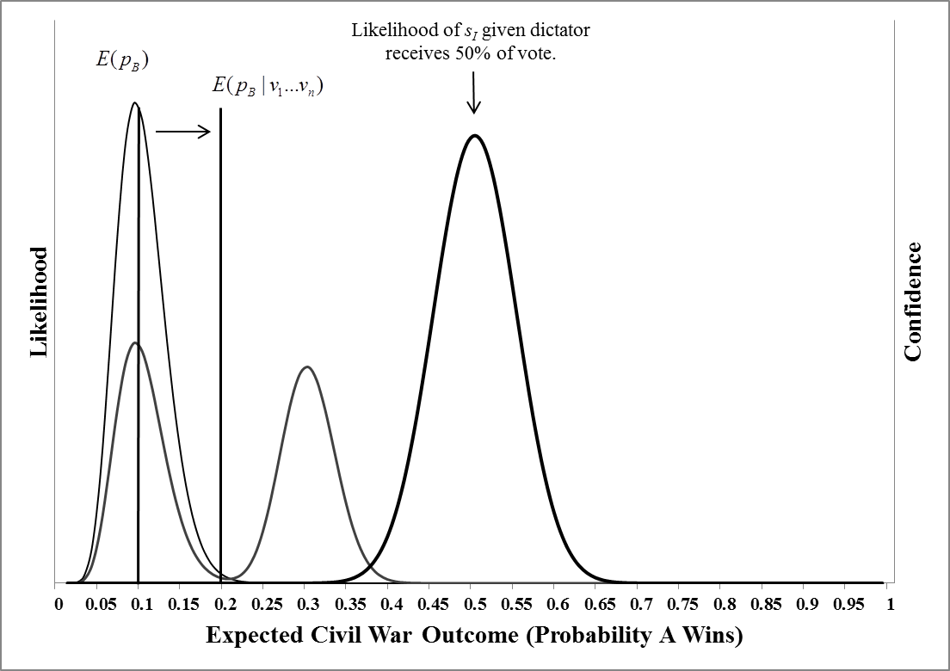

**Figure 1b. Bayesian Updating in the Post-Cold War Period **

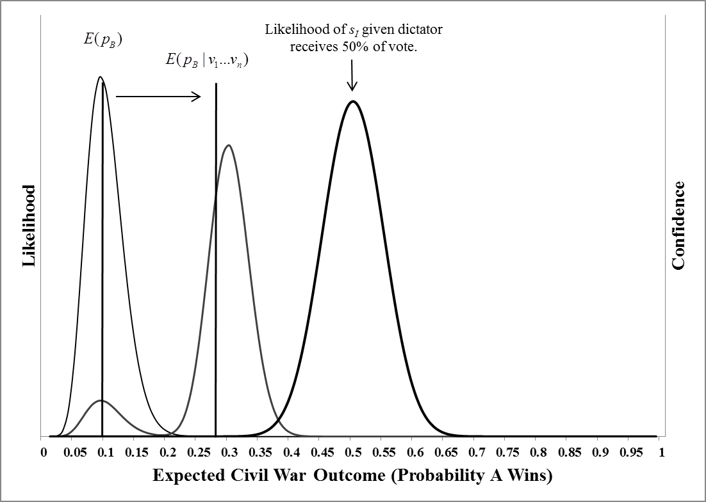

**Results for Cold War period**

|  |  |  |  |  |
| --- | --- | --- | --- | --- |
| **Table A1. Probit Models of Civil War Onset with Exogenous Elections, Africa, 1946-1989** | | | | |
| Variable | Multiparty (100%) | Multiparty (90%) | Multiparty (50%) | |
| GDP | -.173**  (.080) | -.165**  (.080) | | -.103  (.077) |
| GDP growth | -3.29  (2.10) | -3.01  (2.12) | | -3.01  (2.08) |
| Oil Exporter | -1.18***  (.318) | -1.14***  (.316) | | -1.10***  (.298) |
| Ethnic Fractionalization | .063  (.526) | .082  (.528) | | .079  (.542) |
| Population | .250***  (.056) | .240***  (.057) | | -.232***  (.057) |
| Terrain | .822*  (.458) | .771*  (.442) | | .680  (.433) |
| Percentage Muslim | -.003  (.003) | -.003  (.003) | | -.004  (.003) |
| War at (t – 1) | -.637**  (.307) | -.590**  (.294) | | -.570**  (.288) |
| Multiparty Election | .488***  (.183) | .425**  (.206) | | .420  (.259) |
|  |  |  | |  |
| Average Effect | .026**  (.031) | .023*  (.013) | | .026  (.022) |
| Observations | 1246 | 1246 | | 1246 |
| Log likelihood | -110.26 | -111.15 | | -112.24 |
| Pseudo-*R*2 | .127 | .120 | | .112 |
| *Notes*: Parentheses contain cluster-corrected (by country) standard errors. ***Significant at the .01 level, **Significant at the .05 level, and *Significant at the .10 Level. | | | | |

|  |  |  |  |
| --- | --- | --- | --- |
| **Table A2. Recursive Bivariate Probit Models of Civil War Onset with Endogenous Multiparty Elections, Africa, 1946-1989** | | | |
| Variable | Multiparty (100%) | Multiparty (90%) | Multiparty (50%) |
| GDP | -.174*  (.095) | -.222**  (.109) | -.146  (.091) |
| GDP growth | -3.29  (2.12) | -3.01  (2.12) | -2.69  (2.06) |
| Oil Exporter | -1.18***  (.314) | -1.11***  (.306) | -1.09***  (.341) |
| Ethnic Fractionalization | .062  (.521) | .026  (.506) | .053  (.532) |
| Population | .250***  (.056) | .240***  (.055) | .216***  (.057) |
| Terrain | .822*  (.466) | .757*  (.428) | .677  (.413) |
| Percentage Muslim | -.003  (.003) | -.003  (.003) | -.004  (.003) |
| War at (t – 1) | -.636**  (.308) | -.594**  (.296) | -.604**  (.275) |
| Multiparty Election | .492  (.384) | .692*  (.395) | 2.03***  (.617) |
|  |  |  |  |
|  |  |  |  |
| Military | .177  (.266) | -.449  (.325) | -.962**  (.380) |
| Civilian | -.164  (.279) | -.686**  (.332) | -.456  (.305) |
| Democracy | 1.46***  (.348) | .959**  (.414) | .731**  (.332) |
| Oil Exporter | -.222  (.307) | -.734*  (.416) | -.212  (.365) |
| Ethnic Fractionalization | -.876***  (.328) | -.245  (.439) | .037  (.528) |
| Inherited Parties | .095  (.077) | .176**  (.088) | -.125  (.110) |
| Leadership Changes | -.056  (.086) | .127*  (.076) | -.084  (.057) |
| Other Democracies | .818  (1.825) | -2.19  (1.913) | -.717  (2.55) |
| Number of Previous MP Elections | .766***  (.102) | .518***  (.080) | .288***  (.079) |
| Correlation Coefficient (ρ) | -.004  [-.461,.456] | -.185  [-.521,.200] | -.776*  [-.969,.001] |
| Observations | 1246 | 1246 | 1246 |
| Log likelihood | -594.27 | -587.29 | -352.30 |
| *Notes*: Parentheses contain cluster-corrected (by country) standard errors, and brackets contain 95% confidence intervals. ***Significant at the .01 level, **Significant at the .05 level, and *Significant at the .10 Level. | | | |

**Definition of Variables *(Variable name as it appears in tables)***

**acc_nheads_reg *(Leadership Changes)***: Amount of past executive turnover (the number of changes in the executive head accumulated up to each year; based on the variable *nheads* in Cheibub, Gandhi and Vreeland 2010).

**civilian *(Civilian)***: Dummy variable coded 1 if the political regime is a civilian dictatorship, 0 otherise. Derived from the variable *regime* in Cheibub, Gandhi and Vreeland xxx).

**ctryname**: country name.

**cowcode**: Country code as assigned by the Correlates of War project.

**cw_count *(Previous Wars)***: Accumulated number of civil war onsets, generated from *cwsambinit_2005*.

**cwprioinit_1000 *(PRIO)***: Dummy variable coded 1 if a civil war with at least 1,000 battle-related deaths in a given year erupted, 0 otherwise (UCDP/PRIO Armed Conflict Dataset Codebook, Version 4-2014).

**cwsambinit_2005**: Dummy variable coded 1 if a civil war erupted during the year, 0 otherwise (coded by Sambanis 2004, extended dataset).

**Democracy *(Democracy)***: Dummy variable coded 1 if the regime is a democracy,0 otherwise (Cheibub, Gandhi and Vreeland 2010)

**ef *(Ethnic Fractionalization)***: Ethnic fractionalization (identical to the variable *ef* in the Sambanis 2004 dataset).

**elewindow_100 *(Multiparty Election)***: Dummy variable coded 1 if an election in which no party obtained 100% of the votes was held in years *t*, *t+1*, and *t+2*, 0 otherwise (authors’ data).

**elewindow_50 *(Multiparty Election)***: Dummy variable coded 1 if an election in which no party obtained more than 50% of the votes was held in years *t*, *t+1*, and *t+2*, 0 otherwise (authors’ data).

**elewindow_90 *(Multiparty Election)***: Dummy variable coded 1 if an election in which no party obtained more than 90% of the votes was held in years *t*, *t+1*, and *t+2*, 0 otherwise (authors’ data).

**gdppc_maddison *(GDP)***: GDP per capita (The Maddison-Project, http://www.ggdc.net/maddison/maddison-project/home.htm, 2013 version).

**gdppcg_maddison *(GDP growth)***: Growth of GDP per capita (The Maddison-Project, http://www.ggdc.net/maddison/maddison-project/home.htm, 2013 version).

**inher_parties *(Inherited Parties)***: Number of parties in existence in the last year of the previous ruler (Jenifer Gandhi and Adam Przeworski, “Authoritarian Institutions and the Survival of Autocrats, 2007).

**mdpk *(Multidimensional Peacekeeping)***: Dummy variable coded 1 if a multidimensional peacekeeping mission is present, 0 otherwise. Generated from the variable *pkop* in Fortna, Virginia Page. *Peacekeeping and the Peace Kept: Data on Peacekeeping and Civil Wars, 1989-2004* (http://www.columbia.edu/~vpf4/pk&pkept%20data%20notes.pdf).

**military *(Military)***: Dummy variable coded 1 if the political regime is a military dictatorship, 0 otherwise. Derived from the variable *regime* in Cheibub, Gandhi and Vreeland 2010).

**mtn *(Terrain)***: Mountainous terrain (identical to the variable *mtnl1* in the Sambanis 2004 dataset)

**musl *(Percentage Mulim)***: Percentage of Muslims in the population (identical to the variable *muslim* in the Sambanis 2004 dataset)

**n_anympelec_100_africa**: Number of any type of multiparty election (defined as no party achieving 100% of the vote) in Africa (authors’ data).

**Odwp *(Other Democracies)***: Percentage of democratic regimes in the current year (other than the regime under consideration) in the world. Derived from the variable *regime* in Cheibub, Gandhi and Vreeland 2010).

**oil *(Oil Exporter)***: Oil exporter (identical to the variable *oil* in the Sambanis 2004 dataset).

**pop_maddison *(Population)***: Population (The Maddison-Project, http://www.ggdc.net/maddison/maddison-project/home.htm, 2013 version).

**prio_25**: Dummy variable coded 1 if a civil war with 25-999 battle-related deaths in a given year erupted, 0 otherwise (UCDP/PRIO Armed Conflict Dataset Codebook, Version 4-2014).

**psa *(Powersharing Arrangements)***: Dummy variable coded 1 if a peace settlement ending a civil war includes power sharing provisions, 0 otherwise (Stina Högbladh. *Peace Agreement Dataset Codebook*, version 2.0. Uppsala Conflict Data Program, Department of Peace and Conflict Research, Uppsala University, 2012).

**year**: calendar year.