Supplemental Figure 1. Participant Flow Chart
Supplemental Figure 2.PCA-Derived Infant Dietary Factors
- Dendrogram of PCA Dietary Factors (Infant Data)

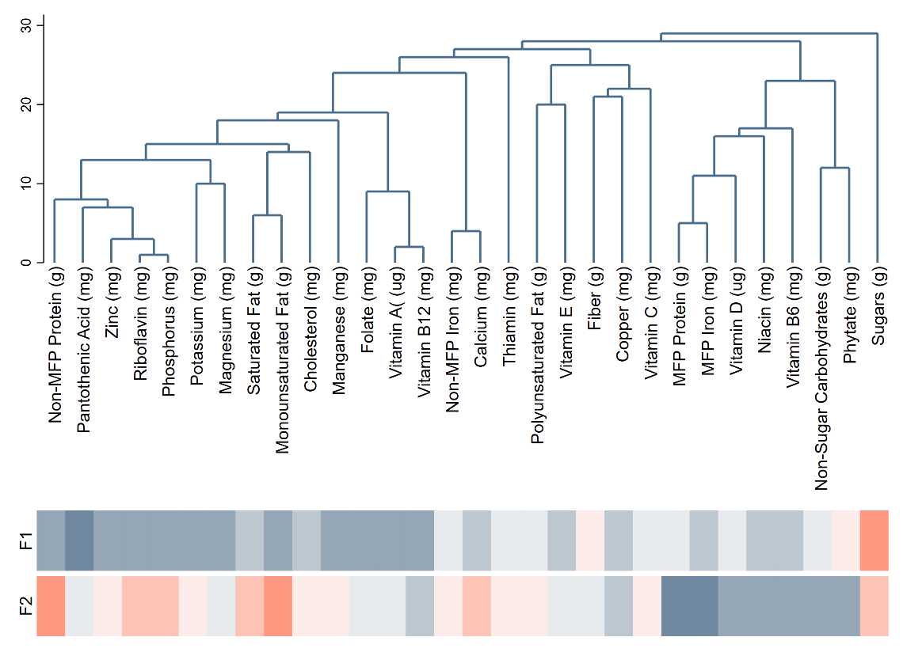
- Dendrogram of PCA-Derived Dietary Factors. (Child Data)
The treelet dendrogram is provided to aid in interpretation
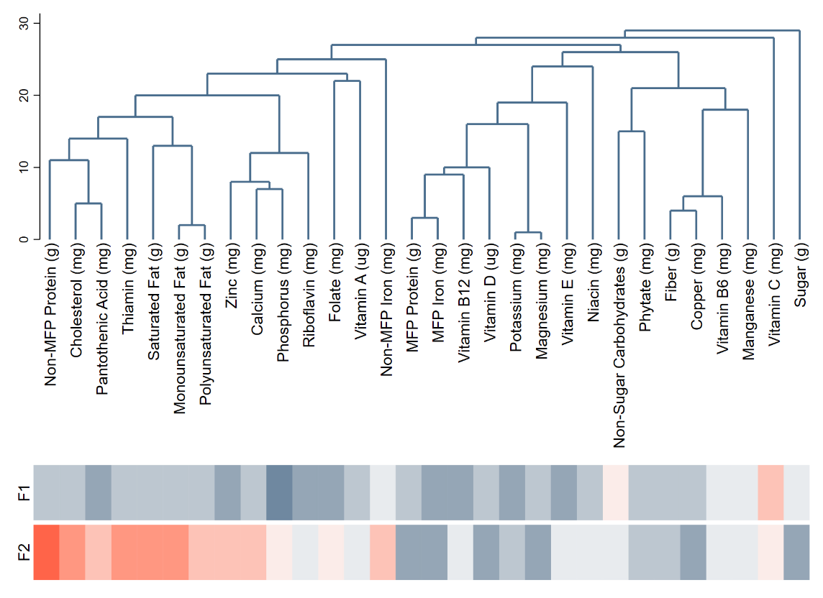

Supplemental Figure 3. PCA-Derived Child Dietary Factors
a. Forest Plot of Associations between PCA-Derived Dietary Factors and Cardiometabolic biomarkers

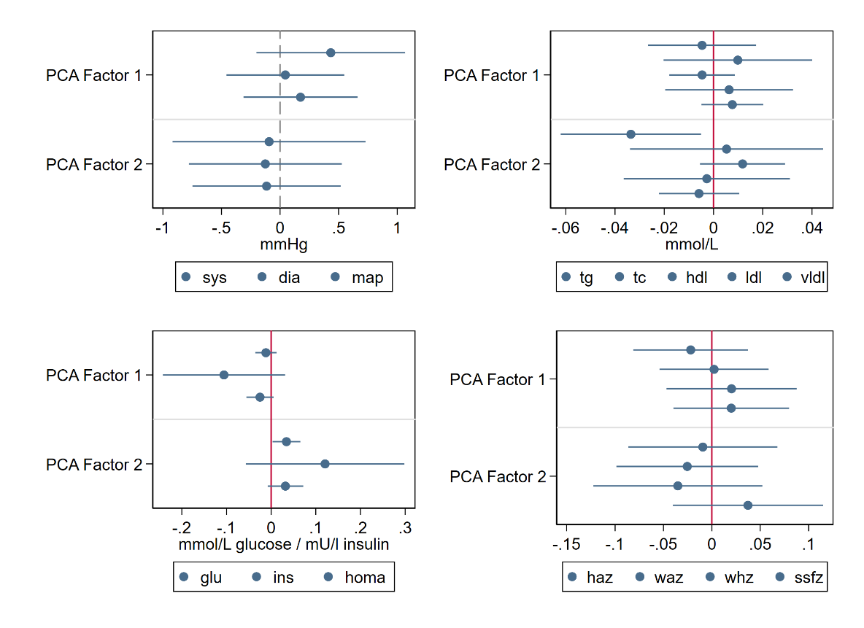
b. Forests plots of associations between PCA-derived factors and cardiometabolic outcomes.
