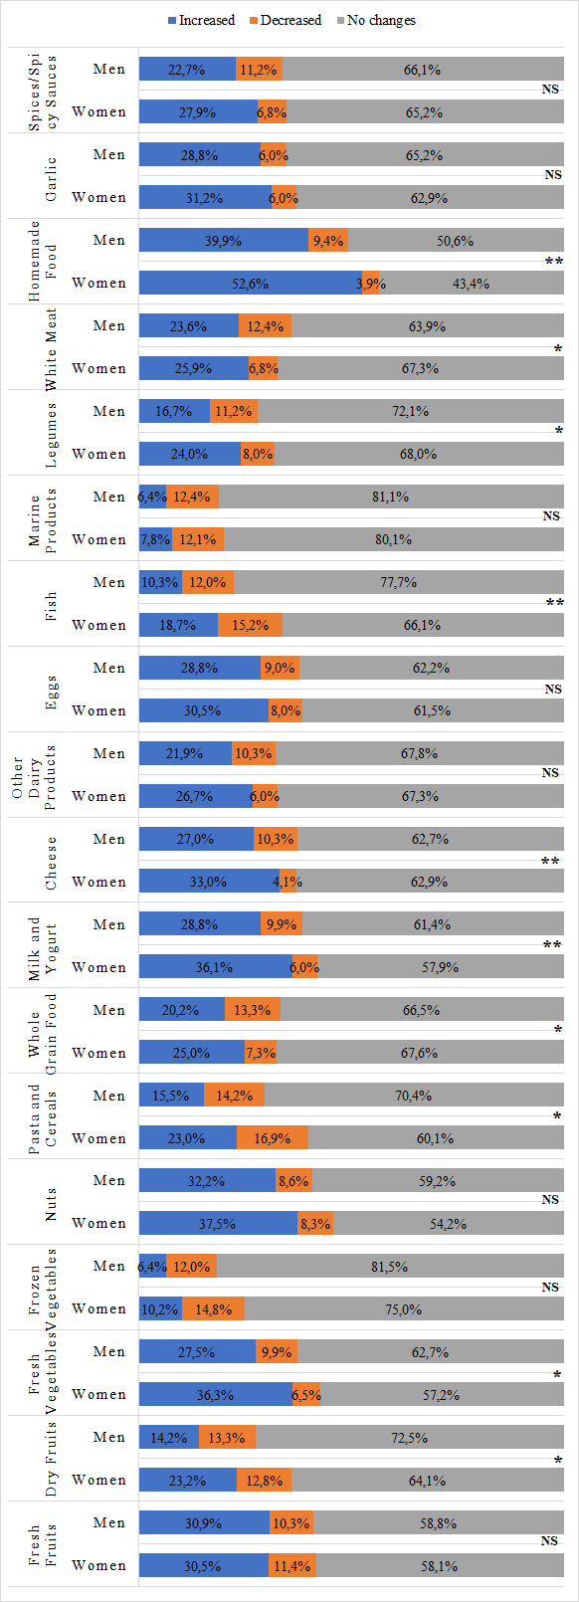
Supplementary Figure 1. The percentage of change in positive MEDAS scored-foods consumption by gender during COVID-19. *p<0.05, **p<0.01, NS; not significant (p>0.05).
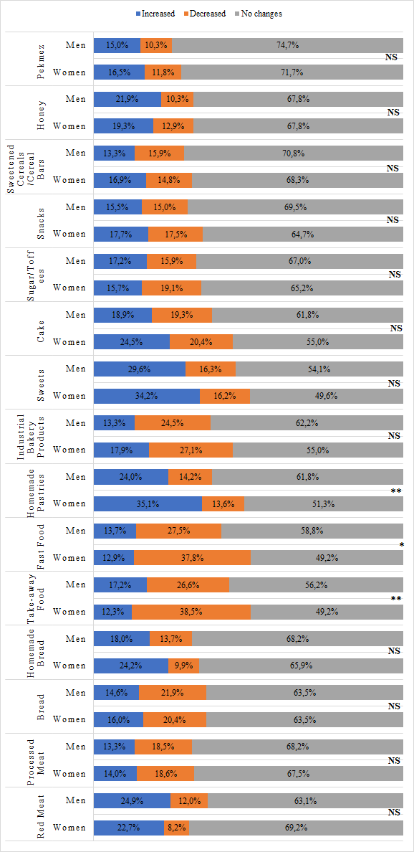
Supplementary Figure 2. The percentage of change in other foods consumption by gender during COVID-19. *p<0.05, **p<0.01, NS; not significant (p>0.05).
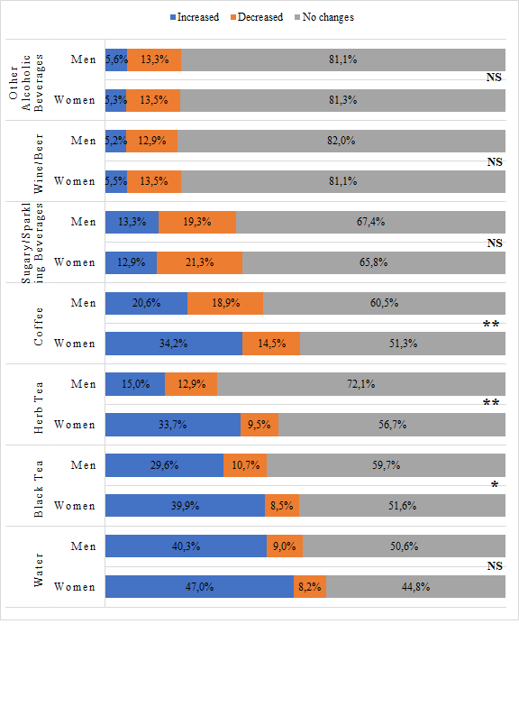
Supplementary Figure 3. The percentage of change in beverage consumption by gender during COVID-19. *p<0.05, **p<0.01, NS; not significant (p>0.05).

