Supplementary Figure 1 Scree plot of principal component analysis (A) and R-square analysis of the proportion of variations accounted for (B).

A
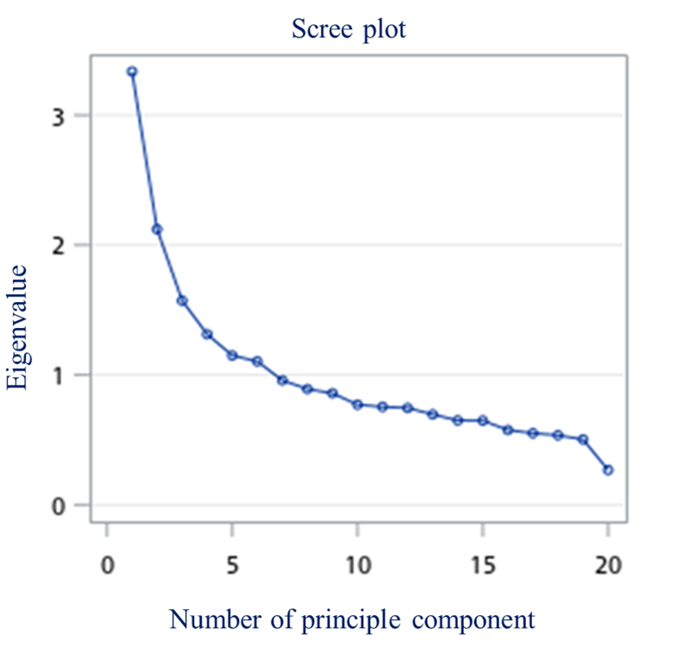

B
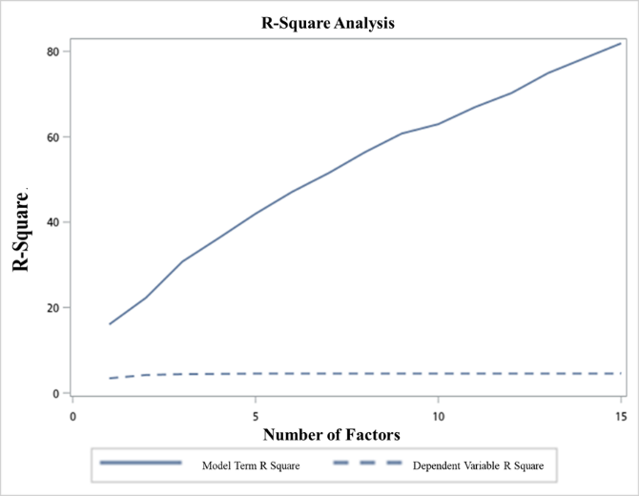

Supplementary Figure 2: Flow diagram of participant enrolment process.
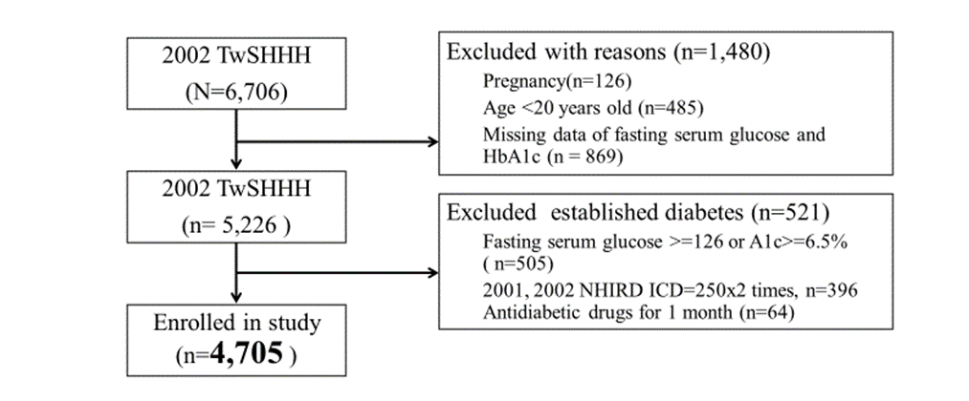
TwSHHH: Taiwanese Survey on Hypertension, Hyperglycaemia, and Hyperlipidaemia; NHIRD: National Health Insurance Research Database

Supplementary Figure 3 Subgroup analyses for incident T2DM according to the comparisons of the highest and lowest quartiles of DASH (A), PCA-Western pattern (B), PCA-prudent (C), PCA-dairy and plant-based (D), PLS-health-conscious (E), PLS fish vegetable (F), and PLS fruit seafood (G).

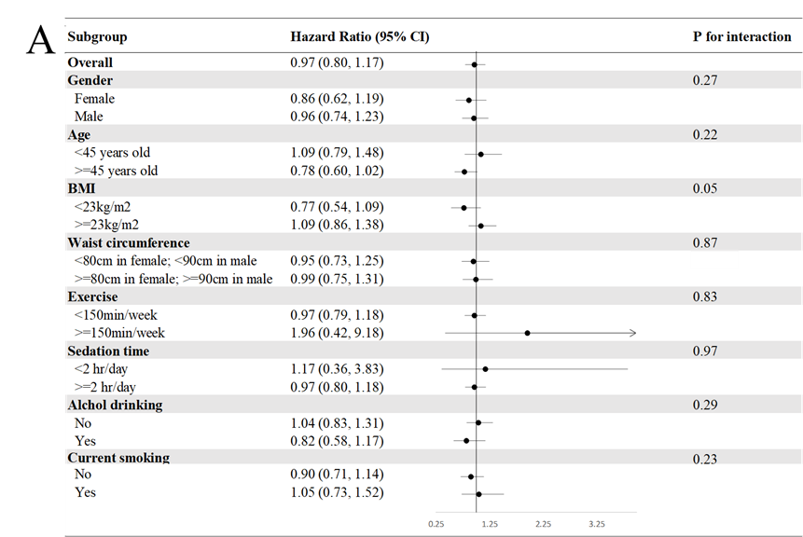
Model 3: Adjusted for age (20–29, 30–39, 40–49, 50–59, >=60 years), gender, current smoking status (yes or no), alcohol consumption (yes or no), BMI (<18, 18–21, 21–23,23–25, >25), exercise (0, <150, >=150 min weekly), sedation time (</>=2 hours daily) and waist circumference (</>=80 cm in females; </>=90 cm in males), systolic blood pressure, family history of diabetes, marital status, education level (</>=9 years), and average monthly income (</>=40,000 New Taiwan Dollars).
Presented as hazard ratios and 95% confidence intervals

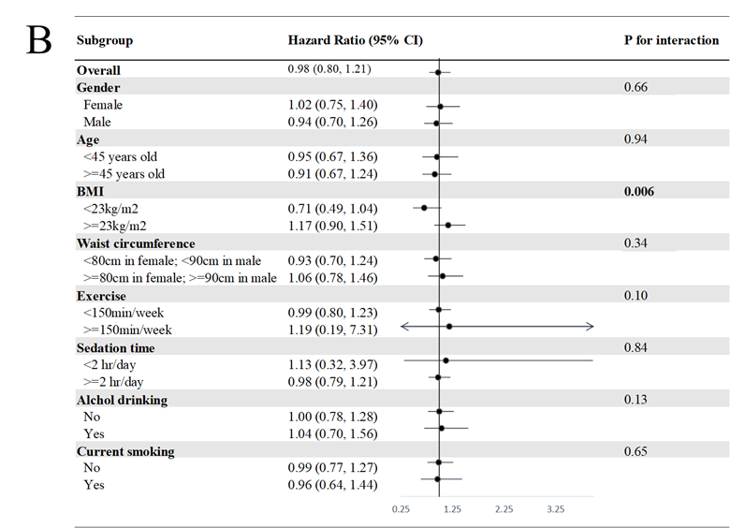
Model 3: Adjusted for age (20–29, 30–39, 40–49, 50–59, >=60 years old), gender, current smoking status (yes or no), alcohol drinking (yes or no), BMI (<18, 18–21, 21–23, 23–25, >25), exercise (0, <150, >=150 min weekly), sedation time (</>=2 hours daily) and waist circumference (</>=80 cm in females; </>=90 cm in males), systolic blood pressure, family history of diabetes, marital status, education level (</>=9 years), and average monthly income (</>=40,000 New Taiwan Dollars).
Presented as hazard ratios and 95% confidence intervals
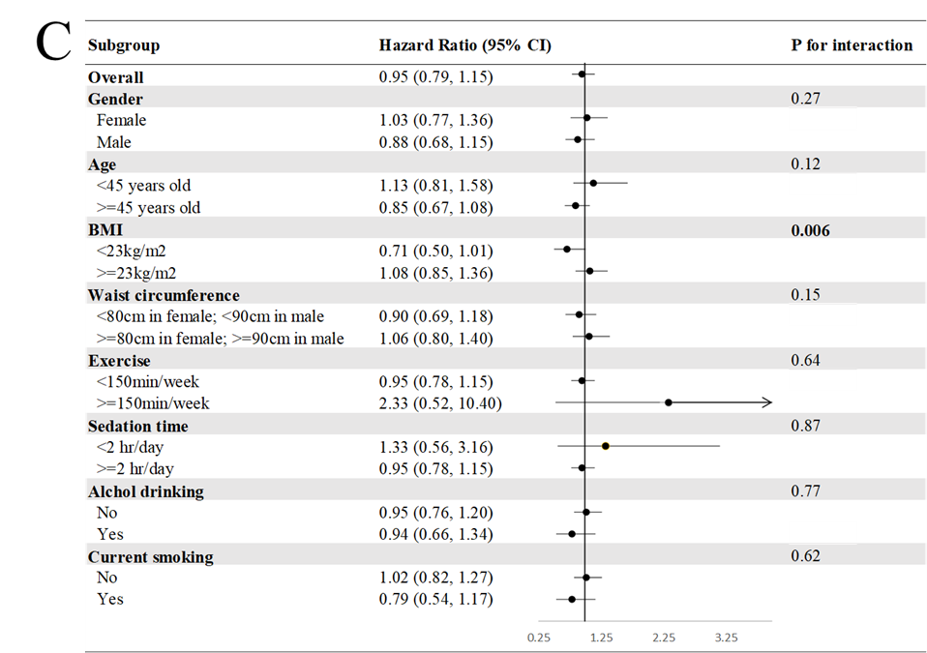
Model 3: Adjusted for age (20–29, 30–39, 40–49, 50–59, >=60 years old), gender, current smoking status (yes or no), alcohol drinking (yes or no), BMI (<18, 18–21, 21–23, 23–25, >25), exercise (0, <150, >=150 min weekly), sedation time (</>=2 hours daily) and waist circumference (</>=80 cm in females; </>=90 cm in males), systolic blood pressure, family history of diabetes, marital status, education level (</>=9 years), and average monthly income (</>=40,000 New Taiwan Dollars).
Presented as hazard ratios and 95% confidence intervals

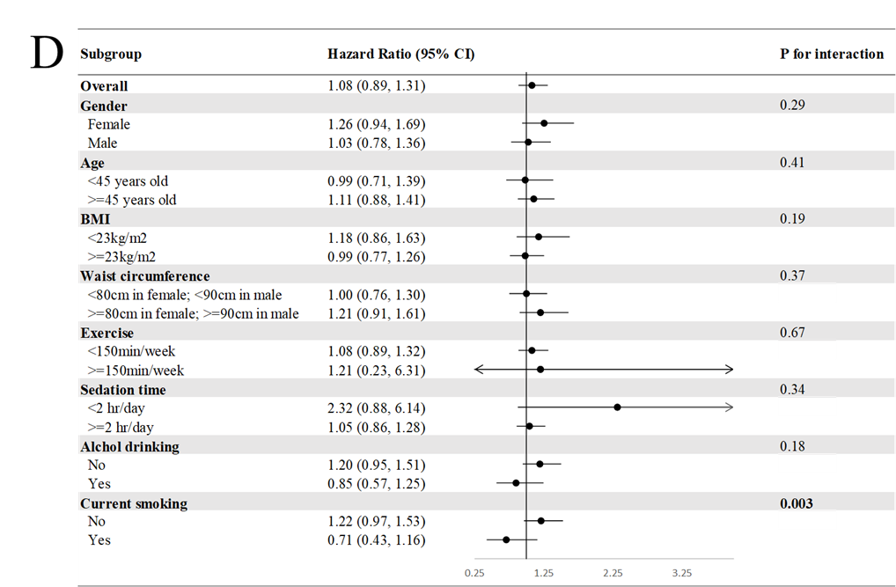
Model 3: Adjusted for age (20–29, 30–39, 40–49, 50–59, >=60 years old), gender, current smoking status (yes or no), alcohol drinking (yes or no), BMI (<18, 18–21, 21–23, 23–25, >25), exercise (0, <150, >=150 min weekly), sedation time (</>=2 hours daily) and waist circumference (</>=80 cm in females; </>=90 cm in males), systolic blood pressure, family history of diabetes, marital status, education level (</>=9 years), and average monthly income (</>=40,000 New Taiwan Dollars).
Presented as hazard ratios and 95% confidence intervals

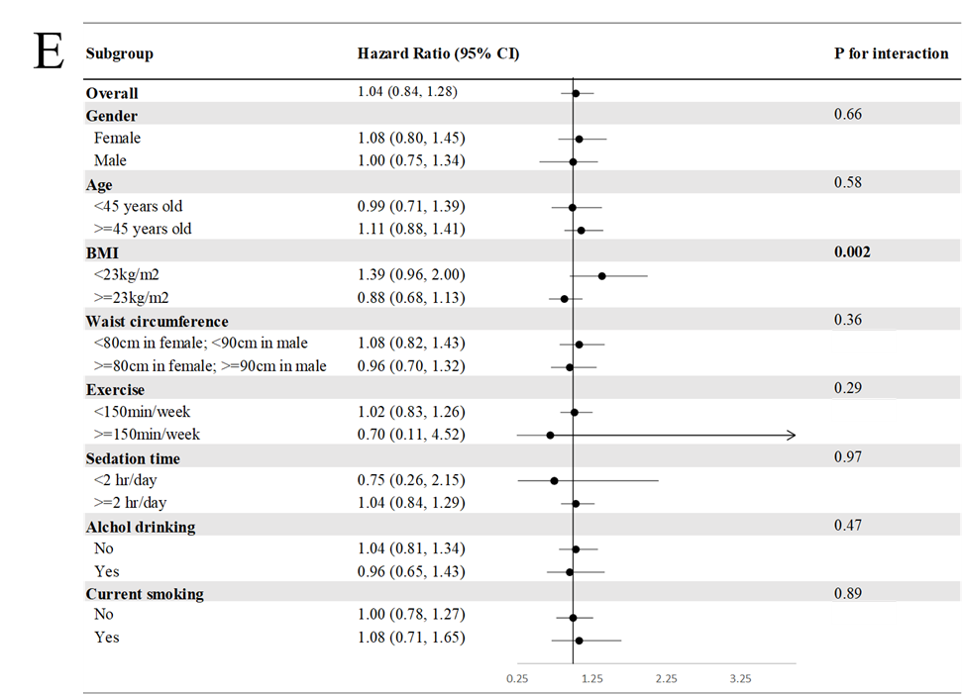
Model 3: Adjusted for age (20–29, 30–39, 40–49, 50–59, >=60 years old), gender, current smoking status (yes or no), alcohol drinking (yes or no), BMI (<18, 18–21, 21–23,23–25, >25), exercise (0, <150, >=150 min weekly), sedation time (</>=2 hours daily) and waist circumference (</>=80 cm in females; </>=90 cm in males), systolic blood pressure, family history of diabetes, marital status, education level (</>=9 years), and average monthly income (</>=40,000 New Taiwan Dollars).
Presented as hazard ratios and 95% confidence intervals

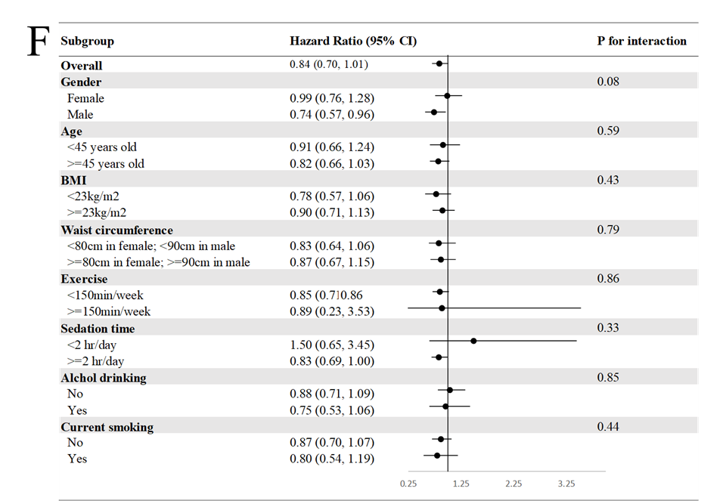
Model 3: Adjusted for age (20–29, 30–39, 40–49, 50–59, >=60 years old), gender, current smoking status (yes or no), alcohol drinking (yes or no), BMI (<18, 18–21, 21–23, 23–25, >25), exercise (0, <150, >=150 min weekly), sedation time (</>=2 hours daily) and waist circumference (</>=80 cm in females; </>=90 cm in males), systolic blood pressure, family history of diabetes, marital status, education level (</>=9 years), and average monthly income (</>=40,000 New Taiwan Dollars).
Presented as hazard ratios and 95% confidence intervals

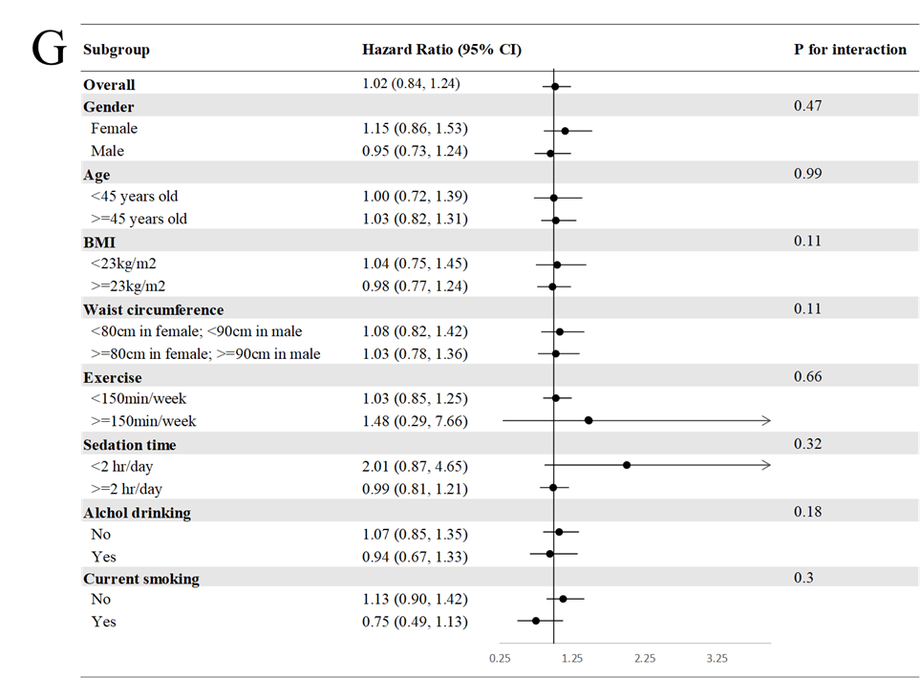 Model 3: Adjusted for age (20–29, 30–39, 40–49, 50–59, >=60 years old), gender, current smoking status (yes or no), alcohol drinking (yes or no), BMI (<18, 18–21, 21–23, 23–25, >25), exercise (0, <150, >=150 min weekly), sedation time (</>=2 hours daily) and waist circumference (</>=80 cm in females; </>=90 cm in males), systolic blood pressure, family history of diabetes, marital status, education level (</>=9 years), and average monthly income (</>=40,000 New Taiwan Dollars).
Presented as hazard ratios and 95% confidence intervals

Supplementary Table 1 Contents of food groups in the locally-specific food frequency questionnaire

Food group | Food items
Meat | Meat or poultry
Fish | Fish
Seafood | Seafood
Egg | Egg
Milk | Milk and gouty milk
Cheese | Cheese
Diary product | Yogurt, yogurt, Yakult
Legumes | Legumes
Vegetables | Vegetables
Fruits | Fruits
Processed meat | Hamburger
French fries | French fries
Pizza | Pizza
Desserts | Biscuits, candies, chocolate
Cake, bread | Cake, bread
Sweetened soft drinks | Coke, Sarsi
Ice cream, milkshake, ice | Ice cream, milkshake, ice
Coffee, tea | Coffee, tea
Sugar-sweetened beverages | Sugar-sweetened beverages
Grains | Rice, noodles

Supplementary Table 2 Official and modified definitions of the alternative Mediterranean diet (aMED)

Alternative Mediterranean diet definition | Our modified definition | Scoring criteria, +1 point if consumption
Vegetables (excluding potatoes) | Vegetables | ≥study median
Legumes (tofu, string beans, peas, beans) | Legumes | ≥study median
Fruit | Fresh fruits | ≥study median
Nuts (Nuts, peanut butter) | -- | ≥study median
Whole grains | Rice, noodles | ≥study median
Fish (fish and shrimp, breaded fish) | Fish | ≥study median
Ratio of monounsaturated to saturated fat | -- | ≥study median
Ethanol | -- | 5–25 g/d
Red and processed meats (hot dogs, deli meat, bacon, hamburger, beef) | Meat or poultry, hamburger | <study median

Supplementary Table 3 Official and modified definitions in the Dietary Approaches to Stop Hypertension (DASH) diet
DASH diet definition | Our modified definition | Scoring criteria according to Q1 (lowest) and Q5 (highest) consumption
Fruits | Fruits | Q1 (≤20%)=1 point  Q2 (21% to 40%)=2 points  Q3 (41% to 60%)=3 points  Q4 (61% to 80%)=4 points  Q5 (81% to 100%)=5 points
Vegetables except potatoes | Vegetables
Nuts and legumes | Legumes
Whole grains | Whole grains
Low-fat dairy | Milk and gouty milk
Sodium | -- | Reverse scoring:  Q1 (≤20%)=5 points  Q2 (21% to 40%)=4 points  Q3 (41% to 60%)=3 points  Q4 (61% to 80%)=2 points  Q5 (81% to 100%)=1 point
Red and processed meats | Meat or poultry, hamburger
Sweetened beverages | Coke, Sarsi, sweetened beverages

Supplementary Table 4 Eigenvalues of the correlation matrix in principal component analysis

 | Eigenvalue | Difference | Proportion | Cumulative
1 | 3.34 | 1.21 | 0.17 | 0.17
2 | 2.12 | 0.55 | 0.11 | 0.27
3 | 1.57 | 0.26 | 0.08 | 0.35
4 | 1.31 | 0.16 | 0.07 | 0.42
5 | 1.15 | 0.05 | 0.06 | 0.47
6 | 1.10 | 0.15 | 0.06 | 0.53
7 | 0.96 | 0.07 | 0.05 | 0.58
8 | 0.89 | 0.03 | 0.04 | 0.62
9 | 0.86 | 0.09 | 0.04 | 0.67
10 | 0.77 | 0.02 | 0.04 | 0.70
11 | 0.75 | 0.01 | 0.04 | 0.74
12 | 0.75 | 0.05 | 0.04 | 0.78
13 | 0.70 | 0.05 | 0.03 | 0.81
14 | 0.65 | 0.00 | 0.03 | 0.85
15 | 0.65 | 0.07 | 0.03 | 0.88
16 | 0.58 | 0.02 | 0.03 | 0.91
17 | 0.55 | 0.02 | 0.03 | 0.93
18 | 0.54 | 0.03 | 0.03 | 0.96
19 | 0.50 | 0.24 | 0.03 | 0.99
20 | 0.27 |  | 0.01 | 1.00

Supplementary Table 5 Factor loadings of the food groups in each dietary pattern identified using principal component analysis

Food groups | Factor 1 | Factor 2 | Factor 3
 | Western | Prudent | Dairy and plant-based
Processed meat | 0.70 | 0.04 | -0.14
French fries | 0.78 | 0.02 | 0.18
Pizza | 0.67 | 0.02 | 0.24
Desserts | 0.39 | 0.03 | 0.11
Cake, bread | 0.31 | 0.16 | 0.33
Sweetened soft drink | 0.58 | 0.15 | -0.26
Sugar-sweetened beverages | 0.55 | 0.15 | -0.23
Ice cream, milkshake, ice | 0.49 | 0.12 | -0.08
Meat | 0.02 | 0.65 | -0.13
Fish | -0.16 | 0.66 | 0.07
Seafoods | 0.12 | 0.64 | 0.07
Egg | 0.18 | 0.53 | 0.07
Legumes | -0.03 | 0.33 | 0.25
Milk | 0.01 | 0.10 | 0.62
Cheese | 0.26 | 0.08 | 0.35
Diary product | 0.22 | 0.09 | 0.52
Vegetables | -0.27 | 0.32 | 0.32
Fruits | -0.18 | 0.28 | 0.57
Grains | 0.03 | 0.22 | -0.51
Coffee, tea | 0.10 | 0.05 | 0.05
Bold font indicates absolute values greater than 0.3.

Supplementary Table 6 Percent of variation accounted for by partial least squares factors

Number of extracted factors | Model Effects |  | Dependent Variables
 | Current | Total | Current | Current
1 | 16.0 | 16.0 | 3.41 | 3.41
2 | 6.22 | 22.27 | 0.77 | 4.18
3 | 8.49 | 30.76 | 0.19 | 4.38
4 | 5.53 | 36.30 | 0.08 | 4.46
5 | 5.67 | 41.97 | 0.06 | 4.52
6 | 5.12 | 47.09 | 0.01 | 4.53
7 | 4.40 | 51.50 | 0.00 | 4.53
8 | 4.92 | 56.42 | 0.00 | 4.53
9 | 4.34 | 60.76 | 0.00 | 4.53
10 | 2.20 | 62.96 | 0.00 | 4.53
11 | 3.98 | 66.94 | 0.00 | 4.53
12 | 3.31 | 70.24 | 0.00 | 4.53
13 | 4.68 | 74.92 | 0.00 | 4.53
14 | 3.49 | 78.41 | 0.00 | 4.53
15 | 3.49 | 81.90 | 0.00 | 4.53

Supplementary Table 7 Factor loadings of the food groups in the dietary patterns identified using partial least squares (PLS) analysis

Food groups | Factor 1  PLS-health conscious | Factor 2  PLS-fish vegetable | Factor 3  PLS- fruit seafood
Processed meat | -0.37 | 0.10 | -0.18
French fries | -0.41 | 0.12 | -0.14
Pizza | -0.37 | 0.09 | -0.03
Fish | 0.02 | 0.65 | 0.26
Vegetables | 0.06 | 0.32 | 0.20
Fruits | -0.03 | 0.22 | 0.46
Seafoods | -0.17 | 0.26 | 0.36
Meat | -0.19 | 0.15 | 0.20
Grains | 0.06 | 0.26 | -0.22
Egg | -0.23 | -0.11 | 0.29
Milk | -0.11 | 0.11 | 0.23
Cheese | -0.22 | -0.12 | 0.09
Diary product | -0.23 | -0.13 | 0.26
Legumes | -0.12 | 0.04 | 0.18
Desserts | -0.22 | -0.02 | -0.15
Cake, bread | -0.24 | 0.01 | -0.09
Sweetened soft drinks | -0.24 | 0.28 | -0.29
Ice cream, milkshake, ice | -0.22 | 0.26 | -0.11
Coffee, tea | -0.09 | 0.18 | 0.04
Sugar-sweetened beverages | -0.26 | 0.11 | -0.18
Bold font indicates absolute values greater than 0.3.

Supplementary Table 8 Sensitivity analyses of the risk of type 2 diabetes according to the aMED, DASH, PCA-Western, PCA-prudent, PCA-dairy and plant-based, PLS-health conscious, PLS-fish vegetable, and PLS-fruit seafood pattern scores
aMED | Q1 | Q2 | Q3 | Q4 | P for trend
Model 0 | Reference | 0.97 (0.74 1.26) | 1.15 (0.90 1.48) | 0.69 (0.50 0.97) | 0.16
Model 1 | Reference | 0.86 (0.66 1.12) | 1.02 (0.80 1.32) | 0.62 (0.44 0.86) | 0.03
Model 2 | Reference | 0.87 (0.67 1.14) | 1.05 (0.81 1.35) | 0.72 (0.51 1.00) | 0.13
Model 3 | Reference | 0.88 (0.67 1.15) | 0.96 (0.74 1.24) | 0.71 (0.50 1.00) | 0.06
DASH | Q1 | Q2 | Q3 | Q4 | P for trend
Model 0 | Reference | 0.69 (0.54 0.87) | 0.61 (0.45 0.83) | 0.73 (0.56 0.96) | 0.001
Model 1 | Reference | 0.78 (0.61 1.00) | 0.77 (0.57 1.06) | 1.14 (0.86 1.50) | 0.92
Model 2 | Reference | 0.84 (0.65 1.07) | 0.82 (0.60 1.12) | 1.17 (0.89 1.55) | 0.65
Model 3 | Reference | 0.81 (0.63 1.04) | 0.85 (0.62 1.17) | 1.14 (0.86 1.52) | 0.62
PCA-Western pattern | Q1 | Q2 | Q3 | Q4 | P for trend
Model 0 | Reference | 0.71 (0.55 0.91) | 0.50 (0.38 0.66) | 0.41 (0.31 0.54) | <0.001
Model 1 | Reference | 0.80 (0.63 1.03) | 0.74 (0.56 0.98) | 0.85 (0.62 1.16) | 0.12
Model 2 | Reference | 0.81 (0.63 1.05) | 0.77 (0.58 1.02) | 0.86 (0.63 1.18) | 0.18
Model 3 | Reference | 0.83 (0.64 1.07) | 0.77 (0.58 1.03) | 0.93 (0.68 1.27) | 0.32
PCA-prudent pattern | Q1 | Q2 | Q3 | Q4 | P for trend
Model 0 | Reference | 0.85 (0.66 1.10) | 0.67 (0.51 0.88) | 0.68 (0.52 0.90) | 0.001
Model 1 | Reference | 0.90 (0.70 1.16) | 0.76 (0.57 1.00) | 0.82 (0.62 1.08) | 0.07
Model 2 | Reference | 0.90 (0.69 1.17) | 0.80 (0.60 1.06) | 0.90 (0.67 1.19) | 0.29
Model 3 | Reference | 0.91 (0.70 1.19) | 0.78 (0.59 1.04) | 0.87 (0.65 1.16) | 0.19
PCA-dairy and plant-based pattern | Q1 | Q2 | Q3 | Q4 | P for trend
Model 0 | Reference | 1.02 (0.79 1.31) | 0.87 (0.67 1.14) | 0.67 (0.50 0.89) | 0.005
Model 1 | Reference | 0.99 (0.76 1.27) | 0.86 (0.66 1.13) | 0.68 (0.50 0.91) | 0.007
Model 2 | Reference | 1.05 (0.81 1.36) | 0.97 (0.73 1.28) | 0.85 (0.62 1.16) | 0.29
Model 3 | Reference | 0.96 (0.74 1.25) | 0.93 (0.70 1.23) | 0.84 (0.61 1.16) | 0.29
PLS-health-conscious pattern | Q1 | Q2 | Q3 | Q4 | P for trend
Model 0 | Reference | 1.47 (1.07 2.03) | 2.05 (1.51 2.77) | 2.55 (1.90 3.43) | <0.001
Model 1 | Reference | 1.09 (0.79 1.51) | 1.35 (0.99 1.84) | 1.36 (0.99 1.86) | 0.03
Model 2 | Reference | 1.07 (0.77 1.48) | 1.25 (0.92 1.71) | 1.20 (0.87 1.64) | 0.19
Model 3 | Reference | 1.01 (0.73 1.41) | 1.19 (0.87 1.63) | 1.16 (0.84 1.60) | 0.26
PLS-fish vegetable diet pattern | Q1 | Q2 | Q3 | Q4 | P for trend
Model 0 | Reference | 0.93 (0.70 1.23) | 1.10 (0.84 1.44) | 1.09 (0.83 1.43) | 0.33
Model 1 | Reference | 0.94 (0.71 1.24) | 1.02 (0.78 1.34) | 1.03 (0.79 1.36) | 0.68
Model 2 | Reference | 0.96 (0.73 1.28) | 1.00 (0.76 1.32) | 1.07 (0.81 1.41) | 0.61
Model 3 | Reference | 0.98 (0.74 1.31) | 1.01 (0.77 1.33) | 0.98 (0.74 1.30) | 0.96
PLS-fruit seafood diet pattern | Q1 | Q2 | Q3 | Q4 | P for trend
Model 0 | Reference | 1.08 (0.83 1.40) | 1.01 (0.78 1.32) | 0.74 (0.56 0.99) | 0.06
Model 1 | Reference | 1.08 (0.83 1.40) | 0.97 (0.75 1.27) | 0.72 (0.54 0.96) | 0.025
Model 2 | Reference | 1.13 (0.87 1.47) | 1.05 (0.80 1.38) | 0.86 (0.64 1.17) | 0.35
Model 3 | Reference | 1.11 (0.85 1.45) | 0.93 (0.71 1.22) | 0.86 (0.63 1.16) | 0.21
Model 1: Adjusted for age (20–29, 30–39, 40–49, 50–59, ≥ 60 years old) and sex
Model 2: model 1 +smoking status (yes/no), alcohol use (yes, no), regular exercise (no, </ ≥150 min/wk), BMI (< 18, 18–20.9, 21–22.9, 23–24.9, ≥ 25)
Model 3: model 2 + SBP, HDL, TG, family history of T2DM (yes/no), marital status(yes/no), education (</≥ 9 years of schooling), average month income (</≥ 40,000 New Taiwan Dollars)
Bold indicates significant differences.

